**MECHANICAL AND TRIBOLOGICAL BEHAVIOR OF ALUMINIUM METAL MATRIX COMPOSITES**

J JEYA BALA MURUGAN 1, PROF S. BRADEESH MOORTHY2, DR.N.NANDAKUMAR3, DR.S.PERIYASAMY 4

1PG SCHOLAR, **2,**ASSISTANT PROFESSOR,**3** PROFESSOR, **, 4**, ASSOCIATE PROFESSOR.,

DEPARTMENT ENGINEERING DESIGN

GOVERNMENT COLLEGE OF TECHNOLOGY OF

,COIMBATORE.,TAMIL NADU

**Abstract:**

**Aluminium alloy Metal Matrix Composites** (MMCs) are gaining wide spread acceptance for automobile and aerospace applications because of their low density, high strength and good structural rigidity. Several technical challenges exist with casting technology. Achieving a uniform distribution of reinforcement within the matrix is one such challenge, which affects directly on the properties and quality of composites. In the present work an attempt has been made to synthesize LM24Al-Iron oxide particulate metal matrix composites by liquid metallurgy route (stir casting technique). The addition level of reinforcement is being varied from 0-7.5 wt. %, in steps of 2.5wt%. Wear resistance of LM24Al- iron oxide composite is increased with addition of iron content. By mixing LM24Al alloy with small amount distribution of iron oxide increase in the hardness of the component is also achieved.

**Keywords** LM24,Tribology,Composites

# **INTRODUCTION TO COMPOSITE MATERIAL**

The composite material can be characterized as the arrangement of material comprising of a blend of mix two or more small scale constituents insoluble in one another and contrasting in structure as well as in material organization. These materials can be arranged by putting two or more unique material in such way that they work mechanically as a solitary unit. The properties of such materials vary from those of their constituents. These materials might have a hard stage installed in a delicate stage or the other way around. Ordinarily in the composite material have a hard stage in the delicate flexible grid where the hard stage go about as a strengthening specialists build the quality and modulus, and delicate stage go about as network.

# 

# **Materials and Methods Materials Used**

Composition of LM24Al. Iron oxide (Fe₂O₃) was selected as reinforcing material

|  |  |  |  |  |  |  |
| --- | --- | --- | --- | --- | --- | --- |
| Element | Al | Mn | Mg | Cu | Fe | Si |
| Percentage | balanced | 1.20-1.80 | 3.80-4.9 | 0.30-0.90 | 0.50 | 7.5-9.5 |

**Table Chemical Composition of LM24Al Alloy**

# **Preparation of Composites**

The LM24 Aluminum composite is utilized as the grid and Iron oxide (Fe₂O₃) as fortification. The fluid metallurgy course has been embraced to set up the cast composites of LM24Al-Fe₂O₃.

In this examination, Al – Iron oxide composites were created shifting rate of Fe₂O₃ (i.e. 0, 2.5, 5, 7.5 wt %) by two stage mix throwing strategy.

The Fe₂O₃ particles were preheated to 600˙C for 2 hours in a different stifle heater to evacuate the dampness content. Aluminum was charged into the graphite cauldron, and the heater temperature was raised up to fluids temperature 670˙C with a specific end goal to dissolve the Al scraps totally and further the melt temperature was dropped to 620˙C to acquire a semi strong state.1.5 wt% Magnesium and afterward preheated iron oxide particles were included into the pot. Mg was added to the melt to advance the wetting activity between Al lattice and Iron oxide support particles. The liquid Al composite slurry was mixed with a stirrer at a velocity of 300 rpm for 15 minutes. Since high torque was required in blending of the composite slurry in semi strong state, a variable torque - speed controlled mechanical stirrer was utilized. A well uniform scattering of iron oxide particles in aluminum were accomplished by the two stage blending technique. At long last the composite melt was warmed to 670˙C and filled the steel mold to set. Argon gas was blown at the rate of 2CC/min into the heater amid the procedure to anticipate oxidation of aluminum and magnesium. The softening was done in an electrical resistive heater (2kW-1Kg limit). Temperatures were measured with a thermocouple (+/- 3 K error).

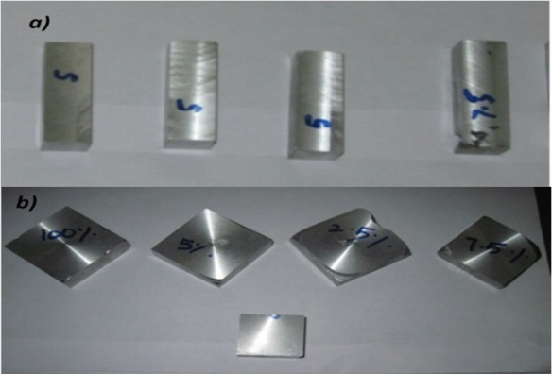 Figure.3.2 (a) few specimen for wear, (b) few specimen for Hardness

# Results and Discussions Hardness

Hardness was measured on the polished surfaces of the Al-Si alloy- iron oxide composite specimens using Brinell hardness tester. A 2.5 mm steel indenter with fixed indentation load of 187.5 kgf was used for all tests. Five readings were taken for the samples of each composition and the average hardness was considered

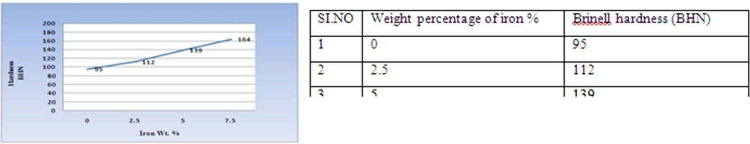

Hardness of Al combination iron oxide composites increments with expansion in weight % of iron oxide particles. The qualities which are exhibited in the Figure 5.2 are normal of the five readings for every arrangement of the composite and the disperse of the hardness qualities were about the 3% of the normal hardness values for the composite. The hardness estimation of Al combination expanded by 22% when the iron oxide substance was fused up to 7.5 wt. %.

# Dry Sliding Wear Test

Dry sliding wear tests were led utilizing pin-on-plate wear testing rig. The wear misfortune and co proficient of rubbing of the composite pin material were recorded with precision 1.0 µm. A barrel shaped pin of size 10mm breadth and 30mm tallness, composite examples were arranged and stacked in a PC interfaced pin-on - circle wear testing rig. Before testing, the surface of the examples was cleaned by utilizing 1000 coarseness paper. The turning plate was made of EN 32 steel and hardness of 65 HRC. Wear tests were completed at 25°C room temperature and 55% relative stickiness for 30 minutes.

Normal wear loss of the composites were analyzed as an element of graphite molecule content at different load and sliding pace conditions against carbon steel as represented graphically in Figure 6.2 and 6.3

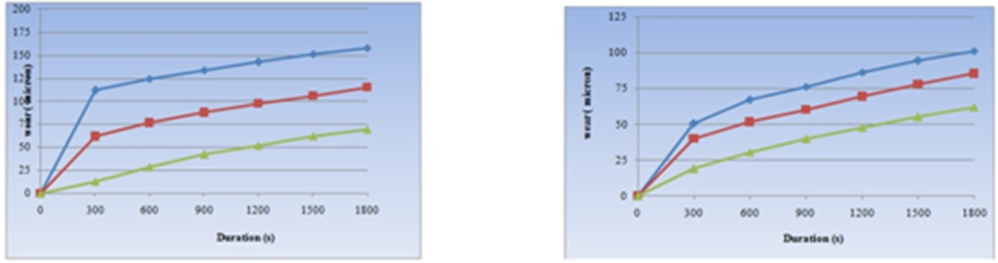

Figure 6.2 Time vs. Wear rate (5N, 2.5M/S) Figure 6.3 Time vs. Wear rate (5N, 1M/S)

It can be watched that when time was expanded wear rate was likewise expanded. Amid 1800sec, wear rate can be expanded from series1 to series2 at 67% and from series2 to series3 at 29.5%

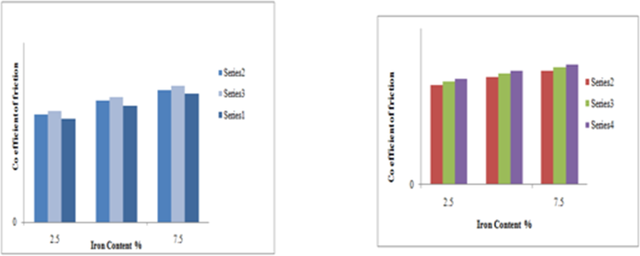It can be watched that when time was expanded wear rate was likewise expanded. At the point when looking at figure6.2 and figure6.3, amid 1800sec it was discovered wear rate expanded somewhere around 67% and 20.9% at 5N, 2.5M/S and 5N,

Figure 6.4. Iron content% vs. Coefficient friction (5N, 1M/S) Figure 6.5. Iron content% vs. coefficient of friction (5N, 2.5M/S)

It can be watched that when iron substance was expanded the coefficient of erosion was likewise expanded. What's more, when burden was expanded, coefficient of erosion likewise expanded. What's more, as sliding speed gets expanded coefficient of grinding likewise gets expanded. At 7.5% of iron substance it was found that 14% expanded from series1 to series2.

It can be watched that when iron substance was expanded the coefficient of contact was additionally expanded. Furthermore, when burden was expanded, coefficient of rubbing additionally expanded. What's more, as sliding speed gets expanded coefficient of grating likewise gets expanded. At 7.5% of iron substance, 18% expanded from series2 to series3. From series3 to series4 is 23% expanded

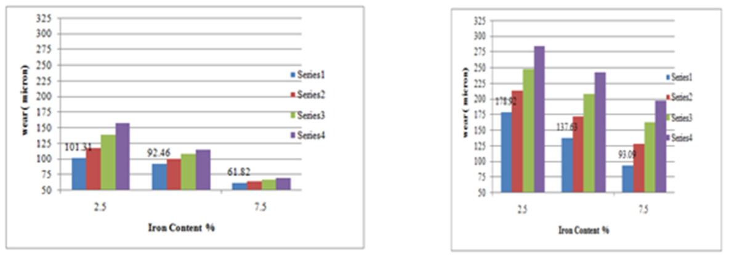

Figure 6.6. Iron content% vs. wear (5N, 1M/S) Figure 6.7 Iron content% vs. wear (5N, 2.5M/S)

It can be watched that when iron substance was expanded wear rate was diminished i.e. wear can be diminished by expanding iron substance in %. At the point when looking at a 2.5% and 5% of iron substance wear diminished around 9%. Furthermore, from 5% to 7.5% of iron substance wear diminished around 32%.

It can be watched that when iron substance was expanded wear rate was diminished i.e. wear can be diminished by expanding iron substance in %. At the point when contrasting a 2.5% and 5% of iron substance wear diminished around 16%. Also, from 5% to 7.5% of iron substance wear diminished around 47.6%.

# **Confirmation Test**

An affirmation test is the last stride in the outline of analysis procedure. The affirmation analyses were directed and results are exhibited in the table 7.6. Normal bends of wear of Al-Iron oxide composite are appeared in Figures 7.3 and 7.4. The trial values for the wear misfortune and co productive of rubbing of the composites and computed values from the relapse mathematical statement are almost same with minimum mistake (± 3 %). The subsequent mathematical statements appear to be equipped for anticipating the wear misfortune and co effective of rubbing to the satisfactory level of precision

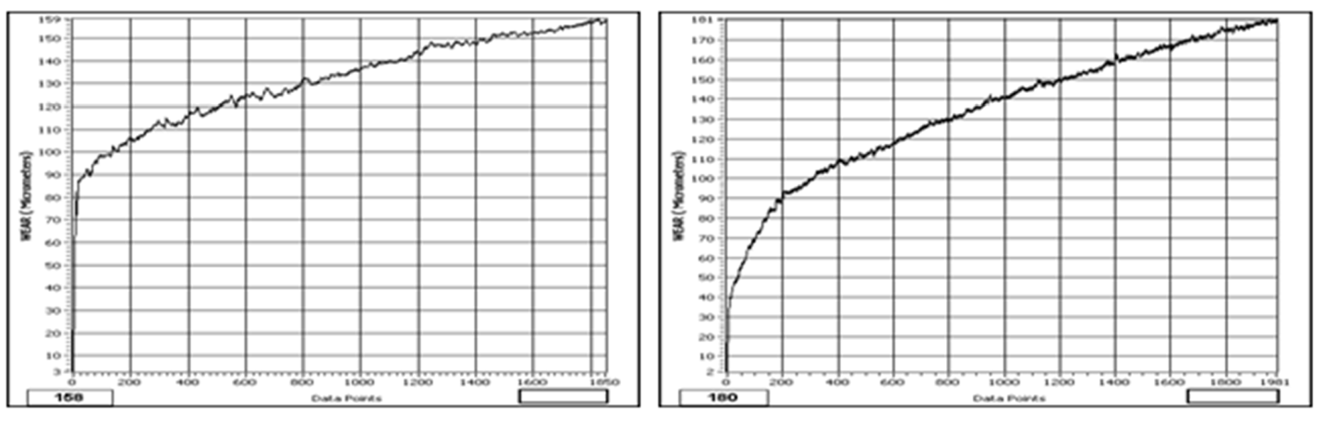

Figure 7.3 Typical curve of wear of Al-7 wt. % Iron oxide composite against steel as a function of sliding velocity at 2.5 m/s and load 20 N.

Figure 7.4 Typical curve of wear of Al-5 wt. % Iron oxide composite against steel as a function of siding velocity at 2 m/s and load 15 N.

**SEM Analysis**

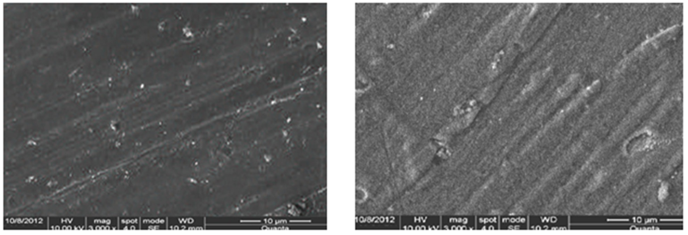

Figure 7.5. SEM micrograph of the worn surface of the Al alloy 7.5 wt. % iron oxide composite at a normal load of 5N with 2.5 m/s sliding velocity

Figure 7.6. SEM micrograph of the worn surface of the Al alloy- 7.5 wt. % composite at a normal load of 25 N with 2.5m/s sliding velocity

# **Conclusions**

The present work on combination and portrayal of LM24Al-Fe₂O₃ composites prompted taking after conclusions. This paper has displayed an utilization of L27 orthogonal exhibit of Taguchi technique and examination of difference for exploring the impacts of wt.% of Iron oxide particles, connected load and sliding speed on the wear misfortune and co - effective of grinding of composites. In view of this study, the accompanying conclusions have been outlined. The outcomes uncovered that connected burden was the most noteworthy component took after by sliding speed and wt. % of iron oxide particles on the wear misfortune. It was found that the ideal elements for least wear misfortune were wt. % of Iron oxide (7.5wt. % Iron oxide), load (5N) and sliding speed (1m/s).

Iron oxide molecule substance was the prevailing variable on the co-effective of sliding so as to grind of the composites took after speed and connected burden. It was found that the ideal variables for least co-proficient of grating were wt. % of Iron oxide (2.5wt. % Iron oxide), load (5N) and sliding speed (1m/s). It was found that gentle wear happens at low connected load and sliding speed while extreme wear happens at higher connected load and sliding speed. Investigation of worn surfaces uncovered that at lower burden, scraped spot was the predominant wear system while at higher burden, de-cover and grip were observed to be prevailing for the Al- Iron oxide composites. Results uncovered that the hardness of composite specimens expanded with expanding the weight rate of iron particles

# **References**

1. Aigbodion, V.S., “Particulate-strengthened of Al-Si alloy/alumino-silicate”, Composite Materials Science and Engineering A, 460-461: 574-578(2007).
2. Park B.G., Ko S.H., Park Y.H. and Lee J.H., “Mechanical properties of in situ Fe3Al matrix composites fabrication by MA- PDS process”. Intermetallics 14 (2006) 660-665.
3. S. Srivastava, S. Mohan Study of Wear and Friction of Al-Fe Metal Matrix Composite Produced by Liquid Metallurgical Method Tribology in industry, Volume 33, No. 3, 2011.
4. G. Mr ´owka-Nowotnik, J. Sieniawski, and A. Nowotnik, “Tensile properties and fracture toughness of heat treated 6082 alloy,” Journal of Achievements in Materials and Manufacturing Engineering, vol. 17, no. 1-2, pp. 1–2, 2006.
5. W. Khraisat and W. Abu Jadayil, “Strengthening aluminum scrap by alloying with iron oxide,” Jordan Journal of Mechanical and Industrial Engineering, vol. 4, no. 3, pp. 372–3377, 2010.
6. T. T. Sasaki, T. Ohkubo, and K. Hono, “Microstructure and mechanical properties of bulk nanocrystalline Al-Fe alloy processed by mechanical alloying and spark plasma sintering,” *Acta Materialia*, vol. 57, no. 12, pp. 3529–3538, 2009.