Analyses of Public Schools as a learning Institution:

A Case Study of a school of Jalandhar.

By: Dr Deepanshu Sharma, Aman Preet Thakur, Nikhil Dogra and Sahilpreet Singh.

Abstract: School plays a very important part in one’s life. From basic grooming to education to personality development, school makes us a social being in complete sense in order to succeed in our future goals. For this case study we went to a school to know its myriad effect on a child’s mind and analyse the process of learning and significance of different activities such as; morning assembly, P.T., and how different government schemes are being applied in public schools.

INTORDUCTION

By far, one of the most crucial ideas in democracy is public education. Any country's development has always depended heavily on education, and India surely has some of the best schools in the world. The elimination of fear, the peaceful expression of ideas, and the freedom to think and develop without being constrained by limitations or obstacles are all made possible by education, which also encourages awareness, aids in better decision-making on the part of the populace, and results in change. Overall, it backs demonstrations against exploitation, injustice, and prejudice. Every person can meaningfully contribute to the development of a civil society with the aid of education, which is a crucial tool. Any student may attend a public school, regardless of academic standing or background, gender, nationality, ethnicity, or religious affiliation.  They are provided without charge and are supported by taxes.

Government schools, often known as public schools, have a lengthy history in India dating back more than 150 years. India's fight for independence was led by public schools. The previous "government" or "municipality" schools produced many notable independence fighters and leaders. Although a sizable portion of the nation's youth attends these public schools, in India, public schools are infamous for their appalling conditions. They are frequently known to be underfunded, overcrowded, and chronically understaffed, excluding a small number of locations. They are also very ineffective. However, in a nation of 1.2 billion people, many parents still lack access to the exclusive schools that offer places to pupils solely on the basis of their test scores. In other words, the bulk of India's future engineers, authors, and philosophers’ study in public schools, and for this reason, public schools cannot be ignored any more while discussing education reform in our nation.

There is a very negative image of public schools in India. At some point its true, at some it isn’t. Usually, if you will ask any parent, they would choose a private school instead of a public institute. Even after being enrolled in public school why student seek private tutors to seek knowledge questions the quality of education imparted in public school. According to a survey conducted in 2018, around 42.6 percent of public primary students in rural India spent 100 to 200 rupees monthly on private tuitions. More than 15 percent of students of public school opted for a private tutor in India that same year. So, this clearly highlight the low faith of students in public school. For analyzing this information, we went to a public school for a field visit and prepared a case study. In this paper we present the case study of a public school of Phagwara through its learning methods and day to day activity.

CASE STUDY

For this research paper we visited a government school of Punjab to see different aspects of a school and how they effect a Child's/Student's life.

The first school we visited is situated in a small village in Jalandhar district of Punjab. The name of this village is Manguwal and name of the school is Government primary school Manguwal.

The school teaches a total of 98 students who are from this village or the neighboring villages only. There are total of 3 teachers in this school (it should be mentioned that all 3 of them are female).

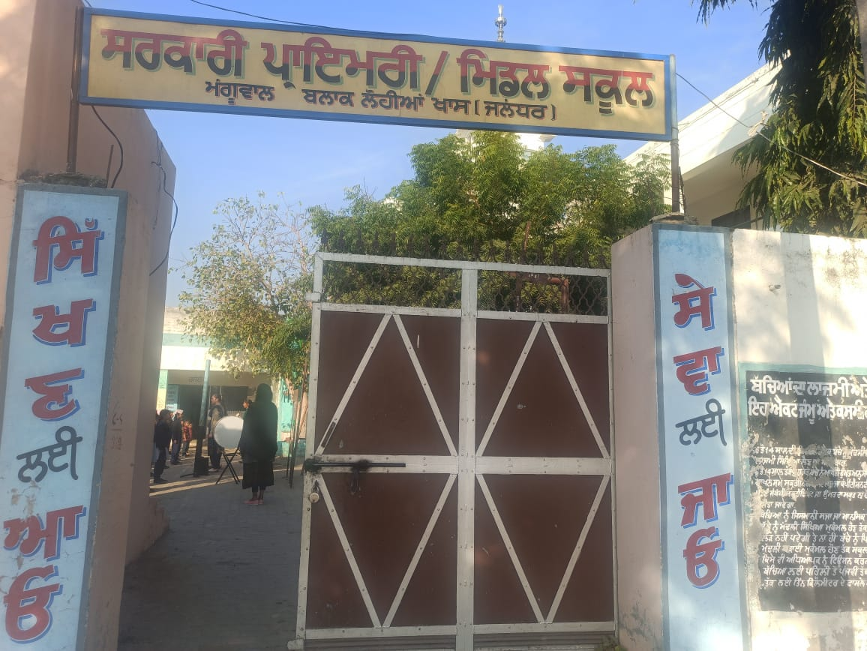

Morning Assembly

Day in school began with morning assembly. To understand the significance of morning assembly and its impact on a student, we visited school quite early.

So, the first bell rang at 8:45 am and the morning assembly started at 9:00 am with the second bell. The morning assembly started with a prayer.

Which according to the teachers, is done because it is a custom in Indian culture to start the day with a prayer to God. (It is worth mentioning that a good quality sound system is provided to the schools which is used in the morning assembly). Just after this prayer students took a pledge. Which is done to show love and respect to our nation. The pledge was taken in Punjabi language only. Along with the respect to nation, student take a pledge to become a good citizen.

After the pledge, some activities took place.

These activities are mentioned in a slide which the education department of Punjab shares a day before. All the activities that the students have to do are mentioned in this slide. The slide begins with the thought of the day. The thought when we visited was "Humanity is the greatest religion". Then questions related to general knowledge and science were asked. Students were able to answer few of these questions but the teacher explained the ones which the students could not answer.

After this, a riddle was asked. After the riddle students practiced 5 English words. (Which tells us that a high importance is given to English language practice).

After these activities, students proceed on to do some physical exercises.

The assembly ended with the national anthem after which the students went back to their classrooms in a parade.

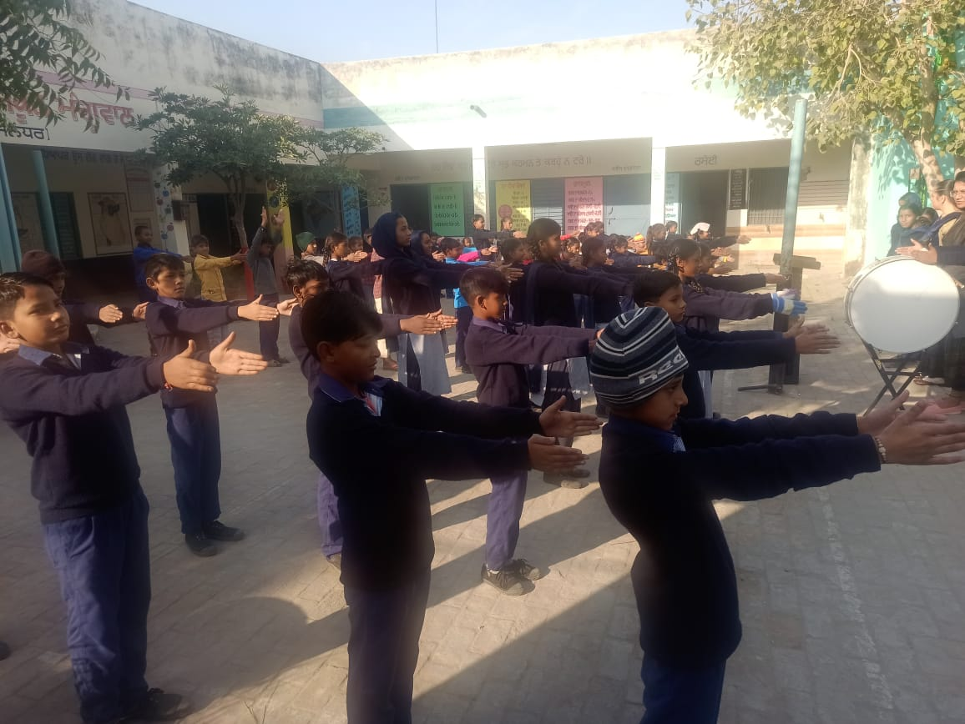

Class-room Visit

Next bell rang at 9:30 am, which meant start of the classes. We visited the 4th standard. The classroom was spacious with adequate number of benches for students. As soon as the teacher entered the classroom, students stood up and said good morning to the teacher. From that moment only, we could feel the connection between the students and the teacher. (We felt that connection when we first entered the school also, the way in which the students were talking to the teacher). The subject taught in the first period was Punjabi. Teacher started with the activity of dictation, in which, she spoke in Punjabi and the students wrote it down.

After which the notebooks were checked. Out of 19 students, 8-9 were good at it, 5-6 were average at it, and the remaining 4 were not up to mark, the mistakes that the students made were corrected with the help of projectors installed in the classroom.

Then the teacher moved on with the syllabus. Chapter-12 of Punjabi was started. Firstly, the teacher read the chapter herself. Then she played a video about the chapter using the projector and the app provided by the education department. After this, some multiple-choice questions were asked and the students who did good in the dictation activity again were better at answering these questions. After which students read the chapter themselves. At last, homework was given to the students. (It is worth mentioning that the weak students were given some extra tasks for home so they may improve).

After the first period we visited other classes also and most of them had a computer or a projector with which, the teacher was teaching the students.

I came back to the 4th standard for the next period also. So, each period is 1 hour long and the next subject to be taught was mathematics.

The mathematics class started with reciting of tables of 2 to 20.

Teacher-learning material or TLM is used if needed. During the mathematics period, Fake currency was used from this TLM as the current chapter was about money. Students were made familiar with different types of currency notes and coins.

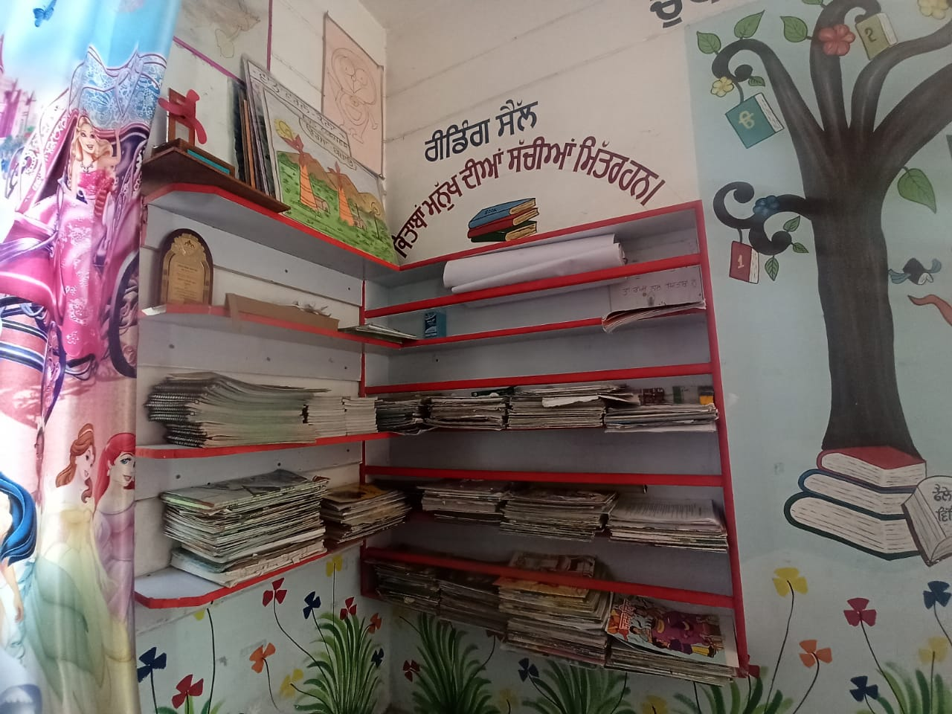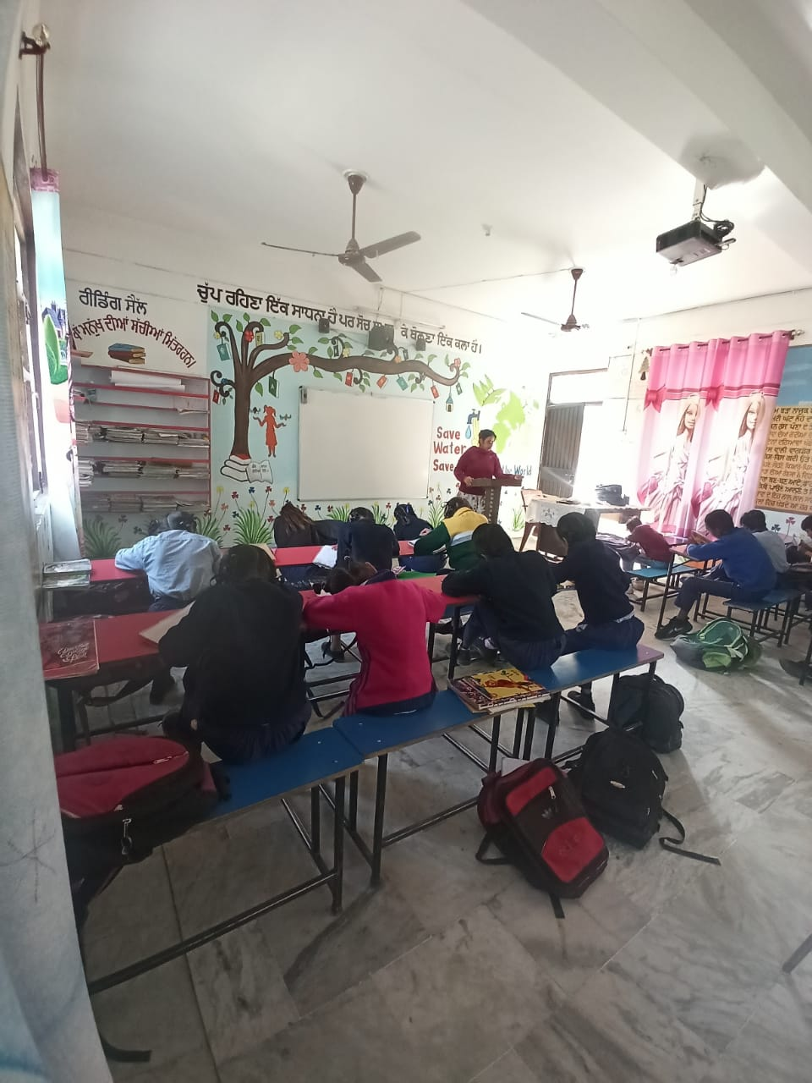

Infrastructure

Infrastructure of this school was in optimal condition but it also had some demerits. The biggest one was the lack of a playground. I think a playground one of the most important parts of any school and the lack of one here was duly felt by us and the students also.

Apart from this lack of playground, the classrooms were well equipped with modern technology as mentioned many times before.

Despite of the lack of an area for a playground, teachers here have done what they could do to make the school more enjoyable for the kids. For example; there is a little playing area for kinder garden students where they can play, which has swings and other fun activities.

The kitchen was in optimal condition also. It was hygienic and clean. The bathrooms were also clean but they could have been better.

When we asked the teachers about the ground water condition, we got the answer we expected. They said the ground water here is very polluted and which leads to life threatening diseases. To tackle this situation, Water filters are installed in the school. Teachers informed us that they are inspected time to time to check if they are working properly or not.

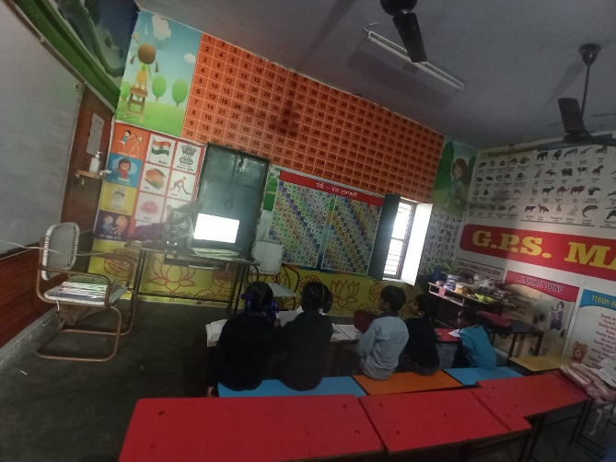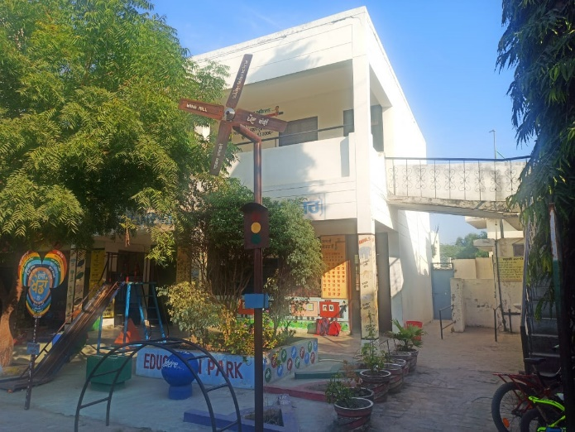

Mid-day meal

This was one of the most important aspects when we decided this topic, to check the quality of the food provided under the mid-day meal scheme.

Here is the schedule of mid-day meal of this school:

Monday: pulses/Dal with Chapati/roti

Tuesday: pulses/Dal with rice and kheer

Wednesday: chickpeas with Chapati/roti

Thursday: Kadhi pakora/ with rice

Friday: any seasonal vegetables with Chapati/roti

Saturday: same as Monday.

On the day of our visit kadhi pakora (a common north Indian household dish) with boiled rice was served. The food was surprisingly very tasty and felt like homemade food. We observed the preparation of food too and the kitchen was hygienic and the products used were of good quality.

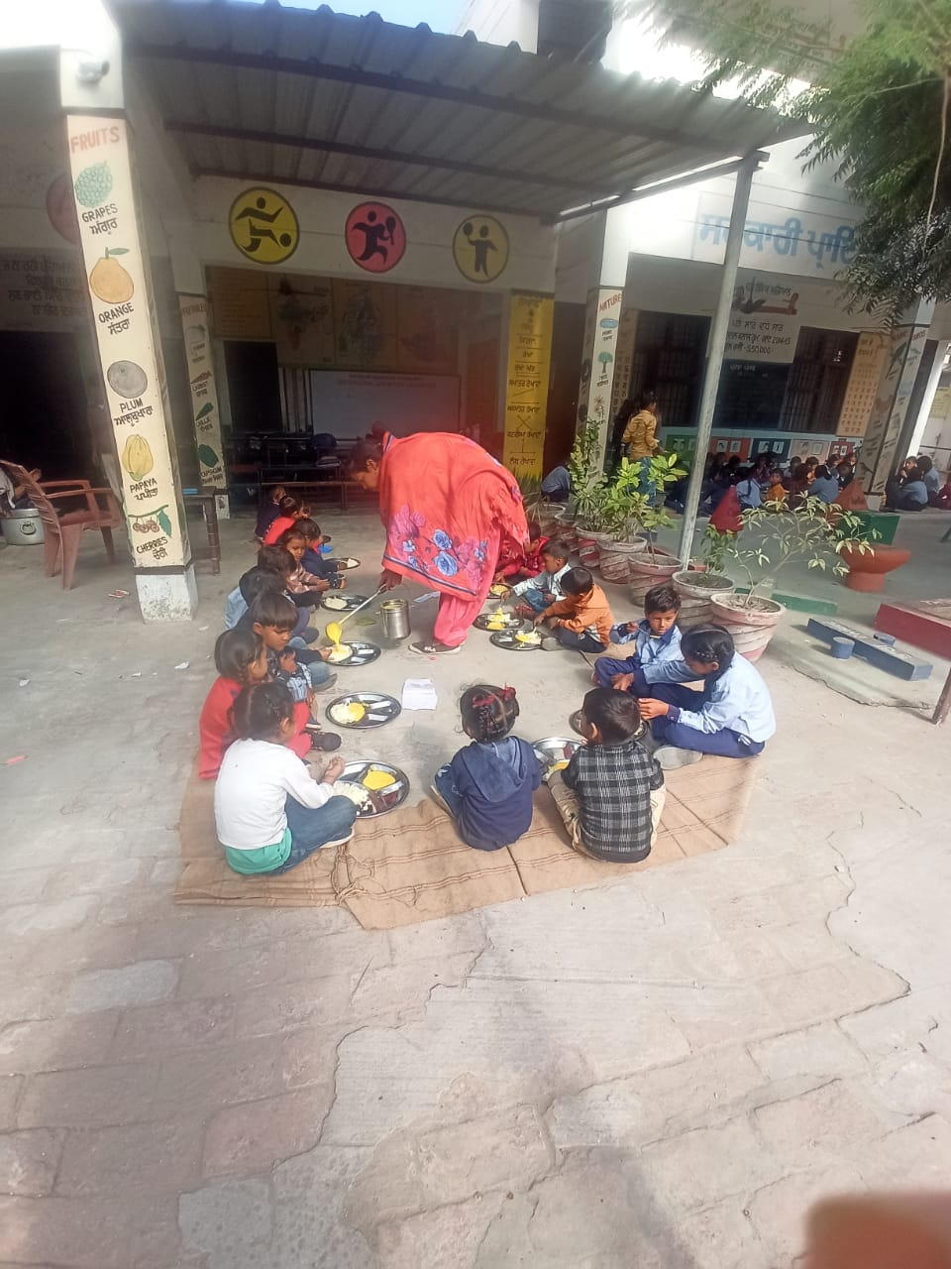A very small number of students brought in their own food from their home but they still ate the M.D.M but the majority of the students ate the Mid-day meal only. I asked some students about the quality of the food and they said it is tasty.

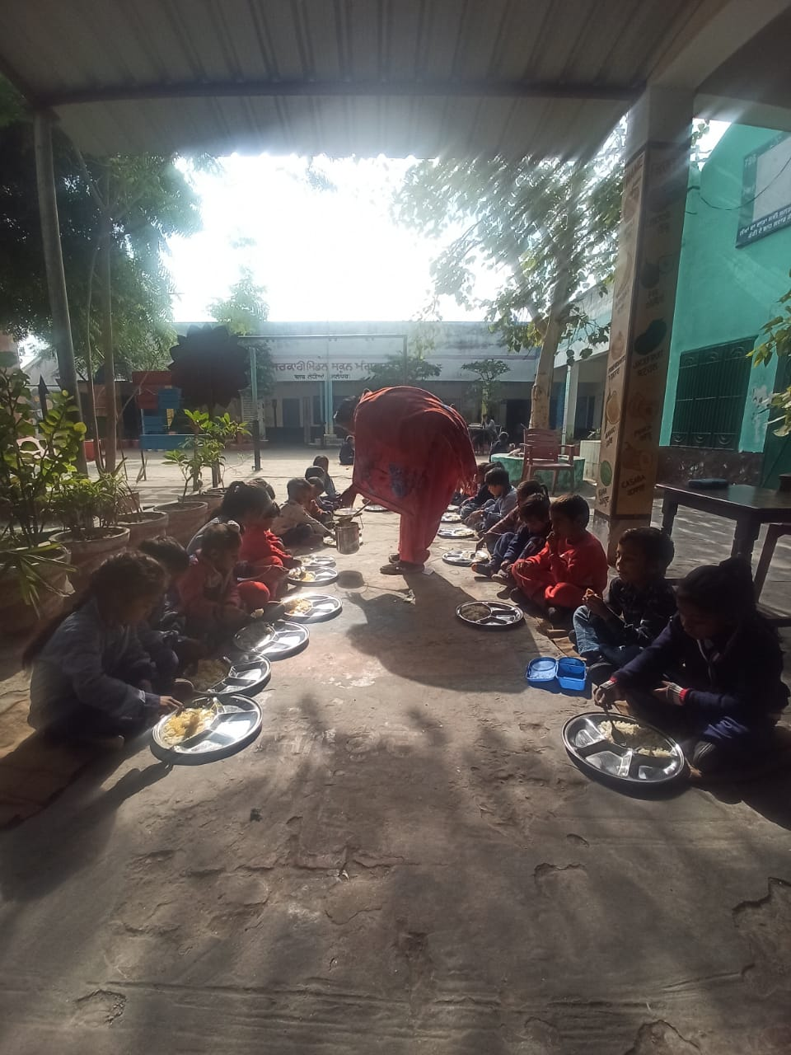

Analysis and conclusion

1.Significance of morning assembly.

Every school recognizes the value of morning assembly and has made it a part of their culture. Students from several grades get together for the morning assembly. The children grow to feel more connected and united as a result of this. During the morning assembly, important instructions and facts that every student should be aware of are frequently covered. Students will better comprehend the material as a result. Every student can feel a connection to the school via the morning assembly. The motivational elements of the morning assemblies include positive reinforcement in the form of awards. Additionally, it pushes pupils to speak in front of the class, which helps kids gain confidence. The kid leaves a morning assembly with a positive outlook to continue studying throughout the day. A morning assembly is the ideal representation of the school since it brings together all of the kids from all classes and branches as well as the principal, teachers, and support personnel. The most important institution in a student's life is school, which holds morning assemblies to inspire kids and provide them motivation for the remainder of the day. The physical activity in form of exercises helps students to stay active through out the day. So overall activity of morning assembly in school was very up to mark, fulfilling its significance.

2. Pedagogy of teachers.

Teaching was very practical and was done according to lesson plans by teachers. Positive reinforcement was used by providing good remarks to encourage the students and equipment were used to rectify the student’s mistake. While teaching, engaging methodology was used for making study more interesting and fun, like use of fake currency for teaching money.

3. Sanitation and its importance.

This becomes a very serious problem for rural India, where it is estimated that 50% of schools lack functional restrooms. This is the reason Coca-Cola India, NDTV, and UN-Habitat joined together to launch the Support My School program in India, which aims to revitalize schools in semi-urban and rural communities and enhance their hygienic and water initiatives. Being a part and a successful example of this initiative the sanitation facilities in school was good but a little more was needed to maintain it. Toilets could have been more clean and good by using phenyls and naphthalene balls for better germ protection and something like air freshener to make it smell good.

4. Midday meal scheme.

In 1995, the Midday Meal Program was established to offer free prepared lunches to schools that had a minimum energy of 450 kcal. Previously known as the "National School Lunch Program," or more often known as a midday meal plan, the PM POSHAN (Poshan Shakti Nirman) initiative to serve a hot prepared lunch in government and government-assisted schools from 2021–2025 was authorized by the Cabinet committee on economic affairs (CCEA). All school-age students enrolled in grades I through VIII in government schools who receive government funding are covered by this centrally funded program.

In school the kitchen for midday meal was very clean and hygienic. The prepared food that we tasted was up to mark and nutritious and after asking few students we also came to know about the variety they are provided by school, of the food, as per chart.

5. Drawback and conclusion.

Lack of a good playground was one of the biggest drawbacks in school. Physical activity is must and so does sports because it conducts the spirit of teamwork, a better social bonding and discipline among student.

Number of teachers were a really big concern for us. There were only three teachers in school which was quite disappointing. The government should take initiative and provide the schools with more teachers for broader teaching aspect.

Overall, we went to the conclusion that public are not so bad in terms of facilities and education. The parents should send their ward to public school so the community could start taking more initiative for its betterment.

References.

<https://tfipost.com/2021/10/importance-of-mid-day-meal-programme/#:~:text=Importance%20and%20objectives%20of%20Mid%20Day%20Meal%20Programme,-Retain%20children%20studying%20in%20classes%20I%20to%20VIII>.

<https://www.nhp.gov.in/mid-day-meal-programme_pg>

<https://borgenproject.org/the-importance-of-sanitation-to-education/>