#### **HEALTH MONITORING AND MANAGEMENT USING IOT**

#### **SHRUTI MEHRA**

#### Student ECE Department, Sharda University,

#### Gautam Budh Nagar,UP, India

ABSTRACT

Life expectancy in most countries has been increasing continually over the several few decades by significant improvements in medicines, public health as well as personal and environmental hygiene. However, increased life expectancy combined with falling birth rates. So, this is essential to develop cost-effective, easy to use systems for the sake of elderly healthcare and well-being. The Internet of things (IOT) makes smart objects the ultimate building blocks in the development of cyber-physical smart pervasive frameworks. The IOT has a variety of application domains, including healthcare. The IOT in modern healthcare is promising technological, economic and social prospects. This report includes advantages of existing IOT based health monitoring devices and advances of IOT based healthcare technologies which is beneficial for elderly people.

Keywords: Analysis, Programming, Research, Methodology, Audino-nano

**1. INTRODUCTION**

1.1 **What is an IOT?**

'IOT' stands for internet of things is a system of interrelated computing devices, mechanical and digital machines, objects or people that are provided with unique identifiers and the ability to transfer data over a network without requiring human to human or human to computer interaction. Life expectancy has been increasing worldwide due to significant improvements in healthcare, and medicine as well as due to growing consciousness about personal and environmental hygiene. In addition, over the past several decades, there has been increasing interest in family planning thereby contributing to declining birth rates around the globe. According to the World Health Organization (WHO), by 2017, the elderly population over 65 years or older are expected to outnumber the children less than 5 years of age. However, this enormous aging population would create a significant impact on the socio-economic structure of society in terms of social welfare and healthcare needs. Besides, this, the cost associated with healthcare services continues to soar because of increasing price of prescription drugs, medical instruments, and hospital care. Therefore, it is an utmost necessity to develop and implement new strategies and technologies in order to provide better health care services at an affordable price to the aging population or to the people of those areas having limited access to healthcare while ensuring maximum comfort, independence, participation among the people.

Remote healthcare monitoring allows people to continue to stay rather than in expensive healthcare facilities such as hospitals or nursing homes. It thus provides an efficient and cost effective alternative to on site clinical monitoring. Such systems equipped with non-invasive and unobtrusive wearable sensors can be viable diagnostic tools to the healthcare personnel for monitoring important physiological signs and activities of the patients in real time from distant facility. Therefore, it is understandable that wearable sensors play a critical role in such monitoring systems that attracted the attention of many researchers, entrepreneurs, and tech giants in recent years. A variety of application specific wearable sensors, physiological and activity monitoring systems.

Wearable devices can monitor and record real time information about one's physiological condition and motion activities. Wearable sensor-based health monitoring systems may comprise different types of flexible sensors that can be integrated into textile fiber, clothes, elastic bands or directly attached to human body. The sensors are capable of measuring physiological signs such as electrocardiogram (ECG), electromyogram (EMG), heart rate (HR), body temperature , electro dermal activity(EDA), arterial oxygen saturation(SpO2), blood pressure(BP), and respiration rate(RR). In addition, micro electro mechanical system (MEMS) based miniature motion sensors such as accelerometers, gyroscopes, and magnetic field sensors are widely used for measuring activity related signals. Continuous monitoring of physiological signals could help to detect and diagnose several cardiovascular, neurological, and pulmonary diseases at early onset. Also, real time monitoring of individual motion activities could be useful in fall detection gait pattern and posture analysis, or in sleep assessment. The wearable health monitoring systems are usually equipped with a variety of electronic and MEMS sensors, actuators, wireless communication modules and signal processing units. The measurements obtained by the sensors connected in a wireless body sensor network(BSN) are transmitted to nearby processing node using a suitable a suitable communication protocol, preferably a lower-power and short range wireless medium ,example- Bluetooth, Zigbee. Near field communication (NFC). The processing node, which could be a personal Digital Assistant(PDA), smartphone, computer or a custom made processing module based on a microcontroller or a field programmable gate array(FPGA) runs advanced processing , analysis, and decision algorithms and may also store and display the results to the user. It transmits the measured data over the internet to the healthcare personnel, thus functioning as the gateway to remote healthcare facilities. In order to be used for long term monitoring purposes, wearable health monitoring systems need to satisfy certain medical and ergonomic requirements. eg- The system needs to be comfortable, the components should be flexible, small in dimensions and must be chemically inert, and non- toxic, hypo-allergenic to the human body.

Wearable Sensors, being progressively more comfortable and less obtrusive, are appropriate for monitoring an individual's health or wellness without interrupting their daily activities. The sensors can measure several physiological signals/parameters as well as activity and movement of an individual by placing them at different locations of the body. The advancement in low power, compact wearable, inexpensive computing and storage devices coupled with modern communication technologies pave the way for low cost, unobtrusive, and long term health monitoring system.

The usage of the IOT in healthcare (the industry, personal healthcare and healthcare payment applications) has sharply increased across various specific internet of things use cases. The improvement of the healthcare with remote monitoring and tele-monitoring as main applications. A area where numerous initiatives exist is tracking, monitoring and maintenance of assets, using IOT . This is done on the level of medical devices and healthcare assets, the people level and the non- medical asset level (eg. hospital building assets).

The range of IOT applications has become wider, smart, and connected healthcare is crucial one. This can be achieved by wearing sensors or embedded in our abode which panoply information of physical and mental health of patients, information captured on regular basis which brings affirmative changes in present health care scenario.

## 1.2 **USES OF WEARABLE DEVICES**

By the use of processing algorithms and data analysis. We can :-

1. It diagnose the pulse rate before it will result in heart attacks,"It's better to take prevention than cure". It gives personalized treatment and management.
2. It will lead to new possibilities in the digital health ecosystem to achieve a range of health outcomes.
3. Sensors monitor physiological data of older people and individuals with chronic conditions can facilitate clinical interactions.

**2. METHODOLOGY**

## 2.1 **OVERVIEW**

'IOT' stands for internet of things is a system of interrelated computing devices, mechanical and digital machines, objects or people that are provided with unique identifiers and the ability to transfer data over a network without requiring human to human or human to computer interaction.

The usage of the IOT in healthcare (the industry, personal healthcare and healthcare payment applications) has sharply increased across various specific internet of things use cases. The improvement of the healthcare with remote monitoring and tele-monitoring as main applications. A area where numerous initiatives exist is tracking, monitoring and maintenance of assets, using IOT . This is done on the level of medical devices and healthcare assets, the people level and the non- medical asset level (eg. hospital building assets).

The range of IOT applications has become wider, smart, and connected healthcare is crucial one. This can be achieved by wearing sensors or embedded in our abode which panoply information of physical and mental health of patients, information captured on regular basis which brings affirmative changes in present health care scenario. By the use of processing algorithms and data analysis. We can:-

1. It diagnoses the pulse rate rate before it will result in heart attacks, “It’s better to take prevention than cure". It gives personalized treatment and management.
2. It will lead to new possibilities in the digital health ecosystem to achieve a range of health outcomes.
3. Sensors monitor physiological data of older people and individuals with chronic conditions can facilitate clinical interactions.

## 2.2 **DESIGNING OF HEALTH MONITORING SYSTEMS**

1. Aurdino Nano
2. Wi-Fi module ESP8266-01
3. Heart Sensor
4. Temperature Sensor LM-35 5
5. LCD(16x2)
6. IR Sensor

## **LAYOUT OF HEALTH MONITORING SYSTEM**

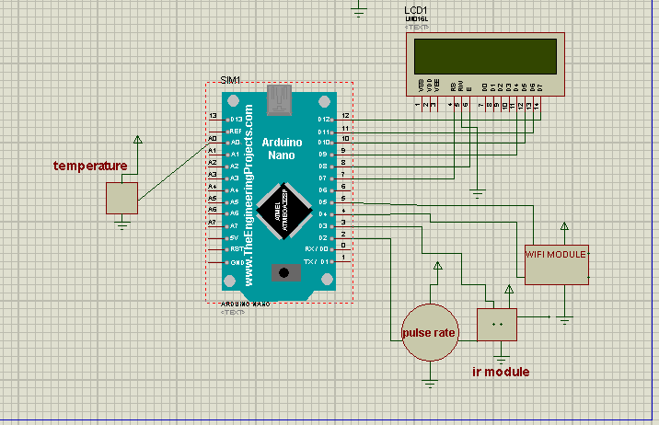

## **CIRCUIT DIAGRAM OF HEALTH MONITORING SYSTEM**

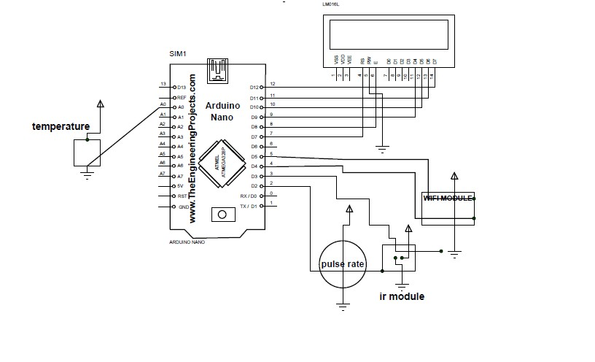

1. 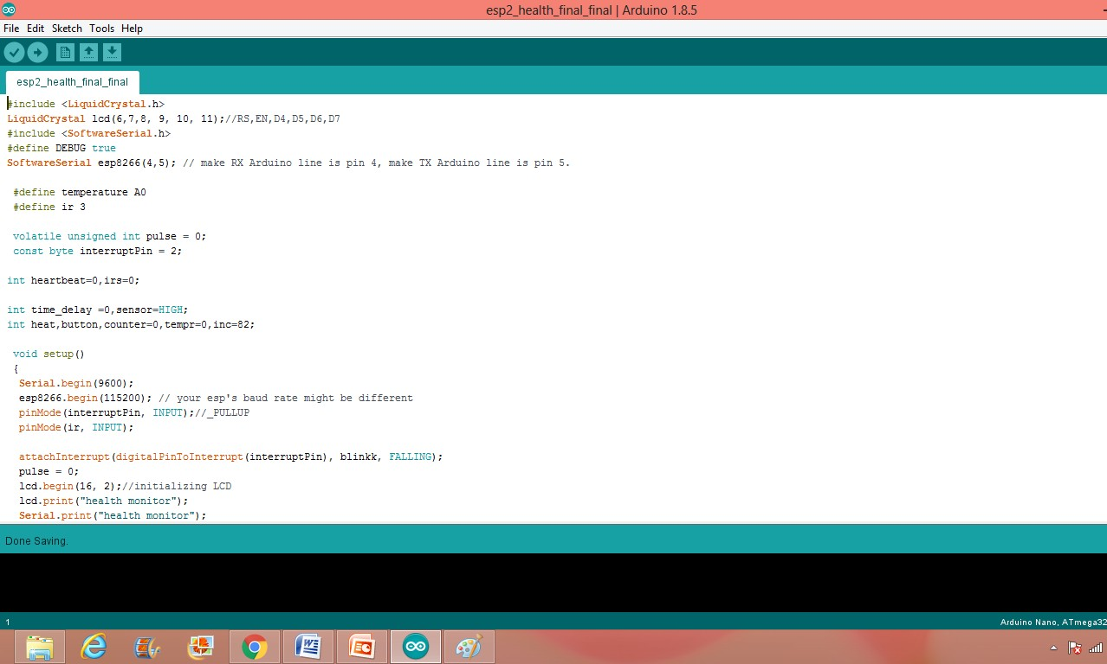 **PROGRAMMING AND ANALYSIS**











1. **RESULTS**

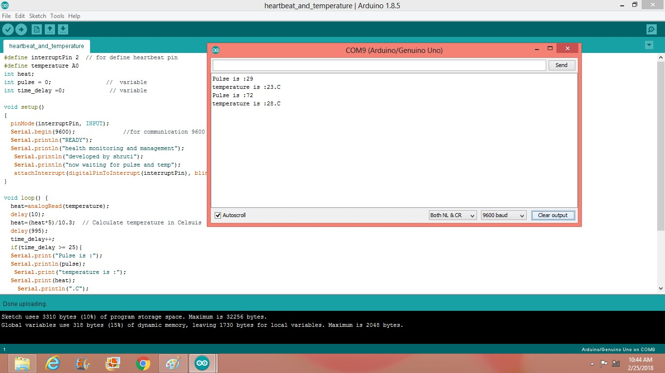

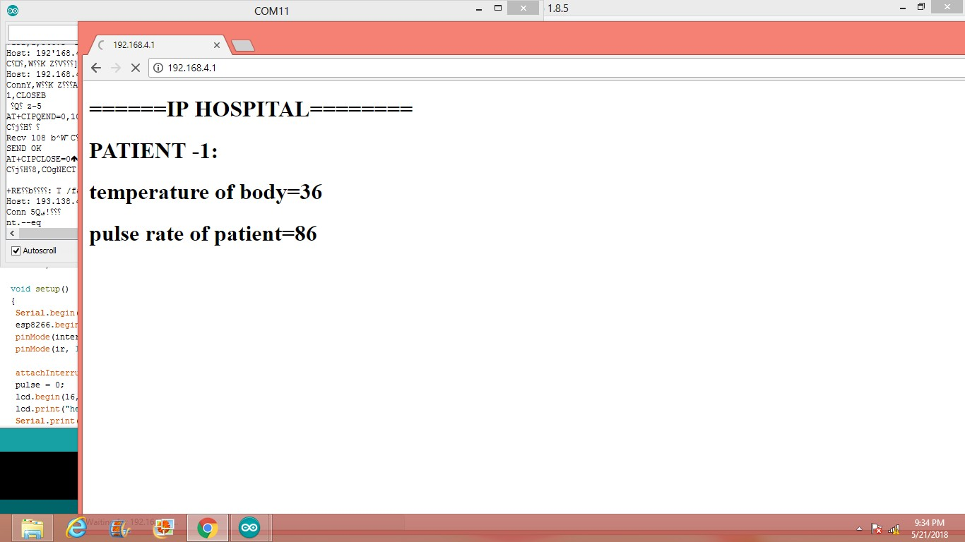

1. **CONCLUSION**

Researchers across the world have started to explore various technological solutions to enhance healthcare provision in a manner that complements existing services by mobilizing the potential of the IOT. This report includes diverse aspects of IOT based healthcare technologies and present various applications of IOT based devices in healthcare showing up and their advantages with technical specifications and platforms that support access to the IOT backbone and facilitate medical data transmission and reception. Substantial R&D efforts have been made in IOT-driven healthcare services and applications. This report is concerning how the IOT can address pediatric and elderly care, chronic disease supervision, private health, and fitness management.

# **REFERENCES**

1. Moeen Hassanalieragh, Alex Page, Tolga Soyata, Gaurav Sharma, Mehmet Aktas, Gonzalo Mateos Burak Kantarci, Silvana Andreescu," Health Monitoring and Management Using Internet-of-Things (IoT) Sensing with Cloud-based Processing: Opportunities and Challenges", 2015 IEEE International Conference on Services Computing.
2. Alexandros Pantelopoulos and Nikolaos G. Bourbakis," A Survey on Wearable Sensor-Based Systems for Health Monitoring and Prognosis", IEEE Transactions on systems, man, and cybernetics Part C: Applications and reviews, Vol. 40, No. 01, January 2010.
3. Arsalan Mosenia, Susmita Sur-Kolay, Anand Raghunathan and Niraj K. Jha," Wearable Medical Sensor-Based System Design: A Survey", IEEE Transactions on multi-scale computing systems, vol. 3, No. 2, April-June 2017.
4. Suriya Begum, Venugopal ," Comparison of various techniques in IoT for healthcare systems", International Journal of Computer Science and Mobile Computing, Vol.5 Issue 3, March- 2016.
5. S.M.Riazul Islami, Daehan Kwak, MD. Humaun Kabir, Mahumd Hossain, AND Kyungsup Kwak," The Internet of Things for Health Care: A Comprehensive Survey", 2015 IEEE. Translations and content mining are permitted for academic research only.
6. Stephanie B. Baker, Weixiang, and Ian Atkinson," Internet of Things for Smart Healthcare: Technologies, Challenges, and Opportunities", 2017 IEEE. Translations and content mining are permitted for academic research only.
7. MD. Mofijul, Islam, MD. Abdur Razzaque, Mohammed Mehedi Hassan, Walaa Nagyi Ismail, and Biao Song," Mobile Cloud-Based Big Healthcare Data Processing in Smart Cities", 2017 IEEE. Translations and content mining are permitted for academic research only.
8. Shao-Jie Hsu, Shih-Syun Lin, Tun-Wen Pa, Hamido Fujita," Proactive Healthcare and an Early Warning Mechanism for Coronary Artery Disease Patients using Internet-of- Thing Devices", 2016 IEEE International Conference on Systems, Man, and Cybernetics' SMC 2016 October 9-12,2016.
9. Akshay Gapchup, Ankit Wani, Durvesh Gapchup, Shashank Jadhav," Health Care Systems Using Internet of Things", International Journal of Innovative Research in Computer and Communication Engineering, Vol. 4, Issue 12, December 2016.
10. Divya Saxena, and Vaskar Raychoudhury, “Design and Veriﬁcation of an NDN- Based Safety-Critical Application: A Case Study with Smart Healthcare”, IEEE 2017.
11. Ms.Kalyani D Shinde, Prof. Sagar B. Shinde, Prof. S. S. Savkare,” A Review on system of IOT Based Human Activity Monitoring By Using Raspberry Pi”, http://www.ijarsmt.com Volume 2, Issue 6, June 2016.
12. Divya Saxena, and Vaskar Raychoudhury,” Design and Veriﬁcation of an NDN- Based Safety-Critical Application: A Case Study with Smart Healthcare”, IEEE Transactions on systems, man, and cybernetics: Systems.
13. Prosanta Gope and Tzonelih Hwang,”BSN-Care: A Secure IoT-Based Modern Healthcare System Using Body Sensor Network” IEEE Sensors Journal”, Vol. 16, No. 5, March 01, 2016.
14. Kenji Aono, Nizar Lajnef, Fred Faridazar and Shantanu Chakrabartty,” Infrastructural Health Monitoring Using Self-powered Internet-of-Things “,2016 IEEE.