A Comprehensive Study of Robotics And Automation

Joselin. J1, Ebinezer.J2, Bhuvan Shankar3

Assistant Professor1, III BCA-students2,3

# Sri Krishna Arts and Science College, Coimbatore1,2,3

# **Abstract:**

**We humans have been fascinated from time immemorial by the concept of artificial human like machines. In the path of designing and developing human like machines, we gained a better understanding about human behaviour, logical thinking and emotions. This paper describes Robotics by looking at the different types of robots, their applications and their significance in today’s world. The role of robotics in automation and its significance are also discussed.**

***Keywords: Robotics, Automation.***

# Introduction

Robotics is the design, construction and use of machines (Robots) to perform tasks traditionally done by human beings. Robots are especially useful in environments where repetitive work is involved as robots can be specifically programmed to perform that task, thereby maximising efficiency. Robotics is an interdisciplinary domain of engineering and computer science. Automation refers to the use of a technology by itself without any external human intervention in completing a task. By combining novel technologies, it is possible to automate processes such as manufacturing, automobile locomotion, computation, etc. Hence in today’s era more and more robots are being used to automate processes which has increased efficiency, reliability and speed of many tasks previously performed by humans. One of the main achievements of robotics is the elimination of hazardous jobs for humans.

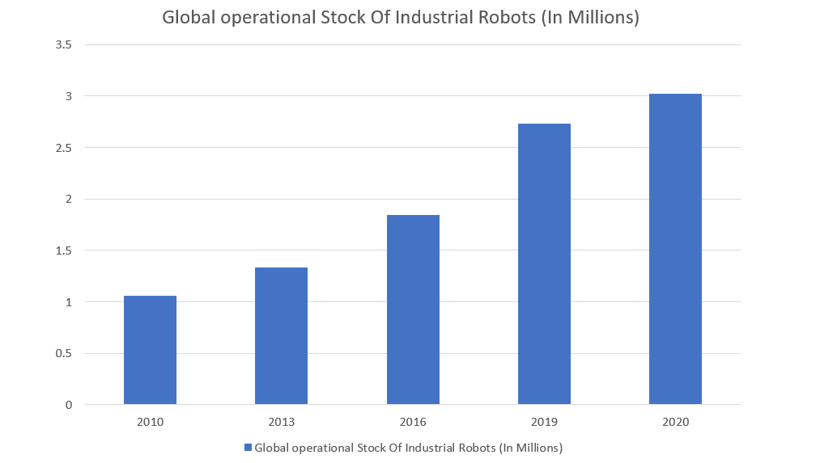

 Figure 1, Illustrates the rapid increase in the use of robotic technologies on an industrial level*.*

1. Types Of Robots

**Humanoid:**

Robots that are designed to mimic human behaviour are humanoid robots. Humanoid robots resemble the human body in shape and human behaviour in function.[1]

**Robot Manipulators:**

A robot arm, also known as a robot manipulator is a mechanical chain of various actuators which combine to perform a task using its end effector. These robots are mainly used in the automation of manufacturing processes.

**Cobot:**

Cobot stands for “Collaborative robot”, Cobots are designed with the intention of creating a robot that is capable of safe direct human-robot interaction. Cobots are hence made of lightweight materials with rounded smooth edges in order to be inherently safe for human interaction. The main applications of Cobots are in human cooperation, coexistence and collaboration.[2]

**Modular Robots:**

By modularizing the structure and function of a robot it is possible to switch between different requirements in the same robot, there by maximizing the versatility of such robots. Repair and maintenance of these robots is effortless as the defective module can easily be replaced. This enables a single modular robot to be fully specialized in a particular task while also being able to be specialized to undertake numerous distinct duties.[1]

**Mobile Robots:**

Mobile robots have the ability to locomote on their own. These robots may include automated guided vehicles such as rovers. These robots rely on the data acquired by their sensors to process their surroundings in order to locomote and perform required tasks.

**Teleoperated Robots:**

Robots that can be operated remotely by a human are called teleoperated robots. Through various onboard cameras and sensors humans are able to analyse and extend their function to remote locations by operating these robots. Teleoperated robots are programmed to perform tasks as requested by humans.

1. Applications Of Robots

Robots have a wide range of applications ranging from performing small and simple tasks to performing major complicated tasks requiring accuracy and precision.

**Medical Robots:**

Medical surgeries are highly complicated and time-consuming tasks, by including robots as aids to human doctors it is possible to reduce the workload and improve the efficiency of surgeries.[3] Other uses of robots in the medical sector include rehabilitation robots, which are designed to improve movement in people with impaired physical functioning. Sanitation and disinfection robots which are used to disinfect hospital premises. Telepresence robots which enable doctors to communicate remotely with patients.

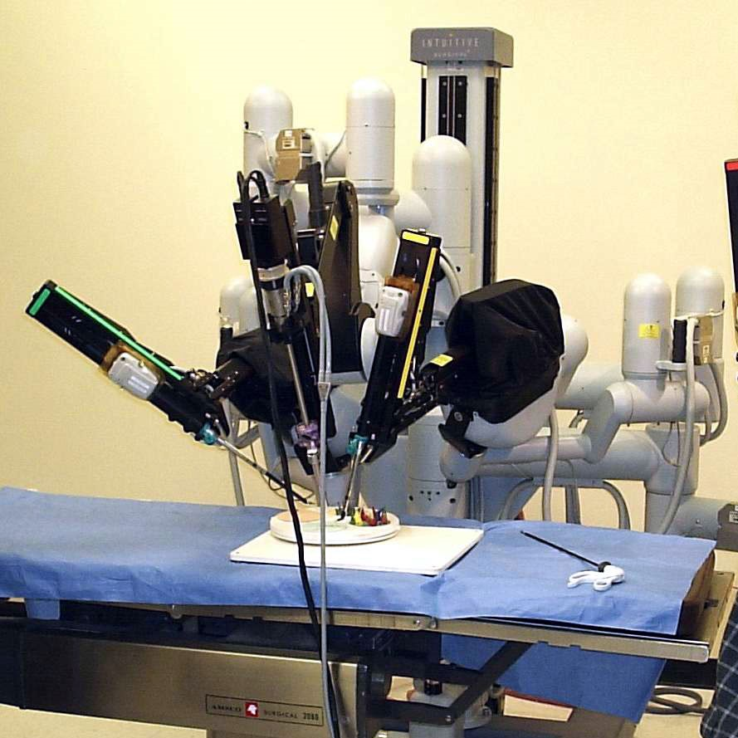

Figure 2, Da Vinci Surgical System – a robotic surgical system created by Intuitive Surgical in 2000. Photograph courtesy of *Intuitive Surgical, Inc.*

**Robots In The Food Industry:**

Robots in the food industry are used in all stages starting from the categorising of raw materials, processing and packaging of the finished food products. Robots with specific tasks are implemented across the manufacturing process. Robotic categorising involves the use of robotic arms to sort the different raw materials. Processing is the use of specific robots for specific tasks such as cutting of fruits. Packaging uses robots to automatically wrap the containers and label them.

**Educational Robots:**

Educational robots are robots designed specifically for the purpose of teaching. People are becoming increasingly interested in robot education. Education experts from both home and abroad argued that an education robot may be an excellent platform for implementing innovation education, quality-oriented education, and technology education.[5]

**Service Robots:**

Service robots are machines that perform service activities such as cleaning houses and aiding with cooking. Service robots tend to focus on doing repetitive and tiresome tasks that humans find dull and boring. Automatic vaccum cleaners used at homes are an example for this type of robots. Also, robotic waiters are being introduced in restaurants.

**Military Robots:**

Unmanned military robot vehicles have been designed to monitor risky areas. The majority of autonomous military robot vehicles have distance and attitude measuring sensors, as well as camera sensors [6]. Military robots can be deployed to zones of high risk thereby drastically reducing the human life loss. These military robots have the ability to be operated remotely through radio communication.

**Industrial Robots:**

Industrial robots are machines that are used in assembly lines and manufacturing processes. Industrial robots have the ability to perform many activities requiring hard labour such as welding, cutting, polishing, etc. The use of such robots has many benefits such as reducing the requirement of hard human labour, increasing the operating time of industries and making the manufacturing process a systemic endeavour.

**Agricultural Robots:**

Robots are being used in a wide variety of fields in the agricultural domain, from robot harvesters, fertilizer sprayers to automated fruit sorting robots, The agricultural industry is widely populated with technologies which strive to maximise efficiency. Agricultural robots are capable of assisting farmers with a wide range of operations. A tomato harvesting robot designed by “National Research Center of Intelligent Equipment for Agriculture”-Beijing, China was able to achieve a success rate of 83.9% [7].

**Space Exploration Robots:**

Space exploration is a demanding task for human astronauts, by utilising robots the risk of loss of life is avoided and also the need for life supporting supplies such as oxygen, food and water is avoided. This enables us humans to explore harsh environments such as that of Mars remotely, it is possible to remotely gather samples and data with robotic rovers.

**Customer Service Robots:**

For cosmetic purposes, there are robots that are designed to look exactly like humans. These robots are generally deployed in high-visibility areas of customer service to promote robotics by showcasing the capabilities of modern robots. These robots can perform repetitive tasks thereby reducing human dependence and workload.

**Robots In Nuclear Power Plants:**

Robots are employed for mobile monitoring and surveillance to eliminate the need for human inspection, primarily to assess radiation levels and temperatures, create contamination maps of nuclear facilities, and broadcast local photos. Among these procedures are fuel handling, fuel processing, control rod manipulation, nuclear vessel inspection, and refurbishment and decommissioning of hazardous installations. The employment of inspection robots has three major advantages. First, faults can be recognised early on, when repair is still possible, or, at the very least, plant shutdowns can be planned with enough foresight to allow for minimal interruption times. Second, because some inspection duties are automated, the radiation dose on individuals exposed to radiation can be decreased. Third, inspection in some parts of nuclear power plants that are currently monitored indirectly by monitoring temperature, radiation, or humidity may become more directly inspected by mobile robots equipped with video cameras or more advanced sensors.[8]

**Rescue Robots:**

Humanity is confronted with an unparalleled number and scale of disasters caused by natural and man-made causes. The need for an effective solution has pushed the creation and development of search and rescue equipment to assist victims. Search and rescue robots are one of the most important application areas within this scope. Robots with sensing and movement skills in disaster regions are capable of effectively mitigating the effects of disasters. These robots have varied functions such as providing vital supplies to people stuck in inaccessible locations, scanning a large area for survivours, removing rubble, evacuating casualties, etc.

1. Applications Of Automation

**Autonomous Vehicles:**

An Autonomous vehicle or robotic car refers to a car or any other vehicle which is capable of navigating and locomoting with little or no human input. A series of sensors are fitted on the vehicle to scan and interpret its surroundings, using the gathered information the vehicle is able to autonomously take decisions and locomote in a safe manner from the starting point to the destination.[9]

**Industrial Automation:**

When manufacturing on an industrial scale, automating the process has several benefits from increased operational time to reliability and efficiency.[10] In all industries automation or partial automation has made its presence felt, In the automobile manufacturing the entire line in the manufacturing plant is semi-automated, the robots help in moving heavy metal parts, welding works, etc.

1. Conclusion

In this paper we have discussed and summarised the various types and applications of robots. Robotics is a field that has drastically changed the way we think of the present and the future, it has opened the door to so many possibilities aimed at automating, maximising available resources and minimising unnecessary labour. By using robotics to perform a task we are able to find the best possible way to do a task and program the robot to do it repeatedly. This paper was aimed at creating a better understanding and increasing the awareness on the future scope and potential of Robotics and Automation.

**REFERENCES**

1. C. Burghart et al., "A cognitive architecture for a humanoid robot: a first approach," 5th IEEE-RAS International Conference on Humanoid Robots, 2005., 2005, pp. 357-362, doi: 10.1109/ICHR.2005.1573593.
2. S. Chen, M. Luo, O. Abdelaziz and G. Jiang, "A general analytical algorithm for collaborative robot (cobot) with 6 degree of freedom (DOF)," 2017 International Conference on Applied System Innovation (ICASI), 2017, pp. 698-701, doi: 10.1109/ICASI.2017.7988522.
3. D. Kim, K. Lee, S. Ji, W. Shon and Y. Kim, "Development of a medical robot system for pedicle screw surgery assisted by fluoroscopic X-ray image," Advanced Robotics and its Social Impacts, 2011, pp. 62-65, doi: 10.1109/ARSO.2011.6301959.
4. *A. B. Ajmal, M. Alam, A. A. Khaliq, S. Khan, Z. Qadir and M. A. P. Mahmud, "Last Line of Defense: Reliability Through Inducing Cyber Threat Hunting With Deception in SCADA Networks," in*IEEE Access*, vol. 9, pp. 126789-126800, 2021, doi: 10.1109/ACCESS.2021.3111420.*
5. *G. Zhang and J. Zhang, "The Issue of Robot Education in China's Basic Education and its Strategies," 2008 IEEE Conference on Robotics, Automation and Mechatronics, 2008, pp. 702-705, doi: 10.1109/RAMECH.2008.4681440.*
6. *Sung-Soo Kim, Sunwoo Kim, Heechan Kang and Myeongcheol Oh, "A remote operating system of an unmanned military robot for indoor test environment," IEEE ISR 2013, 2013, pp. 1-4, doi: 10.1109/ISR.2013.6695665.*
7. *Q. Feng, X. Wang, G. Wang and Z. Li, "Design and test of tomatoes harvesting robot," 2015 IEEE International Conference on Information and Automation, 2015, pp. 949-952, doi: 10.1109/ICInfA.2015.7279423.*
8. *J. Savall, A. Avello and L. Briones, "Two compact robots for remote inspection of hazardous areas in nuclear power plants," Proceedings 1999 IEEE International Conference on Robotics and Automation (Cat. No.99CH36288C), 1999, pp. 1993-1998 vol.3, doi: 10.1109/ROBOT.1999.770400.*
9. *T. Sakaguchi, A. Uno, S. Kato and S. Tsugawa, "Cooperative driving of automated vehicles with inter-vehicle communications," Proceedings of the IEEE Intelligent Vehicles Symposium 2000 (Cat. No.00TH8511), 2000, pp. 516-521, doi: 10.1109/IVS.2000.898397.*
10. *M. d. M. Fernandes, J. A. Bigheti, R. P. Pontarolli and E. P. Godoy, "Industrial Automation as a Service: A New Application to Industry 4.0," in IEEE Latin America Transactions, vol. 19, no. 12, pp. 2046-2053, Dec. 2021, doi: 10.1109/TLA.2021.9480146.*