# Performance Analysis and Comparison of the Micro Virtual Machines Provided by the Top Cloud Vendors.

**Mr. Yugansh Garg**

M. Tech Scholar

Department of Computer Science & Engineering

Sagar Institute of Science and Technology, Gandhinagar Bhopal

yuganshgarg97@gmail.com

**Ms. Bhavana Gupta**

Assistant Professor

Department of Computer Science & Engineering

Sagar Institute of Science and Technology, Gandhinagar Bhopal

bhavanagupta@sistec.ac.in

# ABSTRACT

**Public Clouds are the backbone of the modern IT Industry. The modern tech start-ups to are heavily dependent on the Public Clouds as save the capital expenditure. Public Clouds offer a wide range of Virtual Infrastructure beginning from single core 0.25 GB RAM virtual machines to 128 cored 3904 GB RAM Virtual Servers aided with GPUs. Apart from costing, The performance of the virtual machines can impact on the services offered. The paper tries to analyse the performance of the Light virtual machines provided by the different cloud vendors and maps their ability to handle certain set of tasks. The prime objective is to compare the entry level virtual machines that are mostly used across the industry for the multiple purposes and find which is the efficient and productive. The systems under Test are the 1 GB RAM machines provided by the most popular Cloud service providers.**

# INTRODUCTION

The continuous growth of cloud computing market has led to a variety of cloud services with different performance characteristics. To identify the appropriate service selection, researchers and practitioners conduct cloud performance benchmarking by measuring and objectively comparing the performance of different providers and configurations.

The cloud computing market offers assortment resources on demand with a wide range of performance options. Therefore, it is challenging for the user to make an informed decision about which virtual machine (VM) to select in order to deploy the application for maximum performance. It often happens that users deploy their applications ad hoc without understanding which virtual machines can provide maximum performance. This can lead to underperformance of the application in the cloud and consequently increase operational costs. The research presented in this paper seeks to address this issue. Secondly, after identifying previous studies and their findings, the paper fills a void in current research defining the ways in which cloud platforms can be benchmarked. And several key performance metrics are identified to enable cross-platform comparison against these criteria.

## Cloud Computing

Cloud computing is a model that enable ubiquitous, convenient, on-demand network access to a shared pool of configurable computing resources (e.g., networks, servers, storage, applications, and services) that can be quickly provisioned and released with minimal management effort or service provider interaction. This cloud model consists of five basic characteristics, three service models(Named name IaaS, PaaS and SaaS) and four deployment models.(Public, Private, Hybrid and Community Cloud).[1]⁠

## Virtualization

Virtualization refers to the technique of building an abstraction layer over the hardware that closely resembles the underlying hardware, OS or other system components, thereby, cloning the functionality of the original components into software.[2]⁠

Virtualization is a fundamental concept of cloud computing. Most cloud activities are cantered around virtualization technology. Virtualization technique involves creating a virtual version of the operating system, server, and storage device or network resources. Virtualization technology allows one machine to run multiple platforms at the same time, for example different versions of windows running simultaneously on one machine. Sometimes referred to as machine or processor virtualization, it allows one physical machine emulate the behaviour of multiple machines with the ability to host multiple/heterogeneous operating systems on the same hardware [3]

### Virtual Machines

A virtual machine (VM) is a computing resource that uses software to run programs and deploy apps in place of a physical computer. One or more "guest" virtual machines run on a physical "host" machine. Each virtual machine runs its own operating system and functions independently of other VMs, even if they are all running on the same host.  
Virtual machine technology is used for many use cases in on-premises and cloud environments. .[4]⁠⁠

A VM has a CPU, memory, disks to store files, and can connect to the Internet when needed. While the parts that make up the computer (called hardware) are physical and tangible, virtual machines are often thought of as virtual machines or software-defined computers within physical servers that exist only as code.[5]⁠

The virtual machine runs as a process in an application window, similar to any other application, on the operating system of the physical machine. Key files that make up a virtual machine include a log file, NVRAM setting file, virtual disk file and configuration file.[4]

## Performance Analysis

⁠The Performance of a system relies on the following factors like CPU, GPU, Memory and Storage. Thus the performance analysis is done by providing the machine with certain set of tasks so to calculate the factors like time taken to complete the tasks, load on the processor during the task and load on the Main memory utilised during the process.[6]⁠[7]⁠

# BACKGROUND

## Public Cloud Vendors

The IaaS market continues to grow as cloud-native becomes the primary architecture for modern workloads,” says Gartner's Report 2021. The global Infrastructure as a Service (IaaS) market grew by 41.4% in 2021 to total $90.9 billion $64.3 billion in 2020, according to Gartner, Inc. Amazon maintained its leadership position in the IaaS market in 2021, followed by Microsoft, Alibaba, Google and Huawei.[8]⁠⁠

In the IaaS market, the largest companies by revenue are Amazon (Web Services), Microsoft (Azure) and Google (Compute Engine), as well as the Chinese multinational technology company Alibaba. Despite Amazon being the largest cloud infrastructure vendor by some margin, its market influence may be waning as Google and Microsoft advance, with surveys suggesting that cloud services companies are fighting for a piece of the cloud IaaS market.⁠

## Benchmarking Methodologies

A benchmark is usually a program, or multiple programs designed to evaluate the performance of either hardware, or software. Bench- marks provide a way of comparing the behaviour and speed of various solutions while performing the same task (or a set of tasks). The sub- sequent result can be utilized for choosing the best solution for the task. For example, if we need a computer for running demanding multithreaded tasks, we can choose the right one even without deep knowledge of hardware by comparing results acquired from running a similarly working benchmark (that means one that utilizes many CPU cores) on multiple machines [9]⁠

### Intel MPI Benchmarking

Intel MPI Benchmarks performs a set of MPI performance measurements for point-to-point and global communication operations for a range of message sizes. Intel MPI Benchmarks is developed using the ANSI C plus MPI standard. It is distributed as an open source project that allows benchmarks to be used across different cluster architectures and MPI implementations**.**

Intel Uses Three set of MPI Benchmarks i.e MPI- 1 MPI -2 and MPI -3. MPI -1 includes the set of tasks performing Single Transfer, Parallel Transfer operation[10]⁠. MPI -2 includes operations like one side communication, Input output benchmarks etc[11]⁠. MPI 3 includes non-blocking collective (NBC) operations. These benchmarks measure the remote memory access (RMA) functionality introduced in the MPI-3 standard. IMB-MT – Benchmarks for MPI-1 functions running within multiple threads per level.

### AMD Benchmarking Methodology

AMD broadly used two types of Benchmarking methods; first Application based Bench Marking and Secondly synthetic benchmarking. While app benchmarks show how well the platform is optimized they are not always good for specific versions of certain applications a predictor of what the new application's performance will look like. Unlike application benchmarks, synthetic benchmarks measure the overall performance potential of a particular platform.[12] Secondly AMD Also uses Third-party tools such as Cinebench, Geekbench, PC mark, Passmark 10 and Blender Bench⁠

### GeekBench

Geekbench is tool available in platforms including Windows, Android and Linux.

CPU Benchmark scores are used to evaluate and optimize CPU and memory performance using workloads that include data compression, image processing, machine learning, and physics simulation. Performance on these workloads is important for wide range applications including web browsers, image editors, and developer tools. Geekbench Calculates the score by running the set of following Tasks/ application Sobel, Canny Stereo Matching Histogram Equalization Gaussian Blur Depth of Field Face Detection Horizon Detection Feature Matching Particle Physics SFFT(Fast Fourier Transform)**[13]**

### VM Mark

VM mark is the Virtualization and Virtual machine Benchmarking tool designed by VM Ware. VMmark uses workloads representing highly scalable and complex applications commonly found in data centers. Application load metrics for each tile are calculated and aggregated into a score for that tile by normalizing various performance metrics, such as operations/second or transactions/second, with respect to the reference system. The geometric mean of the normalized scores is then calculated as the final score for the tile. Finally, the resulting tile scores are summed to form part of the final application workload metric.[14]⁠

### Cinebench

Cinebench uses a unique image rendering process that maximizes all CPU cores and gives a perfect picture of the performance inside the PC. Its tests gives a much more accurate "real-world" benchmark measurement than most other benchmarks, which tend to be more synthetic.[15]⁠

### PCMark

PCMark benchmarks measure PC performance using tests based on real-world applications and activities. In PCMark 10, these tests include everyday tasks such as web browsing, video chat, typing and spreadsheets, photo and video editing, and gaming. Each benchmark run produces a high-level score, a medium-level test group score, and a low-level stress score. It can also compare results side-by-side in the app. PCMark 10 shares the same user interface style as 3DMark and VRMark. The familiar layout makes it easy to start comparing with PCMark 10.[16]⁠⁠

## Previous Benchmarking Approaches:

Blesson Varghese used the 6 methodology which divided the test into the two categories i.e capture attributes and group attibutes⁠. Capture attributes included the tests to find the computational ability of the machines where as the group attributes included the inter process communications, transfers and similar tasks.[7]⁠

Cloud assessment by application: Virtual machines are then ranked according to their empirical performance (in this paper performance assessment is time-sensitive to complete execution). Values ​​of individual criteria for

in −μ the evaluation performance is normalized using v̄ i,j = (Vi.j - μj)/σ j where μ j is the mean value of v i, j on m VM and σ j is standard deviation in i,j over m VM. Normalized values ​​are used to evaluate Mpi Vms.[7]

Aaron Paradowsk while comparing the V.Ms hosted on Cloud stack and open stack took in account the factors including Processing speed, time required to process certain number of instructions and load on the Processor and Memory.[17]

Shrutika Dhargave in her paper titled “Evaluation of different Hypervisors Performances using Different Benchmarks "benchmarked hypervirsors using the application benchmarking methods including Hadoop Benchmark, SIGAR framework and GPU Pass-through Performance, FTP and HTTP approache. [18]

This method compares the performance of hypervisors but does not compare the quality of service providers as a whole system.

The paper titled “Experimenting with Application-Based Benchmarkson Different Cloud Providers via a Multi-cloud Execution and Modelling Framework” presents a wider picture of cloud performance analysis by different service providers. It compares the cloud service providers on the basis of the performance against the set of applications. It applies the process is described in order to achieve an optimal compromise between the parameters. Although this work is more advanced in the field of combined metric investigation, yes It also doesn't seem to include a mechanism for triggering and taking measurements. Skymark is a framework designed to analyze the performance of an IaaS environment. The framework consists of 2 components - Grenchmark and C-Meter. Grenchmark is responsible for generating and dispatching the workload, while C-Meter consists of the workload scheduler and sends the task to the cloud administrator who manages the various IaaS clouds plug-in architecture. Skymark focuses on low performance parameters cloud services such as CPU, memory, etc. and not on the underlying application types.[19]⁠

CloudCmp provides a methodology and has a goal very similar to our approach to estimate the performance and cost of legacy cloud-deployed applications. Strong A tail cloud customer can use the results to compare different providers and decide whether should migrate to the cloud and which cloud provider is the best fit for their application them. CloudCmp identifies a set of performance metrics relevant to application performance‐ ance and cost, develop a benchmarking job for each metric, run jobs on different providers and compare.[19]⁠

Papaer titled “Cloud Service Benchmarking “ by David Bermbach presents a client side prospective of cloud benchmarking and performance comparison however the method implemented by David is also the application based benchmarking, which is focussed on the high end machines, the entry level machines were ignored as usual.[20]⁠

## Research Gap

Majority of the work done previously includes either the Application based benchmarking tools or processed the available data. All the above tools are useful in case of the Multicore processors with GUIs but in case of a simple CLI (Command line interface ) based machines, the majority of them fail. Majority of the tools used image processing algorithms, rendering algorithms to benchmark the ability of the processor.

# IMPLEMENTATION

To compare the light weight virtual Machines provided by the different vendors we have used the following configuration of each having the 1 GB RAM, 10 GB Storage and CPUs with the x86 Architecture running ubuntu 20.04 LTS Server versions.

We performed the similar set of tasks to the Virtual machines and monitored the three main attributes.

1. Time taken to complete the Task

2. Average load on the CPU during the task

3. Average load on the memory during the task

Based on the previous Benchmarking done we divided the tasks in two categories as described in figure 1.

1. Data Processing Ability

2. Computational Ability

Table 1 : Tests Description

|  |  |  |  |
| --- | --- | --- | --- |
| Group 1 | Data Processing Ability | Data Transferring Ability | 1.Read / Write Operations  2. Copy Operation |
| Data Encoding/ Decoding Ability | 1. Compression  2. Extraction |
| Group 2 | Computational Ability | Instruction Handling Ability | 1. Encryption  2. Decryption  3. Hashing |
| Arithmetic Calculation Ability | 1. Integer Handling  2.Random Number Generation  3. Sorting Test |
| Float Calculation Ability | 1. Floating Point Test |

Examined the Following machines with almost similar configuration. Each machine have 1 GB RAM and x86 Architecture. The Hardware Configuration of machines is described in Table 2.

## Group 1: Data Processing Ability

This group of processes includes the processes that measure the ability of a machine to handle the basic operations on data including read write operations, copy operation, compression and extraction operation on the data.

### Data Transferring Ability

Here we used a 1 MB file, and created 1024 copies of it. It performed 1024 read and write operations continuously.

Secondly, we copied the same file i.e 1 GB Data, from one folder to another. These tests were used to find the ability of the machine to handle the read, write and copy instruction.

### Data Encoding/ Decoding Ability

We used 1 GB Data and performed the compression and extraction operations over it. During the operation we measured the time taken by the machine, the load on the processor and load on the memory.

### Instruction Handling Ability

This set included three tests, namely hashing, encryption and decryption. In this Test we used a 1 GB iso image and performed the above operations over it.

### Arithmetic Calculation Ability

This set of tests included the operations like Sorting, finding random integer values in a given range and calculating the prime numbers in the certain range. This Test puts the load on memory as well as Processor. This test ultimately tests the calculation ability of a machine.

Table 2: Description of Machines under Test

|  |  |  |  |  |
| --- | --- | --- | --- | --- |
| Service Provider | Machine Series | Hosted Over | No. of Virtual Cores | Cost per hour |
| AWS | T2 Micro | Intel(R) Xeon(R) | 1 | $0.0052 |
| Azure | VM | Intel(R) Xeon(R) | 1 | $0.0092 |
| GCP | N1 | Intel(R) Xeon(R) | 1 | $0.03 |
| GCP | N2 | Intel(R) Xeon(R) | 2 | $0.06 |
| GCP | E2 Micro | Intel(R) Xeon(R) | 2 | $0.0098 |
| GCP | N2D | AMD EPYC 7B12 | 2 | $0.05 |
| IBM | Virtual Server  C1.1X1 | Intel(R) Xeon(R) | 1 | $0.038 |
| Oracle | E2.1 Micro | AMD EPYC 7551 | 1 | 0 |
| Oracle | E2.1 Micro( Prev Gen) | AMD EPYC 7551 | 1 | 0 |
| Oracle | Flex (Intel) | Intel(R) Xeon(R) | 1 | $0.0012 |

### Float Calculation Ability

In this test the machines were put under the test to perform operation over the floating points. This included operations of addition, multiplication of floating-point numbers.

In this Test the Azure VM and Oracle VM Standard3.Flex were not able to calculate the task, the process kept on running for hours, still no result was found.

# RESULTS

## Time based Comparison of Machines

Time remains the best factor to find efficiency of a machine, lower the time of execution, better the performance of the machine is. Figure 1 shows the time based comparison of machines.

## Load on the Processors of the machines during the entire Test

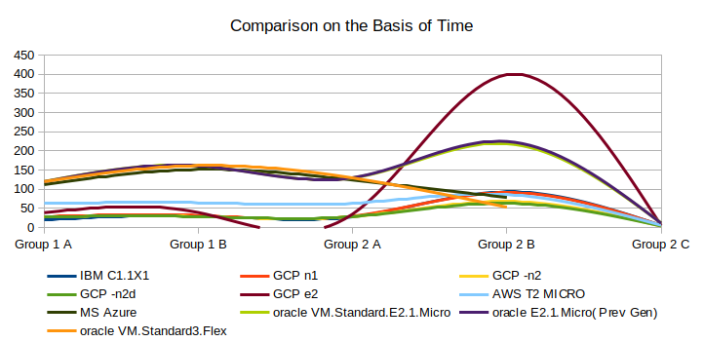  
Figure 1: Comparison of the VMs on the basis of Time Taken

Each Process exerts different load on the processor, and each machine handles the load in the different manner, few machines put higher load on the processor to complete the task as early as possible and even reached to 99% of the efficiency to complete the tast faster, few remained optimized and didn’t put the load on the processor, thus took more time to complete the task. Figure 2 shows the load on the processor during the different processes.

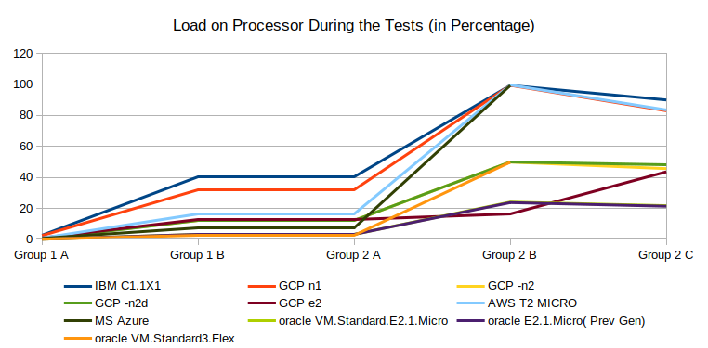  
Figure 2: Load on the Processor during the Tests

## Memory utilization by the machines during the entire Test

Each Process exerts different load on the memory, and each machine handles the load in the different manner, few machines put higher load on the memory to complete the task as early as possible and even reached to 60% the efficiency to complete the task faster. Figure 3 shows the load on the memory during the various steps of tests.

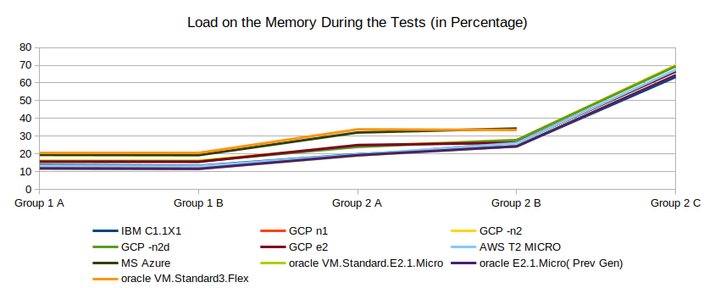  
Figure 3: Memory Utilization During Tests

## 4.4 Final Verdict

If a machine can perform a task faster than others, it should be called better and efficient, however if even a single task is not completed, the machines is said to be failed in the test. Thus, a machine which takes the lower time to complete the task should be called best. Irrespective of the load on the processor and memory, a user generally cares about the speed of the machines i.e how fast it completes the task. Thus, the Time should be considered as the best parameter to compare the final results. Figure 4 represents the time taken by machines in completing the entire tests.

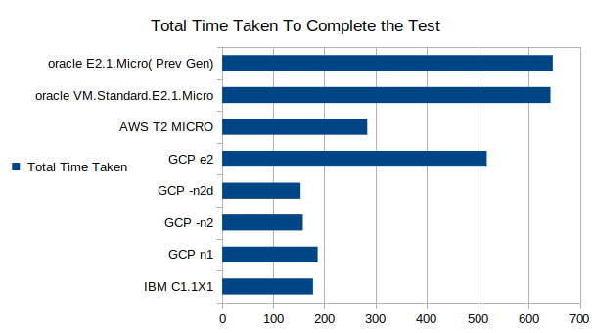  
Figure 4: Total Time Taken by the Machines

# 6. CONCLUSION

The performance of Machine be it real or virtual is dependent on multiple factors such as hardware, synchronisation between hardware and software. However factors like Processor and Memory play the deciding role. Secondly while hiring a cloud based machine, factors such as availability, pricing per hour and Ease in deployment, operation and management cannot be ignored. This if take into account factors like price and ease, AWS proves to be best choice. How ever oracle provides always free machines but performance is not up to the mark.

**REFERENCES**

[1] P. M. Mell and T. Grance, “The NIST definition of cloud computing,” Gaithersburg, MD, 2011. doi: 10.6028/NIST.SP.800-145.

[2] “What is Virtualization? | IBM.” https://www.ibm.com/cloud/learn/virtualization-a-complete-guide (accessed Aug. 26, 2022).

[3] I. Odun-Ayo, O. Ajayi, and C. Okereke, “Virtualization in cloud computing: Developments and trends,” in *Proceedings - 2017 International Conference on Next Generation Computing and Information Systems, ICNGCIS 2017*, Nov. 2018, pp. 35–37. doi: 10.1109/ICNGCIS.2017.10.

[4] VMware, “What is a Virtual Machine?VMware Glossary,” 2022. https://www.vmware.com/topics/glossary/content/virtual-machine.html (accessed Sep. 28, 2022).

[5] “What Is a Virtual Machine and How Does It Work | Microsoft Azure.” https://azure. microsoft.com/en-us/resources/cloud-computing-dictionary/what-is-a-virtual-machine/ (accessed Sep. 28, 2022).

[6] “How to Read and Understand CPU Benchmarks - Intel.” https://www.intel.com/ content/www/us/en/gaming/resources/read-cpu-benchmarks.html (accessed Sep. 28, 2022).

[7] B. Varghese, O. Akgun, I. Miguel, L. Thai, and A. Barker, “Cloud benchmarking for performance,” *Proc. Int. Conf. Cloud Comput. Technol. Sci. CloudCom*, vol. 2015-Febru, no. February, pp. 535–540, 2015, doi: 10.1109/CloudCom.2014.28.

[8] “Gartner Says Worldwide IaaS Public Cloud Services Market Grew 41.4% in 2021.” https://www.gartner.com/en/newsroom/press-releases/2022-06-02-gartner-says-worldwide-iaas-public-cloud-services-market-grew-41-percent-in-2021 (accessed Aug. 26, 2022).

[9] J. Fabo, “The impact of virtualization on benchmark accuracy,” MASARYK UNIVERSITY, 2020.

[10] “MPI-1 Benchmarks.” https://www.intel.com /content/www/us/en/develop/documentation/imb-user-guide/top/mpi-1-benchmarks.html (accessed Sep. 30, 2022).

[11] “MPI-2 Benchmarks.” https://www.intel.com/content/www/us/en/develop/documentation/imb-user-guide/top/mpi-2-benchmarks.html (accessed Sep. 30, 2022).

[12] “AMD Ryzen - Cpu Benchmark Specs & Test.” https://cpu-benchmark.org/amd-cpus/amd-ryzen/ (accessed Sep. 29, 2022).

[13] “Geekbench 5 - Cross-Platform Benchmark.” https://www.geekbench.com/index.html (accessed Sep. 06, 2022).

[14] “VMmark Virtualization Benchmark.” https://www.vmware.com/products/vmmark.html (accessed Oct. 18, 2022).

[15] “Cinebench - Microsoft Store Apps.” https://apps.microsoft.com/store/detail/cinebench/9PGZKJC81Q7J?hl=en-us&gl=us (accessed Sep. 06, 2022).

[16] AMD Ryzen - Cpu Benchmark Specs & Test.” https://cpu-benchmark.org/amd-cpus/amd-ryzen/ (accessed Sep. 29, 2022

[17] IEEE Computer Society *et al.*, “Benchmarking the performance of openstack and cloudstack,” *Lect. Notes Comput. Sci. (including Subser. Lect. Notes Artif. Intell. Lect. Notes Bioinformatics)*, vol. 7759 LNCS, no. February, pp. 173–188, 2015, doi: 10.1007/978-3-319-25414-2_14.

[18] S. Dhargave, “Evaluation of different Hypervisors Performances using Different Benchmarks,” 2016. [Online]. Available: http://www.ijser.org

[19] A. Evangelinou *et al.*, “Experimenting with application-based benchmarks on different cloud providers via a multi-cloud execution and modeling framework,” *Commun. Comput. Inf. Sci.*, vol. 512, pp. 213–227, 2015, doi: 10.1007/978-3-319-25414-2_14.

[20] D. Bermbach, E. Wittern, and S. Tai, *Cloud service* benchmarking*: Measuring quality of cloud services from a client perspective*. 2017. doi: 10.1007/978-3-319-55483-9.