HEALTH MONITORING AND MANAGEMENT USING IOT

Dissertation Report Submitted to

#### Sharda University



In partial fulfillment of the requirements of the award of the degree of

#### MASTER OF TECHNOLOGY

in

#### Electronics and Communication Engineering (DC )

by

#### SHRUTI MEHRA 160112007

Under the supervision of DR. PALLAVI GUPTA HOD ECE DEPARTMENT

Department of Electronics and Communication Engineering School of Engineering and TechnologySharda University

Greater Noida (Session: 2017-18)

## DECLARATION

I, SHRUTI MEHRA, student of M.Tech, hereby declare that the report titled “HEALTH MONITORING AND MANAGEMENT USING IOT”, which is submitted by me to the department of Electronics and Communication Engineering, School of Engineering and Technology, Sharda University, Greater Noida, under the supervision of DR. PALLAVI GUPTA in partial fulfillment of the requirement for the award of degree of M.Tech has not previously formed the basis for the award of any degree or other similar title or recognition.

Place: Greater noida Shruti Mehra-160112007 Date: 15.05.18

#### i

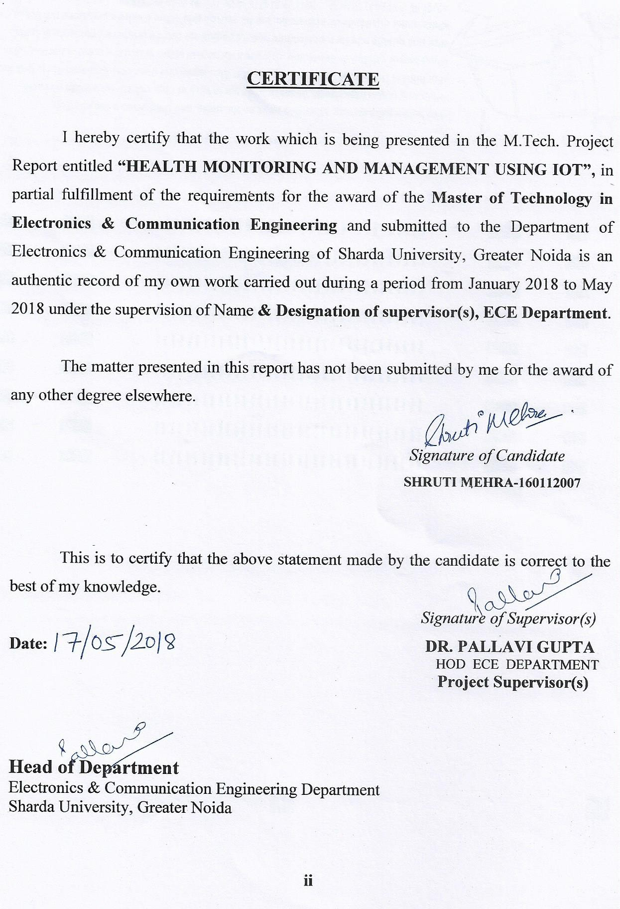

#### ACKNOWLEDGEMENT

I am deeply indebted to DR.PALLAVI GUPTA for his inspiration, support and guid- ance throughout my course here. Her passion and enthusiasm for teaching, sharing her knowledge and motivating students has not only amazed me, but has made an admirer of everyone who has been taught by her. To me, she has been more than a research advisor, his advice on topics ranging from philosophy to sports have benefited and enriched me in several ways.

Whenever I have approached her to discuss ideas for my project, or

any generic problem, or even something personal, I have always found an eager listener. She has also been a fun and enthusiastic partner to discuss various puzzles and riddles. I’m grateful to her for being very supportive in letting me pursue my interests outside of academics, and encouraging me to learn and read widely. I’m happy to be a part of her treasure house of knowledge and a place that offers an excellent environment for research. Not to forget, her sense of humor, and her jovial and affectionate nature have made a lively and fun place to be in. I’m grateful for this opportunity and look forward to continue my interactions with her in future.

SHRUTI MEHRA-

160112007

**iii**

## ABSTRACT

Life expectancy in most countries has been increasing continually over the several few decades by significant improvements in medicines, public health as well as personal and environmental hygiene. However, increased life expectancy combined with falling birth rates. So, this is essential to develop cost-effective, easy to use systems for the sake of elderly healthcare and well-being. The Internet of things (IOT) make smart objects the ultimate building blocks in the development of cyber-physical smart pervasive frameworks. The IOT has a variety of application domains, including healthcare. The IOT in modern healthcare is promising technological, economic and social prospects. This report includes advantages of existing IOT based health monitoring devices and advances of IOT based healthcare technologies which is beneficial for elderly people.

## iv

**LIST OF FIGURES**

1. Arduino Nano
2. Pulse Sensor front
3. Pulse sensor back
4. Temperature sensor
5. IR Sensor
6. IR LED
7. Photodiode
8. Wi-fi module
9. LCD Screen
10. Connected contact lens
11. Depression fighting apple app watch
12. Layout of health monitoring system
13. Circuit diagram of health monitoring system
14. Reading of pulse rate and temperature
15. Reading of patient through wi-fi

**v**

## LIST OF TABLES

### Arduino specifications

1. Pin description wi-fi module

### Pin description of LED

#### vi

**TABLE OF CONTENTS**

Page No.

Declaration i

Certificate ii

Acknowledgement iii

Abstract iv

List of Figures v

List of Tables vi

Chapter 1: Introduction

* 1. what is an IOT 1
  2. uses of wearable devices 2
  3. Comparative study of short range of wireless protocols which are used for transmission of

data in IOT devices 3-4

* 1. Study of various existing IOT based health

monitoring systems 4-6

* 1. Designing of health monitoring system 6-21
  2. Applications of wms in detail 21-24
  3. Challenges of wms based system 24-25

Chapter 2: Literature Review

* 1. Healthcare monitoring and management 26-27

using internet of things (IOT) sensing with cloud based processing, opportunities

and challenges

* 1. A survey on wearable sensor based systems for 27-28

health monitoring and prognosis

* 1. Wearable medical sensor based system design: 28-29

A survey

* 1. Comparison of various techniques in IOT 29-30

for healthcare system

* 1. The internet of things for healthcare: A 30-31

comprehensive survey

* 1. Internet of things for smart healthcare: ` 31-32

technologies, challenges and opportunities

* 1. Mobile cloud based big healthcare data processing 32-33

in smart cities

* 1. Proactive healthcare and an early warning mechanism 33-34

for coronary artery disease patients using Internet of things devices

* 1. Healthcare systems using Internet of things 34

#### Chapter 3: Methodology

* 1. Overview 35
  2. Designing of health monitoring system 35
  3. Layout of health monitoring system 36
  4. Circuit diagram of health monitoring system 37
  5. Programming 38-43

#### Chapter 4: Results

* 1. Pulse rate and temperature 44
  2. Reading of patient through wi-fi 45

#### Chapter 5: Conclusion and Future Scope 46

**References**

## CHAPTER-1

**INTRODUCTION**

## What is an IOT?

'IOT' stands for internet of things is a system of interrelated computing devices, mechanical and digital machines, objects or people that are provided with unique identifiers and the ability to transfer data over a network without requiring human to human or human to computer interaction. Life expectancy has been increasing worldwide due to significant improvements in healthcare, and medicine as well as due to growing consciousness about personal and environmental hygiene. In addition, over the past several decades, there has been increasing interest in family planning thereby contributing to declining birth rates around the globe. According to the World Health Organization(WHO), by 2017, the elderly population over 65 years or older are expected to outnumber the children less than 5 years of age. However, this enormous aging population would create a significant impact on the socio-economic structure of society in terms of social welfare and healthcare needs. Besides, this, the cost associated with healthcare services continues to soar because of increasing price of prescription drugs, medical instruments, and hospital care. Therefore, it is an utmost necessity to develop and implement new strategies and technologies in order to provide better health care services at an affordable price to the aging population or to the people of those areas having limited access to healthcare while ensuring maximum comfort, independence, participation among the people.

Remote healthcare monitoring allows people to continue to stay rather than in expensive healthcare facilities such as hospitals or nursing homes. It thus provides an efficient and cost effective alternative to on site clinical monitoring. Such systems equipped with non-invasive and unobtrusive wearable sensors can be viable diagnostic tools to the healthcare personnel for monitoring important physiological signs and activities of the patients in real time from distant facility. Therefore, it is understandable that wearable sensors play a critical role in such monitoring systems that attracted the attention of many researchers, entrepreneurs, and tech giants in recent years. A variety of application specific wearable sensors, physiological and activity monitoring systems.

Wearable devices can monitor and record real time information about one's physiological condition and motion activities. Wearable sensor-based health monitoring systems may comprise different types of flexible sensors that can be integrated into textile fiber, clothes, elastic bands or directly attached to human body. The sensors are capable of measuring physiological signs such as electrocardiogram (ECG), electromyogram (EMG), heart rate (HR), body temperature , electro dermal activity(EDA), arterial oxygen saturation(SpO2), blood pressure(BP), and respiration rate(RR). In addition, micro electro mechanical system(MEMS) based miniature motion sensors such as accelerometers, gyroscopes, and magnetic field sensors are widely used for measuring activity related signals. Continuous monitoring of physiological signals could help to detect and diagnose several cardiovascular,

neurological, and pulmonary diseases at early onset. Also, real time monitoring of an individual motion activities could be useful in fall detection gait pattern and posture analysis, or in sleep assessment. The wearable health monitoring systems are usually equipped with a variety of electronic and MEMS sensors, actuators, wireless communication modules and signal processing units. The measurements obtained by the sensors connected in a wireless body sensor network(BSN) are transmitted to nearby processing node using a suitable a suitable communication protocol, preferably a lower-power and short range wireless medium

, example- bluetooth, zigbee. Near field communication(NFC). The processing node, which could be a personal Digital Assistant(PDA), smartphone, computer or a custom made processing module based on a microcontroller or a field programmable gate array(FPGA) runs advanced processing , analysis, and decision algorithms and may also store and display the results to the user. It transmits the measured data over the internet to the healthcare personnel, thus functioning as the gateway to remote healthcare facilities. In order to be used for long term monitoring purposes, wearable health monitoring systems need to satisfy certain medical and ergonomic requirements. Eg- The system needs to be comfortable, the components should be flexible, small in dimensions and must be chemically inert, and non- toxic, hypo-allergenic to the human body.

Wearable Sensors, being progressively more comfortable and less obstrusive, are appropriate for monitoring an individual's health or wellness without interrupting their daily activities. The sensors can measure several physiological signals/parameters as well as activity and movement of an individual by placing them at different locations of the body. The advancement in low power, compact wearable, inexpensive computing and storage devices coupled with modern communication technologies pave the way for low cost, unobtrusive, and long term health monitoring system.

The usage of the IOT in healthcare (the industry, personal healthcare and healthcare payment applications) has sharply increased across various specific internet of things use cases. The improvement of the healthcare with remote monitoring and telemonitoring as main applications. A area where numerous initiatives exist is tracking, monitoring and maintenance of assets, using IOT . This is done on the level of medical devices and healthcare assets, the people level and the non- medical asset level(eg. hospital building assets).

The range of IOT applications has become wider, smart, and connected healthcare is crucial one. This can be achieved by wearing sensors or embedded in our abode which panoply information of physical and mental health of patients, information captured on regular basis which brings affirmative changes in present health care scenario.

## USES OF WEARABLE DEVICES

By the use of processing algorithms and data analysis. We can :-

* + 1. It diagnose the pulse rate before it will result in heart attacks ,"It's better to take prevention than cure". It gives personalized treatment and management .
    2. It will lead to new possibilities in the digital health ecosystem to achieve a range of health outcomes.

(c ) Sensors monitor physiological data of older people and individuals with chronic conditions can facilitate clinical interactions.

## Comparative study of short-range of wireless protocols which are used for transmission of data in IOT devices

* + 1. **Bluetooth**

Bluetooth is also known as the IEEE 802.15.1 standard is based on a wireless radio system designed for short-range and cheap devices to replace cables for computer peripherals, such as mice, keyboards, joysticks, and printers. The range of applications is known as wireless personal area network (WPAN). Two connectivity topologies are defined in Bluetooth: the piconet and scatternet. A piconet is a WPAN formed by bluetooth device serving as master in the piconet and one or more bluetooth devices serving slaves . A frequency hopping channel based on address of master defines each piconet. All devices participating in communication in a given piconet are synchronized using the clock of the master. Slaves communicate only with their master in a point to point fashion under the control of the master. The master 's transmission may be either point to point or point to multi-pointA scatternet is a collection of operational bluetooth piconets overlapping in time and space. Two piconets can be connected to form a scatternet. A bluetooth device may participate in several piconets at the same time, thus allowing for the possibility that information could flow beyond the coverage area of single piconet. A device in a scatternet could be a slave in several piconets, but master only one of them.

## UWB

UWB has recently attracted much attention as an indoor short-range high speed wireless communication. One of the most exciting characteristics of UWB is that its bandwidth is over 110Mbps which can satisfy most of the multimedia application such as audio, video delivery in home networking and it can also act as a wireless cable replacement of high speed serial bus such as USB2.0.

## Zigbee

Zigbee defines specifications for low rate WPAN for supporting simple devices that consume minimal power and typically operate in the personal operating space (POS) of 10m. Zigbee provides self-organized, multi-hop and reliable mesh networking with long battery lifetime. Two different device types can participate in an LR-WPAN network- a full function device (FFD) and a reduced function device(RFD). The FFD can operate in three modes serving as a PAN coordinator. An FFD can talk to RFD or other FFD, while an RFD can talk only to an FFD. An RFD is intended for applications that are extremely simple, such as light switch or a passive infrared sensor. They do not have the need to send large amounts of data and mayalso associate with a single FFD at a time. The RFD can be implemented using minimal resources and memory capacity. After an FFD is activated for the first time, it may establish its own network and become the PAN coordinator.

## Wi-Fi-

Wireless fidelity includes standards for wireless local area networks(WLAN). It allows users to surf the Internet broadband speeds when connected to an access point (AP) or in ad hoc mode. This architecture consists of several components that interact to provide a wireless LAN that supports station mobilitytransparently to upper layers. The basic cell of an IEEE 802.11 LAN is called a basic service set (BSS), which is a set of mobile or fixed stations. If a station moves out of its BSS , can no longer directly communicate with other members of the BSS. Based on the BSS, employs the independent basic services set(IBSS) and extended service set (ESS) network configuration. LAN is often without pre-planning for only as long as an ad hoc network. This type of operation is often referred to as an infrastructure network.

## En-Ocean

En-Ocean is a system for transmitting data wirelessly that requires no power supply or maintenance and instead uses energy harvesting technology to generate the small amount of energy needed from the environment.

The frequency varies depending on region. In Japan this is classified as specified low power wireless using the 315MHz and 928MHz frequencies. In the US 315MHz and 902MHz are employed while the EU adopts 868MHz.

## Study of various existing IOT based health monitoring systems showing up their advantages

First of all , I will discuss various IOT based healthcare applications including both single and clustered -condition applications as follows:-

## GLUCOSE LEVEL SENSING-

Diabetes is a group of metabolic diseases in which there are high blood glucose levels over a prolonged period. Blood glucose monitoring reveals individuals patterns of blood glucose changes and helps in planning of metals, activities. An m-IOT configuration method for non invasive glucose sensing on real time basis is proposed .In this method, sensors from patients are linked through IPV6 connectivity to relevant healthcare providers. The utility model in unveils a transmission device for the transmission of collected somatic data on blood glucose based on IOT networks. This includes a blood glucose collector, a mobile phone or a computer and a background processor. A similar innovation is found in . In addition, a generic IOT based medical acquisition detector that can be used to monitor the glucose level.

## ELECTROCARDIOGRAM MONITORING-

The monitoring of the electrocardiogram (ECG), that is, the electrical activity of heart recorded by electrocardiography, includes the measurement of simple heart rate and the determination of the basic rhythm as well as the diagnosis of multifaceted arrhythmias, myocardial ischemia, and prolonged QT intervals .The application of the IOT to ECG monitoring has the potential to give maximum information and can be used to its fullest extent. A number of studies have explicitly discussed IOT-based ECG monitoring. The innovation in introduces an IOT based ECG monitoring system composed of a portable wireless acquisition transmitter and a wireless receiving processor. The system integrates a search automation method to detect abnormal data such that cardiac functions can be identified on real-time basis. There exists a comprehensive detection algorithm of ECG signals at the application layer of IOT network for ECG monitoring.

## BLOOD PRESSURE MONITORING-

In this, there is a combination of a KIT blood pressure (BP) meter and an NFC enabled KIT mobile phone becomes a part of BP monitoring based on IOT is addressed in. A motivating scenario in which BP must be regularly controlled. This is done by using Withings BP device, this device operates on the connection to an apple mobile computing device is addressed. A device for BP data collection and transmission over an IOT network is proposed. This device is composed of a BP apparatus body with a communication module. A location-intelligent terminal for carry on BP monitoring based on IOT is proposed

5

## BODY TEMPERATURE MONITORING-

Body temperature monitoring is an essential part of health care services because body temperature ia a decisive vital sign in the maintenance of homeostasis. In the m-IOT concept is verified using a body temperature sensor that is embedded in the TelosB mote, and a typical sample of attained body temperature variations showing the successful operation of the developed m-IOT system is presented. A temperature measurement system based on home gateway over the IOT is proposed in .

## OXYGEN SATURATION MONITORING-

Pulse oximetry is suitable for the non-invasive nonstop monitoring of blood oxygen saturation. The integration of the IOT with pulse oximetry is useful for technology driven medical healthcare applications. A survey of Co- AP based healthcare services discusses the potential of IOT pulse oximetry. The device comes with connectivity based on bluetooth health device profile, and the sensor connects directly to the Monere platform. An IOT-optimized low-power pulse oximeter for remote patient monitoring is proposed in . This device can be used to continuously monitor patient's health over an IOT network.

## REHABILITATION SYSTEM -

This rehabilitation can enhance and restore the functional ability and quality of life of those with some physical impairment or disability, they represent a vital branch of medicine. The IOT has the potential to enhance rehabilitation systems in terms of mitigating problems linked to aging populations. An ontology based automating design method for IOT-based smart rehabilitation system is proposed in. This design successfully demonstrates that the IOT can be an effective platform for connecting all necessary resources to offer real- time interactions. IOT- based technologies can form a worthwhile infrastructure to support effective remote consultation in comprehensive rehabilitation.

## WHEELCHAIR MANAGEMENT-

A healthcare system for wheelchair user based on IOT technology is proposed in . The design comes with WBANs integrated with various sensors whose functions are tailored to IOT requirements. This system provides for chair vibration control and can detect the status of wheelchair user. This development eventually shows that standard "things" can evolve into connected machines driven by data. This device can monitor vitals of individual sitting in the chair and collect data on the user's surroundings, allowing for the rating of a location's accessibility.

6

## DESIGNING OF HEALTH MONITORING SYSTEMS

1. Arduino Nano
2. Wi-fi module ESP8266-01
3. Heart Sensor
4. Temperature Sensor LM-35 5. LCD(16x2)

6. IR Sensor

## ARDUINO NANO

(Arduino Nano 3.0) or ATmega168 (Arduino Nano 2.x). It has more or less the same functionality of the Arduino Duemilanove, but in a different package. It lacks only a DC power jack, and works with a Mini-B USB cable instead of a standard one. The Nano was designed and is being produced by Gravitech. Schematic and Design Arduino Nano 3.0 (ATmega328): schematic, Eagle files. Arduino Nano 2.3 (ATmega168): manual The Arduino Nano is a small, complete, and breadboard-friendly board based on the ATmega328 (pdf), Eagle files. Note: since the free version of Eagle does not handle more than 2 layers, and this version of the Nano is 4 layers, it is published here unrouted, so users can open and use it in the free version of Eagle.

Specifications: Microcontroller Atmel ATmega168 or ATmega328-

* 1. Operating Voltage (logic level) 5 V
  2. Input Voltage (recommended) 7-12 V Input Voltage (limits) 6-20 V
  3. Digital I/O Pins 14 (of which 6 provide PWM output)
  4. Analog Input Pins 8 DC Current per I/O Pin 40 mA
  5. Flash Memory 16 KB (ATmega168) or 32 KB (ATmega328)
  6. SRAM 1 KB (ATmega168) or 2 KB (ATmega328) EEPROM 512 bytes (ATmega168) or 1 KB (ATmega328).

Nano comes preburned with a bootloader that allows you to upload new code to it without the use of an external hardware programmer. It communicates using the original STK500 protocol (reference, C header files). You can also bypass the bootloader and program the microcontroller through the ICSP (In-Circuit Serial Programming) header.

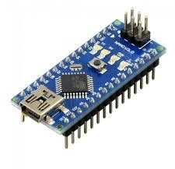

Fig1- Aurdino NANO

## Arduino Nano Pinout

The Arduino Nano, as the name suggests is a compact, complete and bread- board friendly microcontroller board. The Nano board weighs around 7 grams with dimensions of 4.5 cms to 1.8 cms (L to B).

How different is Arduino Nano?

Arduino Nano has similar functionalities as Arduino Duemilanove but with a different package. The Nano is inbuilt with the ATmega328P microcontroller, same as the Arduino UNO. The main difference between them is that the UNO board is presented in PDIP (Plastic Dual-In-line Package) form with 30 pins and Nano is available in TQFP (plastic quad flat pack) with 32 pins. The extra 2 pins of Arduino Nano serve for the ADC functionalities, while UNO has 6 ADC ports but Nano has 8 ADC ports. The Nano board doesn’t have a DC power jack as other Arduino boards, but instead has a mini-USB port. This port is used for both programming and serial monitoring. The fascinating feature in Nano is that it will choose the strongest power source with its potential difference, and the power source selecting jumper is invalid.

## Arduino Nano – Specification

|  |  |
| --- | --- |
| **Arduino Nano** | **Specifications** |
| Microcontroller | ATmega328P |
| Architecture | AVR |
| Operating Voltage | 5 Volts |
| Flash Memory | 32 KB of which 2 KB used by Bootloader |

SRAM 2KB

Clock Speed

16 MHz

Analog I/O Pins 8

DC Current per I/O Pins 40 milliAmps

EEPROM

1 KB

Input Voltage

(7-12) Volts

Table 1- Aurdino specifications

## Arduino Nano Pinout Description

Taking this pin-out diagram below as reference, we shall discuss all the functionalities of each and every pin. Arduino Nano got 36 pins in total. Digital I/O.

For Analog Functions - 9 Pins

Power - 7 Pins

SPI (Apart from Digital I/O Section) - 3 Pins

Reset - 3 Pins

1. **PULSE SENSOR**

Pulse Sensor is a well-designed plug-and-play heart-rate sensor for Arduino. It can be used by students, artists, athletes, makers, and game & mobile developers who want to easily incorporate live heart rate data into their projects. The sensor clips onto a fingertip or earlobe and plugs right into Arduino. It also includes an open-source monitoring app that graphs your pulse in real time

* The front of the sensor is the pretty side with the Heart logo. This is the side that makes contact with the skin. On the front you see a small round hole, which is where the LED shines through from the back, and there is also a little square just under the LED. The square is an ambient light sensor, exactly like the one used in cellphones, tablets, and laptops, to adjust the screen brightness in different light conditions. The LED shines light into the fingertip or earlobe, or other capillary tissue, and sensor reads the amount of light that bounces back. The other side of the sensor is where the rest of the parts are mounted. We put them there so they would not get in the way of the of the sensor on the front. Even the LED we are using is a reverse mount LED.
* For more about the circuit functionality, check out the Open Hardware page. The cable is a 24” flat color coded ribbon cable with 3 male header connectors.
* The Pulse Sensor that we make is essentially a photoplethysmograph, which is a well known medical device used for noninvasive heart rate monitoring. Sometimes, photoplethysmographs measure bloodoxygen levels (SpO2), sometimes they don't. The heart pulse signal that comes out of a photoplethysmograph is an analog fluctuation in voltage, and it has a predictable wave shape as shown in figure 1. The depiction of the pulse wave is called a photoplethysmogram, or PPG. Our latest hardware version, Pulse Sensor Amped, amplifies the raw signal of the previous Pulse Sensor, and normalizes the pulse wave around V/2 (midpoint in voltage). Pulse Sensor Amped responds to relative changes in light intensity. If the amount of light incident on the sensor remains constant, the signal value will remain at (or close to) 512 (midpoint of ADC range). More light and the signal goes up. Less light, the opposite. Light from the green LED that is reflected back to the sensor changes during each pulse. Our goal is to find successive moments of instantaneous heart beat and measure the time between, called the Inter Beat Interval (IBI). By following the predictable shape and pattern of the PPG wave, we are able to do just that. Now, we're not heart researchers, but we play them on this blog. We're basing this page on Other People's Research that seem reasonable to us (references below). When the heart pumps blood through the body, with every beat there is a pulse wave (kind of like a shock wave) that travels along all arteries to the very extremities of capillary tissue where the Pulse Sensor is attached. Actual blood circulates in the body much slower than the pulse wave travels. Let's follow events as they progress from point 'T' on the PPG below. A rapid upward rise in signal value occurs as the pulse wave passes under.
* the sensor, then the signal falls back down toward the normal point. Sometimes, the dicroic notch (downward spike) is more pronounced than others, but generally the signal settles down to background noise before the next pulse wave washes through. Since the wave is repeating and predictable, we could choose almost any recognizable feature as a reference point, say the peak, and measure the heart rate by doing math on the time between each peak. This, however, can run into false readings from the dicroic notch, if present, and may be susceptible to inaccuracy from baseline noise as well.There are other good reasons not to base the beat- finding algorithm on arbitrary wave phenomena. Ideally, we want to find the instantaneous moment of the heart beat. This is important foraccurate BPM calculation, Heart Rate Variability (HRV) studies, and Pulse Transit Time (PTT) measurement. And it is a worthy challenge! People Smarter Than Us (note1) argue that the instantaneous moment of heart beat happens at some point during that fast upward rise in the PPG waveform.
* 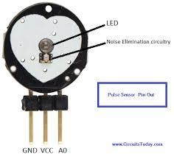Some heart researchers say it's when the signal gets to 25% of the amplitude, some say when it's 50% of the amplitude, and some say it's the point when the slope is steepest during the upward rise event. This version 1.1 of Pulse Sensor code is designed to measure the IBI by timing between moments when the signal crosses 50% of the wave amplitude during that fast upward rise. The BPM is derived every beat from an average of the previous 10 IBI times. Here's how we do it!

•

Fig2 pulse sensor

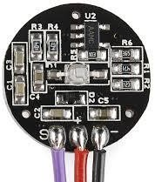

Fig3- PULSE SENSOR

## TEMPERATURE SENSOR LM-35

LM35 is a precession Integrated circuit Temperature sensor, whose output voltage varies, based on the temperature around it. It is a small and cheap IC which can be used to measure temperature anywhere between -55°C to150°C. Ican easily be interfaced with any Microcontroller that has ADC function or any development platform like Arduino.

* Power the IC by applying a regulated voltage like +5V (VS) to the input pin and connected the ground pin to the ground of the circuit.. f the temperature is 0°C, then the output voltage will also be 0V. There will be rise of 0.01V (10mV) for every degree Celsius rise in temperature. The voltage can converted into temperature using the below formulae.

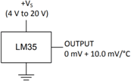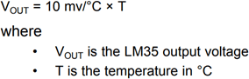

## LM35 Temperature Sensor Applications:

* Measuring temperature of a particular environment
* Providing thermal shutdown for a circuit/component
* Monitoring Battery Temperature
* Measuring Temperatures for HVAC applications

The LM35 series are precision integrated-circuit temperature devices with an output voltage linearlyproportional to the Centigrade temperature. The LM35 device has an advantage over linear temperature sensors calibrated in Kelvin, as the user is not required to subtract a large constant voltage from the output to obtain convenient Centigrade scaling. The LM35 device does not require any external calibration or trimming to provide typical accuracies of ±¼°C at room temperature and ±¾°C over a full −55°C to 150°C temperature range. Lower cost is assured by trimming and calibration at the wafer level. The low-output impedance, linear output, and precise inherent calibration of the LM35 device makes interfacing to readout or control circuitry especially easy. The device is used with single power supplies, or with plus and minus supplies. As the LM35 device draws only 60 μA from the supply, it has very low self-heating of less than 0.1°C in still air. The LM35 device is rated to operate over a −55°C to 150°C temperature range, while the LM35C device is rated for a −40°C to 110°C range (−10° with improved accuracy). The LM35-series devices are available packaged in hermetic TO transistopackages, while the LM35C, LM35CA, and LM35D devices are available in the plastic TO-92 transistor package. The LM35D device is available in an 8-lead surface-mount small-outline package and a plastic TO-220 package.

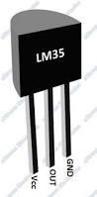

Fig 4 Temperature Sensor

## IR SENSOR(INFRARED SENSOR)

An [infrared sensor](https://www.elprocus.com/ir-remote-control-basics-operation-application/) is an electronic device, that emits in order to sense some aspects of the surroundings. An IR sensor can measure the heat of an object as well as detects the motion.These types of sensors measures only infrared radiation, rather than emitting it that is called as a [passive IR sensor](https://www.elprocus.com/passive-infrared-pir-sensor-with-applications/). Usually in the infrared spectrum, all the objects radiate some form of thermal radiations. These types of radiations are invisible to our eyes, that can be detected by an infrared sensor.The emitter is simply an IR LED ([Light Emitting Diode](http://www.elprocus.com/explain-different-types-leds-working-applications-engineering-students/)) and the detector is simply an IR photodiode which is sensitive to IR light of the same wavelength as that emitted by the IR LED. When IR light falls on the photodiode, The resistances and these output voltages, change in proportion to the magntude of the IR light received.

## IR Sensor Circuit Diagram and Working Principle

An infrared sensor circuit is one of the basic and popular sensor module in an [electronic device.](http://www.elprocus.com/basic-components-used-electronics-electrical/) This sensor is analogous to human’s visionary senses, which can be used to detect obstacles and it is one of the common applications in real time.

This circuit comprises of the following components

* + [LM358 IC](http://www.elprocus.com/op-amp-ics-pin-configuration-features-working/) 2 IR transmitter and receiver pair
  + Resistors of the range of kilo ohms.
  + Variable resistors.
  + LED (Light Emitting Diode).

The transmitter section includes an IR sensor, which transmits continuous IR rays to be received by an IR receiver module. An IR output terminal of the receiver varies depending upon its receiving of IR rays. Since this variation cannot be analyzed as such, therefore this output can be fed to a comparator circuit. Here an [operational](https://www.elprocus.com/op-amp-ics-pin-configuration-features-working/) [amplifier](https://www.elprocus.com/op-amp-ics-pin-configuration-features-working/) (op-amp) of LM 339 is used as comparator circuit.

#### Different Types of IR Sensors and Their Applications

IR sensors are classified into different types depending on the applications.

Some of the typical applications of different [types of sensors](https://www.elprocus.com/types-of-sensors-with-circuits/) are-

The speed sensor is used for synchronizing the speed of multiple motors. The [temperature sensor](http://www.elprocus.com/temperature-sensors-applications/) is used for industrial temperature control. [PIR sensor](http://www.elprocus.com/pir-sensor-basics-applications/) is used for automatic door opening system and [Ultrasonic sensor](http://www.elprocus.com/motion-detector-circuit-with-working-description-and-its-applications/) are used for distance measurement**.**

#### IR Sensor Applications

IR sensors are used in various [Sensor based projects](http://www.elprocus.com/sensor-based-electronics-projects/) and also in various electronic devices which measures the temperature.Sensors are very important part of electronics, Sensors in electronic devices make our life easy by automatically sense and control the devices, without human interaction. There are many kinds of sensors like Fire sensor, humidity sensor, motion sensor, temperature sensor, IR sensor etc. In this article, we will explain about **IR sensor** (Infrared sensor), how it works and how to **build an IR sensor Module**. IR sensor is very popular sensor, which is used in many applications in electronics, like it is used in Remote control system, motion detector, [Product counter,](http://circuitdigest.com/electronic-circuits/object-counter-circuit-diagram) [Line follower Robots,](http://circuitdigest.com/microcontroller-projects/line-follower-robot-using-arduino) Alarms etc.

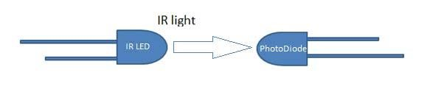IR sensor basically consist an **IR LED and a Photodiode**, this pair is generally called **IR pair** or **Photo coupler**. IR sensor work on the principal in which IR LED emits IR radiation and Photodiode sense that IR radiation. Photodiode resistance changes according to the amount of IR radiation falling on it, hence the voltage drop across it also changes and by using voltage comparator (like LM358) we can sense the voltage change and generate the output accordingly. The placing of IR LED and Photodiode can be done in two ways: **Direct and Indirect**. In **Direct incidence**, IR LED and photodiode are kept in front of one another, so that IR radiation can directly falls on photodiode. If we place any object between them, then it stops the falling of IR light on photodiode.

**Fig 5 IR SENSOR**

And in **Indirect Incidence**, both the IR LED and Photo diode are placed in parallel (side by side), facing both in same direction. In that fashion, when a object is kept in front of IR pair, the IR light gets reflected by the object and gets absorbed by photodiode. Note that object shouldn’t be black as it will absorb all the IR light, instead of reflect. Generally IR pair is placed in this fashion in IR sensor Module.

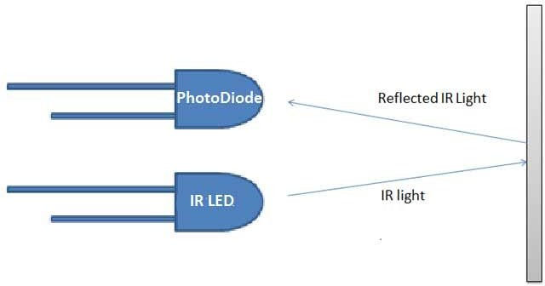

## Fig 7 IR SENSOR

To **build IR module**, we mainly need **IR pair (IR LED and Photodiode) and** [**LM358**](http://circuitdigest.com/lm358-circuits) with some resistors and a LED.

#### IR LED

IR LED emits light, in the range of Infrared frequency. IR light is invisible to us as its wavelength (700nm – 1mm) is much higher than the visible light range. Everything which produce heat, emits infrared like for example our human body. Infrared have the same properties as visible light, like it can be focused, reflected and kilometer like visible light.

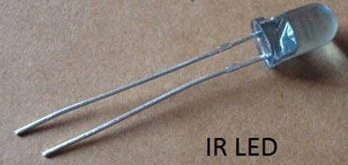

## Fig 8 IR LED

IR LED looks like a normal LED and also operates like a normal LED, it consumes 20mA current and 3vots power. IR LEDs have light emitting angle of approx. 20-60 degree and range of approx. few kilometers26 to several feets, it depends upon the type of IR transmitter and the manufacturer. Some transmitters have the range in kilometers.

16

## Photo-Diode

Photodiode is considered as Light dependent Resistor (LDR), means it has very High resistance in absence of light and become low when light falls on it. Photodiode is a semiconductor which has a P-N junction, **operated in Reverse Bias**, means it start conducting the current in reverse direction when Light falls on it, and the amount of current flow is proportional to the amount of Light. This property makes it useful for IR detection.

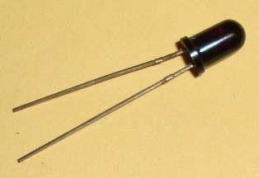

## Fig 9 Photodiode

Photodiode looks like a LED, with a Black colour coating on its outer side. It is used in reversed biased.

## LM358

LM358 is an **operational amplifier** (Op-Amp) and in this circuit we are using it as a **voltage comparator**. The LM358 has two independent voltage comparators inside it, which can be powered by single PIN, so we can use the single IC to build two IR sensor modules. We have used only one comparator here, which have inputs at PIN 2 & 3 and output at PIN 1. Voltage comparator has two inputs, one is inverting input and second isnon-inverting input (PIN 2 and 3 in LM358). When voltage at non-inverting input (+) is higher than the voltage at inverting input (-), then the output of comparator (PIN 1) is High. And if the voltage of inverting input (-) is Higher than non-inverting end (+), then output is LOW.

## WI-FI MODULE (ESP8266-01)

The **ESP8266 ESP-01** is a Wi-Fi module that allows **microcontrollers** access to a **Wi-Fi network**. This module is a self-contained **SOC** (System On a Chip) that doesn’t necessarily need a microcontroller to manipulate inputs and outputs as you would normally do with an **Arduino**, for example, because the ESP-01 acts as a small computer. Depending on the version of the ESP8266, it is possible to have up to 9 GPIOs (General Purpose Input Output). Thus, we can give a microcontroller internet access like the Wi-Fi shield does to the Arduino, or we can simply program the ESP8266 to not only have access to a Wi-Fi network, but to act as a microcontroller as well. This makes the ESP8266 very versatile, and it can save you some money and space in your projects. In this tutorial we are going to show you how to set up the ESP-01 Wi-Fi module, configure it, and verify that there is communication established between the module and another device.

17

* + Wi-Fi Direct (P2P), soft-AP
  + Integrated TCP/IP protocol stack
  + Integrated TR switch, balun, LNA, power amplifier and matching network
  + Integrated PLLs, regulators, DCXO and power management units

• +19.5dBm output power in 802.11b mode

* + Power down leakage current of <10uA
  + Integrated low power 32 bit CPU could be used as application processor
  + SDIO 1.1/2.0, SPI, UART
  + STBC, 1×1 MIMO, 2×1 MIMO
  + A-MPDU & A-MSDU aggregation & 0.4ms guard interval
  + Wake up and transmit packets in < 2ms
  + Standby power consumption of < 1.0mW (DTIM3)

## Voltage Requirements:

* **3.3V DC**
  + The **ESP8266** is a low-cost [Wi-Fi](https://en.wikipedia.org/wiki/Wi-Fi) microchip with full [TCP/IP](https://en.wikipedia.org/wiki/TCP/IP_stack) [stack](https://en.wikipedia.org/wiki/TCP/IP_stack) and [microcontroller](https://en.wikipedia.org/wiki/Microcontroller) capability produced by Shanghai-based Chinese manufacturer, [Espressif Systems](https://en.wikipedia.org/w/index.php?title=Espressif_Systems&action=edit&redlink=1)[.[1]](https://en.wikipedia.org/wiki/ESP8266#cite_note-Espressif_ESP8266-1)
  + The chip first came to the attention of western [makers](https://en.wikipedia.org/wiki/Maker_culture) in August 2014 with the **ESP- 01** module, made by a third-party manufacturer, Ai-Thinker. This small module allows microcontrollers to connect to a Wi-Fi network and make simple TCP/IP connections using [Hayes](https://en.wikipedia.org/wiki/Hayes_command_set)-style commands. However, at the time there was almost no English-language documentation on the chip and the commands it accepted.[[2]](https://en.wikipedia.org/wiki/ESP8266#cite_note-2) The very low price and the fact that there were very few external components on themodule which suggested that it could eventually be very inexpensive in volume, attracted many hackers to explore the module, chip, and the software on it, as well as to translate the Chinese documentation.[[3]](https://en.wikipedia.org/wiki/ESP8266#cite_note-3)
  + The **ESP8285** is an ESP8266 with 1 MiB of built-in flash, allowing for single-chip devices capable of connecting to Wi-Fi.[[4]](https://en.wikipedia.org/wiki/ESP8266#cite_note-esp8285-4)

## The successor to these microcontroller chips is the [ESP32](https://en.wikipedia.org/wiki/ESP32)

* + - Processor: L106 32-bit [RISC](https://en.wikipedia.org/wiki/Reduced_instruction_set_computing) microprocessor core based on the [Tensilica](https://en.wikipedia.org/wiki/Tensilica) Xtensa Diamond Standard 106Micro running at 80 MHz†
    - Memory:
      * 32 KiB instruction RAM
      * 32 KiB instruction cache RAM
      * 80 KiB user data RAM
      * 16 KiB ETS system data RAM
    - External QSPI flash: up to 16 MiB is supported (512 KiB to 4 MiB typically included)

## [IEEE 802.11](https://en.wikipedia.org/wiki/IEEE_802.11) b/g/n [Wi-Fi](https://en.wikipedia.org/wiki/Wi-Fi)

* + Integrated [TR switch,](https://en.wikipedia.org/wiki/Duplexer#Transmit-receive_switch) [balun](https://en.wikipedia.org/wiki/Balun), [LNA,](https://en.wikipedia.org/wiki/Low-noise_amplifier) [power amplifier](https://en.wikipedia.org/wiki/RF_power_amplifier) and [matching network](https://en.wikipedia.org/wiki/Matching_network)
  + [WEP](https://en.wikipedia.org/wiki/Wired_Equivalent_Privacy) or [WPA/WPA2](https://en.wikipedia.org/wiki/Wi-Fi_Protected_Access) authentication, or open networks

18

* + - 16 [GPIO](https://en.wikipedia.org/wiki/General-purpose_input/output) pins
    - [SPI](https://en.wikipedia.org/wiki/Serial_Peripheral_Interface_Bus)
    - [I²C](https://en.wikipedia.org/wiki/I%C2%B2C) (software implementation)[[5]](https://en.wikipedia.org/wiki/ESP8266#cite_note-EspressifBBS_I2C-5)
    - [I²S](https://en.wikipedia.org/wiki/I%C2%B2S) interfaces with DMA (sharing pins with GPIO)
    - [UART](https://en.wikipedia.org/wiki/Universal_asynchronous_receiver/transmitter) on dedicated pins, plus a transmit-only UART can be enabled on GPIO2
    - 10-bit [ADC](https://en.wikipedia.org/wiki/Analog-to-digital_converter) ([successive approximation ADC](https://en.wikipedia.org/wiki/Successive_approximation_ADC))
    - ESP8266-01 is a very low cost Wi Fi enabled chip. But it has very limited I/O. At first glance, once you configure it for programming all the pins are used.
    - This instructiable builds on [Using ESP8266 GP](http://www.forward.com.au/pfod/ESP8266/GPIOpins/index.html)

The ESP8266-01 is the smallest ESP8266 module and only has 8 pins. Of these VCC, GND, RST (reset) and CH_PD (chip select) are not I/O pins but are needed the operation of the module. This leaves GPIO0, GPIO2, TX and RX available as possible I/O pins, but even these have pre-assigned functions. The GPIO0 and GPIO2 determine what mode the module starts up in and the TX/RX pins are used to program the module and for Serial I/O, commonly used for debugging. GPIO0 and GPIO2 need to have pull-up resistors connected to ensure the module starts up correctly. The ESP8266-01 is a very cheap (<3 EUR) and tiny board you can use in your projects to get WIFI/Internet connectivity. This is the smallest available board of the ESP8266 board series.

Technical details:

* features Espressif Systems ESP8266 SoC, which includes 32Bit RISC CPU with WiFi and full TCP/IP stack
* Supports staion and access point mode
* 512Kbit flash memory
* 8 pin header on board
* low power consumption
* 2 GPIOs

#### Pin Configuration:

|  |  |  |
| --- | --- | --- |
| **Pin Number** | **Pin Name** | **Description** |
| 1 | Vcc | Input voltage is +5V for typical applications |
| 2 | Analog Out | There will be increase in 10mV for raise of every 1°C. Can range from -1V(-55°C) to 6V(150°C) |
| 3 | Ground | Connected to ground of circuit |

Table 2 Pin description

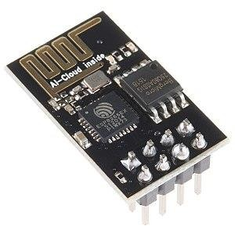

## 6. LCD(16x2)

LCD (Liquid Crystal Display) screen is an electronic display module and find a wide range of applications. A 16x2 LCD display is very basic module and is very commonly used in various devices and circuits. These modules are preferred over [seven segments](http://www.engineersgarage.com/content/seven-segment-display) and other multi segment [LED](http://www.engineersgarage.com/content/led)s. The reasons being: LCDs are economical; easily programmable; have no limitation of displaying special & even [custom characters](http://www.engineersgarage.com/microcontroller/8051projects/create-custom-characters-LCD-AT89C51) (unlike in seven segments), [animations](http://www.engineersgarage.com/microcontroller/8051projects/display-custom-animations-LCD-AT89C51) and so on.

A **16x2 LCD** means it can display 16 characters per line and there are 2 such lines. In this LCD each character is displayed in 5x7 pixel matrix. This LCD has two registers, namely, Command and Data.

**The command register stores the command instructions given to the LCD. A command is an instruction given to LCD to do a predefined task like initializing it, clearing its screen, setting the cursor position, controlling display etc. The data register stores the data to be displayed on the LCD. The data is the ASCII value of the character to be displayed on the LCD. Click to learn more about internal structure of a** [**LCD**](http://www.engineersgarage.com/insight/how-lcd-works)**.**

## Pin Description:

|  |  |  |
| --- | --- | --- |
| **Pin No** | **Function** | **Name** |
| 1 | Ground (0V) | Ground |
| 2 | Supply voltage; 5V (4.7V – 5.3V) | Vcc |
| 3 | Contrast adjustment; through a variable resistor | VEE |

|  |  |  |
| --- | --- | --- |
| 4 | Selects command register when low; and data register when high | Register Select |
| 5 | Low to write to the register; High to read from the register | Read/write |
| 6 | Sends data to data pins when a high to low pulse is given | Enable |
| 7 | 8-bit data pins | DB0 |
| 8 | DB1 |
| 9 | DB2 |
| 10 | DB3 |
| 11 | DB4 |
| 12 | DB5 |
| 13 | DB6 |
| 14 | DB7 |
| 15 | Backlight VCC (5V) | Led+ |
| 16 | Backlight Ground (0V) | Led- |

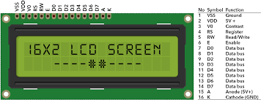Table 3 Pin description of LED

Fig 10 LCD 16x2

## APPLICATIONS OF WMSs in detail

* + 1. **Open APS-Closed -loop insulin delivery-**

It is the Open Artificial Pancreas system. It is an open and transparent effort to make safe and effective pancreas system(APS) technology which is widely available to improve and save lives and reduce the burden of TYPE 1 diabetes.

## Activity trackers -

During cancer treatment - In this patient will wear an activity tracker for up to a week prior treatment and continuously for several months over the course of multiple treatments. These trackers will assist in logging activity level and fatigue with appetite also being logged directly and all data saved to Medidata's patient cloud ePRO app on personal smart phones. Using a variety of data gathered day to day through wearables for diagnosis and treatment. This is particularly used for cancer patients.

## Connected Inhalers-

The most immediate use of IOT technology in healthcare is not to assist in diagnosis, though , but to ensure adherence. Adding sensors to medicines or delivery mechanisms allows doctors to keep accurate track of patients .Eg- Chronic Obstructive Pulmonary Disease(COPD)

## Connected Contact Lenses-

In this smart lens technology which involves non- invasive sensors embedded within contact lenses. The lenses may eventually be able to measure glucose levels diabetes patients from their tears and then store information in mobile device.

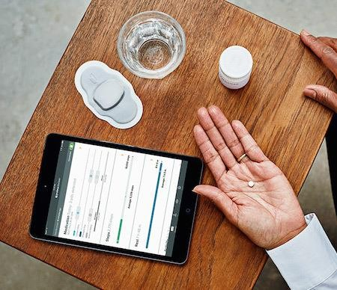

Fig11- Connected contact lenses

## Depression- Fighting Apple Watch App-

It is used to help the patients with major depressive disorder(MDD). In this the app is designed to monitor and access cognitive function with the trial set to examine how an app compares with traditional testing and self- assessment when reporting mood and cognition. Here, both passive and active data is collected.

Fig-12 Depression-fighting apple app watch

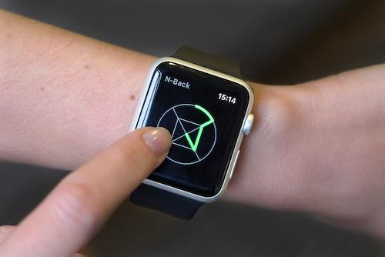

## BASE STATIONS

Due to limited on sensor resources, the sensory data are frequently sent to external devices with more computation power. These devices are referred to as base stations. They may range from smart phones to specialized computing devices, known as central hubs. They commonly have large data storage, and powerful network connectivity through cellular wireless and bluetooth interfaces, and powerful processors.

Smart phones have become dominant form of base stations since they are ubiquitous and powerful and provide all the technologies needed for numerous applications. Moreover, smart phones support highly-secure encrypted transmission, which detects several potential attacks against the system. The base station has its own resource constraints, through much less severe, in terms of storage and battery lifetime. Continuous processing along with wireless transmission to the cloud may drain the base station battery within a few hours, and a result cause user inconvenience.

## CLOUD SERVERS

Since both WMSs and base stations are resource- constrained, sensory data are commonly sent to cloud servers for resource-hungry processing and long term processing and long term storage. Depending on the wireless technology used, the data can be sent either directly or indirectly to the cloud. In addition to the huge storage capacity and high computational power that cloud servers can provide for WMSs -based applications, they facilitate access to shared resources in a pervasive manner, offering an ever increasing number of online demand services. Furthermore, cloud based systems support remote update software, without requiring that the patient install any software on the personal devices, thus making system maintenance quick and cost effective. This makes cloud based systems a promising vehicle for bringing health care services to rural areas.

## CHALLENGES OF WMSs BASED SYSTEM

**There are different types challenges in WMSs**

## Accurate Decisions-

WMSs- based systems process the input data, eg- an EEG signal, and return decisions as output. The quality of service provided by a WMSs- based system depends on the accuracy of decisions made by it. A WMSs based authentication system must confidently determine if the user is authorized to use restricted resources, or a posture corrector must accurately decide whether the user posture corrector is healthy.

* + 1. Fast Response- A short response time is a desirable design goal for the majority of systems. It is desirable for the system to quickly respond to user requests. Moreover a short response time to essential for an authentication system in which the system must quickly authenticate a legitimate user and reject an imposter, eg- If an insulin pump fails to immediately detect an emergency , hyperglycemia or hypoglycemia and provide a response when it is necessary, the patient might suffer from life threatening conditions.
    2. Long battery lifetime- To ensure a long battery lifetime, all components embedded in a WMS and the signal processing algorithms implemented on the dmust be energy efficient. The battery used in a WMS is typically the greatest contributor to both size and weight. WMSs have very limited on sensor energy. Rapid depletion of battery charge, necessitating frequent. Hence, long battery lifetime is a fundamental design goal for a variety of WMSs.

## High Security-

The emergence of the IOT paradigm the magnified the negative impact of security attacks on sensor based systems. The demonstration of several attacks in recent research efforts has led to serious security concerns and highlighted the importance of considering security requirements. To ensure security requirements are broken down into categories- Confidentiality, integrity, availability.

## High quality measurements-

Undoubtedly, the quality of the decisions offered by a WMSs based system depends on the quality of sensory measurements provided by WMSs. The user activities may negatively impact the quality of data obtained by WMSs. eg- Running significantly deteriorates the quality of signal collected by EEG sensors.

## Low cost-

Low cost is one of the most important success factors for acceptance of WMSs in the market. The failure of Microsoft's smart personal object technology due to inadequate cost analyses shows the importance of considering cost of design and development.

## Passiveness-

Passiveness, i.e, minimal user involvement , is a key consideration in designing a WMS based system. It is very desirable that WMSs be calibrated transparently to the user and sensory data be measured independent of user activities. For, user convenience WMSs must be kept lightweight and as small as possible.

25

# CHAPTER-2 LITERATURE REVIEW

## Health Monitoring and Management Using Internet-of-Things (IoT) Sensing with Cloud-based Processing: Opportunities and Challenges

In this paper, it shows the panoply of applications enabled by the Internet of Things (IoT), smart and connected health care is a particularly important one. Networked sensors, either worn on the body or embedded in our living environments, make possible the gathering of rich information indicative of our physical and mental health. Captured on a continual basis, aggregated, and effectively mined, such information can bring about a positive transformative change in the health care landscape. In particular, the availability of data at hitherto unimagined scales and temporal longitudes coupled with a new generation of intelligent processing algorithms can: (a) facilitate an evolution in the practice of medicine, from the current post facto diagnose-and- treat reactive paradigm, to a proactive framework for prognosis of diseases at an incipient stage, coupled with prevention, cure, and overall management of health instead of disease, (b) enable personalization of treatment and management options targeted particularly to the specific circumstances and needs of the individual, and (c) help reduce the cost of health care while simultaneously improving outcomes. In this paper, we highlight the opportunities and challenges for IoT in realizing this vision of the future of health care. Health monitoring systems such as wearable devices shows a rising interest wearable sensors and today several devices are commercially available for personal health care, fitness, and activity awareness. In addition to the niche recreational fitness arena catered to by current devices, researchers have also considered applications of such technologies in clinical applications in remote health monitoring systems for long term recording, management and clinical access to patient’s physiological information. Based on current technological trends, one can readily imagine a time in the near future when your routine physical examination is preceded by a two–three day period of continuous physiological monitoring using inexpensive wearable sensors. Over this interval, the sensors would continuously record signals correlated with your key physiological parameters and relay the resulting data to a database linked with your health records. When you show up for your physical examination, the doctor has available not only conventional clinic/lab-test based static measurements of your physiological and metabolic state, but also the much richer longitudinal record provided by the sensors. Using the available data, and aided by decision- support systems that also have access to a large corpus of observation data for other individuals, the doctor can make a much better prognosis for your health and recommend treatment, early intervention, and life-style choices that are particularly effective in improving the quality of your health. Such a disruptive technology could have a transformative impact on global healthcare systems and drastically reduce

26

healthcare costs and improve speed and accuracy for diagnoses. Technologically, the vision presented in the preceding paragraph has been feasible for a few years now. Yet, wearable sensors have, thus far, had little influence on the current clinical practice of medicine. In this paper, we focus particularly on the clinical arena and examine the opportunities afforded by available and upcoming technologies and the challenges that must be addressed in order to allow integration of these into the practice of medicine

## A Survey on Wearable Sensor-Based Systems for Health Monitoring and Prognosis

The design and development of wearable biosensor systems for health monitoring has garnered lots of attention in the scientific community and the industry during the las years. Mainly motivated by increasing healthcare costs and propelled by recent technological advances in miniature biosensing devices, smart textiles, microelectronics, and wireless communications, the continuous advance of wearable sensor-based systems will potentially transform the future of healthcare by enabling proactive personal health management and ubiquitous monitoring of a patient’s health condition .These systems can comprise various types of small physiological sensors, transmission modules and processing capabilities, and can thus facilitate low-cost wearable unobtrusive solutions for continuous all-day and any-place health, mental and activity status monitoring. This paper attempts to comprehensively review the current research and development on wearable biosensor systems for health monitoring. A variety of system implementations are compared in an approach to identify the technological shortcomings of the current state-of-the-art in wearable biosensor solutions. An emphasis is given to multi parameter physiological sensing sys- tem designs ,providing reliable vital sign measurements and incorporating real- time decision support for early detection of symptoms or context awareness. In order to evaluate the maturity level of the top current achievements in wearable health- monitoring systems, a set of signiﬁcant features, that best describe the functionality and the characteristics of the systems, has been selected to derive a thorough study. The aim of this survey is not to criticize, but to serve as a reference for researchers and developers in this scientiﬁc area and to provide direction for future research improvements. In this paper, it shows the current state in research and development of wearable low-cost unobtrusive systems for health-monitoring which is reviewed by summarizing and comparing the attributes of the most promising current achievements of several worldwide projects and commercial products. It also presents the most important and widely employed biosensor technologies along with the corresponding measured bio -signals. It present the short-range wireless communication standards for WHMS .It presents thematurity of the reviewed systems according to the selected features. This paper also provides a discussion on the current shortcomings in system design, integration, and functionality based on the evaluation results. Furthermore, other challenging issues that have to be overcome in order for wearable biosensor systems to become more efficient and applicable as real-

life solutions are also mentioned. This paper reviews the state of art in research and development of wearable sensor-based systems for health monitoring. As it is shown by the current technology status, WHMS have the potential to revolutionize healthcare by providing low-cost solutions for ubiquitous, all-day, unobtrusive personal health- monitoring and are expected to enable early detection and better treatment of various medical conditions as well as disease prevention and better understanding and self-management of chronic diseases. However, this paper discusses the challenges and issues that need to be resolved for wearable systems to become more applicable to real-life situations and also to become accepted by patients and other users as a reliable, multifunctional, easy-to-use, and minimally obtrusive technology that can increase their quality of living. This paper discusses about the development and issues of patient–system interaction and individual pattern history extraction and adaptation, in order to address the weak features of a wearable system’s unfriendliness and the system being disease specific instead of patient specific which is what would be ideally desired.

## Wearable Medical Sensor-Based System Design: A Survey

This paper discusses about the Wearable medical sensors (WMSs) are garnering ever- increasing attention from both the scientific community and the industry. Driven by technological advances in sensing, wireless communication, and machine learning, WMS-based systems have begun transforming our daily lives. Although WMSs were initially developed to enable low-cost solutions for continuous health monitoring ,the applications of WMS- based systems now range far beyond health care. Several research efforts have proposed the use of such systems in diverse application domains, e.g., education ,human -computer interaction, and security. Even though the number of such research studies has grown drastically in the last few years, the potential challenges associated with their design ,development ,and implementation are neither well-studied nor well recognized. This paper discusses various services, applications based on WMSs and sheds light on the design goals and challenges .This paper provides a brief history of WMS and discuss how the market is growing,then the scope of applications of WMS-based systems. Next it describe the architecture of a typical WMS -based system and the components that constitute such a system, and their limitations. Thereafter, it describes a list of desirable design goals that WMS -based systems should satisfy. Finally, it discusses various research direction related to WMS and how previous research studies have attempted to address the limitations of the components used in WMS- based systems and satisfy the desirable design goals. The paper explains:

* + 1. The scope of applications of WMS- based systems
    2. The architecture of a typical WMS-based system
    3. Constituent components and the limitations of these components
    4. A list of desirable design goals that WMS-based systems should satisfy and how the goals can be prioritized.
    5. It discusses several emerging research topics and directions.
    6. It discuss how the Cloud-based architecture is reaching its limitation and how Fog computing can offer a promising alternative.

## COMPARISON OF VARIOUS TECHNIQUES IN IoT FOR HEALTHCARE SYSTEM

This paper discusses various methods adopted for healthcare issues in the IoT by a number of researchers. The majority of the survey is mainly focused on the different healthcare techniques used in the IoT, such as, Wireless health monitoring, U-healthcare, E-healthcare, Age-friendly healthcare systems and some security techniques for healthcare applications. As health is wealth, and as the number of various diseases have increased in the past few decades, it is very important to monitor the health of the patients on daily basis. Internet of Things(IoT) has become one of the popular area for various applications. IoT will create technological revolution in a large number of applications, such as, smart living, smart home, healthcare systems, smart manufacturing and environment monitoring and within these, healthcare system is one of the most important challenge that our society faces today. Now a days there is ever growing demand for healthcare system to improve human health. In this paper we have discussed various a health monitoring systems, taking smart phone as a tool. By using such monitoring systems, the healthcare professionals can monitor, diagnose, and advice their patients from a remote location at all the time and doctor or patient can access report through online. Also the study analyses the U-healthcare system with respect to the IoT perspective. U-healthcare system is the integration of different technologies and computing system. These include sensor devices to gather patient’s physiological data.This paper also discussed some security techniques that are used in data security for healthcare applications that can be applied in IoT environment security issues and presented security keys for symmetric cryptography to ensure the privacy of the WBAN sensors in the context of IoT. It also proposes to exhibit the step by step development methodology concept in prototyping the Intelligent E-health gateway including intelligent medical packaging and medical sensor networks. For purpose of demonstrating the feasibility of the approach, an exergaming platform and a disease management tool were used as a test case scenario.

## The Internet of Things for Health Care: A Comprehensive Survey

This paper surveys advances in IoT-based health care technologies and reviews the state-of-the-art network architectures/platforms, applications, and industrial trends in IoT-based health care solutions. In addition, this paper analyzes distinct IoT security and privacy features, including security requirements, threat

models, and attack taxonomies from the health care perspective. Further, this paper proposes an intelligent collaborative security model to minimize security risk; discusses how different innovations such as big data, ambient intelligence, and wearables can be leveraged in a health care context; addresses various IoT and eHealth policies and regulations across the world to determine how they can facilitate economies and societies in terms of sustainable development; and provides some avenues for future research on IoT-based health care based on a set of open issues and challenges. The Internet of Things (IoT) makes smart objects the ultimate building blocks in the development of cyber-physical smart pervasive frameworks. The IoT has a variety of application domains, including health care. The IoT revolution is redesigning modern health care with promising technological, economic, and social prospects.

This paper contributes by-

* + - Classifying existing IoT-based healthcare network studies into three trends and presenting a summary of each.
    - Providing an extensive survey of IoT-based healthcare services and applications.
    - Highlighting various industrial efforts to embrace IoT-compatible healthcare products and prototypes.
    - Providing extensive insights into security and privacy issues surrounding IoT healthcare solutions and proposing a security model.
    - Discussing core technologies that can reshape healthcare technologies based on the IoT
    - Highlighting various policies and strategies that can support researchers and policymakers in integrating the IoT innovation into healthcare technologies in practice.
    - Providing challenges and open issues that must be addressed to make IoT- based healthcare technologies robust.

This paper surveys diverse aspects of IoT-based healthcare technologies and presents various healthcare network architectures and platforms that sup- port access to the IoT backbone and facilitate medical data transmission and reception. Substantial R&D efforts have been made in IoT-driven healthcare services and applications. In addition, the paper provides detailed research activities concerning how the IoT can address pediatric and elderly care, chronic disease supervision, private health, and fitness management. For deeper insights into industry trends and enabling technologies, the paper offers a broad view on how recent and ongoing advances in sensors, devices, internet applications, and other technologies have motivated affordable healthcare gadgets and connected health services to limitlessly expand the potential of IoT-based healthcare services for further developments. To better understand IoT healthcare security, the paper considers various security requirements and challenges and unveils different research problems in this area to

30

propose a model that can mitigate associated security risks. The discussion on several important issues such as standardization, network type, business models, the quality of service, and health data protection is expected to facilitate the provide a basis for further research on IoT-based healthcare services. This paper presents e-Health and IoT policies and regulations for the beneﬁt of various stakeholders interested in assessing IoT-based healthcare technologies. In sum, the results of this survey are expected to be useful for researchers, engineers, health professionals, and policymakers working in the area of the IoT and healthcare technologies.

## Internet of Things for Smart Healthcare: Technologies, Challenges, and Opportunities

This paper proposes a standard model for application in future IoT healthcare systems. This survey paper then presents the state-of-the-art research relating to each area of the model, evaluating their strengths, weaknesses, and overall suitability for a wearable IoT health care system. Challenges that health care IoT faces including security, privacy, wearability, and low-power operation are presented, and recommendations are made for future research directions. This paper therefore makes a unique contribution in that it identifies all key components of an end-to-end Internet of Things healthcare system, and proposes a generic model that could be applied to all IoT-based healthcare systems. This is vital as there are still no known end-to-end systems for remote monitoring of health in the literature. This paper further provides a comprehensive survey of the state-of-the-art technologies that fall within the proposed model. Focus is placed on sensors for monitoring various health parameters, short and long range communications standards, and cloud technologies. This paper distinguishes itself from the previous major survey contributions by considering every essential component of an IoT-based healthcare system both separately and as a system. The remain part focus on the provision of healthcare using IoT technologies. Furthermore it examines common sensors that could be used in an IoT healthcare systems, presenting several state-of-the-art sensors that have been developed in recent research. This paper also reviews communications standards for both short- and long- term communications, including a thorough analysis of the new NB-IoT.In this paper they have proposed a unique model for future IoT-based healthcare systems, which can be applied to both general systems and systems that monitor specific conditions. Then they presented a thorough and systematic overview of the state-of-the-art works relating to each component of the proposed model. Several wearable, non-intrusive sensors were presented and analyzed, with particular focus on those monitoring vital signs, blood pressure, and blood oxygen levels. Short-range and long-range communications standards were then compared in terms of suitability for healthcare applications. BLE and NB-IoT emerged as the most suitable standards for short-range and long-range communications in healthcare respectively. Recent works utilizing cloud technologies for data storage were also presented, and showed that cloud is the best means for storing and organizing big data in healthcare. It is also shown by several works that significantly better data processing can be performed in the cloud

than can be performed by wearable devices with their limited resources. The most significant drawback of using cloud is that it introduces security risks, and as such we presented several works focused on improving security in the cloud. It was also found in this that access control and encryption can significantly enhance security, but that no known standard is suitable for immediate application into a wearable, IoT-based healthcare system. Based on our analysis of state of th-art technologies in the ﬁelds of wearable sensors, communications standards, and cloud technology, we identified several significant areas for future research. Machine learning and the development of a secure yet lightweight encryption scheme for cloud storage were the two areas that provide the most opportunity for researchers seeking to make significant improvements in the ﬁeld of IoT-based healthcare.

## Mobile Cloud-Based Big Healthcare Data Processing in Smart Cities

In this paper, we propose an ant colony optimization-based joint VM migration model for a heterogeneous, MCC-based Smart Healthcare system in Smart City environment. In this model, the user’s mobility and provisioned VM resources in the cloud address the VM migration problem. We also present a thorough performance evaluation to investigate the effectiveness of our proposed model compared with the state-of-the-art approaches. The concept involves multiple disciplines, such as Smart health care, Smart transportation, and Smart community. Most services in Smart Cities, especially in the Smart healthcare domain, require the real-time sharing, processing, and analyzing of Big Healthcare Data for intelligent decision making. Therefore, a strong wireless and mobile communication infrastructure is necessary to connect and access Smart healthcare services, people, and sensors seamlessly, anywhere at any time. In this scenario, mobile cloud computing (MCC) can play a vital role by off loading Big Healthcare Data related tasks ,such as sharing ,processing ,and analysis ,from mobile applications to cloud resources ,ensuring quality of service demands of end users. Such resource migration, which is also termed virtual machine (VM) migration, is effective in the Smart healthcare scenario in Smart Cities.

In this work, they propose a VM migration (VMM) model based not only on user mobility but also on load of cloudlet resources. The objective is to select the optimal cloud server for a mobile VM in addition to minimizing the total number of VM migrations, reducing task-execution time. We use Ant Colony Optimization (ACO) to identify the optimal tar- get cloudlet. The main contributions of their work are stated below:

* + - They develop an Ant Colony Optimization (ACO)-based VM migration model, in which VM are migrated to candidate cloud servers so as to maximize the total utility of the MCC system
    - Mobility-aware selection of cloudlets for VM provision- ing in our proposed PRIMIO system helps significantly to reduce service provisioning time.
    - They introduce a joint VM migration approach to so optimize both the resource utilization and task execution time, diminishing the shortcomings of a single VM migration approach.
    - The results of performance evaluation, depicted from test-bed implementation and extensive experiments, show that the proposed PRIMIO system achieves significant improvements compared to state-of-the-art works.

Furthermore, it discuss the state-of-the-art work on VM or task migration in MCC. It presents the network model and assumptions. After that, it present the problem formulation of our VM migration model. It also present a meta-heuristic ACO-based VM migration solution for jointly migrating a set of VMs. Sub- sequent, then they present a numerical evaluation of their proposed model to investigate. They have proposed a mobility and resource- aware joint virtual-machine migration model for heterogeneous mobile cloud computing systems to improve the performance of mobile Smart health care applications in a Smart City environment. Here, we address research challenges to reduce task-completion times as well as to reduce resource over-provisioning in mobile cloud computing that executes both computationally and Big Data-intensive health care tasks. They proposed a PRIMIO model initiates VM migration by considering user mobility and computational load of a cloudlet. As PRIMIO exploits users’ mobility in achieving an optimal solution, it effectively brings cloud resources closer to the user. At the same time, PRIMIO considers the load of the cloudlet to which the system wants to migrate the VM, thereby reducing total number of migrations across the entire task-execution time. Furthermore, they considered rates of resource over-provisioning during VM migration, allowing the overall system to utilize computing resources optimally.

## Proactive Healthcare and an Early Warning Mechanism for Coronary Artery Disease Patients using Internet-of-Thing Devices

This paper proposed an early warning system by integrating loT, big data, and cloud computing technologies which physically linked among personal communication devices of patient/doctor, cloud systems, and hospital medical information systems. The system collects personal heart rate and metabolic equivalent (MET) features from calibrated fitness devices wore by users, and corresponding fitted curves are dynamically calculated and compared to previously trained curve patterns from 213 patients with heart diseases and 124 healthy individuals. The prototype system was already successfully developed and validated by a couple of testing cases with excellent performance. The proposed system was realized by embedding GPS in an Asthma Nebulizer to record location information when the medical equipment was used by patients. According to data analysis, the system could illustrate that patients often required the medication therapy at a few specific locations, and the system could be trained and remind patients not to approach the risky places . Using bracelet devices to record and manage user's sleeping qualities and daily exercise consumption. However, due to ubiquitously connected equipments creating abundant variety of data and transferring them through the Internet, these

unstructured and complicated data cannot be directly extracted and analyzed in a reasonable time manner. Especially, in order to satisfy accurate and instantaneous requirements for healthcare applications, how to effectively validate data veracity, efficiently analyze/manage data contents, and remarkably exploit data value have become the key features to enhance quality of healthcare policies and lower down the required medical cost. To achieve this goal, we employed machine learning, statistical learning, and data mining technologies to build an intelligent system which is abel to interpret information from collected data and discovers important trends from historical records. Regarding the loT device selection, health bracelets are common and inexpensive wearable devices providing users to track and record movement, step, activity, sleeping and heart rate. Therefore, we adopt bracelet devices and proposed an early warning mechanism for 10MT application, and especially, for facilitating patients with cardiovascular diseases. By wearing a bracelet and collecting both heart rate and metabolic equivalent (MET) data, the designed system could automatically send an warning message for Coronary Artery Disease(CAD) patients and his/her doctors or healthcare assistants. In addition, for general conditions, the system could also detect whether the user is at risk for Coronary Artery Disease(CAD). Once the user is claimed as a potential CAD patient, the system offers a pre-registration function of instant notification list for users, when a user is indeed at a dangerous status according to the collected health bracelet data, the developed system will send out urgent notifications to family or caregivers immediately to prevent dangerous consequences.

## Health Care Systems Using Internet Of Things

This paper reviews the concepts, applications and various existing technologies for health care. They have enumerated the difference between those techniques and brief explanation of scope of IoT in personalized health care. They showed many uses of the systems and products that connect to the Internet of Things (IoT) are changing business in numerous industries. Patients and providers both stand to benefit from IoT carving out a bigger presence in healthcare. Some uses of healthcare IoT are mobile medical applications or wearable devices that allow patients to capture their health data. Hospitals use IoT to keep tabs on the location of medical devices, personnel and patients. The new trends in health care are gradually progressing with the help of IoT which may make us more health conscious. This paper surveys advances in IoT-based health care technologies and reviews the state- of-the-art network architectures/platforms, applications, and industrial trends in IoT- based health care solutions. In addition, this paper analyzes distinct IoT security and privacy features, including security requirements, threat models, and attack taxonomies from the health care perspective. Further, this paper proposes an intelligent collaborative security model to minimize security risk; discusses how different innovations such as big data, ambient intelligence, and wearable's can be leveraged in a health care context; addresses various IoT and e-Health policies and regulations across the world to determine how they can facilitate economies and societies in terms of sustainable development; and provides some avenues for future research on IoT-based health care based on a set of open issues and challenges. This paper surveys diverse aspects of IoT-based healthcare technologies and presents various healthcare network architectures and platforms that support access to the IoT backbone and facilitate medical data transmission and reception. The several possible IoT based health care networks, its applications and challenges have been discussed.

# CHAPTER-3

**METHODOLOGY**

## OVERVIEW

'IOT' stands for internet of things is a system of interrelated computing devices, mechanical and digital machines, objects or people that are provided with unique identifiers and the ability to transfer data over a network without requiring human to human or human to computer interaction.

The usage of the IOT in healthcare (the industry, personal healthcare and healthcare payment applications) has sharply increased across various specific internet of things use cases. The improvement of the healthcare with remote monitoring and telemonitoring as main applications. A area where numerous initiatives exist is tracking, monitoring and maintenance of assets, using IOT . This is done on the level of medical devices and healthcare assets, the people level and the non- medical asset level(eg. hospital building assets).

The range of IOT applications has become wider, smart, and connected healthcare is crucial one. This can be achieved by wearing sensors or embedded in our abode which panoply information of physical and mental health of patients, information captured on regular basis which brings affirmative changes in present health care scenario. By the use of processing algorithms and data analysis. We can :-

* + 1. It diagnose the pulse rate rate before it will result in heart attacks ,"It's better to take prevention than cure". It gives personalized treatment and management .
    2. It will lead to new possibilities in the digital health ecosystem to achieve a range of health outcomes.
    3. Sensors monitor physiological data of older people and individuals with chronic conditions can facilitate clinical interactions.

## DESIGNING OF HEALTH MONITORING SYSTEMS

1. Aurdino Nano
2. wi-fi module ESP8266-01
3. Heart Sensor
4. Temperature Sensor LM-35 5. LCD(16x2)

6. IR Sensor

## E:\sssdsdsdzd.pngLAYOUT OF HEALTH MONITORING SYSTEM

Fig 14 Layout of health monitoring system

fig13- Layout of health monitoring system

## CIRCUIT DIAGRAM OF HEALTH MONITORING SYSTEM

Fig 15 Circuit diagram of health monitoring system

**3.5**

,

**PROGRAMMING**

36

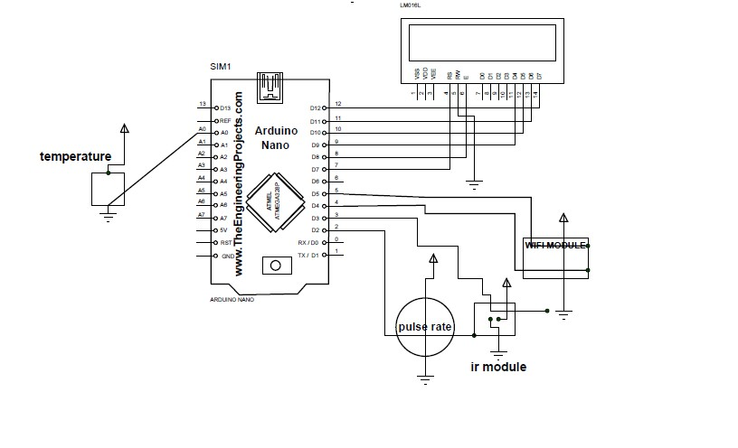fig 14- circuit diagram of health monitoring system

* 1. **PROGRAMMING**











# CHAPTER-4

**RESULTS**

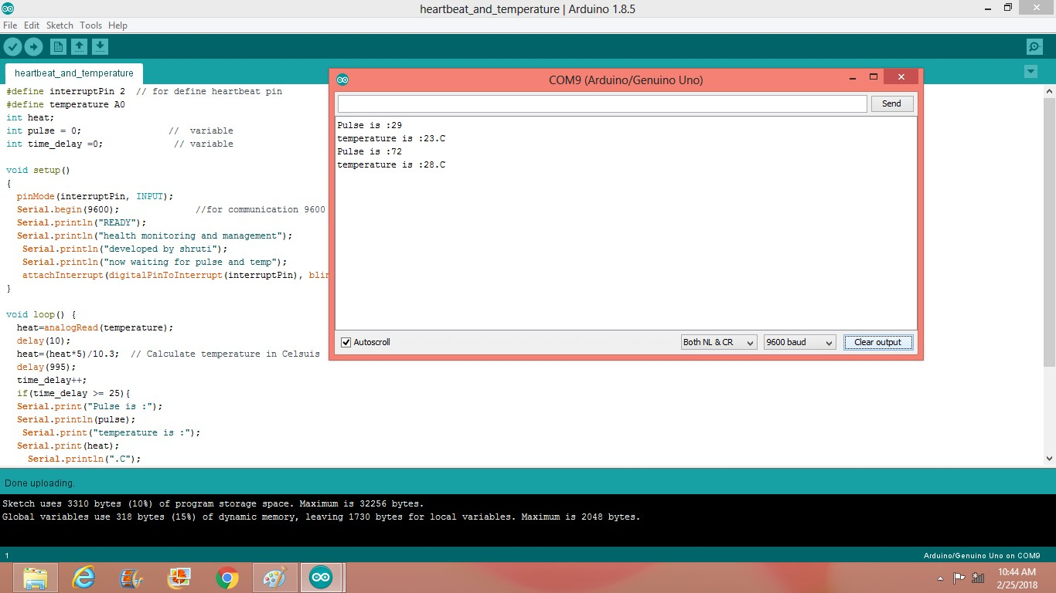

Fig 15 Pulse rate and Temperature

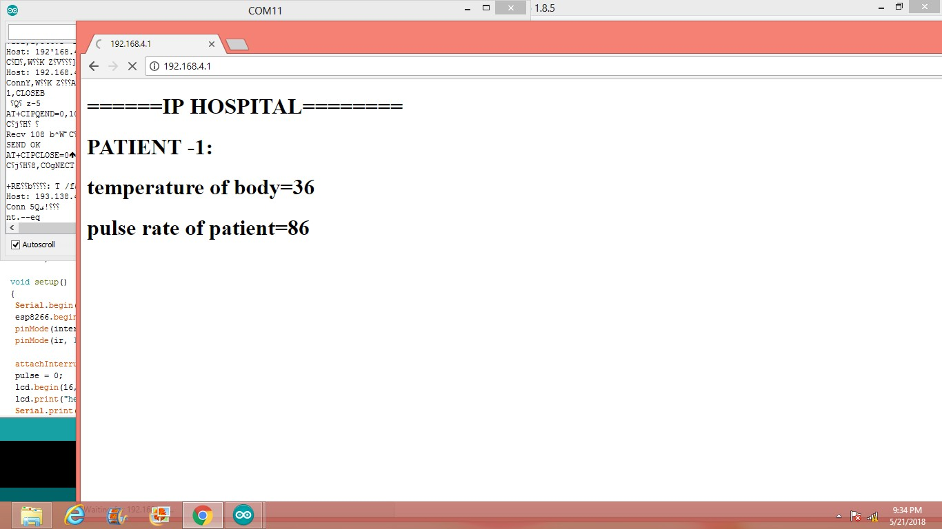

Fig 16 Reading of patient through wi-fi

# CHAPTER-5

**5.1 CONCLUSION AND FUTURE SCOPE**

Researchers across the world have started to explore various technological solutions to enhance healthcare provision in a manner that complements existing services by mobilizing the potential of the IOT. This report includes diverse aspects of IOT based healthcare technologies and present various applications of IOT based devices in healthcare showing up and their advantages with technical specifications and platforms that support access to the IOT backbone and facilitate medical data transmission and reception. Substantial R&D efforts have been made in IOT-driven healthcare services and applications. This report is concerning how the IOT can address pediatric and elderly care, chronic disease supervision, private health, and fitness management.

# REFERENCES

1. Moeen Hassanalieragh, Alex Page∗, Tolga Soyata, Gaurav Sharma∗, Mehmet Aktas†, Gonzalo Mateos∗ Burak Kantarci‡, Silvana Andreescu," Health Monitoring and Management Using Internet-of-Things (IoT) Sensing with Cloud-based Processing: Opportunities and Challenges", 2015 IEEE International Conference on Services Computing.
2. Alexandros Pantelopoulos and Nikolaos G. Bourbakis," A Survey on Wearable Sensor-Based Systems for Health Monitoring and Prognosis", IEEE Transactions on systems, man, and cybernetics—part C: Applications and reviews, vol. 40, no. 1, January 2010.
3. Arsalan Mosenia, Susmita Sur-Kolay, Anand Raghunathan and Niraj K. Jha," Wearable Medical Sensor-Based System Design: A Survey", IEEE Transactions on multi-scale computing systems, vol. 3, no. 2, april-june 2017.
4. Suriya Begum, Venugopal ," Comparison of various techniques in IoT for healthcare systems", International Journal of Computer Science and Mobile Computing, Vol.5 Issue.3, March- 2016.
5. S.M.Riazul Islami, Daehan Kwak, MD. Humaun Kabir, Mahumd Hossain, AND Kyungsup Kwak," The Internet of Things for Health Care: A Comprehensive Survey", 2015 IEEE. Translations and content mining are permitted for academic research only.
6. Stephanie B. Baker , Weixiang, and Ian Atkinson," Internet of Things for Smart Healthcare: Technologies, Challenges, and Opportunities", 2017 IEEE. Translations and content mining are permitted for academic research only.
7. MD.Mofijul, Islam, MD. Abdur Razzaque, Mohammed Mehedi Hassan, , Walaa Nagyi Ismail, and Biao Song," Mobile Cloud-Based Big Healthcare Data Processing in Smart Cities", 2017 IEEE. Translations and content mining are permitted for academic research only.
8. Shao-Jie Hsu, Shih-Syun Lin, Tun-Wen Pa, Hamido Fujita," Proactive Healthcare and an Early Warning Mechanism for Coronary Artery Disease Patients using Internet-of- Thing Devices", 2016 IEEE International Conference on Systems, Man, and Cybernetics' SMC 2016 October 9-12,2016.
9. Akshay Gapchup, Ankit Wani,Durvesh Gapchup, Shashank Jadhav," Health Care Systems Using Internet of Things", International Journal of Innovative Research in Computer and Communication Engineering, Vol. 4, Issue 12, December 2016.
10. Divya Saxena, and Vaskar Raychoudhury, “ Design and Veriﬁcation of an NDN- Based Safety-Critical Application: A Case Study With Smart Healthcare”, IEEE 2017.
11. Ms.Kalyani D shinde, Prof. Sagar B. Shinde, Prof.S.S.Savkare,” A Review on system of IOT Based Human Activity Monitoring By Using Raspberry Pi”, <http://www.ijarsmt.com/>Volume 2, Issue 6, June 2016.
12. Divya Saxena, and Vaskar Raychoudhury,” Design and Veriﬁcation of an NDN- Based Safety-Critical Application: A Case Study With Smart Healthcare”, IEEE Transactions on systems, man, and cybernetics: Systems.
13. Prosanta Gope and Tzonelih Hwang,”BSN-Care: A Secure IoT-Based Modern Healthcare System Using Body Sensor Network “, IEEE Sensors Journal, vol. 16, no. 5, march 1, 2016.
14. Kenji Aono∗, Nizar Lajnef‡, Fred Faridazar§ and Shantanu Chakrabartty†,” Infrastructural Health Monitoring Using Self-powered Internet-of-Things “,2016 IEEE.

**APPENDIX-A**

## IOT vision includes

IoT is a vision which is still at very early stages, where everyone interprets the vision with their own perspectives. There are three main visions of IoT based on the things, digital and semantic perspectives. All these three perspectives of IoT should integrate with each other seamlessly for extracting the full benefits of IoT architecture.

* 1. Things oriented vision
  2. Internet oriented vision
  3. Semantic oriented vision

**Things oriented vision:** This vision provides the perspective that all the real physical objects can have the sensors attached to get the real time information from them. This can be accomplished by the sensors based network of embedded devices using RFID, NFC and other wireless technologies. This vision provides the base for integration

**Internet oriented vision**: This vision provides the perspective that all the devices can be connected through internet and can be described as smart objects. This can be accomplished by using unique IP for each connected object. This vision provides the base for the data integration of all the smart objects, which can be continuously monitored. F all “things” using different sensor based networks to collaborate and co-exist together.

**Semantic oriented vision**: This vision provides the perspective that all the data collected from carious sensors need to be analyzed for meaningful interpretation. This can be accomplished with semantic techniques, which separates raw data from the meaningful data and their interpretation. This vision provides the base for the semantic integration through the use of semantic middleware.

The sensors help to transform the physical world data (e.g: temperature, pressure, humidity, etc) including human health data (heart rate, oxygen saturation, blood pressure, blood glucose, etc) to the digital world and the actuators transforms the digital data to physical actions (e.g: Infusion pumps, dialysis system, etc). The IoT devices have sensors for receiving signals from the environment for analysis, or actuators for controlling the environment based on the inputs, or both sensors and actuators. These devices connect with each other through internet transfer and cloud storage for communication with similar devices and people

## Healthcare Trends

The current trends in the healthcare can be classified in multiple ways based on the perspective of the technology, functionality and the benefits. There is a trend happening with the convergence of consumer devices and medical devices. Most recent smartphones are

being launched with health sensors in the accessories like wrist gear. This enables the mHealth, which refers to the use of mobile and wireless technologies in the practice of medicine and the monitoring of public health. This reduces medical errors based on continual monitoring practices. IoT applications in healthcare can be grouped in to following categories based on the functionality.

1. Tracking of objects and people
2. Identification and authentication
3. Automatic data collection and sensing.

Health trends can be analyzed with respect to the application areas in medical practice. Some of the applications areas are listed below along with the usage of IoT concept and their benefits.

* Wireless patient monitoring: This application is for remote surveillance of patient vital functions through the use of internally and externally located patient devices. As opposed to discrete interactions, the provision of healthcare is moving to a model where information is being transmitted and shared in real time between individuals and caregivers. This is especially relevant for chronicdisease management such as hypertension, diabetes, coronary heart disease, asthma. Examples: Wirelessly monitored pacemakers and automatic defibrillators.

Transforming healthcare through IoT

* Mobile system access: This application is based on the mobile technologies that enable remote/virtual access to current clinical systems (electronic health records [EHRs], picture archiving and communication systems [PACS], etc.). All the medical system can be automated with easy to use mobile app interface. This application of technology in healthcare is referred as e-Health. If the mobile is used as monitoring and delivery of healthcare, the application area is termed as m-Health. Examples: Websites, portals, mobile apps.
* Medical devices: This application is used to capture and track key care compliance and disease management data. Mainly these are used as fitness solutions for tracking of patient activities and smart diagnostic devices used for capturing the data from the sensors for further analysis by doctor. Google glass is also under research for possible medical devices as this can used to perform assisted surgeries and recording, etc. Examples: digital glucometers, blood pressure devices, pedometers, wearables – fitbits, google glass, etc
* Virtual consultation (telemedicine): This application is based on the remote connectivity and multimedia solutions that enable virtual care consultation, education, medicine delivery and therapy procedures as shown in Fig 2. In some countries appointments and wait times are getting longer. Through virtualization, the majority of routine care can happen within minutes and even seconds. The remote diagnostic screening has become common in some countries and markets. There shall be the

possibility to see the advent of tele-surgery for routine procedures using robots and nurse assistants. Examples: Tele-consultations, mobile video solutions. Transforming healthcare through IoT

* Aging in place: This application is used to enable clinically monitoring for independent living of aging populations. These devices mostly come up as wearable for monitoring the elderly patients without the need for manual intervention. The vital signs data from the elderly care is acquired from the monitoring devices and transmitted to a standard mobile device which acts as a network node for transmitting the real-time data to the doctor. The information can be used to give medical assistance to the needful person and in case of higher abnormalities, the nearby efficient hospitals can be alerted and thus the hospitalization costs can be reduced through early intervention and treatment Examples: Personal emergency responses systems (PERS), video consultations, activity monitoring and fall detection.

There has been clinical evidence that the physiological data received from wireless devices has been a valuable contributor for managing or preventing chronic diseases and monitoring patients post hospitalization. As a result, a growing number of medical devices are becoming wearable nowadays, including glucose monitors, ECG monitors, pulse oximeters, and blood pressure monitors and so on. All these data are stores, monitored in real time to see the trend along with analytical capabilities of the modern systems.

The Internet of Things enables health organizations to lift critical data from multiple sources in real-time, and a better decision-making capability. This trend is transforming healthcare sector, increasing its efficiency, lowering costs and providing avenues for better patient care.