INTRODUCTION TO WATER SUPPLY NETWORK IN GIFT CITY

Naveen Saini ¹, Prof. Ankita J Parikh²
ME CIVIL (Infrastructure Engineering) Civil Engineering Department LDRP – Institute of Technology & Research, Gandhinagar, Gujarat, India
Civil Engineering Department LDRP – Institute of Technology & Research, Gandhinagar, Gujarat, India

Abstract— The primary focus of this paper is to study the present condition of water supply network in GIFT city. The city spans over an area of 4 sqm which is further planned to be extended. The development of the city is being carried out in phased manner and is envisaged to finish in next 7 to 10 years. Being developed as a model smart city, water supply in the city is also developed as per the requirement from the developer to curb the wastage of water and keeping the sustainability of the city into vision. This has resulted into unplanned extension of water network to feed the temporary construction into the city. In next part of this paper the solution will be proposed along with the design and scheduling of the construction of water supply network using Bentley WaterGems and Primavera software respectively.
Keywords— GIFT City, Water Supply Network, Sustainability, WaterGems, Primavera

Introduction
Water forms important physical environment of humankind and has a direct bearing on the health. As per CPHEEO manual WHO refers to “Control of Water Supplies to ensure that they are pure and wholesome as one of the primary objectives of environment sanitation.” ^{[1]} With proper planning of the water supply project, quality and quantity of the water supply can be well planned and maintained. Proper designing of the water supply network is necessary to optimize the cost involved in the construction of the project.
The basis of this study is optimizing the time, cost and resources required for designing of the water supply network with an aim to optimize the capital and operational cost of the project while following the required standards.
Planning of the project will be carried out in Primavera or MS Project and the design will be carried out in Bentley WaterGems software.

About GIFT City^{[2]}
GIFT City is an emerging global financial and IT services hub, a first of its kind in India, designed to be at or above par with globally benchmarked business districts. It is supported by state-of-the-art infrastructure encompassing all basic urban infrastructure elements along with an excellent external connectivity. Companies from Financial Services, Technology and all other services sector is being targeted as potential occupants within the city. Few of them have already started operations from GIFT City.

Geographical Conditions: -
GIFT development area lying on the west bank of the river Sabarmati is a part of the North Gujarat Alluvial Plains. So, the slope of water runoff is from East to West towards river. The flow in river is from North to South. The climate of the area is semi-arid and is characterized by a hot summer and general dryness except during the south-west monsoon between the months June and September. The cold season starts from December and lasts till February; the temperature increases from March with May being the hottest month while January the coldest. The average Rainfall in the region is about 635 to 762 mm

Water Management Study: -
The development of the scale of GIFT will have a substantial water requirement. GIFT area falls under dry weather condition where semi-arid climate predominates. Conventional water supply source of river and lake are not available for the GIFT City area. The rainwater runoff from upstream is collected in the Sabarmati River basin area by small hydro-dams. The groundwater aquifers are unsaturated as they are overlain and underlain by weathered rock with high transmissivity. The density of the tube well also contributes to the over exploitation of groundwater resources by virtue of which the groundwater level has acquired a declining trend.
This demands a comprehensive study and planning approach if the city must grow and prosper. It has been observed historically that cities which has grown and prosper as dynamic towns were on the banks of river or has planned well for their future water demand.

Ground Water Table Analysis:
The ground water table is a little deeper in the GIFT City area, ranging around 25 – 30 m or even more. Water table depth is deeper in the northern part, while little shallower towards the riverbanks. The water table depth contour map (See Fig 1) is prepared based on the water table depths.
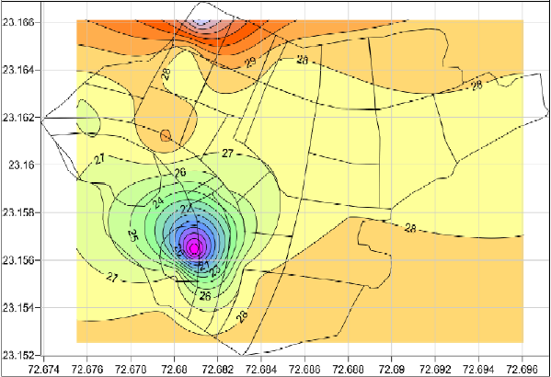
- Water-Table Map of Gift City

Need of the Study
GIFT City is being developed to act as a benchmark for all the smart cities for India. The development is being carried out in phases. The buildings which are operational has got potable water being supplied through utility tunnel (See Fig 1.2). There are many developments that are coming up in the city as it grows – these developments have offices and they require treated water for construction purposes. As per the current practice half of the under developed structures are being served using treated water and other half have got irrigation water. Placing lines as per the requirements of developers create hassle in the pre-planned utility spaces; which in turn creates hurdles for proposed infrastructures.
To solve this issue, it is proposed to use the space envisaged for tunnel and place water supply network in the area. The water supply network will be laid as per the requirements of the operational buildings only and not only serving water during construction. The construction of utility tunnel – which will house this network in future – will be carried out in phased manner.

Scope of Work
To plan the project of “design and construction of water supply network” using Primavera software and find out optimum time for project completion- in order to merge it with the development of the city. To design the water supply network of the area including the components of the water supply network in sync with the existing network.
The scope of the study will include
• Project Planning
• Demand finalization
• Study of the existing network.
• Distribution network design
• Cost analysis

Study Outline
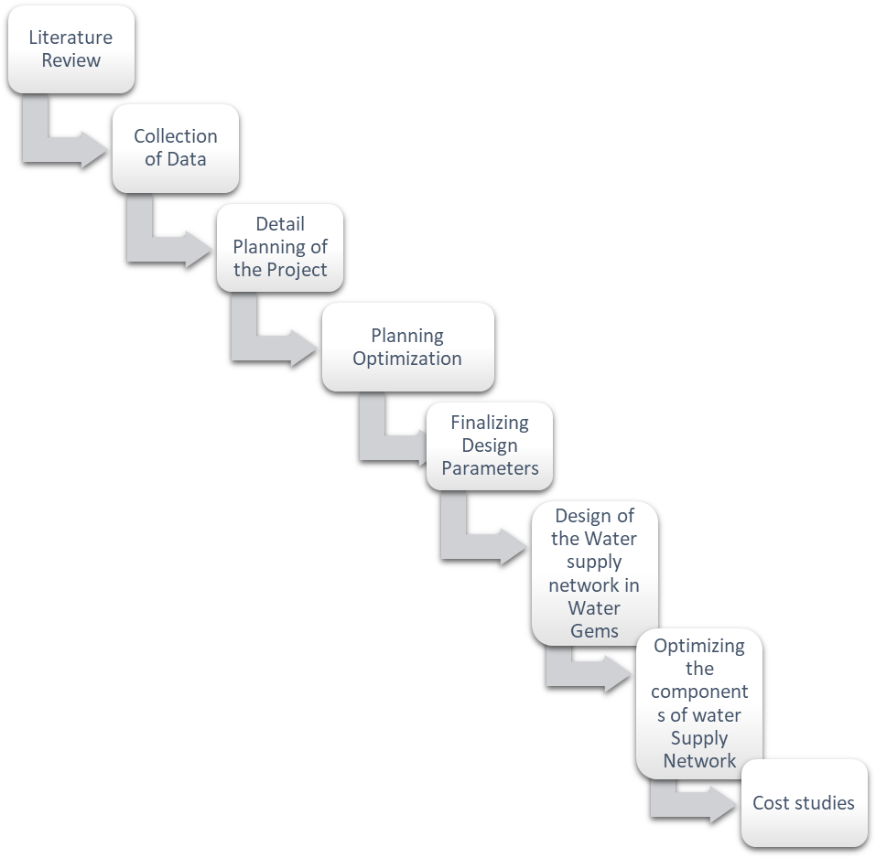

Figure 1: Study Outline Workflow

Present Condition
Figure 2: Present Water Network
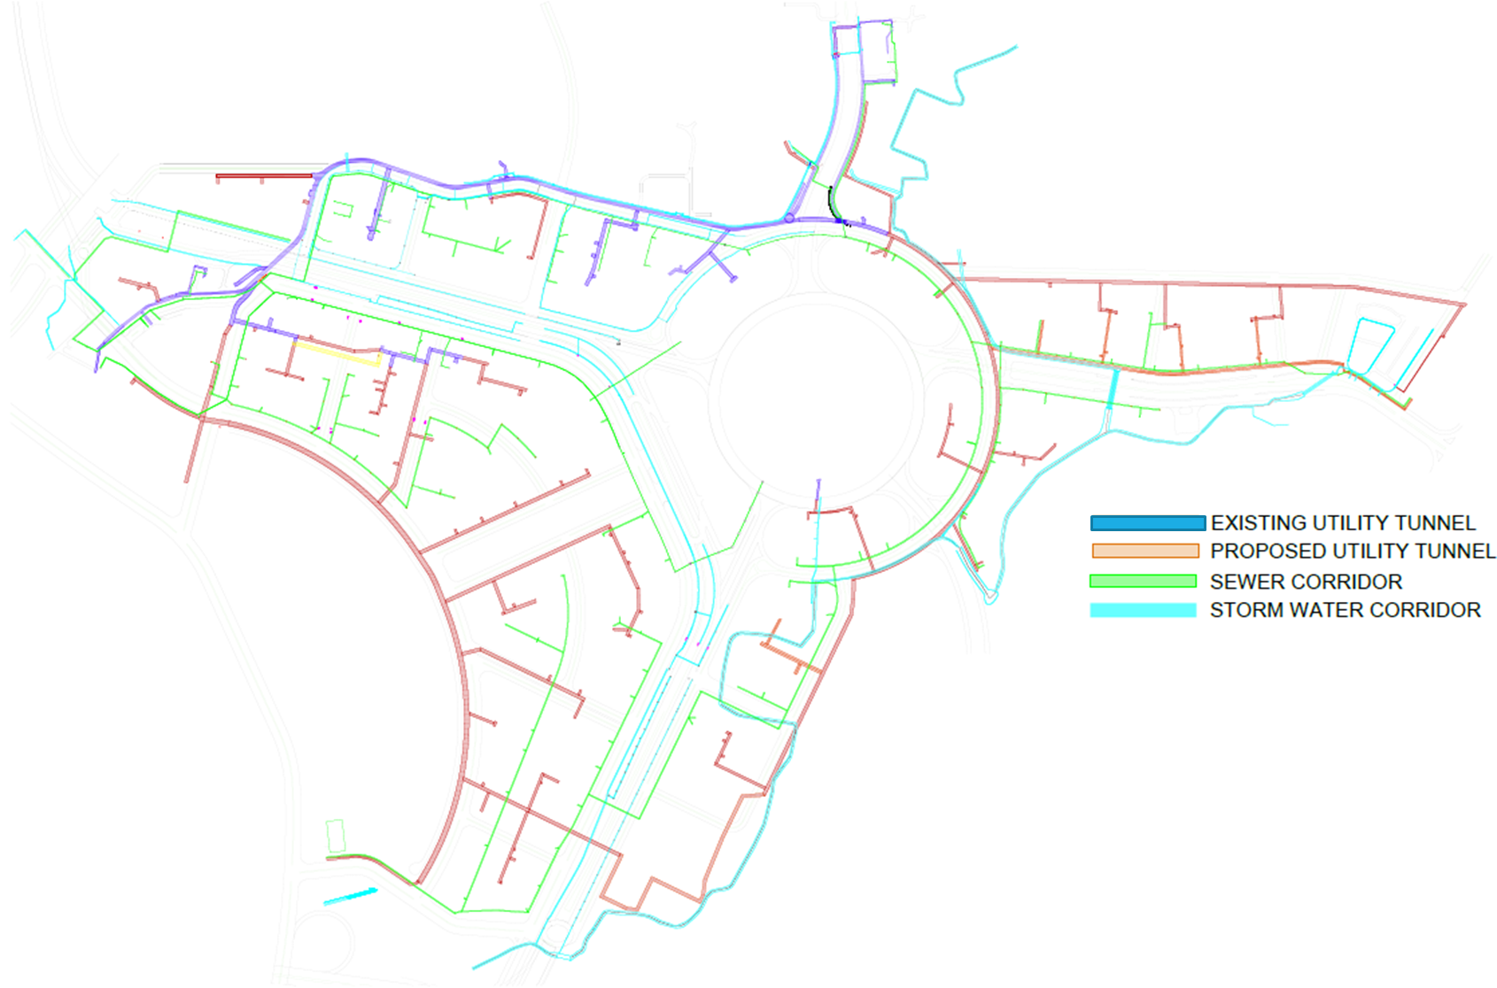

At present the survey and information from the office suggest that the water supply network is being laid for three different purposes namely, irrigation, construction and treated water. The construction sites also have requirement for treated water for drinking purposes in the office and labor colonies, similarly they also need treated water for various complicated construction activities. This resulted in a network which is very random and not following any pattern. As seen in the figure above the green lines suggest the irrigation water red lines are for construction water and Blue are treated water being supplied specifically for drinking purposes into the building which are fully functional.
As per the planning of the city it was planned to put the treated water line in the proposed Utility tunnel, the present scenario if the tunnel is shown in the figure below. Only 2km length of the tunnel is being constructed out of the total length of the tunnel because construction of tunnel is based on the requirements of the developers. The full-fledged construction of the tunnel will take next 10 years to complete. In the mean time the water supply network will run outside the tunnel in the areas where there is no tunnel.
The overall development of the utility services is largely affected by the development of the city in phased manner. As the city develops and developer require the infra services GIFT City develops the services to facilitate the development. This has been into a very random way but as the time has progressed the randomness has taken a shape and is falling into place as per the master plan. The aim is to develop the whole city as per the master plan. Below figure shows the areas being developed and are under development.

FUTURE SCOPE
The present network can further be studied for suitability of the demand – weather the available network design criteria are enough to carry the required water or not. If not then network can be redesigned and proper pipe diameters can be provided
For the issue of the network being laid randomly, a proper water supply network of the whole city can be suggested in the area designated for utility tunnel (as water network is envisaged to be placed in the utility tunnel). All the required connection for construction activities can be supplied from the main line. This will reduce the cost of the service provider i.e., GIFT City and will also reduce the chances of the clashes of water supply network with other network services. Proper design of the network will help in maintain the quality and the quantity of water being supplied and will also help in proper billing of water to the developers. This will also reduce the instances of no pressure to low pressure into far away areas as the design will be considered for the same.
Further part of this paper will also provide a construction schedule for the whole work so that it does not exceeds the time line of laying the planned network. This will be a temporary arrangement with the clause to reclaim the laid network and place it in the utility tunnel once it is constructed.

CONCLUSION
Water constitutes an integral part of any city’s infrastructure and is considered as one the basic needs. GIFT city being the model smart city and the first operational smart city in India the state of water supply network can be streamlined from the present state. The present situation of the network is an outcome if the city administrations commitment to provide services to the developers in the city. There is a need of change in the administration approval of the connections also. To improve and optimize the water network in the city, a fully functional water supply network must be laid in the utility space available for tunnel. This can later be shifted into tunnel upon construction of tunnel.
Further ahead for the expansion of the city there should be enough provision of the water supply utility corridor in the master plan itself. The master plan itself should be developed keeping in mind the phased development of the city and the commitment to the developers.

REFERENCE

- IIT KGP, Manual on Water Supply and Treatment By Central Public Health Works and Environmental Engineering Department, Volume 1, pp 57-79 http://cpheeo.gov.in/cms/manual-on-water-supply-and-treatment.php

[2] https://www.giftgujarat.in/

