Real Time Temperature, Humidity Monitoring & Alert System

Shubham Chaudhari, Vaibhav Kanchi, Tejas Wakchoure, Vaishnavi Swami, Dr. Alpana Adsul

[N](mailto:                                                                      N 5Professor, 1,2,3,4Student 1,2,3,4,5 Department of Computer Engineeringdypvk@gmail.com,)[5](mailto:                                                                      N 5Professor, 1,2,3,4Student 1,2,3,4,5 Department of Computer Engineeringdypvk@gmail.com,)[Professor,](mailto:                                                                      N 5Professor, 1,2,3,4Student 1,2,3,4,5 Department of Computer Engineeringdypvk@gmail.com,) [1,2,3,4](mailto:                                                                      N 5Professor, 1,2,3,4Student 1,2,3,4,5 Department of Computer Engineeringdypvk@gmail.com,)[Student](mailto:                                                                      N 5Professor, 1,2,3,4Student 1,2,3,4,5 Department of Computer Engineeringdypvk@gmail.com,) [1,2,3,4,5](mailto:                                                                      N 5Professor, 1,2,3,4Student 1,2,3,4,5 Department of Computer Engineeringdypvk@gmail.com,) [Department of Computer Engineering](mailto:                                                                      N 5Professor, 1,2,3,4Student 1,2,3,4,5 Department of Computer Engineeringdypvk@gmail.com,)

[Chaudharishubham321@gmail.com,](mailto:                                                                      N 5Professor, 1,2,3,4Student 1,2,3,4,5 Department of Computer Engineeringdypvk@gmail.com,)

Dr. DY Patil College of Engineering and Innovation

***Abstract* – In numerous industries, including the automotive sector, food processing, and evaluation of plastic encapsulations in IC packaging, humidity and temperature monitors are widely used. However, the majority of these displays only offered a few features. In order to have stable, controllable atmospheric conditions, new features that can instantly detect, inform, record, and control humidity and temperature were proposed. The DHT-11 temperature and humidity sensor was utilised in this study to track changes in the room's temperature and humidity levels. On the Android platform, using NodeMCU, the data and information from the DHT-11 sensor will be graphically analysed. When a certain humidity level must be maintained to prevent static electricity buildup, preserve material, and other reasons, a humidifier will be attached to this monitor to restore the atmospheric conditions..** **The proposed system is an advanced solution for monitoring and live reporting the temperature and humidity at different points in specific locations. The real time data from these sensors are stored in cloud server and email is sent to the predefined recipients to let them access the data remotely over internet. When the measurement of temperature and humidity reaches over safe level then the recipients can take immediate action to alert people to be careful about corona virus. The proposed system is designed based on Arduino UNO Board, temperature sensor DHT11 is a basic, ultra low-cost digital temperature and humidity sensor. It uses a capacitive humidity sensor and a thermistor to measure the surrounding air, and spits out a digital signal on the data pin (no analog input pins needed). Its fairly simple to use, but requires careful timing to grab data, humidity sensor, ESP8266 Wi-Fi module, IoT, DC-DC modular, and solar panel. The main characteristics of this proposed system is low cost, low power consumption because of self-powered device, high accuracy and user friendly. The system shows a high degree of accuracy and reliability.**

***Keywords: DHT11 Sensors, IOT,Arduino UNO***

1. INTRODUCTION

Develop a wireless temperature and humidity Monitoring System using mobile app. IOT Device for measuring & monitoring of temperature & Humidity It is a portable unit for temperature and humidity Monitoring, It’s a Continuous measurement. Digital LCD with back light displaying. Battery Indication Wireless Indication Programmable distinct Alarms for Deviations in Temperature & Humidity Display Readings in Temperature, Humidity, LED Status(Power -Up, low battery, charging, network ), switch for power On Monitoring is considered to be an essential aspect of environmental changing conditions. It is basically employed to assess and mapping of biodiversity over vast

regions, in alerting of any changes to the climate conditions, and identifying the zones to be well protected. Therefore, it is inevitable to globally monitoring the earth for identifying and assessing climate changes. originating in human activities, is considered to be the main contributor of the climate changes and has resulted in increasing greenhouse. The prime motivation for the weather station is to track any changes in weather parameters due to their significant impacts on human-being over the years. At the present time, as it is obvious, the global warming has negative impacts on environments so, both humidity and temperature constitute the main factors that should be considered in design of modern weather stations. The highly demanded weather station are characterized with high efficie`ncy, compacted size, portable (in order to measure remote areas), and low power consuming, In contrary to the traditional bulky and high-power consuming weather station.

1. OBJECTIVES

* This work was proposed new features that can detect, notify, record and control the humidity and temperature instantaneously in order to have stable, controllable atmospheric conditions.
* This research was used of temperature humidity sensor DHT-11 to detect level of humidity and temperature changes inside the room.
* The data and information from DHT-11 sensor will be analysed graphically on Android platform using NodeMCU.
* Humidifier will be attached at this monitor to stabilize back the atmospheric conditions when a specific humidity level must be maintained to prevent static electricity build up, preserve material properties, and ensure a comfortable and healthy environment for workers or residents in industries.

1. LITERATURE SURVEY

**In [1], the author describes an IoT-based weather monitoring system.** The environmental parameter can be collected by sensors in this study. The author employs a variety of sensors to scale various parameters such as humidity, temperature, pressure, and rain value, including the LDR sensor. The temperature prototype is also used to compute the dew point value. The temperature sensor can be used to determine the temperature of a certain region, room, or location. The light intensity can be employed as described by the author with the help of the LDR sensor. The author employed an additional functionality of weather monitoring in this as an SMS alert system depending on the value of sensing parameters such as temperature, humidity, pressure, light intensity, and rain exceeding the value of the sensing parameters.

**The author of this work**

**[2] depicts a low-cost live weather monitoring system using an OLED display.** To measure the weather conditions, the author solely employs two devices: Wemos and OLED. Following the connection, the data will be stored in the cloud, and the data will

be shown on the Thingspeak website. The data is shown on an OLED screen and in the cloud by the system. The author's goal is to obtain real-time weather information on an OLED display.

system where a android application is being used to display the stored data in the Thingspeak cloud. The android application uses APIs to collect the data from the Thingspeak server and display the same in the dashboard. but in the system only a temperature and rain sensor is interfaced. The importance of microcontroller sensor outputs for data storage and acquisition is overlooked in many research articles and studies in this field. The data acquired from the device can be processed and charted in real time with a weather station monitoring system, as seen in this article. That is, the details can be exhibited and observed in two ways: directly and indirectly. Direct methodology ensures that weather patterns are recorded and saved in a computer as long as the sensors calculate climatic conditions, whereas indirect methodology ensures that weather patterns are recorded and stored in a computer as long as the sensors calculate climatic conditions. The key challenge in this study is demonstrating and validating that microcontroller and their sensors can be coupled to a data collecting network to create a database system.

1. METHODOLOGY

There are so many embedded devices to interact with environment by connecting internet. The increment of these types of objects is achieving the development of micro-controller-based systems which are replacing old complicated electronic circuits. By using IoT, we can control any electronic equipment in homes and industries. Moreover, we can read a data from any sensor and analyse it graphically from anywhere in the world. Arduino is a microcontroller board which works as a tiny computer. Arduino is a platform to develop an interaction with required programming software. Arduino UNO is micro controller unit to fetch a data of humidity and temperature from DHT11 sensor and process it and give it to a ESP8266 module (wi-fi module). In this paper we have different sections to trace the temperature and humidity. Section I defines the humidity and temperature by using humidity and temperature sensor DHT11, section II reads the DHT sensor module’s output and extracts temperature and humidity values into a suitable number in percentage and Celsius scale, section III system

displays humidity and temperature on LCD, Section IV defines analyzing and designing the system architecture, section V shows the result and future scope.

2. ARDUINO UNO Arduino is a new open-source hardware and software system. It has to take attention of a large technology design and community at affordable cost, which increases its use with advanced technology. Arduino hardware is a motherboard for making interaction between objects and suitable computer programming IDE (Integrated Development Environment).



**Fig. Arduino Circuit**

3. DHT11 SENSOR This module features a humidity and temperature complex with a calibrated digital signal output means DHT11 sensor module is a combined module for sensing humidity and temperature which gives a calibrated digital output signal. DHT11 gives us very precise value of humidity and temperature and ensures high reliability and long-term stability. This sensor has a resistive type humidity measurement component and NTC type temperature measurement component with an 8-bit microcontroller inbuilt which has a fast response and cost effective and available in 4-pin single row package.



**Fig. DHT 11 Sensor**

Temperature and Humidity Standards of the Server Room The server room must have sufficient temperature control to maintain the specified operational limits for the hardware devices in the server room. The server room should have an optimal air conditioning system that is sufficient to maintain the temperature and humidity of the server room. Room temperature standards are also reviewed based on standards from ANSI / TIA-942-A (Telecommunications Infrastructure Standard for Data Centers) [18] [19] with the following conditions:

• Temperature: 18-27 ° C (64-81 ° F) dry bulb temperature.

• Maximum relative humidity: 60% • Maximum dew point: 15 ° C (59 ° F)

• The maximum temperature change rate: 5 ° C (9 ° F) per hour.

Apart from the ANSI / TIA-942-A standard [19], the temperature and humidity limit values are also taken based on the Standard Operating Procedure (SOP) to maintain server security and resilience. The temperature in the server room must also be maintained in accordance with the health standards of the server room. The following formula for obtaining temperature and humidity data so that it can provide a warning automatically:

• iƒ: temp => 30 ° The system will provide notifications (1)

• iƒ: humid => 60 ° The system will provide notifications (2) Where temp is the value of temperature and humid is the value of humidity. The value of temp and humid is obtained in real time through a DHT sensor.

4. The NodeMCU (Node MicroController Unit) is an open-source software and hardware development environment built around an inexpensive System-on-a-Chip (SoC) called the ESP8266

Operating Voltage: 2.5 to 3.3V

Operating current: 800 mA

3.3V 600mA on-board voltage regulation

ESP8266 comes up with 2 switches one is reset and another one is flash button, Reset button is used to reset NodeMCU and flash button is used to download and is used while upgrading the firmware. The board has build in LED indicator which is connected to D0 pin.

The esp8266 has 4 power pins: One VIN pin for input power supply and three 3.3V pins for output power supply. Even if 5V regulated supply is given through VIN, the voltage regulator will decrease it to 3.3v during output. The esp8266 has 3 GND pins which indicate ground supply. Generally, the negative terminals are connected to these pins.

Esp8266 board also has I2C pins which can be used both as I2C master and I2C Slave. These pins are used to connect various I2C sensors and peripherals in your project. I2C interface functionality can be controlled via programming, and the clock frequency is 100 kHz at a maximum.

ESP8266 has two SPI in slave and master modes. These SPIs also support the following general features: 4 timing modes of the SPI format transfer. Up to 64-byte FIFO buffer.

Esp8266 has a secure digital I/O interface which is used directly control the SD cards.

Esp8266 has 4 channels of Pulse width modulation (PWM). The output can be controlled via programming and is frequently used for driving motors and LEDs. The frequency ranges from 100Hz to 1KHz.

There are three control pins on the esp8266: The enable pin (EN), the reset pin (RST) and the wake pin.

The esp8266 chip works when the enable pin is high. When the enable pin is low, the chip works on minimum power.

The reset pin is used to reset the esp8266 chip.

The wake pin is used to wake up the chip from deep sleep mode.

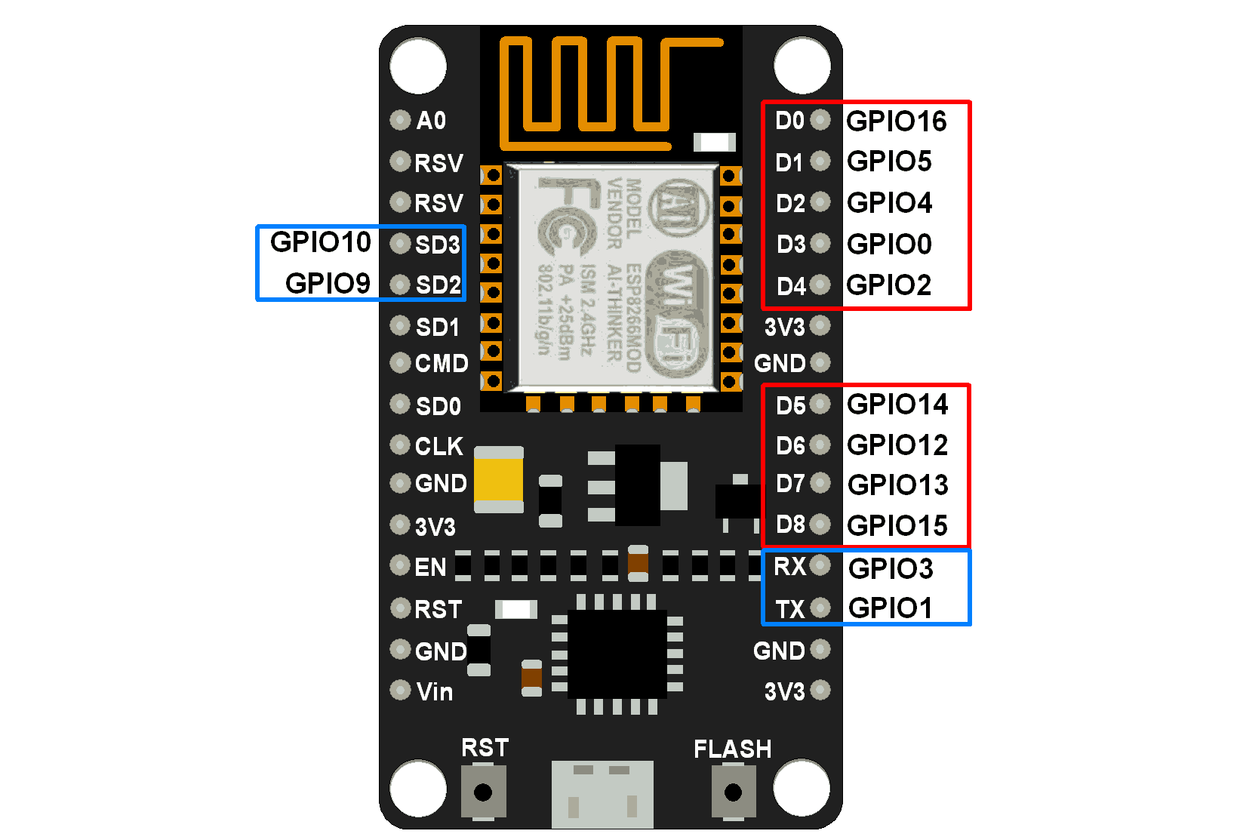

1. OUTPUT

 



1. CONCLUSION

This proposed system can provide a convenient method for effective monitoring of temperature and humidity in real time. This system is compact to an extent and cost effective when compared to prices of instruments used to measure the environmental factors. From the above all analysis, it is ensured that the nested wired systems can be replaced by the wireless sensor networks to get an accurate data as well as to avoid many hazardous issues. The results of system design have been able to send temperature and relative humidity information in real time to a database that is on raspberry. Data is sent via a wireless network between ESP8266 using Arduino UNO. The data of temperature and humidity is relatively stored in the MySQL database and can be displayed as a report.

VII. REFERENCES

1. P. Magrassi, T. Berg, “A World of Smart Objects”, Gartner research report R-17-2243, 12 August 2002.
2. [www.igcn.gigaku.org](http://www.igcn.gigaku.org/).
3. D.-R. UK, "DHT11 Humidity & Temperature Sensor," 30 July 2010. [Online]. Available: [www.droboticsonline.com.](http://www.droboticsonline.com/)
4. Khin KyawtKyawt Khaing, “PIC-Based Temperature Controller”, The Third International Conference on Science and Engineering(ICSE 2011), 2011, Vol-1, page 234-238.
5. Khin KyawtKyawt Khaing & May Thin Khine, “IoT based Temperature, Movement and Light Monitoring System for Smart Building”, MURC 2019, 24th - 25th June 2019, Yangon.
6. Maureira, M. A. G., Oldenhof, D., &Teernstra, L., 2011, "ThingSpeak– an API and Web Service for the Internet of Things," Available online:[http://mediatechnology.leiden](http://mediatechnology.leiden/) .edu/images

/uploads/docs/wt2014_thingspeak.pdf, Accessed on 25 March 2018.

1. <https://www.ibm.com/blogs/internet-of-things/what-is-the-iot/>
2. [https://www.robot-r-us.com/vmchk/sensor-temp/humid/dht11-temperature-and-humidity-](https://www.robot-r-us.com/vmchk/sensor-temp/humid/dht11-%20temperature-and-humidity-sensor.html) [sensor.html.](https://www.robot-r-us.com/vmchk/sensor-temp/humid/dht11-%20temperature-and-humidity-sensor.html)
3. L. Aosong(Guangzhou) Electronics Co., "Temperature and humidity module DHT11 Product Manual," [Online]. Available: [www.aosong.com.](http://www.aosong.com/)
4. NodeMCu ESP8266 ESP-12E, https:// einstronic.com/wpcontent/ …/NodeMCU-ESP-12E- Catalogue.pdf.
5. ACKNOWLEDGMENT

The authors would like to thank Mrs. Alpana Adsul, Head of Department at Computer Engineering ,of Dr. D.Y. Patil College of Engineering and Innovation for her spirited Guidance and moral support. We thank all faculty members and staff of Computer Engineering Department and those who contributed directly or indirectly to this work. We are thankful to Mrs. Deepali Sale, professor at Computer Department, Dr. D.Y. Patil College for her guidance in writing this research paper.

Authors

|  |  |
| --- | --- |
| Shubham Chaudhari | Final year computer engineering student at Dr. DY Patil College of Engineering and Innovation  Email id : [chaudharishubham321@gmail.com](mailto:chaudharishubham321@gmail.com) |
| Vaibhav Kanchi | [vaibhavkanchi123@gmail.com](mailto:vaibhavkanchi123@gmail.com) |
| Tejas Wakchoure | [tejaswakchoure121@gmail.com](mailto:tejaswakchoure121@gmail.com) |
| Vaishnavi Swami | vaishsswami@gmail.com |