Design a Micro-Strip Patch Antenna for Wearable Applications: A Review

Shikhar Choudhary*   
*Department of Electronics & Communication Engineering,*

*ABES Engineering College, Ghaziabad (U.P.), India*shikhar.19b311095@abes.ac.in

Shaswat Awasthi  
*Department of Electronics & Communication Engineering,*

*ABES Engineering College, Ghaziabad (U.P.), India*shaswat.19b311050@abes.ac.in

Saurabh Sur  
*Department of Electronics & Communication Engineering,*

*ABES Engineering College, Ghaziabad (U.P.), India*saurabh.19b311010@abes.ac.in

Manish  
*Department of Electronics & Communication Engineering,*

*ABES Engineering College, Ghaziabad (U.P.), India*manish@abes.ac.in

*Abstract -* **The world is currently struggling with wireless communication, a new and quite overwhelming technology that is revolutionizing it. The use of wireless networks and electrical equipment is expanding in the modern world, and wireless body area networks are also becoming more widely accepted. WBAN has connected wireless networks and electrical equipment by employing and installing several devices on human bodies. Wearable antenna enhances multiple WBAN applications. In a study, it is found that the wearable antenna (low-profile) WBAN are used to track vital human indicators like blood pressure, skin temperature, and pulse rate. Our intention is that we will design a micro-strip patch antenna which can be used for reasonable applications. The operation range of a wearable antenna is around 2.4 GHz–2.5 GHz and for telemedicine and WLAN 5.7–5.9 GHz applications. The rectangular patch antenna can be easily customized to implement the suggested design. This low profile and simple design of this antenna is to integrate with the fabrics.**

1. INTRODUCTION

In upcoming years of technology , this wearable technology is expected to become a billion-dollar business which will incorporate telemedicine, RFID, and consumer electronics. In the upcoming years, wireless connectivity and engagement will become extremely crucial along with the environment. Integrating antennas into clothing can significantly reduce the needs for these kinds of systems, and creating conducting structures on textiles would undoubtedly be advantageous for a variety of applications[1].

There is a flexibility with textiles which requires an extra performance margin that has to be indulged within the design [2]. The wash ability of the antennas is considered through the integration in the clothing [3]. In harsh environments, it is mandatory that the antennas are in working order [4]. In textile antennas, crumpling and bending effects on the radiation and impedance pattern have to be considered [5, 6]. Various materials and manufacturing processes are there that are considered for wearable antennas which include liquid crystal polymers, conducting paint, screen printing, weaving, and nylon covered with conducting metal [7]. There are few technical challenges which are faced while embroidering an antenna when constructed using conductive threads which is examined in [8].

The Micro-strip antennas are described based upon some physical properties. They can be made with a wide variety of geometrical forms and proportions [9]. There are four basic categories in which all the micro-strip antennas can be divided:

Micro-strip Antennas

Micro-strip Micro-strip Printed slot Micro-strip

patch dipoles antennas travelling

antenna wave antennas

Recently, researchers have demonstrated and validated a novel method for overcoming all of the drawbacks of micro-strip patch antennas using meta data [10–13].

While constructing wearable antennas to be worn as part of people's outfits, several factors must be considered. They are:

1. Compactness.
2. Desired radiation characteristics.
3. Low cost.
4. Lightweight.
5. A Function in near the vicinity for the human body with little deterioration.
6. Stable performance under varying conditions.
7. Flexibility.
8. The antenna and the human body should have less of a connection.
9. Improvement in Efficiency and Gain. [14,15]
10. MICRO-STRIP ANTENNAS

The micro - strip patch antennas (MPA) are composed of a plane with one side as a dielectric and any planar or a non-planar conducting patch on the other. It is a common printed resonant antenna for semi-hemispheric coverage. The micro-strip patch antenna has drawn a lot of attention and is frequently employed as a part of an array due to its flat design and straightforward interconnection with micro-strip technology. Many micro-strip patch antennas have been studied up to this point.. A complete list of their key characteristics and geometries are available [16]. The most fundamental and popular types of micro-strip antennas are those with circular and rectangular patches. Rectangular geometries are naturally separable, and their analysis is quite straightforward. The circular patch antenna's symmetrical radiation pattern is advantageous. Figure 1 is a micro-strip antenna basic structure. 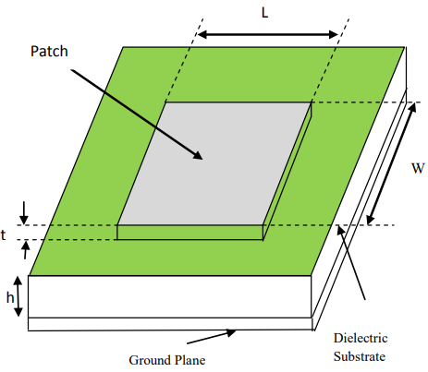

Figure-1: Micro-strip Antenna’s basic Structure

As we discussed above, there are various types of micro-strip antennas. So, below we have discussed some of the characteristics between Printed dipole antennas, micro-strip patch antennas, and micro-strip slot antennas:

1. Micro-strip Patch Antenna
2. Profile is thin.
3. Fabrication is very easy.
4. Polarization is both linear and circular.
5. Shape is flexibility.
6. Bandwidth is between 2-50%.
7. Dual Frequency operation is possible.
8. Spurious radiation exists.
9. Micro-strip Slot Antenna
10. Profile is thin.
11. Fabrication is easy.
12. Polarization is both linear and circular.
13. Spurious radiation exists.
14. Mostly rectangular and circular shapes.
15. The Dual Frequency operation is possible.
16. Bandwidth is between 5-30%.
17. Printed Dipole antenna
18. Profile is thin.
19. Dual Frequency operation is possible.
20. Fabrication is easy.
21. Polarization is only linear.
22. Spurious radiation exists.
23. Rectangular and circular shapes.
24. Bandwidth is between 0-30%.
25. ANTENNA DESIGN

IEEE applications in WLAN uses a basic substrate based antenna . Figure-2 simply states the design procedure (step-by-step) for the antenna. Antenna design is shown through the following steps: (a) design and simulate antenna, (b)making slots on the antenna to excite the lower resonance frequency and reduce size, simulating the creation of rectangular and square gaps in the antenna., (c) meta material square (SRR) inserting within the rectangular slots. During simulation a slight shift in the position of the square SRR has been observed, shifting the resonance frequency as the matching conditions change [17].

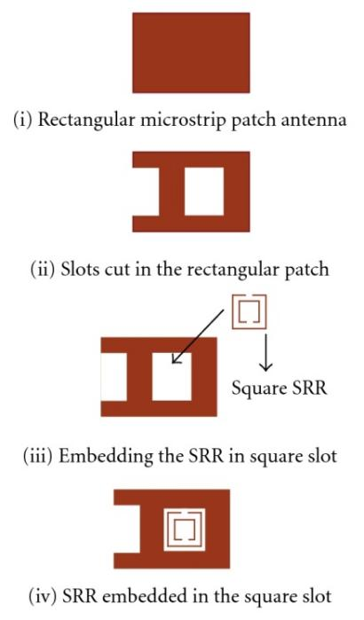

Figure-2: Steps to build the Micro-strip Antenna

1. FEEDING TECHNIQUES

Using either direct or indirect interaction, a feed-line is used to excite and radiate. For feeding, there are numerous approaches available. The most popular four methods are as follows: [18]

1. A Coaxial probe feed
2. A Micro-strip line

C)An Aperture coupling, and

D) A Proximity coupling

Coaxial probe feeding is a feeding method where the inner conductor of the coaxial is connected to the antenna's radiation patch and the outer conductor is connected to the ground plane. The benefits of coaxial feeding include ease of fabrication, ease of matching, and low spurious radiation. The disadvantages include narrow bandwidth and difficulty modelling, particularly for thick substrates

.

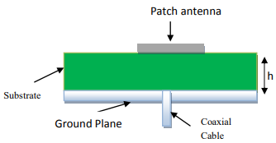

Figure 3: A Coaxial feed patch

Micro-strip line feed is one of the simplest methods to fabricate because it is simply a conducting strip connected to the patch and can thus be thought of as an extension of the patch. It is very easy to design by modifying the insert position. The drawback of this technique is that it limits range because of increasing in surface waves with false feeding radiation derived from the substrate.

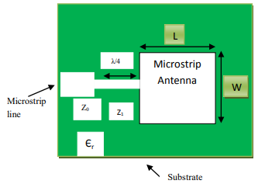

Figure 4: Micro-strip patch antenna line-feed

A ground plane divides two substrates connected together in the aperture coupled feed. A micro-strip feed line on the bottom side of the lower substrate couples energy to the patch via a slot on the ground plane separating two substrates. The feed mechanism and the radiating element both can be optimized independently, according to this configuration. The upper substrate is typically made of a thick low dielectric constant substrate, whereas the bottom substrate is made of a high dielectric constant substrate. The bottom substrate usually has a high dielectric constant. The centre surface isolates feed from the radiation source, removing spurious radiation that interferes with pattern creation & polarization. Benefits allows separate feed mechanism element optimization.

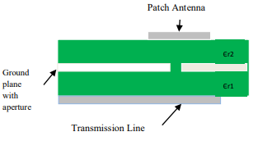

Figure 5: Aperture coupled feed patch antenna

The wider band-width and lower spurious radiation are seen in proximity coupling. However, fabrication is challenging. The feeding stub length and patch width-to-length ratio are used to control the match. It has a capacitive coupling mechanism.

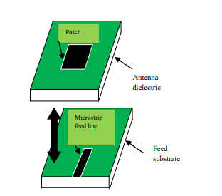

Figure 6: Proximity coupled micro-strip patch antenna

This feeding method has main disadvantage is that, it is difficult to build due to two dielectrics layers that require worse alignment. Total thickness of an antenna has also increased.

There are different designs of micro-strip antennas in the market. But overall, the antenna consists of only four fundamental components [19]. These are:

* 1. A Feed Line
  2. The patch
  3. Ground Plane
  4. A Dielectric Substrate

1. STEPS TO DESIGN IN THE SOFTWARE



1. APPLICATIONS

Micro-strip Antennas are well-known for their efficiency dependability, extensive applicability, and the strong design. The performance of antennas is well understood. The advantages of such a micro-strip patch antenna overcome its disadvantages, such as its small size and ease of design and light weight, and its applications are in a variety of fields including satellites, medical devices, and military systems such as rockets, planes, missiles and other weapons. The use of micro strip is quickly spreading across all industries and places, And it is presently growing in commercial industry due to the low cost of suction. Additionally anticipated due to the vast range of applications for patch antennas. This might replace the use of traditional antennas for the majority of applications [20]. There are various applications of micro-strip patch antenna. Following is a discussion of a few of these applications **:**

1. Satellite Communication: The micro-strip antenna should have round polarized radiation pattern for satellite communication, the circular polarized radiation can be achieved by using square shape micro-strip antenna or circular shape antenna. A circular polarized micro-strip antenna is used in GPS systems. They are expensive because of the positioning, but their size is small.

B) RFID: The micro-strip patch antennas are used in Radio frequency identification system that operates at the frequency between 30Hz to 5.8GHz. The RFID system has a tag and reader. RFID has applications in the domains of mobile communication and medical devices.

C) Telemedicine Application: The flexible wearable antenna operating at the 2.45GHz ISM band and it is compatible for WBAN in this application. The range antenna’s gain used in telemedicine is around 6.5dB to 6.7dB.

D) Worldwide Microwave Access Interoperability (Wi-Max): The communication range in Wi-Max is up-to 48 KM radius and the speed of data is 70Mbps. The kind of antenna used in Wi-Max enabled communication devices are the Micro-strip antenna designed for multi-band frequencies.

E) Medical Application: Microwave energy is believed that it is the most efficient method of inducing hyperthermia mostly in treatment of cancer. The exact radiators that will be utilized for this role must be light, manageable, and sturdy in design. The earliest prototypes of the micro-strip radiators used to induce hyperthermia were built on printed dipoles and round ring with S-band patterns. Later, the idea was based on an L-band micro-strip patch disc**.**

1. Rectenna Application: A rectifying antenna is an antenna used to convert microwave radiation directly into direct current. To address the needs of long-distance communications, Rectenna applications require the design of antennas with extremely high directional qualities. [21]
2. ADVANTAGE & DISADVANTAGE

There are many benefits of this system as compared to older ones but on the other side, it also has some drawbacks. So, some benefits and drawbacks are listed below.

1. Advantages:
2. Lower weight
3. Range is low
4. Profile is thin.
5. This requires no backing of cavity.
6. Circular and linear polarization.
7. Dual and the Triple frequency operation capability.
8. Disadvantages:
9. Lower capability
10. Lower gain
11. Lower capacity to hold power
12. It is not easy to acquire polarization purity
13. FUTURE WORK

For wearable applications, the micro-strip antennas are the better candidate, as textile substrate materials can be used to build it. The antenna may bend during some tasks involving the role of the human. If this happens, the parameters of the system might vary and once those parameters get changes, then radiation parameters of an antenna can fluctuate. The degree of shortness determines the bending. There are numerous categories of diminishing techniques for an antenna that are made up of copper. There is minimum twisting which results in the form of constant output from an antenna. It is also major threat from this type of antenna. For any antenna design, the rate of absorption is to be measured. In kind of devices are installed in the concurrence of the body, this parameter has a relevance to any wearable antenna. The depreciation of this property is an objective to be conquered. Due to this, the evaluation of the properties of SAR of this type of system projected in research can be considered in our vision. For ground and patch self-adhesive, in this research for conducting and radiating part, tape made up of copper is utilized. Materials are made up of electro textile is being taken as account. By using these variations of material, textile or wearable thing can be made. There are numerous kinds of textile materials present. Antenna in ready to wear category can be pointed as “fully textile antenna”. Once they are washable. It can be done if E- textile material is taken as the ground and a radiating element and the same material is considered for substrate. It can be done in future work.

REFERENCES

1. T. F. Kennedy, P. W. Fink, A. W. Chu, N. J. Champagne, G. Y. Lin, and M. A. Khayat, “Body-worn E-textile antennas: The good, the low mass, the con-formal,” IEEE Trans. Antennas Propag., vol. 57, no. 4, pp. 910–918, Apr. 2009.
2. P. S. Hall and Y. Hao, Antennas and Propagation for Body Centric Wireless Communications. London, U.K.: Artech House, 2012.
3. P. Salonen and Y. Rahmat-Samii, “Textile antennas: Effects of antenna bending on input matching and impedance bandwidth,” IEEE Aerosp. Electron. Syst. Mag., vol. 22, no. 12, pp. 18–22, Dec. 2007.
4. P. Vincenzini and C. Carfagna, “Washable screen printed textile antennas,” Adv. Sci. Technol., vol. 80, pp. 118–122, 2012.
5. J. Lilja, P. Salonen, T. Kaija, and P. de Maagt, “Design and manufacturing of robust textile antennas for harsh environments,” IEEE Trans. Antennas Propag., vol. 60, no. 9, pp. 4130–4140, Sep. 2012.
6. P. Salonen, M. Keskilammi, and Y. Rahmat-Samii, “Textile antennas: Effect of antenna bending on radiation pattern and efficiency,” in Proc. IEEE AP-S Int. Symp., 2008, no. 2, pp. 1–4.
7. Q. Bai and R. Langley, “Textile antenna bending and crumpling,” in Proc. 4th EuCAP, 2010, pp. 1–4.
8. J. C. G. Matthews and G. Pettitt, “Development of flexible, wearable antennas,” in Proc. EuCAP, 2009, pp. 273–277
9. Ramesh Garg, Prakash Bartia, Inder Bahl, Apisak Ittipiboon, ‘’Microstrip Antenna Design Handbook’’, 2001, pp 1‐68, 253‐316 Artech House Inc. Norwood, MA.
10. A. Alù, F. Bilotti, N. Engheta, and L. Vegni, “Subwavelength, compact, resonant patch antennas loaded with metamaterials,” *IEEE Transactions on Antennas and Propagation*, vol. 55, no. 1, pp. 13–25, 2007.
11. P. Y. Chen and A. Alu, “Dual-mode miniaturized elliptical patch antenna with *μ*-negative metamaterials,” *IEEE Antennas and Wireless Propagation Letters*, vol. 9, pp. 351–354, 2010.
12. F. Bilotti, A. Alu, and L. Vegni, “Design of miniaturized metamaterial patch antennas with *μ*-negative loading,” *IEEE Transactions on Antennas and Propagation*, vol. 56, no. 6, pp. 1640–1647, 2008.
13. J. G. Joshi, S. S. Pattnaik, S. Devi, and M. R. Lohokare, “Electrically small patch antenna loaded with metamaterial,” *IETE Journal of Research*, vol. 56, no. 6, pp. 373–379, 2010.
14. J. Montero-de-Paz, E. Ugarte-Muñoz, F. J. Herraiz-Martínez, V. Gonzáalez-Posadas, L. E. García-Muñoz, and D. Segovia-Vargas, “Multifrequency self-diplexed single patch antennas loaded with split ring resonators,” *Progress in Electromagnetics Research*, vol. 113, pp. 47–66, 2011.
15. J. G. Joshi, S. S. Pattnaik, S. Devi, and M. R. Lohokare, “Frequency switching of electrically small patch antenna using metamaterial loading,” *Indian Journal of Radio and Space Physics*, vol. 40, no. 3, pp. 159–165, 2011.
16. James j., and P.S. Hall (Eds), Handbook of microstrip antenna, Peter Peregrinus, London, UK, 1989.
17. R. Garg, P. Bhartia, I. Bahl, and A. Ittipiboon, *Micro-strip Antenna Design Handbook*, Artech House, Norwood, Mass, USA, 1980.
18. Ramesh Garg, Prakash Bartia, Inder Bahl, Apisak Ittipiboon, ‘’Microstrip Antenna Design Handbook’’, 2001, pp 1‐68, 253‐316 Artech House Inc. Norwood, MA.
19. Y T Lo and S W Lee, editors, ‘’Antenna Handbook Theory, Applications & Design’’, Van Nostrand Rein Company, NY, 1988.
20. I. J. Bahl and P. Bhartia, *Micro-strip Antennas*, Artech House, Dedham, Mass, USA, 1980.

1. S.A. Patil and P.C. Dhanawade, “Microstrip Antenna and its Applications” published on 12 Jan 2017 and was recently updated on 15 May 2019.