**A STUDY ON CUSTOMER PREFERENCE TOWARDS GOOGLE PAY WITH REFERENCE TO NAMAKKAL**

**SHEELA A1, HARSHAPRIYA R2**

1Assistant Professor, Department of MBA, Paavai Engineering College, Namakkal, Tamilnadu, India

2PG Student, Department of MBA, Paavai Engineering College, Namakkal, Tamilnadu, India

**ABSTRACT**

In today world, smart phone has become an important an area of one’s lifestyle. Mobile users can nowadays use their Smartphones to form money transactions or payments by using applications installed within the phone. There are several mobile wallets which give these services. Mobile wallets are digital versions of traditional wallets that somebody would carry in their pocket. They supply payment services through which the individuals/business can receive/send money via mobile devices. This paper throws strike the customer preference towards the e-wallet services provided by Google pay. It focuses on the services provided by Google pay wallet and its satisfaction level.

**Keywords:** online payment, Mobile Transaction

**1.INTRODUCTION**

Consumer preference is defined as a set of assumptions that focus on consumer choices that result in different alternatives such as happiness, satisfaction, or utility. The entire consumer preference process results in an optimal choice. Consumer preferences allow a consumer to rank different bundles of goods according to levels of utility, or the total satisfaction of consuming a good or service. It is important to understand that consumer preferences are not dependent upon consumer income or prices. So a consumer's capacity to buy goods does not reflect a consumer's likes or dislikes. Customer preference is what type of product an individual customer likes and dislikes. The sweetener blend added to the company's most famous brand is formulated for each country based on customer preference. As part of the ‗Digital India‘ campaign, the government aims to construct a ‗digitally empowered‘ economy that is ‗Faceless, Paperless and Cashless‘. There are different types and modes of digital payments. Some of these include the use of debit/credit cards, internet banking, mobile wallets, digital payment apps, Unified Payments Interface (UPI) service, Unstructured. The mobile wallet, which is called M- wallet, digital wallet, or E wallet, refers to a mobile technology that is used identical to a real wallet. It admits customers to purchase their products online with greater ease. Google Pay is a digital wallet platform and online payment system developed by Google. Google pay makes it easy to keep track of purchases, redeem loyalty points and get personalized suggestions to help the customers to save time and money An payment system facilitates the acceptance of electronic payment for online transactions

**2.METHODOLOGY**

According to industrial research institute in research methodology, research always tries to search the given question systematically in our own way and find out all the answers till conclusion. For finding or exploring research questions, a researcher faces lot of problems that can be effectively resolved with using correct research methodology.

**2.1 Sample size**

The sample size in the study is 80.

**Statistical tools**

* percentage Analysis
* Chi-square test

##### **PERCENTAGE ANALYSIS**

This method is used to compare two or more series of data, to describe the relationship or the distribution of two or more series of data. Percentage analysis test is done to find out the percentage of the response of the response of the respondent. In this tool various percentage are identified in the analysis and they are presented by the way of Bar Diagrams in order to have better understanding of the analysis.

Number of respondents

Percentage of respondents = …………………………………………………………. X 100

Total respondents

**CHI-SQUARE TEST**

It is one of the simplest and widely used non-parametric test in statistical work. The quantity chi-square describes the magnitude of the discrepancy between theory and observation. Which is defined as?

Chi – Square = $\frac{∑\left(oi-Ei\right)2}{Ei}$

Oi = Observed frequency, Ei = Expected frequency

In general, the expected frequency for any can be calculated from the following equations

E = $\frac{RT X CT}{N}$

E = Expected frequency, CT = Column total,

RT = Row total, N = Total number of observations

**3.DATA ANALYSIS AND INTERPRETATION**

**1) AGE OF THE RESPONDENTS**

**TABLE NO - 3.1**

|  |  |  |
| --- | --- | --- |
| **AGE** | **RESPONDENTS** | **PERCENTAGE** |
| Upto 20 years | 10 | 13% |
| 21-30 years | 26 | 32% |
| 31-40 years | 34 | 43% |
| Above 40 years | 10 | 12% |
| **Total** | **80** | **100%** |

**Source: Primary data**

**INTERPRETATION**

The above table shows that, 43% of the respondents are age group between 31-40 years, 32% of the respondents are age group between 21-30 years, 13% of the respondents are age group upto 20 years and remaining 12% of the respondents are age group of Above 40 years.

It is Majority 43% of the respondents are age group between 31-40 years.

**CHART NO - 3.1**

**AGE OF THE RESPONDENTS**

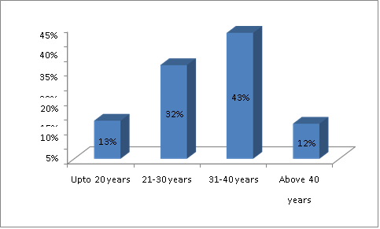

**2) QUALIFICATION OF THE RESPONDENTS**

**TABLE NO - 3.2**

|  |  |  |
| --- | --- | --- |
| **QUALIFICATION** | **RESPONDENTS** | **PERCENTAGE** |
| School level | 14 | 17% |
| Graduate | 23 | 29% |
| Post graduate | 27 | 34% |
| Others | 16 | 20% |
| **Total** | **80** | **100%** |

Source: Primary data

**INTERPRETATION**

The above table 4.4 shows that, 34% of the respondents are Qualified in Post graduate, 29% of the respondents are graduate, 20% of the respondents are other qualification and remaining 17% of the respondents are School level

The Maximum 34% of the respondents are Qualified in Post graduate

**CHART NO – 3.2**

**QUALIFICATION OF THE RESPONDENTS** 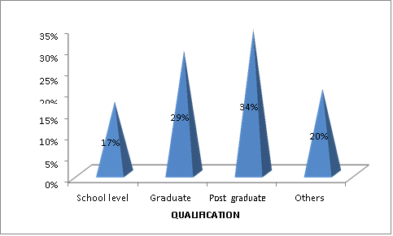

**3) OCCUPATION OF RESPONTS**

**TABLE NO – 3.3**

|  |  |  |
| --- | --- | --- |
| **OCCUPATION** | **RESPONDENTS** | **PERCENTAGE** |
| Self employed | 23 | 29% |
| Business | 26 | 32% |
| Industry purpose | 20 | 25% |
| Engineers and others | 11 | 14% |
| **Total** | **80** | **100%** |

Source: Primary data

**INTERPRETATION**

The above table 4.5 shows that, 32% of the respondents are doing business, 29% of the respondents are self Employed, 25% of the respondents are industry purpose and remaining 14% of the respondents are Engineers and others

It is Maximum 32% of the respondents are doing business.

**CHART NO - 3.3**

**OCCUPATION OF RESPONTS**

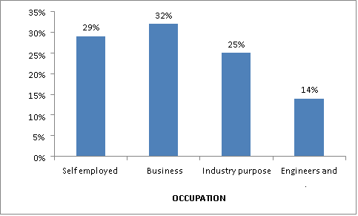

**4) ONLINE TRANSACTION FOR GOOGLE PAY**

**TABLE NO – 3.4**

|  |  |  |
| --- | --- | --- |
| **ONLINE TRANSACTION** | **RESPONDENTS** | **PERCENTAGE** |
| Very easy | 24 | 30% |
| Easy | 27 | 34% |
| Moderate | 16 | 20% |
| Difficult | 13 | 16% |
| **Total** | **80** | **100%** |

Source: Primary data

**INTERPRETATION**

The above table 4.8 shows that, 34% of the respondents Google pay online transaction is Easy, 30% of the respondents are Very easy, 20% of the respondents are Moderate and remaining 16% of the respondents are difficult.

The Maximum 34% of the respondents Google pay online transaction is Easy

**CHART NO - 3.4**

**ONLINE TRANSACTION FOR GOOGLE PAY**

40%

35%

34%

30%

30%

25%

20%

20%

16%

15%

10%

5%

0%

Very easy

Easy

Moderate

Difficult

**ONLINE TRANSACTION**

**PERCENTAGE**

**5) PURPOSE OF USING ONLINE GOOGLE PAY**

**TABLE NO - 3.5**

|  |  |  |
| --- | --- | --- |
| **PURPOSE** | **RESPONDENTS** | **PERCENTAGE** |
| Money transfer | 34 | 42% |
| Recharge | 10 | 12% |
| Utility and bill payment | 10 | 13% |
| Online purchase | 26 | 33% |
| **Total** | **80** | **100%** |

Source: Primary data

**INTERPRETATION**

The above table 4.10 shows that, 42% of the respondents are purpose of google pay Money transfer, 33% of the respondents are Online purchase, 13% of the respondents are Utility and bill payment and remaining 12% of the respondents are Recharge purpose.

The Maximum 42% of the respondents are purpose of google pay Money transfer.

.

**CHART NO - 3.5**

**PURPOSE OF USING ONLINE GOOGLE PAY**

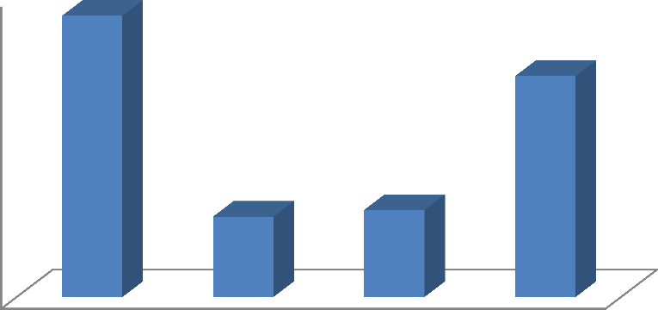

45%

40%

35%

30%

25%

20%

15%

10%

5%

0%

42%

33%

12%

13%

Money Recharge Utility and bill Online

transfer payment purchase

**PURPOSE**

**PERCENTAGE**

**6) RELATIONSHIP BETWEEN AGE OF THE RESPONENTS AND ONLINE TRANSACTION FOR GOOGLE PAY**

The table shows the analysis of relationship between age of the respondents and online transaction for Google pay.

**TABLE NO - 3.6**

**RELATIONSHIP BETWEEN AGE OF THE RESPONENTS AND ONLINE TRANSACTION FOR GOOGLE PAY**

|  |  |  |  |  |  |
| --- | --- | --- | --- | --- | --- |
| **Age / Satisfied with the**  **service cost** | **Very easy** | **Easy** | **Moderate** | **Difficult** | **Total** |
| **Upto 20 years** | 3 | 3 | 2 | 2 | **10** |
| **21-30 years** | 8 | 9 | 5 | 4 | **26** |
| **31-40 years** | 10 | 12 | 7 | 5 | **34** |
| **Above 40 years** | 3 | 3 | 2 | 2 | **10** |
| **TOTAL** | **24** | **27** | **16** | **13** | **80** |

Source: Primary Data

**NULL HYPOTHESIS**

H0: There is no significance relationship between age of the respondents and online transaction for Google pay

**ALTERNATIVE HYPOTHESIS**

H1: There is a significance relationship between age of the respondents and online transaction for Google pay

**TABLE NO - 3.7**

**CHI SQUARE TEST**

|  |  |  |  |  |
| --- | --- | --- | --- | --- |
| **Particulars** | **Observed**  **Frequency** | **Expected**  **Frequency** | **(O-E)2** | **(O-E)2**  **E** |
| R1 C1 | 3 | 3 | 0 | 0 |
| R1 C2 | 3 | 3.3 | 0.09 | 0.027 |
| R1 C3 | 2 | 2 | 0 | 0 |
| R1 C4 | 2 | 1.6 | 0.16 | 0.1 |
| R2 C1 | 8 | 7.5 | 0.25 | 0.033 |
| R2 C2 | 9 | 8.7 | 0.09 | 0.010 |
| R2 C3 | 5 | 5.0 | 0 | 0 |
| R2 C4 | 4 | 4.0 | 0 | 0 |
| R3 C1 | 10 | 10.0 | 0 | 0 |
| R3 C2 | 11 | 11.4 | 0.16 | 0.014 |
| R3 C3 | 7 | 6.5 | 0.25 | 0.038 |
| R3 C4 | 5 | 5.5 | 0.25 | 0.045 |
| R4 C1 | 3 | 3 | 0 | 0 |
| R4 C2 | 3 | 3.3 | 0.09 | 0.027 |
| R4 C3 | 2 | 2 | 0 | 0 |
| R4 C4 | 2 | 1.6 | 0.16 | 0.1 |
| **Calculated value** | | | | **0.394** |

Degree of freedom : (r – 1) (c – 1) = (4 – 1) (4– 1) = 9

Level of significance : 5%

Table value : 5.578

Calculated value : 0.394

**RESULT**

Since the calculated value is less than the table value. So we accept the null hypothesis. There is no relationship between age of the respondents and online transaction for Google pay

**4.RESULTS AND DISCUSSION**

**4.1FINDING**.

* + 1. Majority 43% of the respondents are age group between 31-40 years.
    2. Maximum 34% of the respondents are Qualified in Post graduate.
    3. Maximum 32% of the respondents are doing business.
    4. Maximum 34% of the respondents Google pay online transaction is Easy.
    5. Maximum 42% of the respondents are purpose of google pay Money transfer.

**4.2 SUGGESTIONS**

Google pay users should have the notice to use the appliance securely. Google pay users must take care as and once they use the application.The users should weigh the varied payment wallet apps with all and that they should select the proper app for his or her usage.The app must be redesign to supported the feedback getting from the users. It mustensure to use user friendly by everyone .Google pay users should never share their personal information like PIN numbers, passwords, QR code, UPI ID etc, with anyone,PIN or password should not be stored, the PIN or passwords should be changed frequently and memorized before destroying.Google pay users are advised not to provide sensitive account-related information over unsecured e-mails or over the phone.The risk of technological changes has to be carefully analysed. This is important to update technologies and remain cost effective and customer friendly.The risk of network traffic leads to loss of customers so strength of network connection to be improve

**4.3 CONCLUSION**

The study was accomplished to explore customer preference towards google pay. With the increased aggression of internet connectivity Google pay has led to a rise on the amount of Google pay users. Google pay is getting more and more trending among the buyer. The convenience and simple use as gained a credit to mobile wallet and it are often concluded that they're going to be an incredible growth in adoption of G-pay within the forthcoming years. Customers are increasingly given the opinion or are being asked to provide Services for themselves through the use of Self-Service Technologies. It‘s Important for providers to know the notice level of consumers particularly the adults since they're the audience for each new technology. This study has made an effort to seek out the customer satisfaction level towards Google pay in Namakkal.

**5. REFERENCES**

1. **Dr.T.Santhiya Ran, A.Saravanan(2018)** " A Study On Customer Satisfaction Towards Net Banking With Special Reference To General Banking Customer In Coimbatore City" Journal of Emerging Technologies and Innovative Research (JETIR) [www.jetir.org](http://www.jetir.org/) . November 2018, Volume 5,Issue11
2. **S.Vigneshwari, S.Rajagopalan (2018) -** "Customer Satisfaction Towards Online Banking Services "a International Journal of Pure and Applied Mathematics Volume 119 No. 18I.
3. **Ms. M.Esther Krupa. (2016)** -"A Study on Customer Satisfaction Towards E-Banking Services in Coimbatore City " Indian Journal Of Applied Research. Volume : 6 | Issue : 7 .
4. **Amutha D(2016),** ―A Study of Consumer Awareness towards e-Banking‖, International Journal of Economics & Management Sciences, Volume 5 • Issue 4, 2016
5. **Niodhi singh, Shalini Srivastava and Neena sinha(2016),** ―consumer preference and satisfaction M-wallets: a study on North Indian Consumers‖, International Journal of Bank Marketing.

### WEBSITE

https://pay.google.com/