Carbon nanotube: A detailed review as a dynamic aspect for novel drug delivery system in 21st Century
Rukaiya Shirohiwala¹*, Dr. Chainesh Shah ², Dr. Umesh Upadhyay ³
^{1,2} Department of Pharmacy, Sigma Institute of Pharmacy, Vadodara-390019, India.
³ Principal, Sigma Institute of Pharmacy, Vadodara-390019, India.
Abstract
Carbon nanotubes (CNTs) were discovered in 1991 and shown to have certain unique physicochemical properties, attracting considerable interest in their application in various fields including drug delivery. The unique properties of CNTs such as ease of cellular uptake, high drug loading, thermal ablation, among others, render them useful for cancer therapy. Carbon nanotubes elongated fullerenes, resemble graphite sheets wrapped into cylinders Length to width ratio is very high (few nm in diameter and up to 1 mm in length). Carbon nanotubes are molecular-scale tubes of graphitic carbon with outstanding properties. Carbon nanotubes have drawn great interest and attraction in the field of novel drug delivery system. Nanomedicines can target, diagnose, monitor and treat cancerous cell also. The small nanoscale dimension and astonishing properties make them a distinctive carrier with a wide range of promising applications. These cylindrical carbon molecules have novel properties that make them potentially useful in many applications in nanotechnology. The various nano-size carrier systems are available for biotechnological applications including the drug delivery. Carbon nanotubes are typically used for bioactive delivery due to some unique outstanding properties. Carbon nanotubes drug delivery system opens up new potential and possibilities over nanoparticles, dendrimers, liposomes etc. for biomedical applications and new drug delivery. Considerable work has been done on CNTs as drug delivery systems over the last two decades. However, concerns over certain issues such as biocompatibility and toxicity have been raised and warrant extensive research in this field.
Keyword: Carbon nanotube (CNT), Single-walled nanotubes (SWNT), Multi-walled nanotubes (MWNT), Properties, Functionalization, Purification, Cancer therapy
- Introduction
Pharmaceutical nanotechnology focuses on the top of formulating therapeutically energetic agents in biocompatible nanoforms such as nanoparticles, nanocapsules and conjugates. These systems suggest numerous advantages in drug delivery mainly focusing on better safety and efficiency of drugs i.e., targeted delivery of drugs, improve bioavailability, extending drug or gene effect of drugs, tissue and improving the stability of therapeutic agents in opposition to chemical/enzymatic degradation ^{[1-3]} In the current scenario, nanotechnology is rapidly expanding scientific zone that has achieved a breakthrough in molecular biology, diagnostics, imaging, bioengineering and nanomedicines etc. Carbon nanotubes (CNTs) have established much recent interest as new entities for experimental disease diagnosis and treatment because of their unique electronic, mechanical, thermal, spectroscopic, metallic, semiconducting and superconducting electron transport properties structurally they acquire a hollow core made up of graphite sheets which are rolled into tubes and are closed at their ends by semi-fullerene like structure ^{[3-4]} making them appropriate for storing guest molecules as well as their ability to traverse cellular membranes and contain elastic or young’s modulus of any recognized materials ^{[4, 5]} thus seeing much attention as a potent carrier. The biocompatibility nature, non-immunogenicity, ease of size alteration, greater stability and high drug loading potential makes CNTs a famous tool over the other nanocarriers ^{[12]}. Internal and external surfaces of CNTs can be modified on an individual basis as required and a variety of functional groups can be generated on their surface in support of further conjugation with targeting ligands as well as drug molecules. ^{[13]} The unique and unusual properties of these structures make them a unique material with a whole range of promising applications.
- What is Carbon Nanotube (CNT)?
CNTs is a fullerene molecule, described in 1991 by the Japanese Scientist Sumio Iijima as tube-shaped of graphitic carbon, can be obtained either single or multi-walled nanotube, having a diameter measuring on the nanometre scale, and generally known as buckytubes. Carbon nanotubes (CNTs) have established much recent interest as new entities for experimental disease diagnosis and treatment because of their unique electronic, mechanical, thermal, spectroscopic, metallic, semiconducting and superconducting electron transport properties. Carbon nanotubes can be acquired in numerous ways, the general techniques are Arc discharge, Laser ablation, and Chemical vapour deposition (CVD). Purification of nanotubes includes many techniques: Acid treatment, oxidation, annealing, ultrasonication, cutting, magnetic purification, chromatography techniques. Further functionalization enhanced the water solubility of CNT's and completely transformed their biocompatibility profile. Carbon nanotubes, due to their large surface areas, unique surface properties, and needle-like shape, can deliver a lot of therapeutic agents, including DNA, siRNAs and proteins to the target disease sites. CNTs can be readily excreted through the renal route by means of degradation through myeloperoxidase (MOP) enzyme. ^{[1-13]}
  - Advantage of CNTs
The advantages of CNTs are; ^{[14-18]}
- High electrical along with warm conductivity
- Very high elasticity
- Highly adaptable and flexible (~18% lengthening before disappointment)
- High perspective proportions
- Good field emanation

  - Disadvantage of CNTs
The disadvantages of CNTs are; ^{[14-18]}
- More current innovation so not as much testing has been completed
- Lower lifetime (1750 hours contrasted with 6000 hours for silicon tips) Higher possibilities required for field outflow as the cylinders are not all that very much restricted so the extractor cathode must be further away.

  - History behind Carbon Nanotube (CNT) discovery
In the year 1952, Scientist Lukyanovich and Scientist Radushkevich bring out a research report in the “soviet scholarly diary of physical science”, where they introduce carbon strands that have empty graphitic nature and having a size of around 50 nm. In the year 1979, at Pennsylvania state college, Scientist john Abrahamson offered confirmation of carbon CNT at the fourteenth biennial course of carbon. In the year 1981, a group of Soviet researchers offers the result of the synthetic and auxiliary maneuver of carbon nano extend molecule framed by a thermal catalytically lopsided of carbon monoxide (CO). And finally in the year 1991 after all the investigation work Japanese researcher and specialist Sumio Iijima has found carbon nanotube by circular segment release strategy at Nippon electric organization (NEC). ^{[14-15]}
- Structure of CNTs
Carbon nanotubes are allotropes composed entirely of carbon in the form of a hallow sphere, ellipsoid, or tube, consisting of carbon atoms bonded to each other via sp2 bonds (C‐C distance of 1.4 Å) which are stronger than sp and sp3 bonds rendering CNT’s exceptional mechanical strength and high electrical and thermal conductivity. CNTs belong to the fullerene family of carbon allotropes particularly those which have high aspect ratio. These are hollow cylinders consisting of a hexagonal arrangement of sp2‐hybridized carbon atoms and formed by rolling single or multiple layers of graphene sheets into seamless cylinders. These cylindrical structures have two forms namely single‐walled carbon nanotubes (SWNTs) and multi-walled carbon nanotubes (MWNTs). SWNTs are composed of a single cylindrical graphene layer capped at both ends in a hemispherical arrangement of carbon networks. The inclusion of pentagonal and heptagonal C‐C structures during the growth process enables the closure of cylinder. MWNTs comprise several to tens of concentric cylinders of graphitic shells, each one forming a SWNT. ^{[19-23]}
- Classification of Carbon Nanotubes (CNTs)
Carbon nanotubes are classified as: ^{[19,24]}
- Single-walled nanotubes (SWNT)
- Multi-walled nanotubes (MWNT)
- Double-walled carbon nanotubes
- Nanotorus
- Fullerene
- Nanobud
- Nanohorns
- Functionalized nanotubes
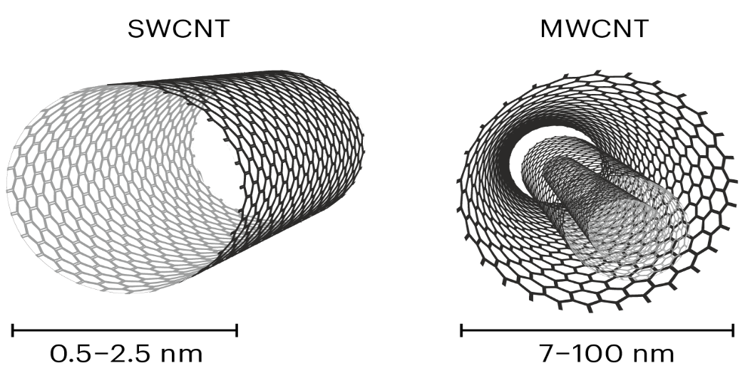 | 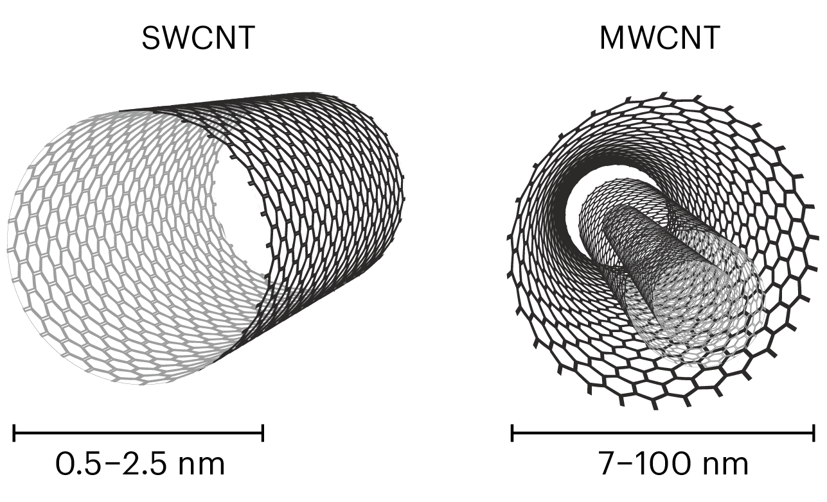
- Single-walled nanotubes (SWNT) | - Multi-walled nanotubes (MWNT)
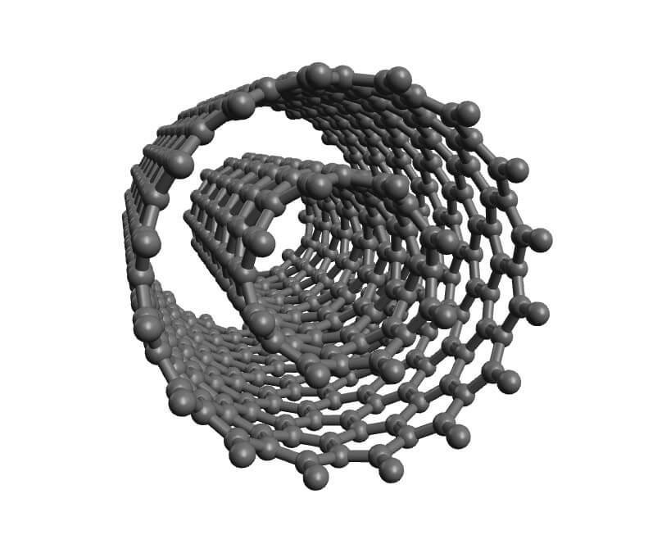 | 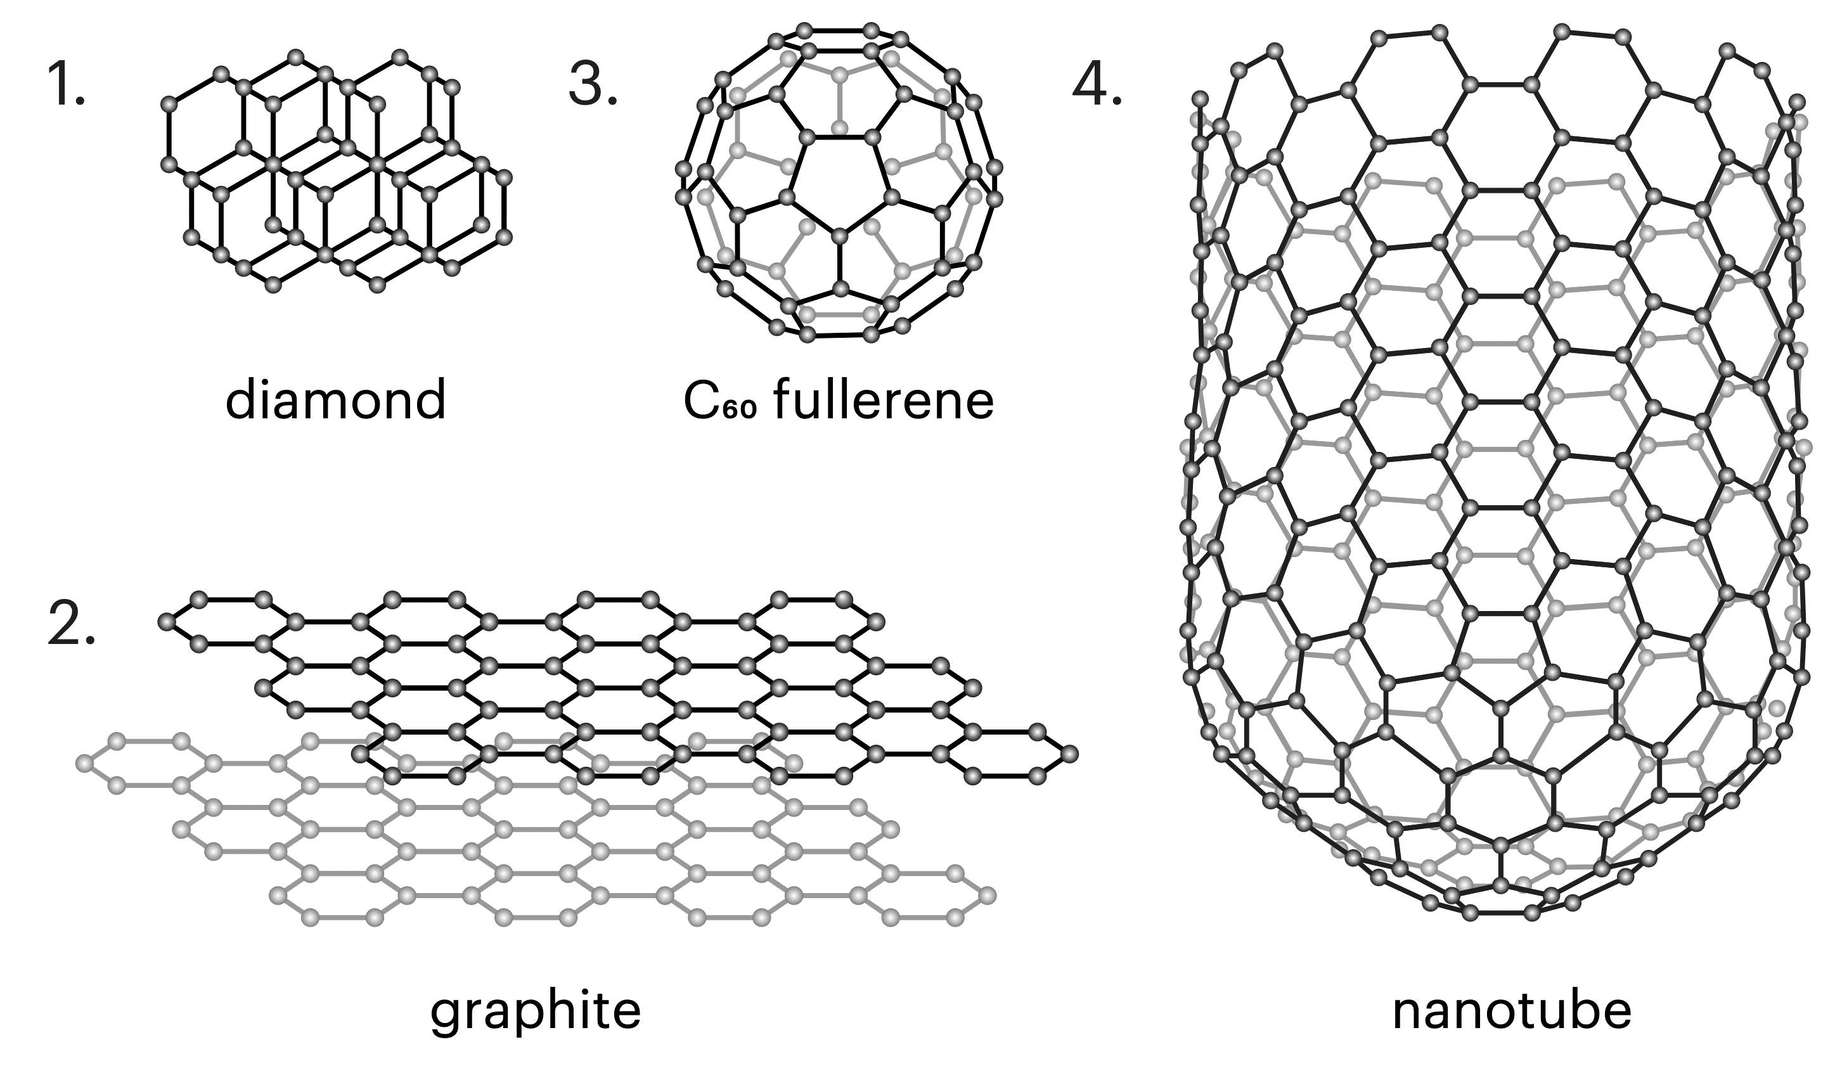
- Double-walled carbon nanotubes | - Fullerene
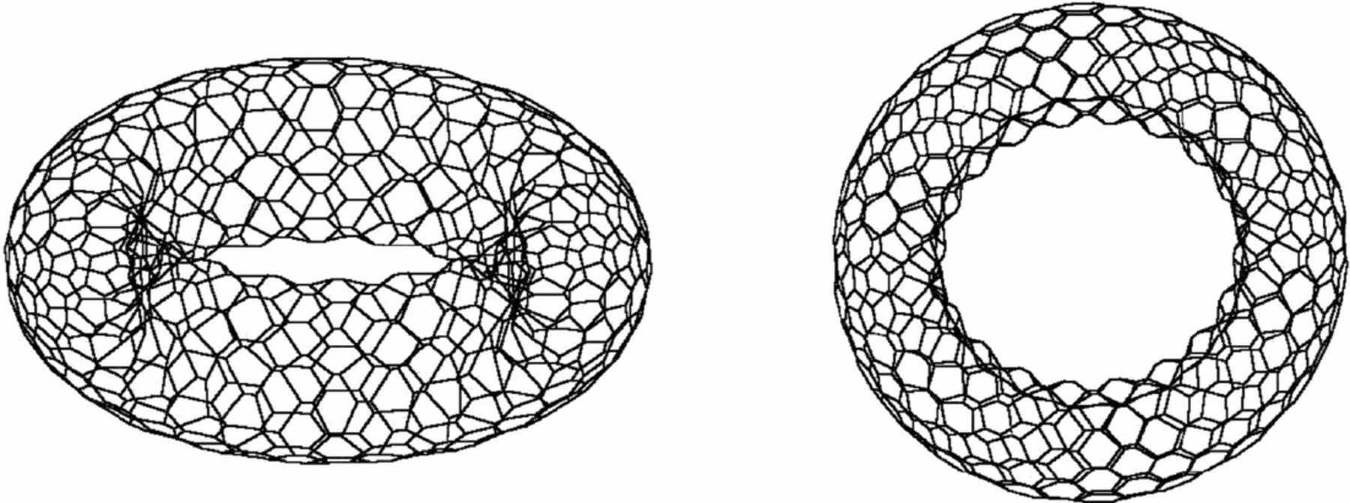
- Functionalized nanotubes

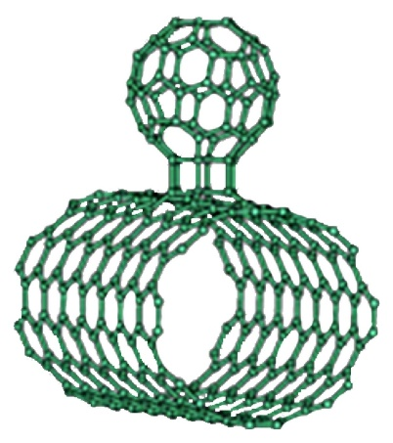 |  | 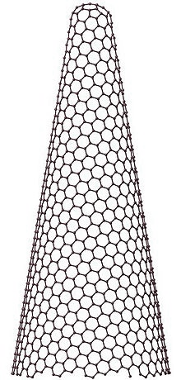
- Nanobud |  | - Nanohorns

Fig-1: Classification of carbon nanotubes.

- Properties of Carbon Nanotubes (CNTs)
Carbon nanotube consist of various properties given as follow: ^{[25-26]}
- Carbon nanotubes can be metallic or semiconducting depending on their structure. This is due to the symmetry and unique electronic structure of graphene. For a given (n, m) nanotube, if n = m, the nanotube is metallic; if n = m is a multiple of 3, then the nanotube is semiconducting with a very small band gap, otherwise the nanotube is a moderate semiconductor. Thus all armchair (n = m) nanotubes are metallic, and nanotubes (5, 0), (6, 4), (9, 1), etc. are semiconducting. Thus, some nanotubes have conductivities higher than that of copper, while others behave more like silicon.
- Due to their nanoscale dimensions, electron transport in carbon nanotubes will take place through quantum effects and will only propagate along the axis of the tube. These electrical and structural properties best serve CNTs as far as bio-sensing is concerned because current changes in the CNTs can signify specific biological entities they are designed to detect. The fact that CNTs are small (nm scale) allows them to deliver smaller doses of drugs to specific disease cells in the body thus reducing side effects and harm to healthy cells unlike conventional drugs, whilst improving disease cell targeting efficiency.
- CNTs have been observed to have enhanced solubility when functionalized with lipids which would make their movement through the human body easier and would also reduce the risk of blockage of vital body organ pathways.
- As far as optical properties are concerned CNTs have been shown to exhibit strong optical absorbance in certain spectral windows such as NIR (near-infrared) light and when functionalized with tumor cell specific binding entities have allowed the selective destruction of disease (e.g. cancer) cells with NIR in drug delivery applications.
- Another property of nanotubes is that they can easily penetrate membranes such as cell walls. In fact, nanotubes long, narrow shape make them look like miniature needles, so it makes sense that they can function like a needle at the cellular level. Medical researchers are using this property by attaching molecules that are attracted to cancer cells to nanotubes to deliver drugs directly to diseased cells.
- In the medical field, three main attributes of CNTs have been exploited: ·
- Their small size.
- Their high surface area to volume ratio.
- Their ability to contain chemicals.
- Carbon nanotubes can be produced small enough to pass through holes in tumours or to transport DNA. The large surface to volume ratio provides a good platform for efficient transportation of chemicals and for the reactions needed for ultra-sensitive glucose detection.

- Synthesis of CNTs
CNT is generally synthesize by three main techniques:
- Arc-discharge: Two electrodes of carbon in presence or absence of catalyst are taken, and an arc is discharged between them. Resulting vapours of carbon get self-assembled and give rise to nanotubes. ^{[1, 10, 30-31]}
- Synthesis of SWNTs: If SWNTs are preferable, the anode has to be doped with metal catalyst, such as Fe, Co, Ni, Y or Mo. A lot of elements and mixtures of elements have been tested by various authors and it is noted that the results vary a lot, even though they use the same elements. This is not surprising as experimental conditions differ. The quantity and quality of the nanotubes obtained depend on various parameters such as the metal concentration, inert gas pressure, kind of gas, the current and system geometry. ^{[19, 27]} Usually the diameter is in the range of 1.2 to 1.4 nm. A couple of ways to improve the process of arc discharge are:
(a) Inert gas
(b) Optical plasma control
(c) Catalyst
(d) Improvement of oxidation resistance
(e) Open air synthesis with welding arc torch
- Synthesis of MWNTs: If both electrodes are graphite, the main product will be MWNTs. But next to MWNTs a lot of side products are formed such as fullerenes, amorphous carbon, and some graphite sheets. Purifying the MWNTs means loss of structure and disorders the walls. However, scientists are developing ways to gain pure MWNTs in a large-scale process without purification. Typical sizes for MWNTs are an inner diameter of 1-3 nm and an outer diameter of approximately 10 nm. Because no catalyst is involved in this process, there is no need for a heavy acidic purification step. This means, the MWNT, can be synthesised with a low amount of defects. ^{[1,20]}
(a) Synthesis in liquid nitrogen
(b) Magnetic field synthesis
(c) Plasma rotating arc discharge
- Laser ablation: Collision occurs between the high-power laser pulse and volume of carbon, which contains the methane or carbon monoxide as a feedstock gas and produce nanotubes in small quantity. ^{[1, 29, 32-34]}
- Chemical Vapor deposition (CVD): Produce MWNT’s or SWNT’s of poor quality and range of large diameter. CVD process is scaled up easily and favours the viable manufacture. ^{[1,30]}

- Purification of CNTs
Purification is the primary step and is always needed before any further use of CNTs. Prepared CNTs contain an assortment of impurities that are essential to be removed prior to their utilisation in drug, gene or vaccine delivery.^{[1, 35-36]} There are numerous approaches that may be utilised for purifying the prepared CNTs that involve filtration, microfiltration, centrifugation, chromatography, annealing, flocculation, oxidation of contaminant, ferromagnetic separation, functionalisation, ultrasonication, selective interaction with organic polymers, cutting, sedimentation and microwave irradiation. ^{[1, 37-39]} These purification techniques enhance the nanotube solubility, which is easier to separate from the insoluble impurities. CNT products contain substantial amounts of metal impurities and non-nanotube carbon. These are vanished by post-manufacturing treatments, and three fundamental methods have been reported for purification they are: ^{[1, 38-41]}
- Gas phase
- Liquid phase
- Intercalation techniques

  - Method of purification
    - Oxidation
Carbon based impurities and surface metal can be taken away by the oxidative treatment. But this may lead to the oxidation of nanotubes along with the impurities. Still, the method is preferred because the damage caused to the nanotubes is comparatively less than that of the impurities and the metal catalyst also serves as the oxidising agent. Metal content, time of oxidation, an oxidising agent and environmental factor including temperature are the common process variable which affects the yield of the process. For example, when the temperature is raised to 600 °C, SWNTs will oxidise, even without a catalyst, this happens in the case with thermal, pure oxygen oxidations and fixed air. These can oxidise all the component without many efforts so as to have better control of time and temperature. Several examples for clearing the metal surface as well as to prepare the sample for a metal removal step. Firstly, the mild oxidation with soluble oxidising agents in the wet environment, such as H₂SO₄ and H₂O₂, which oxidise the defects along with clearing the metal surface. Throughout these processes the metal catalyst stays together, the outer layer of the metal will be oxidised when oxygen is used in the wet atmosphere. After that the density of surface increases and deposit of surface covering carbon ruptures. Now not only the carbon impurities are oxidised but the metal is also partially oxidised and exposed. ^{[1, 42-58]}
    - Acid treatment
Acid treatment: It removes the metal catalyst by exposing the metal surface to oxidation or sonication. Then the metal catalyst is exposed to acid and solvated so that the nanotubes remain in the suspended form. When HNO₃ is used for the treatment, it only affects the metal catalyst but not the nanotubes or other particles of carbonaceous nature [45, 48, 49]. With HCL, less effect on single-walled carbon nanotubes and other carbon particles were observed during reflux but unlike HNO₃, metal should be exposed to acid so that lysis of graphitic carbon and short fullerenes. The metal will be melted and can be removed by using vacuum having high-temperature. ^{[1, 46-59]}
    - Annealing
Annealing: High temperature between 873K-1873K will result in the rearrangements of nanotubes with the consumption of defects resulting in the pyrolysis of graphitic carbon and short fullerenes. The metal will be melted and can be removed by using vacuum having high temperature. ^{[1, 47-59]}
    - Ultrasonication
Sonication is well-known as one of the effectual processes to get rid of the amorphous impurities adhering or binding to the walls of CNTs using suitable solvents. During sonication, the solvent molecules are able to interact with CNTs and hence lead to solubilisation, which can improve purification efficiency. In ultrasonication, vibration caused by sonic waves result in separation of particles and dispersion of nanoparticles agglomerates. Separation of the particles depends on the solvent, surfactant and reagent used. Stability of the dispersed tubes is influenced by the solvent, if the solvent is poor and attached to the metal SWCNT’s are more stable, but solvent like alcohol, mono-dispersed particles are comparatively stable. Ultrasonication in ethanol was adopted to remove the graphite particles. The purity of the nanotubes depends on the exposure time. When an acid is used and if the exposure time is less, only metal get solvates but if the time is long, it will result in cutting down of the tubes. ^{[1,49-54]}
    - Cutting
The nanotubes can be shortened or cut by three steps, chemically, mechanically and the combination of both. ^{[1,53,59-63]}
- Chemically-Chemicals are used for cutting of CNTs. After partially functionalizing the CNTs followed by the pyrolisation in the form of CF₄ or COF₂ fluorated carbon will be driven off the sidewall which leaves behind the nanotubes those are chemically cut.
- Mechanically: Due to high friction between the nanoparticles and the nanotubes the bonds will break and disordered and the cutting is caused by ball-milling.
- The combination of both (chemically and mechanically): In an acid solution cutting of the nanotubes is ultrasonically induced, thus the ultrasonic vibration will provide the sufficient energy for the nanotubes to leave the catalyst surface. After that, the nanotubes will rupture at the defect sites in combination with an acid.

    - Magnetic Purification
Magnetic Purification-Removal of ferromagnetic (catalytic) particles occurs mechanically from their graphitic shells. To get rid of these ferromagnetic particles in an ultrasonic bath the SWNTs suspension and inorganic nanoparticles (ZrO₂ or CaCO₃) were mixed together, followed by the trapping of particles by stable magnetic poles. Since SWNT of high purity will be obtained by chemical treatment. Large equipment is not required, and it has been observed that the production of laboratory-sized quantities of SWNTs containing no magnetic impurities. ^{[1, 52-66]}
    - Chromatography
To separate the CNTs in relation to small length and diameters the chromatography is mainly used. The carbon nanotubes with the porous material are run through a column, through which CNTs will pass. The GPC (Gel Permeation Chromatography) and HPLC-SEC (High-Performance Liquid Chromatography-Size Exclusion Chromatography) columns are some examples which are used in the technique of separation. According to the size of molecules, they get separated with the large size of molecules eluting out first. The only requirement is that the nanotubes should be either solvated or dispersed by means like functionalization and ultrasonication. ^{[1, 66-76]}
- Toxicity of CNTs
In cases where CNTs have a toxic interaction by cells, the mechanisms of toxicity are coming into focus. Results suggest CNTs may cause harm to cells by activating many pathways at once, mostly involving DNA damage. In one study, most cells incubated with CNTs halt at the G1 phase of the cell cycle. ^{[1, 77-78]} Another study showed that mesothelial cells exposed to SWCNTs at concentrations ∼25μg/cm² activated DNA recovery along with changes in the cell cycle and generation of apoptotic signals. It was also observed that CNT/DNA interaction was the preferred route of toxicity in a 3-hour incubation study with 96 μg SWCNT/cm², which induced DNA damage (through micronucleus generation) in lung fibroblasts. It should be possible, through the observation of specific toxic events that result from incubations with different types of f-CNTs, to test for functional groups that reduce the severity of such events. ^{[1, 78-79]} The harmful effect of nanoparticles arises because of high surface area and intrinsic toxicity of the surface. CNT, in the context of toxicology, can be classified as ‘nanoparticles’ due to their nanoscale dimensions, therefore unexpected toxicological effects upon contact with biological systems may be induced. The study of the adverse effects of nano-sized particles and fibres and their interaction in the living organism has been termed as “nano-toxicology”. A nanosized particle could have the potential to cause the toxicity. ^{[1, 77-79]}
Certain properties determine the toxicity of nano-sized particles: ^{[1, 79-84]}
- The surface area/mass ratio of the particles; if the particle is having the larger surface area, it provides the greater contact with the cellular membrane, and as well as provides greater capacity for adsorption and transport of toxic substance.
- Retention of particles within a physiological environment; retention time determines the cellular contact and therefore causes the greater chances for damage. Retention time also determines its mobility either through clearance or migration to nearby tissue.
- Inherent toxicity of the contaminants presents in nanomaterials. The basic idea of nanomaterials’ toxicity can be revealed by its lung deposition. The lung deposition of a nanosized material depends upon its surface area/mass ratio. C60 fullerenes do not prove significant toxicity, it shows the speedy distribution in rates and deposition in many tissues like brain, liver and spleen.

- Functionalization (Modification and limitation) of CNTs
Pristine CNT's(non-functionalized) is inherently hydrophobic, and readily aggregate in bundles due to van der Waals forces and, therefore, the main barrier in the utilisation of CNT in biology and medicinal chemistry is their lack of solubility in most solvents compatible with the biological milieu (aqueous based). To defeat this problem, the several ways existing, numerous strategies have been invented with different molecules is achieved by adsorption, electrostatic interaction or covalent bonding of different molecules and chemistries that make carbon nanotubes more hydrophilic and soluble. The limitation in the applications of CNT’s can be defeated, to some extent, by a process named functionalization. ^{[1, 67-69,85]}
Functionalization of CNTs can be achieved in two ways: ^{[1,85]}
1. Non-Covalent Functionalization-Various non-covalent interactions, for example, π stacking, hydrophobic and van der Waals interactions have allowed for the functionalization of CNTs with a wide range of molecules.
2. Covalent Functionalization-May be described as a chemical grafting of molecules onto the sp2 carbon atoms of the π-conjugated skeleton of the CNTs. The basic reaction for CNT functionalization is oxidation, performed under strongly acidic conditions.
There are two main strategies for covalently functionalizing nanotubes:
a) End and defect modification and
b) Sidewall modification
These covalent modifications arise from the difference in reactivity at the nanotube ends and sidewalls (as well as at structurally perturbed areas) and, accordingly, each type of functionalization requires distinct chemical approaches ^{[1,70-75]}
- Filling of nanotube
The Nanotube obtained in processes closes on both the ends. The ends can be opened by suitable chemistry. One of the methods used is acid treatment which oxidizes the ends and leaves behind the oxide containing functionalities. The common functional groups are –COOH and –OH. ^{[15]}
- Drug loading by CNTs and its mechanism in humans
Nanotubes are hydrophobic in nature and do not show wetting behaviour for most aqueous solvents. It is reported that various organic solvents, HNO₃, S, Cs, Rb, Se, and various oxides such as Bi₂O₂ can wet nanotubes. Nanotube provides capillary pressure proportional to (1/D). Therefore, these wetting agents can be driven to fill inside the nanotube by the capillary pressure. It is also likely to fill non-wetting agents inside a nanotube by applying a pressure which is higher than the capillary pressure. An effective alternative is to use wetting agents such as HNO₃ to assist filling of non-wetting agents inside the nanotube CNT's have very large surface area which allows multi-conjugation of various molecules on the sidewalls. Molecules containing aromatic groups can be easily bound to CNTs non-covalently by strong π–π interactions. Thus, CNTs possess unique and excellent structural, optical and electrical properties for the development of advanced drug delivery systems. ^{[1,83-87]}
In general drug delivery system is designed to improve the physiological and therapeutic profile of a drug molecule. The large inner volume of CNTs allows encapsulation of both low as well as high molecules of drugs. It also permits encapsulation of both hydrophilic and lipophilic drugs. More than one drug can also be loaded in CNTs in the case of multi-drug therapy. Ligands and diagnostic materials can also be conjugated to surface of CNTs by fictionalization to target the drugs to specific sit of action. ^{[1,15]} The CNTs can act as controlled release system for drug by releasing the loaded drugs for a long period of time. The purpose of using nanotubes in the human body Carbon nanotubes are very prevalent in today’s world of medical research and are being highly researched in the fields of efficient drug delivery and biosensing methods for disease treatment and health monitoring. CNT technology has shown to have the potential to alter drug delivery and biosensing methods for the better, and thus carbon nanotubes have recently garnered interest in the field of medicine. The use of CNT’s in drug delivery and biosensing technology has the potential to revoutionalize medicine. Fictionalization of SWNT’s has proven to enhance solubility and allow for efficient tumor targeting/drug delivery. It prevents SWNT’s from being cytotoxic and altering the function of immune cells. ^{[1,15,26]}
Cancer, a group of diseases in which cells grow and divide abnormally, is one of the primary diseases being looked at with regards to how it responds to CNT drug delivery. Current cancer therapy primarily involves surgery, radiation therapy, and chemotherapy. These methods of treatment are usually painful and kill normal cells in addition to producing adverse side effects. CNTs as drug delivery vehicles have shown potential in targeting specific cancer cells with a dosage lower than conventional drugs used that is just as effective in killing the cells, however does not harm healthy cells and significantly reduces side effect. Current blood glucose monitoring methods by patients suffering from diabetics are normally invasive and often painful. For example, one method involves a continuous glucose sensor integrated into small needle which must be inserted under the skin to monitor glucose levels every few days. Another method involves glucose monitoring strips to which blood must be applied. These methods are not only invasive but they can also yield inaccurate results. It was shown that 70 percent of glucose readings obtained by continuous glucose sensors differed by 10 percent more and 7 percent differed by over 50 percent. ^{[1,15,26,31]}
The high electrochemically accessible surface area, high electrical conductivity and useful structural properties have demonstrated the potential use of single-walled nanotubes and multi-walled nanotubes in highly sensitive non-invasive glucose detectors. ^{[26,31]}
- Uptake of CNTs by human cell
CNTs have been aimed and actively explored as multipurpose, innovative nano-carriers for drug-delivery systems. Thanks to their very high aspect ratio, CNTs can penetrate the cell membrane and be uptaken by cells. After entering the cell, CNTs are mainly located inside cell endosomes and lysosomes. Individualised CNTs are able to travel through various cellular barriers and even enter the nucleus. The applicable cell-internalization mechanisms for CNTs are: Endocytosis-phagocytosis pathway. Endocytosis represents the engulfing of an extracellular particle by the cell (for example, viruses, ∼ 100 nm in size) through the formation of a vesicle that is then integrated into the cell. ^{[1,88]} Endocytosis is an energy-using process in which cells absorb molecules (proteins) by engulfing them. Endocytosis is mediated by formation of vesicles, so called endosomes, containing cell bound materials that segregate from the plasma membrane and get internalised.

- Breakdown of CNTs in human body
Carbon nanotubes were once considered bio-persistent in that they did not break down in body tissue or in nature. In recent years, research has shown that laboratory animals exposed to carbon nanotubes via inhalation or through injection into the abdominal cavity develop severe inflammation. This and the tissue changes (fibrosis) that exposure causes lead to impaired lung function and perhaps even to cancer. For example, a year or two ago, alarming reports by other scientists suggested that carbon nanotubes are very similar to asbestos fibres, which are themselves bio-persistent and which can cause lung cancer (mesothelioma) in humans a considerable time after exposure. A team of Swedish and American scientists has shown for the first time that carbon nanotubes can be broken down by an enzyme - Myeloperoxidase (MPO) that found in white blood cells. Their discoveries are presented in Nature Nanotechnology and contradict what was previously believed, that carbon nanotubes are not broken down in the body or in nature. The scientists hope that this new understanding of how MPO converts carbon nanotubes into water and carbon dioxide can be of significance to medicine. This current study thus represents a breakthrough in nanotechnology and nano-toxicology, since it clearly shows that endogenous MPO can break down carbon nanotubes. This enzyme is expressed in certain types of white blood cell (neutrophils), which use it to neutralise harmful bacteria. Now, however, the researchers have found that the enzyme also works on carbon nanotubes, breaking them down into water and carbon dioxide. The researchers also showed that carbon nanotubes that have been broken down by MPO no longer give rise to inflammation in mice. ^{[1,15,89]}
- Applications of CNTs
The application of CNTs are as follows: ^{[90-107]}
- Nanotubes bound to an antibody that is produced by chickens have been shown to be useful in lab tests to destroy breast cancer tumours. The antibody carrying nanotubes are attracted to proteins produced by a one type of breast cancer cell. Then the nanotubes absorb light from an infrared laser, incinerating the nanotube and the tumor they are attached to.
- Diagnosis
- Carbon nanotubes can also be employed as a powerful carrier to pre-concentrate enzymes or electroactive molecules for electrochemical sensing of DNA hybridization as a novel indicator.
- Multiwalled carbon nanotubes functionalized with europium-doped Y₂O₃ nanophosphors gives rise to species that are luminescent in the visible-light range analysed by Z-contrast imaging and such species have potential applications in cancer diagnosis and treatment.
- Carbon nanotubes improve cancer diagnosis through better protein array detection limits.
- In recent trends biological functionalized carbon nanotubes have their potential applications for breast cancer diagnostic.
- Carbon nanotube-filled, nanocomposite-derived catheter exhibited outstanding properties when compared with neat polymer-derived catheters, and it is envisaged that these systems will be widely utilized in various medical devices.
- Nanotube-filled micro catheters were confirmed by measuring the systematic T-cells as well as a histopathological.
- Using nanotubes as a cellular scale needle to deliver quantum dots and proteins into cancer cells.
- Improve the healing process for broken bones by providing a carbon nanotube scaffold for new bone material to grow on.
- Combining carbon nanotubes with biological systems can significantly improve medical science, especially diagnostics and disease treatment.
- carbon nanotubes in medicine is for sensing the molecules or species. Many studies on the electrochemical reactivity of carbon nanotubes showed that carbon nanotubes can enhance the biomolecules and promote the electron transfer in proteins. It has been found that carbon nanotubes promote electron transfer in heme containing proteins. In heme containing proteins carbon nanotubes are able to access the heme centre of biomolecules that is generally not sensed by the glass electrodes.
- Carbon nanotubes can also be used as blood vessels in order to deliver drugs to their target. When the drug delivery is done that way, the drug dosage can be lowered (and it’s cheaper for the pharmaceutical companies). There are two methods, both equally effective.
- Artificial implants: Normally body shows rejection reaction for implants with the post administration pain. But, miniature sized nanotubes and nanohorns get attached with other proteins and amino acids avoiding rejection. Also, they can be used as implants in the form of artificial joints without host rejection reaction. Moreover, due to their high tensile strength, carbon nanotubes filled with calcium and arranged/grouped in the structure of bone can act as bone substitute.
  - the drug can be attached to the side or behind,
  - or the drug can actually be placed inside the nanotube.
- Synthetic muscles– due to their high contraction/extension ratio given an electric current CNTs are ideal for synthetic muscle.
- Tissue engineering
- Polyurethane foams with CNT coating have the potential to be used as bioactive scaffolds in bone tissue engineering due to their high interconnected porosity, bioactivity and nanostructured surface topography.
- Carbon nanotubes can also be incorporated into scaffolds providing structural reinforcement as well as imparting novel properties such as electrical conductivity into the scaffolds may aid in directing cell growth.
- In cardiovascular surgeries remarkable improvements in mechanical strength of implanted catheters is brought by carbon nanotubes and reduce the thrombogenesis after surgery.
- Though challenges still exist, the addition of CNT to improve the mechanical properties of CTS and ceramic (HAp) composite would surely support and stimulate the function of natural bone.
- Artificial muscles- CNTs have sufficient contractility to make them candidates to replace muscle tissue.
- Osteoblastic and proliferation and bone formation.
- As the nanotubes function like a needle at the cellular level. This property is used in attaching molecules that are attracted to cancer cells to nanotubes to deliver drugs directly to diseased cells.
- The attachment of ethylene glycol molecules to nanoparticles of nanotubes stops WBCs from recognizing the nanoparticles a s foreign materials, allowing them to circulate in the blood streams long enough to attach to cancer tumor therapy.
- Used to stimulate an immune response to fight respiratory viruses when inhaled.
- To promote blood cell maturation in bone marrow transplant recipients.
- Magnetic fields drive drug loaded nanoparticles to reduce blood vessel blockages in an animal study.
- Functionalized carbon nanotube as emerging nano-vectors for the delivery of therapeutics.
- Carbon nanotubes as nano-medicines: from toxicology to pharmacology.
- Compressive mechanical properties of carbon nanotubes encapsulating helical copper nanowires.
- CNTs are being highly used in the fields of efficient drug delivery and bio sensing methods for disease treatment and health monitoring.
- Functionalization of SWCNTs enhances solubility and allow for efficient tumor targeting drug delivery.
- Preservative: Carbon nanotubes and nano horns are antioxidant in nature. Hence, they are used to preserve drugs formulations prone to oxidation. Their antioxidant property is used in anti-aging cosmetics and with zinc oxide as sunscreen dermatological to prevent oxidation of important skin components.

- Limitations of CNTs
Limitation of CNTs are: ^{[105-108]}
- Lack of solubility in most solvents compatible with the biological milieu (aqueous based).
- The production of structurally and chemically reproducible batches of CNTs with identical characteristics.
- Difficulty in maintaining high quality and minimal impurities.

- Conclusion
In this Review paper, CNTs are reviewed and detailed from their discovery to the present in terms of their structure, characteristics, growth process, synthesis, purification, and historical context. Characterisation techniques, cellular absorption of CNTs, mechanism of CNT breakdown, toxicity, and biological uses. Although the world may have just recently been interested in carbon nanotubes, significant advances have been achieved since their discovery.
They are distinct nanostructures with the best qualities of any known substance. Numerous techniques are used in the production of CNTs that alter their kinds, yields, and structural surfaces, which alters their electrical and mechanical capabilities as well as their actual structural makeup. Functionalized carbon nanotubes have previously shown promise as safer and more efficient diagnostic tools as well as medication delivery options. CNTs also have the advantage of becoming upcoming nano-devices for the delivery of controlled substances. Given their unusual electrical and mechanical qualities, CNTs' remarkable physical features enable a wide range of possible applications. Some of them are thought to represent an expansion of conventional carbon fibre uses, while many are entirely new ones. The adaptability of this material and the potential to forecast features depending on its well-characterized immaculate precious stone cross-section are what give rise to the enthusiasm in this subject. After all, significant progress has been made in the studies on the use of CNTs as drug carriers for the treatment of cancer. A few significant barriers to practical application have been surmounted. Although there is still more work to be done for the practical use, it is possible to predict that CNTs will one day play a significant role as a class of drug carriers for the treatment of cancer.
References
- Gulbake et al. (2017) The role of carbon nanotubes in nanobiomedicines. Int J Pharm Pharm Sci, 9(6), 235-251
- Moghimi SM, Hunter AC, Murray JC. (2001) Long-circulating and target-specific nanoparticles: theory to practice. Pharmacol Rev 53:283-318.
- Hamidi M, Azadi A, Rafiei P. (2008) Hydrogel nanoparticles in drug delivery. Adv Drug Delivery Rev 60:1638-49.
- Pradeep T. (2017) Nano: the essentials: Understanding Nanoscience and Nanotechnology
- Iijima S. (1991) Helical microtubules of graphitic carbon. Nature. p. 56-8.
- Davis JJ, Coleman KS, Azamian BR, Bagshaw CB, Green ML. (2003) Chemical and biochemical sensing with modified single walled carbon nanotubes. Chem Eur J. 9:3732-9.
- Kroto HW, Heath JR, O'Brien SC, Curl RF, Smalley RE C60: buckminsterfullerene. Nature 1985; 318:162-3.
- Krätschmer W, Lamb LD, Fostiropoulos K, Huffman DR. C60: a new form of carbon. Nature 1990; 347:354-8.
- Galindo-Rodríguez SA, Puel F, Briançon S, Allémann E, Doelker E, Fessi H. (2005) Comparative scale-up of three methods for producing ibuprofen-loaded nanoparticles. Eur J Pharm Sci. 25:357-67.
- Bethune D, Klang C, De Vries M, Gorman G, Savoy R, Vazquez J, et al. (1993) Cobalt-catalysed growth of carbon nanotubes with single-atomic-layer walls. Lett Nat 1993; 365:605-7.
- Andersen AJ, Wibroe PP, Moghimi SM. (2012) Perspectives on carbon nanotube-mediated adverse immune effects. Adv Drug Delivery Rev 64:1700-5.
- Sundaramoorthy R, Vuyyuru M, Dhanaraju MD. (2015) Carbon nanotube: a flexible approach for nanomedicine and drug delivery. Asian J Pharm Clin Res. 8:7.
- Martin CR, Kohli P. (2003) The emerging field of nanotube biotechnology. Nat Rev Drug Discovery 2:29-37.
- Moloni K, Lal A, Lagally MG. (2000) Sharpened carbon nanotube probes. International Symposium on Optical Science and Technology: International Society for Optics and Photonics. p. 76-83.
- Singh GB, Baburao C, Pispati V, Pathipati H, Muthy N, Prassana S, et al. Carbon nanotubes–a novel drug delivery system; 2012.
- Rajwant, K. Pooja, V. Mandeep, K. (2018). Carbon Nanotubes: A Review Article. Indian Journal of Research in Applied Sciences Engineering,6(5), pp. 5075-5079.
- Valentin, N. P. (2004). Carbon nanotubes: properties and application. Materials Science and Engineering R.43 (2), pp. 61–102.
- Beatriz, R.C.M. Karla, F. R. et.al. (2019). Recent advances on the use of carbon nanotubes as smart biomaterials. Journal of Materials Chemistry B. 1(2), pp. 1-20.
- Iijima, S. Ichihashi, T. (1993). Single-shell carbon nanotubes of 1-nm diameter. Nature. 1(4), pp. 363- 603. http://dx.doi.org/10.1038/363603a0
- S. Pradeep Kumar et al. (2012) Pharmaceutical Applications of Carbon Nanotube-Mediated Drug Delivery Systems. Int J Pharm Sci Nanotech. 5(2); 1685-1696.
- Dresselhaus MS, Dresselhaus G, Charlier JC and Hernandez E (2004). Electronic, thermal and mechanical properties of carbon nanotubes. Philos Transact a Math Phys Eng Sci; 362: 2065‐98.
- Trotter H, Phillips R, Ni B, Hu Y, Sinnott SB, Mikulski PT, et al. (2005). Effect of filling on the compressibility of carbon nanotubes: predictions from molecular dynamics simulations. J Nanosci Nanotechnol; 5:536‐41.
- Joselevich E. (2004). Electronic structure and chemical reactivity of carbon nanotubes: a chemist's view. Chemphyschem; 5:619‐24.
- S.K. Smart, A.I. Cassady, G.Q. Lu, D.J. Martin: (2006). The biocompatibility of carbon nanotubes. Carbon, 44, 1034–1047.
- Debnath S K and Srivastva R (2021) Drug Delivery with carbon-based nanomaterials as versatile nanocarriers: progress and prospects. Front Nanotechnol. 3:644564. Doi: 10.3389/fnano.2021.644564
- S. K. S. Kushwaha, et al. (2013) Carbon nanotubes as a novel drug delivery system for anticancer therapy: a review. Brazilian Journal of Pharmaceutical Sciences. 49(4), 629-643.
- Muguruma H, et al. (2007) Carbon nanotube-plasma polymer-based amperometric biosensors: enzyme-friendly platform for ultrasensitive glucose detection. Jpn. J. Appl. Phys., 46(9A), p.6078-6082.
- Journet C. and Bernier P., (1998). Applied Physics A - Materials Science & Processing, 67, (1), 1-9.
- Miao M. Yarn spun from carbon nanotube forests: production, structure, properties and applications. Particuology 2013, 11:378-93.
- Hamers B, ST PJ, Veld M. The Wondrous World of Carbon Nanotubes; 2003.
- Zhang R, Zhang Y, Wei F. (2014) Chapter 4-synthesis and properties of ultralong carbon nanotubes. In: Mark JS, Vesselin NS, Zhangzhang YinA2-Mark J Schulz VNS, Zhangzhang Y. editors. Nanotube Superfiber Materials. Boston: William Andrew Publishing; p. 87-136.
- Rinzler A, Liu J, Dai H, Nikolaev P, Huffman C, Rodriguez-Macias F, et al. (1998) Large-scale purification of single-wall carbon nanotubes: process, product, and characterization. Appl Phys A: Mater Sci Process. 67:29-37.
- Thess A, Lee R, Nikolaev P, Dai H, Petit P, Robert J, et al. (1996) Crystalline ropes of metallic carbon nanotubes. Sci AAAS-Weekly Paper Edition. 273:483-7.
- Singh P, Tripathi R, Saxena A. (2010) Synthesis of carbon nanotubes and their biomedical application. J Optoelectronics Biomed Mater. 2:91-8.
- Mehra NK, Palakurthi S. (2016) Interactions between carbon nanotubes and bio actives: a drug delivery perspective. Drug Discovery Today, 21:585-97.
- Zhao B, Hu H, Niyogi S, Itkis ME, Hamon MA, Bhowmik P, et al. (2001) Chromatographic purification and properties of soluble single-walled carbon nanotubes. J Am Chem Soc, 123:11673-7.
- Mehra NKJ AK, Lodhi N Raj RD V, Mishra D, Nahar M, Jain NK. (2008) Challenges in the use of carbon nanotubes for biomedical applications. Ther Drug Carrier Syst, 25:169–207.
- Hou PX, Liu C, Cheng HM. (2008) Purification of carbon nanotubes. Carbon, 46:2003-25.
- Tsang S, Harris P, Green M. (1993) Thinning and the opening of carbon nanotubes by oxidation using carbon dioxide. Nature London, 362:520.
- Hiura H, Ebbesen TW, Tanigaki K. (1995) Opening and purification of carbon nanotubes in high yields. Adv Mater, 7:275-6.
- Ikazaki F, Ohshima S, Uchida K, Kuriki Y, Hayakawa H, Yumura M, et al. (1994) Chemical purification of carbon nanotubes by use of graphite intercalation compounds. Carbon, 32:1539-41.
- Daenen M, De Fouw R, Hamers B, Janssen P, Schouteden K, Veld M. (2003) The Wondrous World of Carbon Nanotubes. A Review of Current Carbon Nanotube Technologies. Eindhoven university of technology, p. 89.
- Mehra NK, Palakurthi S. (2016) Interactions between carbon nanotubes and bio actives: a drug delivery perspective. Drug Discovery Today, 21:585-97.
- Zhao B, Hu H, Niyogi S, Itkis ME, Hamon MA, Bhowmik P, et al. (2001) Chromatographic purification and properties of soluble single-walled carbon nanotubes. J Am Chem Soc, 123:11673-7.
- Mehra NKJ AK, Lodhi N Raj RD V, Mishra D, Nahar M, Jain NK. (2008) Challenges in the use of carbon nanotubes for biomedical applic ations. Ther Drug Carrier Syst, 25:169–207.
- Hou PX, Liu C, Cheng HM. (2008) Purification of carbon nanotubes. Carbon, 46:2003-25.
- Tsang S, Harris P, Green M. (1993) Thinning and the opening of carbon nanotubes by oxidation using carbon dioxide. Nature London, 362:520.
- Hiura H, Ebbesen TW, Tanigaki K. (1995) Opening and purification of carbon nanotubes in high yields. Adv Mater, 7:275-6.
- Ikazaki F, Ohshima S, Uchida K, Kuriki Y, Hayakawa H, Yumura M, et al. (1994) Chemical purification of carbon nanotubes by use of graphite intercalation compounds. Carbon, 32:1539-41.
- Ju-Nam Y, Lead JR. (2008) Manufactured nanoparticles: an overview of their chemistry, interactions and potential environmental implications. Sci Total Environment, 400:396-414.
- Sinha N, Yeow JW. (2005) Carbon nanotubes for biomedical applications. Nano-Bioscience, IEEE Transactions;4:180- 95.
- Goto H, Furuta T, Tokune T, Fujiwara Y, Ohashi T. Method of manufacturing carbon nanotube. US Patent 20,020,090,468; 2002.
- Chiang I, Brinson B, Smalley R, Margrave J, Hauge R. (2001) Purification and Characterization of single-wall carbon nanotubes. J Physical Chem B 2001, 105:1157-61.
- Harutyunyan AR, Pradhan BK, Chang J, Chen G, Eklund PC. (2002) Purification of single-wall carbon nanotubes by selective microwave heating of catalyst particles. J Phys Chem B, 106:8671-5.
- Farkas E, Elizabeth Anderson M, Chen Z, Rinzler AG. (2002) Length sortingcutsingle wall carbon nanotubes by high performance liquid chromatography. Chem Phys Lett, 363:111-6.
- Hou P, Liu C, Tong Y, Xu S, Liu M, Cheng H. (2001) Purification of single-walled carbon nanotubes synthesized by the hydrogen arc-discharge method. J Mater Res Pittsburgh, 16:2526-9.
- Kajiura H, Tsutsui S, Huang H, Murakami Y. (2002) High-quality single-walled carbon nanotubes from arc-produced soot. Chem Phys Lett, 364:586-92.
- Moon JM, An KH, Lee YH, Park YS, Bae DJ, Park GS. (2001) The high-yield purification process of singlewalled carbon nanotubes. J Physical Chem B, 105:5677-81.
- Huang H, Shiraishi M, Yamada A, Kajiura H, Ata M. Ultrasonic reflux system for one-step purification of carbon nanostructures. Google Patents; 2001.
- Borowiak-Palen E, Pichler T, Liu X, Knupfer M, Graff A, Jost O, et al. (2002) Reduced diameter distribution of single-wall carbon nanotubes by selective oxidation. Chem Phys Lett, 363:567-72.
- Bandow S, Rao A, Williams K, Thess A, Smalley R, Eklund P. (1997) Purification of single-wall carbon nanotubes by microfiltration. J Physical Chem B, 101:8839-42.
- Georgakilas V, Voulgaris D, Vazquez E, Prato M, Guldi DM, Kukovecz A, et al. (2002) Purification of HiPCO carbon nanotubes via organic functionalization. J Am Chem Soc, 124:14318-9.
- Nepal D, Kim DS, Geckeler KE. (2005) A facile and rapid purification method for single-walled carbon nanotubes. Carbon, 43:660-2.
- Shelimov KB, Esenaliev RO, Rinzler AG, Huffman CB, Smalley RE. (1998) Purification of single-wall carbon nanotubes by ultrasonically assisted filtration. Chem Physics Lett, 282:429-34.
- Gao B, Bower C, Lorentzen J, Fleming L, Kleinhammes A, Tang X, et al. (2000) Enhanced saturation lithium composition in ball-milled single-walled carbon nanotubes. Chem Phys Lett, 327:69-75.
- Thiên-Nga L, Hernadi K, Ljubovic E, Garaj S, Forró L. (2002) Mechanical purification of single-walled carbon nanotube bundles from catalytic particles. Nano Lett, 2:1349-52.
- Aqel A, El-Nour KMMA, Ammar RAA, Al-Warthan A. (2012) Carbon nanotubes, science and technology part (I) structure, synthesis and characterisation. Arabian J Chem, 5:1-23.
- Niyogi S, Hu H, Hamon M, Bhowmik P, Zhao B, Rozenzhak S, et al. (2001) Chromatographic purification of soluble single-walled carbon nanotubes (s-SWNTS). J Am Chem Soc, 123:733.
- Peretz S, Regev O. (2012) Carbon nanotubes as nanocarriers in medicine. Curr Opin Colloid Interface Sci, 17:360-8.
- Sayes CM, Liang F, Hudson JL, Mendez J, Guo W, Beach JM, et al. (2006) Functionalization density dependence of single-walled carbon nanotubes cytotoxicity in vitro. Toxicol Lett, 161:135-42.
- Wang Y, Iqbal Z, Malhotra SV. (2005) Functionalization of carbon nanotubes with amines and enzymes. Chem Phys Lett, 402:96-101.
- Shim M, Shi Kam NW, Chen RJ, Li Y, Dai H. (2002) Functionalization of carbon nanotubes for biocompatibility and biomolecular recognition. Nano Lett, 2:285-8.
- Qin Y, Liu L, Shi J, Wu W, Zhang J, Guo ZX, et al. (2003) Large-scale preparation of solubilized carbon nanotubes. Chem Mater, 15:3256-60.
- Kirikova M, Ivanov A, Savilov S, Lunin V. (2008) Modification of multiwalled carbon nanotubes by carboxy groups and determination of the degree of functionalization. Russ Chem Bull, 57:298-303.
- Campidelli S, Klumpp C, Bianco A, Guldi DM, Prato M. (2006) Functionalization of CNT: synthesis and applications in photovoltaics and biology. J Phys Org Chem, 19:531-9.
- Hirsch A, Vostrowsky O. (2005) Functionalization of carbon nanotubes. Functional molecular nanostructures: Springer, 193-237
- Shvedova AA, Kapralov AA, Feng WH, Kisin ER, Murray AR, Mercer RR, et al. (2012) Impaired clearance and enhanced pulmonary inflammatory/fibrotic response to carbon nanotubes in myeloperoxidase-deficient mice. PloS One, 7: e30923.
- Shvedova AA, Pietroiusti A, Fadeel B, Kagan VE. (2012) Mechanisms of carbon nanotube-induced toxicity: focus on oxidative stress. Toxicol Appl Pharmacol, 261:121-133.
- Kagan VE, Konduru NV, Feng W, Allen BL, Conroy J, Volkov Y, et al. (2010) Carbon nanotubes degraded by neutrophil myeloperoxidase induce less pulmonary inflammation. Nat Nano, 5:354-9.
- Pacurari M, Yin XJ, Zhao J, Ding M, Leonard SS, Schwegler-Berry D, et al. (2008) Raw single-wall carbon nanotubes induce oxidative stress and activate MAPKs, AP-1, NF-κB, and Akt in normal and malignant human mesothelial cells. Environ Health Perspect, 116:1211.
- Jacobsen NR, Pojana G, White P, Møller P, Cohn CA, Smith Korsholm K, et al. (2008) Genotoxicity, cytotoxicity, and reactive oxygen species induced by single-walled carbon nanotubes and C60 fullerenes in the FE1-Muta™ Mouse lung epithelial cells. Environ Mol Mutagen, 49:476-87.
- Uhrich KE, Cannizzaro SM, Langer RS, Shakesheff KM. (1999) Polymeric systems for controlled drug release. Chem Rev 1999, 99:3181.
- Kostarelos K. (2003) Rational design and engineering of delivery systems for therapeutics: biomedical exercises in colloid and surface science. Adv Colloid Interface Sci, 106:147-68.
- Jain AK, Kumar Mehra N, Lodhi N, Dubey V, Mishra DK, Jain PK, et al. (2007) Carbon nanotubes and their toxicity. Nanotoxicology, 1:167-97
- Lacerda L, Bianco A, Prato M, Kostarelos K. (2006) Carbon nanotubes as nanomedicines: from toxicology to pharmacology. Adv Drug Delivery Rev, 58:1460-70.
- Meyyappan M. (2005) Carbon nanotubes: science and applications: CRC Press.
- Wang J, Kawde AN, Jan MR. (2004) Carbon-nanotube-modified electrodes for amplified enzyme-based electrical detection of DNA hybridization. Biosens Bioelectron, 20:995-1000.
- Vashist SK, Zheng D, Pastorin G, Al-Rubeaan K, Luong JHT, Sheu FS. (2011) Delivery of drugs and biomolecules using carbon nanotubes. Carbon, 49:4077-97.
- New study on carbon nanotubes gives hope for medical applications. https://www.sciencedaily.com/releases/2010/04/100405092028.htm
- Textbook of Engineering Chemistry-II, by PARSHVA publishers private limited, Authours- Dr. Srinivasulu Doddaga, Dr. Ashima Srivastava, Dr. Roli Verma. of the page 102,103,104.
- Carbon nanotube applications and use.
https://www.understandingnano.com/nanotubes-carbon.html
- C. Srinivasan, (2008) “Carbon nanotubes in cancer therapy” Current Science 94, 300.
- T. A. Hilder, J. M. Hill, (2008) “Carbon nanotubes as drug delivery nanocapsules” Current Applied Physics 8, 258.
- M. Metzger, G. Leibowitz, J. Wainstein, B. Glaser, I. Raz, (2002) “Reproducibility of glucose measurements using the glucose sensor” Diabetes Care 25, 1185.
- J. Clendenin, J. Kim, S. Tung, (2007) “An Aligned Carbon Nanotube Biosensor for DNA Detection” Proc of 2007 2nd IEEE conference on Nanotechnology, 1028.
- Hilder, TA, and JM Hill. (2009) "Modeling the Loading and Unloading of Drugs into Nanotubes." Small 5, 300-08.
- Pastorin, G (2008) "Crucial Functionalizations of Carbon Nanotubes for Improved Drug Delivery: A Valuable Option?" Pharmaceutical Research 26, 746-69.
- 40. Bhirde, AA, V. Patel, J. Gavard, GF Zhang, AA Sousa, A. Masedunskas, RD Leapman, R. Weigert, JS Gutkind, and JF Rusling. (2009) "Targeted Killing of Cancer Cells in Vivo and in Vitro with EGF-Directed Carbon NanotubeBased Drug Delivery." ACS Nano 3, 307-16.
- N. W. S. Kam, M. O’Connell, J. A. Wisdom, H. Dai, (2005) “Carbon nanotubes as multifunctional biological transporters and near-infrared agents for selective cancer cell destruction” PNAS 102, 11600.
- Hua he et al., Carbon nanotubes: applications in pharmacy and medicine. Biomed research international 2013, 1-12, DOI: https://doi.org/10.1155/2013/578290
- Aliev et al. (2009) "Giant-Stroke, Superelastic Carbon Nanotube Aerogel Muscles. Sciencemag.org, 323 (5921): 1575. (Retrieved 2010-02-26.)
- Methanol-powered artificial muscles start to flex - tech - 16 March 2006 - New Scientist Tech
- Haddon, Robert C.; Laura P. Zanello, Bin Zhao, Hui Hu (2010). "Bone Cell Proliferation on Carbon Nanotubes". Nano Letters 6 (3): 562–567. (Retrieved 4 November 2010.)
- Jayachandran V, Se-Kwon Kim, Chitosan. (2010). Composites for Bone Tissue Engineering: An Overview. Marine Drugs 8: 2252- 2266.
- Harrison B, Atala A. (2007). Carbon nanotube applications for tissue engineering. Biomaterials; 28(2): 344-353.
- Pingang He, Ying Xu, Yuzhi Fang (2006), Application of carbon nanotubes in electrochemical DNA Biosensors. Microchimica Acta; 152 (3-4): 175-186.
- Kasif T, Ranjani S, Kousik S, Shoaxin Lu, Eric W, Hisn-Neng W, Tuan Vo-Dinh., Balaji P (2005). Applications of carbon nanotubes for cancer research. NanoBioTechnology 1(2): 171- 182.
- Lacerda L, Bianco A, Prato M, Kostarelos K (2006). Carbon nanotubes as nanomedicines: From toxicology to pharmacology. Adv. Drug. Deli. Rev 58:1460-1470.

