**A STUDY ON THE EFFECTIVENESS OF THE EMPLOYEE ENGAGEMENT IN INARCO PVT. LTD.**

Mr. Vivek Sharma

[210617200640@paruluniversity.ac.in](mailto:210617200640@paruluniversity.ac.in)

MBA, HR Department, Parul University

Ms. Himani Solanki

[210617200633@paruluniversity.ac.in](mailto:210617200633@paruluniversity.ac.in)

MBA, HR Department, Parul University

Dr. Rinki Mishra

[Rinki.mishra26545@paruluniversity.ac.in](mailto:Rinki.mishra26545@paruluniversity.ac.in)

Asst. Professor

**PARUL INSTITUTE OF MANAGEMENT AND RESEARCH**

**MBA PROGRAMME**

PARUL UNIVERSITY, LIMDA, WAGHODIA

**ABSTRACT**

Employee Engagement is the buzz word term for employee communication. It is a positive attitude held by the employees towards the organization and its values. It is rapidly gaining popularity, use and importance in the workplace and impacts organizations in many ways. HR practitioners believe that the engagement challenge has a lot to do with how employee feels about the about work experience and how he or she is treated in the organization. Engagement differs from job in as it is concerned more with how the individual employees his/her self during the performance of his / her job. The aim of this paper is to present the importance, effect of employee engagement at the INARCO Pvt. Ltd. A manufacturing company. The study has been carried out in a company located in Bhavnagar on a convenience sample of 30 respondents through the distribution of structured Questionnaires to employees of the company. The study has found the satisfactory level of the employees regarding various factors related to their commitment towards their company. In general, there is a positive attitude has been found among employees and they are actively engaged towards their company

**INTRODUCTION**

Employee engagement has been considered part of management theory since the 1990s and became widely adopted in the 2000s.The ability of an employee to see how their own work contributes to the overall company performance. Some experts define engagement in terms of employee’s feelings and behavior.

Employee Engagement is a human resource concept that describes the level of enthusiasm and dedication a worker feels toward their job. Engaged employees care about their work and about the performance of the company, and feel that their efforts make a difference.

It is about having a clear understanding of how an organization is fulfilling its purpose and objectives, and how it is changing to fulfil those better and being given a voice in its journey to offer ideas and express views that are taken account of as decisions are made.

Employee Engagement is about positive attitudes and behaviors leading to improved business outcomes, in a way that they trigger and reinforce one another. It's about our employees feeling pride and loyalty working for our organization, being a great advocate of the organization to our clients, users and customers, going the extra mile to finish a piece of work.

The terms engagement and job satisfaction are often used interchangeably. However, research has revealed that although there is some overlap in the drivers of engagement and satisfaction, there are also key differences in the components that determine each.

**FACTOR OF EMPLOYEE ENGAGEMENT**

* Appreciation for your work
* Good relationship with colleagues
* Good work life balance
* Good relationship with superiors
* Company’s financial stability
* Learning and career development
* Job security
* Attractive fixed salary
* Interesting job content
* Company values

**IMPORTANCE OF EMPLYOEE ENGAGEMENT**

When the employees are allowed to operate freely, job satisfaction can contribute substantially to the organizational effectiveness. It can contribute to productive output in the form of high quantity and quality of products or service as well as to organizational maintenance. Ultimately the stress may catch up with a person and signs of poor corporate citizenship may appear. Hence job satisfaction is much more important to the individual than to the organization. Individuals can change their job thereby obtaining more satisfying work. Organization can shift people from job to job but their capacity to move is limited. The study of job satisfaction enriches management with a range of information pertaining to job, employee, environment etc. which facilitated it in decision making and correcting the path of organizational policies and behavior

It indicates the general level of satisfaction in the organization about its programs, policies etc.

It is a diagnostic instrument for knowing employees‟ problems, effecting change sand correcting with least resistance.”

**LITERATURE REVIEW**

**T. Suhasini and Dr. Kalpana (2018)**

The study reveals that Employee Engagement is a comprehensive task and cannot be accomplished by the effective training programs also. Organizations can improve engagement by opportunity thinking, enhancing employee decision making, and commitment. Employee engagement results in reduced turnover intentions and increased innovative work-related behavior.

**V.Siva Kumar (2015)**

This study describes that the high level of employee Engagement increases the growth of the organization and acts as a retention strategy. From this study it is observed that employee engagement in private banks is not satisfactory.

**Johnson (2011)**

Asserts that if applied correctly the engagement data can well act as a warning system for the organization, the study reports a negative correlation between the specific instances of work place deviations and levels of EE within the organization.

**Sweetman & Luthans (2010)**

Defined from the psychological perspective, engagement is a state-like phenomenon which is portrayed as an affective-cognitive state-like condition. It is not a temporary state such as mood nor as relatively non-malleable as fixed characteristics such as personality traits. It is deemed quite stable.

**Fernandez (2007)**

Displays the dissimilarity between job satisfaction, the well-known construct in management, and engagement competing that employee satisfaction is not the same as employee engagement and since managers cannot depend on employee satisfaction to retain the best and the brightest; employee engagement becomes a critical concept.

**Towers Perrin (2007)**

Investigated and reported that those organizations with more engaged employees subsequently increased their operating income by 19% and earning per share (EPS) by 28% annually.

**Saks (2006)**

Argues that organizational commitment additionally differs from engagement in this it refers to a person’s perspective and attachment towards their organization, whilst it could be argued that engagement is not simply an attitude, it is the degree to that a personal is focused to their work and absorbed within the performance of their role.

**The Publication of the Conference Board of USA (2006)**

Describes employee engagement as an intensified emotional association that an employee feels for his or her organization that influences him or her to utilize greater discretionary effort to his or her work.

**Mc. Bain (2006)**

According to him employee engagement is a modern concept, which defines employees’ commitment, job satisfaction and involvement.

**Robinson (2006)**

According to him employee engagement can be attained through designing an organizational environment where positive emotions such as involvement and pride are encouraged, subsequently organizational performance improves, employee turnover reduces.

**Stockley (2006)**

Defined ‘engagement’ as an extent that the employee believes in the mission, purpose and values of the organization and reveals their commitment through their actions as an employee and their attitude towards the organization and the customer.

**Robinson et al. (2004)**

Defined employee engagement is a positive attitude believed by the employees towards the organization and its values. An engaged employee is responsive towards business environment, and works with colleagues to improve performance within the job for the advantage of the organization. The organization must place effort to develop and encourage engagement, which requires a two-way relationship between employer and employee.”

**Harter et al. (2002)**

Engagement is defined as employee’s involvement, satisfaction and enthusiasm towards work this definition was derived from items in the Gallup Workplace Audit (GWA 1999), developed by the Gallup organization, which were constructed on employee opinions of work characteristics.

**Miles (2001)**

Defined Engagement as Involvement of the employees in high-engagement forces that create empathetic, negotiation, feedback and accountability, empower people to creatively support their subunits, teams and individual jobs with the major change of the enterprise. It is developing employees to work with not only their minds and body but also with ‘hearts’.

**Maslach et al. (2001)**

Engagement is considered by energy, involvement, and efficacy, which are the direct opposite of the three burnout dimensions of exhaustion, cynicism, and inefficacy. Engagement of employees was first conceptualized by Kahn (1990) as the “harnessing of organizational members’ selves to their work roles”. Kahn recognized three antecedents of employee engagement: psychological meaningfulness (measured by job enrichment, work role fit and co-worker relations), psychological safety (measured by supervisor relations, co-worker relations and co-worker norms) and psychological availability (Measured by resources, work role security and outside activities).

**Nandini Borah (2018)**

Though employee engagement has emerged as a major construct, there is substantial amount of ambiguity regarding its conceptualization and measures. This paper makes an attempt to critically review the existing literature around the construct and identify research gaps in the field for systematic empirical investigation in order to substantiate future studies. Review of literature was done in order to examine the gaps in the current literature. Four major gaps were identified through the review. Also, a conceptual framework has been developed which incorporates the identified gaps in research to conduct future empirical studies.

**Nitin Arora (2018)**

To plan, design, implement and improve the implementation process for the hospital. To design and study the sustainability model. To analyze the impact of cost on maintaining the standards. Suggest measures to overcome challenges.

**Sandhir Sharma (2016)**

Banking being one of the key service sectors in India has witnessed an explosive growth and expansion. Rising incomes enhanced the need for banking services which resulted in great boom in terms of advanced technology, prompt communication system and conception of various banks to cope up with multinational led environment. Committed employees create the customer stories which make the brand creditable. The research paper endeavors to identify gaps in employee engagement models in Indian banking sector. Based on study; a conceptual model is proposed to make an endearing approach towards Employee Engagement.

**Hitakshi Dutta (2022)**

Purpose To study the impact, awareness and preparedness of COVID-19, a! pandemic” that has aroused the attention of the entire world because of rapid infection rates; among the targeted rural communities as basis to analyze their self-sustainability level. Design/methodology/approach A mixed methodology/approach combining critical literature review and questionnaire-based survey has been followed in two villages, covering a sample of 150 households located in Solan district of Himachal Pradesh, India. The parameters were selected to check awareness/preparedness regarding basic guidelines, immunity, requirements of essential facilities to deal with COVID-19 patients, the effect of lockdown on social and financial status, difficulties in education. Findings The villages have the potential to transform into Smart Villages or Smart Communities with the adaption of self-sustainable processes. The self-reliance on agriculture and traditional lifestyle in targeted rural areas make them relatively safer as compared to the urban areas. The community's overall awareness about COVID-19 and its preparedness was found satisfactory, with some variations that require more innovative strategies with academic interventions. Research limitations/ implications Although the scope of the study was limited to two remote villages of Himachal Pradesh (India), the results could be generalized for an in-depth understanding about other villages in the state to convert them into smart villages. Originality/value It summarizes a systemic perspective based on selected parameters on how COVID-19 lockdown has affected different aspects of life in rural communities. Further, collaborative efforts and adoption of self-sustainability model can lead to the remarkable transformation of villages into smart villages.

**Blazej Motyka**

Scholars and practitioners indicate that low level of employee engagement at work is currently one of the most alarming global economic problems. The potential consequence of this phenomenon is declining work performance. Therefore, it becomes important to understand the concept of work engagement, its meaning for employees, and implications for employers. The article is a systematic review of the body of literature, presenting the results of research on the association between employee engagement and various performance categories.

The paper’s objective is to summarize prior studies based on their ordering and categorization, identify gaps in the current knowledge, and propose an agenda for future research. The article presents these findings in a synthetic manner, offering practical and academic implications arising therefrom. Results of the review indicate that, in the case of most peer-reviewed publications, a statistically significant relation between employee engagement and numerous categories and subcategories of performance was confirmed.

**Manoj Kumar Mohanty (2022)**

Information Communication Technology (ICT) in recent years is acting as a vital force in the socioeconomic development of a Country. The potentiality of ICT impacting many activities like economic, social, education, healthcare, productivity, poverty alleviation can be observed in extant literature. Thus, the policymakers need to give more emphasis on ICT to significantly speed up the overall socio-economic development and inclusive growth in the State of Nagaland.

**Sasmita Choudhury**

The concept of employee loyalty has changed in the 21st century in the backdrop of the modern workforce. Today, employers see loyalty in terms of employees’ attitude, behavior and work performance rather than the length of the service that one has rendered. Engendering loyalty from the employees is more crucial in the current knowledge economy where the human talent is the deciding factor in creating market differentiation and competitive advantage. High levels of engagement in global and domestic firms foster customer loyalty, promote retention of talent, and improve organizational performance, enhance productivity and stakeholder value. The Indian economy is currently poised as the third largest economy of the world based on Purchasing Power Parity (PPP) and the sixth on the basis of Gross Domestic Product (GDP). Currently 12% of the country’s total workforce and 50% of the total export contributed by manufacturing sector. About 100 million jobs and 25% of India’s GDP are expected from manufacturing sector by 2022. This country also diverse in the form of demographic and human capital. That’s why it is more important to understand the engagement drivers of employees closely and formulate strategies to create and retain engaged employees. This study tried to capture the all the possible drivers of engagement, required engagement environment, attributes which acts as facilitators of engagement, Signs of engagement and the derived outcomes form the perspective of Indian manufacturing sector.

**Arka Kumar Das Mohapatra**

In the past two and half decade a paradigm shift has taken place in the field of financial economics from standard finance to a new field of finance named as Behavioral Finance. Behavioral Finance enriches the standard finance theories or models by giving insights from psychology, neuroscience, sociology, organization behavior and law and explains how the cognitive errors and emotions of investors influences their decision-making process. Behavioral Finance is an emerging field that combines the understanding of behavioral and cognitive psychology with financial decision-making process. It is the fastest growing area in the field of academic research in finance. This investigates whether behavioral biases are evident among Indian risk seeking Investors or not and which bias is most prominent among risk seeking investors.

**Moganetsi S Phineas**

Motivated and engaged employees tend to contribute more in terms of organizational productivity and support in maintaining a higher commitment level leading to the higher customer satisfaction. Employees Engagement permeates across the employee-customer boundary, where revenue, corporate goodwill, brand image is also at stake. This paper makes an attempt to study the different dimensions of employee engagement with the help of review of literature. This can be used to provide an overview and references on some of the conceptual and practical work undertaken in the area of the employee engagement practices.

**Abubakar Abdullahi Radda**

The strategic relevance of employee engagement, it has now become a phenomenon of high importance, high up on the agenda of organizations and popular in management literature. This organizational behavior was articulated by Professor Kahn in 1990 and since then it has become a top organizational concern for researchers and practitioners alike. People want to find meaningfulness at work and will employ discretionary effort in their job roles if the conditions are right. Talent management and retention have become essential aspect of human resources (HR) strategy and employee engagement is a viable solution. Employee engagement has been linked to positive organizational outcomes. Every organization seeks to retain their employee, frown at high employee turnover and increase positive organizational outcomes. In most organizations, HR professionals have recognized employee engagement as a problem facing industries. Data from recognized management consultants " organizations, Gallup, Blessing White, CIPD and Towers Watson on comprehensive employee engagement surveys were analyzed. Findings indicated that employee engagement was related to nine organizational outcomes viz. " customer loyalty/engagement, profitability, productivity, turnover, safety incidents, shrinkage, absenteeism, patient safety incidents, and quality (defects).

**Pelatihan PDP**

The primary objective of this research article is to study the drivers of employee engagement especially the influence of leadership style. The article has used a multi-cross-sectional descriptive design. The empirical study is based on the data collected from 340 front-line employees from five organizations across the service sector in the Delhi-National Capital Region (NCR). The results from this study reveal significant relationships between leadership styles and employee engagement. A moderating influence of age and education was also found in the relationship between leadership styles and employee engagement. The study highlights the importance and the significant role of employee engagement and the role leadership styles play in developing a culture of engagement. Appropriate leadership styles and human resource (HR) practices that drive engagement need to be fostered in organizations to drive performance. The instruments used for the study are Multi-factor Leadership Questionnaire (MLQ-5X Short Rater Form) for leadership style and E3 (Development Dimensions International [DDI]) to capture employee engagement.

**Deepika Katiyar**

This paper explores the relationship between leadership styles and engagement in the workplace. The competitive global markets are forcing organizations to look past their products and the bottom line and move beyond just employee motivation and towards having an engaged workforce. Due to globalization, companies are changing their structure and competing in a bigger arena The purpose of this paper is to explore what type of leadership style is more conducive to increasing the levels of employee engagement. First, employee engagement and leadership are discussed followed by an exploration of what leadership style is more conducive to increasing employee engagement levels. Lastly, implications and conclusions bring this paper to a close.

**Ata UI Musawir**

Drawing on social exchange theory, this research investigated the processes underlying the linkage between servant leadership and project success. Specifically, we tested two distinct mediating mechanisms: project work withdrawal and work engagement that have received limited attention in the project management literature. The proposed parallel mediation model was tested using survey data from 247 project management practitioners. The findings suggest that enhanced followers' work engagement and reduced project work withdrawal mediate the relationship between servant leadership and project success. Further, we found that project work withdrawal has a relatively stronger mediating effect in the servant leadership―project success relationship. The results shed light on the beneficial consequences of servant leadership on project success by engaging followers in daily project operations and reducing costs to the organization by diminishing project work withdrawal. We further posit that servant leadership may be an effective style for addressing the inherent challenges faced by managers in most projects.

**MAJOR PROFESSOR: Dr. C. Keith Waugh**

The purpose of this study was to discover the relationship between employee engagement with chosen engagement drivers (quality of life, company practices, total rewards, work, people, and opportunities) along with the consequence of intention to turnover and job satisfaction. An experimental survey was carefully designed to examine employee engagement, job satisfaction, and intention to turnover for full-time university employees across the United States. This study sought to identify the definitive relationship between the selected engagement drivers (quality of life, company practices, total rewards, work, people, and opportunities) from on Hewitt’s global research study for employees, job satisfaction within the university for a specific role, along with an employee’s intention to levels of employee engagement had low turnover intentions and were satisfied with their jobs.

**Springer link (2017)**

Numerous studies on employee engagement in the HRD (human resource development) field have contributed to the promotion of employee engagement in organizations, yet issues and challenges remain. The purpose of this study is to investigate how employee engagement has been discussed in four representative HRD journals: Human Resource Development Review (HRDR), Human Resource Development International (HRDI), Human Resource Development Quarterly (HRDQ), and Advances in Developing Human Resources (ADHR). We conduct a literature review based on Torraco’s (Hum Resour Dev Rev 4(3):356–367, 2005) framework, resulting in the selection of 24 articles for further review: 10 empirical articles and 14 conceptual articles. These articles are then classified, summarized, and synthesized by year of publication, research type and aim, and analysis of findings. Based on the results of the literature review, we analyze and identify the current state of employee engagement research in the HRD field and suggest implications for HRD scholars.

**OBJECTIVE OF THE PROPOSED RESEARCH STUDY**

Primary Objective

* The Primary objective of the research is to find the employee engagement or employee’s satisfaction level in the organization.

Secondary Objective

* To access the general attitude of the employees towards the organization.
* To understand the problem of the employees in the working condition.
* To know how employee’s opinion about work place, pay and benefits.
* To study and analyses the various factors affecting the job satisfaction level.

**SOURCE OF INFORMATION**

The research methodology mainly includes that the research would be mainly using primary data and secondary data as a source of information.

**PRIMARY DATA**

The primary data would be collected from employees through questionnaire.

**SECONDARY DATA**

Secondary data for this study was collected from.

* Previously published records, statistics, research reports and documents.
* Books, Periodical and websites.

**RESEARCH INSTRUMENT**

The research will put to use structured non-disguised questionnaire to get responses from the employees at INARCO Pvt. Ltd.

**SAMPLING DECISION**

REPRESENTATIVE SAMPLE:

The primary data that would be collected from that of the employees at INARCO Pvt. Ltd. shall be collected and regarded as the representative sample unit in this study.

**SAMPLING FRAME:**

The representative sampling unit in appropriate and justified size would be conveniently Drawn from different employees across various departments, age-group, occupation, education, gender, and income from the selected respondents.

SAMPLE SIZE:

The appropriate number of customers will be of 40-50 for study and for those adequate representatives’ samples will be considered.

SAMPLING DESIGN AND METHODS:

* For the study convenient samples will be taken which are appropriate for the study.
* For the study random samples will be taken which will validate the authenticity of the report.

SAMPLING MEDIA:

Sampling media would be achieved in the form of filling up of questionnaire.

**SIGNIFICANCE OF THE PROPOSED STUDY**

Employee Engagement is an important aspect as far as an organization is considered. Employees are back bone of every organization. So, it is responsibility of the management to keep the employees to contribute more. It is said that satisfied employees are more productive. So, every organization is giving high priority to keep their employees satisfied providing several facilities which improves satisfaction and reduces dissatisfaction. I want to know whether the employees in INARCO Pvt. Ltd., Bhavnagar are satisfied or not. So, I had to address the problem in my study.

**LIMITATIONS OF THE PROPOSED RESEARCH STUDY:**

* This is subjected to the basis and prejudices of the respondents; hence 100% of accuracy cannot be assured.
* The research was carried out in a short span of time, where the research could not widen the study.
* The period of study was too short. So, it was not possible to collect the relevant information within that period.
* The findings are based on the answers given by the employees, so any error or bias may be affecting the validity of the finding.
* This study is only limited to this company.
* To create good image, respondents may give responses vary from the facts.
* Some respondents hesitated to give the actual situation; They feared that management would take any action against them. Geographical location of this study is limited to Bhavnagar.



As per the report employees with age of 20-30 are of 68.4% and employees with age of 30+ are of 31.6%

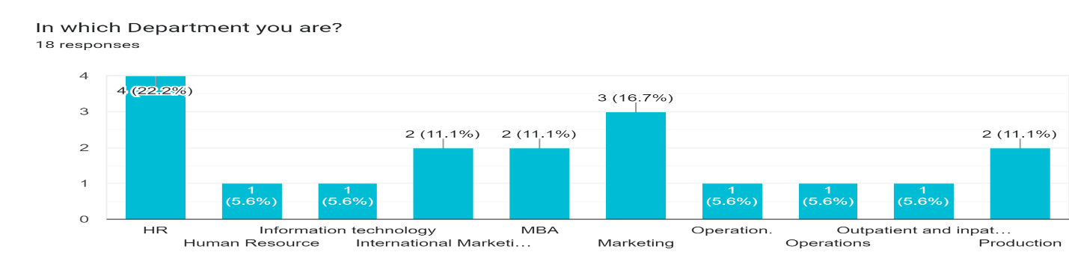

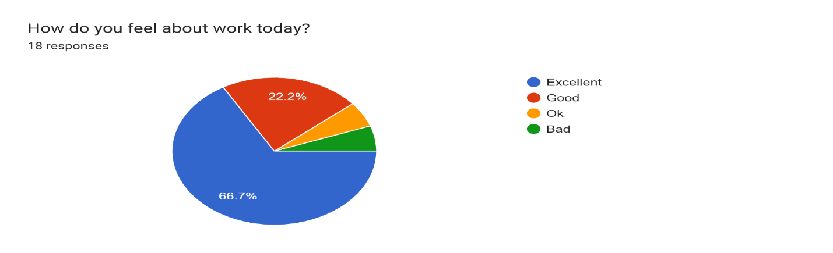

The above graph shows that 66.7% of employees feel excellent towards work at particular day and 22.2% of employees feel good towards working into the company and remaining 11.1 feels ok or bad towards working in the company at that particular day or working in the company. According to the above graph which is obtained after the research done clearly says that 77.8% of the employees would recommend the company to there known and 22.2% are not sure about recommendation. 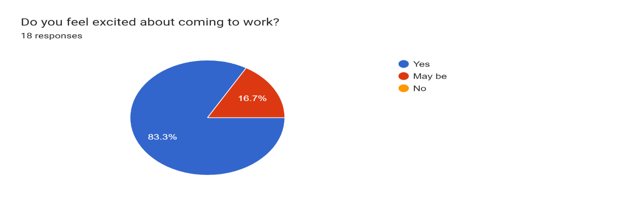

According to the above graph which is obtained after the research clearly says that 83.3% of the employees feels excited about the coming to the company and 16.7% are not sure about it.

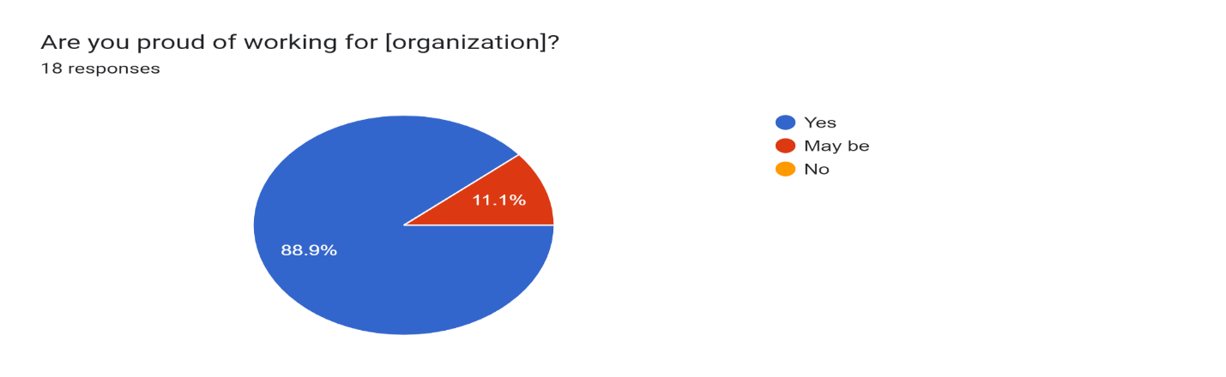

According to the above graph which is obtained after the research clearly says that 89.9% of the employees feels proud working in the company and 11.1% are not sure about it.

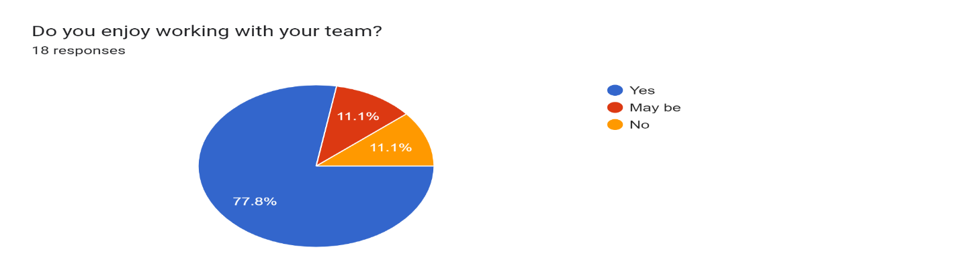

According to the above graph which is obtained after the research clearly says that 77.8% of the employees enjoys working with their team members, 11.1% are not sure about it and 11.1% doesn’t like working with the team.

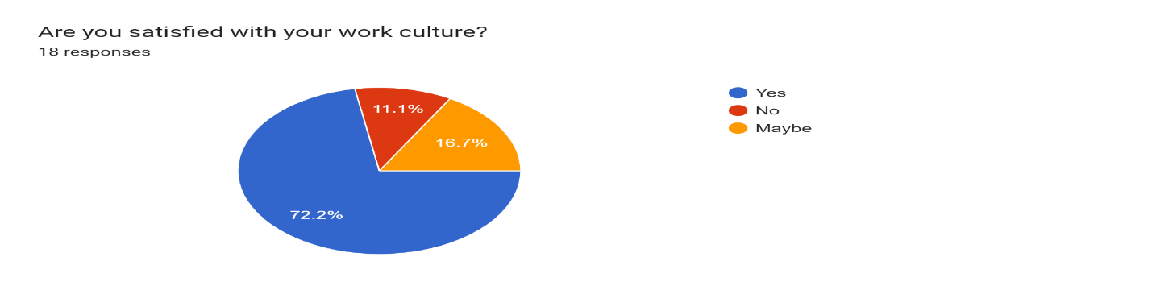

According to the above graph which is obtained after the research clearly says that 72.2% of the employees are satisfied with work culture, 11.1% are not and 16.7% are not sure about it.

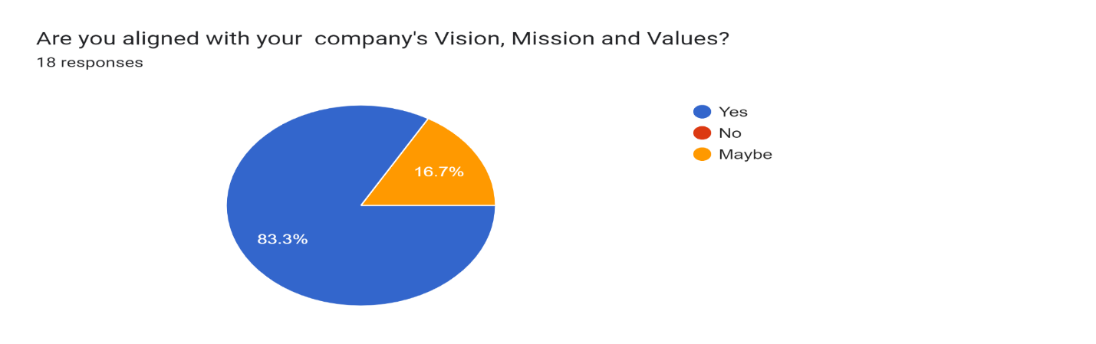

According to the above graph which is obtained after the research clearly says that 83.3% of the employees are aligned with company’s vision, mission and values and 16.7% are not sure about it.

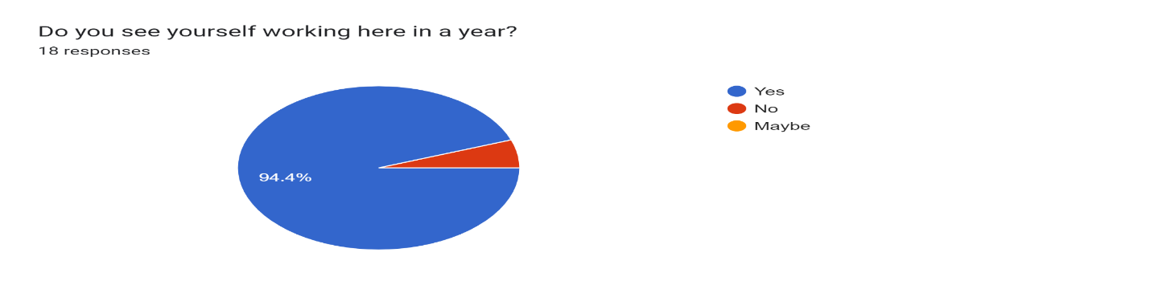

According to the above graph which is obtained after the research clearly says that 94.4% of the employees want to work in the company for year or more than that and remaining are don’t.

**Conclusion**

After analyzing the data from the responses and research paper following conclusion were made,

This report is timely; Engagement is enjoying significant level of popularity as a concept, notably in the UK, where the ‘engage for success’ movement has raised awareness of the potential for engagement to affect individual wellbeing.

It is observed that different departments have there different working environment, working culture and way of responding towards the company and hence we need to keep them aligned towards there working environment where they can work with great enthusiasm and motivation our company does the same thing which helps employees follow there work or complete their work with great enthusiasm.

The policies and the activity of Employee Engagement in the company is working with excellence and the effect of Employee Engagement at INARCO Pvt. Ltd. is at positive side.

**Reference**

* [Premium Cots & Aprons | Inarco](http://www.inarco.com/)
* [What Is Employee Engagement? Definition, Strategies, and Example (investopedia.com)](https://www.investopedia.com/terms/e/employee-engagement.asp#:~:text=What%20Is%20Employee%20Engagement%3F%20Employee%20engagement%20is%20a,and%20feel%20that%20their%20efforts%20make%20a%20difference.)
* [Employee Engagement: Strategies, Models and Best Practices (valamis.com)](https://www.valamis.com/hub/employee-engagement)
* [How Companies Can Improve Employee Engagement Right Now (hbr.org)](https://hbr.org/2021/10/how-companies-can-improve-employee-engagement-right-now)
* [How Companies Can Improve Employee Engagement Right Now (hbr.org)](https://hbr.org/2021/10/how-companies-can-improve-employee-engagement-right-now)
* [What Is Employee Engagement? Definition, Benefits, Strategies. | Built In](https://builtin.com/employee-engagement)
* [What Is Employee Engagement (forbes.com)](https://www.forbes.com/sites/kevinkruse/2012/06/22/employee-engagement-what-and-why/?sh=a3dff9e7f372)