**Awareness and Perception of Youth Towards Metaverse Marketing**

Dr. Pretty Bhalla | Jateen Khepar | Shubhankar Roy | Shubhika Mehra | Varun Tripati | Siranjeevi

**INDEX**

|  |  |  |
| --- | --- | --- |
| **Chapter number** | **Table of contents** | **Page number** |
| 1 | Abstract | 3 |
| 2 | Introductions and research questions | 4 |
| 3 | Literature review | 8 |
| 4 | Objectives and research gap | 10 |
| 5 | Research methodology | 11 |
| 6 | Analysis and interpretation | 12 |
| 7 | Conclusion | 22 |
| 8 | References | 23 |

## 

## Chapter- 1 Abstract

The subject of "Awareness and Perception of Youth Towards Metaverse Marketing" explores how young people perceive and understand the newly developing idea of metaverse marketing and how it might affect their purchasing behavior. Virtual reality and other immersive technologies are being utilized to create brand experiences and market products in the metaverse due to the rapid growth of technology. This study intends to investigate youths' awareness and perceptions of metaverse marketing and how it might affect their purchasing decisions.

The metaverse is an internet-accessible virtual world that can be used for socializing, commerce, and entertainment. It is expected to grow significantly over the next few years, providing a new platform for businesses to reach out to and engage with consumers. However, research on how young people perceive and respond to metaverse marketing is limited. Understanding youth awareness and perceptions of metaverse marketing are critical for businesses and marketers to engage with this demographic effectively.

The following study will be having approach which is called as mixed method approach that includes collection of quantitative and qualitative data. Data will be gathered from a sample of young people aged 18 to 25 through surveys and interviews. The survey will seek to learn about participants' awareness and understanding of metaverse marketing, as well as their perceptions of the concept and likelihood of engaging in metaverse marketing. The interviews will provide more information about participants' perceptions of metaverse marketing and how it may influence their purchasing behavior.

This study's findings are expected to provide useful insights for businesses and marketers looking to engage with young consumers in the metaverse. It will also add to the existing body of knowledge on metaverse marketing and its potential impact on consumer behavior. This study will help businesses understand the youth's perceptions and awareness of metaverse marketing, allowing them to develop effective marketing strategies to reach and engage with young consumers in the metaverse.

To summarize, "Awareness and Perception of Youth Towards Metaverse Marketing" is an important area of research that will assist businesses and marketers in better understanding and engaging with young consumers in the metaverse. This study will provide valuable insights into young people's perceptions and behavior regarding metaverse marketing, which will help businesses and marketers develop effective marketing strategies to reach and engage this demographic.

## Chapter-2 Introduction and Research Questions

The phrase "metaverse" refers to the notion of a future internet made up of persistent, shareable, 3D virtual locations connected into a perceived virtual world. The word is made from of the prefix "meta" (meaning "beyond") and the stem "verse" (from "universe").

Somehow these are the kind of virtual worlds, for the brands to be successful in commerce there is very much possibility. Never before has it been so crucial to have the cultural, commercial, and artistic knowledge necessary to thrive in them as businesses build a true virtual identity and enhance the daily lives of customers.

Involving Generation Z, which frequently doesn't really differentiate among offline and online encounters, is one example. Based on a Facebook analysis, 77% of worldwide consumers say that Facebook is the significant digital platform toward which they belong.

The metaverse's use of both virtual and augmented reality restricts fascinating dimensions. The metaverse encompasses not only multiple platforms, and also virtual and real-world environments. As per McKinney & Co, the metaverse services accounted a multitude of chances to reach out to customers through expanding brand creativity and abilities.

A over than 50% rise in celebrity endorsements on sites like WeChat in China and YouTube and Twitter in the Westerners during the last 5 years illustrates the move toward individual content providers. This transition is important to the growth of the metaverse; a lot of the unique and intriguing encounters would almost probably originate from such creative users.

Companies profit from the metaverse in a wide range of ways. Every company is required to use Metaverse applications in line with its unique business strategy and customer needs. Based on a March 2022 poll, over than 17percent from all IT organisations there in globe had invested inside the Metaverse.

A "Metaverse" is a tri digital encounter wherein avatars or holograms facilitate growth. We may communicate with each other, study, work, and enjoy in this alternate reality. Metaverse is a communal cosmology built with augmented reality (AR) and virtual reality (VR) (Zarantonello& Schmitt, 2022). The Metaverse may now employ the same spoken and nonverbal norms as real, like tone of voice, motions, and imitating, thanks to any of these current tools. Out of a historical timeline, the phrase "metaverse" first appeared in Neal Stephenson's book "The Virtual Samurai" in 1992. The portrayed world transfers us into a sci fi realm similar to ours.

Metaverse marketing is a very young and rising sector that uses virtual reality and augmented reality technologies to create immersive marketing experiences. Companies are beginning to investigate the possibility of metaverse marketing as a method to engage with consumers in new and imaginative ways as technology advances and virtual worlds become more accessible. However, like with any new technology, it is critical to understand how it is regarded by customers, particularly the teenage market, which is generally the first to adopt new technology.

Previous study has revealed that young individuals are more likely to be aware of and have a favourable impression of virtual reality and augmented reality technologies than older age groups. According to a research conducted by the Virtual Reality Industry Forum, 63% of customers aged 18-34 are aware of virtual reality, compared to 46% of consumers aged 35-54. Furthermore, according to another survey performed by the Virtual Reality Company, young people are more likely to be interested in experiencing virtual and augmented reality in the context of marketing.

Metaverse marketing may be used to a variety of businesses, including gaming, entertainment, education, real estate, and tourism. Metaverse marketing may be utilised in the gaming industry to offer more immersive experiences for gamers, allowing them to connect with companies in a more meaningful way. It may be utilised to generate virtual concert and movie experiences in the entertainment business. It may be used to construct virtual classrooms and virtual tours in the education business. It may be utilised in the real estate sector to give virtual tours of properties. It may be utilised in the tourism business to provide virtual tours and experiences of major tourist spots.

It is crucial to highlight, however, that metaverse marketing is not yet commonly used, and additional study is required to properly grasp its potential influence on customer behaviour. There are also possible ethical difficulties with metaverse marketing, such as privacy and data collecting. Concerns have been expressed, for example, concerning firms operating in virtual worlds collecting and using personal data, as well as the possibility of virtual environments being used to acquire data on customer activity without their knowledge or agreement.

While metaverse marketing is still in its early phases, preliminary research indicates that it has the potential to be a successful method of engaging with young customers. More study is needed, however, to fully understand the potential influence of this technology on consumer behaviour and the ethical implications of its use. The present status of research on young knowledge and perception of metaverse marketing, including studies on consumer attitudes and actions, as well as the possible ethical implications of this technology, will be examined in this literature review.

To summarise, metaverse marketing is a new and growing sector that creates immersive marketing experiences using virtual reality and augmented reality technologies. It has the potential to be a successful means of connecting with customers, particularly the teenage market, which is generally the first to adopt new technologies. More study is needed, however, to fully understand the influence of this technology on consumer behaviour and the ethical implications of its use. The purpose of this literature review is to investigate the present state of research on young knowledge and perception of metaverse marketing, including studies on consumer attitudes and actions, as well as the potential ethical implications of this technology. In response to these concerns, the following research questions will be investigated in this dissertation:

Personal Questions:

P1: Age

* 18-25
* 25-30
* 30-35

P2: Income

* 0LPA - 2.5LPA
* 2.5LPA - 5LPA
* 5LPA - 10 LPA
* ABOVE 10LPA

P3: State

_Your answer_

Research Questions:

RQ1: Type of marketing methods you are aware of: (Multiple choice)

* Metaverse Marketing
* Influencer Marketing
* Content Marketing
* Digital Marketing

RQ2: What is Metaverse?

* It refers only to virtual reality gaming
* Immersive, embodied, successor to mobile internet with multiple applications for augmented and virtual reality technologies
* It’s just the new name for the social network - The Facebook 21
* N/A

RQ3: What is it about Metaverse that excites you? (Multiple choice)

* Applications in Medicine and simulations
* Applications of Virtual reality including virtual games
* Augmented reality and its applications in real life

RQ4: What are your concerns about Metaverse that could stop you from using it? (Multiple choice)

* Data Privacy
* Other Cyber risks e.g.: Vulnerabilities in the platform/code
* Lack of regulation for any crime

RQ5: If you could, would you invest in a property in Metaverse?

* Yes
* No

RQ6: When it comes to using the Metaverse, what do you look forward to the most?

* Experiencing things I wouldn’t normally experience
* Escaping reality
* Being able to virtually test or try products
* Meeting new people

RQ7: According to you which industry uses metaverse for engagement?

* Retail
* Travel
* Food & Beverage
* Beauty

RQ8: What do you understand by the term Metaverse Marketing?

* Allows companies to create their own world that represents their brand.
* Consumers can purchase digital forms of products/services from their homes.
* Just another way of marketing

RQ9: According to your knowledge which company follow metaverse marketing? (Multiple choice)

* Nike
* Samsung
* Hyundai
* Coca-Cola
* Louis Vuitton
* Adidas
* Gucci

RQ10: What impact do you think the Metaverse will have on Marketing in the future?*

* Positive
* Neutral
* Negative
* Not sure

RQ11: Do you think Metaverse is here to stay or is it a passing fad?

* It is the future of internet
* It is a short-lived fad, since it’s still aspirational
* Too early to predict its success

## Chapter-3 Literature Review

* Throughout the book Snow Crash, Neal Stephenson created the term "Metaverse" to depict a region wherein people avatar and computer agents interact in tri virtual world, just like they do in real life.
* Collaborative Virtual Environments (CVEs) are critical interactive web sites and places whereby people can connect, explore, and work despite being physically isolated. Initial research into the social aspects of CVEs by Bailenson and team found that CVEs had striking similarities to face-to-face contacts, which included the use of nonverbal signals in a virtual context and altered interactions. The studies emphasized the social intricacies of CVEs, implying future potential applications of these internet social situations. Yet, studies are largely carried out in a lab setting, restricting the usefulness of their findings to non-traditional scenarios (e.g., laboratories vs actual world).
* Buyers valued the process of experiment with a variety of digital avatar, which led to "creative freedom," according to Ducheneaut et al. Inter gender gaming was made possible because to character customization. According to Freeman et al., while playing the games which mimic normal offline gender norms, participants prefer cross-gender interaction to minimize prejudices. Since many people, the act of exhibiting, developing, and altering their avatars has evolved into an interesting experience as they engage, discover, and test in an online social environment.
* Three aspects contribute to the popularity of Habbo Hotel, among the greatest social virtual worlds for youngsters. The ability to co-create social aspects is the initial component, which implies the gamers are not required to be dependent into in interaction but may rather produce contact among themselves. Secondly, it makes use of the virtual environment to store artefacts such as avatars, objects, and events such as escape, pornography, and identity. Finally, the privacy and protection of an ecosystem enable for freedom of speech and experimenting with different avatar styles and group events requiring identification. Such factors indicate that young teens recognise certain types of social digital environments as being less dangerous than the real world for performing an experiment with identity, and that they primarily use these ecosystems for social experimental work, environment and achieve challenges and possibilities across identity even though, for most kids, active participation in a virtual space might be the first time they have authority across an avatar.
* Ryan et al. demonstrated how Self-Determination Theory (SDT) applicable to a diverse group of individuals regardless of background, social, or financial conditions. As per SDT, intrinsic motivation and physiological interaction are necessary for an user's progress.
* Vogel et al. designed a deafness app, whereas Loiacono et al. developed a game to help children with neurodegenerative disorders enhance their social abilities.
* Another study tried to understand how kids learn and engage in vr. Roussos et al. created a storyline, holistic, social constructivism setting that led to three guidelines for successful Virtual teaching simulators for kids:

1) concentrating on deeper educational needs, that demand the dismissal of weak and deceptive models on everyday life

2) The adoption of realistic VR technology has to have the potential to improve the teaching aim.

3) Current educational studies must be applied to improve VR-based learning spaces.

## So according Bailey et al. and Schmitz et al., children react in different ways to vr as compared to traditional medium. Yet, these experiments were confined to kids aged 4 to 6, therefore it is unknown how kids at various stages of growth react to VR. Moreover, little study has been conducted on what kids do and the way they are seen within VR, that raises a wide range of ethical concerns.

## Chapter-4 Objectives and Research Gap

## **Objectives**

* Youth perception regarding metaverse

## In order to fully understand the possible advantages and disadvantages of this latest tech, think about the implications of employing Metaverse as a marketing and advertising tool.

## **Research Gap**

The notion of the metaverse, a virtual environment in which users may interact and communicate with one another, is gaining traction. Businesses are beginning to investigate the possibility of metaverse marketing as a new approach to contact customers as more people spend time in these virtual environments. Despite the increased interest in metaverse marketing, there has been little study on young understanding and impression of this burgeoning trend.

Young people, who are frequently seen as early adopters of new technology, will most likely be among the first to engage with metaverse platforms and experiences. However, research on how young people perceive and participate with metaverse marketing initiatives has yet to be conducted. It is unknown, for example, whether young people are aware of metaverse marketing and, if so, how they view it in relation to traditional types of advertising. Furthermore, research has yet to investigate what characteristics may impact their knowledge and participation in these efforts.

Furthermore, research is required to investigate how youth knowledge and perceptions of metaverse marketing differ from those of other age groups. When it comes to virtual experiences, younger generations may have different expectations and tastes, which may impact their participation with metaverse marketing initiatives. Furthermore, study is required to understand how teenage behaviour and views toward metaverse marketing may change over time as technology and platforms improve.

Moreover, it is critical to comprehend the effects of metaverse marketing on youngsters. For example, it is critical to analyse the possible influence on their privacy and security, as well as the risk of addiction and other undesirable consequences.

Finally, there is a substantial vacuum in studies on young awareness and impression of metaverse marketing. Understanding how young people view and participate with metaverse marketing efforts is critical for firms trying to target and connect effectively with this significant group in the metaverse. Furthermore, study is needed to understand how young people's behaviour and views regarding metaverse marketing differ from those of other age groups, as well as the possible consequences for young people.

## Chapter-5 Research Methodology

For this study, a group of young individuals aged 18 to 35 will be chosen. Because it is simple to locate and recruit individuals who suit the target demographic, the sample will be chosen using a convenience sampling approach.

Data collection will be done using a mixed-methods technique. A survey will be performed to collect quantitative data on youth awareness and perceptions of metaverse marketing. The data will be collected from more than 100 candidates.

The survey will be designed using multiple-choice and open-ended questions. The poll will assess participants' knowledge and awareness of metaverse marketing, as well as their opinions and attitudes about it.

Data from the survey will be examined using descriptive statistics using SPSS.

Limitations: The report's sample is small and might not be representative of the entire population of youth. Furthermore, self-selection bias may exist in the study since individuals are more likely to join if they have a significant interest in metaverse marketing.

Ethical Considerations: All participants will be told about the study's aim and requested to express informed permission. All information will be kept private and anonymous.

## Chapter-6 Analysis and Interpretation

Analysis of Personal data:

**P1: Age**

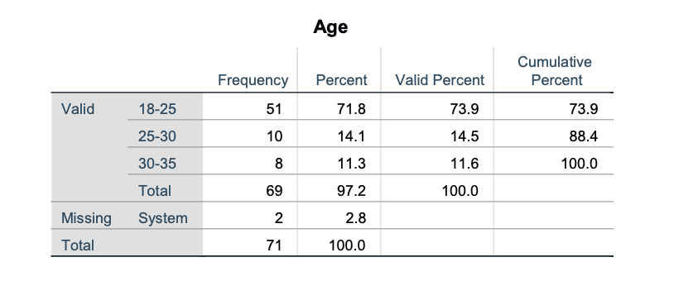

Interpretation: In order to find the percentage of the age of the respondents we have run a test using SPSS software and have come up with the following results,

We mostly targeted the youth audience since the project is about their behaviour towards the metaverse 71% of the respondents come under the 18-25 age group.

**P2: Income**

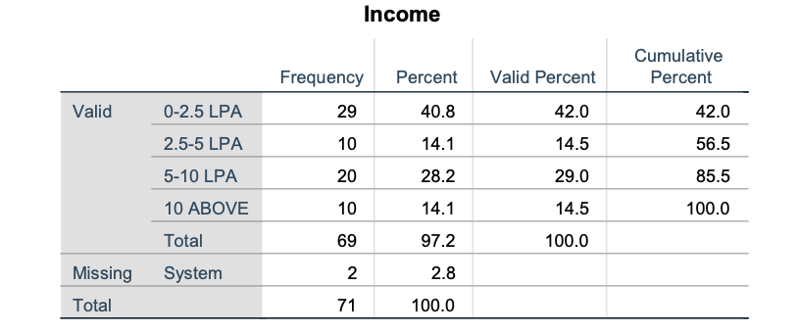

Interpretation: Another personal question would be to find the level of the annual income of our respondents and we have arrived at the result that at least 40% earn 0-2.5 LPA while 28% of the respondents earn 5-10 LPA and 14% income would come under 2.5-5 LPA and also the same per cent for those earning above 10 LPA. Since most of our respondents are students who are undergoing internships, freshers or unemployed the majority came under the lowest income category

**P3: State**

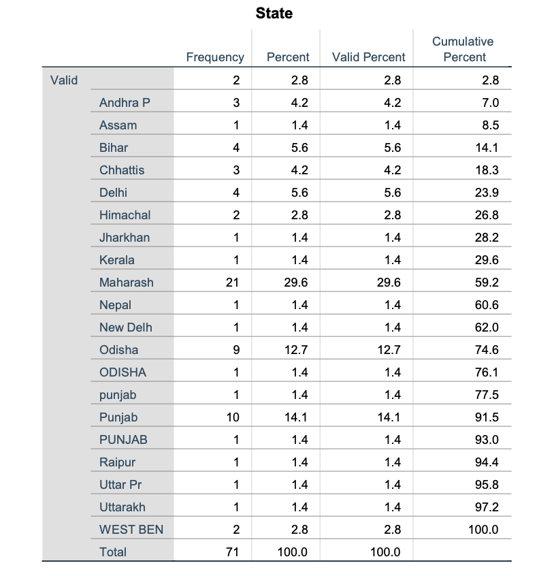

Interpretation: In order to find out and categorise where the respondents come from in India we have run a test t find which state contains the most number of respondents. And we have found that 29.6% of the respondents come from the Maharashtra state in India and more than 15% of respondents from Punjab state.

Research Questions:

**RQ1: Type of marketing methods you are aware of: (Multiple choice)**

Interpretation: In our research questions we have framed the question to find the type of marketing methods our respondents are aware of. After data collection, we have come to a finding that 55% of our respondents are familiar with metaverse marketing while 23% are for influencer marketing and 20% for digital marketing. Since the metaverse is a new concept youth are very curious about how it will be used for marketing purposes and use that platform to come out on top.

**RQ2: What is Metaverse?**

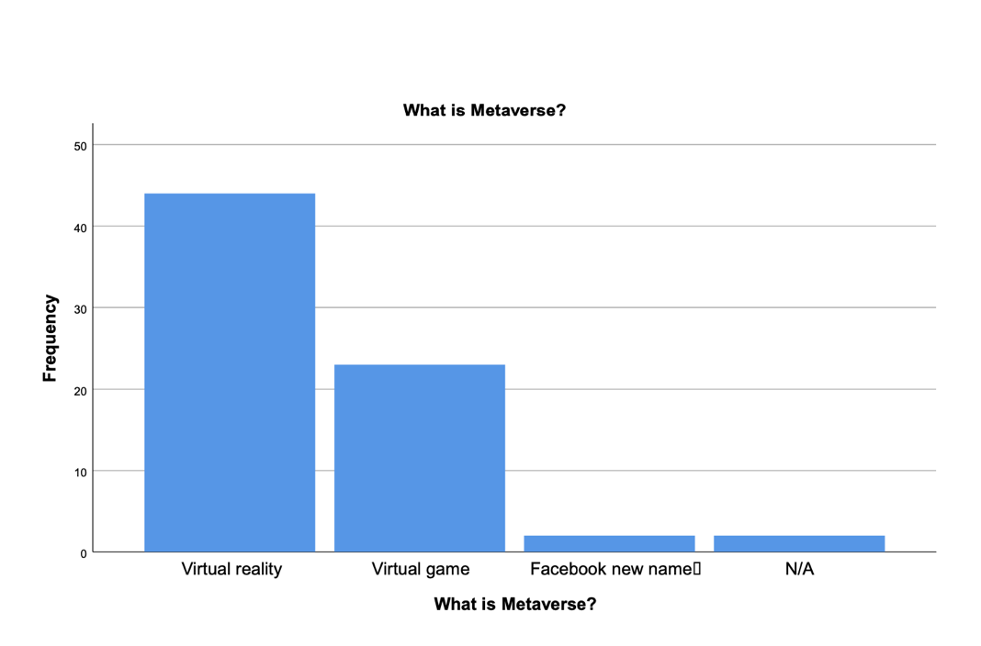

Interpretation: In order to learn how and what exactly the youth think about metaverse we prepared a question regarding that in our questionnaire and the collection of data we have learnt that majority of the respondents know that it as a virtual reality platform while some take it as a virtual game and a very few say it is the new name of Facebook. We have come to a conclusion that youth audience mainly have a brief idea through social media and other sources about the metaverse that it is mainly virtual reality.

**RQ3: What is it about Metaverse that excites you? (Multiple choice)**

Interpretation: We collected data to find out what makes the youth audience feel the most excited about the metaverse and have found out that it is the applications that makes the respondents most excited to use metaverse. Since many applications such as virtual reality theme parks which were only seen in movies now that users get to experience them in real life they are really excited about the applications on metaverse.

**RQ4: What are your concerns about Metaverse that could stop you from using it?

Interpretation: While we focused the questionnaire mainly on the bright side of metaverse we prepared this question to find out what main factor for the youth would be a concern to use the platform. After collecting data and running test it is shown that 39.1% of the respondents are worried and concerned about the data privacy and 37.7% about the cyber risks associated with it. This might be because due to the recent allegations made on Facebook and TikTok regarding that these companies sell the personal data of their users to other parties which worries most f the youth audience as they are aware these days about their data privacy.

**RQ5:  If you could, would you invest in a property in Metaverse?**

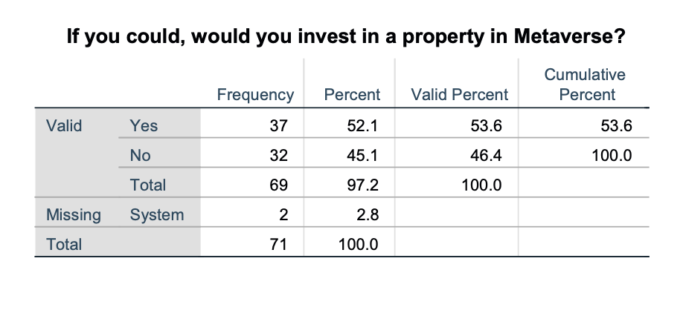

Interpretation: In metaverse you can digitally buy and own a piece of land where you can construct your very own virtual property. It is one of the most revolutionary features in the virtual platform. When asked about the willingness of our respondents intention weather or not to invest in metaverse property more than half that is 52.1% would like to make the invest and the remaining 45.1% are not sure about it. This shows us that even though numbers are slightly towards the yes still some are confused about the concept of owning a virtual property and the purpose and features behind it as it is a new feature and no one has done it before.

**RQ6: When it comes to using the Metaverse, what do you look forward to the most?**

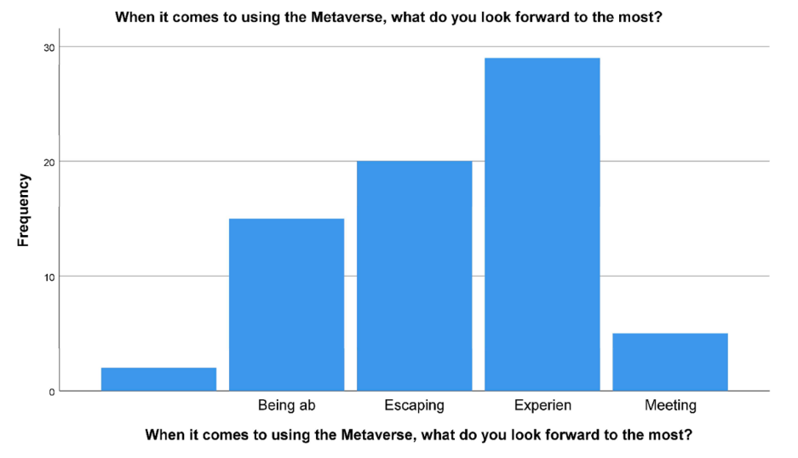

Interpretation: This question was prepared and included in the questionnaire to find out what key factor will drive the youth to use metaverse. After collection of data from respondents we know that at least 40% would like to use metaverse for the experience and 28% would use it to escape reality and the remaining to meet people and so on. Since metaverse is a new platform that is entirely different from all the other platforms used by people before they seem to be curious about the experience it offers to the users since they have no idea about it and it’s the youth audience who show keen interest towards experiencing metaverse by doing research about it.

**RQ7: According to you which industry uses metaverse for engagement?**

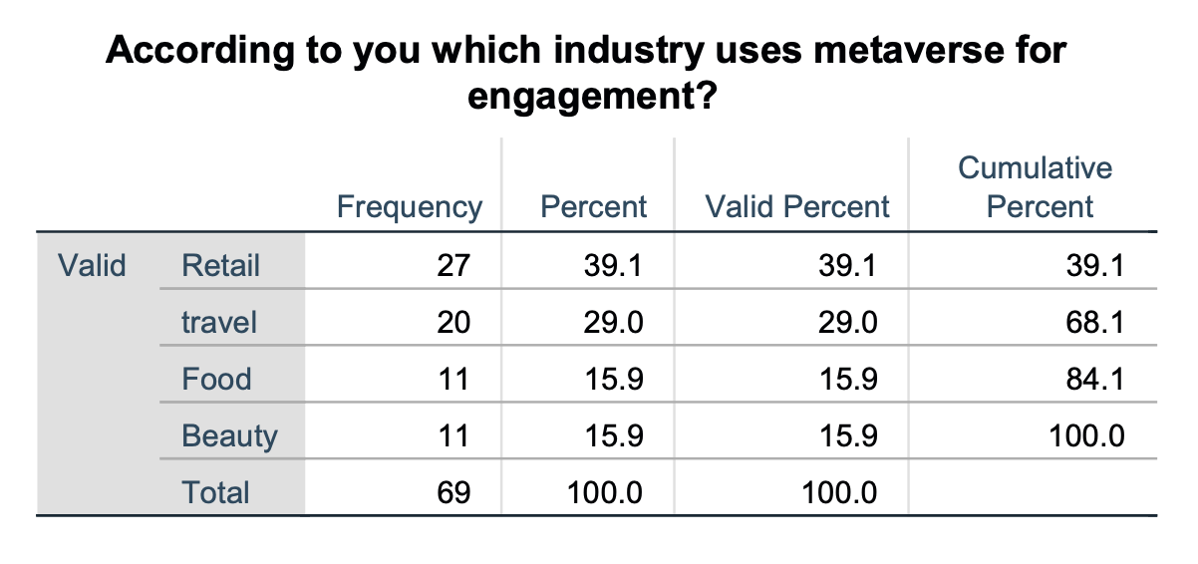

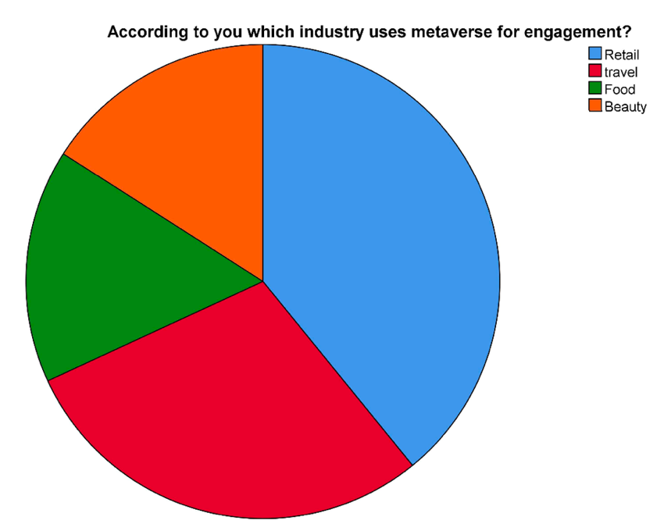

Interpretation: Now to focus on the marketing part of the metaverse we have prepared a research question and made it a part of our questionnaire about which industry does the youth audience think would use metaverse as a platform to engage with them. As per the responses we got insights that the retail industry would use the virtual reality platform to build a relationship with their customers and make them their potential buyer which is agreed by 39.1% of the respondents followed by the travel industry and the food and beauty industry. The youth know that the retail industry can use metaverse to promote their products and services as it is a new platform and more innovation and priority would be given by them to build engagement.

**RQ8: What do you understand by the term Metaverse Marketing?**

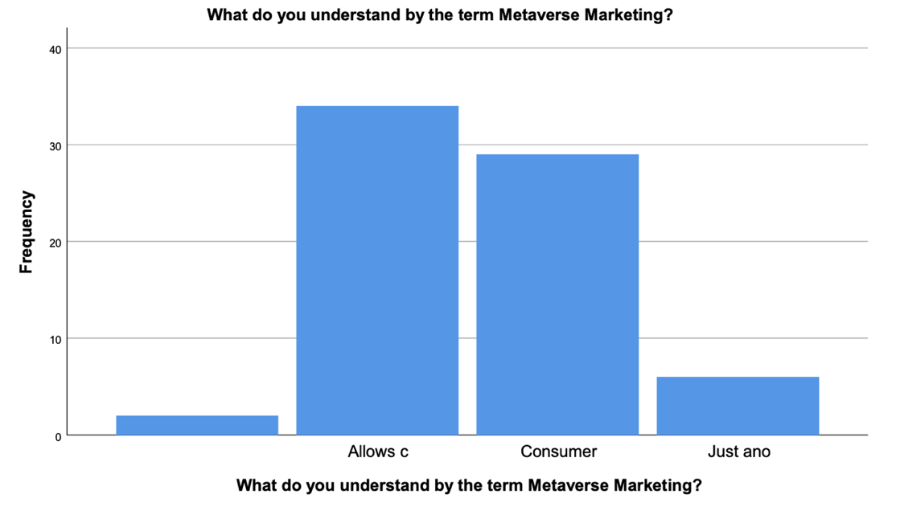

Interpretation: In order to learn what the youth basically understand about metaverse marketing we have prepared a research question based on it and after the gathering of data we have found out that majority of respondents have opted that the companies create their own world to represent their brand while some agree that consumers use the platforms to buy digital products/services, and a few went with just another way of marketing. So generally, the youth audience have an idea that the companies would use this platform to create their own space like a city/town virtually to attract the customers towards their brand.

**RQ9: According to your knowledge which company follow metaverse marketing?**

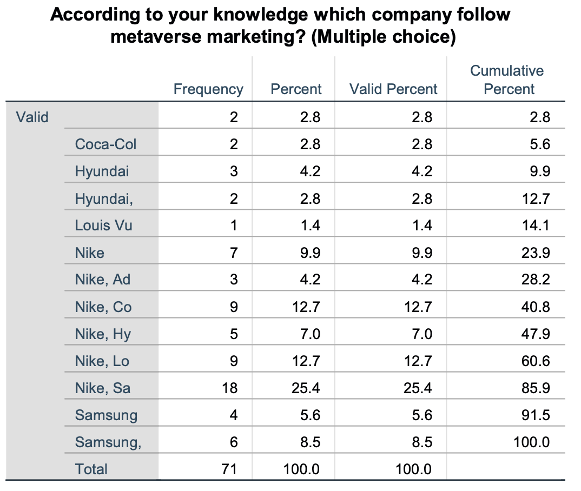

Interpretation: A research question was prepared on the questionnaire to determine weather the respondents have knowledge about the companies that are a part of metaverse and does activities over there to promote their products and services. Based on the data we gathered it was clear that our survey respondents the youth audience know that companies like Nike, Samsung, Adidas, Louis Vuitton, and Gucci are involved in metaverse and use it to promote their brand. In the survey the majority 25.4% know about the involvement of Nike and Samsung in metaverse marketing. This shows that youth are aware of the companies that are in metaverse and also used many sources such as social media, news articles, etc to gain such information.

**RQ10: What impact do you think the Metaverse will have on Marketing in the future?**

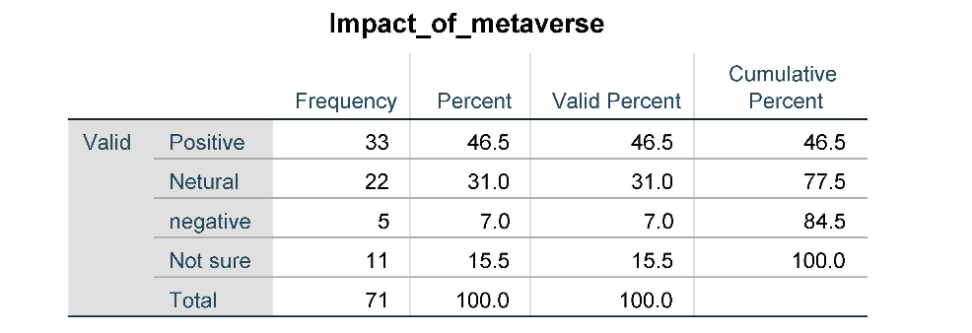

Interpretation: In order to learn the perception of the youth towards metaverse we have prepared a research question about impact that the metaverse has created in their minds weather it is positive or negative or neutral. After the gathering and running of data we have come to the findings that 46.5% of the respondents seem to have a positive impact while 31% opted that metaverse has negative impact and 15.5% are not sure about it and confused. Our interpretation is that since the youth audience are always curious to learn new things and always stay well informed, they have thoroughly studied about the benefits as well as the cons that metaverse has to offer. Even though positive impact has a slight majority over negative we can’t easily say that most of the youth are happy about metaverse.

**RQ11: Do you think Metaverse is here to stay or is it a passing fad?**

Interpretation: We wanted to learn how metaverse would turn out in the long run among the masses. So, we prepared a specific research question on it and included it on our questionnaire. Based on the data collected it is saying that 55.1% strongly agree that there is a bright future for metaverse, and it would go strong in the long run while 15.9% are sure it is just a passing cloud and the remaining 29% say that it is too early to predict since most of the people does not have access to it yet. The interpretation would be that youth have confidence that metaverse would do well in the long run because of all the big corporate companies making huge investments in the platform as well as some movies and tv shows which shows how in future humans would use virtual reality.

## Chapter-7 Conclusion

In view of the analysis done in this paper it can be determined that the youth are aware of the concept of metaverse and their perception towards it is mainly positive and agree that it would work in the long run. The Metaverse Virtual World has the ability to usher in the next major technological advance. The Metaverse has indeed piqued the interest of a number of the world’s largest technology behemoths by demonstrating its multiple capabilities. It enhances their customer engagement also while connecting individuals. The Metaverse has a great deal of potential to replacing "Reality," a type of Internet in which most people's encounters are digitized. We continue to have numerous concerns to confront as a population since socialising, the digital revolution, and the illusions of ideal digital environments will all have a significant influence on how we conduct our everyday lives in the actual world.

Since metaverse growth is in in its early stages, it will likely play a greater part in our lives because among rapid breakthroughs, large investments in this subject, and a major thrust from pandemic. Even Bill Gates thinks that in a few years, most working and interactions will actually happen in the metaverse instead of just traditional meeting venues and corporate travel. As per our study, half of those surveyed believe that the metaverse is about to stay and has a strong future, allowing firms to concentrate on marketing techniques and consumer experience, which would benefit consumers. As brands like Nike and Samsung has already made a commendable impact on the users now it’s the time for other companies to think about entering metaverse.

## Chapter-8 References

1. The Associated Press is a news organisation. Facebook wishes to enter the metaverse. Here's what it is and how it will function in October 2021. URL https://www.npr.org/ 2021/10/28/1050280500/what-metaverse-is-and-how-it-willwork#:~:text=The%20term%20%22metaverse%22%20is%20the%20latest%20bzzword% 20to,to%20signal%20its%20embrace%20of%20the%20futuristic%20idea.
2. Snow Crash: A Novel, Neal Stephenson, Spectra, 2003.
3. The ecological approach to visual perception, by JJ Gibson. 1979, Boston, Massachusetts, United States
4. Greg Wadley, Nicolas Ducheneaut, Ming-Hui Wen, Nicholas Yee, and Nicolas Ducheneaut. Body and mind: a study of avatar personalization in three virtual worlds. In Proceedings of the SIGCHI conference on human factors in computing systems,
5. Joe Sanchez's Virtual World Social History. Library Technology Reports.
6. Gregor McEwan, Carl Gutwin, Regan L Mandryk, and Lennart Nacke are among the cast members. I'm only here to play online games about social dynamics and sociality. In the Proceedings of the 2012 ACM Conference on Computer Supported Cooperative Work.
7. Nick Yee and Jeremy N Bailenson. Chameleons in digital form: Automatic integration of nonverbal movements in immersive virtual settings. Psychological science,
8. Jeremy N Bailenson, Jim Blascovich, Andrew C Beall, and Jack M Loomis are among those involved. In immersive virtual environments, interpersonal distance exists. Personality and social psychology bulletin,
9. Doug A Bowman and Ryan P McMahan. Virtual reality: how much immersion is enough?
10. Rob Kooper, Larry Hodges, and Barbara Olasov Rothbaum. Exposure treatment using virtual reality. 1997, Journal of Psychotherapy Practice and Research.
11. Mel Slater, Domna Banakou, and Sameer Kishore. Virtually becoming Einstein improves cognitive task performance while decreasing age prejudice. Frontiers in psychology, 9:917, 2018.
12. Richard A Bartle. Designing virtual worlds. New Riders, 2004
13. Remy Evard. Collaborative networked communication: Muds as systems tools
14. Bonnie Ruberg and Adrienne Shaw. Queer game studies. U of Minnesota Press, 2017
15. James J Gibson. The theory of affordances. Hilldale, USA,
16. Jackie Marsh. Young children’s play in online virtual worlds. Journal of early childhood research,
17. Matt M¨antym¨aki and Kai Riemer. “fun and friends and stuff” on the stickiness of social virtual worlds among teenagers
18. Ben Lang. https://www.roadtovr.com/unassuming-one-man-vr-project-gorillatag-sees-42k-players-in-first-two-weeks/.
19. Bob G Witmer and Michael J Singer. Measuring presence in virtual environments: A presence questionnaire. Presence,
20. Frank Biocca. The cyborg’s dilemma: Progressive embodiment in virtual environments. Journal of computer-mediated communication.