**EFFECT OF INSTAGRAM ON SOCIAL AND MENTAL WELLBEING OF ZOOMERS'**

**CAPSTONE PROJECT REPORT**

Submitted by

**Charu Katiyar (12101608)**

**Ishita (12110168)**

**Guided by:**

**Udayan Giri(Assistant Professor)**

in partial fulfilment of Capstone for the award of the degree of

**MASTERS OF BUSINESS ADMINISTRATION**

**Mittal School of Business**

**LOVELY PROFESSIONAL UNIVERSITY**

Phagwara, Punjab

**ACKNOWLEDGEMENT**

First of all, we would like to express our sincere appreciation to our mentor for encouraging this research. Thanks to Udayan Giri from Lovely Professional University for his support throughout the entire process and his many insightful suggestions that made this difficult task simpler. We appreciate your time and work since without you, completing this thesis would not be feasible.

We would also want to use this occasion to express our sincere gratitude to our family and friends, who are always there for us in good times and bad, and who encourage and believe in us. You give us hope and are the wind beneath our wings.

Additionally, we would want to express our gratitude to all of the anonymous contributors who answered our questions and made this project possible.

**INDEX**

Chapter-1

INTRODUCTION………………………………………….5

Chapter-2

RESEARCH METHODOLOGY…………………………10

2.1.LIMITATIONS………………………………………..12

2.2. LITERATURE REVIEW…………………………….12

Chapter-3

DATA COLLECTION……………………………………19

Chapter-4

DATA ANALYSIS……………………………………….20

4.1.Confirmatory Factor Analysis………………………...20

4.2. Questionnaire Analysis………………………….……23

Chapter-5

CONCLUSION …………………………………………..34

5.1.RECOMMENDATIONS……………………………..34

5.2.FUTURE REASEARCH……………………………..35

Chapter-6

REFERENCES …………………………………………...36

6.1.Bibliography ………………………………………….38

**EFFECT OF INSTAGRAM ON SOCIAL AND MENTAL WELLBEING OF ZOOMERS'**

**CHAPTER-1**

**INTRODUCTION**

1. WHAT IS SOCIAL MEDIA

Computer-based tools called "social media" allow people to exchange thoughts, ideas and information through online communities and networks. Social media users can quickly share anything on the Internet, including videos, photos, documents, and personal information. A user interacts with social media through her web-based software or applications on a computer, tablet, or smartphone. Originally used as a means of connecting with friends and family, social media has since been embraced by businesses as a popular new channel for communicating with consumers. The power of social media is the ability to connect and share information with anyone on the planet, or many people at once.

Over 3.8 billion people use social media worldwide. With well-known social networks such as Facebook, YouTube, Twitter and Instagram, he has been joined by new platforms such as TikTok and Clubhouse, the world of social media is constantly growing and evolving. By 2023, he is expected to have over 257 million people using social media in the US.

1.1 TYPES OF SOCIAL MEDIA

Social media can have many activities supported by technology. This category includes articles on blogs, social games, social networking, video sharing, business networking, virtual worlds, reviews, and more. Even governments and politicians use social media to connect with people in their respective fields. People use social networks to keep in touch with friends and relatives. Some people use various social media platforms to network for employment, find people around the world who share their interests, and discuss thoughts, feelings, insights, and feelings. increase. Users of this social network participate in these activities. The use of social media within our company is very important. Businesses use the platform to find and connect with consumers, market their products, track consumer trends, and provide customer service or support. Social media is very useful for business. This allows you to combine customer contact and social engagement on your e-commerce site. The ability to collect data helps us focus our marketing efforts and market research. Facilitate the distribution of timely, accurate and unique deals and coupons to prospective customers to help promote your products and services. Social media can support the growth of customer relationships through associated loyalty programs.

2. SOCIAL MEDIA MARKETING

In order to assist people create social networks, exchange information, develop a company's brand, boost sales, and enhance website traffic, social media marketing, sometimes referred to as digital marketing or e-marketing, employs social media platforms. Give it room to expand and develop. Businesses have a method to interact with current clients and draw in new ones thanks to social media marketing (SMM). Additionally, there are data analytics tools made expressly to assist marketers in monitoring the effectiveness of their campaigns and locating fresh chances for interaction. The incredible power of social media in his three primary marketing areas, connection, engagement, and consumer intelligence, serves as the foundation for social media marketing (SMM).

Connect: From video platforms like YouTube and social networking sites like Facebook to microblogging services, social media offers an incredible diversity of ways to connect with your audience. Social media helps businesses engage with customers in previously impossible ways (such as Twitter).

Engagement: eWOM (electronic word-of-mouth) recommendations from current and potential customers, whether through active "liking" or passive "commenting," may provide businesses with unpaid advertising chances since social media engagement is dynamic. These interactions are measurable because they occur on social media platforms and because the positive contagion effects of eWOM play a significant role in consumer choice. Companies, for instance, can evaluate their "social justice." H. Operations for social media marketing (SMM) return on investment.

3. INSTAGRAM

One of the social networking sites that regular Internet users frequent is Instagram. On October 6, 2010, Kevin Systrom and Mike Krieger developed a straightforward photo-sharing and photo-taking programme. According to the website's FAQ section, Instagram is "a fun and quirky way to share your life with friends through a series of images" (Instagram, 2015). After snapping the pictures with their phones and applying the app's filters, users may publish them. Everyone who registers for an Instagram account has access to a profile and news feed.. Each user profile has a "Followers" and "Following" count that shows how many people the person is following in addition to how many people they are themselves (Webtrends, 2015). You can "like" an Instagram post by double-clicking it, and you may comment on someone else's post by tapping the comment button. To locate more accounts to follow, use the Search button. You may also search through suggested pictures or a list of individuals to find folks. More functions were added as the software developed. To make it easier for users to find one another and their photos on Instagram, hashtags were first used in January 2011.

A hashtag is a word or phrase that is prefixed with the hash or pound symbol (#) and is used to distinguish talks on a certain topic. Direct was added to Instagram in December 2013. This feature allows users to use the programme as a messaging service to send photographs to particular recipients. Instagram has evolved over the last five years into a platform for users to engage and communicate visually. Each user profile contains a "Following" and "Following" count that displays the total number of individuals the person is both following and following themselves (Webtrends, 2015). When you double-click a post on Instagram, you may "like" it, and when you click the comment box, you can interact with other users by leaving a comment. You may use the Search button to find new accounts to follow. To find people, you may also look through suggested images or a list of names. As the software evolved, more features were added. In January 2011, hashtags were added on Instagram to help users locate content and one another.

3. INSTAGRAM INFLUENCERS AND GEN Z

The terms “Generation Z,” “Zoomer,” and “digital nomad” are often used when referring to this generation. Millennials, currently the largest generation, will soon be overtaken by the next generation, according to Deloitte. In the near future, digital nomads will make up her third of the world's population (Deloitte, 2020). As a result, organizations and influencer marketing agencies need to understand how to meet the needs and aspirations of today's generation. To remain relevant, brands need to recognize that they will need to shift their strategies to effectively reach and capture the attention of Gen Z consumers. No two generations are the same, but according to Forbes (Forbes, 2019), Gen Z is redefining who matters and who doesn't in today's market. A fascinating white paper produced by IMA explores Gen Z's visionary culture and changing behaviors. This white paper examines the issues brands are currently grappling with. How is Generation Z currently changing the cultural milieu of society?

In the Harvard Business Review article Branding in The Age of Social Media, it is said that "people want to engage with people more than they want to connect with enterprises. Learning this lesson is essential. This exemplifies why it is crucial to work with powerful individuals who have a devoted and receptive fan base or community. Brands need to forge strong bonds with the generation that places a high value on authenticity. knowing the origins of their thoughts and the places they come from If they can't accomplish it, the intended result won't ever be attained. According to IMA, the issues firms are facing are neither primarily creative or financial in nature (Whitepaper: Anticipating Culture and the Changing Behavior). The only thing that was different was how they dealt with the Zoomers.

How businesses can alter the game and effectively meet the needs of the youth is the urgent issue for which they are urgently searching for a solution. They are knowledgeable with the ins and outs of the internet since they have had access to it their whole lives. It's vital to remember that people might differ even within the same generation. As stated by Influencer Marketing Hub and previously confirmed, values are the name of the game (Influencer Marketing Hub: Changing the game, 2020). According to the Influencer Marketing Center, digital nomads are common in many different businesses. They live all across the world, whether it is nearby or far away. People that multitask and use a lot of technology are tolerant of diversity because they have an open mind. They care more about the truth, on the other hand. As a consequence, they are always looking for the finest offers. They put a lot of emphasis on social interaction and regard inclusivity, honesty, and pragmatism to be their guiding principles (Influencer Marketing hub: changing the game, 2020). This generation places more trust in people than in brands, as was already said. As a result, it seems like influencer marketing is a perfect fit for Gen-Z. According to Morning Consult, younger people favour influencers.

Most reports show that they are being followed, and 50% show that they think their advice is accurate (Morning Consult, 2020). Forbes claims that Gen-Z also mostly disregards well-known celebrities in favour of writers of more relevant information. According to The Influencer Marketing Hub, influencer marketing is the best strategy for connecting with an online audience. Wansi, Jalean 30 Nomads How do Instagram influencers effect Gen Z customers' purchasing behaviours. Considering their love of influencers, their extensive social media use, and the significance of the social environment of the things they buy According to the Influencer Marketing Hub, while attempting to attract Zoomers using influencer marketing on Instagram, the following crucial points should be kept in mind.

1. The aim of collaboration should always be to meet the requirements of the generation. Either they should accomplish all three, or they should A) provide a good deal, B) encourage happiness or self-care, C) be in line with their beliefs about diversity or sustainability, D) offer personalisation, or E) do all of the above. Many teenagers feel pushed to stand out in a society that values radical inclusion by being different (Influencer Marketing hub: changing the game, 2020).
2. Less is frequently more when it comes to sponsored material. An influencer loses credibility if they work with businesses too frequently and their feeds end up just featuring paid material. They will lose their community's respect and confidence as a result. The best course of action is to pick influencers that maintain a good balance (Influencer Marketing Hub, 2020).
3. It's crucial to remember the tenet that quality should always come before quantity. It should be clear that this has anything to do with transparency. Being honest and forthright about the goods or services they are endorsing can help an influencer gain the trust of the younger generation (Influencer Marketing Hub, 2020).

They mostly agree with what has been said when evaluating Forbes, another source. But they also provided some additional advice for using mindfulness.

1. Increasing societal awareness. Forbes estimates that over 50% of today's youngsters have bought products to support the issues that a company supports. They hold that consumer spending and social interaction are perfectly in sync. recognising their perspective and encouraging the use of genuine counsel rather than marketing (Forbes, 2020).
2. Get their attention given that there is not much time left. They move quickly as they browse, click, or swipe, much like digital nomads. Therefore, it's crucial to grab their attention right away using the tactics listed below: interactive components that encourage engagement, such as Instagram Stories stickers. To build a strong brand presence, use concise, direct movies with subtitles.

**CHAPTER-2**

**RESEARCH METHODOLOGY**



**PROBLEM**

In the last ten years, Instagram has experienced significant growth. It's still unclear, though, whether social media helps or hurts people's mental stability. This study intends to investigate how Instagram has affected the economic and social development of Zoomers. We carried out an online cross-sectional survey research (N = 205) and empirically examined a mediation route connecting Instagram use to social and economic development.

**RESEARCH DESIGN**

A quantitative causality design was employed. This particular study falls under the descriptive technique, which analyses the precise influence of independent and dependent variables as well as how they are mediated by other factors that have been developed through a hypothesis.

**SAMPLE**

These survey results were gathered in India between December 2022 and January 2023. There was purposive sampling. To draw participation, a web link to the online survey was posted on social networking websites. Additionally, the snowballing technique was used to expand the sample size. There are 205 people in the final sample. The age range in our sample is 18 to 25 years old, or 76.1%. In our dataset, 59.5% of the population is male, 40% of the population is female, and 47.8% of the population has attended college or earned a degree.

**MAJOR OBJECTIVE:**

* To analyse the effect of Instagram on the economic growth of users
* To study the social media comparison with Instagram vis-à-vis on Income
* To analyse the impact of Instagram on the social and mental health of GenZ

**MINOR OBJECTIVE:**

* To study the frequency of online shopping through Instagram and other social media apps
* To take feedback and identify the level of satisfaction among users of Instagram

Every project's work is based on a certain methodology, which is a means of methodically resolving the issue or achieving the project's goals. Through observation, data collecting, and data analysis, it is a crucial guide that results in the completion of any project job*.*

**FACTORS AFFECTING THE RESULTS OF THE RESEARCH STUDY:**

**1st objective**

* **Influencer marketing:** Influencer marketing is without a doubt one of the most successful marketing strategies used today. Many industry experts concur that it's the greatest marketing plan overall. In recent years, influencer marketing has expanded dramatically and established itself as a key element of the marketing mix. It's difficult to find businesses now days that don't use it. It's a powerful marketing tactic that helps you to establish an authentic connection with your target market.
* **Brand collaborations:** The definition of brand collaboration is the strategic partnership of two or more brands to create a special and speciality product or service to gain a competitive edge in the market.
* **Interface smoothness:** This describes how user-friendly the interface is for the user while making an online transaction. evaluates how user-friendly each social media application is.

**2nd objective**

* **Facebook:** Facebook is a social networking site where users may link to news articles or other important online content as well as converse live, watch short movies, submit comments, and swap images.
* **YouTube**: American social networking and online video-sharing corporation YouTube is based in San Bruno, California. Steve Chen, Chad Hurley, and Jawed Karim gave it its formal debut on February 14, 2005. It is currently owned by Google and is the second most frequently visited website after Google Search.
* **Moj:** The massively popular app TikTok has recently been replaced in India by the Moj App. It provides TikTok-like features like short movies, emoticons, stickers, and more. In addition to this, the Moj App supports 15 languages and lets users download videos.

**3rd objective**

* **Racism:** the belief that certain races are essentially superior to others, that inherited physical attributes may influence personality, intellectual ability, morality, and other cultural and behavioural aspects, and that people can be divided into unique and exclusive biological groups called "races."
* **Belief:** An idea that someone considers to be genuine or real is referred to as a belief. Many young toddlers fervently hold the Tooth Fairy to be a genuine person.
* **Culture**: The term "culture" is a catch-all that refers to social norms, institutions, and behaviour that exist in human societies as well as the individuals that make up these groups and their skills, knowledge, and beliefs in addition to the laws, conventions, and customs that they adhere to.
* **FOMO:** The fear of missing out is the feeling or perception that others are having more fun, living better lives, or enjoying greater experiences than you are. It causes a strong feeling of jealousy and decreases self-esteem. Facebook and other social media platforms frequently make problems worse.
* **Social mindset**: Another aspect of having a social impact attitude is prioritising time and people over things. Adopting a social impact mindset is at the heart of the minimalist movement. It has inspired people to think for themselves, to free themselves from a culture that is consumed, and to put more emphasis on life and experiences.

**LIMITATION**

The impact of Instagram on Zoomers' social and mental health has a number of limitations (those born after 1996). These restrictions include, among others:

* + Selection bias: Inaccurate results may emerge from the study's selection of participants not being representative of the greater population.
  + Self-Reporting: The data gathered is based on self-reported information, which is prone to prejudice and dishonesty.
  + Correlation versus causation: The study may discover a link between Instagram use and social and mental health, but it is unable to establish that Instagram is the root cause of the impacts.
  + Limited Timeframe: The research might only track Instagram's impacts for a short while; long-term consequences might be different.
  + Complex Relationships: There are several variables that may affect how Instagram usage affects social and mental health, including genetics, personality, and life events.

When analysing the findings of research on Instagram's impact on Zoomers' social and mental wellbeing, it's critical to bear these limitations in mind.

**LITERATURE REVIEW**

1. Baldonado, 2018

Understanding the history of social media and Gen Z is essential to understanding Instagram's positive and negative impact on Gen Z. Social media has become a widespread and important research topic over time and with the spread of technology. A lot of research has been done, but currently there is little to no research on the impact of social media, especially Instagram, on her Gen Z. Each generation's reaction to something is influenced by determining factors and events. Both his September 11, 2001 terrorist attacks and the Great Recession, which had a huge impact on this generation, were defining moments for his Generation Z. As mentioned earlier, Gen Z is a generation that grew up with technology. This is the feature that distinguishes this generation from previous generations. Research shows that Gen Z is exposed to more types of social media every 60 seconds than any other generation. This is the feature that distinguishes this generation from previous generations. Research shows that Gen Z is exposed to more types of social media every 60 seconds than any other generation.

1. White, 2017, p. 43

Social networks are now part of Gen Z culture and a constant presence in everyday life. 92% say they use the internet every day. A quarter said they use the Internet "almost all the time." 91% use devices to fall asleep. Both positive and negative effects come from Gen Z's constant connection with the internet world. Instagram messages have an emotional, mental and spiritual impact on Gen Z.

1. Strate, 2017, p. 5

The media ecology hypothesis examines how media influence people and how they shape their thoughts and actions. This theory, formally called "the study of media as an ecosystem", was first discussed by Neil Postman. We should consider three of his communication theories that are relevant. The first theory to be discussed is media ecology theory, followed by media addiction theory and cultivation theory.

1. McLuhan, 1964, p. 24

The term "media" is expanded because, according to Marshall McLuhan, "the medium is the message." From 1918 to his 1963 Marshall his McLuhan developed a theory of media that is still valid today. According to him, “Media is the medium that shapes and regulates the scope and nature of human association and behavior.” The uses and content of such media are diverse enough not to affect how people interact. A medium's ability to deliver content, not the content itself, determines the strength of the medium. Technology, and more specifically media, evolves much faster than ideas. Beliefs can change the way people interact with each other, but media also changes the extent of those interactions. According to McLuhan, media create forms of consciousness, not illiteracy. When he discussed his proposal in 1963, television and radio got a lot of attention because he was two common media. Technology has evolved since then, but McLuhan's core concepts from media ecology theory are still relevant to contemporary media and technology. McLuhan considered discourse to be the most rapidly acting type of violence. A person can choose to harm with his words or not. This is simply to say that the social and personal impact of any medium or expansion of ourselves arises from the new scale that each expansion of ourselves introduces into our interests.

1. Yang, 2015

In 1976, American Communications Association researchers Sandra Bohl-Rokeach and Melvin Defleur first put forward the theory of media addiction. Media platforms become dependent on their users when certain goals are achieved, such as rapport, social stability, and engaged audiences. A medium must meet the needs of an individual user, and once that is done, the user becomes increasingly dependent on that medium and her platform. If people believe that Instagram will quickly meet their needs, and if those who believe so become dependent on Instagram, the same thinking applies to Instagram as well.

1. If, 2020, as cited in Vitelar, 2019, p. 8

Using media addiction theory, we can conclude that Gen Z users are increasingly dependent on social media, especially Instagram, for information and solutions to their needs and desires. The influence of social media will grow as Gen Z becomes more dependent on it. According to Media Dependency Theory, ``The greater impact of such media on users' perceptions and behaviors leads individuals to become more dependent on certain types of media.'' Affected by how dependent it is.

1. (Fredberg, 2010).

A new class of unrelated and independent advocates, known as “social media influencers,” use blogs, tweets, and other forms of social media to influence the opinions of their audiences. A social media influencer grows her following on Instagram, YouTube, Twitter, and her Facebook to increase brand awareness. Fredberg believes the success of social media influencers is important to brands, so a technology was developed to identify and measure influencer relevance to companies and organizations. This technology tracks blog hits, shares, likes, comments and followers. These are all essential ingredients for a successful social media influencer. A new way for businesses to engage with their customers more directly, organically, and at scale in their daily lives is social media influencer his marketing. Social media influencers make products more accessible to the general public by promoting them through their personal lives.

1. Ledbetter, 2017

When one party tries to persuade another to do something, Ledbetter argues, "there are dynamics that affect the course and content of the relationship between the two." The best way for brands to reach consumers is through influencers. Due to their openness and transparency with consumers, influencers have gained significant social impact and reputation, which makes the phenomenon so popular.Traditional marketing is largely the main While targeting stream audiences, influencer marketing has the unique ability to target specialized audiences that were previously unreachable.

1. (Mancuso & Stuth, 2015)

Instagram combines product placement with electronic word of mouth (e-WOM). It is so subtly done, which is why it seems to be so effective. More than 90% of Instagram users, according to a Business Insider survey, are under 35. More than any other network, Instagram provides the ability for image-based storytelling. A form of "stealth" marketing is influencer marketing, that utilises a market in a Fraudulent, covert, covert, undetectable, and deceptive methods of deliberately influencing viewers without their knowledge of what is happening.

1. Abidin, 2015

These influencers appear to be creating these posts on their own initiative, but they actually receive payment. Additionally, because they take the form of a personal narrative and contain influencers' insights from having used the product or service themselves, these advertorials have been found to be more effective than traditional commercials. An Instagram user who has gained reputation in a particular business, sector, or niche as a result of her reach and authenticity is known as an Instagram influencer. This user can influence others, reach a sizable following, and start trends on social media. As a result, snapping images of these people's daily lives has turned into a lucrative industry. They used to do this on blogs, but Instagram has become more popular recently. Most commercial lifestyle bloggers are young women between the age of 18 and 35. On average, 70% of her followers are women between 15 and 35 years old. Celebrities can be social media influencers, but Instagram is also home to many of those. ――You are called a “micro-celebrity”.

1. Marwick, 2010

Micro-celebrities may not be well known outside the Instagram community. Micro-celebrities are seen as more 'real' and 'enthusiastic' than traditional celebrities because they interact directly and honestly with their fans through social media.

People enjoy following "luxury profiles," which are accounts that frequently post about their pricey possessions and way of life. Look at "What many young people hope of possessing and the lifestyle they dream of living," say "Followers".

1. Soltysinska, 2017

Users frequently engage with and follow "aspirational" content. Because 83% of influencers claim to have recently bought a product after seeing it on social media, influencers are influenced by other influencers.

Influencer marketing works best for businesses looking to connect with "younger" consumers. This is a result of younger consumers avoiding traditional media. They are using the internet to follow carefully vetted influencers who share their interests

1. Gilbreath, 2017

For today's marketers, influencer marketing is crucial. According to eMarketer, in 2017, among half marketers increased their spending on influencer marketing.. Brands and marketers are aware that voices from genuine, reliable accounts have a significantly higher chance of getting through ad blockers.

1. Gelb, 2017

Influencers may effectively grow a brand's online presence and have a genuine impact on their following. The findings, which demonstrate that unfavorable emotions in teens' potential for loneliness them to linger too long on social networking, are consistent with this idea. Social media thus fulfils the desire for social engagement or acts as a form of self-reflection for adolescents.

1. Alderton, 2014

Many businesses utilize influencer marketing to introduce their brand and its story to consumers rather than to sell a product. Because of this, many lifestyle brands are using this technology. The discrepancy between what women really look like and the ideal female beauty standards enforced by social media is known as digitized female body dysmorphia. Images published online can be used to detect digitized anomalies. An individual's online girlfriend image is "fixed" by removing some features deemed unattractive using a variety of tools, including: B. Photoshop, modifiable

1. (Anderson and Jiang, 2018)

High social mobility results in high social media activity, which is produced by widespread use of computers utilisation, smartphones, and the internet. Numerous platforms that enable connecting with others and maintaining relationships have been developed over the past ten years, including Facebook, Foursquare, Google+, Instagram, LinkedIn, Pinterest, Reddit, Snapchat, Tumblr, Twitter, and YouTube. The use of social media has dramatically increased during the past ten years, according to numerous sources. Americans aged 18 and above report using at least one of these platforms in 97 percent of cases.

1. (Verrastro et al., 2020)

The discrepancy between what women really look like and the ideal female beauty standards enforced by social media is known as digitized female body dysmorphia. Images published online can be used to detect digitized anomalies. A variety of tools are used to "fix" a person's online girlfriend image by removing some features deemed unattractive. B. Photoshop, including Instagram. (Larios-Gomez ´ et al., 2021)

1. (Larios-Gomez ´ et al., 2021)

I wonder if social media restrictions (lack of public events, limited access to movie theaters, etc.) are affecting these vibrant alternatives to the grim realities of fashion. The conclusion is that the pandemic has caused a range of economic and social changes, including rising unemployment, a weakened health care system, the digitization of education, disruptions to supply chains due to border closures, and restrictions on social activity due to significant price hikes. Backed by studies that show it has had a significant impact. infection rate. Purchase-related issues are also changing, such as increased internet sales and a focus on local products.

1. Anderson and Jiang, 2018

High social mobility results in high social media activity, which is produced by the widespread utilising computers, smartphones, and the internet. Numerous platforms that enable connecting with others and maintaining relationships have been developed over the past ten years, including Facebook, Google+, Pinterest, Reddit, Google, Snapchat, LinkedIn, Twitter, and YouTube. The use of social media has dramatically increased during the past ten years, according to numerous sources. About 70% of Americans use social media, and 97% of American adults report using at least one. For Singaporeans, these proportions are comparable.

1. (De Veirman et al., 2017; Djafarova and Rushworth, 2017)

Social networking networks are becoming more and more popular among both individuals and businesses. Compared to conventional advertising mediums like radio or television, social network services are less expensive. Due to the large increase in users, they are also more efficient. Social networking is a low-cost tool to interact with customers, market companies, and eventually make money. Additionally, consumers follow other shoppers to get ideas for their own purchases. In other words, choose to see all posts by another user in your content feed). Instagram has become a money maker for some of its most famous users. The more likes and followers a user has, regardless of their age or the type of products offered, the more likely they are to be small or large. Businesses are more likely to reach out to you for promotional purposes.This is why users are trying to gain popularity on their network.

**CHAPTER-3**

**DATA COLLECTION**

A well-known example of a commonly used online survey administration software for data collection and analysis is Google Forms. Google form is inexpensive and self-administered, and it offers minimal risk of data inaccuracies. Hence, the questionnaire was administered in a Google Form and then distributed via social media channels such as WhatsApp, Facebook, Telegram and Instagram to 205 Respondents Generation Z individuals within the age range of 18 to 25. It took each respondent 5 to 10 minutes to complete the questionnaire. The data collected underwent descriptive analysis to study the credibility of the impact of Instagram on the economic and social growth of Zoomers.

Two types of data, primary & secondary, were mostly gathered to determine the appropriate data for the research, as described below:-

* **PRIMARY DATA:**

Primary data are distinct in nature because they were collected recently and for the first time. Although there are several approaches to obtaining primary data, we conducted our research using questionnaires.

* **SECONDARY DATA:**

Secondary data is gathered from the literature and earlier studies to complete the study.

**CHAPTER-4**

**DATA ANALYSIS**

**Confirmatory Factor Analysis**

Confirmatory analysis (CFA), a statistical technique, is used to verify the factor structure of a set of observed data. The study used CFA to test the hypothesis that there is a relationship between potential observable variables and the latent ideas that underlie them.

| Factor Loadings | | | | | | | | | | | | | |
| --- | --- | --- | --- | --- | --- | --- | --- | --- | --- | --- | --- | --- | --- |
| **Factor** | | **Indicator** | | **Estimate** | | **SE** | | **Z** | | **p** | | **Stand. Estimate** | |
| Expenditure |  | 1. I get influenced easily by seeing an ad on social media? |  | 0.860 |  | 0.0697 |  | 12.33 |  | < .001 |  | 0.746 |  |
|  |  | 2. I often buy products on influencer recommendation? |  | 0.981 |  | 0.0739 |  | 13.28 |  | < .001 |  | 0.785 |  |
|  |  | 3. I use Instagram for 2 purchasing. |  | 1.090 |  | 0.0717 |  | 15.20 |  | < .001 |  | 0.857 |  |
|  |  | 4. I recommend social media for 2 purchasing. |  | 0.970 |  | 0.0728 |  | 13.33 |  | < .001 |  | 0.787 |  |
|  |  | 5. I believe all brands recommended by influencers on social media are genuine. |  | 0.927 |  | 0.0745 |  | 12.44 |  | < .001 |  | 0.750 |  |
|  |  | 6. I believe all brands invest in influencer marketing? |  | 0.636 |  | 0.0726 |  | 8.76 |  | < .001 |  | 0.573 |  |
|  |  | 7. Social media presence of brand influences my purchasing decision? |  | 0.918 |  | 0.0696 |  | 13.19 |  | < .001 |  | 0.781 |  |
|  |  | 8. Do you prefer to shop |  | -0.175 |  | 0.0294 |  | -5.95 |  | < .001 |  | -0.408 |  |
|  |  | 9. I often buy products through Instagram? |  | 1.180 |  | 0.0760 |  | 15.53 |  | < .001 |  | 0.868 |  |
|  |  | 18. Do you buy products on influence |  | 0.910 |  | 0.0755 |  | 12.05 |  | < .001 |  | 0.733 |  |
|  |  | 19. I believe that all brands pay an influencer for influencer |  | 0.538 |  | 0.0751 |  | 7.16 |  | < .001 |  | 0.483 |  |
|  |  | 20. Do you think instagram earning can make your life stable |  | 0.830 |  | 0.0730 |  | 11.37 |  | < .001 |  | 0.704 |  |
|  |  | 21. Do you think you can do full time work on instagram |  | 0.936 |  | 0.0782 |  | 11.96 |  | < .001 |  | 0.730 |  |
| Time Spent |  | 11. Do you have a different personality on your social media pages? |  | 1.027 |  | 0.0773 |  | 13.28 |  | < .001 |  | 0.797 |  |
|  |  | 12. I firmly believe that social media influences my behavior and actions. |  | 0.949 |  | 0.0708 |  | 13.41 |  | < .001 |  | 0.804 |  |
|  |  | 13. I post on social media every day? |  | 1.007 |  | 0.0786 |  | 12.82 |  | < .001 |  | 0.779 |  |
|  |  | 14. Social media is the first thing that I check in the morning? |  | 0.740 |  | 0.0736 |  | 10.06 |  | < .001 |  | 0.650 |  |
|  |  | 15. How often do you use social media? |  | 0.106 |  | 0.0300 |  | 3.53 |  | < .001 |  | 0.254 |  |
|  |  | 16. I feel anxious using social media platforms. |  | 0.969 |  | 0.0810 |  | 11.97 |  | < .001 |  | 0.740 |  |
|  |  | 17. Has Instagram affected your mental health? |  | 0.805 |  | 0.0837 |  | 9.61 |  | < .001 |  | 0.629 |  |
|  |  | 22. Scrolling through instagram/working on instagram makes me happy |  | 0.782 |  | 0.0729 |  | 10.72 |  | < .001 |  | 0.684 |  |
|  | | | | | | | | | | | | | |

**Factor Estimates**

Finding a rough estimate of a parameter, such as the mean (average), for a population using random samples from that population is known as factor estimation in statistics. Although probabilistic claims about the accuracy of such values established via several studies can be made, the exact accuracy of any one estimate is unknown.

| Factor Covariances | | | | | | | | | | | | | |
| --- | --- | --- | --- | --- | --- | --- | --- | --- | --- | --- | --- | --- | --- |
|  | |  | | **Estimate** | | **SE** | | **Z** | | **p** | | **Stand. Estimate** | |
| Expenditure |  | Expenditure |  | 1.000 | ᵃ |  |  |  |  |  |  |  |  |
|  |  | Time Spent |  | 0.850 |  | 0.0277 |  | 30.7 |  | < .001 |  | 0.850 |  |
| Time Spent |  | Time Spent |  | 1.000 | ᵃ |  |  |  |  |  |  |  |  |
| ᵃ fixed parameter | | | | | | | | | | | | | |
|  | | | | | | | | | | | | | |

**Model Fit**

To evaluate how well the research model suited the measurement model, the GFI (goodness-of-fit index), TLI (Tucker-Lewis index), IFI (incremental fit index), and CFI (comparative fit index) were utilised. The criteria for determining a good match were TLI of 0.9 or more, CFI of 0.9 or more, and RMSEA of 0.08 or less.

| Test for Exact Fit | | | | | |
| --- | --- | --- | --- | --- | --- |
| **χ²** | | **df** | | **p** | |
| 668 |  | 188 |  | < .001 |  |
|  | | | | | |

| Fit Measures | | | | | | | | | | | |
| --- | --- | --- | --- | --- | --- | --- | --- | --- | --- | --- | --- |
|  | | | | | | | | **RMSEA 90% CI** | | | |
| **CFI** | | **TLI** | | **SRMR** | | **RMSEA** | | **Lower** | | **Upper** | |
| 0.931 |  | 0.911 |  | 0.0717 |  | 0.054 |  | 0.029 |  | 0.081 |  |
|  | | | | | | | | | | | |

**Path Diagram : Displays the theory's cause and effect links in a graphical manner.**

The average standard estimate of both the factors, Expenditure & Time Spent, is more than 0.5, and because the value of "p" is less than 0.001, all values will be accepted. This leads us to the conclusion that daily use of Instagram has had an impact on users' spending, and that their screen time exceeds that of average users.

**Questionnaire Analysis**

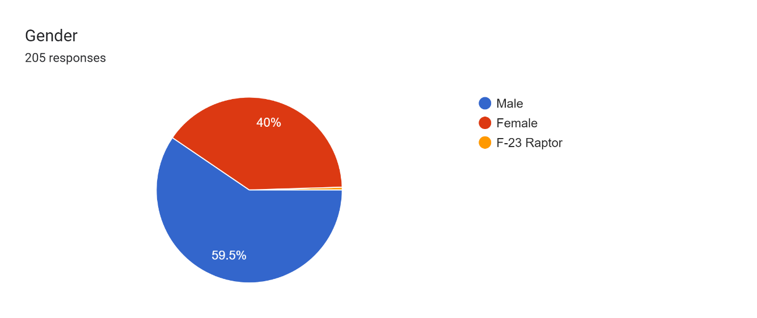

We can see from the graph above that 82 of the respondents were female, making up 40% of the total population, and 122 were male, constituting 59.5% of the overall population. Thus, we may conclude that, out of 205 respondents overall, more men than women responded.

We can see from the graph above that there were 12 responders who were under the age of 18, or 5.9% of the population overall. There were 156 responders (76.1% of the total) in the 18 to 25 age range. There were 31 responses, or 15.1%, who fell between the 25–35 age range. Seven responders, or 3.4%, had more than 35 responses. Thus, we may deduce that there are 156 respondents, or 76.1% of the total, who fall into the 18 to 25 age range.

We might infer from the aforementioned data that 98 out of 205 respondents have monthly incomes of less than $15,000, or 47.8%, of the total.

According to the aforementioned graph, all 205 respondents are from various states, with 23 respondents, or 11.2%, being from Uttar Pradesh.

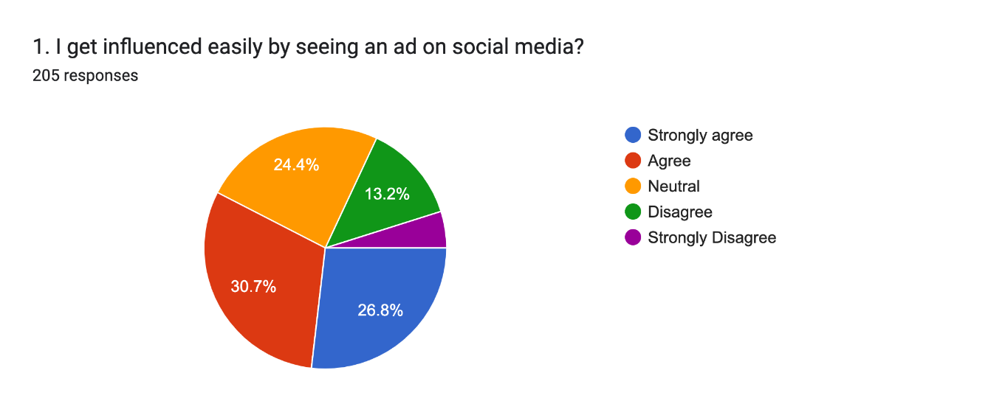

30% of individuals concur that they are heavily affected by social media advertisements that claim consumers are more inclined to purchase things from Instagram.

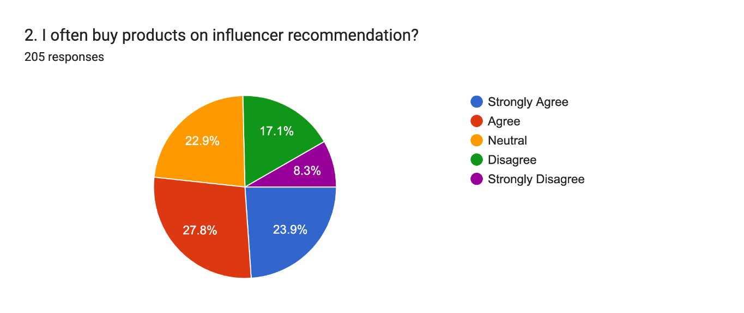

Purchasing a product based on an influencer's recommendation is controversial. The majority however remains in agreement that they are likely to purchase the product from Instagram.

Forms response chart. Question title:  

3. I use Instagram for online purchasing.
. Number of responses: 205 responses.

According to the aforementioned graph, 58 respondents, or 28.3% of the entire population, agree that they use Instagram to make online purchases, while 41 respondents, or 20% of the whole population, highly agree.

According to the aforementioned graph, which shows that 56 persons and 27.3% of people are indifferent about all companies that influencers on social media endorse,

According to the aforementioned graph, 33.2% of respondents, or 68 firms, believe that all brands should invest in influencer marketing.

According to the aforementioned graph, 33.7% of respondents (68 in total) agree that brand influencers' social media activity affects their choice to buy.

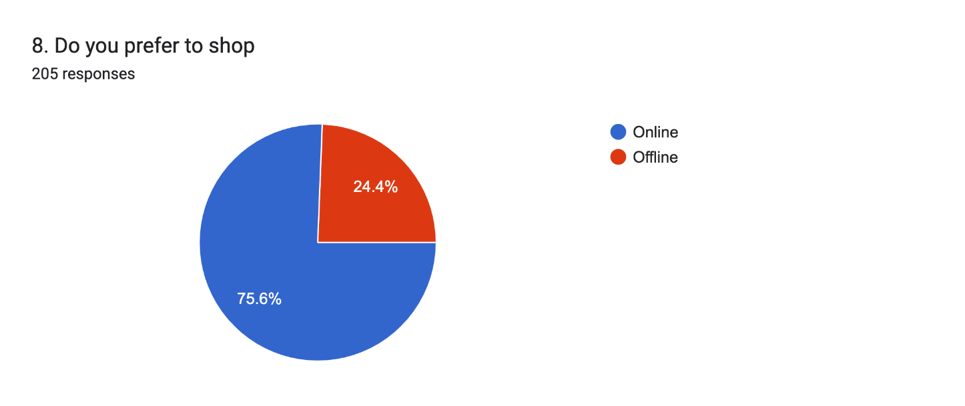

In comparison to physical purchasing, 75% of people prefer to purchase online.

According to the aforementioned graph, 24.4% and 50 individuals strongly believe that they frequently purchase things using Instagram.

According to the aforementioned graph, users are most active on Facebook (125%) followed by Instagram (168), WhatsApp, and then Snapchat (167).

According to the aforementioned graph, 57 individuals (27.8%) dispute that they have different personalities on social networking networks.

Forms response chart. Question title: 12. I firmly believe that social media influences my behavior and actions.
. Number of responses: 205 responses.

According to 31% of people, social media has an impact on their beliefs and behaviour, and they maintain a distinct persona on social media applications than in real life.

The fact that 40% of people admit that they check social media as soon as they get up every morning speaks much about millennials' addiction to utilising social media.

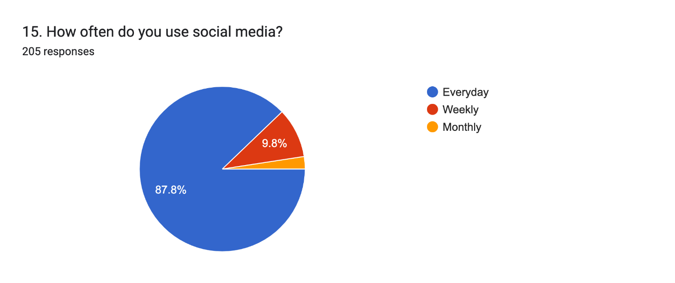

Almost the whole population uses social media everyday which has made it the most growing platform.

According to the aforementioned graph, 46 respondents (or 22.4%) of those surveyed agreed that accessing social media sites made them uneasy.

According to the aforementioned graph, 62 respondents (30.2%) who strongly believe that Instagram negatively impacted their mental health.

The aforementioned graph indicates that 54 respondents (or 26.3%) agreed that they buy things online.

According to the aforementioned graph, 70 respondents (34.1%) of those surveyed concur that all firms pay influencers for influencer marketing.

According to the aforementioned graph, 61 respondents (or 29.8%) firmly feel that they can work on Instagram full-time.

According to the aforementioned graph, 83 respondents (or 40.5%) agreed to the extent that browsing through Instagram makes them happy.

**CHAPTER-5**

**CONCLUSION**

The data mentioned above suggests that people are using Instagram more regularly and maintaining several personalities. Most individuals undoubtedly use Instagram every day. Instagram's use for online shopping isn't as widespread as it is for other social media platforms. Customers do not see Instagram as a means of making good money from online businesses as a result.

Given that the advertisements themselves are merely 15-second long photographs or videos, this shows how Instagram users see the entertainment value of Instagram stories advertising. The responses showed a high and statistically significant association between entertainment and attitude, which was predicted to have a direct relationship. This means that even if the narrative advertisements are just 15 seconds long, millennial respondents can and do find them to be intriguing and increase the perceived value of the advertisement. Because of this, producing intelligent or humorous content will enhance the advertising value for all audiences as well as how Instagram stories advertisements are perceived.

**RECOMMENDATION**

On the basis of the most recent studies on Instagram's impact on Zoomers' social and emotional wellbeing, the following suggestions are made:

* Use Instagram sparingly: To prevent potential harm to your wellbeing, it's best to use Instagram sparingly and to keep your daily usage time to a minimum.
* Be aware of the stuff you consume on Instagram and refrain from engaging with offensive or dangerous material that might hurt your wellbeing.
* Use Instagram to interact with friends and family members and to share memorable moments and pleasant experiences.
* Regularly take pauses from the platform to prevent feeling overburdened or hooked to Instagram.
* If you feel that using Instagram is having a substantial negative effect on your mental health, you should consider seeking treatment from a mental health professional.

It's crucial to keep in mind that these suggestions might not apply to everyone and that Instagram's impact on wellbeing is multifaceted and impacted by a range of elements, including user preferences, usage habits, and material seen.

**FUTURE REASEARCH**

Future studies on Instagram's impact on Zoomers' social and mental health can concentrate on a number of topics:

* Longitudinal studies: Studies that follow people over an extended length of time, or longitudinal studies, can help us better understand the long-term consequences of Instagram use on wellbeing.
* Individual differences: Personality, motivation, and life experiences are just a few examples of individual variations that may play a role in moderating the link between Instagram use and wellbeing.
* Analysis of the content: Material analysis may be used to identify the kinds of content that have favourable or unfavourable impacts on wellbeing.
* Intervention studies: Intervention studies can evaluate the efficacy of measures used to lessen Instagram's detrimental impacts and foster good well-being results.
* Multidisciplinary approaches: Multidisciplinary techniques can offer a more thorough understanding of the link between Instagram use and wellbeing by combining tools from psychology, sociology, and communication.

By focusing on these issues, future study can contribute to a deeper understanding of the nuanced link between Instagram use and wellbeing and the creation of practical tactics for enhancing Zoomers' overall well-being.

**CHAPTER-6**

**REFERENCES**

1. Fatima M., Niazi S., Ghayas S. (2017). Relationship between self-esteem and social anxiety: Role of social connectedness as a mediator. *Pakistan Journal of Social and Clinical Psychology*, 15(2), 12–17.
2. Zorn, Robert L. (2017). Coming in 2017: A new generation of graduate students-The Z Generation. College and University, 92(1), 61-63.
3. Watson, A. (2022). Frequency of using selected news sources among Generation Z in the United States as of February 2022. Statista.
4. **The grass is always greener on my Friends' profiles: The effect of Facebook social comparison on state self-esteem and depression.** Personality and Individual Differences, 147 (2019), pp. 111-117,
5. **The interplay between Facebook use, social comparison, envy, and depression** Current Opinion in Psychology, 9 (2016), pp. 44-49,
6. **The relationship between online social networking and depression: A systematic review of quantitative studies**

Cyberpsychology, Behavior, and Social Networking, 19 (11) (2016), pp. 638-648,

1. **Measuring mobile phone use: Self-report versus log data**

Journal of Computer-Mediated Communication, 18 (2013), pp. 508-519,

1. **What does media use reveal about personality and mental health? An exploratory investigation among German students** PloS One, 13 (1) (2018), Article e0191810
2. **Comparing the mental health of Facebook users and Facebook non-users in an inpatient sample in Germany**

Journal of Affective Disorders, 259 (2019), pp. 376-381,

1. **The impact of posting selfies and gaining feedback (“likes”) on the psychological well-being of 16-25-year-olds: An experimental study** Cyberpsychology: Journal of Psychosocial Research on Cyberspace, 12 (2) (2018),
2. **Depression among users of social networking sites (SNSs): The role of SNS addiction and increased usage**

Journal of Addiction and Preventive Medicine, 107 (2016),

1. **A systematic review: The influence of social media on depression, anxiety and psychological distress in adolescents** International Journal of Adolescence and Youth, 25 (1) (2020), pp. 79-93,
2. Influencer Rates: How Much Do Brands Pay Influencers? (2019, November 7). Retrieved May 20, 2020, from <https://mediakix.com/blog/influencer-rates/>
3. Influencer Report. (n.d.). Retrieved May 4, 2020, from <https://morningconsult.com/influencer-report-engaging-gen-z-and-millennials/>
4. INFLUENCER: meaning in the Cambridge English Dictionary. (n.d.). Retrieved March 7, 2020, from https://dictionary.cambridge.org/dictionary/english/influencer Instagram
5. Branded Content Policy: What Marketers Must Know. (2017, October 5). Retrieved May 20, 2020, from <https://mediakix.com/blog/Instagram-branded-contentpolicy-partnership-tags/>
6. Wallace, T. (2020, April 1). Instagram Shopping: Does It Work? (It Does For These Brands). Retrieved May 20, 2020, from <https://www.bigcommerce.com/blog/Instagramshopping/#how-to-grow-an-engaged-Instagram-audience>
7. Wagner, K., & Molla, R. (2017, September 14). Here's how much social media stars get paid to post ads. Retrieved March 22, 2020, from <https://www.vox.com/2017/9/14/16290536/social-media-how-much-celebrities-makeads-advertising-Instagram-influencer>
8. Wikipedia (2019). Instagram. Diperoleh dari https://id.m.wikipedia.org/, diakses pada tanggal 29 Desember 2019.
9. Barker, S. (2020, January 7). How Social Media Influencers Can Impact Your Customers' Purchase Decisions. Retrieved May 20, 2020, from https://www.Social Media Today.com/news/how-social-media-influencers-can-impact-your-customers-purchasedecisions/569813/
10. Clement, J. (2019, December 3). Instagram: active users 2018. Retrieved March 8, 2020, from <https://www.statista.com/statistics/253577/number-of-monthly-active-Instagramusers/>
11. Clement, J. (2020, April 24). Instagram: age distribution of global audiences 2020. Retrieved May 20, 2020, from <https://www.statista.com/statistics/325587/Instagram-global-agegroup/>
12. Donovan, S. D. S. (2020, February 3). Changing the Game: Influencer Marketing for Generation-Z. Retrieved May 4, 2020, from <https://influencermarketinghub.com/influencer-marketing-for-generation-z/>
13. Essay, B. (2020, March 28). Instagram Influencer Marketing in 2020 (Strategies From a Real Influencer). Retrieved May 20, 2020, from https://www.bigcommerce.com/blog/Instagram-influencer-marketing/#influencermarketing-on-Instagram
14. Eudaimonia. (2017, January 26). How Instagram Started. Retrieved March 14, 2020, from https://medium.com/@obtaineudaimonia/how-Instagram-started-8b907b98a767
15. Finally, W. (2019, September 12). What is the difference between hashtags and tags? Retrieved May 20, 2020, from <https://instazood.com/blog/what-is-the-differencebetween-hashtags-and-tags/>
16. Spitznagel, E. (2020, January 25). Generation Z is bigger than millennials - and they're out to change the world. Retrieved May 20, 2020, from <https://nypost.com/2020/01/25/generation-z-is-bigger-than-millennials-and-theyre-outto-change-the-world/>

**BIBLIOGRAPHY**

We have taken help from different sources:

* Google Scholar
* Wikipedia
* Research paper
* Internet