**Unmanned Aerial Vehicles (UAVs) and LWE**

*Swapnil kumare,Founder,shikvan NGO*

*------------------------------------------------------------------------------------------------------------------------------------------------------------------------------------------------------------------------------------------------------*

Unmanned aerial vehicles, commonly known as UAVs or drones, have revolutionized the way we think about air power. Their range of uses is vast and varied, from military operations to surveillance and reconnaissance. And the technology keeps improving, with newer models boasting longer flight times, more features and greater maneuverability. But UAVs are far more than just a toy or a tool—they can be used to enhance air power in ways that were once impossible. In this blog post, we’ll explore how UAVs are transforming air power by looking at some of their current and potential applications.

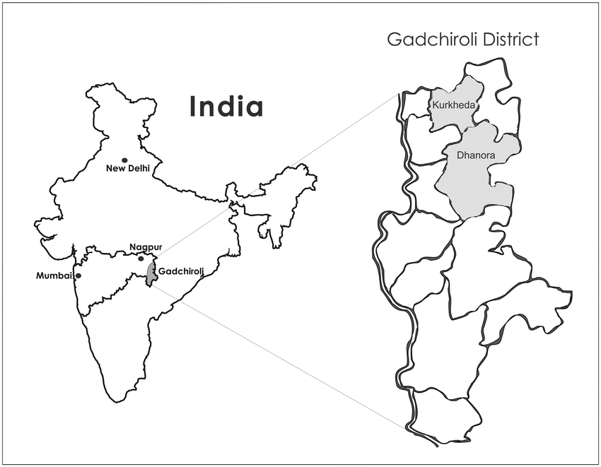**Abstract**

Air power is the use of military aircraft and other flying machines for the purposes of conducting or enabling warfare. Today, air power has evolved to include unmanned aerial vehicles (UAVs), also known as drones.  
  
While UAVs are often associated with intelligence, surveillance, and target acquisition (ISTAR) missions, they are also capable of carrying out airstrikes. In fact, UAVs have been used for this purpose in a number of conflicts, including extremism in the central part of India and insurgency in northeast region.  
  
The use of UAVs for airstrikes raises a number of important questions. First, there is the question of whether or not UAVs are effective at conducting airstrikes. Second, there are concerns about the civilian casualties that can result from using UAVs for airstrikes. Finally, there is the question of whether or not the use of UAVs for airstrikes is ethical.  
  
In order to answer these questions, it is necessary to understand how UAVs are being used for airstrikes and what effect they are having on the battlefield. This article will provide an overview of how UAVs are being used for airstrikes from prevention of naxal attack in Gadchiroli district ,sukama and some part of chattisgarh  and will assess their effectiveness and impact on tribals.

**Introduction**

Unmanned aerial vehicles, or UAVs, have come to revolutionize the way we think about air power. From military operations to agricultural uses, these versatile robots are now a staple in many industries. In this blog post, we’ll explore how UAVs are changing the game when it comes to air power. We’ll also discuss their potential uses and implications for the future of warfare and beyond. So whether you’re interested in military applications or just curious about what the future holds, read on to find out more about unmanned aerial vehicles and their growing impact on modern society.

**Observation**

Unmanned Aerial Vehicles (UAVs) have been used by the US military for over a decade, but their use is not without controversy. Some argue that UAVs are more effective and efficient than traditional aircraft, while others claim that they are less accurate and more prone to collateral damage.  
  
What is clear is that UAVs are here to stay, and their use is only going to increase in the years to come. As such, it's important to understand how they work and what their capabilities are.  
  
UAVs are typically controlled by a ground-based operator who uses a joystick or other similar device to control the aircraft. The operator has a view of the aircraft's surroundings via a camera mounted on the UAV, and can also see any targets that have been identified by the UAV's onboard sensors.  
  
UAVs can be equipped with a variety of weapons, including Hellfire missiles, precision-guided bombs, and even machine guns. They can also be used for reconnaissance missions, or simply to provide surveillance of an area.  
  
UAVs have proven themselves to be valuable assets in combat situations, but they are not without their drawbacks. One major concern is that UAV operators may become too reliant on them, and as such could make decisions that put civilians at risk. Another issue is that UAVs can be hacked, which could lead to them being used against their operators.

**Conclusion**

Unmanned aerial vehicles are revolutionizing air power and modern warfare. They provide a cost-effective option for militaries around the world to conduct reconnaissance, surveillance, and precision strikes without risking of human life. With advancements in technology, UAVs will continue to become more advanced, agile, and autonomous. As they do so, they will undoubtedly play an increasingly important role in 21st century warfare.

**References:-**

1.Dr Shima Keene, "Lethal and Legal? The Ethics of Drone Strikes", *U.S. Army War College -*

**2.**John Croft, "Drone Aids TransAsia Flight 222 Accident Investigation", *Aviation Week*, February 2016, [online] Available: http://aviationweekcom/commercial-aviation/drone-aids-transasia-flight-222-accident-investigation.

**3.**Kim Hartmann and Christoph Steup, "The Vulnerability of UAVs to Cyberattacks", *5th International Conference on Cyber Conflict*, 2013.

**4.**Matt Bishop, "Introduction to Computer Security" in , Boston, USA:Addison-Wesley, 2004.

**5.**Kevin Mitnick, "The Art of Deception: Controlling the Human Element of Security" in , John Wiley & Sons, 2003.

5. <https://indianexpress.com/article/india/after-gap-of-9-months-naxal-drones-seen-in-gadchiroli-again-7430967/>

6. <https://timesofindia.indiatimes.com/city/nagpur/maoists-refute-drone-attack-allegations-claiming-they-have-none/articleshow/85468636.cms>

7. https://gadchiroli.gov.in/