A study on Metaverse implementation in educational platform

Bhaskar Panthri Shreya Ramtirth
Student of MCA Student of MCA Zeal College, Pune, Maharashtra, India Zeal College, Pune, Maharashtra, India
panthribhaskar@gmail.com shreyaramtirth4@gmail.com

Simran Hundani Subodh Awarker
Student of MCA Student of MCA
Zeal College, Pune, Maharashtra, India Zeal College, Pune, Maharashtra, India
Hundanisimran58@gmail.com subodhawarkar786@gmail.com
Dr. B.J Mohite
Head of Department of MCA
Zeal College, Pune, Maharashtra, India
bjmohite@gmail.com

Abstract— The metaverse is a virtual world that can be accessed through the internet, and it has the potential to be used as a platform for education and training. The concept of a metaverse for education refers to the use of virtual reality or other immersive technologies to create a shared, interactive, digital environment that can be used for educational purposes. In a metaverse for education, students and teachers can meet, communicate, and collaborate in a virtual space, rather than being limited to a physical location In the context of education, the metaverse presents an opportunity to create immersive, interactive learning experiences that can supplement or even replace traditional forms of classroom instruction the metaverse provides a variety of tools and resources for creating, sharing and consuming educational content, which can help teachers to design interactive and engaging lessons, and students to learn at their own pace, based on their own interests and needs

Keywords— Metaverse, Augmented/Virtual Reality, Artificial Intelligence, Virtual World, Mixed Reality.

Introduction
In 1992, the metaverse made its debut. Although many people thought the phrase "Metaverse" was new, the idea behind it is not. But all was focused on the Metaverse because of Zuckerberg's press release. A statistical examination of the metaverse technology, which has been debated in the literature since the 1990s, is presented in this paper. For the metaverse, a brand-new and popular topic, a field investigation is specifically conducted. In this approach, descriptive data on journals, organizations, well-known scholars, and countries in the area are offered. Additional evaluation of hot- button issues and highly cited researchers is also provided.

We found that there were few studies in the literature on the historical development of the metaverse, whose popularity peaked in recent months. Additionally, it can be observed that the topic is actively addressed by virtual reality and augmented reality technology, and that the sectors of education and digital marketing are interested in the issue. In the next 15 to 20 years, the metaverse will likely have influenced many aspects of our life, utilizing the possibilities presented by advancing technology.

There are several potential benefits to using a metaverse for education. For example, it can allow students and teachers to interact and engage with educational materials in a more immersive and interactive way, and can provide a more flexible and convenient platform for learning. It can also enable students to access educational resources and experiences that might not be available in their physical location.
There are also some challenges to using a metaverse for education, such as the need to ensure that the virtual environment is accessible and usable by all students, and the need to ensure that it is secure and private. Additionally, there may be technical and logistical issues to consider, such as the need for appropriate hardware and software, and the need to ensure that students and teachers have the necessary skills and knowledge to use the metaverse effectively.
Some of the key characteristics of the metaverse include:
- Persistence: The metaverse is a persistent space, meaning that it exists and evolves over time, even when individual users are not present.
- Interactivity: The metaverse allows users to interact with each other and with virtual objects and environments in real-time.
- Immersion: The metaverse is designed to provide a sense of immersion for users, allowing them to feel as if they are physically present in a virtual world.
- Portability: The metaverse is accessible from a range of devices, including computers, smartphones, and virtual reality headsets, allowing users to access and interact with it from anywhere.

Everything is connected to the Internet, which is referred to as the "Internet of Things" (IoT). Users can transition between the actual and virtual worlds at any moment thanks to its implementation of virtuality and reality. The identity of a user (who am I?) and social connections across two worlds (what is my relationship with them?) will introduce a new way of existence in a metaverse. The Metaverse's fundamental purpose is to facilitate human-computer connection. Its degree of performance directly dictates the limit of human perception, and the limitation determines the Metaverse's usefulness to humans.

Users will have an immersive experience thanks to digital reality. It comprises of 360-degree video, mixed reality, virtual reality, and augmented reality. Humans may exceed the constraints of space and time thanks to this technology. The immersive method may significantly expand comprehension and improve students' study experiences.

Compared to traditional education, the use of the Metaverse in education has a far higher economic value. Everyone in the Metaverse is capable of producing a variety of digital products. Additionally, interactions will be more adaptable and practical (e.g., virtual to virtual and virtual to reality).

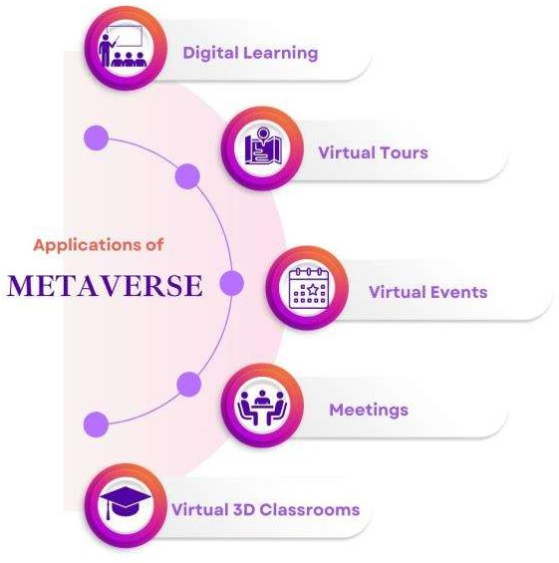
Fig.1. Application of Metaverse in Education

STATEMENT OF PROBLEM

One of the current problems with the education system is the lack of integration of virtual reality and the metaverse into classrooms. While technology has advanced significantly in recent years, many schools and educators have been slow to adopt these new tools and resources for teaching and learning. This has resulted in a disconnect between the real world and the virtual world, and students are not being adequately prepared for the increasing importance of the metaverse in their future careers and personal lives. By not fully embracing the potential of virtual reality and the metaverse in education, we are limiting students' opportunities to learn, explore, and engage with the world around them in a meaningful way. In the view of above researcher decided the topic for in depth study.

RESEARCH OBJECTIVE
- To provide comprehensive review on metaverse learning.
- To clarify the vision of metaverse in learning.
- To increase the effectiveness of the teaching- learning process in order to satisfy the demands of the modern day.
- To make awareness of metaverse for adding values in traditional education system.
- To identify some key challenges and future prospective in metaverse learning.

RESEARCH METHODOLOGY

The research methodology for this work is a systematic literature review (SLR) also comes under Fundamental research. Fundamental research's main goals are the development of theories and generalizations. It looks for information with a variety of uses in order to augment theories already accepted in a certain sector or business.
The purpose of this research is to look into aspects of metaverse to uplift current education system. We used the methods described by Keele, S. (Guidelines for Performing Systematic Literature Reviews in Software Engineering) to ensure objectivity in the context of information selections and outcomes in representations.

Data Collection
For the purpose of the research, we relied on secondary data collection methodology.

Secondary data
Reviewed other published literature and researched journals and also gone through some website to collected proper data regarding metaverse and education implementation.

CONCEPTUAL BACKGROUND

- Why Metaverse for education?
The metaverse is an immersive virtual world that can be accessed via the internet. It has the potential to revolutionize education by providing a new platform for learning and collaboration.
The combination of physically continuous virtual space and virtually improved physical reality, encompassing all virtual worlds, mixed reality, and the internet, results in the creation of the metaverse, a shared virtual environment. In this setting, people may engage in real-time interactions with one another, with virtual items, and with the environment.
Utilizing the metaverse in teaching has a variety of possible advantages. The construction of immersive and interactive learning experiences, for instance, is made possible by the metaverse and has the potential to engage students in ways that more conventional teaching methods might not be able to. Additionally, it may expand the number of students who have access to education who may not otherwise be able to do so, such as those who live in remote areas or who have other transport problems.
Additionally, since students may collaborate virtually on projects and tasks, the metaverse can offer a platform for collaborative learning. Due to the fact that each student may select their own learning route and speed, it can also make it easier to create individualized learning experiences. Overall, the metaverse has the power to transform education by giving students a fresh and cutting- edge approach to engage with instructional material.
The metaverse could be helpful in education for a number of reasons, including:
- Adaptability: Since students may access educational materials at any time and from any location in the metaverse, they can study at their own speed and according to their own schedule.
- Teamwork: Regardless of their geographical locations, students may work together and cooperate on projects in the metaverse.
- Interaction: The immersive aspect of the metaverse can enhance learning by making it more interactive and engaging, which can aid in enhancing memory retention.
- Convenience: Students who may have impairments or who live in rural places with limited access to education may find it easier to complete their education thanks to the metaverse.
- Personal studying: The metaverse makes it possible to design learning experiences that are suited to the requirements and preferences of certain students.

Overall, the metaverse has the power to change education by introducing a brand-new, universally accessible platform for learning and collaboration.

- How Metaverse evolves education?
The metaverse, which includes the total of all virtual worlds, augmented reality, and the internet, is a shared virtual environment generated by the fusion of digitally improved physical reality and physically persistent virtual space. It is a collective virtual shared environment formed by the fusion of physically persistent virtual space and virtually improved physical reality, which includes the total of all virtual worlds, augmented reality, and the internet.
It's possible that the metaverse's development will have a big impact on schooling. The following are some possible effects of the metaverse on education:
- Virtual field trips: Virtual field excursions allow students to virtually go to any area in the globe without ever leaving the classroom, making for a more engaging and hands-on educational experience.
- Collaborative learning environments: Collaborative learning environments: Students might cooperate and complete tasks together.
- Personalized learning: Learning that is more personalized and adaptable might be made possible by the metaverse because students could study at their own speed and in ways that are specific to their needs and interests.
- Virtual internships and job training: Virtual internships and job training: Through virtual internships and job training programmers, the metaverse may provide students chances to develop skills and experience necessary for the real world.

- Traditional education v/s Metaverse education

Traditional education refers to educational systems that typically involve a physical classroom, teacher, and students, who meet in person to learn. This type of education has been the norm for many years and is still widely used today.
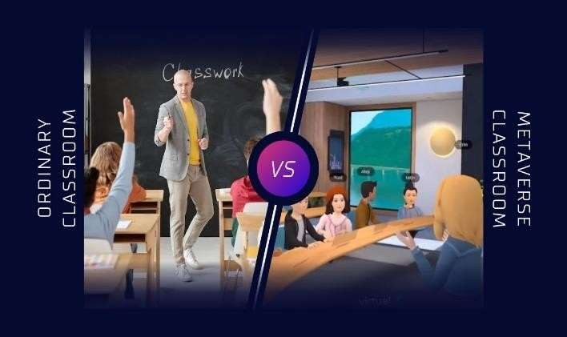

Fig.2. Ordinary Vs Meta Classroom ([11],[12])

II. Proposed Algorithm

Watermark embedding algorithm –

Metaverse education, on the other hand, refers to educational systems that use virtual reality or other immersive technologies to create a "metaverse" or virtual world where students can learn and interact with one another. In a metaverse education system, students may not necessarily be physically present in the same location, and may instead participate in classes and other educational activities from a varied of locations using virtual reality or other immersive technologies.
Both traditional education and metaverse education have their own advantages and disadvantages. Traditional education allows for face-to-face interaction between students and teachers, which can be beneficial for building relationships and fostering a sense of community. However, it can also be limited by geography and other logistical factors. Metaverse education, on the other hand, allows for greater flexibility and access to educational resources, but may not provide the same level of personal interaction and support as traditional education.

Metrics | Traditional education | Metaverse education
Way of teaching | Face to face teaching in the physical mode where students & teachers come together. | Virtual world where students can learn and interact with one another.
Popularity | It is used more. | It has not emerged that much.
Live Experiences | None. | Can give live experiences using technology.
Flexibility | It is not flexible compared to metaverse because need to stay physically at one place. | It is flexible for students who is learning from different locations.
Cost | It needs a lot of infrastructure, investment, etc. | It is virtual world which does not need infrastructure but the cost of VR gadgets matters, requires maintenance.
Technology | None. | Web 3.0
Equipment | Pen, book, paper. | Wearable devices, computers.

Table -1. Difference Table of Traditional and Metaverse education

- Pitfalls of Metaverse

Like any new technology, the metaverse has its own set of challenges and limitations when it comes to education. Here are a few potential drawbacks to consider:
- Accessibility: While the metaverse can increase accessibility for some students, it may not be accessible to all students. For example, students who do not have access to a computer or the internet may be unable to participate in virtual learning.
- Technology issues: Technical difficulties and glitches can be frustrating for students and teachers and may disrupt the learning process.
- Cyberbullying and online safety: As with any online platform, there is a risk of cyberbullying and other online safety concerns in the metaverse. Educators will need to be vigilant about addressing these issues and creating a safe and positive virtual learning environment.
- Limited tactile learning: The metaverse is primarily a visual and auditory learning environment, which means that it may not be as effective for students who learn best through hands-on, tactile experiences.
- Cost: Developing and maintaining a virtual learning environment can be expensive, and schools and educators may need to invest in new technology and infrastructure in order to fully utilize the metaverse for education
There are several potential drawbacks to the use of metaverse platforms on health:
- Physical health problems: Spending long periods of time in virtual reality environments may lead to physical health problems such as eyestrain, neck and back pain, and carpal tunnel syndrome.
- Mental health problems: Some people may become overly reliant on or addicted to the virtual world, leading to negative consequences in their real lives. This can lead to mental health problems such as depression and anxiety.
- Disruptions to sleep: The use of virtual reality technology, especially before bedtime, may disrupt sleep patterns and lead to sleep disorders.
- Social isolation: Spending too much time in virtual environments may lead to social isolation and a decrease in real-world social interactions.
- Loss of touch with reality: Spending too much time in virtual environments may lead people to lose touch with reality and become disconnected from the physical world. This can have negative impacts on mental and emotional well-being.

FINDINGS AND SUGGESTIONS
Findings -
- The metaverse can provide a more immersive and interactive learning experience, as students can engage with content in a more interactive and hands-on way.
- Metaverse allowing students to access educational resources and experiences that might not be available in their physical location.
- There are also challenges to using the metaverse for education, such as the need for specialized hardware and software, and the need to ensure that access to the metaverse is equitable and inclusive.
- Virtual reality (VR) technology can be used to create realistic simulations and environments that can be used for training and learning.
- The metaverse includes persistence, interactivity, immersion, and portability.
- The metaverse has the potential to offer exciting new opportunities for education, but it will be important to approach it with care and consideration to ensure that it is used effectively and inclusively.

Suggestion-
Here are a few technical suggestions for using the metaverse:
- Use a high-quality headset: The quality of your headset can have a big impact on your experience in the metaverse. Look for a headset with a high-resolution display and a wide field of view to get the most immersive experience.
- Check your internet connection: A stable and fast internet connection is essential for a smooth metaverse experience. Make sure you have a strong and reliable connection to avoid lag or other issues.
- Use high-quality audio: Good audio is essential for an immersive metaverse experience. Consider using headphones or earbuds with a built-in microphone to get the best audio quality.
- Keep your software and hardware up to date: Make sure to keep your operating system, drivers, and other software up to date to ensure that you have the best possible metaverse experience.
- Use a virtual private network (VPN): if you are using the metaverse for work or other sensitive activities: A VPN can help to protect your privacy and security while using the metaverse.

CONCLUSION

Despite our best efforts, there may still be certain technologies or concepts that we do not cover in this article while discussing the Metaverse revolution in education. We believe that by examining the Metaverse in education, this paper will provide researchers and professionals with some ideas for future study topics. An outline of how education and the metaverse interact was given in this work. Numerous studies and real-world examples demonstrate that collaborating with Metaverse is a viable strategy for achieving relative equality in educational possibilities. New technologies remove numerous obstacles, such as those related to time, location, and money, and as a result, they resolve problems that are challenging to tackle in the actual world.

Metaverse and education are closely linked and mutually beneficial. The Metaverse needs talented individuals, which education can help cultivate and provide. At the same time, the Metaverse offers a new and promising environment for education, with the potential to address various issues and provide unique visualization opportunities. However, there are also moral considerations and the need for further research in areas such as assessment criteria, governance mechanisms, and the protection of private information.

REFERENCES

- Keele, S. Guidelines for Performing Systematic Literature Reviews in Software Engineering; Technical Report2016,Ver. 2.3 Technical Report; EBSE: Durham, UK, 2007.
- Dr. B. J. Mohite, “Issues and Strategies in Managing E-Waste in India”, Indian Journal of Research in Management, Business and Social Sciences (IJRMBSS), I ISSN No. : 2319-6998 I Vol. 1 I Issue 1 I Mar. 2013.
- Prof. Kirti Samrit, “An Assessment Approach of Intelligent Transportation System using Information Technology: Literature Review ”, at International Conference organised INCON, by IBMR, Chinchwad, dated21 -22nd January 2017.
- Hong Lin , Shicheng Wan , Wensheng Gan , Jiahui Chen , Han-Chieh Chao, “ Metaverse in Education: Vision, Opportunities, and Challenges ” arXiv:2211.14951v1 [cs.CY] 27 Nov 2022.
- Muhammet Damar Dokuz Eylül Universty İzmir, Turkey muhammet.damar@deu.edu.tr “Metaverse Shape of Your Life for Future: A bibliometric snapshot” 0000-0002-3985-3073.
- Julián de la Fuente Prieto , Pilar Lacasa , Rut Martínez-Borda “Approaching metaverses: Mixed reality interfaces in youth media platforms” .
- Ahmed Tlili1, Ronghuai Huang1, Boulus Shehata1, Dejian Liu, Jialu Zhao, Ahmed Hosny Saleh Metwally, Huanhuan Wang, Mouna Denden, Aras Bozkurt, Lik-Hang Lee, Dogus Beyoglu, Fahriye Altinay, Ramesh C. Sharma, Zehra Altinay, Zhisheng Li, Jiahao Liu, Faizan Ahmad, Ying Hu, Soheil Salha, Mourad Abed and Daniel Burgos “Is Metaverse in education a blessing or a curse: a combined content and bibliometric analysis”.
- https://olc.worldbank.org/about-olc/education-meets-
the-metaverse-reimagining-the-future-of-learning.
- https://www.leewayhertz.com/metaverse-in- education.
- https://slejournal.springeropen.com/articles/10.1 186/s40561-022-00205-x.
- https://images.pexels.com/photos/5212342/pexelsph oto5212342.jpeg?auto=compress&cs=tinysrgb&w=1 260 &h=750&dpr=1
- https://blog.cryptostars.is/education-in-metaverse-a-new-dimension-343bb7670c5c

