**FOOD SANITATION AND HYGIENE IN BAKERY**

**–FROM FARM TO FORK**

**DR.D. PADMAVATHI M.Sc., M.Phil., ., Ph.D,**

**Post doctoral research scholar ,Dept of Science&Engineering Srinivas University, Mangalore-** **575001, India**

**Orcid id 0000-0002-2929-471** **Email id : dr.deenapadmavathi@gmail.com**

**Coauthor : DR.Praveen B.M,Director,**

**Research and Innovation Council,Mukka,Mangaluru-574146**

**Karnataka ,India Mobile;9980951074**

**Orcid id:0000-0003-2895-5952**

**Email id : researchdirector@srinivasuniversity.Edu.in**

**Abstract**

 Protecting food from risk of contamination,preventing objectionable matter getting into food, including harmful bacteria, poisons, and foreign bodies. Preventing any bacteria present multiplying to a level which would result in the illness of consumers or the early spoilage of food.Hygiene means to maintain bakery in such a neat and clean condition that there is least possibility of causing contamination. The main purpose of hygiene is not merely to fulfil the rules and regulations of food departments but also to meet the moral obligations to consumer. For bakeries, the main task is to produce bread of the best quality. The bakery industry is gaining a better understanding that there are hazards associated with its products and that the oven, always considered the “great equalizer,” is effective only for some microbial hazards introduced before the oven. This paper reveals the importance of best sanitation and hygienic practices guidelines and suggestions for healthy baking

Keywords:Bakery,Baking,Sanitation,hygiene,health,toxins,microorganisams,food,nutrition.

**Introduction**  
Hygiene is a subject of not only ever-increasing importance but also a matter of essential and absolute necessity in bakery industry. Hygiene means to maintain bakery in such a neat and clean condition that there is least possibility of causing contamination. The main purpose of hygiene is not merely to fulfil the rules and regulations of food departments but also to meet the moral obligations to consumer. In practice it is observed that clean-looking products produced under hygienic conditions always attract the consumers. Hence while organising sanitation programmes, one has to plan for preventive measures rather than corrective approach, i.e., it is better to buildup the bakery building on a plinth to prevent rodent entry rather than to control rodent after finding its evidences. Applying the rules of good hygiene practices in the production process helps to ensure that all raw materials which present contaminations outside of the acceptable limits will not be accepted, that the production respects the right hygiene and manufacturing conditions and the food is protected from the sources of contamination and potential hazards that would make them unproper for consumption. The requirements of hygiene and food safety for the food and for the industry specific for bread and bakery specialties production are stipulated in numerous international, european and national acts, some of them with consultative character, others binding, but all with the purpose to substantiate the quality and food safety of these products and to support the producers to make a correct, efficient processing and with as little as possible negative impact on the consumer [

## Food hygiene is important for the following reasons:

1. If food or drink is not safe to eat, you cannot eat or drink. The easiest example of this is safe drinking water. We would never drink water that did not come from a reputable source. The very same principle applies to food.
2. Every day, people worldwide get sick from the food or drink they consume. Bacteria, viruses and parasites found in food can cause food poisoning.
3. There is no immediate way of telling if food is contaminated because you cannot see, taste or smell anything different from the norm.
4. Food poisoning can lead to gastroenteritis and dehydration or potentially even more serious health problems such as kidney failure and death.
5. This risk is especially significant for those in the high-risk category: Small children/ babies, pregnant moms, the elderly and immunocompromised, especially HIV infections and cancer patients.
6. Food hygiene and safety prevent germs from multiplying in foods and reaching dangerous levels.
7. Ensures daily healthy family living.
8. Keeping one healthy and preventing the additional cost of buying medication and medical check-ups. This is especially important in business. Companies worldwide lose Billions of Dollars per year due to staff downtime.
9. Hand washing accounts for 33% of all related food poisoning cases. It is therefore important to maintain good personal hygiene practice. This is something we are taught early in our childhood, yet hand washing is still a critical problem in the kitchen

**General Sanitation and hygiene guidelines of Food service Institution**  
  
Personal hygiene means the hygiene that deals with individual or personal hygiene or sanitary conditions. Every baker/owner/employee working in a bakery unit has a part to play in the hygienic practices, which will minimise the possibilities of infection through the bakery foods that are prepared. Hence, some recommended measures of personal hygiene intended to prevent the transmission of bacteria harboured in the bowel, nose and throat are discussed below:

**Hands**

* Hands should be washed properly before handling the food material as hand is the most likely source of contamination in food industry. Frequent washing of hand will help remove bacteria so that they cannot reach the processed bakery foods. Hands should be washed with plenty of soap or diluted Hydrochloric acid solution and warm water, followed by rinsing in running water. The basin should be provided near/inside the working premises.
* If the person suffers from any skin diseases like ulcer, pus or even large cut should not be allowed to prepare bakery products. Otherwise the infection may get transmitted to consumer through products.
* Use rubber gloves while working, if possible. But these gloves should be washed with appropriate sanitiser strictly before starting and after finishing the work. Otherwise the gloves themselves may contaminate the food items.
* Baker should not wear hand jewellery (like ring) including wristwatch or bangles. Because the food may stick inside the hand wear even after proper washing of hands, which get contaminated with atmospheric bacteria when baker goes outside the factory and that will contaminate the fresh food while working again.
* Nails should be kept short and scrupulously clean.

**Head**

* The hair should be cut short and kept clean.
* Combing of hair should be avoided in the actual working premises as well as in the sales room.
* Hair should be kept tidy by means of cap or head scarf which covers at least 2/3 part of head. Cap/scarf prevent falling of hair and dandruff into products while preparation which may spread harmful organisms from the lesions of the scalp. A cap/scarf also helps in absorbing the perspiration gathered on forehead which would otherwise find an easy entry in the dough processing. The cap/scarf should be washed at least twice a weak.

**Cloth**

* A light coloured (preferably white) protective uniform clothing (including apron) preferably made up of cotton should be worn while working in bakery. The uniform should be comfortable so it does not obstruct smooth movement while working.
* The uniform should be laundered/washed regularly (at least twice a week). Regular repair and replacement of lost button etc. is also essential.
* All large establishments should be provided with adequate changing rooms, rest rooms and provision for storing clothes and other personal belongings.
* Provision of bathrooms in changing rooms will encourage a high standard of personal cleanliness.

**Human Excreta**

* Disposal of excreta should be proper, quick and far away from the actual working premises.
* Person who suffers from diarrhoea should not be allowed to work in bakery.
* Hands should be washed thoroughly after defecation.

**Habits**

* Fingering the nose/eye/ear/mouth while working should be strictly prohibited as it carries a lot of bacteria, which immediately contaminates the bakery food.
* The mouth or nose should be guarded properly (with handkerchief) while coughing or sneezing because it can discharge number of bacteria suspended in the droplets of moisture.
* While on duty, the use of tobacco in any form should be avoided, because not only the smoke and ash from cigarettes/bidi are harmful but many smokers contaminate their fingers while taking the cigarettes / bidi from their lips. Similarly, while keeping tobacco in mouth for chewing or removing loose pieces of tobacco from mouth also contaminate the food through finger. Other habits such as chewing pan and taking snuff also result in contamination of the fingers.
* Eating of food, drinking of beverages or chewing of gum is also restricted to designated area.

**Hygienic Practices**

* Employees should be encouraged to practice good personal hygiene habit at all times.
* Every bakery should have a first aid box in case of any accidental cuts or burns.
* Periodical as well as incidental medical checkup with health authority should be followed strictly. It is not only a safeguard for the health of a worker but will also protect the health of customers. Because during checkup, if any worker is found suffering from unravelled diseases, he may not be allowed to work in food production which prevents the contamination.
* It is preferable to have health card of each employee.

**Hygienic Awareness**

* Each and every employee (particularly labourer) must get aware of the importance of cleanliness and hygiene. And for that they must receive training on the subject as well as refresher training should also be arranged, periodically.

**Miscellaneous**

* Every employee must have a bath daily.
* Employees’ lunch-boxes, water bags, tiffins and/or personal items are not to be placed in working premises.
* Personal items, such as pens, pencils, thermometer etc. are avoided to carry in production area. Even if it is necessary to carry, it should be kept aside so it does not fall while preparation.
* No persons with obvious boils, sores, infected wound or any other infections or communicable disease is to be permitted for work.
* Responsibility of ensuring compliance of the above requirements should be clearly assigned to the competent authority.

**Sanitation and hygiene in Bakery**

* Bakery proprietors should become familiar with the municipal laws dealing with the sanitary measures and should educate their staff in enforcing them.
* Every precaution should be taken to create perfect conditions of cleanliness.
* The working area must be kept spotless by cleaning all the while.
* Cleaning operations shall be performed in a manner to prevent contamination of materials and products. And for that, principle aim is to make such facilities, which provide minimum hand contact with raw material, machineries etc. And secondly to prevent gross contamination between ingredients and finished food or between refuse and these materials.
* All production equipments and supplies shall be arranged in an orderly fashion. No other equipment should be placed in ingredient storage or production area.
* All equipment and processing should be controlled in such a way that, no excessive physical dust, oil mist or spillage is produced in working or storage area.
* Cleaning equipment like brooms, dustpans etc. should be supplied and be readily available for use as and when required.
* Food contact surfaces i.e. working table, equipment, machineries, and utensils should be washed with detergent/sanitiser, brushed and wiped off before the beginning and after finishing the work. It is necessary to eliminate food residue and maintain a good appearance. At the end of work, it should be kept at proper place in a proper way.
* All cleaning compounds, sanitiser and detergents, insecticides, pesticides etc. should be properly labelled and stored in a locked compartment.
* The entire establishment must supply potable water for cleaning purpose.
* Utensils and intermediate containers may be washed during use (if time permits) or as needed and stored in an inverted position off the floor.
* Pans, trays or other main product equipments shall be cleaned frequently to prevent transfer of carbon particles in the products. Such pans should be stored in an inverted position to prevent contamination by dust etc.
* Pallets and skids are to be kept clean and maintained in good condition. When pallets or other wooden surfaces are washed, they must be properly dried before use.
* Effective measures should be taken to prevent the inclusion of metal, wood, glass or other extraneous materials. This can be accomplished through the use of sifters, magnets, strainers and metal detectors at appropriate locations.
* All dry ingredients should be sifted through 30-mesh screen for finely milled material and 10-mesh screen for all other material, and all liquid ingredients strained before use.
* Single-service containers i.e. paper-egg-tray should not be reused.
* Wash hands signs must be properly displayed in all rest-rooms, lunchrooms, over sink, entry of the production area to prevent contamination through hand, as it is most important source of infection.
* Each person should be responsible for the cleanliness of the area he has been allotted.
* The floor is also to be kept clean, free from dusted flour and leftover pieces of the dough. After finishing the work, the floor must be mopped with hot water and phenyl.
* Any spillage must be immediately wiped and mopped preferably with phenyl etc.
* The greasing of bread pans and the depanning of the bread should be carried out in such a way so as to minimise the possibility of floors getting greasy. After use, the bread pans should be wiped clean and stacked in such a manner so as to avoid the dust getting deposited inside the pans.
* Ingredients should not be stored in the working premises, but should be drawn from the stores as required and should be placed, weighed down for each mixing in suitable clean containers.
* Perishable ingredients such as compressed yeast, milk, fruits etc. should not be left open for long in the bakery. They should be used as quickly as possible preferably immediately after purchase.
* The spoiled ingredients or ready products should be dumped away to prevent the obnoxious odour and contamination getting spread to other materials.
* Bakery products are mostly sterilised by the heat of the oven. Hence, care must be taken to prevent the contamination after baking is over (i.e. while packing, transportation, selling etc.)
* Throw the scrap, wrappers of ingredients or any other garbage in the dustbins provided for that purpose. The garbage can must be cleaned properly by dumping the garbage at appropriate place, and washing after each disposal. Otherwise it may attract flies, cockroaches and mice. Garbage cans made up of plastic with cover are preferred.
* Hot water jetting must be done in drains to avoid logging due to use of flour, sugar and ghee.

**Advantages of Cleanliness: Cleanliness helps not only in selling but also in production.**

* Beneficial in Production: By maintaining clean, well-lighted, ventilated bakery, the efficiency of operations will increase. The bakery employees will be more careful about their work and will be proud of their profession. This will result in the reduction of waste, improvement in quality and quantity of output.
* Beneficial in Selling: Furthermore, cleanliness itself is an advertisement to boost up the sale. If the bakery is kept spotlessly clean, you would not hesitate to invite the housewives to visit the bakery, and witness for themselves the extreme care which is taken in making the baked goods which are available to them fresh daily. Nothing impresses the modern housewife more than thorough cleanliness and neatness. If she is assured that the bakery is operated with the same care that she employs in her own kitchen, she is sure to become your permanent customer. Moreover, she will be induced to buy more and more bakery products. But on the contrary, if the housewife witnesses that no cleanliness is maintained in the bakery, she represents a lost customer and it will be next to impossible to regain. The same condition is applied to the bakery sales room and sales staff.

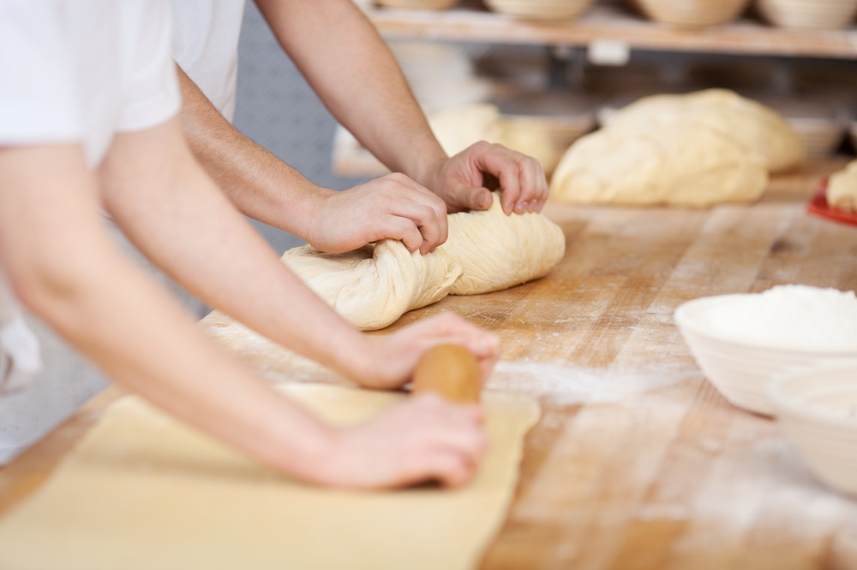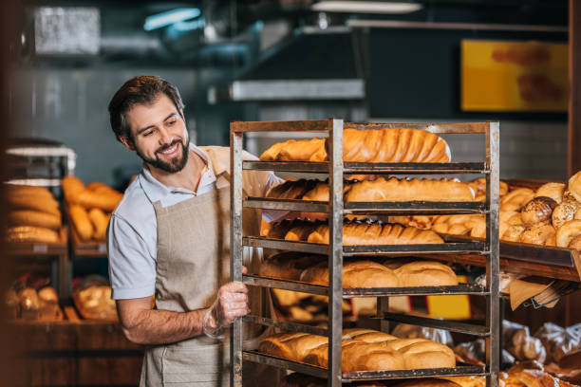 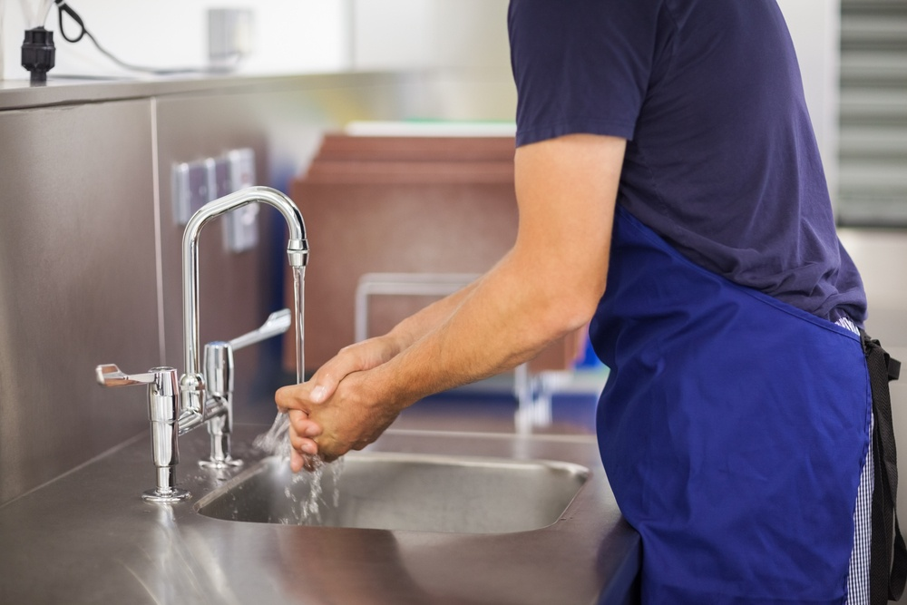

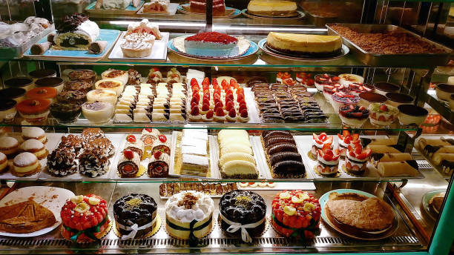

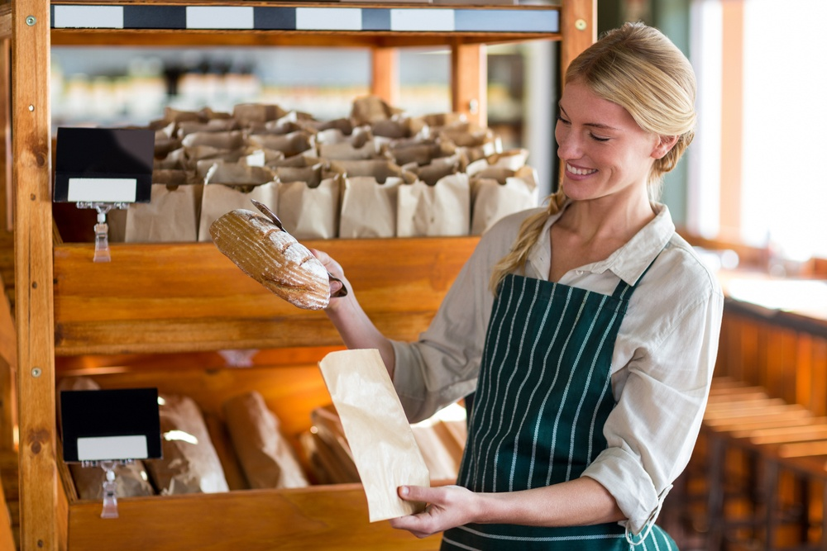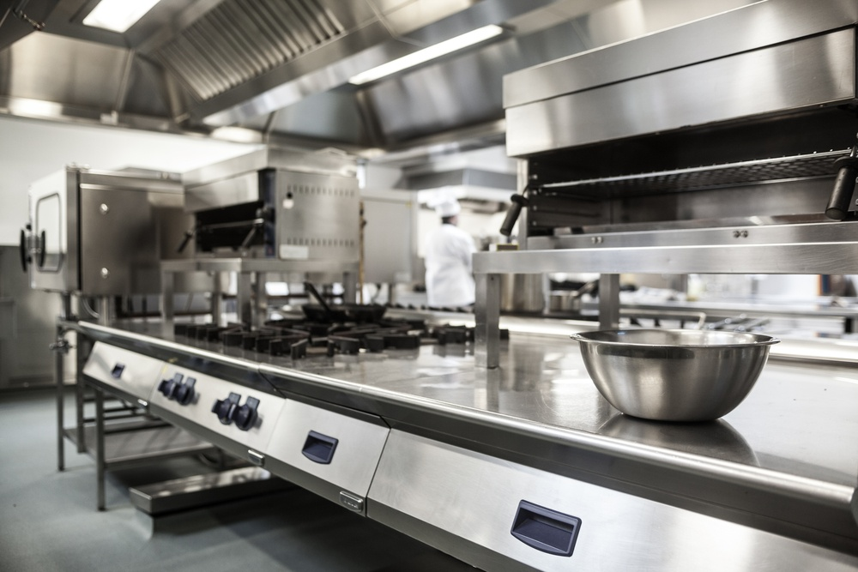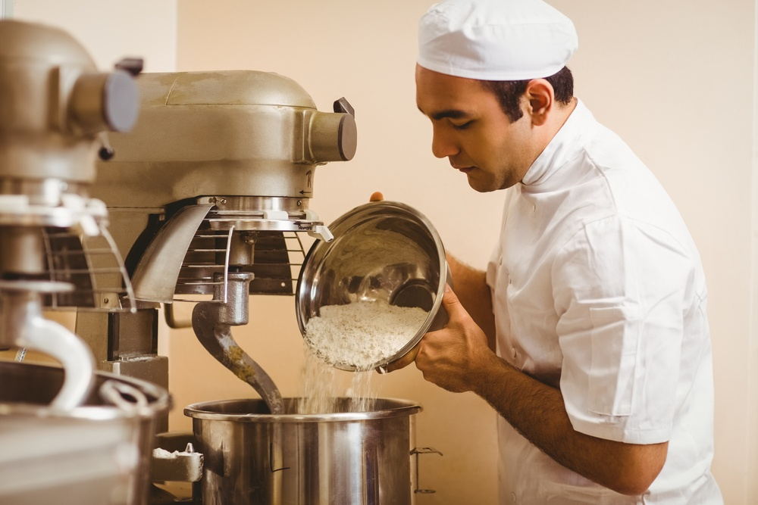

## ****How To Prevent Accident and Injury in a Bakery?****

**Clean.**First of all, no matter how busy you are, make sure your workplace is clean. Water, flour and sugar can create a slippy paste, so make sure surfaces are regularly wiped down. Keep equipment out the way when not being used  so there’s no danger of other bakers tripping over a rogue baking tray.

**Anti-Slip.**Second, with those slippery surfaces, you may want to consider putting down anti-slip mats as well as making sure that floors are mopped regularly and free of standing water.

**Double Duty.**Furthermore, the food itself can cause dangers. Hot sugar and multiple ovens pose risk of burns. Make sure to protect your hands with heavy-duty tea towels (as oven gloves are impractical when you’re moving from task to task). For lifting heavy objects, try and encourage teamwork to cause fewer musculoskeletal injuries as baker injuries can mean lost time and money for both the baker and the bakery.

**Beat the Heat.**For hot environments, consider a cooling system to keep your bakers cool and comfortable. Make sure the clothes, aprons, and hats worn are made of breathable and hygienic fabrics.

**Noise Reduction.**To combat noise, you may want to provide earplugs as an optional feature in the kitchen. You can find some ear plugs that allow a healthy amount of sound through - so you can hear your coworkers - but that protect your ears from harmful decibels.

**Workplace Flow.**Finally, an important safety feature to consider is the placement of mixing equipment and ovens, and how your bakers move around them. Make sure your kitchen has an efficient layout. Speak with the head baker about how everyone moves and works in the kitchen. Having a proper layout of both kitchen equipment and staff makes everything more efficient and safe. Think of hazards that pose risk of injury to your staff, and get together as a team to figure out what equipment you need to prevent injury.

## ****Public Facing Bakery versus Commercial Bakery: How they Differ on Safety****

**Layout.**With smaller bakeries, there may be fewer people to navigate around, so they will automatically be safer than a large-scale bakery in which there are many moving parts. Both types of bakeries need to have efficient layouts - in the kitchen itself and in all areas of the bakery.

**Training.**Where they differ most will be in training and adhering to regulations. The larger the workforce, the more training you’ll need to do for your staff. Also, a well-oiled machine should work smoothly and may need very little communication - for example you might have some bakeries in which the bakers know what to do and when to do it and everything runs smoothly without the head baker having to shout directions to her apprentices and other staff - but in order to get to that level of efficiency, everyone must be properly trained. Training also stops each person being a danger to others. The workplace has enough hazards without an untrained staff member knocking into another causing a chain reaction of negative consequences.**One area that won’t differ is hygiene in the food workplace, it's important to maintain extremely high hygiene standards. When you're working with food, work surfaces and all kitchen utensils need to be clean and steps must be put in place to avoid cross contamination. Also as you’re dealing with food and utensils and potentially customers, it’s really important that all staff keep washing and sterilising their hands regularly to avoid possible cross contamination.**

## ****All Bakers Should Wear Slip-Resistant Shoes At Work:****Slip resistant shoes can improve and maintain health and safety in the bakery; all bakers should wear the correct footwear at all times, and it’s especially important that your footwear prevents slips and provides comfort. Wearing durable footwear means the shoes last longer, and are less costly over time. Furthermore, we have slip-resistant styles that are designed for the catering industry in mind and provide comfort and support to feet and joints.

**Conclusion**  
To conclude, continuous improvement of the sanitation practices and hygienic design of bakeries cannot be accomplished by one group alone. To redesign equipment, OEMs should be working with their customers and with many of their customers’ departments (engineering, production, sanitation, maintenance, safety, etc.) to obtain feedback during the design and building phases. Involving only a few of the departments is likely to lead to further modifications after the quipment is built, adding cost and time to the delivery. The same goes when equipment is scheduled for rebuild or modifications by the bakery; different departments should be working together to improve hygienic design and cleanability that will further improve sanitation efficiency and effectiveness, and, most importantly, reduce risks that could harm consumers.

#### REFERENCES

1. Food and Agriculture Organization of the United Nations, “Climate change unpacking the burden on food safety,” *Food Safety and Quality Series*, 2020.

View at: Google Scholar

1. M. J. Firestone, P. Lee, and C. W. Hedberg, “Improving inclusion and exclusion criteria in foodborne illness outbreak investigations a case study,” *Epidemiology and Infection*, vol. 148, 2020.

View at: Publisher Site | Google Scholar

1. C. E. Thirkell, T. S. Sloan-Gardner, M. C. Kaczmarek, and B. Polkinghorne, “An outbreak of Bacillus cereus toxin-mediated emetic and diarrhoeal syndromes at a restaurant in Canberra, Australia 2018,” *Communicable Diseases Intelligence*, vol. 43, 2019.

View at: Publisher Site | Google Scholar

1. G. Wu, Q. Yuan, L. Wang et al., “Epidemiology of foodborne disease outbreaks from 2011 to 2016 in Shandong Province, China,” *Medicine*, vol. 97, no. 45, article e13142, 2018.

View at: Publisher Site | Google Scholar

1. H. Venkat, J. Matthews, P. Lumadao et al., “Salmonella enterica serotype Javiana infections linked to a seafood restaurant in Maricopa County, Arizona, 2016,” *Journal of Food Protection*, vol. 81, no. 8, pp. 1283–1292, 2018.

View at: Publisher Site | Google Scholar

1. J. S. Nkhebenyane and R. Lues, “The knowledge, attitude, and practices of food handlers in central South African hospices,” *Food Science & Nutrition*, vol. 8, no. 6, pp. 2598–2607, 2020.

View at: Publisher Site | Google Scholar

1. P. S. Toh and A. Birchenough, “Food safety knowledge and attitudes: culture and environment impact on hawkers in Malaysia.: knowledge and attitudes are key attributes of concern in hawker foodhandling practices and outbreaks of food poisoning and their prevention,” *Food Control*, vol. 11, no. 6, pp. 447–452, 2000.

View at: Publisher Site | Google Scholar

1. E. di Giannatale, L. Sacchini, T. Persiani, A. Alessiani, F. Marotta, and K. Zilli, “First outbreak of food poisoning caused by Salmonella enterica subspecies enterica serovar Berta in Italy,” *Letters in Applied Microbiology*, vol. 55, no. 2, pp. 122–127, 2012.

View at: Publisher Site | Google Scholar

1. Y. Liu, Y. H. Tam, J. Yuan et al., “A foodborne outbreak of gastroenteritis caused by Vibrio parahaemolyticus and norovirus through non-seafood vehicle,” *PLoS One*, vol. 10, no. 9, article e0137848, 2015.

View at: Publisher Site | Google Scholar

1. Centers for Disease Control and Prevention, “Foodborne illness outbreaks at retail establishments National Environmental Assessment Reporting System, 16 state and local health departments, 2014–2016,” 2019.

View at: Google Scholar

1. C. N. Rosiane, M. S. Elizandra, and F. B. . S. J. Jackline, “Good hygiene practices and microbiological contamination in commercial restaurants,” *African Journal of Microbiology Research*, vol. 12, no. 16, pp. 362–369, 2018.

View at: Publisher Site | Google Scholar

1. J. A. Tóth, K. Szakmár, A. Dunay, B. C. Illés, and A. Bittsánszky, “Hygiene assessments of school kitchens based on the microbiological status of served food,” *Acta Scientiarum Polonorum Technologia Alimentaria*, vol. 17, no. 2, pp. 159–168, 2018.

View at: Publisher Site | Google Scholar

1. S. Miguéis, C. Santos, C. Saraiva, and A. Esteves, “Evaluation of ready to eat sashimi in northern Portugal restaurants,” *Food Control*, vol. 47, pp. 32–36, 2015.

View at: Publisher Site | Google Scholar

1. W. Y. Low, R. Jani, H. A. Halim, A. A. Alias, and F. M. Moy, “Determinants of food hygiene knowledge among youths: a cross-sectional online study,” *Food Control*, vol. 59, pp. 88–93, 2016.

View at: Publisher Site | Google Scholar