**EMPLOYING HEURISTIC SEARCH MECHANISM AND PLOTTING CONCEPT OF INFORMED SEARCH TO ADDRESS EIGHT PUZZLE PROBLEMS**

**Gaurav D Saxena1, Parmod2**

**1Department of Computer Science, Kamla Nehru Mahavidyalaya, Nagpur, Maharashtra, India**

**2Research Scholar, Department of Computer Science and Engineering, Chaudhary Devi Lal University, Sirsa, Haryana, India**

**ABSTRACT**

The sheer volume of options quickly overwhelms a uniformed control strategy that chooses one random or every node to expand at each stage. The size of this task rises exponentially, making it an NP-complete problem. A search strategy incorporating such information is known as a heuristic search method. Heuristic information is used by many AI systems to lower search costs. These techniques might be quite expensive to uncover because they are frequently successful. Finding effective strategies for problem-solving will be even more crucial as computer power continues to grow. The 8 puzzle problem in this research is solved with the use of the heuristic function. This method seems to be more optimistic because there are just 8 puzzles, as opposed to the infinite number of answers that may be found via an exhaustive search.

**Keywords**: Informed Search, Uniformed Search, Heuristic, 8-puzzle problem

1. **INTRODUCTION**

The concept of artificial intelligence is the idea and creation of systems that can perform different tasks that necessitate human intellect is known as artificial intelligence (AI). Machines can now think, pick up new expertise, and adapt to different circumstances owing to artificial intelligence (AI). It refers to a group of algorithms or computational techniques that try to give computers traits or skills comparable to those held by humans [1,2]. This terminology is mostly employed in sectors involving comprehending and executing intelligent jobs, among others.

Intelligent heuristics are required to efficiently search through data by artificial intelligence systems. This technique relies heavily on heuristic data, which can help with a variety of AI issues. An AI system can calculate the cost of achieving a specified objective from any given condition by using informed searching techniques. Heuristics [4–8] are the name for this function. We might be able to successfully analyze and repair frequent problems with our machines by knowing how these notions interact.

1. **EXPANSION OF INFORMED SEARCH CONCEPT**

We must first define a search problem before starting the heuristic search. A search problem often relates to the state space, starting point, and final goal that we're trying to attain. The solution to this problem typically entails performing actions or employing algorithms to quickly change these variables into one another. Heuristics are techniques that may be used to enhance an algorithm's performance while maintaining a reasonable its efficiency [9–16].

The heuristic search method is a way to make information searches more effective. It accomplishes this by advising which route to take first when several possibilities are available. This occurs, for instance, when the traversal process is started and the initial node is expanded. With the aid of the subject knowledge it includes, you may decide more effectively where to search next to get what you're looking for. I'll describe how heuristic search functions in this part and then give an implementation example so you can understand its effects firsthand.

1. **CONCEPT OF HEURISTIC FUNCTION**

Heuristics are rules of thumb that work well in many cases, but they're not guaranteed to be successful every time. We assess their strength in comparison to other potential heuristic options in order to enhance the likelihood of success. Heuristics can take numerous forms, such as counting the number of tiles that are misplaced when arranging a game board or estimating the separation between two points. We will emphasize the idea of the Number of Misplaced Tiles in this examination.

It is feasible to calculate how far a node is from the objective by using a heuristic evaluation function on that node. Making more informed choices about which nodes to look at throughout the search process is possible with this knowledge. It would be logical for a search strategy to concentrate on looking at this node as the lower the value of this function for a particular node, the more probable it is that that node provides an ideal path towards the objective. [19]

1. **EIGHT-PUZZLE PROBLEM WITH HEURISTIC SEARCH**

Consider a problem which is analogous to the 8 puzzle. In this case, there are nine pieces out that eight of them have numbers from 1-8 assigned to them and one piece (the empty space) has no number. We can move these pieces around by using four possible moves--UP, LEFT, DOWN, RIGHT--to get them into the goal state. For each step we take in solving this problem, our heuristic value changes (henceforth referred to as h).

It normally takes 20 moves to find a solution to a problem. This is due to the search tree's depth, which is approximately 20, and the fact that each node (which represents a choice or potential solution) branches off after taking into account its neighboring nodes. The location of the blank square in relation to other squares on the grid determines the branching factor, which expresses how many choices are looked at before making a final decision. In general, if it's discovered in the middle of the grid, there will be four branching; if it's found close to one edge, there will be three branching; however if it's found in a corner, there will only be two branching. [19]

If all 320 states—or around 3.5 billion—were examined in an exhaustive manner, finding a particular piece of information may take quite a while. This is due to the fact that there are only 9! or 362,880 potential states. This search would be much easier to control and more effective if repetitive state were avoided. [19]

Limiting back on the number of steps needed to find a solution is one technique to enhance problem solving. We may accomplish this with the use of a heuristic search, which gives us an estimate of the number of steps we must take to go from where we are now to where we want to be. In this section, we'll examine a number of potential strategies for the 8-puzzle. [19]

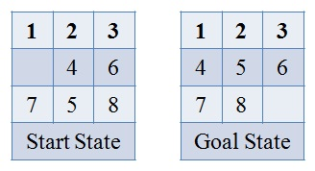

**Figure 1**: Problem Statement (Start & Goal State).

The search problem will be resolved using the chosen heuristic function. The algorithm applies the four operations to the initial state in order to arrive at the intended goal. It then goes through each step along this path to get the heuristic value, compares it to all other states acquired, and selects the most favorable one as its new destination. Making ensuring that the starting point and the intended destination match is crucial while attempting to accomplish a given aim. In this instance, several tiles in the starting state are out of place and don't match up with those in the goal state.

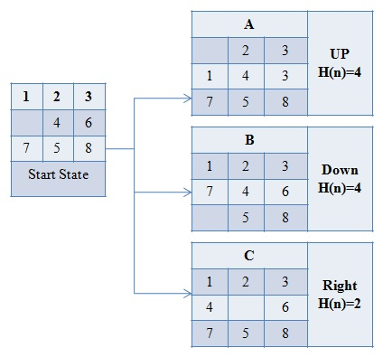

**Figure 2:** Traversing at depth 2

The first step is to move the tile up, so that the newly-obtained state has four misplaced tiles. This can be done by moving it down and right as shown in Figure 2. We compared the obtained state spaces by their heuristic values and conclude that Node C, which has a low heuristic value of 2, should be moved to the right. Then we expand Node C so it has a lower heuristic value of h(n)=2.

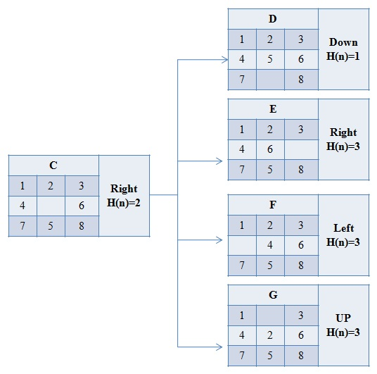

**Figure 3:** Traversing at Depth 3.

After moving the tile down of selected node (Node C), we found that its heuristic value was 1. After moving the tile towards the remaining three directions, our heuristic value at that depth was 3. We then compared this number with all of the state space or nodes obtained and chose Node D as having a less heuristic value than it did when we first entered it into consideration. Moving to Node D will expand out from there in accordance with our chosen algorithm.

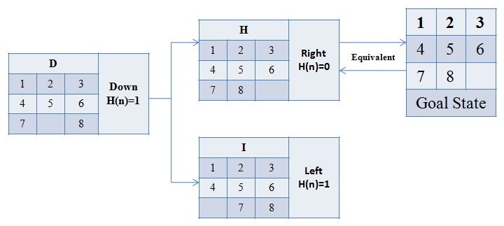

**Figure 4:** Traversing at Depth 4 Reached Goal state with Heuristic information of 0.

After expanding the node selected (Node D) and selecting a tile towards the right, it was seen that this move had no heuristic value- meaning that it reached the goal state or removed any misplaced tiles.

1. **CONCLUSION**

We have found that as in the uniformed search, we need to explore every state at every depth, if we want to find our goal. However, an informed search uses heuristic values about states or nodes which can help us reach our destination more quickly without having to expend too much energy. By using this information, we are able to choose the most efficient path—overcoming one of the drawbacks of uniformed searches.

1. **REFERENCES**
2. Ida AJ. Artificial Intelligence: AI is nearby. Emerging Library Technologies. Chandos Publishing, Witney. 2018: 1-22.
3. Analysis of Ethical Development fpr public policies in the acquisition of ai-based systems.
4. Tzeng CH. A theory of heuristic information in game-tree search. Springer Science & Business Media; 2012 Dec 6.
5. russel and norvig
6. Thorton C, Du Boulay B, Artificial intelligence through search. Springer Science & Business Media; 2012 Dec 6.
7. Ballard DH. An introduction to natural computation. MIT press; 1999 Jan 22.
8. Chopra R. Artificial Intelligence. S. Chand Publishing; 2012.
9. Hidayat W, Susanti F, Wijaya DR. A Comprative Study of Informed and Uniformed Search Algoriths to Solve Eight- Puzzle Problem. Journal of Computer Science. 2021; 17(11): 1147.1156.
10. Jones MT. Artificial Intelligence: a systems approach. Laxmi Publications, Ltd.; 2008.
11. Hasson O, Mayer A, Valtorta M. A new result on the complexity of heuristic estimates for the A* algorithm. Artificial Intelligence1992 May 1; 55(1): 129-43.
12. Tuncer A. 15- Puzzle Problem Solving with the Artificial Bee Colony Algorithm Based on Pattern Database. J. Univers. Comput. Sci.. 2021 Jan 1; 27(6): 635-45.
13. Grosan C, Abraham A. Intelligent systems. Berlin: Springer; 2011.
14. Freeman RH. Searching for a better Plan. George Mason University; 1992.
15. Grosan C, Abraham A. Intelligent Systems. Berlin: Springerl; 2011.
16. Kweon OJ. Using Genetic Algorithms to Solve the Travelling Salesman Problem. Review of Computational Science and Engineering. 2017 Jan; 1: 82.
17. Kulkarni P, Joshi P. Artificial Intelligence: Building Intelligent systems. PHI Learning Pvt. Ltd.; 2015 Feb 26.
18. Konar A. Artificial intelligence and soft computing: behavioral and cognitive modelling of the human brain. CRC press; 2018.
19. Jain VK. Artificial Intelligence Today. BFC Publications. 2022.
20. Coppin B. Artificial intelligence illuminated. Jones & Bartlett Learning; 2004.
21. Reinefeld BA. Complete Solution of the Eight-Puzzle and the Benefit of Node Ordering. InProcs. int. joint Conf. on Ai Chambery Savoi 2010 (pp. 248-253)
22. Mishra AK, Siddalingaswamy PC. Analysis of tree based search techniques for solving 8-puzzle problem. In2017 Innovations in Power and Advanced Computing Technologies (i-PACT) 2017 Apr 21 (pp. 1-5).IEEE
23. Pathak MJ, Patel RL, Rami SP. Comparative analysis of Search Algorithms. International Journal of Computer Applications. 2018; 179(50): 40-3.
24. Garg D. Comparative study of various searching algorithms. InNational Conference on Innovative Trends in Computer Science Engineering (ITCSE-2015) held at BRCMCET, Bahal on 4th Apr 2015.
25. Kapi AY, Sunar MS, Zamiri MN. A review on Informed search algorithms for video games path finding. International Journal. 2020 May; 9(#).
26. Shafique A, Shaukat FS, Qadri AI. Comparative Analysis of Search Algorithms in AI.
27. Lordan AE. A Comparative study of the A* heuristic search algorithm used to solve efficiently in a puzzle game. InIOP Conference Series: Materials Science and Engineering 2018 (Vol. 294, No.1, P. 012049). IO Publishing.
28. Guomundsson Gp. Solving general game playing puzzles using heuristics search (doctoral dissertation).
29. Gayatri P. Performance Analysis of Various Uniformed and Informed SEarch Strategies on 8 Puzzle Problems-A Case study.
30. David DS, S Deepa, Saxena GD, Singhal A, Bhalerao S. An Efficient Algorithm for Extricate Keywords in the text using High Utility Itemset Mining. Dongbei Daxue Xuebao/ Journal of Northeastern University. 2022;25(04):1754-73.
31. C Sharanya, Singhal A, S Balaji, Behera PC, Saxena GD, Dash C. Resourceful Decentralized Intellectual Routing Protocol For Wireless Sensor Networks. Dongbei Daxue Xuebao/ Journal of Northeastern University. 2022;25(04):1951–64.
32. Sharanya C, Gowtham MS, Jaya JA, Somasundaram K, S Balaji, Saxena GD, David DS. Development of Energy Competent Routing Protocol with Anfis Based Optimized Routing in Wireless Multi-Hop Ad Hoc Networks. Journal of Pharmaceutical Negative Results. 2022; 13(09): 5028-44.
33. V Sujatha, Rama Prabha KP, V Nirmalkumar, Dash C, S Karthikeyan, Chauhan A, Saxena GD. An Advancement of human activities Detection based on wireless sensors and Machine Learning. Gongcheng Kexue Yu Jishu/ Advanced Engineering Science. 2022; 54(02): 5855-66
34. Pattnaik SK, Rama Prabha KP, Gowtham MS, D Anandhasilambar, Mohaptra S, S Balaji, Saxena GD. Development of Elegant Parking Platform based on Internet of Things. Gongcheng Kexue Yu Jishu/ Advanced Engineering Science. 2022; 54(02): 6031-42.