**Utilizing a Variety of Bracing Systems for the Purpose of Seismic Retrofitting of RC Buildings**

**Ankit Raj1, Dr. Jyoti Yadav2**

1M. Tech Scholar, Dept. Of Civil Engineering, Sarvepalli Radhakrishnan University, Bhopal, M.P, India

2Assistant Professor, Dept. Of Civil Engineering, Sarvepalli Radhakrishnan University, Bhopal, M.P, India

**Abstract-**In the event of an earthquake, the buildings, which initially looked to have adequate levels of strength, may collapse like houses of cards, and flaws may become apparent. Experience gained from the recent earthquake that occurred in Bhuj in 2001 reveals that the majority of the collapsed structures were found to have deficiencies that prevented them from meeting the criteria of the current construction regulations. In the last 10 years, four of the world's most deadly earthquakes have taken place in India, and our country is routinely shaken by earthquakes with intensities ranging from low to moderate. Since many buildings were severely damaged or completely destroyed as a result of the earthquake, the resilience of framed structures to withstand violent vibrations has been called into doubt. Because of this, ensuring that existing structures are qualified to withstand earthquakes has become an especially pressing concern. Qualification for seismic activity ultimately results in the retrofitting of substandard buildings.

**Keywords: - Bracing Systems, earthquake, substandard buildings, design**

**1. INTRODUCTION**

India now has a big number of structures that are very weak against earthquake forces, and the number of these structures is continually increasing. This was made clear by the recent earthquake. Any old structure that has to be retrofitted is a difficult process that calls for expertise; however, doing so with RC buildings

is especially difficult because of the material's complicated behaviour. Building behaviour during earthquakes is greatly influenced by the placement and detailing of the reinforcement, in addition to the size and quantity of the members and reinforcement. The retrofitting engineer must take into consideration three types of problems that might occur in a building: Damage caused by an earthquake or similar natural disaster, poor design and details, and material degradation with time and usage. The three sources recommend a retrofit plan to address the flaws and show that the building will be able to safely withstand any future earthquake forces anticipated for the duration of the construction. Growing concern is being expressed in particular about the seismic rehabilitation of older concrete buildings in seismically active regions since it is necessary to identify structures that are prone to damage and establish an acceptable degree of safety [1]. As a result, the field of structural engineering has created new design and seismic techniques that take performance-based structures into account and are shifting away from streamlined linear elastic approaches and toward a more non-linear approach. An inelastic process known as the pushover analysis, which is gaining popularity as performance-based regulations for building design or restoration in seismically active places, may be used to determine how vulnerable a structure is to damage. A pushover study is essentially a series of incremental static analyses performed to create a building's capacity curve. A target displacement, or an estimate of the displacement the design earthquake will cause on the structure, is established based on the capacity curve. The magnitude of the building's damage at this target displacement is thought to be typical of the building's damage when exposed to design-level ground shaking. The nonlinear static pushover (NSP) was used in a variety of ways to constructions. These approaches are enumerated.

(1) Capacity Spectrum Method (CSM) (ATC)

(2) Displacement Coefficient Method (DCM) (FEMA-356)

(3) Modal Pushover Analysis (MPA).

The Many scholars have developed the strategy, with just little variations in the calculating process. Due to the potential for highly inelastic behaviour of reinforced concrete structures under seismic loads, the global inelastic performance of RC structures will be dominated by plastic yielding effects, and as a result, the analytical models' ability to capture these effects will have an impact on the pushover analysis's accuracy. In general, there are two basic categories of analytical models for the pushover analysis of frame structures: (1) dispersed plasticity (plastic zone) and (2) concentrated plasticity (plastic hinge). Although the plastic hinge technique is less complicated than the plastic zone approach, it has certain limitations, including the inability to represent the more complex member behaviour that involves significant yielding under the combined acts of compression and bi-axial bending and buckling processes [1].

**• Seismic Retrofitting**

All buildings created before to the enactment of contemporary laws for the construction of structures in seismic zones, those erected before thirty years, or those constructed lately but improperly planned, constructed, or maintained may be candidates for retrofitting. These structures are susceptible to seismic damage. Due to cost constraints, it is not always feasible to reinforce older structures to the degree required by new seismic regulations. The structure must be retrofitted to reach the necessary performance level. Other variables, including as social, cultural, economic, historical, aesthetic, and political, should be addressed in addition to engineering safety [13].

a) Seismic design code requirements are up graded since the design of these buildings is with an older version of the code,

b) Seismic design codes used in their design are deficient,

c) Engineering knowledge makes advances rendering insufficient the previous understanding used in their design, and Existing building can become seismically deficient.

d) Designers lack understanding of the seismic behavior of the structures.

Indian buildings built over the past two decades are deficient because of items (b), (c) and (d) above. The last revision of the Indian seismic code in 1987 IS 1893 (1984) is deficient from many points of view, and engineering knowledge has advanced significantly from what was used. Also, the seismic design was not practiced in most buildings being built [2].

**2. OBJECTIVES OF THE STUDY**

a) To use SAP2000's pushover analysis to examine how an existing RC building responds to seismic loads.

b) To provide a retrofit plan for an existing RC building in accordance with seismic studies.

c) To choose the best retrofitting method for successfully and efficiently withstanding seismic loads.

d) To examine how a standard RC building reacts to seismic stresses compared to a building with energy dissipation devices.

**3. MODELING AND ANALYSIS OF**

**BUILDING**

* **Modeling and Analysis of Building**



Fig. 1 Elevation of Building

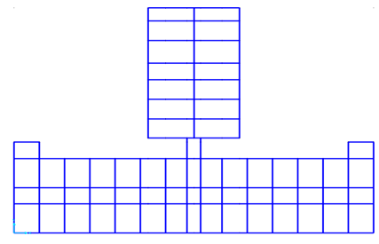

Fig 2: Plan of building

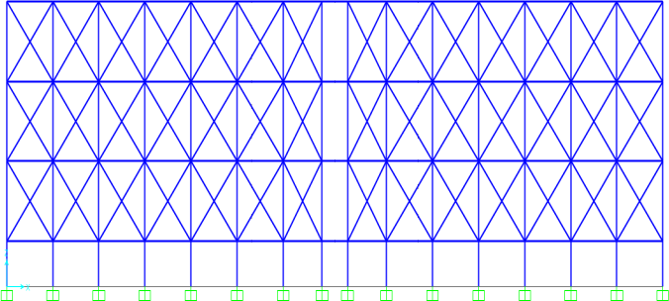

Fig 3: Elevation of X Braced Building

**4. RESULTS AND DISCUSSION**

The non-linear response of an existing RC frame building to loads has been investigated in the current research using SAP 2000. The goal of this research is to examine the load-displacement graph's fluctuation and determine the frame's maximum base shear and displacement. The pushover curve is produced once the analysis and Capacity Spectrum Curve of an Existing Building in X direction are shown in the figures. Additionally, a table that provides the pushover curve's step coordinates and lists the number of hinges in each condition is obtained (for example, between IO, LS, CP or between D and E). The table below displays this data.

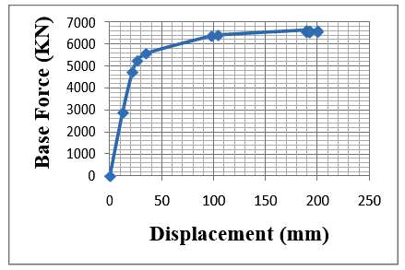

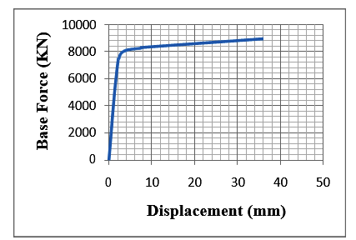

Fig 4: The pushover curve

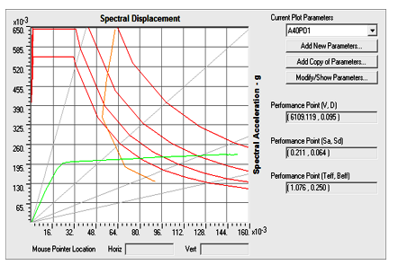

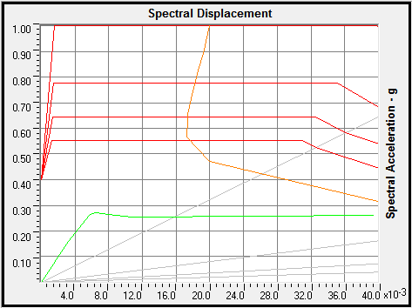

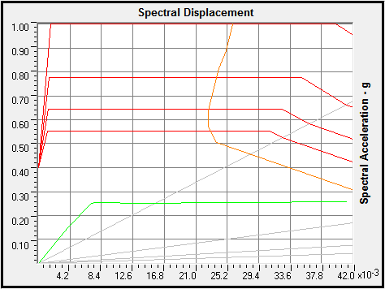

Fig. 5: Capacity Spectrum Curve of an Existing Building in X direction

**5. CONCLUSION**

Based on analysis results following conclusion are drawn

1. In a building without bracing, the joints of the structure showed fast deterioration, and the inter-storey deflections grew quickly in the non-linear zone. Joints on lower levels have suffered severe damage, whilst the first and second floors have only seen mild damage. Roof level has seen some minor damage.

2. The intersection of the demand and capacity curves and the distribution of hinges in the beams and columns show that the behaviour of adequately specified reinforced concrete frame buildings is appropriate. Few hinges formed in the columns and the majority in the beams.

3. The findings on capacity, demand, and plastic hinges provided information about the actual behaviour of buildings.

4. Although the performance factors show a substantial increase, it is seen that inherent flaws in the details of the beam-column joints still show up after bracing systems are provided in the Y-direction. When the system exhibits a negative stiffness, it is necessary to develop adequate performance characteristics.

5. When compared to a braced building structure, the floor displacement is largest when one is not. Floor displacement in a braced

building frame is lowest for X bracing and about same for inclined and inverted V bracing.

6. It is concluded from the foregoing discussion that the deflection of an inclined bracing system is nearly identical to that of X-bracing, inverted V bracing, and base shear, and that base shear is also nearly identical. Therefore, from an economic standpoint, we can provide an inclined bracing system to the structure in order to withstand seismic forces without compromising the strength and stiffness of the structure.

**REFERENCES**

1. Incorporating Different Seismic Retrofitting Techniques and Materials for RC Framed Building Using SAP2000, International Journal of Emerging Trends in Engineering and Development ISSN 2249- 6149 Issue 2, Volume 3. (April-2012).

2. C.V.R. Murty (2002). Seminar on seismic assessment and building retrofitting in Mumbai, February 16, 2002, "Quantitative approach to seismic strengthening of RC frame structures"

3. L.A. Toranzo-Dianderas, W. Huang the 14th World Conference on Earthquake Engineering, held in Beijing, China, from October 12–17, 2008, presented a case study of performance-based seismic evaluation and retrofit of an existing hospital building in California, United States.

4. Giuseppe Oliveto and Massimo Marletta, Seismic Retrofitting of Reinforced Concrete Buildings Using Traditional and Innovative Techniques, ISET Journal of Earthquake Technology, Paper No. 454, Vol. 42, No. 2-3, June-September 2005, pp. 21-46

5. Ghobarah, Rehabilitation of a Reinforced Concrete Frame Using Eccentric Steel Bracing, Engineering Structures Volume. 23 Pages 745–755, 2001.

6. Keiji Kitajima, Hideaki Chikui, Hideaki Ageta and Hajime Yokouchi, Application To Response Control Retrofit Method By Means Of External Damping Braces Using Friction Dampers, 13th World Conference on Earthquake Engineering Vancouver, B.C., Canada August 1-6, 2004 Paper No. 2112

7. Mitsukazu Nakanishi and Hiromi Adachi, Pseudo- Dynamic Test on An Existing R/C School Building Retrofitted with Friction Dampers, 13th World Conference on Earthquake Engineering Vancouver, B.C., Canada August 1-6, 2004 Paper No. 2112

8. N. Lakshmanan, Seismic Evaluation and Retrofitting of Buildings and Structures, ISET Journal of Earthquake Technology, Paper No. 469, Vol. 43, No. 1-2, March-June 2006, pp. 31-48

9. CERONI. Francesca, MANFREDI Gaetano, Maria Rosaria PECCE. A formulation of plastic hinge length in R.C. Columns. Department of Engineering, University of Sannio. Department of Analysis and Structural Design, University of Naples Federico II. 17 May 2007.

10. X.-K. Zou, C.-M. Chan. Optimal seismic performance- based design of reinforced concrete buildings using nonlinear pushover analysis. Department of Civil Engineering, Hong Kong University of Science and Technology, Kowloon, Hong Kong, China. May 2005.