**Analytical Study on Pushover Technique Retrofitting of a Multistory R.C.C. Framed Building**

**Ankit Raj1, Dr. Jyoti Yadav2**

1M. Tech Scholar, Dept. Of Civil Engineering, Sarvepalli Radhakrishnan University, Bhopal, M.P, India

2Assistant Professor, Dept. Of Civil Engineering, Sarvepalli Radhakrishnan University, Bhopal, M.P, India

**Abstract -** The objective of the current research is to ascertain the earthquake load bearing capability of a structure and, as a result, to increase that capacity by making certain suitable retrofitting arrangements. The Non-Linear Static Pushover analysis approach, a performance-based seismic engineering technique, has been applied successfully in this context. Using SAP2000, a product of Computers and Structures International, the pushover analysis was conducted. A total of 28 instances for a specific six-story structure in Zone-IV have been examined, taking into account the retrofitting of various structural components, such as beams and columns, in various combinations and at various storey levels. The retrofitting is carried out starting from the lowest story and working its way up. Every story level's reaction from the building to each scenario is noted.

**Keywords: Performance-based seismic engineering (PBSE), Retrofitting, nonlinear static pushover analysis, Performance level, Finite element analysis, Sap 2000**

1. **INTRODUCTION**

In Pushover analysis, a static horizontal force profile, usually proportional to the design force profiles specified in the codes, is applied to the structure. The force profile is then incremented in small steps and the structure is analyzed at each step. As the loads are increased, the building undergoes yielding at a few locations. Every time such yielding takes place, the structural properties are modified approximately to reflect the yielding. The analysis is continued till the structure collapses, or the building reaches certain level of lateral displacement. The structural capacity under static horizontal loads that increase until the structure collapses is evaluated using a nonlinear approach. Some capacity curves are recognized by the fluctuation of base shear as a function of the displacement of a control point on the structure as the results of the pushover investigations. Performance Based Design is one of the burgeoning topics in seismic design of buildings. The topic is still mostly a research and academic concern, and it is only just beginning to enter the world of practical application. From a stage when a structure's linear elastic analysis was adequate for both its elastic and ductile design to a stage where a particularly designed non-linear process needs to be done, which ultimately effects the seismic design as a whole, seismic design is gradually evolving.

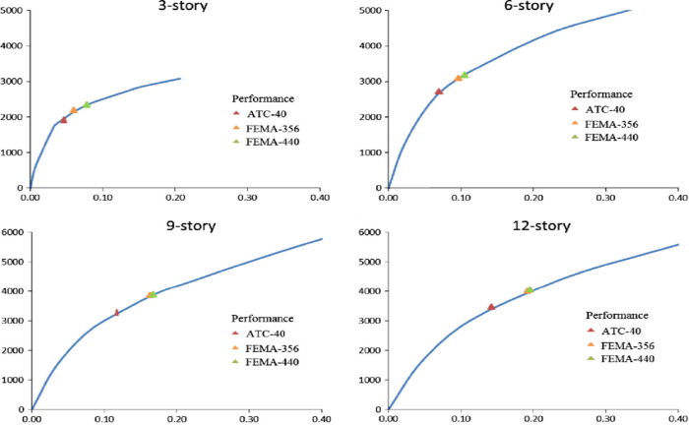

Fig. 1. Inverted Triangular Loading for Pushover

**A. Essential for Pushover Analysis**

Conventionally, seismic assessment and design has relied on linear or equivalent linear (with reduced stiffness) analysis of structural systems. In this approach, simple models are used for various components of the structure, which is subjected to seismic forces evaluated from elastic or design spectra, and reduced by force reduction (or behavior) factors. The ensuing displacements are amplified to account for the reduction of applied forces.

**B. Explanation of Pushover Analysis**

The non-linear static pushover procedure was originally formulated and suggested by two agencies namely, federal emergency management agency (FEMA) and applied technical council (ATC), under their seismic rehabilitation programs and guidelines. This is included in the documents FEMA-273, FEMA-356 and ATC-40.

Methods and design criteria to achieve several different levels and ranges of seismic performance are defined in FEMA 273. The four Building Performance Levels are Collapse Prevention, Life Safety, Immediate Occupancy, and Operational. These levels are discrete points on a continuous scale describing the building’s expected performance, or alternatively, how much damage, economic loss, and disruption may occur.[4]

The three Structural Performance Levels and two Structural Performance Ranges consist of

• Immediate Occupancy Performance Level

• Damage Control Performance Range (extends between Life Safety and Immediate Occupancy Performance Levels)

• Life Safety Performance Level

• Limited Safety Performance Range (extends between Life Safety and Collapse Prevention Performance Levels)

• Collapse Prevention Performance Level

In addition, there is the designation of S-6, Structural Performance Not considered, to cover the situation where only nonstructural improvements are made.

• The four Nonstructural Performance Levels are: Operational Performance Level

• Immediate Occupancy Performance Level

• Life Safety Performance Level

• Hazards Reduced Performance Level

In addition, there is the designation of N-E, Nonstructural Performance Not Considered, to cover the situation where only structural improvements are made.

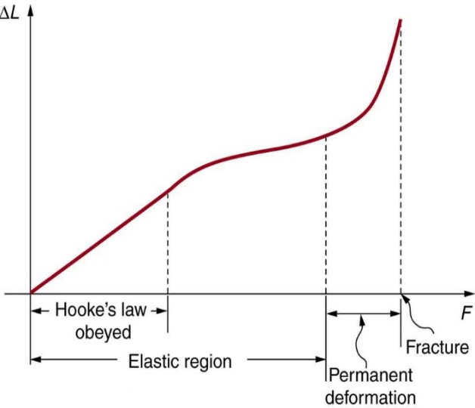

Fig. 2. Force - Deformation Curve [4]

1. **LITRATURE REVIEW**

According to Jong-Wha Bai (August 2002), Seismic retrofitting is an effective method of reducing the risks for existing seismically deficient structures. Numerous intervention techniques are available for improving the seismic behavior of RC building structures. It is important to obtain accurate as-built information and analytical data to perform a seismic evaluation of the existing structure and to select the appropriate retrofitting strategy. A number of experimental and analytical studies focused on seismic retrofitting techniques and extensive seismic damage control activities in practice have contributed to the present state of development. Further research should be conducted to improve the selection of appropriate retrofit techniques using criteria based on performance, economy and constructability [16]. According to Gajjar R. K. et al (2002), pushover Analysis results from powerful softwares can be transferred to virtual reality platforms in order to make the outputs more user friendly and easy to understand, besides making it very simple to re-analayze and observe the end results any number of times, till the user is able to grasp the full impact of his final decision. Virtual reality platforms provide a fantastic opportunity as add-on modules to complex analysis software which generally need a high degree of decision and understanding of behaviour of the structure under consideration even prior to modeling it on the desktop. Instant graphical outputs in virtual reality, bring into focus the errors in primary configuration details, in modeling or in designing. The user can therefore afford to make mistakes and correct them at the touch of a few strokes on the keyboard. As the concept is still in its infancy, and as 3D graphics have been hitherto limited to the highly sophisticated domain of movie animation, the computer time and effort required in creating real-life images seem extremely daunting, but are worth the pain if the expense and amount of on-site rehabilitation and on-table interpretation from innumerable tables and numbers, is borne in mind. The concept of VR can then be extended to the web where other stake holders too sitting across the globe can interact and give valuable inputs towards an optimum and robust solution [13]. Chopra et. al (May 2003), laid down the concept of modal pushover analysis (MPA). They analysisd six SAC buildings, each analyzed for 20 ground motions, and their statistical analysis leads to bias and dispersion in the procedure. The results demonstrated that by including a few “modes” (typically two or three), the height-wise distribution of demands estimated by MPA is generally similar to the “exact” results from nonlinear response history analysis. The MPA procedure estimates seismic story-drift demands to a degree of accuracy that should be sufficient for most building design and retrofit applications [15]. Jain et. al (August 2002), carried out pushover analysis for seismic retrofitting of buildings for a flat slab building. The various retrofitting techniques used by them included jacketing of columns only, providing additional beams and providing both columns jacketing and additional beams. They concluded that jacketing or retrofitting of columns result in a much higher drift capacity. The additional beams significantly reduce softening caused by sagging hinges. But they have a comparatively lower drift capacity. However, jacketing of both beams and columns result into the best response of the system [12].

1. **METHODOLOGY**

The main objective of seismic design of buildings is to avoid total catastrophic damage so that structural damages caused, if any, could be repaired after the earthquake event. Static pushover analysis is an attempt by the structural engineering profession to evaluate the real strength of the structure and it promises to be a useful and effective tool for performance-based design. The following cases in Table 1 have been incorporated in the study.

|  |  |  |
| --- | --- | --- |
| **Sr.**  **No.** | **Case No.** | **Description of Cases** |
| 1 |  | Original structure |
| 2 | 1 | Retrofitting beams of 1st storey only |
| 3 | 2 | Retrofitting columns of 1st storey only |
| 4 | 3 | Retrofitting beams & columns of 1st storey only |
| 5 | 4 | Retrofitting beams of 1st +2nd storey only |
| 6 | 5 | Retrofitting columns of 1st +2nd storey only |
| 7 | 6 | Retrofitting beams & columns of 1st +2nd storey only |
| 8 | 7 | Retrofitting beams of 1st +2nd+3rd storey only |
| 9 | 8 | Retrofitting columns of 1st +2nd+3rd storey only |
| 10 | 9 | Retrofitting beams & columns of 1st +2nd+3rd storey only |
| 11 | 10 | Retrofitting beams of 1st +2nd+3rd+4th storey only |
| 12 | 11 | Retrofitting columns of 1st +2nd+3rd+4th storey  only |
| 13 | 12 | Retrofitting beams & columns of 1st +2nd+3rd+4th storey only |
| 14 | 13 | Retrofitting beams of 1st +2nd+3rd+4th+5th storey only |
| 15 | 14 | Retrofitting columns of 1st +2nd+3rd+4th+5th storey only |
| 16 | 15 | Retrofitting beams & columns of 1st  +2nd+3rd+4th+5th storey only |
| 17 | 16 | Retrofitting beams of 1st +2nd+3rd+4th+5th +6th storey only |
| 18 | 17 | Retrofitting columns of 1st +2nd+3rd+4th+5th +6th storey only |
| 19 | 18 | Retrofitting beams &  columns of 1st  +2nd+3rd+4th+5th +6th storey only |

TABLE 1: Description of various cases

**A. Description of a Building**

In the present work, a six storied reinforced concrete frame building situated in Zone IV, is taken for the purpose of study. The plan area of building is 12 x 12 m with 3.0m as height of each typical storey. It consists of 4 bays of 3m each in X-direction and Z-direction (3 x 4= 12m). Hence, the building is symmetrical about both the axis. The total height of the building is 18m. The building is considered as a Special Moment resisting frame. The retrofitting of frame elements, i.e., Beams and columns is done in various combinations at all the storey levels. The plan of building is shown in fig. 3; the front elevation is shown in fig. 4 and 3d view in fig. 5.

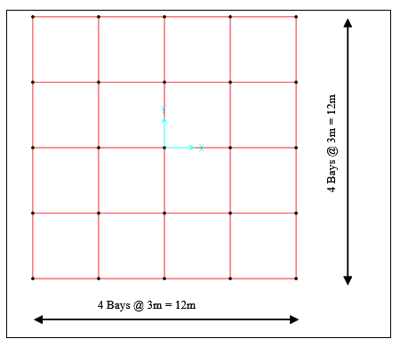

Fig. 3. Plan of Building

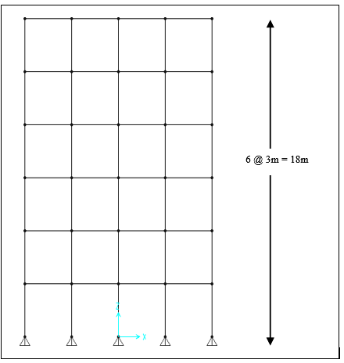

Fig. 4. Elevation of Building

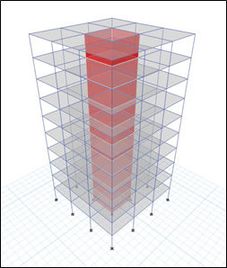

Fig. 5. 3D view of Building

**B. Sectional Properties of Elements**

The sectional properties of elements in case of the original structure are taken as follows: Size of Column = 450 x 450mm, Size of Beam = 0.230 x 300 mm, Thickness of Slab = 125mm thick When the structure was retrofitted, the size of columns was increased to 600x600mm, while that of beam was changes to 300x450mm. A nominal percentage i.e. 1% of the increased area can be provided for the retrofitting purposes.

**C. Loads Considered**

The following loads were considered for the analysis of the building. The loads were taken in accordance with IS:875[1][2].

**D. Gravity Loads**

The intensity of dead load and live load at various floor levels and roof levels considered in the study are listed below [9]. Live load at all floor levels = 3.0 kN/m2 This live load is reduced by 25% for calculating the seismic weight of the structure as per provisions of IS1893:2002(PART 1).

**E. Seismic Loads**

The design lateral force due to earthquake is calculated [11] as follows: Design horizontal seismic coefficient: The design horizontal seismic coefficient Ah for a structure shall be determined by the following expressions: -

Ah = Z I Sa 2 R g

Provided that for any structure with T≤0.1 sec. The value of Ah will not be less than Z/2 whatever the value of R/I.

Z= Zone factor

I = Importance factor depending upon the functional use of the structure.

R = Response reduction factor, depending upon the perceived seismic damage performance of the structure.

Sa /g =Average response acceleration coefficient for rock or soil sites.

* Seismic Weight

The seismic weight of each floor is its full dead load plus appropriate amount of imposed load. While computing the seismic weight of each floor, the weight of columns and walls in a storey shall be equally distributed to the floors above and below the storey. The seismic weight of the whole building is the sum of the seismic weights of all the floors.

* Design Seismic Base Shear

The total design lateral force or seismic base shear (Vh) along any principal direction is determined by the following expression: -

Vh = AhW

Where W is the seismic weight of the building.

* Dead Load At all Floor Levels

Weight of Slab: 0.125 x 25 =3.125 kN/m2

Weight of Screed: 0.050 x 20 =1.000 kN/m2 Weight of Floor Finish: 0.025 x 24 = 0.600 kN/m2 Weight of partition Wall =1.000 kN/m2

Total Dead Load = 5.725 kN/m2

Total Dead Load Taken = 6.0 kN/m2

A wall load of 12kN/m has been applied to all the outer beams at all the floor levels

* Live Load

Fundamental Natural Time Period

The approximate fundamental natural time period of vibration (Ts) in seconds of a moment resisting frame building without brick infill panels may be estimated by the following empirical expressions:

TS = 0.075h0.75 for RC framed building TS = 0.085h0.75 for steel framed building Where h=Height of the building in meters for all other buildings, it is given by: -

Tn = 0.09h/√d

Where h=Height of the building in meters

d= base dimension of the building at the plinth level,in meters, along the considered direction of the lateral force.

* Distribution of design force

The design base shear (Vh) computed is distributed along the height of the building as below:

Qi = Vh Wi hi2

∑Wi hi2

Where,

Qi = design lateral force at each floor level i Wi = seismic weight pf floor i.

i = height of floor i measured from the base.

* Design lateral force

The design lateral force shall first be computed for the building as a whole the design lateral force shall then be distributed to the various floor levels. The design seismic force thus obtained at each floor level, shall then be distributed to individual lateral load resisting elements depending on the floor diaphragm action.

1. **PUSHOVER ANALYSIS USING SAP2000**

The following steps are included in the pushover analysis. Steps 1to 4 are to create the computer model, step 5 runs the analysis, and steps 6 to 10 review the pushover analysis results.

1. Create the basic computer model (without the pushover data) as shown in Figure 6. The graphical interface of SAP2000 makes this quick and easy task. Assigned sectional properties & applies all the gravity loads i.e., Dead load and Live load on the structure [5].

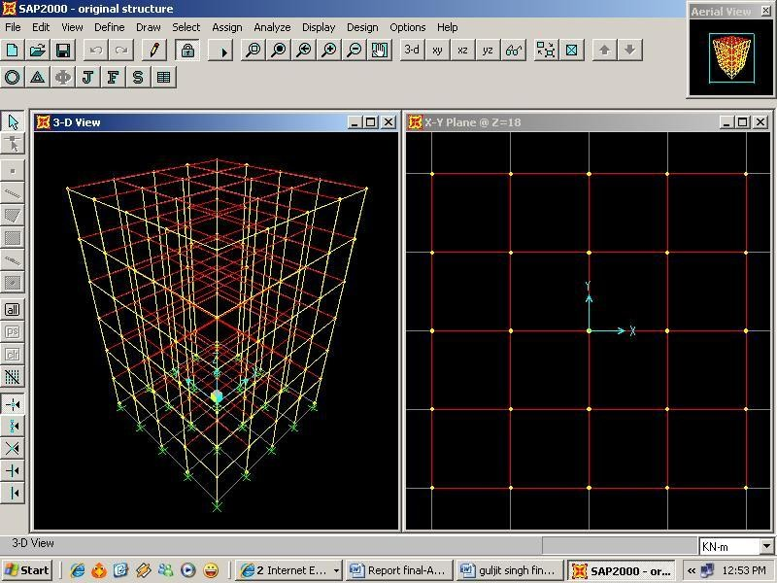

Fig. 6. Basic Model in SAP2000

Define properties and acceptance criteria for the pushover hinges as shown in Figure 7. The program includes several built-in default hinge properties that are based on average values from ATC-40 for concrete members and average values from FEMA-273 for steel members. In this analysis, PMM hinges have been defined at both the column ends and M3 hinges have been defined at both the ends of all the beams.

2. Use the frame components you've selected to locate the pushover hinges on the model by giving them a variety of hinge attributes and placements.

3. Specify the scenarios for pushover loads. In SAP2000, several pushover load cases may be executed concurrently. Another option is to begin a pushover load case from the end circumstances of an earlier pushover load case that was performed as part of the same study. Typically, gravity load was applied using the initial pushover load case, and successive lateral pushover load cases were defined starting from the gravity pushover's ultimate circumstances. Pushover load cases may be pushed to a set force level to control the force, or they can be pushed to a predetermined displacement to control the displacement. Typically, lateral pushovers are displacement controlled, whereas gravity load pushovers are force controlled. A gravity load combination of DL+0.25LL has been employed in this instance. The term GRAV has been assigned to this combo. The case known as PUSHPAT has been subjected to the lateral loads.

4. Start the fundamental static analysis. The static nonlinear pushover analysis was then performed.

5. Control nodes were created for each storey level using the Pushover curve. For this, many pushover instances were defined in the same study, and displacement was tracked for a different node in each case.

6. The pushover curve is shown in Figure 10 as being achieved. Additionally, a table was created that summarises the number of hinges in each condition and provides the coordinates for each step of the pushover curve (for example, between IO and LS, or between D and E).

7. The measured capacity spectrum curve. The updated capacity spectrum graphic may be quickly produced after changing the earthquake's magnitude and damping data on this form. The point at which the capacity curve and the single demand spectrum curve cross is known as the performance point for a particular set of values. Additionally, a table was created that displays the capacity curve's coordinates, the demand curve's coordinates, and other details required to convert the pushover curve to Acceleration-Displacement Response Spectrum format (also known as ADRS format).

8. Step-by-step hinge information, including pushover displacement shape, was gathered.

9. The pushover analysis's output may be produced in tabular form for the whole model or for specific model components. Joint displacements at each pushover step, frame member forces at each pushover step, and hinge force, displacement, and state at each pushover step are among the output kinds that are accessible in this form [5].

**5.RESULT**

**A. Ground Force**

Table 2 presents the base force for the six-story structure with different combinations of element retrofitting at different floor levels. Figure 7 depicts the fluctuation of base force under different retrofitting situations. Observations indicate that upgrading simply the beams results in a relatively small percentage increase in the base force that the structure can support, ranging from 11.9% to 26.93%. With the retrofitting of story columns, there is a significant increase in the structure's base force bearing capability. The percentage change ranges between 15.64 and 98.25 percent. Further, it is noted that retrofitting of columns at the second storey decreases the base force capacity, but retrofitting of columns after the second story results in a significant increase in base force. The retrofitting of beams and columns results in a continuous rise in base force capacity, which becomes more pronounced from the third storey.

|  |  |  |  |  |
| --- | --- | --- | --- | --- |
| RETROFITTI NG LEVEL | CASES | INCREAE  IN  NO. OF  ITERATIONS | BASE  SHEAR  (KN) | %  INCREASE |
| Original  structure |  | 4 | 3049.4314 |  |
| RETROFITT ING UPTO  1st STOREY | CASE 1 | 5 | 3415.1372 | 11.9 |
| CASE 2 | 6 | 3722.8994 | 22.08 |
| CASE 3 | 5 | 3763.8350 | 23.42 |
| RETROFITT ING UPTO  2nd STOREY | CASE 4 | 7 | 3800.3967 | 24.62 |
| CASE 5 | 4 | 3526.5369 | 15.64 |
| CASE 6 | 6 | 3543.8384 | 16.21 |
| RETROFITT ING UPTO 3rd STOREY | CASE 7 | 5 | 3588.6655 | 17.68 |
| CASE 8 | 4 | 3689.0637 | 20.97 |
| CASE 9 | 4 | 3679.8408 | 20.67 |
| RETROFITT ING UPTO  4th STOREY | CASE 10 | 5 | 3646.4312 | 19.57 |
| CASE 11 | 8 | 3848.0723 | 26.18 |
| CASE 12 | 8 | 5204.1719 | 70.66 |
| RETROFITT ING UPTO  5th STOREY | CASE 13 | 6 | 3870.7119 | 26.93 |
| CASE 14 | 6 | 5983.6665 | 96.22 |
| CASE 15 | 8 | 6493.8042 | 112.95 |
| RETROFITT ING UPTO  6th STOREY | CASE 16 | 6 | 3835.5139 | 25.77 |
| CASE 17 | 6 | 6045.7153 | 98.25 |
| CASE 18 | 8 | 6533.5293 | 114.25 |

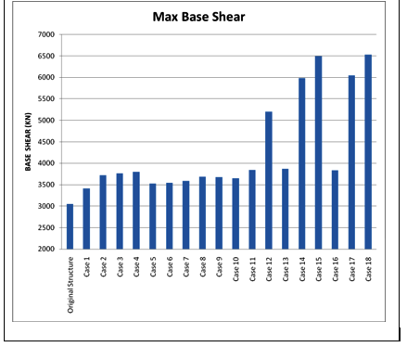Table 2: Comparison of Base Shear

Fig. 7: Variation in base share

**B. Roof Deformation**

presents the Roof displacement for the six-story structure with different combinations of element retrofitting at different floor levels. Figure 8 shows the fluctuation of Roof displacement under several retrofitting scenarios. It is noticed that retrofitting beams alone minimises roof displacement up to the fourth level, after which it slightly increases to the fifth storey (31.16% to 8.05%) and then drops again to 14.23%. This proportion ranges between 31.16 and 8.05 percent. Nevertheless, retrofitting of columns alone reveals a reduction in roof displacement up to the second floor, followed by an increase up to the fifth storey and a modest decrease at the sixth storey. The change in percentage ranges from -8.59% to 102.61 %. The combination of retrofitting beams and columns demonstrates a continuous reduction in roof displacement up to the third floor, an increase up to the fifth storey, and a modest decrease at the sixth storey.

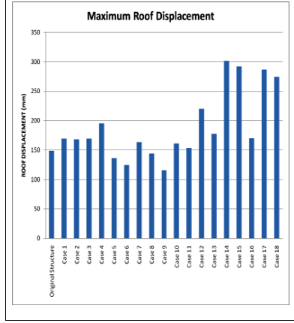

Fig. 8: Variation of Roof Displacement

1. **CONCLUSIONS**

On the basis of this investigation, the following conclusions may be drawn:

1. There is a modest increase in base shear owing to the retrofitting of just beams. Retrofitting the beams results in a modest rise of just 11.9% to 26.93%.

2. The retrofitting of columns leads in a significant improvement in base shear. This increment fluctuates between 15.64 and 98.25 percent. The maximum increase applies only when all columns up to the sixth floor are retrofitted.

3. The retrofitting of both beams and columns increases the base shear of the structure significantly. This range is between 16.21% and 114.25%. Maximum increase of 114.25 percent is achieved when all beams and columns up to the sixth floor are upgraded.

4. The retrofitting of beams minimises roof displacement up to the fourth floor, increases it at the fifth storey, and then decreases it again at the sixth storey of the building. This drop ranges between 31.16 and 8.05 percent.

5. The retrofitting of columns results in a substantial reduction in the maximum roof displacement up to the second floor, followed by an appreciable rise at the fifth storey and a little decrease at the sixth storey, which the structure can safely support. This drop ranges between 102.61 and -8.59 percent. Maximum roof displacement is recorded when all columns up to the fifth floor have been retrofitted.

6. The retrofitting of beams and columns in various combinations causes a drop in roof displacement from 13.90% to -22.16% up to the third floor, a rise from -22.16% to 96.17% up to the fifth floor, and a little decrease at the sixth floor.

**REFERENCES**

[1] IS: 875 (Part I) – 1987, " Code of Practice for Design Loads (Other Than Earthquake) For Buildings and Structures ", Second Edition, Bureau of Indian Standards, New Delhi.

[2] IS: 875 (Part II) – 1987, " Code of Practice for Imposed Loads (Other Than Earthquake) For Buildings and Structures ", Second Revision, Bureau of Indian Standards, New Delhi.

[3] Council for Applied Technology (1996). California's "Seismic Evaluation and Retrofit of Concrete Buildings, Report No. ATC-40."

[4] FEMA (1997), "FEMA 273 – NEHRP Guidelines for the Seismic Rehabilitation of Buildings", Federal Emergency Management Agency, Washington, District of Columbia, United States of America.

[5] SAP2000 (June 1998), "Detailed Tutorial Including Pushover Analysis", Computers and Structures Inc., Berkeley, California, United States.

[6] Ashraf Habibullah and Stephen Pyle (1998), "Practical Three-Dimensional Nonlinear Static Pushover Analysis," Structure Magazine, United States of America.

[7] American Society of Civil Engineers, "Pre-standard and Commentary for the Seismic Rehabilitation of Buildings, FEMA-356," Federal Emergency Management Agency, Washington, DC, 2000.

[8] Chapter 15, Performance-Based Seismic Engineering, Seismic design guide, Farzad Naeim, Hussain Bhatia, and Roy M. Lobo, 2000.

[9] Bureau of Indian Standards, New Delhi, IS 456:2000, "Indian Standard Code of Practice for Plain and Reinforced Concrete," fourth revision.

[10] Gupta, B., and Kunnath, S.K., "Adaptive spectra-based pushover approach for seismic appraisal of buildings," Earthquake Spectra, vol. 16(2), pages 367-391, July 2000.

[11] IS Code 1893-2002(Part 1) "Criteria for Earthquake Resistant Design of Structures (part 1), General requirements and Buildings, Fifth Edition.

[12] Sudhir K. Jain and T. Srikant, "Analysis of seismic retrofitting of structures," published in The Indian Concrete magazine in August 2002.

[13] R. K. Gajjar and S. C. Patodi, "Studying Damage of RCC Columns under Seismic Forces Using Virtual Reality," M.E Thesis, The M.S. University of Baroda, Baroda, India, 2002.