**MARKETING IN THE METAVERSE: AN OPPORTUNITYFOR VIRTUAL MARKETING FOR ZOOMERS (GENZ)**

**Rituraj Singh Sisodiya, Srishti Vaidya**

MBA, Mittal School Of Business, Lovely Professional University, Jalandhar, India

**ABSTRACT**

The "metaverse," an ultra digital environment, has the power to significantly change how brands, businesses, and consumers interact in a seamless connected universe of virtual realities. The capacity of the metaverse is being increased by both individual users' desire to communicate and transact in virtual places and commercial investments of billions of dollars in developing metaverse-related technology. However, because to its rapid expansion, there is a lack of understanding regarding the current extent of the metaverse and the probably attributed for marketing practise and research. To stay relevant, lead their industries, and sway user satisfaction' marketers may take use of the rich interactive stage that the expanding Internet usage offers. Thus, it is thought that understanding how zoomers view virtual marketing would help marketers use the metaverse to influence users' satisfaction. Therefore, the purpose of this study was to comprehend how zoomers view virtual marketing in metaverse as a shift from traditional marketing. In order to accomplish the goals of the study, a quantitative technique was employed to gather and analyse data. A total of 200 people were given questionnaires to complete, and the Statistical Package Jamovi was used to analyse the data. The study's findings indicated a relationship between the characteristics and user happiness, with users finding it simple to communicate with businesses via online marketing.

Keywords: Consumer perception, Online Marketing, Internet,Virtual marketing,

Metavers, Social media,

**1.INTRODUCTION**

Internet penetration has been in bloom in the past decade. Undoubtedly, the Internet has altered a number of facets of human life. Innovations, particularly in information and technology, are the major determinants of improved social and economic situations. A digital presence not only offers new ways to run a business, but it also presents new difficulties for companies looking to implement new technologies and win over and keep their customer's loyalty. Today is the time when technology is evolving at high speed. Spinning around, the metaverse is a concept gaining immense popularity. Going virtual, having a virtual life, the metaverse is an attractive opportunity for digital marketers. Convincing people online has the power of marketing today. While digital marketing is booming today, in the upcoming world, there would be a greater opportunity with Zoomers. To attract Zoomers or better said as generation Z, the best platform is the online mode. With the shift to the metaverse in the era of Zoomers, digital marketing is going to have a huge scope. With the belief that everything can be done online, the metaverse is a concept of building a world online. A whole new world exists virtually, and in that virtual reality, people would be living their lives. A new frontier in the digital world, the metaverse, has recently gained significant interest and funding. Gen Z is defined by more than simply their ideals or societal background because they are the first generation of technologically linked, digital natives. Their actions and attitudes as they mature in this reality have an impact on the experiences and developments in the metaverse. They are entering adulthood, starting careers, and going through their most formative years as a generation, which has prepared them to begin influencing institutions and nations as the leaders of tomorrow. This, together with the fact that they are digital natives, prepares them for a new technical advance: the metaverse, which has the potential to be just as disruptive to how we connect with one another as the Internet was before it. This research will help us understand the effect of digital marketing and its penetration in the generation of Zoomers.

* 1. **Background to the study**

The term "Metaverse" is used frequently these days. The Metaverse aims to give people new experiences in the fascinating virtual universe by fusing virtual reality, augmented reality, sensory technologies, and spatial computing. The Metaverse, however, is a science fiction fantasy that exists naturally rather than just being a virtual reality. It is not constrained by IT firms; it has the potential to create a brand-new global economy. However, as a result of the growth of mobile devices and social networking services that place a focus on convenience and accessibility, consumers who are influenced by social platforms have grown less active in the metaverse (Liffreing, 2021). The Metaverse is viewed as a place where people may go to eat, shop, play games, meet people, attend concerts, and establish a virtual existence by even well-known companies like Nike and others. It would seem that the Metaverse is ready to continuing tearing down platform barriers and bringing together previously divided eco-systems in a brand-new decentralised unity verse. The components that make up Metaverse. Digital money and non-fungible tokens are the key components that make up the economy in the digital era. These are used by users to buy and sell real and digital goods and services, including tickets to events like concerts and entertainment and social gatherings. Moreover, social media and virtual offices allow people to connect, collaborate, and hold conversations.

* 1. **Research problem**

When a firm wants to enter a market, extend its market, or increase sales, it is crucial to consider how consumers perceive the organisation.and create shareholder value, it is crucial to consider how consumers perceive it. Despite the growth and expansion of internet marketing, this does not ensure that consumers would see it favourably or believe it to be a viable option. Consumer buying behaviour in relation to internet marketing provides a clue as to how consumers perceive it, and it also provides businesses with a general consensus on how consumers view virtual marketing. According to the literature, consumers are still disposed toward and extremely interested in virtual marketing. Therefore, the goal of this study is to comprehend how consumers view the metaverse. The study's objectives are listed below.

* 1. **Research objectives**
* To study the penetration effect of digital marketing on zoomers (gen z).
* To study the attitude of zoomers towards virtual marketing.
* To study the comparative study of virtual marketing v/s traditional marketing
  1. **Research questions**
* What is the perception of zoomerse about the convenience of virtual marketing?
* What is the perception of zomerse with regards to metaverse as an effective communication channel for virtual marketing?
* What is the perception of zoomers about the cost effectiveness of virtual marketing?
  1. **Research Methodology**

A survey is used to collect data as part of the quantitative methodology for the study. These techniques make it possible to gather a lot of data rapidly, affordably, and comparatively. Additionally, the quantitative research methodology was chosen because it uses online surveys or sampling procedures to collect numerical data from a certain population of potential viewers to measure the issue. The gathered data can also be put to use for additional in-depth study to learn more about how virtual influencer marketing with Gen Z as the customer segmentation performed. Simple random sampling is the probability sampling technique.The sample size is 200 participants, and the answer rate is 100%. The questionnaire can be answered online by the participants. The survey in- cluded 23 questions aboutthe response background and their knowledge about virtula marketing in metaverse .The response rate is considered sufficient according to (Baruch and Holtom, 2008), a approxi of 35 to 40 percent of the sample size is sufficient to achieve generalization.

The participants also answer about Metaverse information such as brand image, Interface quality, virtual credibilty, UI/UX, Innovation, Enjoyment, Economy flow ,Knowledge. Pool of questions were

prepared forms are multiple choices.

* 1. **Research model**

The purpose of the theoretical framework developed for this study is to comprehend user pleasure in the metaverse through virtual marketing. This model includes elements such as brand perception, interface quality, online trustworthiness, UI/UX, innovation enjoyment, economic flow, and knowledge. This model was chosen because it enables organisations to comprehend consumers' perceptions of how convenient it is to purchase a good or service. Additionally, accessibility and communication are seen as crucial components of marketing.ng.

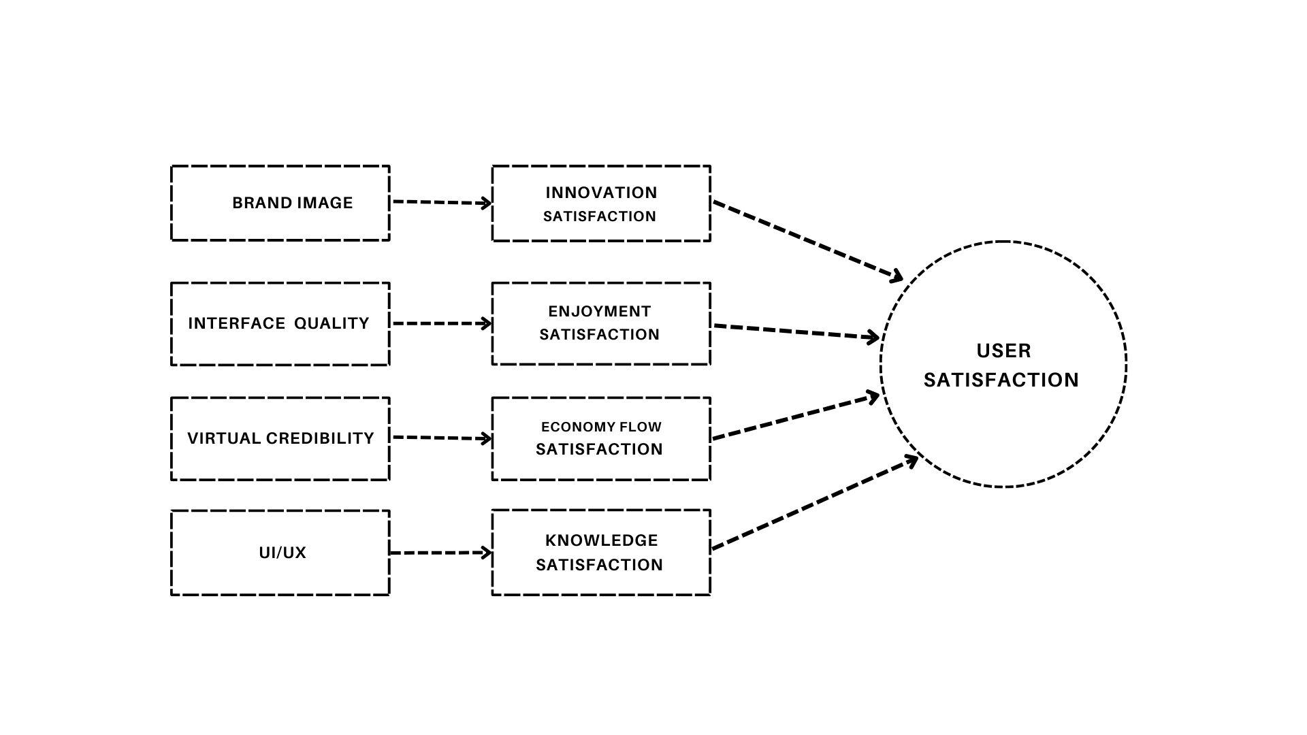

Figure 1: Research model for user satisfaction in Metavers

* 1. **Significance of the study**

Not many research have looked at how consumers perceive virtual marketing, particularly from the perspective of students, in the metaverse. The majority of earlier studies have been undertaken to outline the benefits and drawbacks or difficulties of online marketing. This study is significant since it examines how users perceive their pleasure. Additionally, the study looks at how brand image, interface quality, virtual credibility, UI/UX, innovation, enjoyment, economy flow, and knowledge relate to virtual marketing.

* 1. **Justification for the study**

Studies that examine user satisfaction with virtual marketing in the setting of developing nations are few and far between. The majority of comparable investigations have been carried out in industrialised nations wherein virtual and metaverse technology is well established and used. Therefore, the purpose of this study is to aid organisations in developing nations like India in understanding the idea of virtual marketing. It also serves as a tool for understanding how users perceive the procedures and endeavours of virtual marketing. assisting them in understanding how to handle any challenges this occurrence might put on them.

* 1. **Limitation to the study**

There is only drawback to this study. There are no prior research studies on user satisfaction with virtual marketing, particularly from the standpoint of students. The researcher used study and writing from the field of marketing to remedy this constraint.

1. **LITERATURE REVIEW**

With rising internet usage, virtual marketing has gained more and more importance. Thus, technology is now ingrained in marketing culture. The goal of this research is to discover how people perceive virtual marketing, as indicated in chapter one. Since the discovery of consumer behaviour under the constraints of marketing, these two—virtual marketing and metaverse—have grown in popularity as research topics. This chapter examines and discusses user happiness in the literature while also examining and emphasising virtual marketing for zoomerse.

* 1. **Metaverse**

The term "Metaverse" is frequently used at the moment. Users can have new experiences in an intriguing virtual world thanks to virtual reality, augmented reality, and sensory technology. The Metaverse, however, is a cyberpunk fantasy that truly exists rather than just being a virtual environment. It can create a brand-new global economy and is not constrained by IT firms. Even well-known corporations like Kfc and Samsung see the Metaverse as a location where people can go eat, purchase, play games, meet other people, attend concerts, and create a virtual existence.

* 1. **Marketing in metaverse**

Metaverse has given digital marketing a new dimension despite recent advancements in digital technology and digitalization giving marketers tactical benefits to sell and advertise goods and services. Scavenger hunts and other team-based activities are only two examples of the kind of marketing campaigns that can be made using the metaverse's library of 3D virtual environments. As part of their digital marketing strategy, Epic Games, Samsung, and Tinder are investigating the possibilities of the metaverse to draw in new clients, interact with current ones, and develop a client-centric brand. The accessibility of the future still appears to be rather bright, even though the effects of the virtual world on digital marketing techniques and their success have not yet been observed in the real world.

* 1. **Opportunities**

The opportunity for marketers to promote their goods in the metaverse will also be plentiful. Since Second Life's first introduction in 2003, brands have been using digital billboards, and they will be helpful for increasing exposure in the metaverse. Brands have also introduced NFT  collections, such as Lamborghini paintings and virtual clothes by Adidas, to market oneself in the metaverse and provide a new source of income. Furthermore, social media and virtual offices enable people to connect, collaborate, and hold conversations (Masterson 2022).

* 1. **Virtual marketing**

Marketing strategies carried out online are referred to as virtual marketing, sometimes known as digital marketing. Marketers employ online platforms, tools, and data to build professional networks, attract new business possibilities, and create a brand identity. By addressing a specific audience with tailored messaging, they achieve this. Given that more than half of the world's population utilises the internet, it makes sense to reach people where they are. Virtual marketing has grown essential since it enables businesses in many industries to interact with their clients online. Companies can engage with potential clients whenever they use social media marketing, SEO, email marketing, and other methods on Google, Facebook, and other platforms.

* 1. **Zoomers perception**

Zoomers consider social values more than previous generations did when making purchasing selections. In order to successfully appeal to Zoomers, brands need to demonstrate social consciousness in addition to a strong online presence. Generation Z is especially attracted to businesses that bravely support societal ideals that are consistent with popular customer sentiment. Brands must put their money where their mouth is in order to show that they support a cause. Businesses must integrate ethical social responsibility across their entire branding in order to inspire trust among Zoomers. Gen Z, who make up about 40% of all customers worldwide, spends a large amount of their time online. In actuality, Zoomers have a special relationship with digital technology and are more digitally savvy than any previous generation.

* 1. **Factors affecting User satisfaction**

(X Wang, KF Yuen, CC Teo, and YD Wong, 2021) defined customer satisfaction as the propensity to act or respond to opportunities and judged platform satisfaction by the user's inclination to keep using or suggest it.

* + 1. **Brand image**

In the metaverse are a crucial sector for marketers. Long-term brand success depends on building brand loyalty. In contrast to online blogs or chat rooms, members of the brand community will be able to communicate more successfully and effectively in the metaverse. Additionally, just like in the real world, the metaverse permits the organisation of events and competitions, offering advertisers more opportunities to engage with their target audience. The metaverse's tactical tools may also help in the performance of brand-related actions also providing recommendations for future advancement. The eras Alpha, Z, and Y make up the three main user groups in the metaverse.

* + 1. **Interface quality**

The success of an e-commerce website is determined by the quality of the customer interface, perceived security, and consumer loyalty; however, the relationships between these factors are not comprehended. We developed a model to investigate the links between them and the important website results—A web-based survey was used to collect data for the model's evaluation, and SEM was used for empirical analysis. The analytical findings revealed that customer interface quality and perceived security had a positive effect on customer satisfaction and thus on their commitment to an e commerce. The moderating effect is investigated. More specifically, our research discovered that switching costs positively mitigated the effect of customer satisfaction on customer loyalty.

* + 1. **Virtual credibility**

The internet is the most popular platform for people to share their thoughts on a specific product. It facilitates communication between people and provides a forum for debate on goods and services with other internet users. Online reviews are one type of eWOM (electronic word of mouth) that provide information about goods and services from the consumer's point of view. With the growth of electronic commerce, more people are using online review sites and participating in communities where they can discuss their experiences. The reliability of the messages in this mode of communication is problematic due to the limited customer interactions with the reviewer.

* + 1. **UX/UI**

Architects of UI and UX for Metaverse must understand and achieve the platform's business and client objectives strategically. The Metaverse is more than just an immersive and entertaining platform; it aims to gradually educate people about blockchain and cryptocurrency. Brands are now incorporating this into their games. However, in addition to games, UI and UX designers must offer clients digital approaches that pique their interest in bitcoin. Because the Metaverse is a platform-independent framework that combines design thinking with immersive technology, it is relevant to and used in the Metaverse. Clients will not actually engage as ongoing representatives in the Metaverse unless UI and UX are present. Rather, they will simply be observers. Users will be able to interact with the UI and UX.

* + 1. **Innovation**

Metaverse, the next-generation virtual reality platform, provides customers and businesses all over the world with embodied internet and digital experiences. It is said about the Metaverse that if you believe in it, it may permanently alter the way we live. To elaborate, the Metaverse is a vast virtual environment in which people can imitate real-life activities such as shopping, attending events, and so on. The idea is to use blockchain, web 3.0, VR/AR, and cryptocurrencies to bring the virtual world to the real world, transforming how people connect with one another. The metaverse is the future that everyone is looking forward to. Because no one can avoid it, everyone will eventually become involved in the Metaverse (Reaume 2022).

* + 1. **Knowledge**

In the near future, there may be limitations on the types of digital marketing and promotion you can use in the metaverse. For example, a cookie maker may rely on the aroma of freshly baked chocolate chip cookies to increase sales of their products. Unfortunately, there is no way to detect digital cookies. As a result, certain businesses may need to become more inventive in terms of how they sell their products. However, there is far more flexibility than constraints in the metaverse. To promote a new dinosaur exhibit, a natural history museum, for example, could encourage young visitors to spend the afternoon acting as a "virtual zookeeper," feeding and tending to a virtual newborn Triceratops.

* + 1. **Enjoyment**

B2C businesses are attempting to determine whether there is a way to get consumers to not only experience but also recognise their brand in the Metaverse. It is primarily a play that promotes brand recognition. As an example, Ho used a burrito joint. The restaurant would build a storefront in a busy area of the metaverse where customers could operate. What exactly is the problem? They may prepare a dish or purchase some food to see if anyone orders it. Or they could turn the need for food to "power up" into a game.

* + 1. **Economy flow**

Consumers won't have to depend on intermediaries any longer thanks to blockchain technology. As a result, designers won't require banks, credit cards, or even cash. We'll utilise tokenized electronic money in its place. It will get simpler to securely authenticate identities using the blockchain rather than passwords as blockchain technology advances. As a result, passwords will no longer be necessary. The Metaverse can be utilised as a marketing tool because it enables direct customer interaction for businesses. Users can access virtual stores, play games, go to live events, and more. They can use social media networks to share pictures and videos.

* 1. **Comparison of traditional versus virtual marketing**

Whereas the new strategies will be needed for metaverse marketing, traditional marketing efforts should not be abandoned entirely. Many traditional forms of advertising, such as hoardings and signage on virtual building sides, may still be legal in the metaverse. This is already visible in how major corporations cover digital stadiums in popular video games with digital marketing, just as they would in real life. In the near future, there may be limitations on the types of digital marketing and advertising that can be used in the metaverse. For example, a cookie maker may rely on the aroma of freshly baked chocolate chip cookies to increase sales of their products. Unfortunately, there is no way to detect digital cookies. As a result, some companies may require..

* 1. **Consumer perception and virtual marketing**

It has gotten simpler for businesses and consumers to speak directly about customers' requirements and needs and how enterprises may meet those expectations as virtual marketing has become a significant part of daily life. Customers are more inclined to choose a business if they think it comprehends their demands and has the expertise and resources required to satisfy those needs. Because it produces a win-win situation, this is ideal for them. However, some data hints that brand trust is closely correlated with fulfilment and customer experience.

* 1. **Virtual marketing for zoomers**

The physical and virtual worlds have recently begun to merge. During the First and Second Industrial Revolutions, the separation of material production and consumption was an attempt to increase efficiency. As online transactions become more prevalent in the Third Industrial Revolution, data has become a valuable commodity, and offline transactions are rapidly being supplanted by online ones. The Fourth Industrial Revolution is being described as an intelligent revolution as people and things become more connected than ever before. Production and consumption frequently occur concurrently, as in the case of social customisation.

* 1. **Challenges for marketers in embracing metaverse**

Because digital marketers are skilled at managing content and channels, customer acquisition expenses are reduced. But to use the metaverse, one would need to be conversant with fifth-generation internet connectivity, augmented reality, and virtual reality. Digital marketers may occasionally find it challenging to merge their software and technology skill sets in order to fully capitalise on the power of the metaverse. It must also solve privacy and trustworthiness issues if it wants to win the confidence of its consumers. Basic rules that are adhered to by all parties participating in a business would've been necessary for the usage of virtual money for sales and the appraisal of digital content in the metaverse.

1. **RESEARCH METHODOLOGY**

The research study on user satisfaction, virtual marketing, and the metaverse was covered in the chapter that came before it. The chapter demonstrates how user satisfaction affects the uptake and achievement of virtual marketing. Additionally, it discussed earlier difficulties that were encountered and which affected consumers' impressions. The approach utilised to accomplish the objectives and research questions is defined in this chapter, along with how well it fits the study. The study's goal, to better understand user satisfaction with virtual marketing in the metaverse for zoomerse, was also given in this chapter along with the methods and procedures employed to accomplish it.

* 1. **Research Objectives**

The objective of this study are:

* To study the penetration effect of digital marketing on zoomers (gen z).
* To study the attitude of zoomers towards virtual marketing.
* To study the comparative study of virtual marketing v/s traditional marketing

These objectives were chosen because they helped answer the study's research questions.

* 1. **Research Design**

The analytic, qualitative, hypothetical, or case study research structures or designs are some of the several kinds of research designs which are available to a researcher. Exploratory research is typically carried out when there is a lack of information related to the phenomena under study. On the other hand, a descriptive study is only conducted when it is necessary to comprehend the characteristics of the variables. However, a case study is employed to produce a thorough comprehension of a study. This study employed a case-study research methodology. The case study approach is chosen because it effectively offers a detailed, in-depth, and deeper understanding of the phenomenon, allowing for the chance to increase the body of knowledge.

* 1. **Research Approach**

This study employs the quantitative research methodology. "Quantitative research methods structured observations and statistical, mathematical, or quantitative analysis of data gathered through surveys, questionnaires, and polls, or by utilising well-before statistical data to use computational techniques." The quantitative approach is renowned for its ability to evaluate all controlled variables. The reliability, validity, and generalizability of quantitative research's dimensions is one of its advantages (Cooper and Schindler, 2006)

* 1. **Target population**

The collection of units or individuals with distinctive features in which the researcher is interested in conducting the study is referred to as the target population (Vogt, King and King ,2004). The study's target group consisted of Zoomerse students at the University of LPU who were born in the 1990s or the early 2000s.

* 1. **Data and sample construction**

The data sources, data tool, and quantitative questions were taken into account when devising the data collection method for this study. The literature review provided secondary data sources, such as journals, books, websites, and newspaper stories. Primary data for this research were gathered via a questionnaire. The researcher was able to draw the appropriate conclusion from the questionnaire's questions and aims, which helped the researcher produce findings and suggestions.

* 1. **Sampling**

A sample is a portion of the population picked for a study. It is a portion of the population that is frequently selected by either non-probability or probability techniques. A sample that is picked randomly, giving each unit in the population a chance to be chosen, is known as probability sampling. On the other hand, a non-probability sample size is a sample that wasn't picked at random. As a result, the researcher has a list of specifications in mind for the study subjects. This suggests that not all units will be selected to take part in the study using this sampling methodology.

* Snowball sampling is when a researcher selects a target demographic from the general population and solicits recommendations from that population.
* Purposive sampling is sometimes referred to Judgement sampling technique. This occurs when a researcher has a goal in mind for their study and evaluates the sample unit with that goal in mind while keeping certain qualities in mind, from which point a pertinent sample is selected. In order to accomplish the research goal, the chosen individuals are given the chance to respond to questions.
* Practical sampling. This sampling method often bases the selection of the sample unit that will participate in the study on factors like proximity. This approach is often useful for the researcher.
* According to the definition of "quota sampling," units are chosen based on the ratio of the sample population.

In accordance with the concept provided above, a non-probability sampling was chosen for this study. An easy-to-use sampling technique was used in the study. Given that the writers are also students at the Lovely Professional University in Punjab's Mittal School of Business, the sample was appropriately chosen.

* 1. **Questionnaire design**

A survey was created online and used to collect the data for this investigation. The questionnaire is divided into four main sections. The most crucial section is the one that inquires initially about generation Z membership. They have five options: "from 15 to 21 years," "from 22 to 26 years," "over 27 to 32 years," "32 to 40 years," and "over 40," They can resume the survey if they choose options 2 and 3, else they must stop it now. as the Generation Z Age Bracket in 2023 is around between 11 and 26 years. The second section then inquires about the respondents' gender. In part 3, there are inquiries over the contributing user satisfaction such as brand image, Interface quality, virtual credibilty, UI/UX, Innovation, Enjoyment, Economy flow ,Knowledge. Question forms are multiple choices, rating scales, matrix, image choice.

1. **EMPIRICAL FINDINGS**

Chapter 2 and Chapter 3 of the previous chapter addressed the literature and research technique, respectively. The analysis and explanation of the data are the main topics of this chapter. Data cleaning, conversion, and modelling are all components of the procedure known as data analysis. Its objectives are to draw attention to pertinent facts, offer suggestions, and facilitate decision-making. The data gathered for this study were analysed using the quantitative statistical analysis approach. The analysis of statistical data findings are reported in this chapter, together with an explanation of the results supported by literary references.

* 1. **Findings**

On a 5-point Likert scale, the respondents were asked to rate their opinions of the brand image, Interface quality, virtual credibilty, UI/UX, Innovation, Enjoyment, Economy flow ,Knowledge.

|  |  |  |  |  |
| --- | --- | --- | --- | --- |
| **Agree** | **Highly Agree** | **Neither agree nor disagree** | **Highly Disagree** | **Disagree** |
| 1 | 2 | 3 | 4 | 5 |

Table 1: User Satisfaction scale

* 1. **Reliability of the Questionnaire**

The data collection tool must be consistent and dependable for quantitative research. The Cronbach alpha test was used to gauge the respondents' level of dependability and consistency. Cronbach alpha, which is expressed as a value between 0 and 1, gives the size of the core consistency of a scale check.The items in the questionnaire used in this study were run through a reliability test in Jamovi and a Cronbach alpha of 0.717 was obtained (Table 2).

|  |
| --- |
| **Cronbach's Alpha** |
| 0.717 |

Table 2: Reliability Test

* 1. **Demographics**
     1. **Age**

Above Table 3 shows that out of the 200 participants in the study, 2 of the participants belong to the 15-21, 79 participants belonged to the 22-26 age group, 79 participants were between the ages 27-32 and 4 participants was between the 41 above.

|  |  |  |
| --- | --- | --- |
|  | **Division** | **No. Of people** |
| Age | 15-21 | 2 |
|  | 22-26 | 79 |
|  | 27-32 | 23 |
|  | 32-40 | 6 |
|  | 41 above | 4 |
| Total |  | 117 |

Table 3:Age groups for internet usage

* + 1. **Gender**

Table 4 below reveals that among the 117 respondents, 71% were men and 43% were women, indicating that there were more men than women represented in the study. Similar findings were found in the study conducted by Bae and Lee (2011), which found that there is a gender disparity in Internet usage and that women were considered as high risk and avoided using digital sites. In terms of values, attitudes, and role behaviour, men and women differ. According to the study, men engaged in virtual marketing at a higher rate than women.

|  |  |  |
| --- | --- | --- |
|  | **Division** | **No. Of people** |
| Sex | Male | 71 |
|  | Female | 43 |
| Total |  | 117 |

Table 4:Gender groups for internet usage

* 1. **Analysis of the Data** 
     + 1. **Time spent on the internet**

In Table 5, participants  were asked to identify how much time they often spend online. Of the 117 respondents, 0% spent less than 1 hour online, 33% spent 2–3 hours online, 45% spent 4–6 hours online, 31% spent 7–10 hours online, and 5% spent 11 hours or more online. The majority of respondents said they spent 4-6 hours online.

|  |  |
| --- | --- |
| **Division** | **No. Of people** |
| 0-1 hours | 0 |
| 2-3 hours | 33 |
| 4-6 hours | 45 |
| 7-10 hours | 31 |
| 11 or more hours | 5 |
| Total | 117 |

Table 5: Time spent on the internet

**Exploratory Factor Analysis**

|  |  |  |
| --- | --- | --- |
| **Measured variable** | **Variable** | **Factors** |
| **Brand image** | I believe in products that are endorsed by my favourite celebrities | 0.649 |
| I buy only branded products | 0.619 |
| Association of product with a particular group of company lead me to preference for such products | 0.852 |
| I have trust on branded products. | 0.804 |
| **Interface Quality** | I think brand advertising through virtual platforms and virtual influencer is good for brand. | 0.679 |
| If I will come up with an engagement to buy a product advertise in metaverse | 0.748 |
| **Virtual Credibility** | I can buy a product on metaverse platform | 0.683 |
|  | I trust metaverse for buying products | 0.544 |
| **UI/UX** | I think metaverse is best to provide clear visual representation of product. | 0.544 |
| Virtual marketing has changed my way of purchasing behavior | 0.705 |
| **Innovation** | I will use metaverse for purchasing or business purpose | 0.411 |
| I will recommend virtual platforms to others also to use in business and online purchasing | 0.165 |
| **Enjoyment** | If there is increment in price I will stick for same product. | 0.868 |
| I am a price sensitive customer. | 0.367 |
| **Knowledge** | I know about all virtual platforms that sell products. | 0.875 |
| I prefer real human influencer | 0.700 |
| I do not know that virtual influencer exits | 0.157 |
| I have not interest in virtual influencer and metaverse | 0.370 |

Table 6:Exploratory Factor Analysis

To go forward with a validity assessment for each factor, a validity study of the parameters as well as confirmatory and exploratory factor analyses were carried out. Whenever the sample group was 100 or more, Fabrigar conducted a validity evaluation, and when there were at least 5 measurement elements in the sample, it produced the desired results. Therefore, omitting the demographic question items, the latest research had 18 questions, and as previously noted, a factor analysis was done on the valid sample. According to Table 6, which lists the findings of the factor analysis, the user satisfaction model component's Kaiser-Meyer-Olkin (KMO) value was 0.656.

**Bartlett’s test**

According to Table 5, the independent variables' Bartlett sphericity test result was 1296.026, the significant value was 0.000, and the Kmo of the user satisfaction  element was 0.793.

|  |  |  |  |
| --- | --- | --- | --- |
| **X2** | **df** | **p** | **KMO** |
| 614 | 190 | <0.01 | 0.797 |

Table 7:Bartlett’s test

**Confirmatory Factor Analysis**

A statistical method called confirmatory analysis (CFA) is used to confirm the factor structure of a collection of observed variables. CFA is being used by the study to test the idea that there is a connection between the variables that may be observed and the latent conceptions that underlie them.

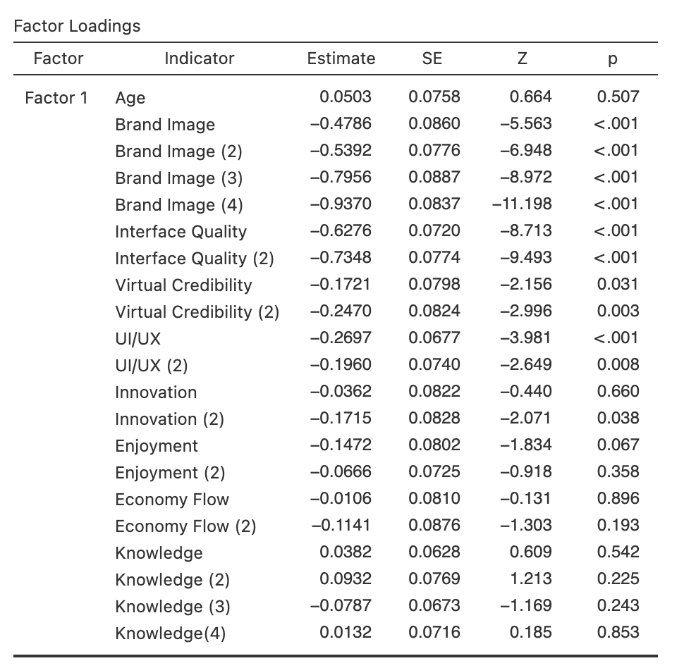

Table 8:Confirmatory Factor Analysis

**Correlation Matrix**

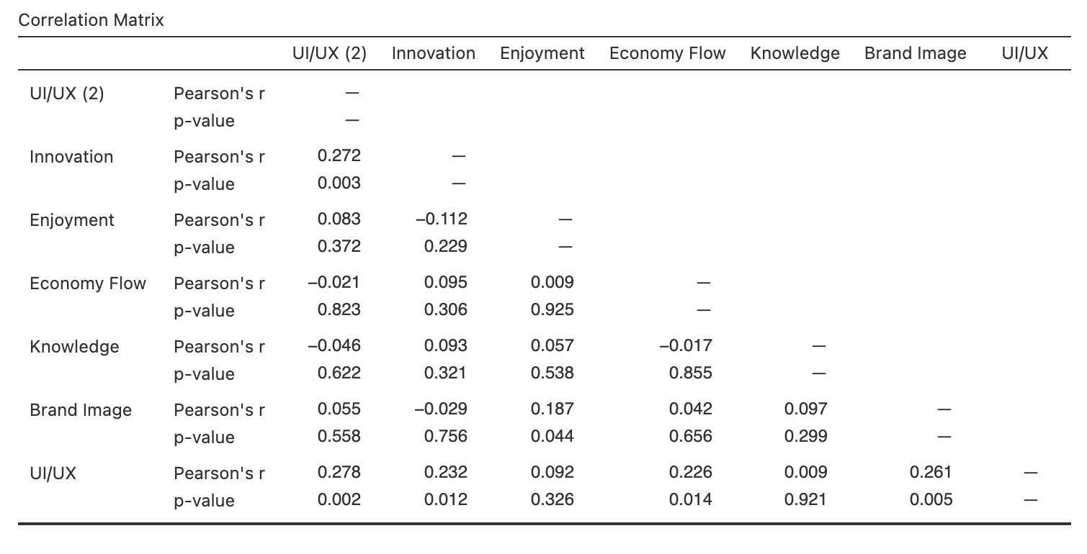

Table 9: Correlation Coefficient between variables

Table 9 examines the relationship between the study's constructs and its contributing variables. The collected results showed that there is a correlation between parameters like brand perception, interface quality, virtual credibility, UI/UX, and innovation. enjoyment, prosperity, and knowledge. According to a study by Todor (2016), virtual marketing has a higher enjoyment factor than conventional forms of marketing. However, a good time is sure to attract a lot of visitors, which may have an impact on how well the virtual marketing performs.The study also demonstrates that user experience and innovation are unrelated. This research is comparable to one by Adiwijaya (2016), who showed that people rely their satisfaction with an online experience on the usability, dependability, and security of the website they are interacting with. The single element influencing the experience may alternatively be the consumers' point of view. Additionally, the outcome demonstrates that there is no connection between satisfaction and UX/UI. As shown in Table 9, there is no connection between convenience and performance. This shows that internet marketing is offered at the convenience of the users, who can choose to accept or reject what is offered to them. This tends to alter the customers' opinion of marketing as a whole. Additionally, virtual marketing provides limitless content and the flexibility to be updated whenever and wherever, allowing the marketer to shape meat verse.

The results also revealed a strong positive association between knowledge and economic flow. Accessibility generates more value and trust among consumers and the advertiser while also raising awareness and allowing advertisers to reach a bigger audience. The study also shows a connection between brand image and enjoyment. In order to have a complete picture of the customer experience, organisations must assess how well they meet customer expectations. There is, however, a possibility that some clients won't be content, and this might have such an effect on how they perceive the business, which might subsequently have such an influence on how well it performs on the market.

**Goodness-of-fit index of the measurement mode**

GFI (goodness-of-fit index), TLI (Tucker-Lewis index), IFI (incremental fit index), and CFI (comparative fit index) were used to assess the research model's fit based on the measurement model. A satisfactory fit was deemed to be indicated by GFI of 0.8 or more, TLI of 0.9 or more, CFI of 0.9 or more, and RMSEA of 0.8 or less.

According to Table 10, all performance indices were appropriate. Covariance structural analysis was employed in these analyses to support user satisfaction.

|  |  |  |  |  |
| --- | --- | --- | --- | --- |
| **INDEX** | **CFI** | **TLI** | **RMSEA** | **GFI** |
| baseline | ≥0.9 | ≥0.9 | ≤0.08 | ≥0.8 |
| Observation | 0.916 | 0.905 | 0.0772 | 0.823 |

Table10: Goodness-of-fit

**Chapter 5**

1. **RECOMMONDATION AND CONCLUSION**

The previous chapter covered the study's findings in regard to its objectives. This chapter provides a synopsis of the dissertation. The study's findings and recommendations for future research are also covered in this chapter in order to gain a deeper understanding of virtual marketing and user happiness.

* 1. **Future research**

The following are suggested as crucial topics to be taken into consideration for future research following the investigation of the literature and depending on the results of this study.

* The study focused on students at the charming professional university, namely those in the Mittal School of Business. Future studies ought to encompass and represent a sample of students from various departments and fields, colleges, and even institutions.
* The internet and technology are both continually evolving and growing. Future research should be conducted to understand the challenges given by new developments and features in internet and technology, as well as how they may alter users' preferences for online virtual marketing.
* Future studies should be conducted to determine how social trends affect users' perceptions of virtual marketing and their decision to adopt it as their preferred method of advertising.

1. **Recommendations**

Additional research is still required in a number of areas of internet marketing, according to the conclusions of this study and the review of literature.

* The outcomes of this research and the review of the literature suggest that additional investigation on a few issues linked to online marketing is still required. In order to gain a more comprehensive understanding of students' perceptions of internet marketing, the study should be carried out on campus among a larger variety of students (i.e., involving students from various fields or colleges).
* Other studies should examine how businesses use pertinent media platforms to stay current with what is occurring in the market structure while maintaining brand integrity because the metaverse is dominating marketing on a global scale.

1. **Conclusion**

Modern marketing has new opportunities and perspectives thanks to the Internet's ongoing expansion, daily technological advancements, and constantly evolving consumer perception. Internet usage is increasing every day, and more and more businesses are utilising this development. This study has demonstrated that user satisfaction of virtual marketing describe zoomers attitude. As virtual marketing has changed how businesses use the Internet to conduct business, it has created endless options and possibilities for marketers. How marketers interact, engage, and transact business with customers through online platforms, Just a few of the opportunities and possibilities it has provided include how marketers present their products and brands "online" and how marketers encourage and influence consumer behaviour.

Second, the results demonstrated that metaverse's user satisfaction concept may be used as a marketing tool to understand a variety of variables and attitudes. To put it differently, the fourth industrialization and the era of the internet are both built on digital platform media, including metaverse networks, and the market is rapidly growing as a result. The Zoomerse, the largest consumer group, were identified after extensive investigation into their lifestyle and preferences. Moreover, given the expectation that the digital consumer class in the metaverse will gradually enlarge from the zoomerse era to all generations, it would be preferable to perform brand management segmentation, target specific, and positioning analysis in advance to create a strategy suitable for each consumption class.

**REFERENCES**

Canavesi, B. 2022. What is the Metaverse: Where we are and where we’re headed: ATD. ATD. Avail- able at: https://www.td.org/atd-blog/what-is-the-Metaverse-where-we-are-and-where-were-headed. Accessed 28 May 2022.

Kemp, S. 2022a. Digital 2022: Finland - DataReportal – global digital insights. DataReportal. Availa- ble at: https://datareportal.com/reports/digital-2022-finland. Accessed 15 June 2022.

Liffreing, I., 2021. What Brands Should Know about the Metaverse: Companies Need to Reinvent their Marketing Playbook for Digital Worlds. Advertising Age, 92(12).

Baruch, Y. and Holtom, B.C. (2008). ‘Survey response rate levels and trend in organizational research’, Human Relations, 61(8), pp. 1139-1160.

Masterson, V. 2022. We could be spending an hour a day in the metaverse by 2026. But what will we be doing there? World Economic Forum. Available at: https://www.wefo- rum.org/agenda/2022/03/hour-a-day-in-metaverse-by-2026-says-gartner/. Accessed 13 July 2022.

Reaume, A. 2022. What is the Metaverse? Meaning and what you should know. SeekingAlpha. Availa- ble at: https://seekingalpha.com/article/4472812-what-is-Metaverse. Accessed 28 May 2022.

Wang, X., Yuen, K. F., Teo, C. C., & Wong, Y. D. 2021. Online consumers’ satisfaction in self-collection: Value co-creation from the service fairness perspective. International Journal of Electronic Commerce, 25(2), 230-260.

Vogt, D.S., King, D.W. and King, L.A. (2004). Focus groups in psychological assessment: enhancing content validity by consulting members of the target population. Psychological assessment, 16(3), pp. 231.

Cooper, D.R. and Schindler, P.S. (2006). Business Research Methods. New York: Irwin McGraw Hill.

Nunnally, (insert comma) J., Bernstein, I. and Berge, J. T. (1967). Psychometric theory (226): JSTOR.

Todor, R.D. (2016). Blending traditional and digital marketing. Bulletin of the Transilvania University of Brasov. Economic Sciences. Series, 9(1), pp. 51.

Bae, S. and Lee, T. (2011). Gender differences in consumers’ perception of online consumer reviews. Electronic Commerce Research, 11(2), pp. 201-214.

Bobrowsky, M., & Needleman, S. (2022). What is the metaverse? The future vision for the internet. Retrieved 25 August 2022, from <https://www.wsj.com/story/what-is-the-metaverse-the-future-vision-for-the-internet-ca97bd98>

Dillman, D. A. (2011). Mail and Internet surveys: The tailored design method--2007 update with new Internet, visual, and mixed-mode guide, 2nd ed. New Jersey: John Wiley and Sons Inc.

Douglas, M. (2013). Essays on the Sociology of Perception .London: Routledge.  
Field, A. (2013). Discovering statistics using IBM SPSS statistics, 4th ed. Los Angeles: Sage

Publication.

Gommans, M., Krishman, K.S. and Scheffold, K.B. (2001). From brand loyalty to e-loyalty: A conceptual framework. Journal of Economic and Social Research, 3(1).

Grossnickle, J. and Raskin, O. (2000). The handbook of online marketing research: knowing your customer using the Net. New York: McGraw-Hill Professional.

Grobler, E. (2014). Social media marketing versus traditional marketing in the South African motor industry (Doctoral dissertation, University of the Free State).

Lokken, S.L., Cross, G.W., Halbert, L.K., Lindsey, G., Derby, C. and Stanford, C. (2003). Comparing online and non‐online shoppers.International Journal of Consumer Studies, 27(2), pp. 126-133.

Mabry, L. (2008). Case study in social research. The SAGE handbook of social research methods, 10(1), pp. 214-227.

Maynard, A.D. (2015). Navigating the fourth industrial revolution. Nature nanotechnology, 10(12), pp. 1005.

McBurney, DH. and White, TL. (2007). Research Methods: United States of America: Thomson Learning Inc.

Wheelwright, T. 2022. 2022 cell phone usage statistics: How obsessed are we? Reviews.org. Availa- ble at: https://www.reviews.org/mobile/cell-phone-addiction/#:~:text=On%20average%2C%20Ameri- cans%20spend%202,on%20their%20phones%20in%202022. Accessed 15 June 2022.

Wilson, R. 2022. Meet 'Imma': The Virtual Influencer who is the face of many leading brands today. Marketing Mind. Available at: https://www.marketingmind.in/meet-imma-the-virtual-influencer-who- is-the-face-of-many-leading-brands-today/. Accessed 7 July 2022.

Writer, G. 2020. 67 shades of Skin: How Buttermilk delivered Dior’s most inclusive influencer activa- tion to date. [Talking Influence]. Available at: https://talkinginfluence.com/2020/09/15/67-shades-of- skin-how-buttermilk-delivered-diors-most-inclusive-influencer-activation-to-date/. Accessed 4 June 2022.

Peertopeermarketing Editors. 2022. Virtual influencer: What are they and why you need them [2022 update]. P2P marketing. Available at: https://peertopeermarketing.co/virtual-influencer/. Accessed 23 July 2022.

QuestionPro Editors. 2022. Quantitative research: What it is, Tips & Examples. QuestionPro. Availa- ble at: https://www.questionpro.com/blog/quantitative-research. Accessed 13 July 2022.

Reaume, A. 2022. What is the Metaverse? Meaning and what you should know. SeekingAlpha. Availa- ble at: https://seekingalpha.com/article/4472812-what-is-Metaverse. Accessed 28 May 2022.

Santora, J. 2022. 18 influencer marketing trends to watch in 2022. Influencer Marketing Hub. Availa- ble at: https://influencermarketinghub.com/influencer-marketing-trends. Accessed 7 June 2022.

Bui, M., Krishen, A. S., Anlamlier, E., & Berezan, O. (2022). Fear of missing out in the digital age: The role of social media satisfaction and advertising engagement. Psychology & Marketing,  39(4),  683– 693.

Kara, C. (2006). "Young consumers and perception of brands in Hong Kong: a qualitative study. *Journal of Product and Brand Management*, 15(7), pp. 416-426.

Keaveney, S.M. and Parthasarathy, M. (2001). Customer switching behavior in online services: An exploratory study of the role of selected attitudinal, behavioral, and demographic factors. *Journal of the academy of marketing science*, 29(4), pp. 374-390.

Kiang, M.Y., Raghu, T.S. and Shang, K.H.M. (2000). Marketing on the Internet—who can benefit from an online marketing approach? *Decision Support Systems*, 27(4), pp. 383- 393.

Kim, J. and Hahn, K.H. (2012). Effects of personal traits on generation y consumers' attitudes toward the use of mobile devices for communication and commerce.*Human Technology: An Interdisciplinary Journal on Humans in ICT Environments*