Review on Analysis of Multilevel Inverter Based on SVPWM for Renewable Energy Sources
Uma Verma ¹, Dr. Shweta Chourasia²
¹M.Tech Student, Department of Electrical and Electronics Engineering, Bhopal Institute of science and Technology, Bhopal, Madhya Pradesh, India
²Associate Professor Department of Electrical and Electronics Engineering, Bhopal Institute of science and Technology, Bhopal, Madhya Pradesh, India

ABSTRACT
Solar power is the conversion of solar energy into thermal and electric electricity solar energy is the cleanest and most prolific renewable energy source, and the United States boasts some of the world's most important solar resources. This paper covers the fundamentals of solar power system modeling, as well as the model construction of conversion controllers in a two techniques. It can be deduced from the given figures that the level of distortion in the power consumed at the supply terminals during transient loading at 0.1 and 0.2 seconds has decreased. Because of the major modifications in both systems, the developed controller has shown to be an excellent solution for driving the system's inverter.
Keywords: Solar Power, PWM inverter, PV cell, MLI, CMLI
1. INTRODUCTION
Solar power is the conversion of solar energy into thermal and electric electricity. Solar energy is the cleanest and most prolific renewable energy source, and the United States boasts some of the world's most important solar resources. Solar technology can be used to generate power, provide lighting or a warm indoor atmosphere, and heat water for household, commercial, or industry usage, among other things. Solar energy can be harnessed in three ways: photo - voltaic, solar heating systems and concentrated solar power Photovoltaic employ an electrical method to create electricity directly from sunshine which can be used to power everything from small gadgets like calculations and traffic signs to residences and major commercial organizations. Solar heating and cooling (SHC) and concentrating solar power (CSP) utilize the excess energy to heat spaces or liquid in SHC systems, or to power typical electricity-generating turbines in CSP power stations.
Because the costs of Photovoltaic panels and systems that work have decreased by as much as 50% in the last 5 years, the use of solar photovoltaic (PV) devices has exploded. Advancements in electricity company network integrates directly and the use of PV arrays in stand-alone applications Photovoltaic systems are becoming more popular as a renewable/alternative energy source due to the local energy production and building automation with storage batteries and backups hybrid electric vehicles
2. MULTILEVEL INVERTERS (MLI)
Multilevel inverters are the industry's preferred solution for applications involving high voltage and high energy technology has lately emerged as a viable option for controlling high-power medium-voltage electricity. MLIs have been widely used in industry for years, particularly in heavy industries such as electric vehicles (EVs), ship propulsion drives, rolling mills, the papermaking, and metal processing as a result, an AC provider with particular features is required, such as variable output voltage amplitude to function over a wider variety of low, middle, and elevated concentrations, as well as variable output frequency to ensure a varied spectrum of switch speed. For these sectors, a controlled AC/DC conversion can be used to fulfill this task and support fixed power sources.
3. PHOTOVOLTAIC ARRAYS
The Photovoltaic Cells converts the solar energy of the sun to electrical energy i.e. electricity. The basic unit of a PV array is a PV cell. The PV cells grouped together to form a PV panels and these PV panels can be further grouped together to form a PV array. The PV cells can be either circular or rectangular in shape. Each PV cells can be considered as a simple p-n junction diodes and the surface of these diodes are exposed directly to the sunlight and in turn the charge carriers are generated which produces electricity.
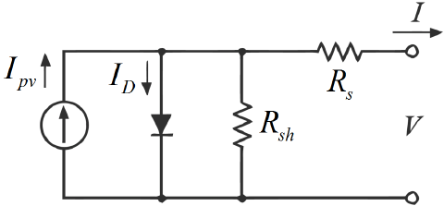
Figure 1: Basic Circuit diagram of a PV cell using one diode.
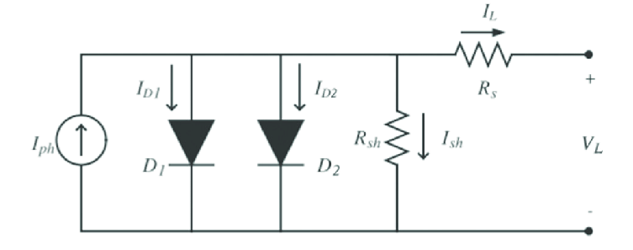
Figure 2: PV cell using two diode models.
The basic diagram of a PV cell is shown in figure and to compensate the error the two diode model is also given in the PV cell is represented by a current source and the Rp and Rs is the parallel and series resistance respectively. V and I are the output voltage and output current respectively it is evident that the net current I is the summation of I pv and Id so
I=Ipv-Id
Where Id=I0 exp (qV/akT)
I0=Leakage current of the diode.
q=Electronic charge
k=Boltzmann Constant
T=Temperature of the pn junction
a=Diode identity constant
The equation is the ideal equation which is a bit different from the practical one. Actually the practical PV array is composed of more than one PV cells and so the basic equation requires some additional terms. The actual equation is given below
I=Ipv-[exp {V+(RsI/Vta)}-1]-(V+RsI/Rp)
Table: PV module Parameters
Model | 1Soltech 1STH
Maximum Power | 213.5 Watts
Number of parallel strings | 40
Number series modules | 10
Open circuit voltage | 36.3 Volts
Shot circuit current | 7.84 Ampere
Irradiation | 900 wb/m²
Temperature | 30⁰C
4. Reference Signal Generation for PWM
The three phase grid linked three leg IGBTs based inverters technology presented in this study is extensively utilized in dispersed generating interfaces. The inverter was controlled by readily observed PI current regulators. DC-AC converters are required when the generated power is sent to the grid or utilized by AC loads (inverters). The output of integrators can be single phase or three phases. The central plant inverter system, the string inverter scheme, the multi-string integrator scheme, and the micro grid inverter (AC modules) scheme are indeed the four most typical grid - connected system inverter for solar systems The former technique was the central air conditioning inverters, which used centralized inverters to connect a large number of PV modules to the grid. PV modules are linked in a series (called a string). To achieve high levels of power, these strands are placed in parallel using string diodes. The today's technology is string inverter, which are a smaller version of industrial plant inverters with each strand linked towards the inverters. Multi-string inverters feature multiple strings that are linked by a common DC-AC inverter via their own Power converter. Because their individual controllability, dc / dc converters are preferable to central plant inverters.
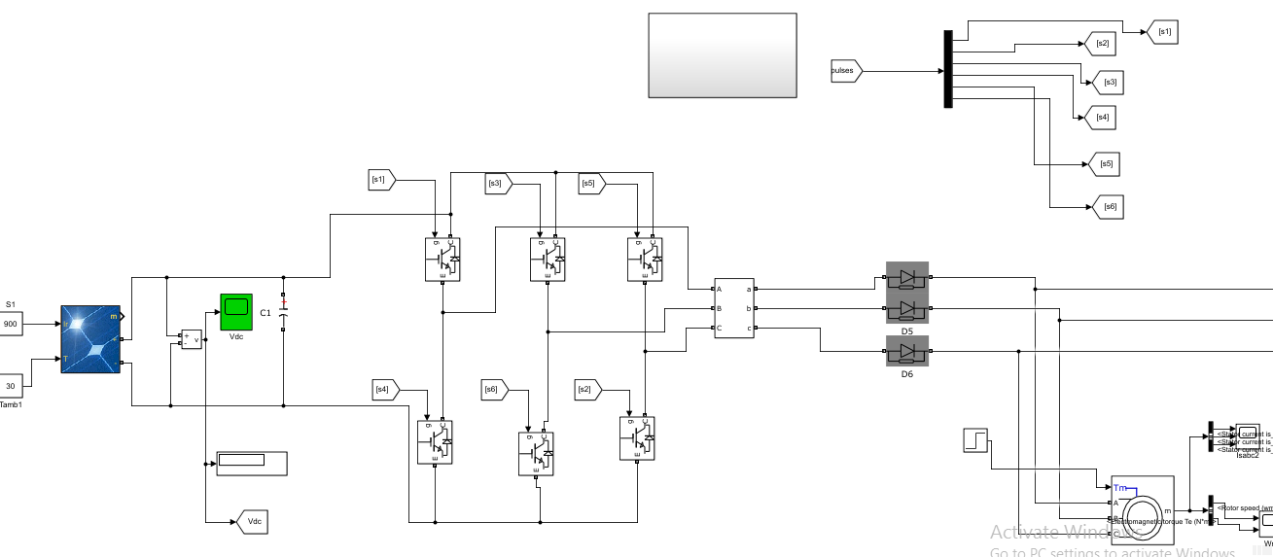
Figure 3: MATLAB/SIMULINK designing of three phase converter

5. MODULATION STRATEGIES
High-frequency switching methods have many commutations for the power semiconductors of the fundamental output voltage in one cycle the classification of various approaches based on the switching frequency of multilevel inverters
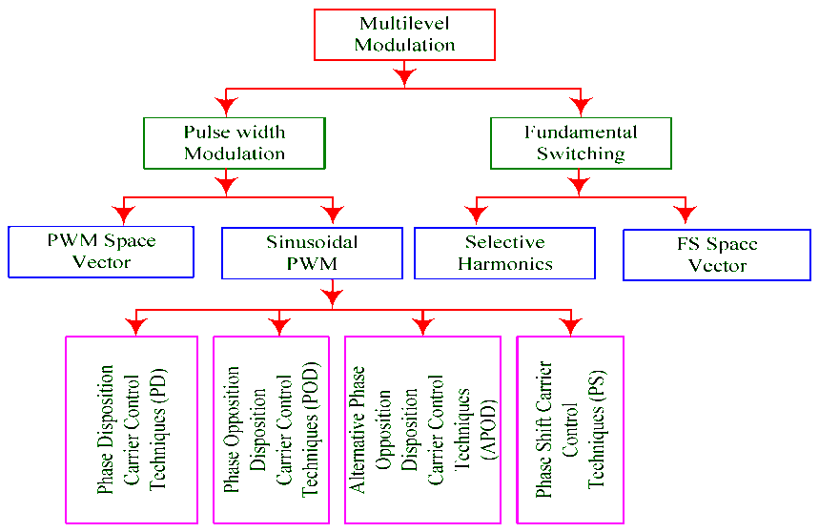
Figure 4: Modulation Strategies
6. SPACE VECTOR PWM

The principle of SVPWM method is that the command voltage vector is approximately calculated by using three adjacent vectors. The obtain variable output having a maximum fundamental component with minimum harmonics. During the past years many PWM techniques have been developed for letting the inverters to possess various desired output characteristics to achieve the following aim
- Wide linear modulation range
- Less switching loss.
- Lower total harmonic distortion.
- The space vector modulation (SVM) technique is more popular than conventional technique because of the following excellent features:
- It achieves the wide linear modulation range
- Associated with PWM third-harmonic injection automatically. It has lower base band harmonics than regular
- PWM or other sine based modulation methods, or otherwise optimizes harmonics. 15% more output voltage then conventional
- Modulation, i.e. better DC-link utilization. More efficient use of DC supplies voltage.
- SVM increases the output capability of SPWM
- Without distorting line-line output voltage waveform. Advanced and computation intensive PWM
- Technique.
- Higher efficiency.
- SINUSOIDAL PWM TECHNIQUES (MULTI CARRIER)
The carrier signal in multicarrier PWM systems is a triangle wave as the different carrier arrangements, while the reference wave is a sinusoidal signal.
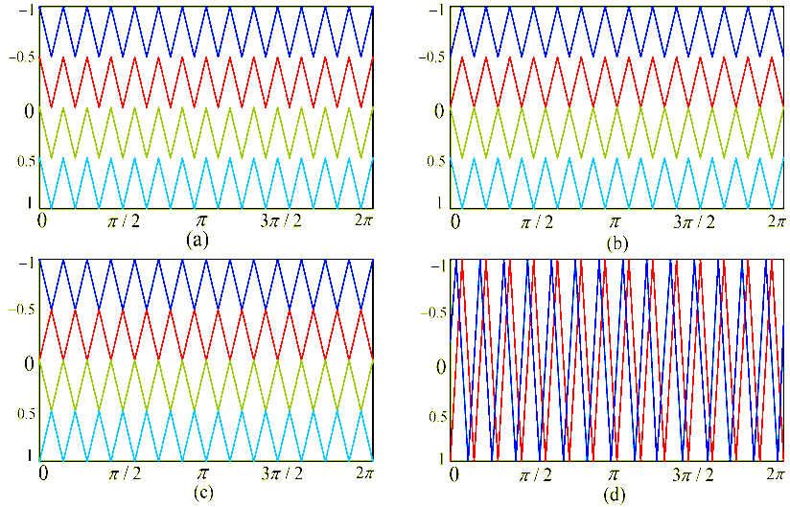
Figure 5: Carrier arrangements of (a) phase disposition (PD); (b) phase opposition disposition (POD); (c) alternative phase opposition disposition (APOD); and (d) phase shifted (PS) techniques.
The unipolar switched inverter generates less EMI and offers reduced switching losses, and are beneficial from the efficiency point of view When the amplitude modulation index (m_{a}) is more than unity, over modulation occurs. It causes the creation of lower-order harmonics, which reduces the number of pulses in the line to line voltage waveform. Moreover, the pulse width tends to disappear in the middle of the positive and negative half cycles.
first_page
settings
Order Article Repri
8. LITERATURE REVIEW
Bharatiraja et al. Offers a capacitors unbalancing control strategy for neutral point clamped multilevel inverters (NPC-MLI) built on a field programmable gate array (FPGA) for a freestanding autonomously photovoltaic (PV) system employing an innovative space vector PWM (SVPWM) scheme.
Susheela et al. For five and seven levels diodes clamping switching devices, a reverse mapping oriented space vector pulse width modulation (SVPWM) approach is presented. The transfer function is expressed in this technique as the sum of a candidate vector and an errors vector.
Pongiannan & Yadaiah, Provides PV-tied Z-NPC-MLI energy systems with a novel hysteresis current control SVPWM (HSVM) method in the inverters input stage, as well as neutral point (NP) balanced control and direct current regulate.
Bharatiraja et al.) PWM techniques for three-level diodes clamping multilevel inverters (DC-MLI) are proposed, whereby use a simple switching signals to identify the triangles for maximum throughput voltages and minimal CMV over the whole modulating region. There are two ways presented here: SVPWM portion elimination
Thomas et al. The goal is to find the best SVPWM approach for diode clamped MLI. The diode clamped MLI induction generator diesel generator is driven using both traditional SVPWM and the new SVPWM approaches.
Chamarthi et al. intends to make the SVM method for an n-level MLI easier to implement by introducing generalized equation which not only allow for direct market controlling pulses computations and eliminate the need for look up tables, but also results in efficient shifting.
9. CONCLUSION
The structure of improved PWM inverter control system is very simple which is based on the voltage type control method and the PWM power type control method. From the result of simulation, conclusions are come to as follows. First, the improved PWM inverter control method can make the voltage and the current waveform of the grid tend to sine wave effectively and quickly, and the power factor will reach to one. Second, the power can be sent to the grid or load arbitrary through controlling the PWM regulator, while the control system has a good stability.
Third, as the increasing number of inductive load penetrate to the grid, the load waveform distortion is produced, but it will not affect the reliability of power supply. Compared with sinusoidal PWM, space vector PWM can work with a higher modulation index and the harmonic content of the inverter voltage is less in the space vector PWM than in sinusoidal PWM. The SVPWM technique can be further applied to three level, four leg and multilevel inverters. This software implementation used in this paper can be extended further to over modulation region i.e. modulation index m>1which will be a future enhancement.
10. REFERENCES
- Bharatiraja, C., Jeevananthan, S., & Latha, R. (2014). Electrical Power and Energy Systems FPGA based practical implementation of NPC-MLI with SVPWM for an autonomous operation PV system with capacitor balancing. International Journal of Electrical Power and Energy Systems, 61, 489–509. https://doi.org/10.1016/j.ijepes.2014.03.066
- Susheela, N. Kumar, P. S., & Sharma, S. K. (2018). Generalized Algorithm of Reverse Mapping based SVPWM Strategy for Diode Clamped Multilevel Inverters. 9994(c). https://doi.org/10.1109/TIA.2018.2790906
- Pongiannan, R. K., &Yadaiah, N. (2021). A Hysteresis Space Vector PWM for PV Tied Z-Source NPC-MLI With DC-Link Neutral Point Balancing. 9. https://doi.org/10.1109/ACCESS.2021.3068335
- Bharatiraja, C., Jeevananthan, S., Munda, J. L., &Latha, R. (2016). Electrical Power and Energy Systems Improved SVPWM vector selection approaches in OVM region to reduce common-mode voltage for three-level neutral point clamped inverter. International Journal of Electrical Power and Energy Systems, 79, 285–297. https://doi.org/10.1016/j.ijepes.2016.01.002
- Thomas, R. V., Rakesh, E., Jacob, J., &Chitra, A. (2015). Identification of Optimal SVPWM Technique for Diode Clamped Multilevel Inverter based Induction Motor Drive.
- Chamarthi, P., Member, S., Chhetri, P., & Agarwal, V. (2016). Simplified Implementation Scheme for Space Vector Pulse Width Modulation of n -level Inverter with On-line Computation of Optimal Switching Pulse Durations. 0046(c). https://doi.org/10.1109/TIE.2016.2586438
[7] Aly, M., & Ramadan, H. A. (2019). Design and implementation of adaptive SVPWM algorithm for multilevel inverters in renewable energy applications. Solar Energy, 183(October 2018), 745–754. https://doi.org/10.1016/j.solener.2019.03.069
[8] Kale, A. S. (2017) Comparative Study of SPWM and SVPWM Cascaded H-bridge Multilevel Inverter.
[9] Lasseter, R. H., Chen, Z., & Pattabiraman, D. (2020). Grid-Forming Inverters: A Critical Asset for the Power Grid. IEEE Journal of Emerging and Selected Topics in Power Electronics, 8(2), 925–935. doi:10.1109/JESTPE.2019.2959271.
[10] Aghazadeh, A., Davari, M., Nafisi, H., & Blaabjerg, F. (2019) Grid integration of a dual two-level voltage-source inverter considering grid impedance and phase-locked loop. IEEE Journal of Emerging and Selected Topics in Power Electronics.
[11] Aghazadeh, A., Khodabakhshi-Javinani, N., Nafisi, H., Davari, M., & Pouresmaeil, E. (2019). Adapted near-state PWM for dual two-level inverters in order to reduce common-mode voltage and switching losses. IET Power Electronics, 12(4), 676–685. doi:10.1049/iet-pel.2018.5268.
[12] Aghazadeh, A., Jafari, M., Khodabakhshi-Javinani, N., Nafisi, H., & Namvar, H. J. (2018). Introduction and advantage of space opposite vectors modulation utilized in dual two-level inverters with isolated DC sources. IEEE Transactions on Industrial Electronics, 66(10), 7581-7592. https://doi.org/10.1109/TIE.2018.2880720
[13] Gupta, K. K., & Bhatnagar, P. (2017). Multilevel inverters: Conventional and emerging topologies and their control. In Multilevel Inverters: Conventional and Emerging Topologies and Their Control. Academic Press. doi:10.1016/C2016-0-03360-0.
[14] Ponraj, R. P., & Sigamani, T. (2021). A novel design and performance improvement of symmetric multilevel inverter with reduced switches using genetic algorithm. Soft Computing, 25(6), 4597–4607. doi:10.1007/s00500-020-05466-
[15] Ali, A. N., Jeyabharath, R., & Udayakumar, M. D. (2016). Cascaded Multilevel Inverters for Reduce Harmonic Distortions in Solar PV Applications. Asian Journal of Research in Social Sciences and Humanities, 6(11), 703. doi:10.5958/2249-7315.2016.01223.5.
[16] Kouro, S., Rebolledo, J., & Rodríguez, J. (2007). Reduced switching-frequency-modulation algorithm for high-power multilevel inverters. IEEE Transactions on Industrial Electronics, 54(5), 2894–2901. doi:10.1109/TIE.2007.905968.
[17] Gautam, S. P., Sahu, L. K., & Gupta, S. (2016). Reduction in number of devices for symmetrical and asymmetrical multilevel inverters. IET Power Electronics, 9(4), 698–709. doi:10.1049/iet-pel.2015.0176.
[18] Nguyen, N. V., Nguyen, T. K. T., & Lee, H. H. (2014). A reduced switching loss PWM strategy to eliminate common-mode voltage in multilevel inverters. IEEE Transactions on Power Electronics, 30(10), 5425-5438. https://doi.org/10.1109/TPEL.2014.2377152.
[19] Chowdhury, M. R., Rahman, M. A., Islam, M. R., & Mahfuz-Ur-Rahman, A. M. (2021). A New Modulation Technique to Improve the Power Loss Division Performance of the Multilevel Inverters. IEEE Transactions on Industrial Electronics, 68(8), 6828–6839. doi:10.1109/TIE.2020.3001846.

