A Review-Experimental Study of Impact of Laser Parameters On Laser Beam Machining and Simulation

Vaibhav U Khurana
PG Student
Department of Mechanical Engineering, LDRP-ITR
Gandhinagar, India.
Vaibhavkhurana2882@gmail.com

Dr. Ankit Darji
Assistant Professor
Department of Mechanical Engineering, LDRP-ITR
Gandhinagar, India.
ankitdarjildrp@gmail.com

Abstract:- Laser beam machining (LBM) is a widely used thermal advance machining process capable of high accuracy machining of almost any material with complex geometries. CO2 and Nd.YAG lasers are mostly used for industrial purposes. Drilling, cutting, grooving, turning and milling are the applications of LBM with different material removal mechanisms. Modelling and simulation of the LBM process is indispensable for optimization purposes. Modelling can be done by implementing analytical, numerical, experimental and artificial intelligence-based methods. This paper provides a review of the various methods used for modelling and simulation of the laser beam machining process as well as key researches done in this field so far. A reliable application requires a localized and controlled continuous heating of the material within the machining zone directly in front of the tool contact area. In this research statistical and technological knowledge is fully involved in the experimental activities. Therefore, a statistical study based on design of experiment (DoE) was carried out in order to investigate the effects of laser process parameters and their interactions. The aim of the paper is to characterize the laser heating process by detecting how the individual LAM parameters influence working temperature, heat affected zone (HAZ) extension and laser track
Keywords:- Laser cutting, Surface roughness, Process parameter, kerf width, CO2 , Heat affected zone

1.INTRODUCTION
Emergence of advanced engineering materials and requirement of precision in manufacturing have made conventional machining unreliable in modern industry. Therefore, advanced manufacturing processes were introduced to obviate new industry requirements. Laser beam machining (LBM) is one of the can shape almost all ranges of engineering materials from metallic alloys to non-metals as well as composite materials. Laser beam is widely used in cutting, drilling, machining, etching, welding and heat treatment [1].
Material removal in LBM is based on high heat flux generated by laser beams which melt and vaporize the workpiece material in the focused point. Unique privileges of LMB such as being a non-contact process, automation adaptability, cost reduction, small heat affected zone (HAZ) and resolving the need for finishing operations have made it famous in the manufacturing industry. The laser beam is generated by the so-called phenomenon stimulated emission which is caused when) 135–145 high energy photons strike the medium. These photons excite the electrons of the medium atoms into amplified state which results in emission of photons with the same wavelength of absorbed light from the medium; this light is a coherent and focused beam called laser [20, 21]. The first laser was created by Townes and Schawlow in 1957 using ruby medium .
The lasing medium can be gas, liquid or solid, but in manufacturing processes CO2 and Neodymium yttrium aluminium garnet (Nd.YAG) are mostly used as medium. CO2 lasers have high beam power with good efficiency without sacrificing the quality of the beam. On the other hand, Nd.YAG lasers have shorter wavelengths of about 1μm which make them suitable for machining reflective materials due to higher light absorption compared to CO2 lasers. Although Nd.YAG lasers operate with low powers, they can be used in pulsed mode with high peak power to cut thick materials. Thinner materials can also be cut by Nd.YAG lasers using short pulse duration [2, 22].

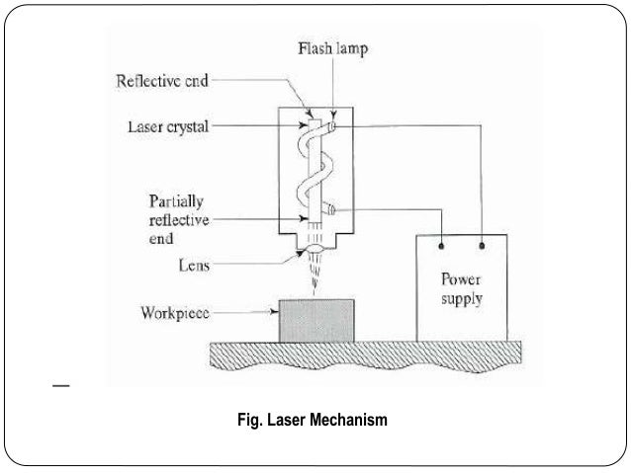
[24]

2. LITERATURE REVIEW
1. In 2008, Avanish Dubey In laser beam cutting (LBC) process, It has been found that the kerf width during LBC is not uniform along the length of cut and the unevenness is more in case of pulsed mode of LBC[8,14]. In this paper, two kerf qualities such as kerf deviation and kerf width have been optimized simultaneously using Taguchi quality loss function during pulsed Nd: YAG laser beam cutting of aluminium alloy sheet (0.9 mm-thick) which is very difficult to cut material by LBC process. A considerable improvement in kerf quality has been achieved .
2. Yusof et al. (2008) have found that at all cutting speeds, the kerf width increases by increasing the laser powers while sideline length and percentage over length decreases by increasing laser power. Increasing the cutting speed in pulsed mode led to rough surface and incomplete cutting while in CW mode, increasing the cutting speed with equivalent increase in power, led to better quality and smoother cut surface upto 8 m/min cutting speed. The SR also increases by increasing the peak power, gas pressure, pulse frequency and duty cycle. The surface roughness of the cut specimen can also be changed by changing spot over lap and pulse width.
3. In 2012 Snežana Radonjić and Pavel Kovač has defined process parameter of laser machine Experimental research carried out during laser processing of AISI 314 resulted in an optimal cut . The optimal cut is obtained using the following processing parameters: feed rate 1250 mm/min, laser power 4400 W, focal point 16 mm, gas pressure 17 bars and nozzle distance 7 mm.
4. In March 2015, M Madic has been worked on an experimental analysis and optimization of CO2 laser cutting process on stainless steel plates. In this paper, multiobjective optimization of the cut quality characteristics such as surface roughness, width of HAZ and kerf width in CO2 laser cutting of stainless steel . The applied methodology integrates modelling of the relationships between the laser cutting factors (laser power, cutting speed, assist gas pressure and focus position) and cut quality characteristics using ANNs, formulation of the multi-objective optimization problem using weighting sum method and solving it by CSA (Comparative Sequence Analysis).Cuckoo search method is used for optimization purpose .
5. In 2006 Miroslav and Predrag has worked on surface roughness by laser cut. Quality is very important. Observation of the cut surface can reveal two zones: the upper one in the area of the laser beam entrance side and the lower one, in the area of the laser beam exit side. The former is a finely worked surface with proper grooves whose mutual distance is 0.1...0.2 mm while the latter has a rougher surface characterized by the deposits of both molten metal and slag. Standard roughness Rz increases along with the sheet thickness, but decreases with increase of laser power. By cutting with laser power of 800 W standard roughness R is 10 μm for sheet thickness of 1 mm, 20 μm for 3 mm, and 25 μm for 6 mm. Correlation which connected the standard roughness (ten point height of irregularities) and mean arithmetic profile deviation, the linear and exponential relationships can be used .
6. In April 2012 Martin Grepl1, Marek Pag ́aˇc1, Jana Petr ̊u1 researches on Laser Cutting of Materials of Various Thicknesses and found upon that suit- able parameters for cutting Haynes .To avoid any influence of the surrounding atmosphere on the cut, it is suitable to measure the re- cast layer using a microprobe, and then to perform a microchemical analysis. We recommend that in- creased attention be paid to a study of the recast layer and its increased dependence on cutting parameters. It would be suitable to perform the micro- hardness measurement at the melting boundary of the original material and more importantly, on the recast layer itself. Our paper has contributed a comprehensive view on the influence of the process parameters on a narrow group of materials used in the aerospace industry.
7. In august 2011 B.S.Yilbas has researches on Laser hole cutting into Ti-6Al-4V alloy and thermal stress analysis

3. LASER CUTTING PARAMETERS
The process of laser cutting involved many parameters, which can be generally divided into two main categories—beam parameters and process parameters [23].

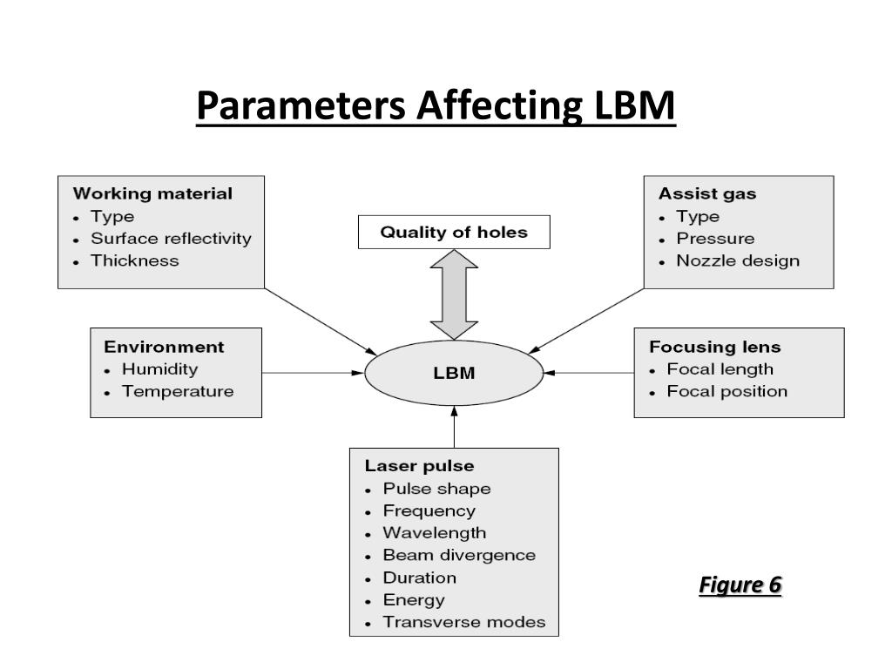
[18]

A. BEAM PARAMETERS

These are parameters that characterize the properties of the laser beam which include the wavelength, power, intensity and spot size, continue wave and pulsed power, beam polarization, types of beam, characteristics of beam, beam mode.

Wavelength The wavelength depends on the transitions in the process of stimulated emission with respect to the physical mechanisms involves in energy coupling and the process efficiency, stability and quality, the wavelength plays a most decisive role. It has important effect on material‘s surface absorptivity. For a specific material type, there is a certain wavelength which can have maximum absorption of laser energy with a lowest reflection. Due to the shorter wavelength of fiber lasers (in the range of 1 μm almost the same as Nd-YAG laser) compared to CO2 lasers (10.6μm), it leads to the higher absorption in metallic material.

Power, intensity and spot size The size of a laser system is usually specified in the term of power. The power of laser system is the total energy emitted in the form of laser light per second. Without sufficient power, cutting cannot be started.

The intensity of the laser beam is the power divided by the area over which the power is concentrated. The high intensity of laser beam causes rapid heating of the material, which means that little time is available for heat to dissipate into the surrounding material. Additionally, the reflectivity of most metals is much lower at high intensities, compared to the low beam intensity. Moreover, the intensity determines the thickness of material which can be cut.

Spot size is the irradiated area of laser beam. In laser cutting application, it is required to focus beam into minimum spot size. Due to the better beam quality of fiber laser with very low divergence, the user can get spot diameters smaller than conventional lasers producing longer working distances.

Continuous wave (CW) and pulsed laser power Both the continuous wave and pulsed laser power can achieve the high intensity needed for laser cutting. The cutting speed is determined by the average power level. Average power level with CW laser is higher compared to the pulsed laser.

B. PROCESS PARAMETERS

These are parameters that characterize the properties of the laser beam which include focusing of laser beams, focal position and dual focus lens, process gas and pressure, nozzle diameter, stand-off distance and alignment, and cutting speed.

Focusing of Laser Beams The focal length of lens is about the distance from the position of focal lens to the focal spot. In the fiber laser system, the laser beam is delivered by the fiber optics and use a collimator to form the divergent laser beam. After that, it comes to the focusing lens or mirror and it focuses the parallel laser beam onto the work piece. The cutting process requires the spot size is small enough to produce the high intensity power. The focal length of the lens has a large impact on size of the focal spot and the beam intensity in the spot.

Focal Position In order to get optimum cutting result, the focal point position must be controlled. There are two reasons: the first reason is that the small spot size obtained by focusing the laser beam results in a short depth of focus, so the focal point has to be positioned rather precisely with respect to the surface of the work piece; the other one is differences in material and thickness may require focus point position alterations .

Process Gas and Pressure The process gas has five principle functions during laser cutting. An inert gas such as nitrogen expels molten material without allowing drops to solidify on the underside (dross) while an active gas such as oxygen participates in an exothermic reaction with the material. The gas also acts to suppress the formation of plasma when cutting thick sections with high beam intensities and focusing optics are protected from spatter by the gas flow. The cut edge is cooled by the gas flow thus restricting the width of the HAZ. The commonly used gases are the oxygen and nitrogen. Nitrogen is mainly used for stainless steel and aluminum, whereas the oxygen is used for mild steel . In the process of oxygen cutting, the presence of oxygen contributes to an exothermic reaction, which effectively increases the laser power. It results into high cutting speeds and the ability to cut thick material. When cutting thick material, the gas pressure must decrease with the increasing thickness, in order to avoid the burning effect, whereas the nozzle diameter is increased .

Nozzle Diameter, Stand-Off Distance Nozzle is used to deliver the assist gas. The nozzle has three main functions in the laser cutting process: to ensure that the gas is coaxial with the beam; to reduce the pressure to minimize lens movements and misalignments; and to stabilize the pressure on the work piece surface to minimize turbulence in the melt pool . The stand-off distance, which is the distance between the nozzle and the work piece, is also an important parameter. The stand-off distance is usually selected in the same range as the diameter of cutting nozzle-between 0.5 and 1.5 mm-in order to minimize turbulence. A short stand-off distance provides stable cutting conditions, although the risk of damage to the lens from spatter is increased. The stand-off distance is optimized to maximum the cutting speed and quality.

Cutting Speed The cutting speed must be balanced with the gas flow rate and the power. As cutting speed increases, the cutting time decreases and less time for the heat to diffuse sideways and the narrower the HAZ. The kerf is also reduced due to the need to deposit a certain amount of energy to cause melting. However, striations on the cut edge become more prominent, dross is more likely to remain on the underside and penetration is lost. When the cutting speed is too low, excessive burning of the cut edge occurs, which degrades edge quality and increases the width of the HAZ. In general, cutting speed for a material is inversely proportional to the thickness.

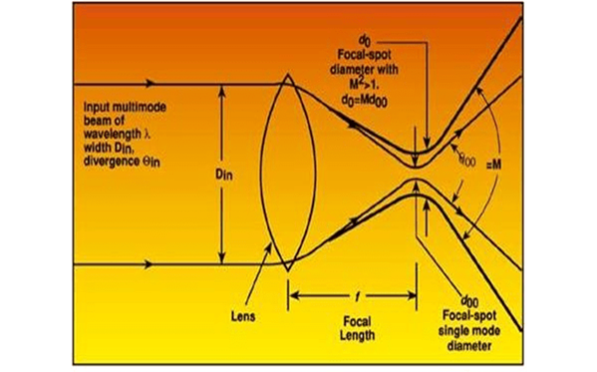
[19]
4. EXPERIMENTAL WORK STATION

Laser cutting machine –Model No. RD-CF3015B. With the laser cutting and engraving machine Model No. RD-CF3015B offers the possibility to process extremely broad materials on a comparatively small system. The processing area is 1500 x 3000. With the optional camera recognition system which is also available for other systems the production flow can be automated, leading to an increased economy of the laser processing .power – 1000 [W] .I have worked on the machine with change in lens ( size and shape ) and change in optical properties. Different temperatures of material were used ( 1. preheated 2. room temperature
5. CONCLUSION

Many works have already discussed on the optimization of the cutting parameters of CO2 laser on mild steel. However, parameters on cutting stainless steel have not yet discussed much. Therefore this experimental work discusses on the optimization of laser cutting parameters on stainless steel because, stainless steel is widely applied in industries. The purpose of this experimental work is to optimize the process parameters on cutting stainless steel by laser beam machining technology. This optimization process reduces the time and cost.

6. REFERENCE
- Dubey, A.K. and Yadava, V., 2008. Laser beam machining—A review. International Journal of Machine Tools and Manufacture, 48(6), pp.609-628.
- Tabata, N., Yagi, S. and Hishii, M., 1996. Present and future of lasers for fine cutting of metal plate. Journal of materials processing technology, 62(4), pp.309-314.
- Radonjić, P.D.S., Save, S., Kovač, P.D.P., Obradovića, T.D. and Sad, N., 2012. Defining New Processing Parameters in Laser Cutting.
- Radovanovic, M. and Madic, M., 2011. Experimental investigations of CO2 laser cut quality: a review. Nonconventional Technologies Review, 4(4), p.35.
- Radovanovic, M. and Dasic, P., 2006. Research on surface roughness by laser cut. The Annals of University Dunarea de Jos of Galati Fasicule VIII, Tribology, 12, pp.84-88.
- Grepl, M., Pagáč, M. and Petrů, J., 2012. Laser cutting of materials of various thicknesses.
- Yilbas, B.S., 1997. Parametric study to improve laser hole drilling process. Journal of Materials Processing Technology, 70(1-3), pp.264-273.
- Sharma and V. Yadava, Modelling and optimization of cut quality during pulsed Nd:YAG laser cutting of thin Al-alloy sheet for straight profile, Optics & Laser.
- B.D.Prajapati,R.J.Patel,andB.C.Khatri.ParametricInvesti- gation of CO2 Laser Cutting of Mild Steel and Hardox-400 Material. IJETAE, 3(4):204–208, 2013.
- A.Riveiro et al. The Role of the Assist Gas Nature in Laser Cutting of Aluminium Alloys. Physics Procedia, pages 548–554, 2011.
- Arindam Ghosal, and Alakesh Manna. Response surface method based optimization of ytterbium fiber laser pa rameter during machining of Al/AL2O3-MMC. Optics and Laser Technology, pages 67–76, 2013.
- P.S.Chaudhary,andProf.D.M.Patel.Parametriceffectfiber laser cutting on surface roughness in 5 mm thick mild steel sheet (IS2062). International journal of engineering research and technology, 1(6), 2012.
- Avanish Kumar Dubey, and Vinod Yadava. Optimization of kerf quality during pulsed laser cutting of aluminium alloy sheet. Journal of materials processing technology, pages 412–418, 2008.
- Dipesh Patel, and Prof. D.M.Patel. Parametric Analysis of Ytterbium: fiber laser cutting process. 2010.
- Introduction to Laser Material Processing by Columbia University. [24] P.K. Mishra. Non Conventional Machining. Narosa Publi- cation House, pages 147–159, 2005.
- Dr Mark Richmond (Product Manager âA ̆S ̧ JK Fiber Lasers) and Dr Mo Naeem (Worldwide Applications Ex- pert, GSI Group, Laser Division, Cosford Lane, Rugby, Warwickshire, CV21 1QN, UK). Introduction to Fiber Lasers and their Applications.
- Miroslav Radovanovic , Predrag Dasic pages 84-88 Research on Surface Roughness By Laser Cut.
- PARAMETERS AFFECTING LBM - Bing images
- laser beam machining - Bing images
- A. Kuar, B. Doloi, B. Bhattacharyya, Modeling and analysis of pulsed Nd:YAG laser machining characteristics during micro-drilling of zirconia (ZrO2), Int. J. Mach. Tools Manuf. 46 (2006) 1301–13\10.
- C. Bagger, F.O. Olsen, Pulsed mode laser cutting of sheets for tailored blanks, J. Mater. Process. Technol. 115 (2001) 131–135.
- 2] J. Meijer, Laser beam machining (LBM), state of the art and new opportunities, J. Mater. Process. Technol. 149 (2004) 2–17.
- laser machine mechanism - Search Images (bing.com)

