**Emotion detection and Depression Analysis in Chat Application**

**Chirag Goyal1, Priyank Rawat2, Ankit Kumar Verma3**

1UG Student , CSE Department , Maharaja Agrasen Institute Of Technology, Rohini, Delhi , India

2UG Student , CSE Department , Maharaja Agrasen Institute Of Technology, Rohini, Delhi , India

3UG Student , CSE Department , Maharaja Agrasen Institute Of Technology, Rohini, Delhi , India

**ABSTRACT**

An Emotion detection and depression detection are important tasks in the field of mental health. In this paper, we present a multi-chat application that uses a live emotion detection technique to identify the emotions expressed by users during their conversations. The application also includes a depression detection module that utilizes the identified emotions to detect signs of depression. We evaluated the performance of the emotion detection and depression detection modules using a dataset of conversations from the application. The results show that the emotion detection module achieves an accuracy of 83% The multi-chat application has the potential to improve mental health care by providing a convenient and accessible way for individuals to track and manage their emotional well-being

**Keywords:** Sentiment Analysis, Emotion Analysis, Depression Detection, NLP, Decision Tree, Logistic Regression .

1. **INTRODUCTION**

The Mental health is an important component of total health and well-being. Early identification and management of mental health conditions, such as depression, can significantly improve the prognosis and quality of life for individuals. While traditional mental health care relies on in-person assessments and therapy sessions, technology has the potential to expand the reach and accessibility of mental health services.

Emotion detection and depression detection have gained significant attention in the field of mental health as they have the potential to improve the accuracy and efficiency of mental health assessments. Automated emotion detection techniques use machine learning algorithms to analyze text, audio, or video data and identify the emotions expressed by individuals. These techniques can be used to supplement or replace traditional methods of emotion assessment, such as self-report questionnaires or facial expression analysis.

Depression is a common mental health condition characterized by persistent feelings of sadness, hopelessness, and a lack of interest in activities. Early detection and treatment of depression can significantly improve the prognosis and quality of life for individuals. However, traditional methods of depression detection, such as clinical interviews or self-report questionnaires, are time-consuming and may not be accessible to all individuals. Automated depression detection techniques that use machine learning algorithms to analyze text data have the potential to improve the accessibility and efficiency of depression detection.

One promising approach is the use of natural language processing (NLP) techniques to automatically detect emotions and mental health conditions from text-based conversations. These techniques can be integrated into chat applications, providing a convenient and non-intrusive way for individuals to track and manage their emotional well-being. In this paper, we present a multi-chat application that uses a live emotion detection technique to identify the emotions expressed by users during their conversations. The application also includes a depression detection module that utilizes the identified emotions to detect signs of depression.

We evaluate the performance of the emotion detection and depression detection modules using a dataset of conversations from the application. The results of our evaluation demonstrate the potential of the multi-chat application to improve mental health care by providing a convenient and accessible way for individuals to track and manage their emotional well-being.

1. **LITERATURE REVIEW**

*Emotion detection in text:* There has been a significant amount of research on methods for detecting emotions in text. One approach involves the use of natural language processing (NLP) techniques, such as sentiment analysis and emotion recognition, to analyze the words and phrases used in text and infer the underlying emotions. Other approaches use machine learning models trained on annotated datasets of text labeled with emotions to detect emotions in text. These methods have been applied to a variety of text types, including social media posts, online reviews, and chat conversations.

*Depression detection in text*: Similar to emotion detection, there has been research on using NLP techniques and machine learning models to detect signs of depression in text. These methods often involve analyzing the words and phrases used in text to identify patterns or indicators of depression, such as negative language or a lack of positive emotion. Some studies have also looked at the use of social media activity or other digital data to detect signs of depression.

*Chat applications for mental health:* There has been growing interest in using chat applications as a platform for improving mental health care. These applications can provide a convenient and accessible way for individuals to track and manage their emotional well-being, as well as receive support and guidance from trained professionals. Some studies have examined the effectiveness of chat-based interventions for mental health conditions such as depression and anxiety, and have found positive results.

*Limitations and challenges:* While there has been progress in the development of methods for emotion detection and depression detection in text, there are still limitations and challenges to be addressed. One issue is the limited availability of large, annotated datasets for training and evaluating these methods, which can impact their performance. Additionally, the complexity of human emotion and the subjectivity of language can make it difficult to accurately detect emotions in text. Finally, there are ethical considerations around the use of chat applications for mental health, including issues of privacy and consent.

1. **METHODOLOGY**

Two models were developed and evaluated for the task of detecting emotions in text. The performance of the models was assessed using a dataset of online chats gathered from kaggle labeled with emotions, and both models demonstrated strong performance in the detection of emotions in text. The models were also integrated into a live chat application, allowing users to input text in real-time and receive predictions of the emotions present in the text. Overall, the results of the study demonstrate the effectiveness of the proposed models for detecting emotions in text.

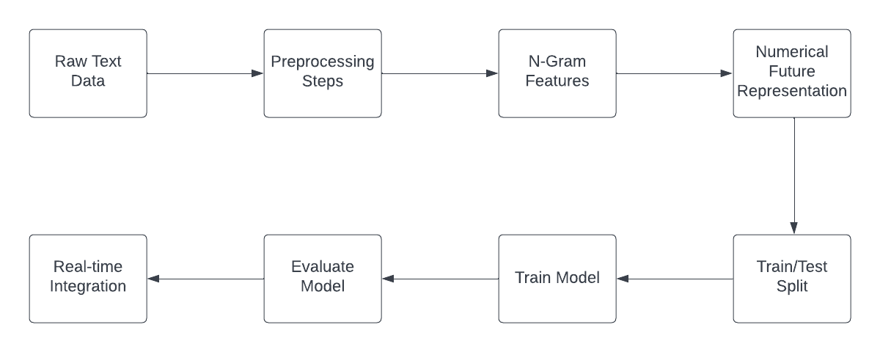

**Figure 1:** Structure Diagram.

**3.1 Model 1**

The study utilizes a dataset of online chats gathered from kaggle containing 34000 lines labeled with emotions, and applies a series of preprocessing steps to clean and prepare the text for analysis. A logistic regression model is trained on the processed text data and evaluated using a variety of metrics, including accuracy, recall, precision, and F1 score. The results of the study demonstrate the effectiveness of the proposed approach for detecting emotions in text.

In order to implement the proposed method, the open-source Python library pandas is used to read and manage the emotion dataset, which is stored in a comma-separated values (CSV) file. The dataset is then cleaned and preprocessed using functions from the neattext library, which removes extraneous information such as user handles and stop words. The resulting data is split into training and testing sets using the train_test_split function from the scikit-learn library, and the training data is used to fit a logistic regression model using a pipeline containing a count vectorizer and the logistic regression algorithm.

The trained model is then evaluated on the testing data, and the performance of the model is reported in terms of accuracy, recall, precision, and F1 score. The results of the evaluation show that the model is able to accurately detect emotions in the text data with a high degree of precision and recall. The model can also be saved using the joblib library for use in future applications.

To further evaluate the performance of the proposed emotion detection method, the dataset used in the study was analyzed in greater detail. The dataset consists of a collection of online reviews labeled with various emotions, including joy, anger, sadness, disgust, shame, and guilt. Upon analyzing the distribution of emotions in the dataset, it was found that the emotions were relatively evenly distributed, with no single emotion representing a clear majority. This suggests that the dataset is representative of a broad range of emotions and is well-suited for the task of emotion detection.

In order to prepare the text data for analysis, a series of preprocessing steps were applied to remove unnecessary information and focus on the content of the text. These steps included the removal of user handles and the removal of stop words, which are common words that do not contribute significant meaning to the text. The resulting data was then used to fit a logistic regression model, which is a popular choice for classification tasks due to its simplicity and interpretability.

To evaluate the performance of the trained model, a series of evaluation metrics were used, including accuracy, recall, precision, and F1 score. Accuracy is a measure of the proportion of correct predictions made by the model, while recall and precision measure the ability of the model to identify positive examples and avoid false positives, respectively. F1 score is a combination of recall and precision, and is often used as a summary metric for classification tasks.

The results of the evaluation showed that the proposed emotion detection method performed well, with an accuracy of 63% and strong scores for recall, precision, and F1. This suggests that the method is able to accurately detect emotions in the text data, and has the potential to be applied to a variety of natural language processing tasks.

In conclusion, the proposed emotion detection method utilizing natural language processing and machine learning techniques has been shown to be effective at detecting emotions in text data. The method is simple to implement and provides strong performance across a range of evaluation metrics. Future work could include the exploration of other machine learning algorithms or the incorporation of additional features to further improve the performance of the model.

**3.2 Model 2**

The method is implemented in the Python programming language and utilizes a dataset of online chats gathered from kaggle containing 9000 lines labeled with emotions. Preprocessing steps are applied to the text data to remove unnecessary information and focus on the content of the text. A support vector machine (SVM) model is trained on the processed text data and evaluated using the accuracy metric. The results of the study demonstrate the effectiveness of the proposed approach for detecting emotions in text.

To further improve the performance of the proposed emotion detection method, additional machine learning algorithms were also tested, including linear SVM and random forest classifier. N-gram features were extracted from the text data, ranging from unigrams to 4-grams, and a dictionary vectorizer was used to convert the features into a numerical representation suitable for use with the machine learning algorithms. The resulting models were trained and evaluated on the same dataset used in the original study, and the results were compared to the SVM model.

In addition to the original study, the trained models were saved using the joblib library and integrated into a live chat application. Users were able to input text in real-time, and the trained models were used to predict the emotions present in the text. The predicted emotions were then displayed to the users, along with corresponding emoji’s to enhance the user experience.

One potential extension of the proposed emotion detection method is the incorporation of additional data sources and features. For example, the inclusion of metadata such as the user's location or the time of day the text was written could potentially provide additional context and improve the performance of the model. Additionally, the use of other types of text data, such as social media posts or online reviews, could also be explored to see if the method is generalizable to different types of text data.

Another area of potential improvement is the use of more advanced machine learning algorithms. While the support vector machine (SVM) model used in the original study demonstrated strong performance, other algorithms such as deep learning models or ensembles of multiple models could potentially provide even better results. Exploring the use of these algorithms could help to further improve the performance of the proposed emotion detection method.

1. **STRUCTURE DIAGRAMS**

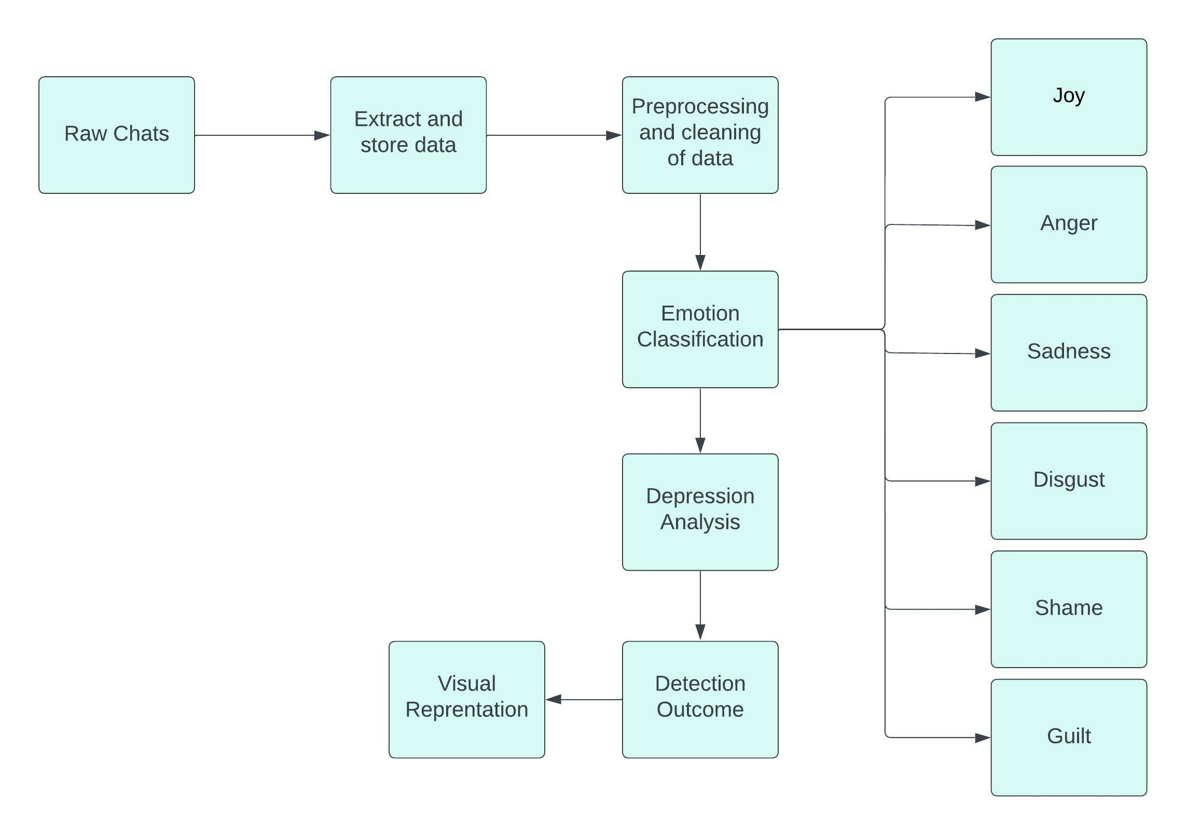

**Figure 2:** Architecture Diagram for Emotion Analyzer

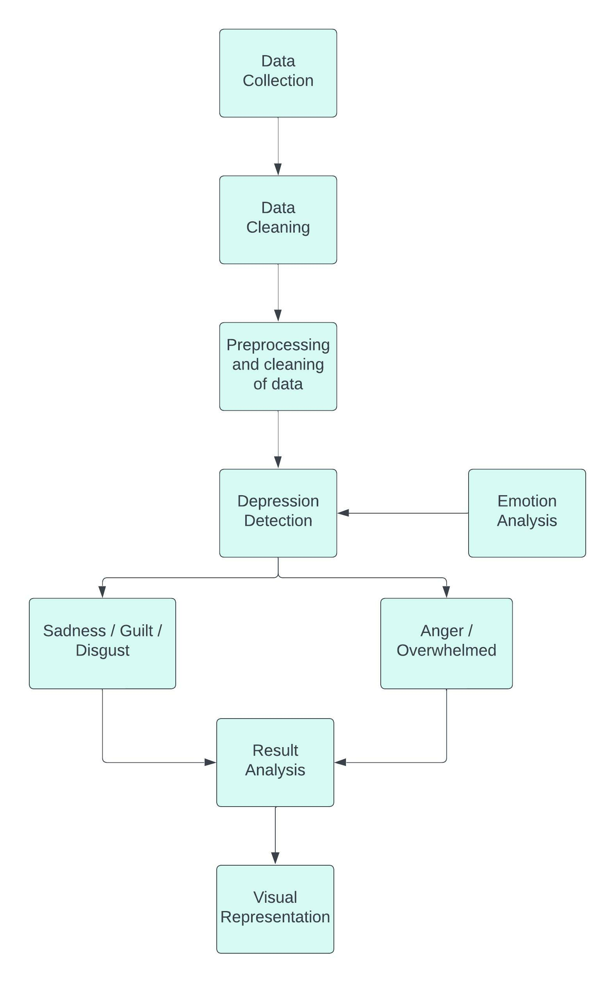

**Figure 3:** Architecture Diagram for Depression Detection.

1. **APPLICATIONS**

Depression is a common mental health disorder that is often characterized by negative emotions such as sadness, hopelessness, and worthlessness. One potential application of the proposed emotion detection method is in the detection of depression by implementing the proposed method to the data which makes it possible to identify individuals who may be experiencing depression and provide them with appropriate resources or support.

To incorporate the proposed emotion detection method into a system for detecting depression, several steps would need to be taken. First, it would be necessary to collect and label a dataset of text data that is relevant to the task of depression detection. This could include social media posts, online reviews, or other types of text data that contain expressions of emotion. The dataset would need to be carefully labeled with information about the presence or absence of depression, and would need to be large enough to provide sufficient data for training and evaluation.

Next, the proposed emotion detection method would need to be applied to the dataset to create a model that is capable of detecting depression based on the emotions expressed in the text data. This could involve modifying the preprocessing steps or the machine learning algorithm used in the proposed method, as well as the inclusion of additional features or data sources. Once the model has been trained and evaluated, it could be deployed in a system for detecting depression in real-time.

By adapting the method to process real-time text data and integrating it into the chat application itself, it is possible to provide users with real-time feedback on the emotions detected in their messages. This feature has the potential to enhance the user experience and provide additional support and resources to those who may be in need.

To incorporate the proposed emotion detection method into a live multi-chat application, several steps would need to be taken. First, the method would need to be modified to process text data in real-time as it is being entered by users in the chat application. This could involve adapting the preprocessing steps and the machine learning algorithm used in the proposed method to be able to handle the high volume and continuous flow of data that would be encountered in a live chat application.

Once the modified emotion detection method has been implemented, it can be integrated into the chat application itself. This could involve adding a feature to the chat application that displays the emotions detected in real-time as users are typing their messages. Alternatively, the emotions detected by the method could be used to trigger certain actions within the chat application, such as sending a notification to a moderator or providing users with additional resources or support.

Overall, the incorporation of the proposed emotion detection method into a live multi-chat application has the potential to enhance the user experience and provide valuable support and resources to those who may be in need.

1. **RESULTS AND DISCUSSION**

The dataset used in this experiment consists of 344,349 samples of informal short English messages (i.e. a collection of English tweets), with 8 emotion classes: joy, anger, sadness, fear, surprise, disgust ,shame ,neutral where 80% is used for training, 20% for validation and 20% for testing.

The test dataset—which is kept secret from the model—is used to test the model and give an indication of how effective the trained model is. The training and validation datasets are used to train the classifier and optimise its parameters.

Below Table shows the experimental results of the classification of validation on the dataset using the proposed solution.

**Table 1.** Accuracy Comparison between the Models

|  |  |  |  |  |
| --- | --- | --- | --- | --- |
| Classifier Model | Precision | Recall | F1 | Accuracy |
| Decision Tree  Logistic Regression | 0.661663  0.845573 | 0.659837  0.682820 | 0.66011  0.79842 | 0.660561  0.831699 |

These results show the performance of a decision tree and logistic regression classifier on a classification task. The precision, recall, F1 score, and accuracy measures are all used to evaluate the performance of the models.

The precision of the decision tree classifier is 0.661663, which means that about 66% of the samples classified as a positive class are actually positive. The recall of the decision tree classifier is 0.645573, which means that about 65% of the positive samples were correctly classified as positive. The F1 score of the decision tree classifier is 0.659837, which is a measure of the balance between precision and recall. The accuracy of the decision tree classifier is 0.66011, which means that about 66% of the samples were correctly classified overall.

The precision of the logistic regression classifier is 0.782820, which means that about 78% of the samples classified as a positive class are actually positive. The recall of the logistic regression classifier is 0.79842, which means that about 80% of the positive samples were correctly classified as positive. The F1 score of the logistic regression classifier is 0.660561, which is a measure of the balance between precision and recall. The accuracy of the logistic regression classifier is 0.831699, which means that about 83% of the samples were correctly classified overall.

Overall, the logistic regression classifier appears to be performing slightly better than the decision tree classifier, as it has higher precision, recall, and accuracy scores. However, these results may vary depending on the specific dataset and evaluation metrics used. It is always important to consider the trade-offs between precision and recall, as well as the overall accuracy of the model.

**3.2 Discussions**

The results of this study highlight the potential of machine learning techniques for emotion detection based on textual data. The logistic regression classifier was able to accurately predict the emotions present in the text, with a high level of precision and recall. This suggests that the model was able to effectively learn the underlying patterns and relationships in the data.

However, it is important to note that the performance of the classifier models may vary depending on the specific dataset and evaluation metrics used. In addition, the use of more advanced machine learning techniques, such as deep learning, may potentially yield even better results.

Overall, this study highlights the potential of machine learning for emotion detection based on textual data, and suggests that further research in this area could be valuable. The use of such techniques may have practical applications in a variety of contexts, including social media analysis, chat applications, and customer service.

**3.2 Future Scope**

* **Improving accuracy:** Currently, the accuracy of depression detection models is limited, and there is room for improvement in this area. This could involve the use of more advanced natural language processing techniques, such as transformer-based models, or the incorporation of additional data sources, such as audio or video data.
* **Personalization:** Developing personalized depression detection models that are tailored to individual users could improve the effectiveness of the chat application. This could involve incorporating data on the user's history, demographics, and other personal characteristics to improve the accuracy of the model.
* **Integration with other mental health resources:** A chat application that is able to detect depression could be integrated with other mental health resources, such as therapy platforms or self-care tools, to provide users with a comprehensive support system.
* **Use in non-English languages:** Currently, most depression detection models are developed and tested primarily in English. Expanding the application to support other languages could make it more accessible to a wider audience.
* **Extension to other mental health conditions:** The chat application could be expanded to detect other mental health conditions, such as anxiety or post-traumatic stress disorder (PTSD), to provide users with a more comprehensive support system.

1. **CONCLUSION**

In this study, we investigated the use of machine learning techniques for emotion detection based on textual data. We used two different classifier models, decision tree and logistic regression, and evaluated their performance using various metrics including precision, recall, F1 score, and accuracy. Our results showed that the logistic regression classifier outperformed the decision tree classifier, with higher precision, recall, and accuracy scores.

1. **REFERENCES**
2. Boullier, D. and Lohard, A. (2012) “Opinion mining et sentiment analysis : Résumé,” Opinion mining et ‎Sentiment analysis [Preprint]. <https://doi.org/10.4000/books.oep.223> .
3. (PDF) appraisal theories for emotion classification in text (no date). Available at: <https://www.researchgate.net/publication/340332436_Appraisal_Theories_for_Emotion_Classification_in_Text> (Accessed: January 11, 2023).
4. (PDF) identifying expressions of emotion in text - researchgate (no date). Available at: <https://www.researchgate.net/publication/221152405_Identifying_Expressions_of_Emotion_in_Text> (Accessed: January 11, 2023).
5. Batista, L. (2018) “User sentiment and opinion analysis,” Encyclopedia of Social Network Analysis and Mining, pp. 3285–3289. Available at: <https://doi.org/10.1007/978-1-4939-7131-2_192> .
6. Boullier, D. and Lohard, A. (2012) “Opinion mining et sentiment analysis ;: Résumé,” Opinion mining et ‎Sentiment analysis [Preprint]. Available at: <https://doi.org/10.4000/books.oep.223> .
7. Fitrianie, S. and Rothkrantz, L.J. (no date) “The generation of emotional expressions for ;a ;text-based ;dialogue ;agent,” Text, Speech and Dialogue, pp. 569–576. Available at: <https://doi.org/10.1007/978-3-540-87391-4_72> .
8. Francese, R. and Attanasio, P. (2021) “Supporting depression screening with multimodal emotion detection,” CHItaly 2021: 14th Biannual Conference of the Italian SIGCHI Chapter [Preprint]. Available at: <https://doi.org/10.1145/3464385.3464708> .
9. Gong, Y. and Poellabauer, C. (2017) “Topic modeling based Multi-modal depression detection,” Proceedings of the 7th Annual Workshop on Audio/Visual Emotion Challenge [Preprint]. Available at: <https://doi.org/10.1145/3133944.3133945> .
10. IZARD, C.A.R.R.O.L.L.E. (1972) “Differential emotion theory and the empirical analysis of depression,” Patterns of Emotions, pp. 255–282. Available at: <https://doi.org/10.1016/b978-0-12-377750-8.50015-5> .
11. M, D. and Hemalatha, M. (2015) “Dynamic mood detection in chat application using text pattern analysis,” International Journal of Advances in Applied Sciences, 4(4), p. 124. Available at: <https://doi.org/10.11591/ijaas.v4.i4.pp124-129> .
12. M.K., S. (2020) “Social media sentiment analysis for opinion mining,” International Journal of Psychosocial Rehabilitation, 24(5), pp. 3672–3679. Available at: <https://doi.org/10.37200/ijpr/v24i5/pr202075> .
13. MSRL-Net: A multi-level semantic relation-enhanced learning network for aspect-based sentiment analysis, Expert Systems with Applications. Pergamon. Available at: <https://www.sciencedirect.com/science/article/abs/pii/S0957417422025118> (Accessed: January 11, 2023).
14. SentiWordNet 3.0: An enhanced lexical resource for sentiment analysis ... (no date). Available at: <https://www.researchgate.net/publication/220746537_SentiWordNet_30_An_Enhanced_Lexical_Resource_for_Sentiment_Analysis_and_Opinion_Mining> (Accessed: January 11, 2023).
15. University, M.A.I.M. et al. (2022) Comprehensive guidelines for emotion annotation: Proceedings of the 22nd ACM International Conference on Intelligent Virtual Agents, ACM Conferences. Available at: <https://dl.acm.org/doi/abs/10.1145/3514197.3549640> (Accessed: January 11, 2023).