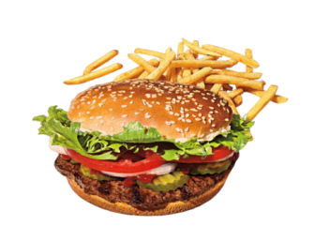

**The Technical**

**Hot dog**

**Starts from Rs.30/- only**