Three Phase Transmission Line Fault Detection and Analysis System

## **Geeta S. Metkar,** Student, Masters in Engineering, Department of Electrical Engineering, TSSM's Bhivarabai Sawant College of Engineering and Research, Narhe, Pune, Maharashtra, India.

**D. R. Pisal,** *Professor, Department of Electrical Engineering, TSSM's Bhivarabai Sawant College of Engineering and Research, Narhe, Pune, Maharashtra, India.*

## **Prof. A. P. Kinge ,** Professor, Department of Electrical Engineering, TSSM's Bhivarabai Sawant College of Engineering and Research, Narhe, Pune, Maharashtra, India.

***Abstract* -** Transmission line is the most important part of the power system. Transmission lines a principal amount of power. The requirement of power and its allegiance has grown up exponentially over the modern era, and the major role of a transmission line is to transmit electric power from the source area to the distribution network. The exploded between limited production, and a tremendous claim has grown the focus on minimizing power losses. Losses like transmission loss and also conjecture factors as like as physical losses to various technical losses, Another thing is the primary factor it has a reactive power and voltage deviation are momentous in the long-range transmission power line.

In essentially, fault analysis is a very focusing issue in power system engineering to clear fault in short time and re-establish power system as quickly as possible on very minimum interruption. However, the fault detection that interrupts the transmission line is itself challenging task to investigate fault as well as improving the reliability of the system.

The transmission line is susceptible given all parameters that connect the whole power system. This paper presents a review of transmission line fault detection.

***Key Words*:** Three phase transmission line fault, Symmetrical fault, Unsymmetrical fault, Overhead line transmission fault.

# INTRODUCTION

Regarding the distribution system, transmission lines perform the most important part that is to transfer electric power from the generating station to load centers. Since the development of the distribution and transmission system, power system engineers have been an object for locating and detecting faults. As long as the fault detected in short duration, it provides a good service for protecting the apparatus as well as an open way for disconnecting the part where this incident happened at fault, and with the help of this, it gives safe way to the system from any damages. So it is needed to detect the fault otherwise due to fault it causes any disturbance which further tough time to the interconnected system that based on limitations. The structure of the transmission line constructed to investigate the location of the fault and can give separation only the part where the fault occurs. Stimulating method help in identify and isolate the fault in short period. A stable voltage can be achieved by the use of a series capacitor achieved. Series capacitors line inductance can be reduced by [L(dv/dt)] along the line. If the line current leads the voltage, mean voltage increase. On the other side, there could be a voltage drop if line voltage is lagging by the line current. In this outlook, the voltage that has been boosted up and the voltage dropped decreased by the series capacitor as if the line inductance is smaller for the series recompensed line as associated with the unpaid line.

Suppose when more than two conductors develop contact each other or with the contact take place on the ground to 3 phase systems that are considered at fault which could be a balanced fault or unbalanced fault. Due to these faults stresses are produced in power system equipment that could damage the power system components. So to avoid these harms and to make power quality better, it is essential to know the reasons of fault as well as the location of the transmission lines and solve it properly. The problem of finding the type of fault related to the transmission line as well as finding the location of the fault is a quite complicated job. The most exclusive problem of being worried is to investigate fault for the power industry. Apparently for the detection of fault some protective devices are used (relay) and also make control over it with the help of special control devices as well as devices called recording these all are used to cut the session where the fault is being occurred in the system. Most important work is to collect all information regarding fault from this it is to be easy to investigate and make it possible to correct soon. Lots of researchers have been worked for knowing the skills for finding the locations of fault in distribution as well as in the transmission network related to methods of artificial intelligence like fuzzy set theory and artificial neural networks.

In our project we will monitor various faults like, under voltage, Over-voltage, Unbalance voltage, Single phasing, Over temperature and protect them against any abnormal conditions, same will be send in term of SMS using a GSM module. In addition to this we also give a provision for automatic restoration (reset) after fault may get OK, which result less human

Interactions. For monitoring and control purpose we are used a PIC microcontroller 18f, Potential transformer (PT), Regulator, Relay, LCD.

# 2. VARIOUS FAULTS IN 3 PHASE LOADS

1) Overvoltage: When the voltage in a circuit or part of it is raised above its upper limit, this is known as

Overvoltage. The conditions may be hazardous. Depending on its duration, the Overvoltage event can be transient a voltage spike or permanent, leading to a power surge. Electronic and electrical devices are designed to operate at a certain maximum supply voltage, and considerable damage can be caused by voltage that is higher than that for which the devices are rated. Due to this Overvoltage there may be Mal-operation of Circuit –Breaker or other accessories can be take place and hence Power system may get collapse. Thus monitoring of such faults becomes necessary.

2) Single phasing: Single phasing is an unwanted condition where one phase in a three-phase Power system is missing, due to a tripped breaker or other condition. With just two lines hot, there is no phase rotation and thus the power delivered to the load is single-phase. This is very bad for most three-phase loads with reduced power and continuously drawing current.

3) Temperature: Hot spot of the winding is the maximum limit of the load capability. Previously the hot spot is calculated by knowing the measurement of oil temperature and of load of current. Abnormal temperature readings almost always indicate some type of failure in a 3 phase devices. For this reason, it has become common practice to monitor the hot spot, main tank, and bottom tank temperatures, windings temperature, bearing temperature in case of induction motors.

4) Moisture: The presence of water in the oil can lead to reduction in the dielectric strength of transformer oil also ageing of oil is also affected .Thus all this can lead to electrical breakdown of transformer oil. This is very critical situation therefore continuous monitoring of operation is required to protect transformer from all of this.

5) Vibration: Transformer vibration (and consequently noise) is caused by the magnetostriction of the core laminates (the extension and contraction of the core lamination. Under alternating fluxes, this extension and contraction takes place twice during a normal voltage or current cycle. This means that transformer is vibrating twice of the frequency of supply resulting in vibration to occur mainly at 120 Hz. This vibration level depends on the transformer construction and design. Vibration level shall increase by through fault current, phase to ground or phase to phase fault. Thus monitoring is necessary for any kind of vibration in the Transformer.

6) Phase Loss Protection / Phase Imbalance Protection: A three-phase motor can continue operating if one of the phases is lost. However, this causes a considerable mechanical stress on the equipment while also increasing the current of the two operational phases. This condition may cause a motor to fail prematurely. It is important to note that negative effects start as soon as the phases are imbalanced with respect to voltage - there is no need for one of them to be completely shut-off, even though the effect is much more drastic. Protection against phase loss and imbalance is accomplished with an auxiliary circuit, just like voltage protection. Typically, phase imbalance must not exceed 2% in order to guarantee optimal motor performance.

# 3. WAYS OF DETECTING VARIOUS FAULTS

The proposed of monitoring system consists of Global Service Mobile (GSM) Modem, with PIC microcontroller and different sensor. It is installed at the 3 phase devices and the finding parameters recorded using the analog to digital converter (ADC) of the embedded system. The acquired parameters are processed and recorded in the system memory. If there is any abnormality or an emergency situation the system generate tripping signal and sends SMS (Short Message Service) messages to designated mobile telephones containing information about the abnormality.

1) Measurement of Over-voltage: To measure overvoltage we used step down transformer in our project. The transformer connect across the phase and neutral of each phases (R, Y, B), which step down voltage from 300v AC (max) to 5 volt AC, further This voltage will be converted to DC by means of rectifier and give it to the input of ADC, the ADC will convert this signals in equivalent digital signals and give it to microcontroller. Further microcontroller compares these digital signals with the settled overvoltage (260v) and under voltage (180v) if the signals is greater than 260 volt and less than 180volt then the microcontroller trips the contactor. If in case of phase failure the microcontroller treat this fault as a under voltage because if any phase is not available that means the voltage is less than 180 v (0 volt is less than 180 volt) in this case also microcontroller trips the contactor.

2) Single Phasing: Single phasing can be prevented by using single phasing preventer. Single phasing preventer is an electronic circuit which prevents the three phase electronic operated electrical machines from single phase cut off, phase reversal and phase imbalance.

3) Temperature Monitoring: In order to make on-line monitoring possible, thermocouples are placed externally on the transformer and provide real-time data on the temperature at various locations on the transformer. High main tank temperatures have been known to indicate oil deterioration, insulation degradation and water formation.

4) Moisture: Online monitoring can be used to Improve the accuracy of Oil .Moisture sensors available can easily detect the presence of any moisture

# 4. Experimental Setup

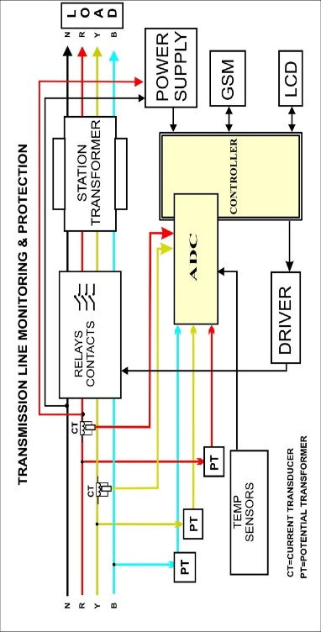

**BLOCK diagram**

# 5. WORKING

The above block diagram represents the actual BLOCK diagram of the WEB BASED MONITORING OF SUBSTATION TRANSFORMER. It consists of various blocks such as microcontroller, measurement devices and sensor unit along with interfacing IC. The parameters for e.g. VOLTAGE, CURRENT, TEMPERATURE, HUMIDITY by using microcontroller which is further connects with a PC or laptop this collected data will further send to server which will situated at any part of world through internet communication.

In further connection in case of fault such as unbalanced voltage, under voltage, overvoltage etc. the fault is being analyzed by microcontroller programming and the signal is being send to the driver relay to disconnect the contactor and isolate the substation.

As shown in the figure the power transformer is used to step down the voltage of 230V single phase to 12V. The 12V supply is being rectified to 12V by using the full wave rectifier. This rectified supply is regulated to 5V. This 5V of supply is need for the working of MICROCONTROLLER, and the various equipped sensors. The P.T. and the current transducer are energized by the line conductors. The LCD used to display the monitored parameters on the station substation itself. The driver IC is used as a current booster to amplify the current from the microcontroller, used to drive the relay.

The microcontroller is being programmed to certain limits. The oil temperature, oil level and the humidity within the transformer. Whenever the fault occurs such as overvoltage, over current, under voltage, phase failure etc. the direct effect will be developed on the transformer. So in case of fault condition the microcontroller will give the command to driver IC, so that the relay is to be tripped and the transmission line will isolate.

# 6.Simulation with result

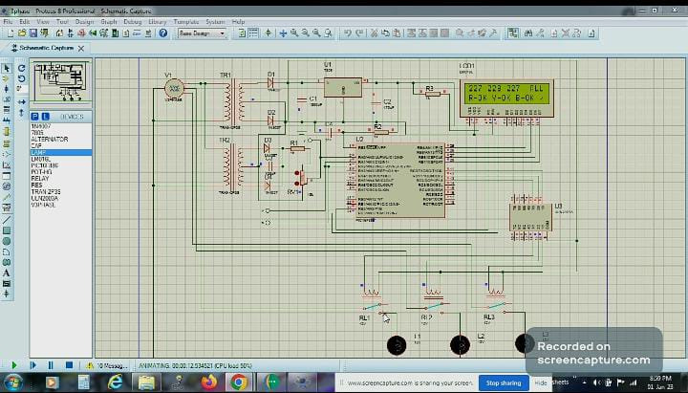

**Fig.1 Similation at no fault condition**

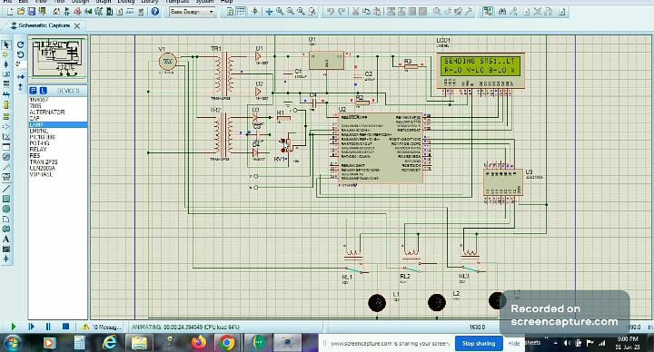

**Fig.2 Simulation at fault condition**

# 7. CONCLUSION

The transmission line has a crucial function to maintain the reliability and to keep the quality of an electric power transmission system. On the other hand, the exposure to high voltage environment may also be able to cause risk to human health. Therefore an integrated monitoring system is necessary to be implemented for easy monitoring and controlling the substation while minimizing interaction of humans to the substation devices. All the substation devices conditions are displayed uninterruptedly in remote area or a monitoring place.

In short the easy parameter monitoring will allow reducing the man power requirement at the substation area. This parameter monitoring system will be done around the clock throughout the year. The overall efficiency of the substation will increase as its maintenance plan is reduced.

# REFERENCES

* W.L. Chan, L.L. Lai, “Internet Based Transmission Substation Monitoring’’, IEEE Transactions on Power Systems, Vol. 14, No. 1, February 1999.
* B. Qiu and H. B. Gooi, “ Web-Based SCADA Display Systems (WSDS) for Access via Internet’’, IEEE TRANSACTIONS ON POWER SYSTEMS, VOL. 15, NO. 2, MAY 2000.
* Sumit Dutta, Shreya Prakash, David Estrada Eric Pop, IEEE, “A Web Service and Interface for Remote Electronic Device Characterization’’, IEEE TRANSACTIONS ON EDUCATION, VOL. 54, NO. 4, NOVEMBER 2011.
* ‘A Course on Web Languages and Web-Based Applications’, K. Sridharan, IEEE TRANSACTIONS ON EDUCATION, VOL. 47, NO. 2, MAY 2004
* [www.google.co.in/images](http://www.google.co.in/images)
* [www.wikipedia.com](http://www.wikipedia.com)
* [www.fadooengineering.com](http://www.fadooengineering.com)
* V.K. MEHTA , (Power System) , chapter 25
* B.L. THERAJA & A.K. THERAJA , Volume 2, (AC &DC machines