**INNOCUOUS DESIGN OF BMS FOR EV’S**

**DR.L.Chitra,ME,PHD**

**Head of department,**

*1Department of Electrical and Electronics Engineering, Aarupadai Veedu Institute of Technology,*

*Vinayaka Missions Research Foundation*

*Corresponding author mail id: chitra@avit.ac.in*[*@gmail.com*](mailto:prakash.yours@gmail.com)*,*

**Raghav N2,**

**UG Scholor**2 **,**

*2,Department of Electrical and Electronics Engineering, Aarupadai Veedu Institute of Technology,*

*Vinayaka Missions Research Foundation*

*Corresponding author mail id:* raghu222@gmail.com[*@gmail.com*](mailto:kiransreevalsan7@gmail.com)

**Muhammad Safal4,**

**UG Scholor**4**,**

*3Department of Electrical and Electronics Engineering, Aarupadai Veedu Institute of Technology,*

*Vinayaka Missions Research Foundation*

*Corresponding author mail id*: safalmuhammad[@gmail.com](mailto:cmsahal.98@gmail.com)

**Mrudul S Raj5,**

**UG Scholor**5**,**

*4Department of Electrical and Electronics Engineering, Aarupadai Veedu Institute of Technology,*

*Vinayaka Missions Research Foundation*

*Corresponding author mail id*: *mrudul8421@gmail.com*

**Venketesh Pradeep3**

**UG Scholor3 ,**

*2,Department of Electrical and Electronics Engineering, Aarupadai Veedu Institute of Technology,*

*Vinayaka Missions Research Foundation*

*Corresponding author mail id* venkatesh11pradeep[*@gmail.com*](mailto:kiransreevalsan7@gmail.com)

Abstract - Battery management systems (BMS) is used in battery safe, reliable and increases the senility without entering into a damaging state. In order to maintain the state of the battery, voltage, current, ambient temperature different monitoring techniques are used. For monitoring purposes different analog/digital sensors with microcontrollers are used. This project addresses state of charge, state of health, and state of life and also maximum capacity of a battery used in EVs in Indian conditions

This Prototype ensures safe charging, discharging and proper cell optimization ,thus providing a secure riding experience for the people and the society. .By adding safety features to the existing Battery Management System , we have tried to bring out a much safer and efficient prototype . In this prototype we are using a Blynk Application to connect with the microcontroller which helps us with the current status , faults and other errors happening in the Battery Management System.

In our project we used lithium ferrous phosphate (LiFePo4) battery instead of lithium ion battery.The main reason for this is lithium ion batteries may overheat and even catch fire.This was the major factor we made us to opt for lithium ferrous phosphate batteries over lithium ion batteries.Also there are some more factors.That is , lithium ferrous phosphate batteries are more efficient compared to lithium ion batteries and also when we go through the chemical reaction which takes place in the cells lithium ferrous phosphate batteries are bit safer as compared to lithium ion

The DHT 11 sensor which is connected outside the system collects The data of the outside temperature and give the signals to the micro controller and this micro controller give signals to the thermo electric peltier module . This thermoelectric peltier module Will act according to the temperature of the outside atmosphere.

And finally the integration of Bluetooth, Bluetooth LE and Wi-Fi ensures that a wide range of applications can be targeted, and that the module is all-around: using Wi-Fi allows a large physical range and direct connection to the Internet through a Wi-Fi router, while using Bluetooth allows the user to conveniently connect to the phone or broadcast low energy beacons for its detection.

1. INTRODUCTION

The major role of a BMS is in an Electric vehicle, it plays a major role in safety and Life Expectancy of a Vehicle. But BMS has some problems which tends to be a threat to the passengers traveling in Electric vehicles. One of the famous failure modes of the system is thermal run-away, which is often associated with fire hazards. And we often end up with miss-balance of charges at the cells of the battery pack, which affects the performance of the battery.

Nowadays in EV’s battery is failing due to poor cell monitoring and management. Also, charging the whole battery in series creates uneven charges in cells. This combined with high average atmospheric temperature may cause the battery to blast or catch on fire So in this project we are making a safe and more efficient version of the existing battery management systems in EVs. The project focuses on efficient temperature management and charging conditions for each cell in a battery for safety purposes.

The future of EVs in transportation has already shown its successful progression till now but there are some setbacks .The problems are mainly temperature variations in different regions in the world and inefficient charging methods. This project is a prototype of a BMS which is equipped with safety features. And a efficient charging system which is programmed to analyze and control each cell in a battery

Battery management systems range from simple to complex and can embrace a wide range of different technologies to achieve their prime directive to “take care of the battery.” However, these systems can be categorized based upon their topology, which relates to how they are installed and operate upon the cells or modules across the battery pack.

1. DESCRIPTION OF THE PROPOSED WORK

The Concept of this Design is to make the whole system Much more safe. The whole point of this innocuous design of the BMS and cell monitoring system, Carried out in a way that it is safer in all means.

It starts with the selection of the cell , every regular EV battery is designed With lithium polymer cell. The proposed model Constructed As in such Taken all the variables in hand , Such as temperature, humidity, thermal Throttling short-circuiting and many other variables which are responsible for the damage or Accidents in the BMS , especially in EV.

Thus in the proposed system, We have come to a conclusion to use The lithium iron phosphate battery or LFP cell. The reason behind The selection of this particular cell Is explained in the previous chapter.

Construction of this module is of eight lithium iron phosphate cells in series, With each cell attached with a separate LM35 Temperature sensor, ACS712 and voltage sensor To measure temperature,current and voltage Of each cell separately. And this battery pack will be attached to a peltier module, To increase and decrease the temperature around the batteries for ideal conditions.

To control all this ESP 32 microcontroller is used as a brain of this operation and the data being collected is being sent through a mobile app and also in a webpage. And collected data is used to control the temperature around the battery with the help of the Peltier module. The working of the party module is explained in the previous chapter.And also solid-state Relay is used as a failsafe switch in case anything goes wrong in the System. And all this is constructed and put in a block diagram which is shown below.

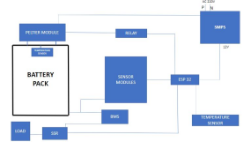

Fig. 1. Block diagram of the proposed work

The proposed system consists of a microcontroller , sensors , relays, LiFePO4 battery , current sensor and a peltier module. During the working of this Battery Management System each of the cells are monitored with the help of an ACS712 . This ACS712 helps to examine the health of the cells . This way we will be able to get to know the current condition of each cell. This monitors the amount of charge in each cell, the present health of the cell, load detection and management, switch-mode power supplies, and overcurrent fault protection. Once the analyzing of the cells are done , the data is provided to the ESP32 . This ESP32 is the microcontroller used in this prototype and it controls the working of this Battery Management System.If any of the cells requires charging or discharging , it will be sorted with the help of ESP32. We used Arduino IDE to configure this microcontroller with the system.

In this prototype , we are using 2 DH11 sensors which are used to sense the temperature in and out of the system. We have programmed the data for the lowest and highest temperature of a battery cell in the microcontroller. These data are given according to the atmospheric condition of a particular place. Both of these sensors will keep on monitoring the temperature of the cell and the atmosphere. After analyzing the temperatures from both the sensors, ESP32 2ill figure out whether the cell needs to be cooled or heated for the requirement.

In an investigation carried out on batteries disclosed that the operating temperature of the battery should be lower than 45C and more specifically for the Li-on batteries , the operating temperature should be in the range of -20C - 60C with a temperature difference of 5C .Otherwise if the operating temperature reaches 120C then 1/5th of the battery capacity can drop.If the cells have to be cooled or heated , the thermo electric peltier module will maintain the temperature according to the analyzed data by the Temperature and Humidity sensors.

The performance , reliability and safety issues of Li-on batteries can be suitably addressed if the operating temperature is maintained in the range of 15C - 35C.

By adding these few additional features to the existing Battery Management System , we have tried to bring out a much safer and efficient prototype . In this prototype we are using a Blynk Application to connect with the microcontroller which helps us with the current status , faults and other errors happening in the Battery Management System.

1. ESP32

Esp 32 is the micro controller used in this prototype . Micro controllers have been widely used for IOT based or arduino based systems . This micro controller help us to connect the sensors and the modules in this system . The whole Battery Management system have been managed by this micro controller . This micro controller is connected to the two DHT11 sensors which are connected inside the Battery Management system and outside the system. Micro controller is also connected to the thermo electric peltier module which act as the heating and cooling agent. The DHT 11 sensor which is connected outside the system collects The data of the outside temperature and give the signals to the micro controller and this micro controller give signals to the thermo electric peltier module . This thermoelectric peltier module Will act according to the temperature of the outside atmosphere.

The data of temperature from sensors are analyzed in the ESP32. Further activities will be taken only if its required for the efficient working of the cell its actions are based on the data is provided with then its done by ESP32 giving signals to the peltier module which maintains the temperature of the battery management system

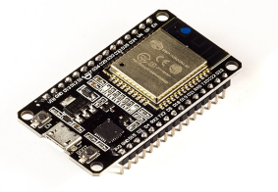

Fig 2

The integration of Bluetooth, Bluetooth LE and Wi-Fi ensures that a wide range of applications can be targeted, and that the module is all-around: using Wi-Fi allows a large physical range and direct connection to the Internet through a Wi-Fi router, while using Bluetooth allows the user to conveniently connect to the phone or broadcast low energy beacons for its detection. The sleep current of the ESP32 chip is less than 5 *µ*A, making it suitable for battery powered and wearable electronics applications. The module supports a data rate of up to 150 Mbps, and 20 dBm output power at the antenna to ensure the widest physical range. As such the module does offer industry-leading specifications and the best performance for electronic interaction, range, power consumption, and connectivity.

The operating system chosen for ESP32 is freeRTOS with LwIP; TLS 1.2 with hardware acceleration is built in as well. Secure (encrypted) over the air (OTA) upgrade is also supported, so that users can upgrade their products even after their release, at minimum cost and effort.

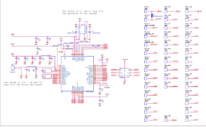

Fig 3

1. **ACS172**

ACS172 operates both on AC and DC. in this project, ACS172 works as a current sensor. It senses the flow of the current through the cells. In this prototype, this is one of the major steps of sensing the conditions of each cell. The current status of each cell is provided to ESP32. The current status is shown in the unit of mAm

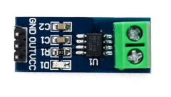

Fig 4

The Allegro™ ACS712 provides economical and precise solutions for AC or DC current sensing in industrial, commercial, and communications systems[10] The device package allows for easy implementation.

Acs 712 is the current management sensor used in this prototype. It is one of the important Component of this project. It is a sensor which senses the health , capacity and performance of the battery cells . It monitors each and every cells equally , by which way we will be able to get a proper status of each and every cell. This is one of the important process of this project. By getting to know the proper and current status of the battery cell , we will be able to make this system more safer and efficient.

The ACS 712 will measure the current capacity of the battery cell and if the battery is not fully charged , then the ACS712 will send signals to the micro controller and the battery is made to be fully charged . With the help of an arduino , we have connected our micro controller to the Blynk app , from where we could get the details of the battery cells precisely. All the details of the battery cells will be displayed in the app. By this way we will be alerted if there is any fault in the Battery Management System . It will help us to be more safer from accidental situations.

1. THERMO ELECTRIC PELTIER MODULE

Peltier module (thermoelectric module) is a thermal control module which has both heating and cooling effects. By passing an electric current through the module, it is possible to change the surface temperature and keep it at the target temperature.

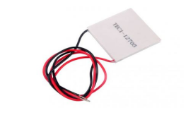

Fig 5

It is among the important parts of this Battery Management System . This thermo electro petlier module is connected to the micro controller and the batter cells . The cooling and heating of the battery cells are done by this petlier module . It has the efficiency to cool down the battery as well as increase ots temperature. Therefore it shows that it is one of the main component used in this Battery Management System . If the temperature of the battery cells is increased , the micro controller will give signals to the thermo electric petlier module . Then this petlier module will cool down the battery cells with the help of a cooling system . On the other hand , if the temperature of the battery is low , then the micro controller in this system woll give signals to the petlier module . The petlier module will increase the temperature of the cells .

1. Lithium Ferrous Phosphate Battery

The lithium iron phosphate battery or LFP battery is a type of lithium-ion battery using lithium iron phosphate as the cathode material, and a graphitic carbon electrode with a metallic backing as the anode.

In our project we used lithium ferrous phosphate (LiFePo4) battery instead of lithium ion battery.The main reason for this is lithium ion batteries may overheat and even catch fire.This was the major factor we made us to opt for lithium ferrous phosphate batteries over lithium ion batteries.Also there are some more factors.That is , lithium ferrous phosphate batteries are more efficient compared to lithium ion batteries and also when we go through the chemical reaction which takes place in the cells lithium ferrous phosphate batteries are bit safer as compared to lithium ion.when we check out efficiency lithium ferrous phosphate batteries are better than lithium ion batteries. As we all know nowadays when we check the price graph of the petrol it is increasing ,people choose electric vehicles over petrol vehicles so cost effective is a major factor which people look out for so in comparing with battery side ferrous phosphate batteries is much cheaper than compared to lithium ion batteries. lithium ferrous phosphate batteries maintain a good performance without decreasing it to an extent.

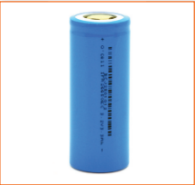

Fig 6

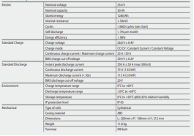

Fig 7

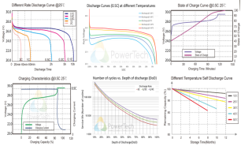

Fig 8

D**.**  LiFePO4 8SM 24V BMS

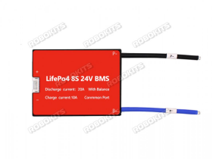

Fig 9

we used LiFePO4 8SM 24V BMS in our project. it is designed for lithium batteries for charging. The use of this in our project is it protects from over charge and over discharge. The features of this BMS are state of charge calculations ,cell over-voltage and under-voltage protection. it comes with fully sealed waterproof technology and also it ensures dustproof, shockproof, anti-squeezing, and other protective functions. The working temperature range of this BMS is from -20 degree Celsius to 70 degree Celsius.

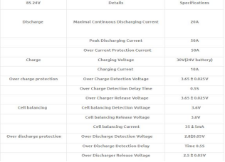

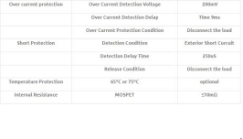

1. DHT11 Temperature and humidity sensors

[6] The DHT11 is a basic, ultra low-cost digital temperature and humidity sensor. It uses a capacitive humidity sensor and a thermistor to measure the surrounding air, and spits out a digital signal on the data pin

[7]In our project we used lithium ferrous phosphate (LiFePo4) battery instead of lithium ion battery.The main reason for this is lithium ion batteries may overheat and even catch fire.This was the major factor we made us to opt for lithium ferrous phosphate batteries over lithium ion batteries.Also there are some more factors.That is , lithium ferrous phosphate batteries are more efficient compared to lithium ion batteries and also when we go through the chemical reaction which takes place in the cells lithium ferrous phosphate batteries are bit safer as compared to lithium ion.when we check out efficiency lithium ferrous phosphate batteries are better than lithium ion batteries. As we all know nowadays when we check the price graph of the petrol it is increasing ,people choose electric vehicles over petrol vehicles so cost effective is a major factor which people look out for so in comparing with battery side ferros phosphate batteries is much cheaper than compared to lithium ion batteries. lithium ferrous phosphate batteries maintain a good performance without decreasing it to an extent.

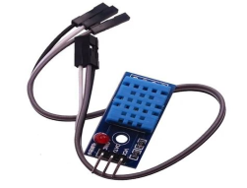

Fig 10

1. RELAY

In this project we are using a 4 channel relay which has been connected with the thermo electric peltier module . It is an efficient board which can be used to control voltage, current load, etc. It is designed to interface with microcontrollers such as Arduino, ESP32 etc.

We are using this 4 channel relay in BMS to control the battery charging depending upon its condition and health . If it is enabled as in the battery cells requires flow of charge , then the relay will be open and the current will pass through. By this way the charging of the battery cells is done . And at the same time if the battery is fully charged , the relay will get a signal from the microcontroller to stop the flow of the charge.

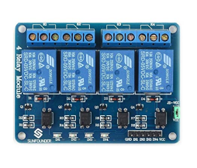

Fig 12

III. RESULT AND DISCUSSIONS

In this project we have came up with a safer and more efficient prototype of an existing Battery Management System , which in many ways is better than the current existing system. We have added two humidity and temperature sensors, a current sensor and with the help of a Microcontroller we are providing cooling and heating solution depending on the battery cell status

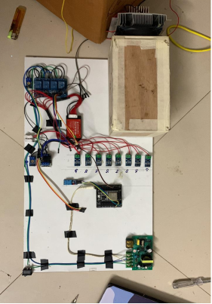

Fig 13

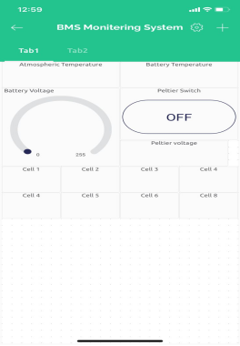

Fig 15

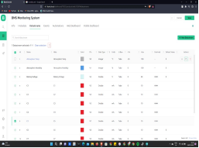

Fig 16

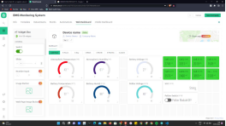

Fig 17

IV. CONCLUSION

The proposed work helps to improve the performance of the Battery Management System through remote access. This can be regularly used for the monitoring of the status of the Battery. It will be highly useful for EVs that are used in Indian conditions.

Blink app allows us to quickly build interfaces for controlling and monitoring our BMS from an iOS or Android device. We have created a project dashboard and made an interface which can be use to understand the current battery condition

V. REFERENCES

**[1]** [AS8506, ] AS8506. Datasheet rev 1.Lithium-Ionbattery cell monitor and balancer IC. Available online:http://www.ams.com/eng/content/download/476603/1402377/244331.

**[2]** [Bergveld, 2001] Bergveld, H. J. (2001). Battery Management Systems Design by Modelling. [BQ76PL536, ] BQ76PL536. Datasheet rev 1.Lithium-Ion battery monitor and secondary pro-tection IC. Available online:http://www.ti.com/lit/gpn/bq76pl536.

**[3]** [Cao et al., 2008] Cao, J., Schofield, N., and Emadi, A. (2008). Battery balancing methods: A comprehensive review. 2008 IEEE Vehicle Power and Propulsion Conference, pages 1–6. Available from: http://ieeexplore.ieee.org/lpdocs/epic03/wrapper.htm?arnumber= 4677669.

**[4]**  [Electropaedia, b] Electropaedia. Temperature and discharge rate. Available from: http: //www.mpoweruk.com/soc.htm.

61

**[5]** [Energy, 2012] Energy, E. (2012). Cost and performance of ev batteries. Final report for The Committee on Climate Change. Available from: http://www. element-energy.co.uk/wordpress/wp-content/uploads/2012/06/CCC-battery-cost_ -Element-Energy-report_March2012_Finalbis.pdf.

**[6]** [Faria et al., 2013] Faria, R., Marques, P., Moura, P., Freire, F., Delgado, J., and de Almeida, A. T. (2013). Impact of the electricity mix and use profile in the life-cycle assessment of electric vehicles. Renewable and Sustainable Energy Reviews, 24:271–287. Available from:<http://linkinghub.elsevier.com/retrieve/pii/S1364032113002220>.

**[7]**  [Huet, 1998] Huet, F. (1998). A review of impedance measurements for determination of the state-of-charge or state-of-health of secondary batteries. 70:59–69.

**[8]** [Kuhn et al., 2005] Kuhn, B., Pitel, G., and Krein, P. (2005). Electrical Properties and Equalization of Lithium-Ion Cells in Automotive Applications. 2005 IEEE Vehicle Power and Propulsion Conference, pages 55–59. Available from: http://ieeexplore.ieee.org/ lpdocs/epic03/wrapper.htm?arnumber=1554532.

**[9]** [Ng et al., 2009] Ng, K. S., Moo, C.-S., Chen, Y.-P., and Hsieh, Y.-C. (2009). Enhanced coulomb counting method for estimating state-of-charge and state-of-health of lithium-ion batteries. Applied Energy, 86(9):1506–1511. Available from: http://linkinghub.elsevier. com/retrieve/pii/S0306261908003061.

**[10]** [Parthiban et al., 2007] Parthiban, T., Ravi, R., and Kalaiselvi, N. (2007). Exploration of artificial neural network [ANN] to predict the electrochemical characteristics of lithium-ion cells. Electrochimica Acta, 53(4):1877–1882. Available from: http://linkinghub.elsevier. com/retrieve/pii/S001346860701047X.