**DESIGN OF IMAGE DENOISER USING COMBINED ADAPTIVE PARTICLE FILTER AND CURVELET TRANSFORM**

**Ramkhelavan Prajapati1, Agya Mishra2**

1,2 Department of Electronics & Telecomm. Engineering,

Jabalpur Engineering College

Jabalpur, (M.P.), India

---------------------------------------------------------------------***---------------------------------------------------------------------

**Abstract –** This paper presents a combined image denoiser. This work is based on Particle filter and Wavelet (Curvelet) transform combination, particle filter generates weights through SIR algorithm to cancel the interference of noise present in the image, while curvelet transform is used to shrink the remaining segments of noise, so this method can both remove image blurr and maintain good texture as well.

This is a new approach in image enhancement and Interference cancellation. This paper concludes that it is quite efficient algorithm among other adaptive filtering techniques.

Simulation result also depicts proposed algorithm performs extremely well when noise density is increased, as obtained image is completely visible. This approach comprises of generation of particles by performing weight normalization, resembling and update state. Therefore, for large number of particles execution time is more when compared to other adaptive filtering approach.

***Key Words*:** Particle Filter **(**PF), Curvelet (CLet), Wavelet (Wlet), Peak signal to noise Ratio (PSNR), Deblurring.

**1.INTRODUCTION**

Particle filtering uses a genetic selection sampling approach, with a set of particles (also called samples) to represent the posterior distribution of some stochastic process given noisy and/or partial observations. The state-space model can be nonlinear and the initial state and noise distributions can take any form required.

Particle filter techniques provide a well-established methodology for generating samples from the required distribution without requiring assumptions about the state-space model.

Particle filters implement the prediction-updating transitions of the filtering equation directly by using a genetic type selection particle algorithm the fact many that periods, the intricacy of the framework begins expanding.

Image denoiser basically performs interference cancellation. The adaptive filter cancels unknown interference from a desired information carrying signal, here a reference signal is utilized which regularly had almost no data signal part [12]. Interference cancellation using proposed algorithm is been shown in that nonlinear filter gives better results compared to linear filters, these are also called as adaptive filters, in the new era of the technology nonlinear filters in combination with some other algorithm gives the best results.

The fundamental commitment of the work deals with definitions of the different adaptive filters & particle filters along with their algorithm [1], Fundamental Particle Filter or normal weighted adaptive filter face the problem of degeneracy in which after few iterations, all but one particle will have negligible weight. And this may be solved by SIR Particle Filter which uses resampling and update stage at its algorithm.

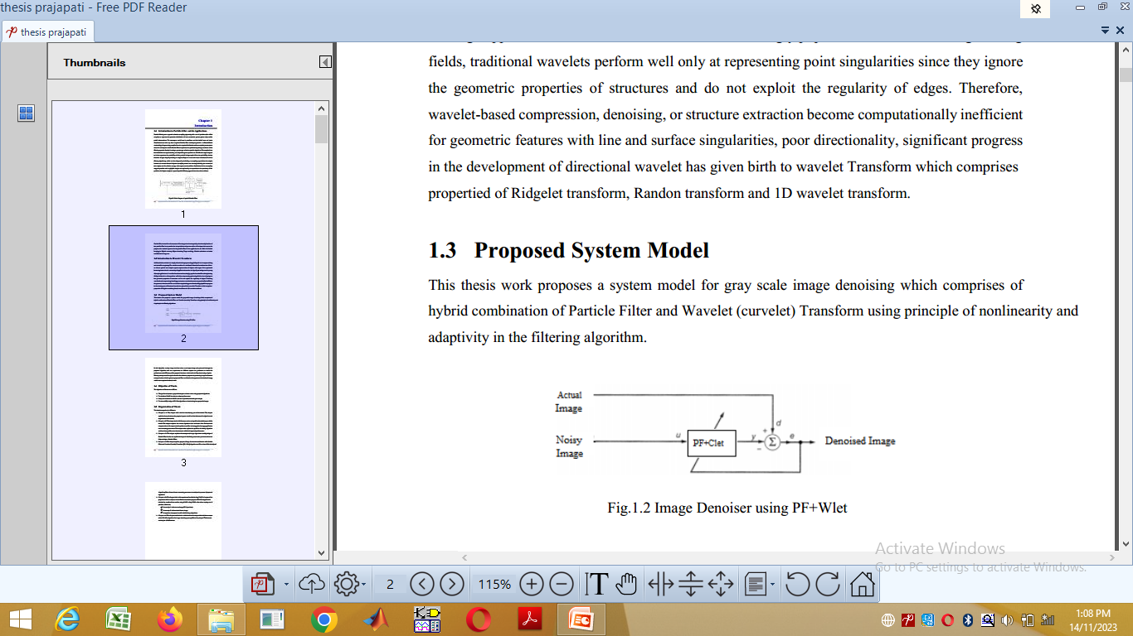

Figure 1.Image Denoiser using PF+Clet

**2. LITERATURE REVIEW**

In this [1] algorithm both grey information andedge structure information is considered compared to traditional Gaussian filter which only considers grey information of the image. This is possible only because of combination of Gaussian filter and weighted particle filter. Results are in terms of PSNR and different four types of parameters have been given hybrid combination of filter works better than any Gaussian filter or NL-means filter. This method selects pixels that are similar to the current pixel to do weighted average within a fixed small window but not range in the whole image and weight not only relates to images grey value, but also uses variance of its edge structure.

In this [2] RBPF with MLE is Rao-Blackwellized particle filter with maximum likelihood estimation. Rao-Blackwellization is done by combining particle filter with a bank of kalman filters. Maximum likelihood estimation finds the distribution of noise by evaluating likelihood around a particle dependent.

In this algorithm [3] standard approach employs reconstruction of system matrix. Magnetic particle imaging is new modality, which allows the determination of the spatial distribution of magnetic nanoparticles in-vivo. As an effect of measurement based calibration and because measurement based acquisition system matrix contains noise and this limits the quality of reconstruction result.

In this approach [4],[5] Particle filter along with wavelet transform for image denoising of a standard grey scale image is used Particle filter effectively restores image suffering from space variant blur, nongaussian noise and nonlinearity due to sensor but is less efficient in suppressing Gaussian noise component

**3. CONCEPT OF COMBINED MODEL**

Particle filter along with wavelet transform for image denoising of a standard grey scale image is used Particle filter effectively restores image suffering from space variant blur, non Gaussian noise and nonlinearity due to sensor but is less efficient in suppressing Gaussian noise component. This limitation is overcome by using combination of particle filter along with DWT

**3.1 PF Model**

Particle Filters are sequential Monte Carlo methods based on point mass (or “particle”) representation of probability densities, which can be applied to any state space model and which generalize the traditional adaptive filtering approaches. General 2-D PF algorithm is simple to understand and easy to implement [10]. The key thought is that required posterior density function will be represented by set of random variables with its related weights and to evaluate projections based on these samples and weights. PF framework described in has been presented below.

Particle filtering uses a genetic selection sampling approach, with a set of particles (also called samples) to represent the posterior distribution of some stochastic process given noisy and/or partial observations. The state-space model can be nonlinear and the initial state and noise distributions can take any form required. Particle filter techniques provide a well-established methodology for generating samples from the required distribution without requiring assumptions about the state-space model. Particle filters implement the prediction-updating transitions of the filtering equation directly by using a genetic type selection particle algorithm. The samples from the distribution are represented by a set of particles, each particle has a likelihood weight assigned to it that represents the probability of that particle being sampled from the probability density function. Weight disparity leading to weight collapse is a common issue encountered in these filtering algorithms, which can be mitigated by including a resampling step before the weights become too uneven. Several adaptive resampling criteria can be used, including the variance of the weights and the relative entropy with respect to the uniform distribution. A general particle filtering approach has been shown below

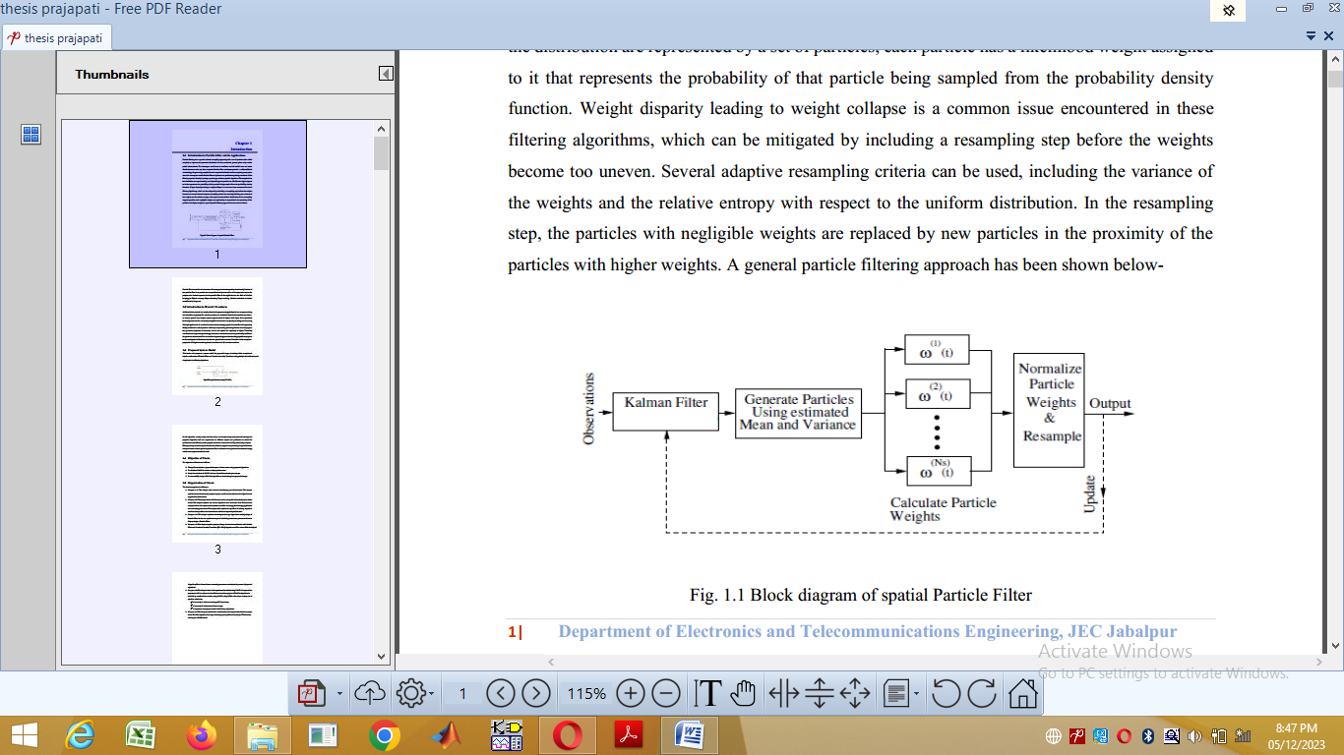

Figure 2: Block diagram of spatial Particle Filter

**3.2 Curvelet Transform Algorithm**

Although the DWTs has established an impressive reputation as a tool for mathematical analysis in signal processing but it has the disadvantage of poor directionality, significant progress in the development of directional wavelet has given birth to the Curvelet Transforms which is a combination of Ridgelet transform, Randon transform and 1D wavelet transform. The ridgelet transform is ideal at defining straight-line singularities. To examine local line or curve line singularities, a characteristic thought is to divide image in different parts, and afterward employ the ridgelet transform to the resultant sub images. The original curvelet transform was tested surprisingly for image denoising applications, the utilizations of the original curvelets were stretched out for image enhancement applications, astronomical image applications and satellite image representations. When second generation curvelet transforms were invented it resulted in better applications in 1-D, 2-D and 3-D signal processing. Best methodologies related with the discrete curvelet transform are hybrid combinations, where curvelets are used in combination with another technique for signal processing. These strategies may result in best performance of curvelet transform for representing curves [15]. Block diagram of curvelet transform steps has been shown in the Fig. 2

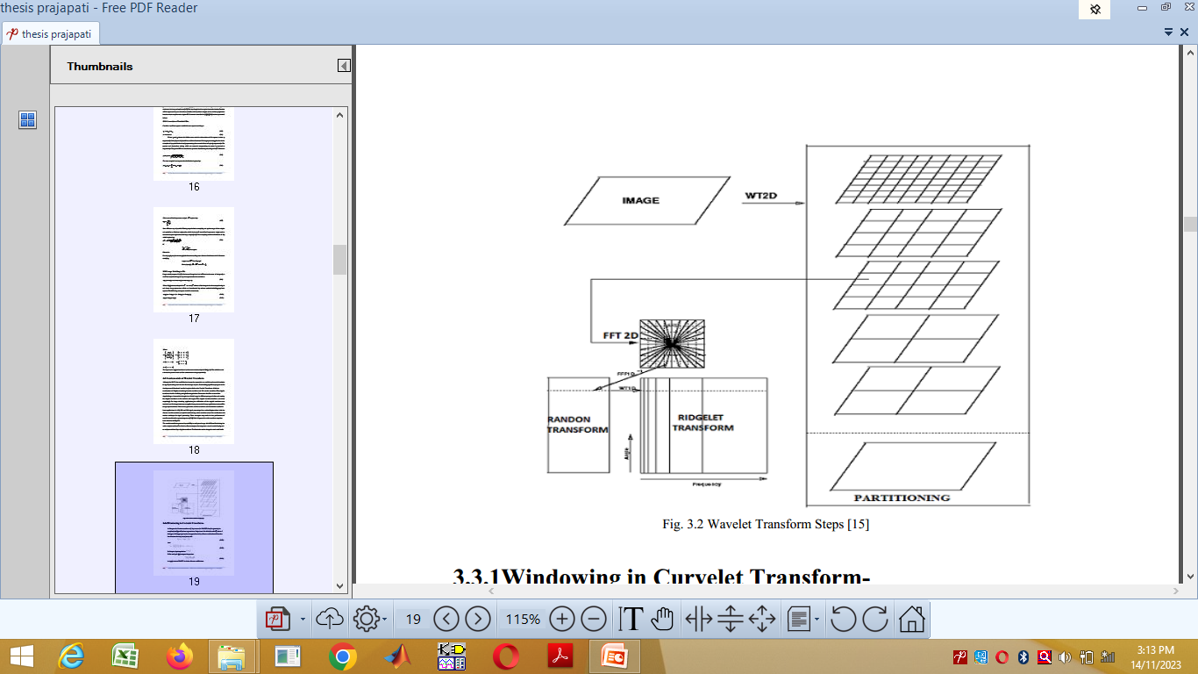

Figure 3: Wavelet Transform Steps

**4. Proposed Work**

**4.1 PF-Clet Denoising Approach**

This work proposes a system model for gray scale image denoising which comprises of adaptivity in the filtering algorithm. Hybrid combination of Particle Filter and Wavelet (curvelet) Transform using principle of nonlinearity.

Image enhancement is largely a subjective process while image restoration is for the most part an objective process, restoration attempts to recover or reconstruct an image that has been degraded by using priory knowledge of the degradation phenomenon, thus restoration techniques are oriented towards modeling the degradation and applying inverse process in order to recover original image. In this algorithm a noisy image has been taken as an input image and processed through the proposed algorithm and two experiments in different aspects are performed to check the performance and efficiency of the proposed denoiser.

Using adaptive filtering concept actual image is taken for the reference purpose and processing image is gaussian noise corrupted image which is given to proposed filter combination that generates the denoised image, which is the required denoised result.

This approach is a key to denoise the image which is affected by addition of gaussian noise, Gaussian noise degrades the image and its additive behavior creates many problems in image restoration, this can be eliminated by using particle filtering approach

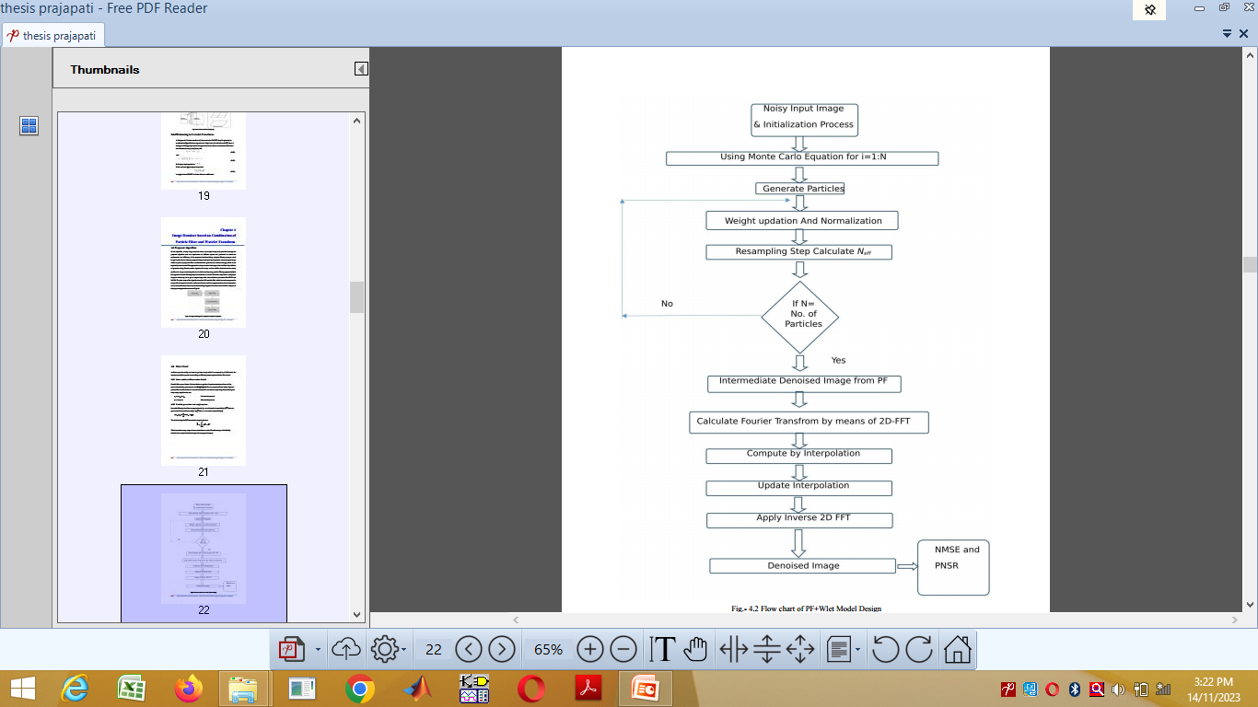

Figure 4: Flow chart of PF+Clet Model Design

This approach is a key to denoise the image which is affected by addition of gaussian noise, Gaussian noise degrades the image and its additive behavior creates many problems in image restoration, this can be eliminated by using particle filtering approach [8]. In this approach Particle Filtering steps are combined to Curvelet Transform steps from a noisy input image to denoise it, and to get an output image with some reference parameters like PSNR and NMSE. The prior stage of the algorithm involves SIR particle filter which is used to suppress the heavy tailed component of noise while curvelet uses nonlinear approximation and decomposition of data into sub-bands at last wavelet thresholding is applied for noise removal. Flow chart of the proposed approach is shown in Fig. 5.

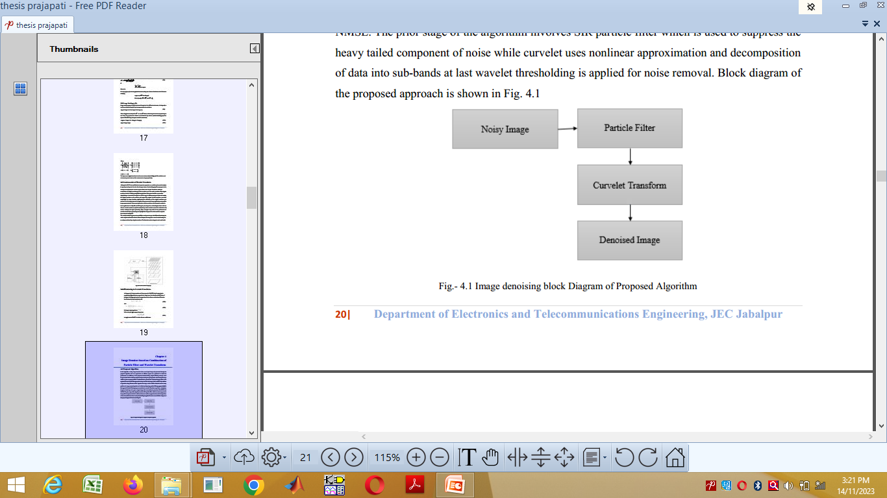

Figure 5: Image denoising block Diagram of Proposed Algorithm

**4.2 Efficiency Check Parameters**

To check performance of proposed method following two measuring parameters are calculated [2], one parameter is NMSE and other is PSNR which is calculated based on calculation of NMSE. Formula for both of the parameters are shown

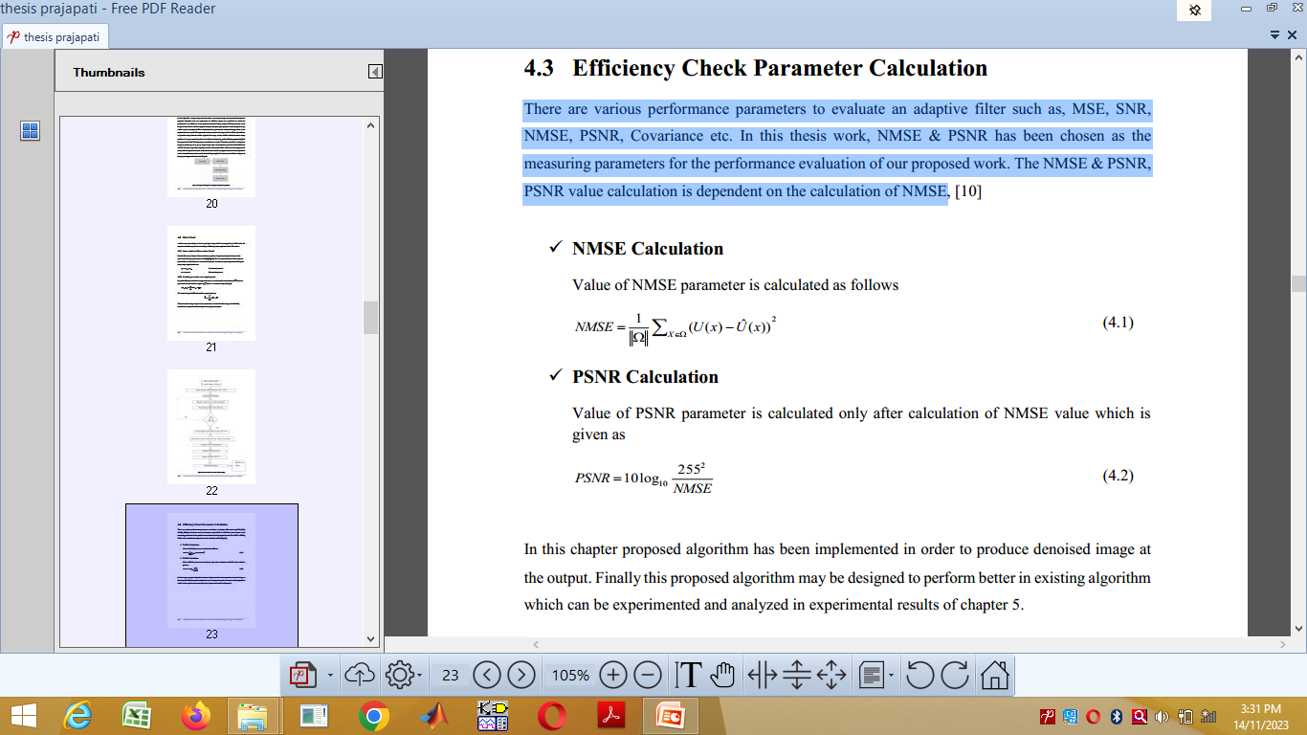

**5. RESULTS AND DISCUSSION**

In order to validate and demonstrate the proposed approach standard 128*128 gray scale test images is taken and proposed algorithm is used to restore images that have been corrupted by additive behavior of gaussian noise, and to justify performance

**5.1 Case Study**

In the first case reference gray scale 128*128 image with added Gaussian noise of 10% density having SNR 10dB has been taken, and then this noisy image is been given input to the particle filter with N=100 where N being number of particles. Which estimates meanwhile image and its posterior values. Then to this estimated image curvelet transform is applied and obtained output is proposed method’s result. For some calculations reference parameters like PSNR and MSE are calculated.

i. Input Image: In input of the experiment Lena Image of dimension 128*128, type-gray scale, Format PNG has been taken for case study-1, Fig. (a)

ii. Noisy Image:To test and check proposed denoiser Algorithm’s performance input Lena image is mixed with Gaussian noise of 10% density at 10dB SNR value, Fig. (b)

iii. Denoised Image of Proposed Model Intermediate stage (PF) output is now passed through the Curvelet Transform stage and obtained result is denoised image as shown in the Fig 6(c)

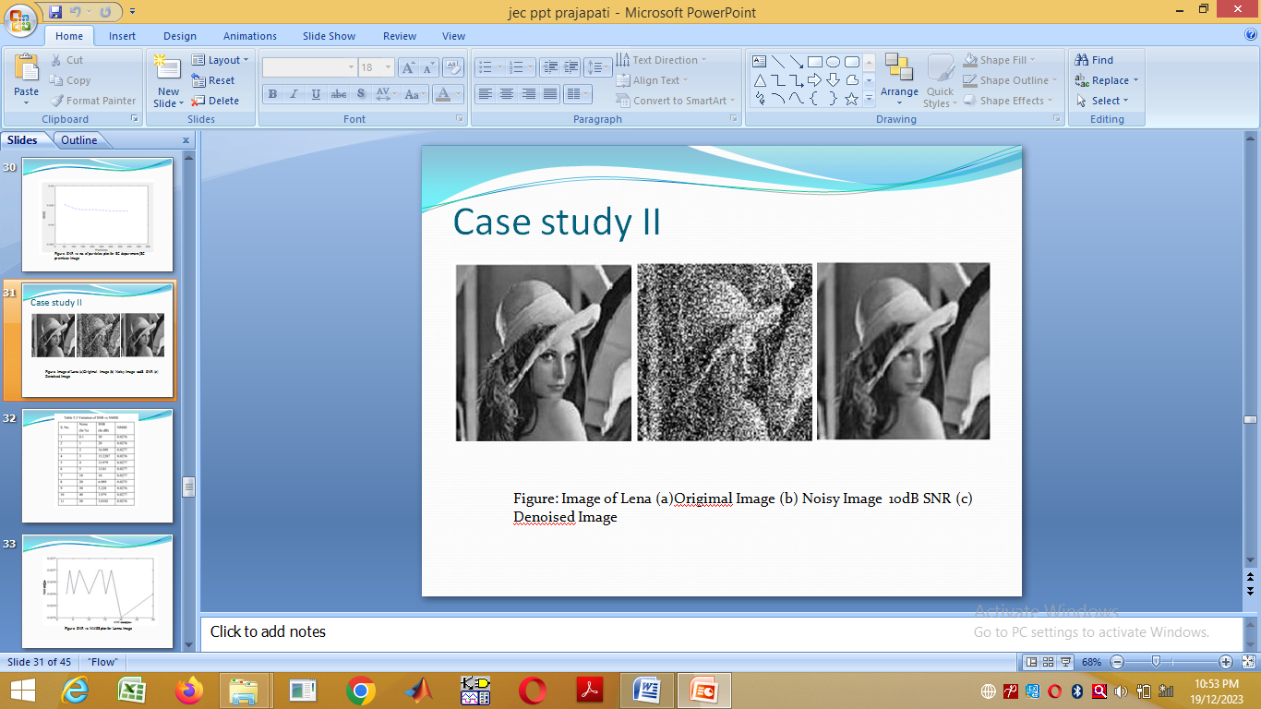

1. (b) (c)

Fig. 6(a) to (c) Results Obtained of Proposed Algorithm at Different Stages

**5.2 Analysis of SNR vs NMSE**

In this examination proposed method is tested for various SNR levels identified with their percentage noise density and distinctive NMSE values are obtained. This table contains noise density (in percentage), SNR values (in dB) related to noise density and obtained NMSE values.

TABLE I: NOISE PERCENTAGE, SNR VALUES &NMSE VALUE TABLE

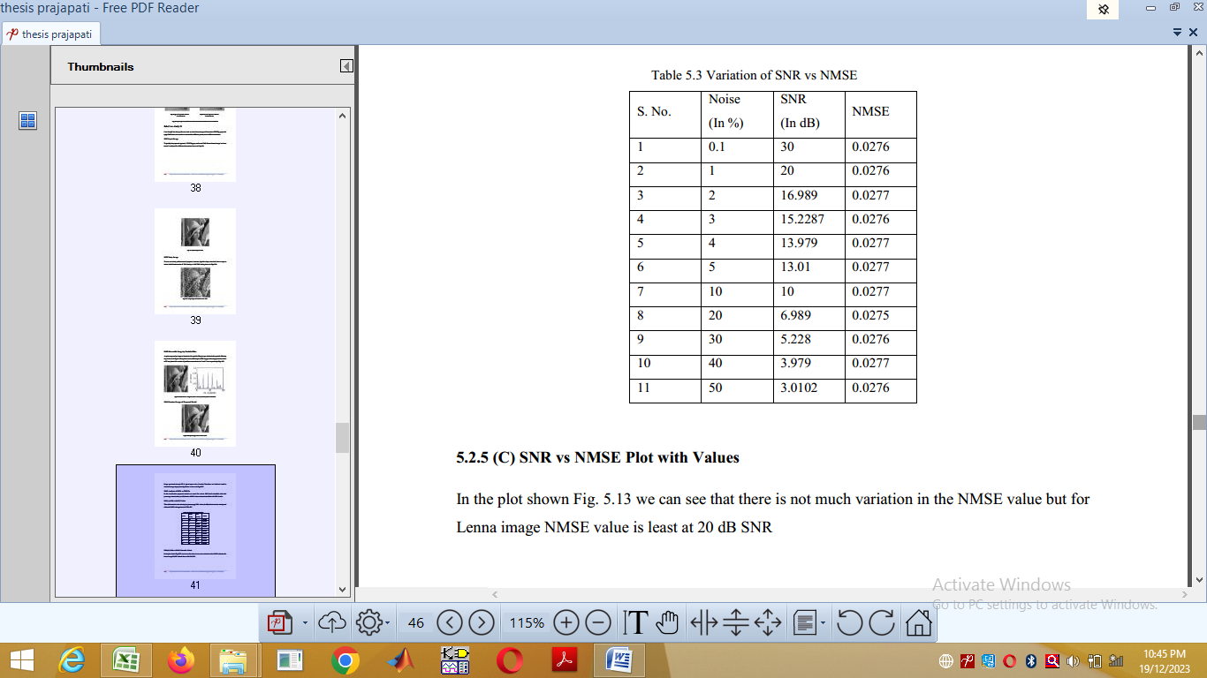

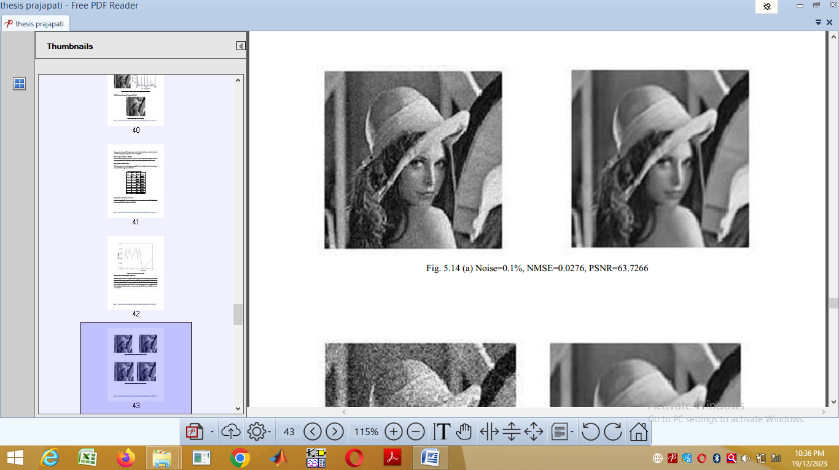

Figure 7(a) Noise=0.1%, NMSE=0.0276, PSNR=63.7266

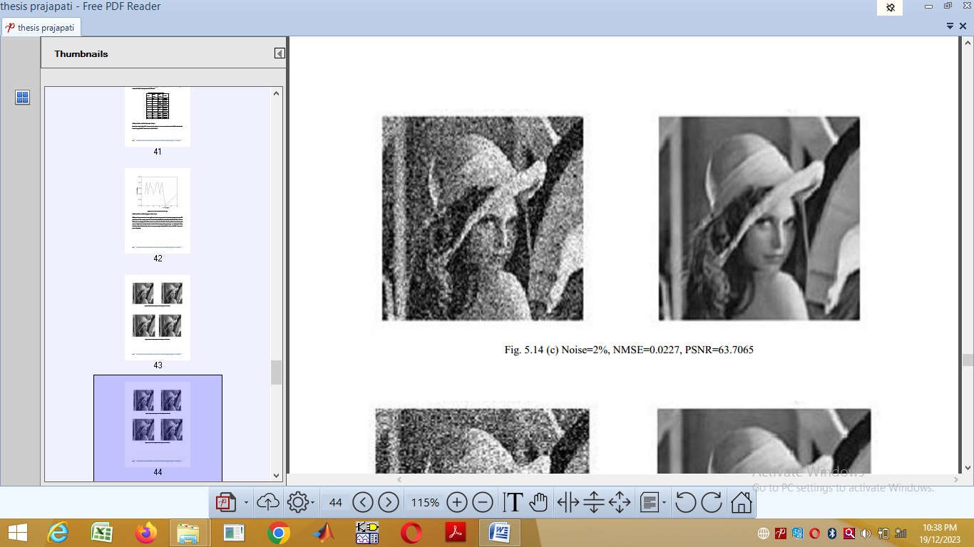

Figure 7(b) Noise=2%, NMSE=0.0227, PSNR=63.7065

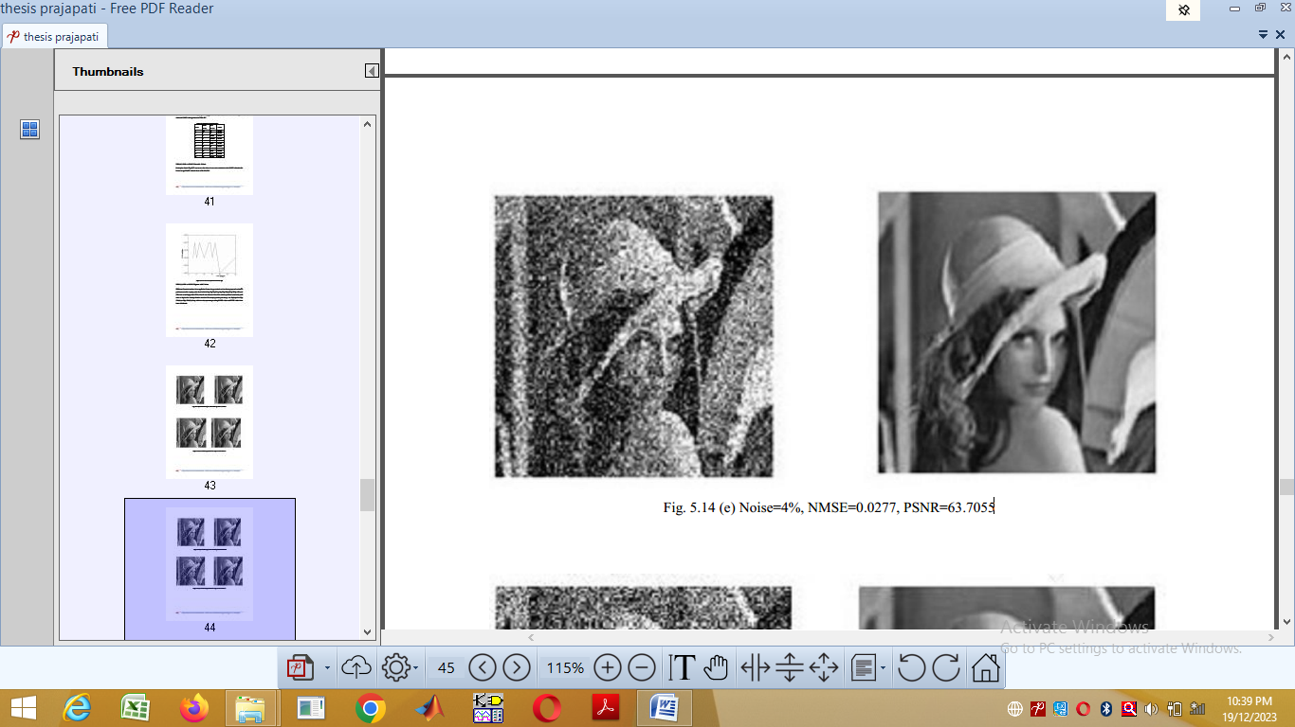

Figure 7(c) Noise=4%, NMSE=0.0277, PSNR=63.7055

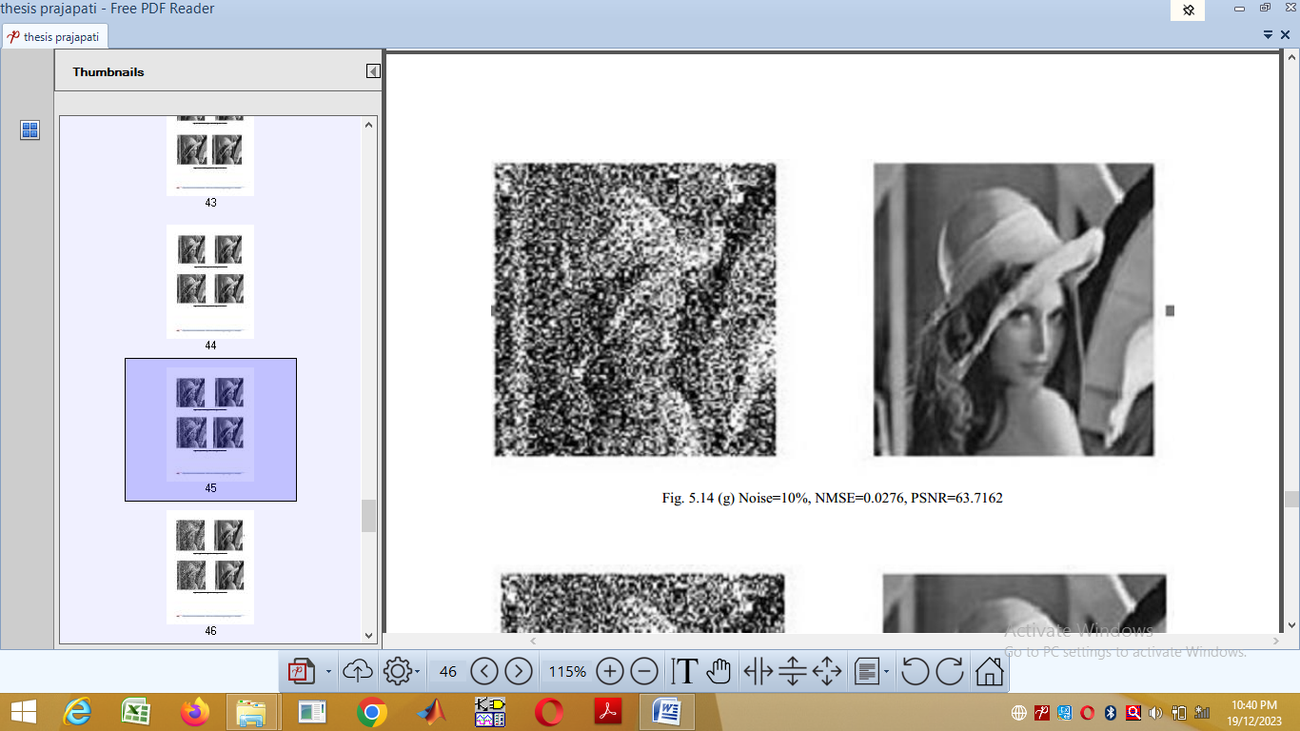

Figure 7(d) Noise=10%, NMSE=0.0276, PSNR=63.7162

Figure 7:(a) to (d) Results of Proposed Algorithm at Different Noise Levels

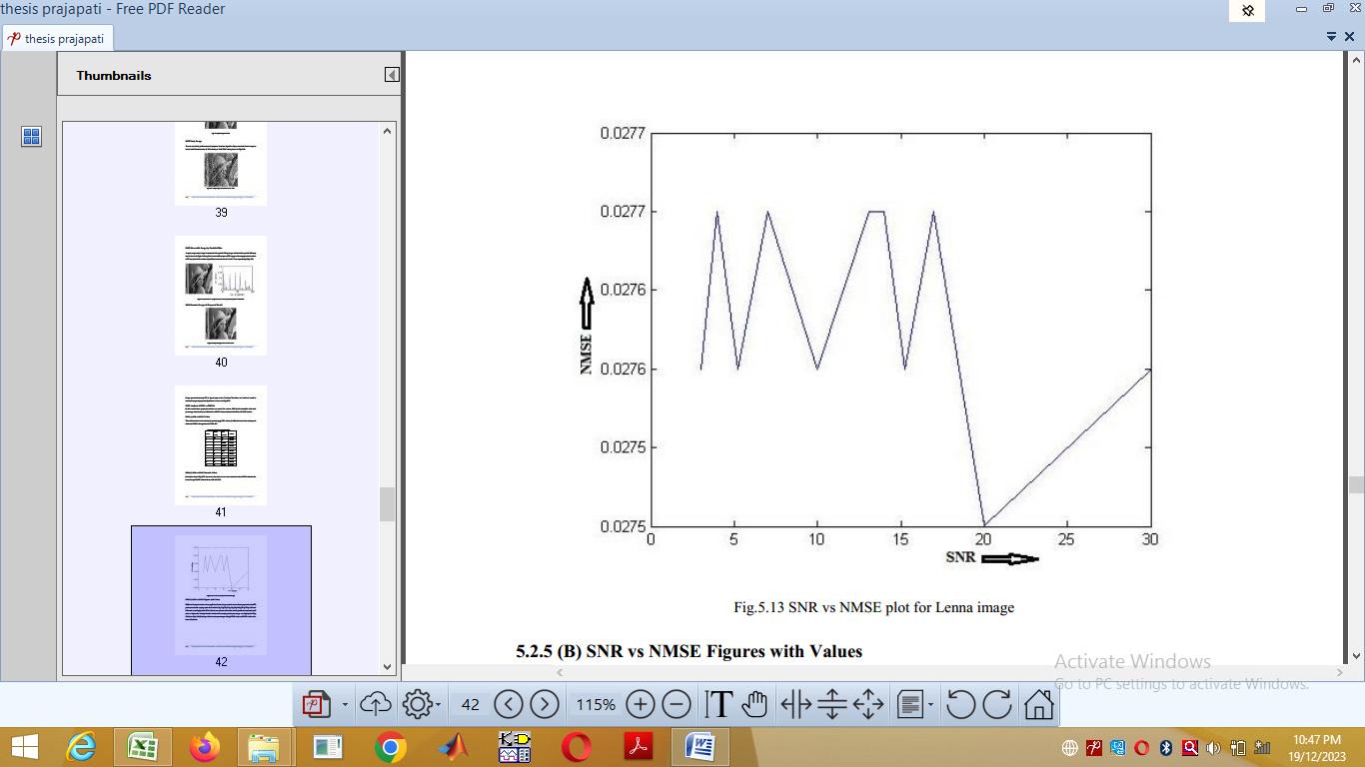

Figure 8: SNR v/s NMSE plot for Lena image

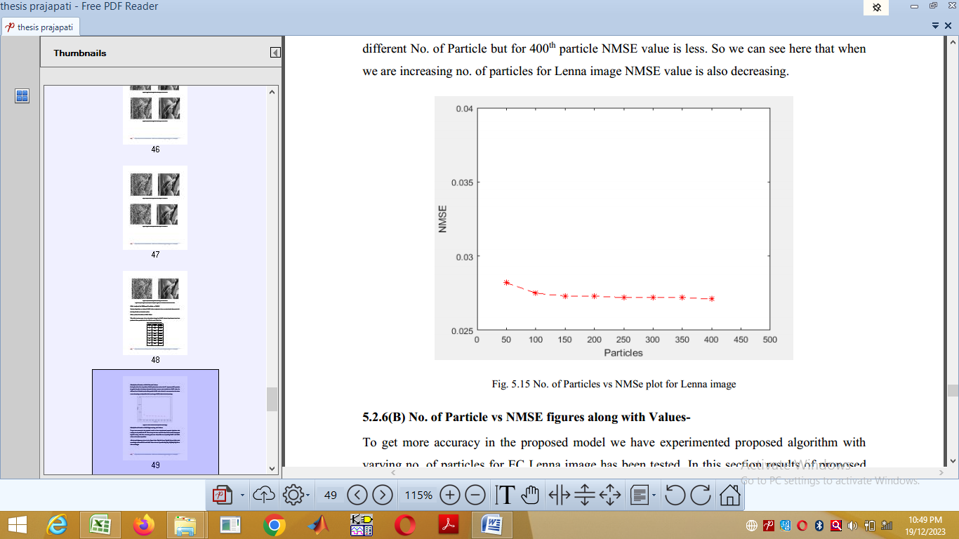

Figure 9: SNR vs no. of particles plot for Lena image

**5.3 Comparison of Proposed Model with Existing Algorithm**

In this section proposed model was tested and analyzed and compared with the existing model with reference to some parameters like PSNR, NMSE. This was performed by two comparisons as given below. First of all proposed model was tested for N=100, SNR=10dB and compared with only PF denoiser and results obtained for two parameters PSNR and NMSE are shown in the Table.

Table II : Proposed Model Comparison with PF and existing Algorithm

|  |  |  |  |
| --- | --- | --- | --- |
| S.No. | Algorithm Used | PSNR Value | NMSE Value |
| 1. | **PF+Clet** | **63.711** | **0.0276** |
| 2. | PF | 26.6399 | 1.1027 |
| 3. | Ref [1] | 34.51 | 0.4201 |

**6. CONCULSION**

This paper proposes a new denoising algorithm based on Particle filter and Curvelet transform combination, particle filter generates weights through SIR algorithm to cancel the interference of noise present in the image, while curvelet transform is used to shrink the remaining segments of noise, so this method can both remove image noise and maintain good texture as well. The PF+Clet Image Denoiser is successfully designed and implemented, which is a new approach in image enhancement and Interference cancellation. This paper concludes that it is quite efficient approach which has been implemented and evaluated on standard 128*128 image (Lenna image), different experiments applied to these test images and different results are obtained, here two measuring parameters are PSNR and NMSE.

**6. REFERENCES**

1. Nguyen Ngoc Hien, Dang Ngoc Hoang Thanh, Uğur Erkan And João Manuel R. S. Tavares “Image Noise Removal Method Based on Thresholding and Regularization Techniques” IEEE Access, vol 10, July 2022, page no. 71584-71597.
2. M. Sanjeev Arulampalam, Simon Maskell, Neil Gordon and Tim Clapp, “A Tutorial on Particle Filters for Online Nonlinear/Non-Gaussian Baysian Tracking” IEEE transaction on Signal Processing, Vol.50, No.2, February 2002.
3. Arnaud Doucet, Simon Godsill and Christophe Andriew, “On Sequential Monte Carlo sampling methods for Baysian filtering” Kluwer Academic Publishers, Vol.10, No.10, August, pp-197-208 .
4. S. Ibrahim Sadhar, P.Y. Praveen Kumar, A.N. Rajgopalan: “Particle filters for image restoration”, National Conference on Communication (NCC04) Banglore .2004.
5. Yan Zhai, Mark Yeary, Victor DeBrunner, Joseph P. Havlicek, Osama Alkhouli: “Image restoration Using using a hybrid combination of particle filtering and wavelet denoising”, IEEE ,2005
6. Alexander Weber, Jurgen Weizenecker. Ulrich Heinen, Michale Heidenereich, Thorsten M. Buzug “Reconstruction enhancement by denoising the magnetic partical imaging system matrix using frequency domain filter”, IEEE Transactions on Magnetics, vol. 51, no. 2, February 2016.
7. Stylianos Ploumpis, Angelos Amanatiadis, Antonios gasteratos: “A stereo matching approach based on particle filters and scattered control landmarks”,Image and Vision Computing, vol. 38, pp 13-23
8. Dr. Anna Saro Vijendran, Bobby Lukose : “A new implementation of particle filter for digital noisy image”, International Conference on Intelligent Computing Application, 2014 pp 198-202.
9. Manyu wang, Sheng Zheng, Xiaolong Li, Xiongjie Qin (2014): “A new image denoising method based on Gaussian filter”, IEEE International, pp 163-167.
10. Aarti Pareyani, Dr. Agya Mishra: “Low contrast image enhancement using adaptive filter and DWT: a literature review”, Indian Journal of Computer Science and Engineering (IJCSE), vol. 6 pp 91-97
11. Ekta Kesharwani, Dr. Agya Mishra: “Image Denoising Based on Particle Filtering: A Literature Review” Indian Journal of Computer Science and Engineering (IJCSE), vol. 7, No.-6, Nov-Dec 2016, pp-223-229.
12. William k. Pratt, “Digital Image Processing”, John Wiley and Sons, Inc. 2001
13. S. Haykin, “Adaptive Filter Theory”, Pearson Education, 2002
14. Aarti Pareyani, Dr. Agya Mishra: “Low contrast gray scale enhancement using Particle Sworm Optimization (PSO) with DWT” International journal of Computer Applications 130(8), pp-8-13, 2015.
15. Petar M. Djurit, Jayesh H. Kotecha, Jainqui Zhang, Yufei Huang, Tadesse Ghirmai, Monica B. Bugallo and Joaquin Mieguez: “Particle Filtering” IEEE Signal processing magazine, pp-19-38, September 2003.
16. Jianwel Ma and Gerlind Plonka: “The Curvelet Transform (A Review of recent application)” IEEE Signal Processing Magazine, pp-118-133, March 2010