**Personalized Music Recommendation through Machine Learning**

Swathi Panchireddy1 , Nagamani Yanda2

GMR Institute of Technology, Rajam, 532127

swathipanchireddy2003@gmail.com

**ABSTRACT:** Using machine learning, one can create a system that recommends songs or playlists to users based on their listening habits, preferences, and other pertinent information. The intention is to improve the user's musical experience by offering tailored suggestions. This paper offers a method for music recommendation that makes use of machine learning techniques to provide personalized recommendations based on user preferences and context. This study develops a comprehensive recommendation strategy by combining content-based and collaborative filtering. Collaborative filtering algorithms determine the mood and emotion of users by examining their listening habits and tastes, and then suggest songs that fit those moods and emotions. The technology offers a dynamic platform for people to discover, enjoy, and interact with music that speaks to their individual likes and moods by combining collaborative, content-based, and machine learning features.

***Keywords:*** content-based filtering, music recommendation, data collection, collaborative filtering, personalized recommendation.

**INTRODUCTION:** People in today's generation value music much when it comes to communicating their emotions, like loneliness, sadness, happiness, etc. To solve that, picture yourself with a personal music assistant that always knows only the songs you enjoy, even those you've never heard before. That's the beauty of machine learning-powered tailored music recommendations. It's similar like having a friend who knows exactly what kind of music you like and can recommend the greatest songs for you. With so many options for music available, machine learning helps us find the songs that best fit our individual tastes, improving the quality and personalization of our music experience. This introduction examines how machine learning enables this, and in order to create such an application system, we employ hybrid models, content-based filtering, collaborative filtering, and other recommendation techniques. Creating recommendation systems that are tailored to the musical tastes of certain users requires a methodical approach when creating application systems for music recommendation. To guarantee that consumers have a personalized and interesting music discovery experience, it entails collecting a variety of music data and user interactions, preparing the data, choosing suitable recommendation algorithms, training models, and assessing ongoing monitoring and improvement.

**LITERATURE SURVEY:**

**[1]**. The main goal of this work is to develop a factorization and data mining based personalized music recommendation system.Based on consumers' short- and long-term preferences, this algorithm recommends music and playlists.It makes use of To screen the recommendation candidate set and guarantee coverage of user preferences, collaborative filtering recommendation—more precisely, user-based CF and item-based CF—was integrated.These include difficulties like the cold start issue for brand-new users and scalability issues with big databases.

[2]. The authors of this research present a framework that incorporates physiological signals to identify user moods, hence improving music recommendation engines. They use multi-channel physiological data from GSR and PPG sensors to successfully recognize emotions.They enhance recommendation performance by taking the listener's emotional state into account. Certain people and situations may have varied levels of accuracy and dependability in the GSR and PPG sensors' abilities to detect and interpret emotions.

**[3].** In this research, CNNs, attention mechanisms, and network embedding are combined.These approaches consist of three basic parts: context-aware recommendation, CAME for expressing music aspects, and HIN for processing different kinds of information.It might be hampered by poor data quality, a small sample size, and possible differences in wearable sensor accuracy.

**[4].** In order to improve the way music is grouped and recommended, the authors of this research created a music recommendation system employing an intelligent computer program known as the Artificial Fish Swarm Algorithm, or AFSA.To process a large amount of data rapidly, the author additionally employed a potent technology called Spark.The enhanced technique looks to be very complicated; it addresses local extremum problems and uses the Artificial Fish Swarm technique (AFSA) for global optimization.

**[5].** The goal of this research is to develop a system that can identify a person's face and emotions, then suggest music to them depending on the emotions that are most prevalent.Convolutional Neural Networks (CNN), a method for more effectively evaluating unstructured data, were used in this.The suggested model's accuracy in predicting emotions was 73.02%.

**[6].** The TROMPA-MER dataset is presented in this study. It is intended for use in music emotion recognition (MER) and is enhanced with a variety of category annotations, including annotator metadata.A computational effort called Music Emotion Recognition (MER) attempts to forecast the feelings that a listener may experience or that are expressed through music.This method may have been used for both emotion-based music suggestions and virtual reality.

**[7].** In addition to evaluating different user attributes and suggesting techniques for measuring them by analyzing variations in features, the goal of this study is to develop a system that can recommend music to individuals.To achieve this, they utilize an ingenious computer method known as a convolutional neural network. When someone asks for recommendations, the system finds similar songs based on their tastes after creating an understanding of music and training it with historical listening patterns.

**[8].** This essay explores a novel approach to making personalized music recommendations for individuals.They have developed a unique algorithm that combines two techniques: B-NCF and User Collaborative Filtering (User CF). Using a dataset from Yahoo Music, they tested this algorithm and discovered that it performs better at music recommendation than the industry standard, NCF.

**[9].** This study uses biosignals that people respond to music to analyze and understand human emotions. It offers a cutting-edge method for identifying emotions through the use of musical stimuli.First, a model is created utilizing a variety of machine learning techniques to classify music into 37 moods based on the selection of effective music attributes. Second, biosensors such as EEG, ECG, and EMG are used to gather human emotions, which are subsequently correlated with the song's mood. Based on the user's actual mood, the suggested model is incorporated into playlist creation, and experimental analysis yields an 81% accuracy rate.

**[10**]. The use of personality factors in music recommendation systems is discussed in this work, with particular reference to the Big Five Inventory (BFI) and its revised form, the BFI-2.The idea of Personality-Aware Music Recommendation Systems (PA-MRS), which take into account the user's personality while making recommendations, is also mentioned.

**[11].** This research emphasizes how important it is to take into account a user's profile when evaluating sentiment measurements.The improved Sentiment Metric (eSM), a sentiment intensity metric used by the system, produces a sentiment value that is more accurate by accounting for the user's profile and sentiment variations.Using the crowdsourcing approach to assess its performance, the suggested music recommendation system received a 91% user satisfaction rating.

**[12].** The iMusic system uses a topic model-based methodology to tackle the problem of individualized music recommendation.It visualizes discrete clusters and groups music sessions according to past usage patterns.By combining user preferences depending on various times of the day and importing data from social networks, the system seeks to improve recommendation accuracy.

**[13].** In this research, we present "Moodify," a music recommendation system built with Reinforcement Learning (RL) technique.Moodify strives to evoke a particular emotion in addition to making musical recommendations based on your mood.In order to improve the system's capabilities, they are also investigating sophisticated learning strategies, which bodes well for the future of mood-altering musical experiences.

**[14].** This work proposes an Emotion-Aware Personalized Music Recommendation System (EPMRS) to improve the user's listening experience by establishing a relationship between music and user data such as location, time, and music history. The correlation is attained by the amalgamation of two methodologies: the extraction of music features through Deep Convolutional Neural Networks (DCNN) and the generation of implicit user ratings for songs through Weighted Feature Extraction (WFE).

**[15].** The suggested RPMRS uses reinforcement learning (RL) in conjunction with content-based techniques that leverage audio and lyrics elements to deliver dynamic and personalized music suggestions.For lyrics, this feature extraction algorithm uses Word2Vec and TF-IDF techniques, and for audio, it uses a WaveNet Autoencoder.The proposed model's scalability and computing complexity are not thoroughly discussed.

**[16].** This paper discusses the creation of a "android application" that can read people's emotions from their facial expressions. It can sense your emotions when it looks at your face. It then recommends songs based on your emotional state.About 75% of the time, this program gets it properly, which is pretty decent.But, merely staring at your face is insufficient to elicit certain feelings, such as fear and disgust.It may also require information about your body temperature or heart rate. It can be challenging to select the ideal music to match those feelings. They may therefore work on that in the future.

**[17].** The goal of the study is to develop a music recommendation system that makes song recommendations depending on an individual's mood.Technologies like OpenCV, a specialized training tool that teaches computers to recognize emotions, and Point Detection Algorithm, a technique for analyzing faces and detecting emotions, were employed in this study.

**[18].** The purpose of this study is to improve music streaming services by giving users more individualized playlists. The intention is to draw in and keep clients, as they may become disinterested if they are unable to discover music they enjoy. The goal of the project is to improve playlist recommendations by better understanding and organizing music genres through the use of computer algorithms, specifically CNN. It also looks at using these methods to investigate how individuals interpret music in contexts other than music.

**[19].** This paper draws attention to the increasing interest in creating automatic systems that can identify context and emotions when recommending music. It covers a range of methods, such as those that concentrate on emotions, those that concentrate on context, and hybrid methods that combine the two.The main obstacles that need to be overcome for music recommendation systems to be successful range from technological problems to user-centered concerns.

**[20].** This paper connects music suggestions with face expressions via computer vision and machine learning.They employed Deep Neural Networks (DNNs), which are essentially extremely intelligent computer brains.They have demonstrated exceptional object, motion, and facial recognition skills. Convolutional Neural Networks (CNNs) are a particular type of neural network that is specifically designed to focus on facial recognition. These networks are highly adept at identifying emotions and faces.

**[21].** This project employs Convolutional Neural Network (CNN) models and the GTZAN dataset to classify audio recordings into different genres.It exhibits the capacity to identify pertinent data from audio files by categorizing them into ten musical genres.In addition, it has an algorithm that makes recommendations for related songs to users based on their listening habits.

**[22].** A hybrid music recommendation algorithm is presented in this paper. To increase the accuracy of music recommendations, this method combines an enhanced neural network model with an attention mechanism. The study shows that by obtaining a notable improvement in accuracy, the suggested algorithm beats conventional techniques, especially the LSTM-based recommendation system.

**[23].** MoodPlay, a cutting-edge music artist recommender system that surpasses conventional algorithmic accuracy, is presented in this research study.MoodPlay lets users explore music collections based on emotional qualities instead of just artist names by integrating content and mood-based filtering into its interface.To illustrate the efficacy of their methodology, the paper provides use cases and offline assessments in addition to describing the system's design, algorithms, and interactions.

**[24].**  As a novel solution to the hubness issue in recommendation systems, the paper presents mutual proximity graphs. Mutual k-nearest neighbor (knn) graphs have low overall connectedness, even if they totally preclude hub formation. Limited improvement is achieved even when mutual knn graphs are enhanced with a minimal spanning tree.

**[25].** The purpose of the paper is to investigate many promising methods for enhancing music recommendation systems.These include employing content-based algorithms, utilizing Convolutional Neural Networks, utilizing audio signals (such as audio frequency) for song recommendations, attaining real-time capabilities, and experimenting with clustering strategies for music recommendations.The ultimate objective is to create user-centric music recommendation algorithms that are more aware of and sensitive to the unique requirements and tastes of each user.

**[26].** This study uses the CNN algorithm for categorization and focuses on Western music.It creates comprehensive characteristics by combining spectrum and note data, and it analyzes the categorization outcomes using recommendation algorithms. By creating a relationship between users and musical compositions, this method improves prediction accuracy and yields accurate suggestions. On the other hand, the study mainly contrasts CNN algorithm and recommendation algorithms with content and context recommendation approaches.

**[27].** This paper discusses future research goals and a number of important difficulties in the field of music recommender systems (MRS).Addressing the "cold start" issue for both users and products, the requirement for automated playlist continuation, and the significance of comprehensive evaluation that goes beyond accuracy metrics are among the main obstacles.In addition, the study outlines innovative avenues for future research, including situation-aware MRS that takes contextual elements into account, psychologically inspired MRS that takes users' emotions and personalities into account, and culture-aware MRS that acknowledges the impact of cultural backgrounds on musical tastes.

**[28].** Addressing bias and fairness issues in music recommender systems is the main goal of this paper.The suggested approach seeks to lessen popularity bias, guaranteeing that suggestions are more in line with user tastes and give artists equal visibility. Experiments show that these objectives were successfully met, with better prediction accuracy across various user groups.Nonetheless, it is acknowledged that more study is required to improve and broaden the approach, including maximizing cluster-based quotas and investigating cutting-edge recommendation algorithms.

**[29].** This essay acknowledges the significant influence of music on human emotions and performance in professional and athletic contexts. It draws attention to the lack of an algorithm that uses users' physiological responses to propose music. The research creates an intelligent music selection system in order to close this gap. It entails building an emotional music database, tracking heart rate variability with wearable sensors, and recording user preferences with machine learning.The trial findings, which demonstrate enhanced performance, low mental strain, and high user satisfaction, are encouraging.

**[30].** The increasing interest in creating automatic systems that can identify context and emotions in the context of music recommendations is highlighted in this research. It covers a range of methodologies, such as context-focused, emotion-focused, and hybrid methodologies that combine the two.The main obstacles that must be overcome for music recommendation systems to be successful range from technological to user-centered problems.

GRAPHICAL REPRESENTATION:

**METHOLODY:**

**[1]**

User behavior was broken down and a variety of contributing elements were examined using the factorization machine (FM) learning technique. The suggestion candidate set was screened using a combination of item-based and user-based collaborative filtering recommendations. The user's interest value was predicted using a dynamic interest model. The association rule algorithm based on the collaborative filtering recommendation algorithm and the content-based recommendation algorithm were compared with the frequent pattern growth algorithm.

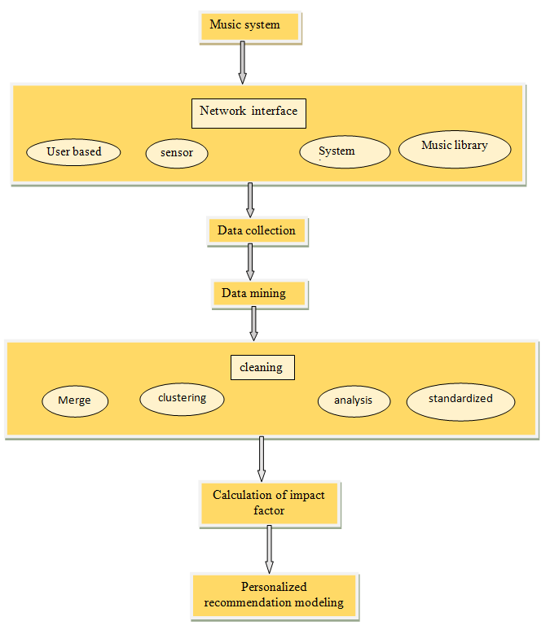

1.FACTORIZATION TECHNIQUE: In machine learning, factorization techniques refer to a collection of approaches utilized for dimensionality reduction and matrix factorization. These methods are especially well-liked for breaking down huge user-item interaction matrices into smaller matrices in collaborative filtering and recommendation systems.Factorization techniques can be classified into two categories: matrix and tensor.

2.COLLABORATIVE FILTERING:It is a well-liked recommendation system technique that generates customized recommendations by utilizing the combined behavior and interests of a group of users. It is predicated on the notion that people who have previously enjoyed comparable goods are likely to concur with or enjoy other items in the future. User-based collaborative filtering and item-based collaborative filtering are the two primary categories into which collaborative filtering techniques may be roughly divided.

3.DATA MINING: In the fields of machine learning and data analysis, data mining is an essential procedure. Finding patterns, correlations, and information from huge datasets are all part of it. Preprocessing data, determining important associations, and extracting useful information from huge datasets are common uses for data mining techniques.

4.CONTENT-BASED FILTERING:It is a recommendation system technique that makes item recommendations to users based on both the user's preferences and the features and characteristics of the things. This is a typical method used in systems that offer tailored recommendations.

5.FP-GROWTH: Mining for frequent patterns in huge datasets is made popular and effective by the Frequent Pattern Growth (FP-Growth) algorithm. Data mining and association rule finding tasks are the main applications for it. FP-Growth is a useful technique in data analysis and machine learning because it works especially well with sparse and high-dimensional datasets.

Performance Metrics:

The accuracy of the music recommendation results is demonstrated to be sufficient for recommending user satisfaction.It highlights the feasibility and practicality of the recommended music, indicating that the recommended music is indeed viable. The accuracy of the recommendation results gradually and steadily increases with the increase in the number of users' music, reaching more than 30.

**[2]**

A mood-based music recommendation system that combines real-time mood recognition with music recommendation is proposed in this work.The two primary elements of the system are the recommendation engine for music and facial expression recognition for mood identification.Based on the user's facial expressions, the mood identification module combines computer vision and machine learning algorithms to determine the user's mood. To provide a small-sized trained model and facilitate simpler integration with Android-ML, it makes use of the MobileNet model in conjunction with Keras.The music recommendation module adds a capability to standard music player apps by suggesting songs based on the detected mood.

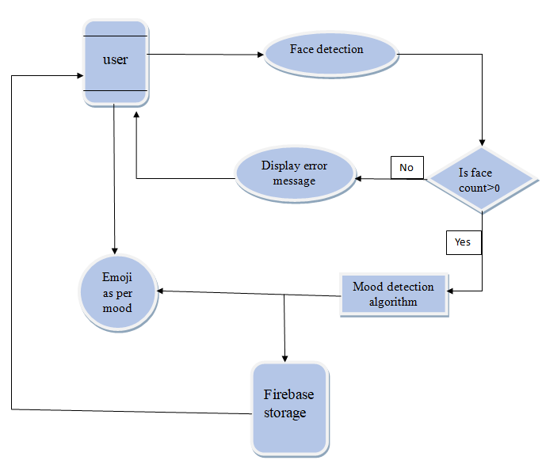

1.DATA COLLECTION: This section explains the process used to gather or acquire the datasets. This contains details on the data format, sources, and any preprocessing that was done on the data.

2.DATA PREPROCESSING: It is the process of applying transformation, normalization, or cleaning techniques to the gathered data. For instance, how the emotion classification model was trained using labeled or standardized photos.

3.FACE DETECTION: The Haar cascade and Viola-Jones algorithms were used.Software tools such as Anaconda and Python 3.5 were used to implement these methods.Furthermore, the usage of OpenCV for image processing applications is mentioned in the study.Real-time facial expression recognition and classification, including happy, sad, angry, surprised, and neutral, is made possible by the integration of these techniques.

4.MOOD DETECTION: The topic of mood detection or facial expression recognition is addressed in this research using MobileNet, a lightweight Convolutional Neural Network (CNN) architecture.

5.CONVOLUTIONAL NEURAL NETWORK: One type of deep learning neural network that excels at tasks involving visual input is the convolutional neural network (CNN). Examples of these tasks include object detection, picture and video recognition, and image categorization.In addition to detecting mood and emotion, it is utilized to extract pertinent audio elements.

6.ANDROID APPLICATION DEVELOPMENT: the process of creating an Android application, which includes storing the labels.txt file and the.tflite model in the assets folder and developing the methods for loading and using the model in the app.

Performance Metrics:

Using a CNN model, the face expression recognition module's accuracy is reported to be 88%.The system also uses a trained model for mood recognition; however, for accurate results, additional training with more photos and epochs may be necessary.

**[3]**

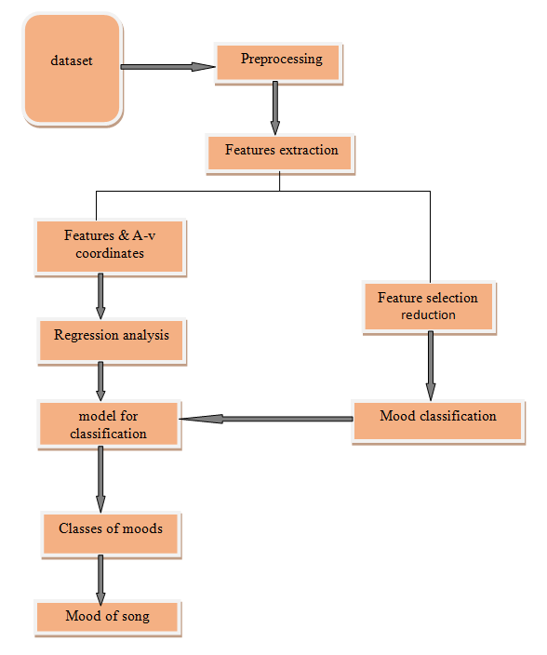

There are three stages to the model:

* Phase 1: Analyzing auditory signals to determine the song's mood.
* Phase 2: Using physiological signals from the EEG, GSR, ECG, and pulse detector to predict the human's emotion.
* Phase 3: Charting the emotional state of people and music.

The suggested algorithms for every stage of the model are covered in the article.In order to get better results in subsequent research, it also discusses the use of sophisticated parameter optimization techniques such halving grid search and Bayesian optimization.

1.FEATURE EXTRACTION: A crucial stage in getting data ready for activities like data analysis, pattern recognition, and machine learning is feature extraction. It entails converting the initial data into a collection of pertinent and educational properties that machine learning algorithms can use as input. A model's performance can be greatly enhanced by effective feature extraction, which lowers noise, dimensionality, and concentrates on the most crucial information in the data.

2.CONVOLUTIONAL NEURAL NETWORK: A Convolutional Neural Architecture One type of deep learning neural network that works especially well for tasks involving visual data is the convolutional neural network (CNN). Examples of these tasks include object detection, picture and video recognition, and image categorization.

3.EEG (ELECTROENCEPHALOGRAM): The Electroencephalogram, or EEG, is a non-invasive technology that quantifies and captures brain electrical activity. In order to identify and capture the electrical impulses generated by the brain's neurons, electrodes are applied to the scalp. EEG is frequently utilized to improve the efficacy and personalization of music suggestions by taking into account each person's unique brain activity and emotional reactions to music.

4.ECG (ELECTROLECTROCARDIOGRAM**) :** Electrocardiogram, or ECG is the electrical activity of the heart can be measured and recorded using this non-invasive technology over an extended period of time. It serves as a biometric gauge of the physiological status of the user. To gauge a user's emotional or stress level, for instance, heart rate and heart rate variability (HRV) derived from ECG signals can be utilized. suggestions for music can thereafter be modified to fit the user's physiological state.

5.EMG(ELECTROMYOGRAPHY): Electromyography, or EMG, is a physiological and medical technology that measures and logs the electrical activity generated by muscles as they contract and relax. Interactive music control could be made possible with the use of this data. Users might, for instance, stretch or relax particular muscles to adjust the tempo and volume of the music or to activate specific music events.

Performance Metrics:

Several cutting-edge performance indicators are used to assess the suggested model's performance.This study addresses the use of R values to assess the goodness of fit of the model and cites the usage of Root Mean Square Error (RMSE) as a metric for assessing the model's fit to the data.

The study also discusses the use of F1 values for mode testing and Confusion Matrix to calculate relative accuracy.

**CASE STUDY:**

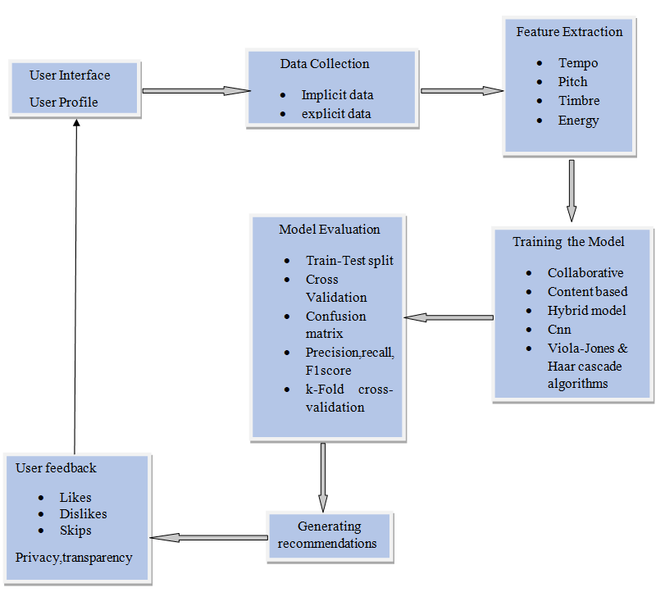

**DISCUSSION:**

The user interface, which includes features like search bars and user profiles, acts as the point of entry for users in this case study on a music recommendation system. Secure access to user profiles is ensured via frontend processing of user input, including preferences and queries, prior to interaction with the authentication module. The recommendation engine draws from the user profile database and music catalog, leveraging user data and past behavior to provide tailored recommendations. It is powered by machine learning algorithms. Computational operations, such as model updates and training, are handled by the backend processes.

User feedback is gathered via a feedback loop, which helps to improve subsequent recommendations. The system's functionality is improved by integration with external APIs, and users are kept informed about upgrades through a notification system. To enable insights, the logging and analytics component logs system performance and interactions. Administrators can keep an eye on user statistics and system health with the help of an admin dashboard, and user data is protected by a privacy and security module. This all-inclusive approach prioritizes user privacy and system performance in order to provide precise and customized music recommendations.

**CONCLUSION:**

Machine learning-based music recommendation has become a potent and cutting-edge method for improving the listening experience. These systems can assess user preferences, habits, and trends to deliver relevant and tailored music recommendations by utilizing large databases and complex algorithms. This technology helps consumers explore a variety of genres and performers in addition to saving time when looking for new music. Furthermore, with time, machine learning-based music recommendation algorithms learn from user feedback and preferences, evolving and adapting continuously. Because of their dynamic nature, recommendations are always up to date and adaptable to the user's evolving preferences. Accuracy was reached by algorithms such as CNN, collaborative filtering, and content-based filtering at 73.03%, and by techniques like AFSA at 96.2%. PPG and GSR both attained 71.5% accuracy. Machine learning-based music suggestion is an example of the creative and technological fusion that can result in a more unique and varied musical experience. In conclusion, machine learning-based tailored music recommendations have enormous potential for the future of music consumption. These technologies could transform how we find, listen to, and enjoy music as they develop, enhancing our lives with a wide variety of sounds catered to our individual tastes.

**REFERENCES:**

[1] Sun, D. (2021). Using factor decomposition machine learning method to music recommendation. Complexity, 2021, 1-10.

[2] Ayata, D., Yaslan, Y., & Kamasak, M. E. (2018). Emotion based music recommendation system using wearable physiological sensors. IEEE transactions on consumer electronics, 64(2), 196-203.

[3] Wang, D., Zhang, X., Yu, D., Xu, G., & Deng, S. (2020). Came: Content-and context-aware music embedding for recommendation. IEEE Transactions on Neural Networks and Learning Systems, 32(3), 1375-1388.

[4] Sun, J. (2022). Personalized music recommendation algorithm based on spark platform. Computational Intelligence and Neuroscience, 2022.

[5] Bakariya, B., Singh, A., Singh, H., Raju, P., Rajpoot, R., & Mohbey, K. K. (2023). Facial emotion recognition and music recommendation system using CNN-based deep learning techniques.Evolving Systems, 1-18.

[6] Gómez-Cañón, J. S., Gutiérrez-Páez, N., Porcaro, L., Porter, A., Cano, E., Herrera-Boyer, P., ... & Gómez, E. (2023). TROMPA-MER: an open dataset for personalized Music Emotion Recognition. Journal of Intelligent Information Systems, 60(2), 549-570.

[7] Zhang, Y. (2022). Music recommendation system and recommendation model based on convolutional neural network. Mobile Information Systems, 2022.

[8] Cao, Y., & Liu, P. (2022). Personalized music hybrid recommendation algorithms fusing gene features. Mathematical Problems in Engineering, 2022.

[9] Garg, A., Chaturvedi, V., Kaur, A. B., Varshney, V., & Parashar, A. (2022). Machine learning model for mapping of music mood and human emotion based on physiological signals. Multimedia Tools and Applications, 81(4), 5137-5177.

[10] Kleć, M., Wieczorkowska, A., Szklanny, K., & Strus, W. (2023). Beyond the Big Five personality traits for music recommendation systems. EURASIP Journal on Audio, Speech, and Music Processing, 2023(1), 4.

[11] Rosa, R. L., Rodriguez, D. Z., & Bressan, G. (2015). Music recommendation system based on user's sentiments extracted from social networks. IEEE Transactions on Consumer Electronics, 61(3), 359-367.

[12] Roy, S., Biswas, M., & De, D. (2020). iMusic: a session-sensitive clustered classical music recommender system using contextual representation learning. Multimedia Tools and Applications, 79, 24119-24155.

[13] De Prisco, R., Guarino, A., Malandrino, D., & Zaccagnino, R. (2022). Induced Emotion-Based Music Recommendation through Reinforcement Learning. Applied Sciences, 12(21), 11209.

[14] Abdul, A., Chen, J., Liao, H. Y., & Chang, S. H. (2018). An emotion-aware personalized music recommendation system using a convolutional neural networks approach. Applied Sciences, 8(7), 1103.

[15] Chang, J. W., Chiou, C. Y., Liao, J. Y., Hung, Y. K., Huang, C. C., Lin, K. C., & Pu, Y. H. (2021). Music recommender using deep embedding-based features and behavior-based reinforcement learning. Multimedia Tools and Applications, 1-28.

[16] Mahadik, A., Milgir, S., Patel, J., Jagan, V. B., & Kavathekar, V. (2021). Mood based music recommendation system. INTERNATIONAL JOURNAL OF ENGINEERING RESEARCH & TECHNOLOGY (IJERT) Volume, 10.

[17] Shalini, S. K., Jaichandran, R., Leelavathy, S., Raviraghul, R., Ranjitha, J., & Saravanakumar, N. (2021). Facial Emotion Based Music Recommendation System using computer vision and machine learning techiniques. Turkish journal of computer and mathematics education, 12(2), 912-917.

[18] Hsin, B. (2023). Machine Learning Classification Techniques Applied in modern-day Music Recommendation Systems. Highlights in Science, Engineering and Technology, 34, 392-397.

[19] Assuncao, W. G., Piccolo, L. S., & Zaina, L. A. (2022). Considering emotions and contextual factors in music recommendation: a systematic literature review. Multimedia Tools and Applications, 81(6), 8367-8407.

[20] Phaneendra, A., Muduli, M., Reddy, S. L., & Veenasree, R. (2022). EMUSE–An emotion based music recommendation system. International Research Journal of Modernization in Engineering Technology and Science, 4(5), 4159-4163.

[21] Dias, J., Pillai, V., Deshmukh, H., & Shah, A. (2022). Music genre classification & recommendation system using CNN. Available at SSRN 4111849.

[22] He, X. (2022). Improved Music Recommendation Algorithm for Deep Neural Network Based on Attention Mechanism. Mobile Information Systems, 2022.

[23] Andjelkovic, I., Parra, D., & O’Donovan, J. (2019). Moodplay: interactive music recommendation based on artists’ mood similarity. International Journal of Human-Computer Studies, 121, 142-159.

[24]Flexer, A., & Stevens, J. (2018). Mutual proximity graphs for improved reachability in music recommendation. Journal of new music research, 47(1), 17-28.

[25] Verma, V., Marathe, N., Sanghavi, P., & Nitnaware, P. (2021). Music recommendation system using machine learning. International Journal of Scientific Research in Computer Science, Engineering and Information Technology, 7(6), 80-88.

[26] Chen, X. (2020). The application of neural network with convolution algorithm in Western music recommendation practice. Journal of Ambient Intelligence and Humanized Computing, 1-11.

[27] Schedl, M., Zamani, H., Chen, C. W., Deldjoo, Y., & Elahi, M. (2018). Current challenges and visions in music recommender systems research. International Journal of Multimedia Information Retrieval, 7, 95-116.

[28] Wundervald, B. (2021). Cluster-based quotas for fairness improvements in music recommendation systems. International Journal of Multimedia Information Retrieval, 10(1), 25-32.

[29] Chiu, M. C., & Ko, L. W. (2017). Develop a personalized intelligent music selection system based on heart rate variability and machine learning. Multimedia Tools and Applications, 76, 15607-15639.

[30]Assuncao, W. G., Piccolo, L. S., & Zaina, L. A. (2022). Considering emotions and contextual factors in music recommendation: a systematic literature review. Multimedia Tools and Applications, 81(6), 8367-8407.