**AttendEase- A Attendance Software for Educational Institutes**

Rhythm Choudhary1, Manoj Kumar2,Naman Nangia3

1,2Assistant Professor, Department of Computer Applications

3Student, Department of Computer Applications

1,2,3Maharaja Surajmal Institute, C-4, Janakpuri, New Delhi

[1rhythmchoudhary@msijanakpuri.com](mailto:1rhythmchoudhary@msijanakpuri.com), 2[1rhythmchoudhary@msijanakpuri.com](mailto:1rhythmchoudhary@msijanakpuri.com),

3naman01114902021@msijanakpuri.com

**ABSTRACT**

AttendEaseis a comprehensive attendance management system tailored for teachers and students. The system offers a user-friendly interface for efficient attendance tracking, promoting a seamless experience in classroom management. It is designed to address the challenges faced by educators and students in conventional attendance systems.

AttendEase revolutionizes attendance management in educational institutions through innovative technology. Developed using Expo managed React Native, Nodejs, MongoDB, and hosted on Vercel, it signifies a transformative shift from traditional methods. More than a mere attendance tracker, it reflects a commitment to leveraging technology for educational enhancement. The Expo managed React Native ensures a mobile-friendly interface, aligning with evolving educational dynamics. Nodejs empowers the backend for efficiency and scalability, while MongoDB offers flexible data storage crucial for real-time updates. Hosted on Vercel, AttendEase remains a robust solution, showcasing a dedication to advancing educational practices through cutting-edge technology.

**Keywords-** Attendance management system, LMS, Student Information system, AI.

1. **INTRODUCTION**

Attendance Management Systems (AMS) have evolved from traditional manual methods to become integral components of educational and organizational efficiency. In the past, attendance tracking relied on labor-intensive processes involving paper registers and manual data entry. These methods were not only time-consuming but also prone to errors, limiting the accessibility of real- time attendance information. The advent of technology ushered in a transformative shift, leading to the development of digital solutions that address the shortcomings of manual systems.

The landscape of attendance tracking has undergone a revolutionary transformation through continuous technological advancements. Traditional methods, characterized by manual recording and paper registers, have given way to sophisticated and automated systems that leverage cutting- edge technologies, reshaping the way attendance is managed in educational institutions and organizations.

One of the foremost technological advancements is the widespread adoption of biometric authentication. Biometric systems [1], utilizing unique physical or behavioral characteristics like fingerprints, facial recognition, or iris scans, offer a highly secure and accurate means of identifying individuals. This innovation not only eliminates the possibility of proxy attendance but also enhances overall system security. Biometric attendance tracking provides a seamless and contactless experience, aligning with contemporary concerns about hygiene and public health. Moreover, Radio-Frequency Identification (RFID) technology has played a pivotal role in modernizing attendance tracking [2-5]. RFID tags, embedded in student or employee identification cards, enable automated and instantaneous data capture as individuals pass through designated checkpoints. This method enhances the efficiency of attendance monitoring, offering real-time updates without requiring physical contact or manual intervention. The implementation of RFID technology has significantly reduced the administrative burden associated with attendance management.

The advent of mobile applications and cloud-based solutions has further revolutionized attendance tracking. Mobile applications provide convenient and accessible platforms for both educators and students to mark and monitor attendance. Cloud-based systems facilitate centralized data storage, enabling real-time synchronization and accessibility from various devices [3]. This not only streamlines the recording process but also ensures that attendance records are up-to-date and accessible anywhere, anytime.

Furthermore, the integration of data analytics tools has empowered educational institutions and organizations to derive valuable insights from attendance data. Analyzing attendance trends, identifying patterns, and predicting future attendance scenarios contribute to informed decision- making. These analytical capabilities enable proactive measures to be taken in addressing attendance-related challenges and optimizing resource allocation.

In conclusion, technological advancements in attendance tracking have ushered in an era of efficiency, accuracy, and enhanced security. Modern AMS leverages a diverse range of technologies, including biometrics, RFID, and mobile applications, to automate and enhance the attendance tracking process. Automation is a key feature, relieving educators and organizational staff of administrative burdens and ensuring more accurate and timely data. Real-time monitoring capabilities empower educators with instantaneous updates on attendance, enabling on-the-spot decision-making. Biometric authentication methods, such as fingerprint or facial recognition, enhance security and eliminate concerns related to proxy attendance.

Moreover, these systems often incorporate advanced features like data analytics tools, offering valuable insights into attendance trends, patterns, and anomalies. The user-friendly interfaces of modern AMS, accessible through mobile applications and web platforms, prioritize simplicity and ease of use for both educators and students. While these systems bring about numerous benefits, challenges like privacy concerns, initial implementation costs, and resistance to change may arise. However, transparent communication, robust data protection measures, and demonstrating the long-term advantages of digital attendance management often address these challenges.

In conclusion, Attendance Management Systems signify a substantial advancement in attendance tracking methodologies [6-7]. The integration of technology not only enhances efficiency and accuracy but also contributes to a more streamlined and data-driven educational and organizational environment. As institutions continue to embrace digital transformation, Attendance Management Systems [8-9] emerge as pivotal tools in fostering connectivity, security, and the seamless management of attendance records.

The proposed AttendEase system is driven by a core objective- to transform the conventional landscape of attendance management in educational institutions. In an era where technology is reshaping educational practices, our primary goal is to simplify and modernize the process of tracking attendance for both teachers and students [13-14]. By leveraging innovative technologies, AttendEase aims to introduce a comprehensive system that addresses the limitations and challenges associated with traditional manual methods of attendance tracking.

Beyond mere automation, the scope of AttendEase system extends to fostering a paradigm shift in the approach to attendance management. This system not only streamlines administrative tasks but also enhances the overall educational experience. AttendEase is designed to be more than just a tool; it is a solution that promotes efficiency, transparency, and proactive engagement.

The objectives of AttendEase are as follows-

* + 1. Efficiency Improvement:
       - Streamline and automate the attendance tracking process to eliminate the need for manual data entry and reduce the time spent on administrative tasks.
       - Introduce features such as QR code scanning or biometric recognition to enhance the speed and accuracy of attendance capture.
    2. Accuracy Enhancement:
       - Minimize errors associated with manual attendance recording by implementing automated mechanisms, reducing the likelihood of discrepancies in attendance data.
       - Use technology to ensure precise and reliable attendance records, eliminating common issues like duplicate entries or inaccuracies.
    3. Real-time Tracking:
       - Enable real-time monitoring of attendance, allowing teachers and administrators to access up- to-date information on student attendance status.
       - Implement features that reflect changes in attendance instantly, providing a dynamic and accurate representation of attendance patterns.
    4. User-Friendly Interface:
       - Design an intuitive and user-friendly interface that caters to the needs of both teachers and administrators.
       - Prioritize simplicity and accessibility to ensure that users can easily navigate the system without extensive training.
    5. Integration with Student Database:
       - Ensure seamless integration with the existing student database to maintain consistency in student records and avoid discrepancies between attendance and other academic data.
       - Establish a unified platform where attendance information aligns with student profiles.
    6. Reports and Analytics:
       - Generate comprehensive reports and analytics on attendance data, offering valuable insights into student attendance trends, patterns, and overall class engagement.
       - Equip educators and administrators with actionable data to make informed decisions and implement strategies for improving attendance and student participation.

This paper is organized as follows: Section 2 discusses the impact of AttendEase on teachers. In Section 3, system planning is introduced. Section 4 provides the tech stack of the system. Different output screens of the system are provided in Section 5. Section 6 provides the conclusion and future scope of the system.

1. **IMPACT OF AttendEase ON TEACHERS**

The impact of the AttendEase system on teachers is profound, revolutionizing the way they manage and interact with attendance data. Here's a detailed exploration of how this innovative attendance management system positively influences teachers:

1. Streamlined Administrative Tasks:

Teachers often spent valuable time manually taking attendance, especially in larger classrooms, leading to delays and potential errors.The AttendEase system automates the attendance tracking process, freeing up teachers from tedious administrative tasks. This allows educators to focus more on teaching and engaging with students.

1. Efficient Time Management:

Collating and managing attendance records from various classes consumed significant time, especially during peak academic periods. The centralized dashboard in AttendEase provided a quick overview of attendance trends across all classes, saving teachers’ time in data compilation. This efficiency allows for better time management and planning.

1. Quick Access to Insights:

Analyzing attendance trends and generating detailed reports required manual effort and often involved a time lag. Teachers can access comprehensive reports and analytics instantly through the dashboard in AttendEase. This real- time information empowers educators to make data-driven decisions for better class management.

1. Improved Classroom Dynamics:

The manual attendance process could disrupt the flow of the class and impact the overall learning experience. The streamlined attendance process in AttendEase promotes a seamless classroom experience. Teachers can maintain a more continuous and focused learning environment, fostering better student engagement.

1. Proactive Identification of Attendance Patterns:

Recognizing attendance patterns and addressing potential issues required manual analysis over an extended period. The system's analytics feature allows teachers to identify patterns promptly. This proactive approach enables educators to address attendance-related concerns in a timely manner, supporting student success.

1. Enhanced Communication:

Communicating with students about attendance status often relied on periodic manual updates. The automatic email notification system in AttendEase ensures students receive timely updates on their attendance status. This promotes transparent communication, encouraging students to take responsibility for their attendance.

1. Personalized Teaching Strategies:

Adapting teaching strategies based on attendance data was challenging without quick and accurate insights. Teachers can tailor their approaches based on detailed attendance reports in AttendEase. This customization allows for a more personalized and effective teaching experience.

1. **SYSTEM PLANNING**

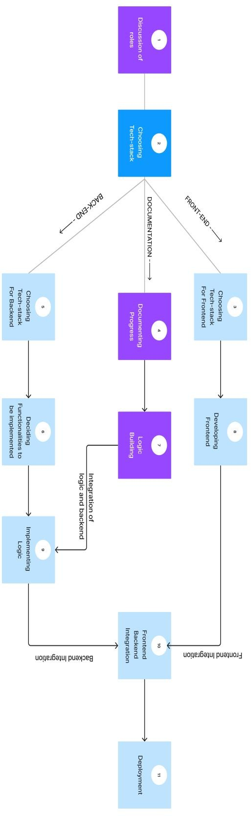The entire system planning is shown in Fig 1.

Fig 1: System Planning

1. **TECH STACK**
2. Frontend - Expo Managed React Native:
   * Expo: Utilizing Expo accelerates the development process by providing a set of tools and services for building React Native applications. It simplifies tasks like building, testing, and deploying, making it an efficient choice for frontend development.
   * React Native: Leveraging React Native allows for cross-platform app development with a single codebase. It provides a native-like user experience while optimizing development time and resources.
3. Backend - Node.js:
   * Node.js: Chosen for the backend, Node.js is known for its event-driven architecture and non-blocking I/O operations, making it well-suited for handling concurrent requests. Its JavaScript runtime ensures consistency across the tech stack.
4. Database - MongoDB:
   * MongoDB: A NoSQL database, MongoDB, is employed for its flexibility in handling unstructured data. Its document-oriented structure aligns with the dynamic nature of attendance data, providing scalability and ease of integration.
5. Hosting - Vercel:
   * Vercel: As a cloud platform, Vercel offers seamless deployment for frontend applications. Its integration with Expo allows for a straightforward deployment process, ensuring the availability and performance of the frontend.
   * Node.js Server: For the backend, Node.js applications can be deployed on platforms such as Vercel Now, ensuring scalability and ease of management. Vercel provides a serverless environment, reducing infrastructure management overhead.
6. Communication:
   * APIs: Node.js serves as the backend API server, handling requests and responses. The frontend communicates with the backend through RESTful APIs, ensuring a smooth flow of data between the client and server.
7. Scalability:
   * Node.js Scalability: The event-driven and non-blocking architecture of Node.js enables horizontal scalability. This ensures that the app can efficiently handle increased loads and user activity as the user base grows.
8. Development Environment:
   * Expo CLI and VS Code:** For local development, Expo CLI facilitates the creation and management of React Native projects. VS Code serves as a feature-rich integrated development environment for coding, debugging, and version control.
9. 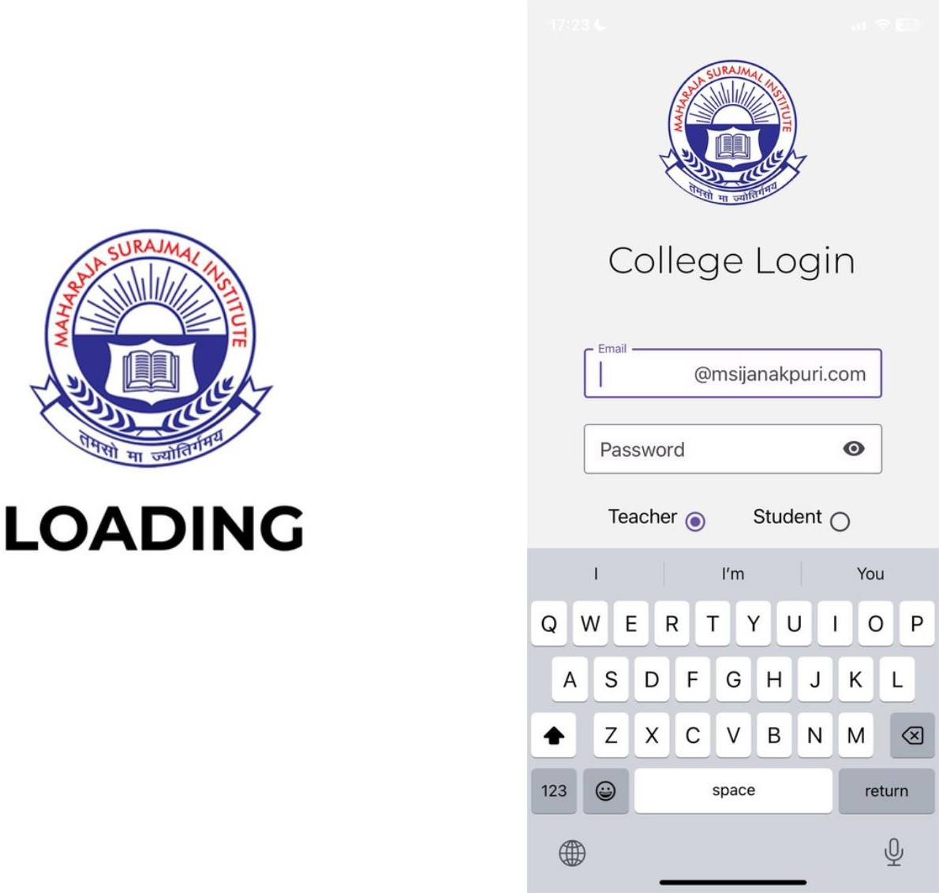**INPUT AND OUTPUT SCREENS**

Different panels of the system are shown in Fig 2 to Fig 9.

Fig 2: Login Panel

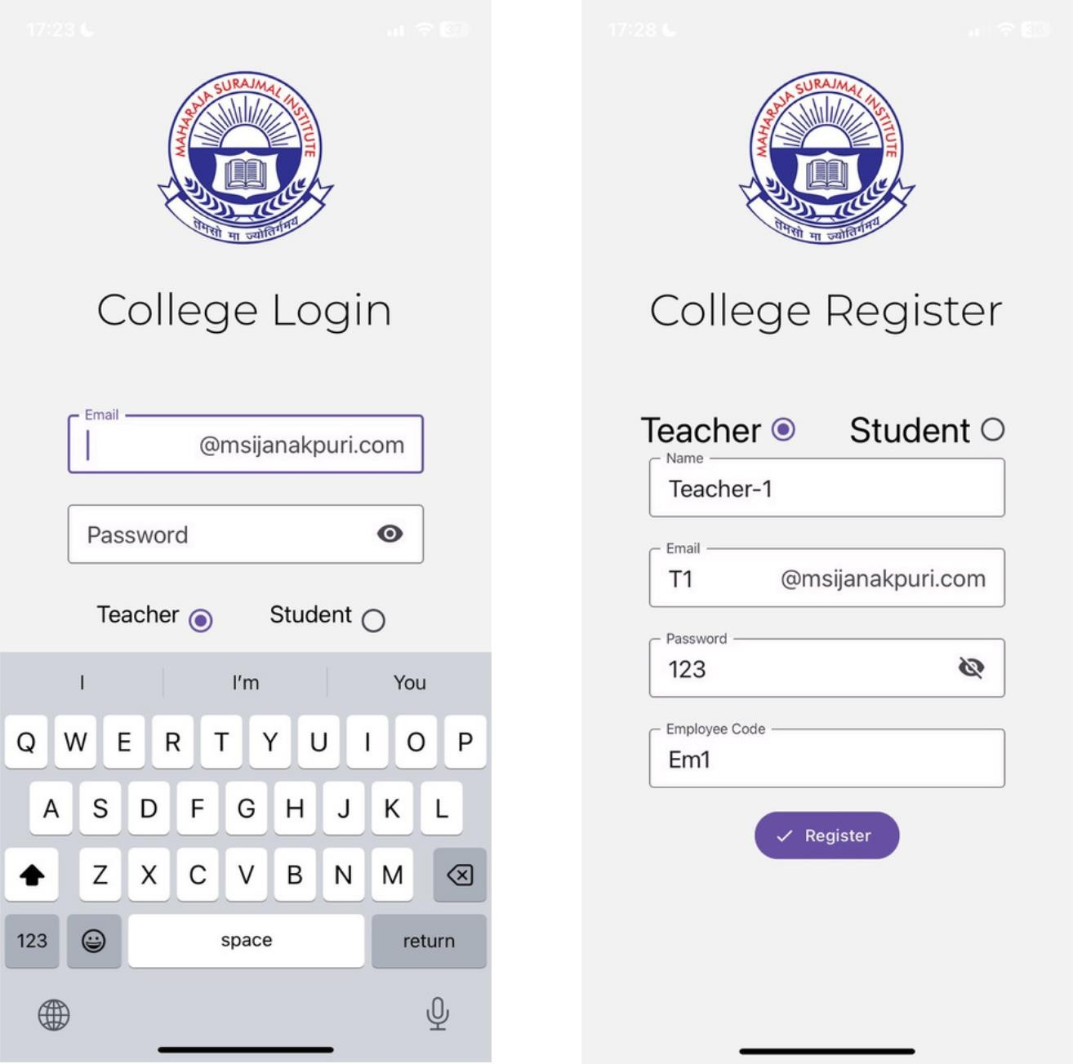

Fig 3: Registration Panel

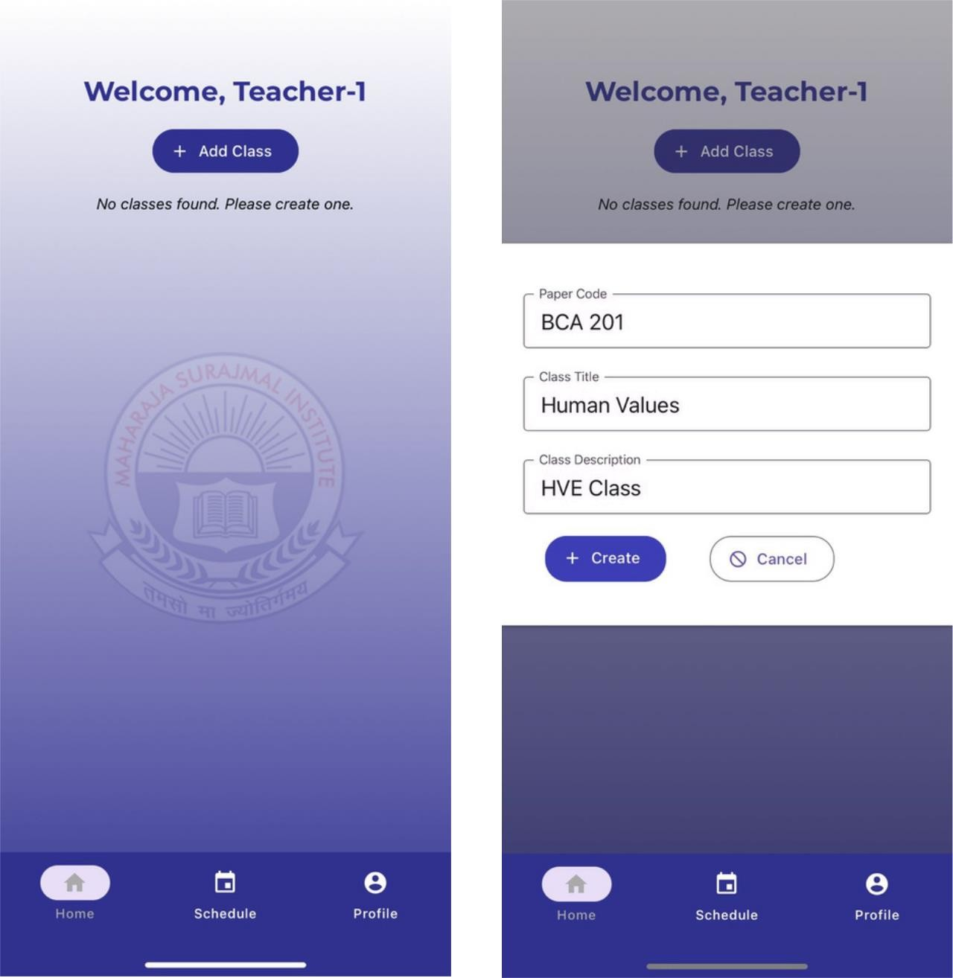

Fig4: Adding a class

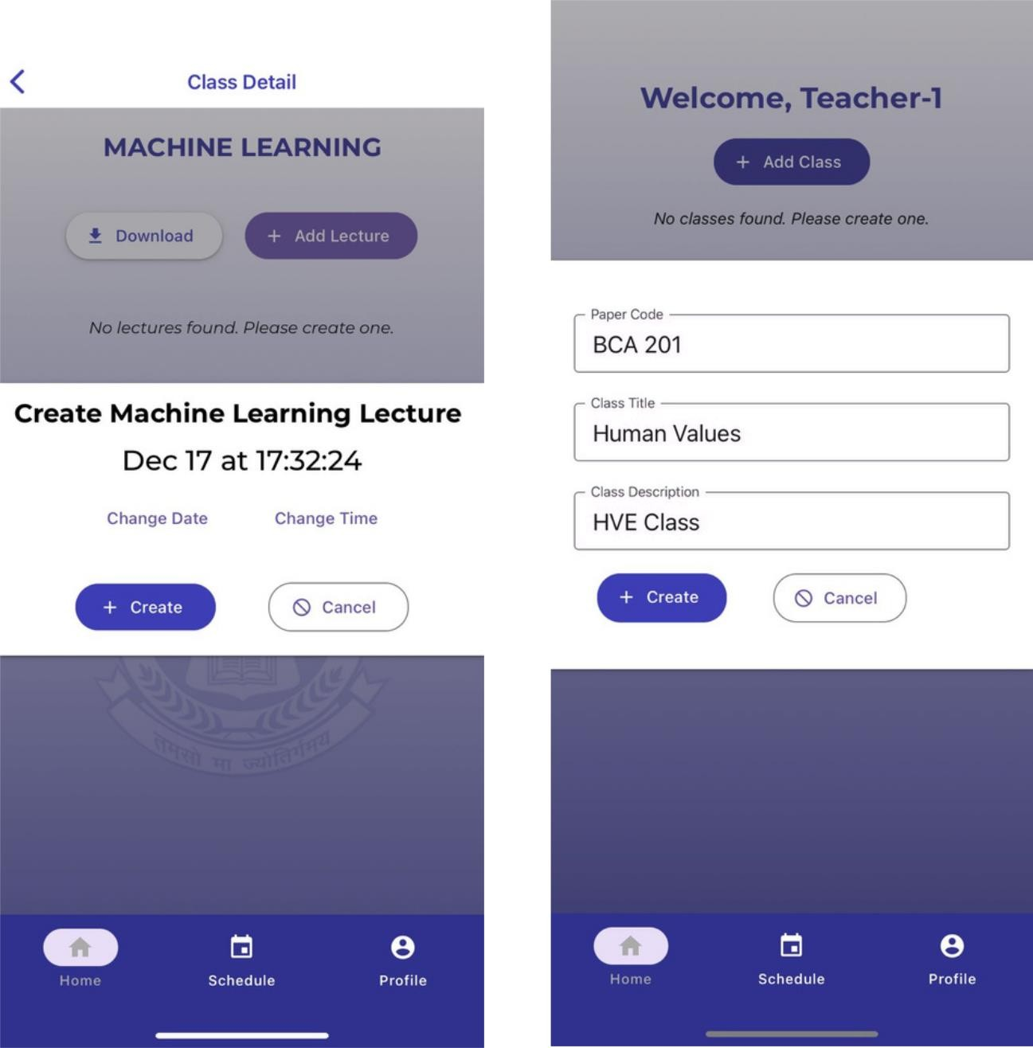

Fig5: Adding a lecture

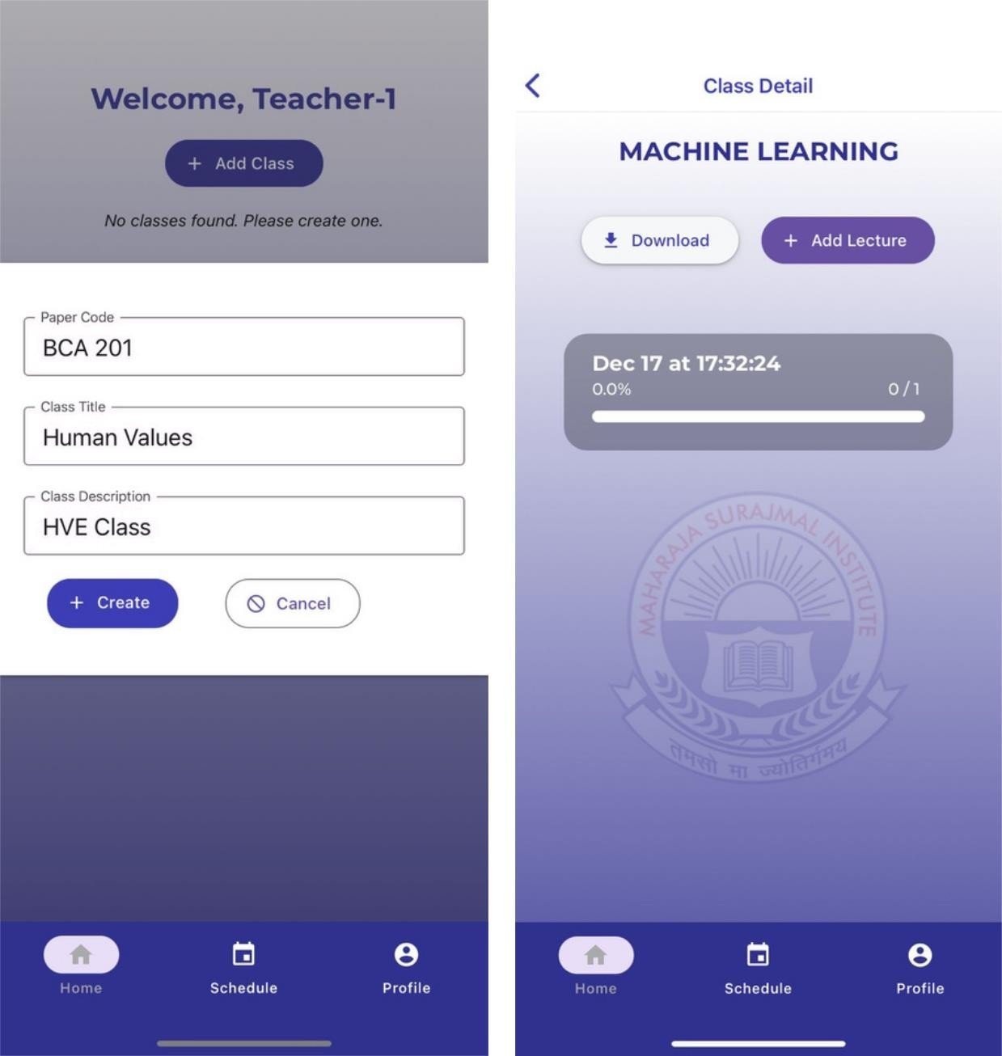

Fig 6: Class details

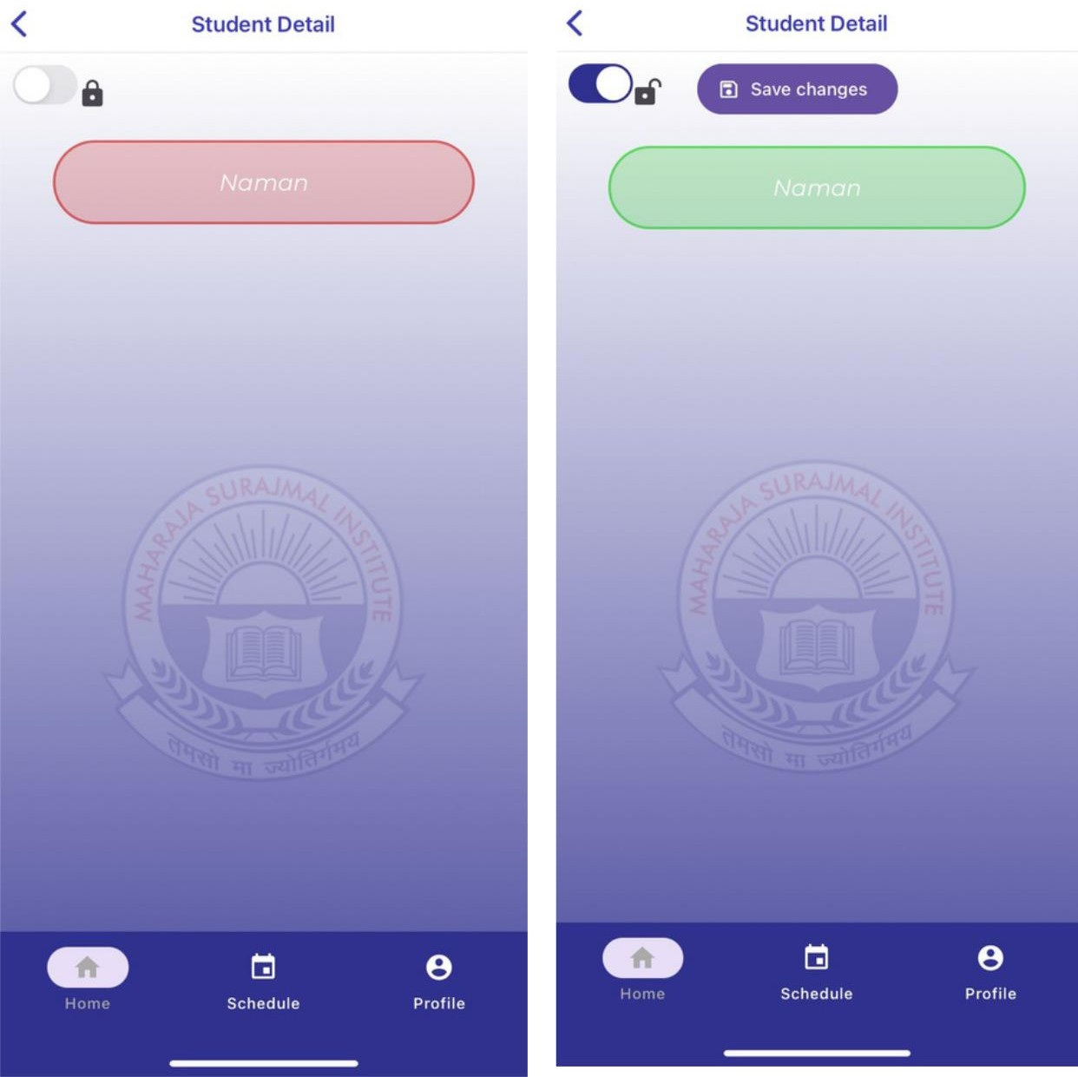

Fig 7: Students detail

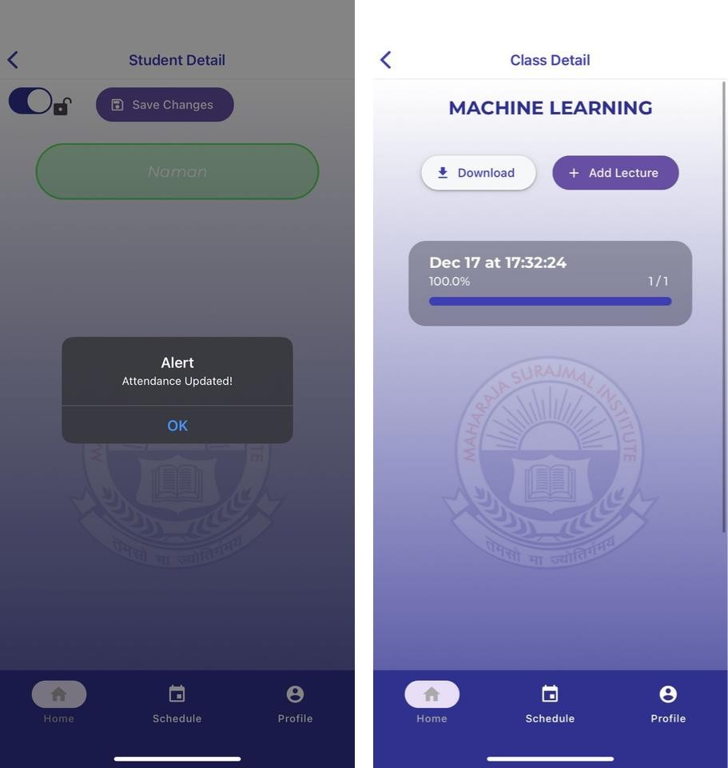

Fig 8: Attendance update confirmation

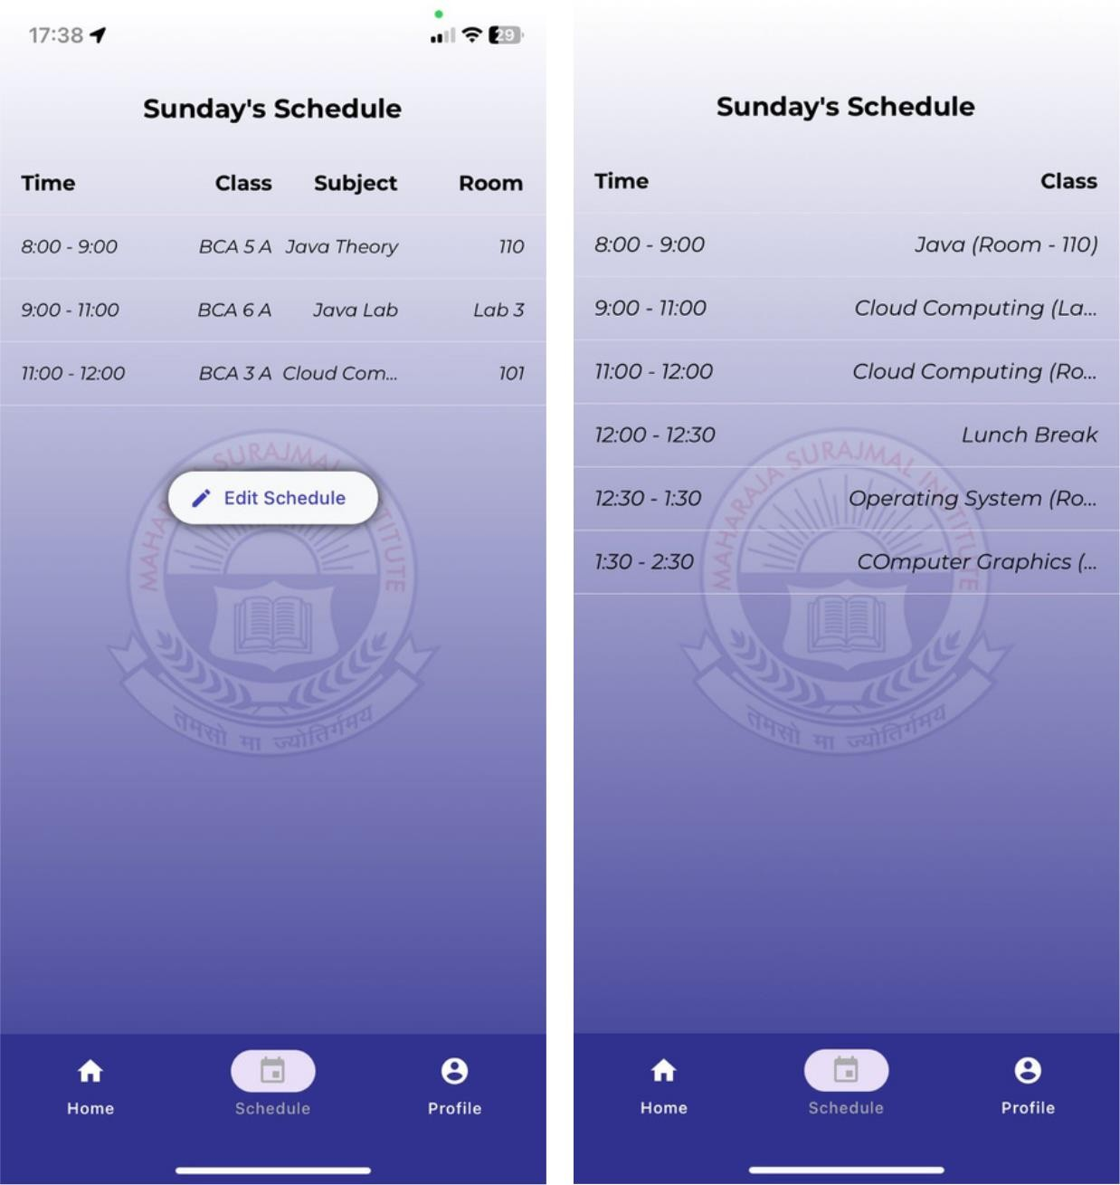

Fig 9: Detailed schedule

1. **CONCLUSION AND FUTURE SCOPE**

The AttendEase system is an innovative attendance management system designed to simplify the process for both teachers and students in educational institutions. It leverages modern technologies to enhance traditional attendance tracking methods.

Looking ahead, AttendEase holds immense potential for future development and expansion, marking a stepping stone towards an even more advanced and comprehensive attendance management solution. One avenue for future development lies in the integration of artificial intelligence (AI) and machine learning algorithms. By harnessing these technologies, AttendEase can evolve to predict attendance trends, identify patterns, and provide proactive recommendations for educators. This predictive analytics approach would not only enhance the system's capabilities but also contribute to a more anticipatory and preventive attendance management process.

Furthermore, considering the growing reliance on mobile devices, the future development of a dedicated mobile application for AttendEase is a logical progression. This would empower both teachers and students with the flexibility to manage attendance on the go, receive instant notifications, and access attendance-related information anytime, anywhere. A mobile application would align with the contemporary needs of users and further contribute to the seamless integration of AttendEase into the daily routines of educational stakeholders.

In terms of expansion, AttendEase could explore integration possibilities with other educational platforms and systems, creating a holistic ecosystem. Seamless integration with Learning Management Systems (LMS) and Student Information Systems (SIS) would ensure a unified digital infrastructure, allowing for the smooth flow of data across different educational tools. This expansion would not only facilitate efficient data management but also contribute to the overall digital transformation of educational institutions.

Moreover, AttendEase could explore customization features to cater to the unique needs of different educational setups. The ability to adapt the system to various academic structures, attendance policies, and institutional requirements would make 'AttendEase' a versatile solution applicable across a spectrum of educational institutions.

1. **REFERENCES**
2. Dhall, A., & Sharma, S. (2017). "Biometric Attendance System Using Fingerprint Recognition." (2017) 2nd IEEE International Conference on Recent Trends in Electronics, Information & Communication Technology (RTEICT) (pp. 810-814). IEEE.
3. Kulkarni, M., & Bhosale, S. (2018). "Smart Attendance System Using RFID and IoT." 4th International Conference on Computing Communication Control and Automation (ICCUBEA) (pp. 1-6). IEEE
4. Mishra, P., & Meena, Y. K. (2019). "Automated Attendance System Using RFID Technology and Cloud Computing." In 2019 International Conference on Sustainable Computing in Science, Technology and Management (SUSCOM) (pp. 1-6). IEEE.
5. Rajput, M. R., & Patil, D. S. (2020). "RFID Based Attendance System with Notification." In 2020 7th International Conference on Signal Processing and Integrated Networks (SPIN) (pp. 473-477). IEEE.
6. Arya, V., & Kumar, V. (2015). "Automation of Attendance System Using RFID and Bluetooth Beacon." In 2015 IEEE Calcutta Conference (CALCON) (pp. 45-50). IEEE.
7. Naik, R.N., Mal, M., Koli, S.S., Karnani, A., & Chetwani, B. (2016). SMART ATTENDANCE MANAGEMENT SYSTEM (SAMS). Journal of emerging technologies and innovative research.
8. Al Hajri, E., Hafeez, F., & N V, A. A. (2019). Fully Automated Classroom Attendance System. *International Journal of Interactive Mobile Technologies (iJIM)*, *13*(08), pp. 95–106. <https://doi.org/10.3991/ijim.v13i08.10100>
9. S.Meena, Develop and Implementation of Attendance Management System, International Journal of Scientific & Engineering Research Volume 9, Issue 4, April-2018 ISSN 2229-5518, pp 85-88
10. Ravi Kishore Kodali, Raghu Vamshi Hemadri, National Institute of Technology, Warangal, Attendance Management System , International Conference on Computer Communication and Informatics (ICCCI ), 2021
11. Kaneez Laila Bhatti1, Laraib Mughal, Faheem Yar Khuhawar, Sheeraz Ahmed Memon, (2018)  
    Smart Attendance Management System Using Face Recognition,CT EAI, DOI: 10.4108/eai.13-7-2018.159713
12. Prof. Arun Katara, Mr. Sudesh V. Kolhe, Mr. Amar P. Zilpe, Mr. Nikhil D. Bhele, Mr. Chetan J. Bele, “Attendance System Using Face Recognition and Class Monitoring System”, International Journal on Recent and Innovation Trends in Computing and Communication, Vol.5 Issue.2, Feb 2017
13. Jacksi, Karwan & Mohammed, Falah & Zebari, Shahab. (2018). Student Attendance Management System. International Journal of Engineering and Technology. 6. 49-53. 10.21276/sjet.2018.6.2.1.
14. Dr. A. Babu Karuppiah, R. Raja, M. Jaya lakshmi, L. Johnsilin shiny, B. Sri Devi, “Online Attendance system” International Journal of Engineering Research & Technology, 2017
15. Anusha V Pai, Atul Krishna, Kshama P M, Menita Correa “Web Service for Student Attendance management system” International Journal of Advanced Research in Science and Engineering, 3 march 2016.
16. Dr. A. Babu Karuppiah, M. Jeyalakshmi, L. Johnsilin Shiny, B. Sri Devi, 2017, Online Attendance System, INTERNATIONAL JOURNAL OF ENGINEERING RESEARCH & TECHNOLOGY (IJERT) NCIECC – 2017 (Volume 5 – Issue 09)