**CRAFTS OPERATED DURING FISHING BY LOCAL FISHERMEN OF SELUD, THUTI AND NAVI UKAI VILLAGES OF GUJARAT, INDIA**

**Bengani. R*, Manoj. K, Gamit T**

Department of Aquatic Biology

Veer Narmad South Gujarat University, Surat, Gujarat

**ABSTRACT**

Fishing crafts are essential for catching fish on a large scale in water bodies. There are various types of crafts used in different parts depending upon the nature of water bodies, the age of fish and their species. Generally, locally made crafts may be non-mechanized or mechanized. Different types of crafts were seen used for fishing by the local fishermen. The tube boat locally known as ‘Tube’ is a very popular fishing craft in the upper part of the Ukai reservoir used by the fishermen of Selud, Thuti and Navi Ukai villages.

**Keywords:** Dam, fish, catch, fishing

**INTRODUCTION**

Fish signifies an enormous as well as a diverse resource of the aquatic systems of the world related to their food chain that has been a unique bequest to humankind and other fish-eating creatures. Globally, fish provides 6.7 per cent of all protein consumed by humans, as well as offering a rich source of long-chain omega-3 fatty acids, vitamins, calcium, zinc and iron [1]. The abundant water resources include 29,000 km of rivers, 3.15 million hectares of reservoirs, 2.35 million hectares of ponds and tanks, 0.2 million hectares of floodplains and 33 wetlands [2]. Gujarat is the seventh largest state and is situated in the western corner of the country. It comprises the third largest proportion of inland water resources of the country in the form of rivers and canals - 3865 km, reservoir - 2.86 lakh ha, billabong, oxbow and derelict - 0.71 lakh ha [2]. Gujarat has shown tremendous development in inland culture and capture fisheries over the last three decades [ [3]. Ukai reservoir is located on Tapi River and this river passes through Madhya Pradesh, Maharashtra and Gujarat before emptying into the Gulf of Cambay at Surat district of Gujarat state. This reservoir was completed in 1971 with a catchment area of 6225500 ha and, a water spread area of 520 km2 at full reservoir level along with a mean depth of 11.8 m. The total number of fisherman villages supported by the Ukai reservoir is around 118 with 14956 active fishers [4]. Based on the topographical variations and differences in habits and habitats of fishes, different types of crafts are used in various inland water systems of India. This study is an attempt to document the crafts presently used by the fishermen of Selud, Thuti and Navi Ukai villages near the Ukai catchment area.

**2. METHODOLOGY**

Visits to the selected study sites were made from January 2021 to March 2021. Fishermen were interviewed to collect information about their fishing mode and crafts used.

**2.1 Study area**

The selected sites for carrying out the present study were the Selud pump house, Thuti of the Ukai Reservoir catchment area and Navi Ukai. Selud and Thuti are a village in Uchchhal Taluka in Surat district of Gujarat State. Thuti is located on the bank of river Tapi. It is located 92km east of the district headquarters in Surat. Navi Ukai is a small village in Songadh Taluka in Surat district of Gujarat State. It is located 80km east of the district headquarters in Surat. Navi Ukai is located on the bank of river Tapi and is considered a good source for a variety of freshwater fishes. The map of the study area is depicted in Fig. 1 . The selected sites are Fig2,3 &.4.

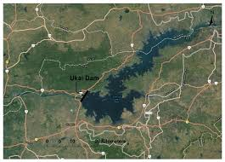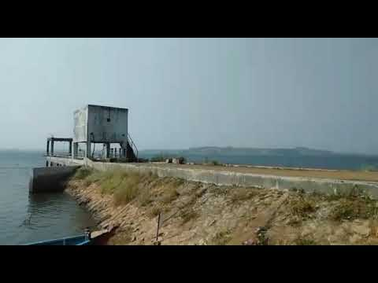

Fig.1 Map showing study area Fig.2 Selud pump house

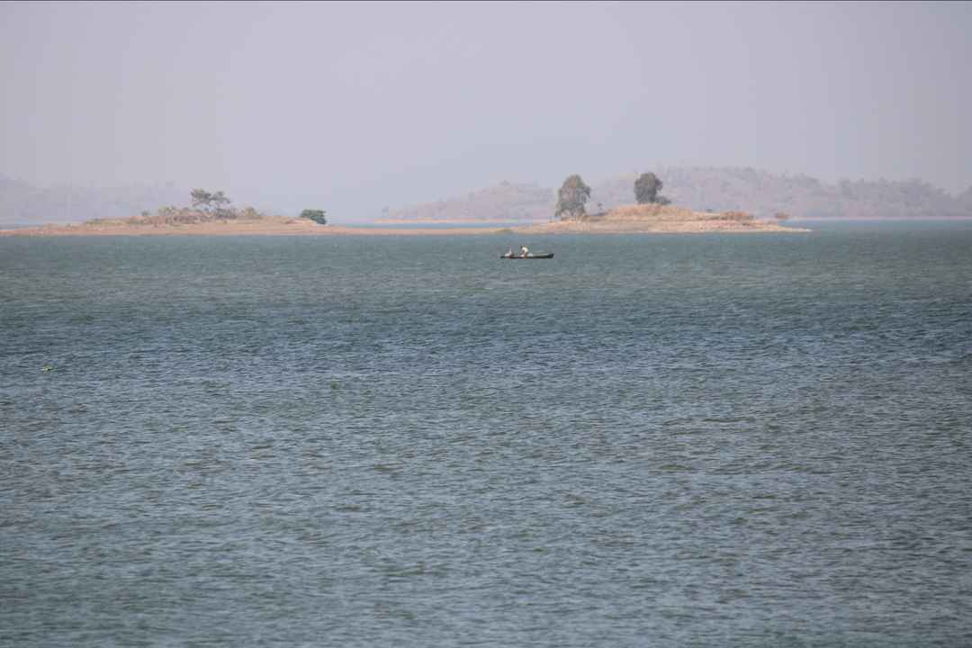 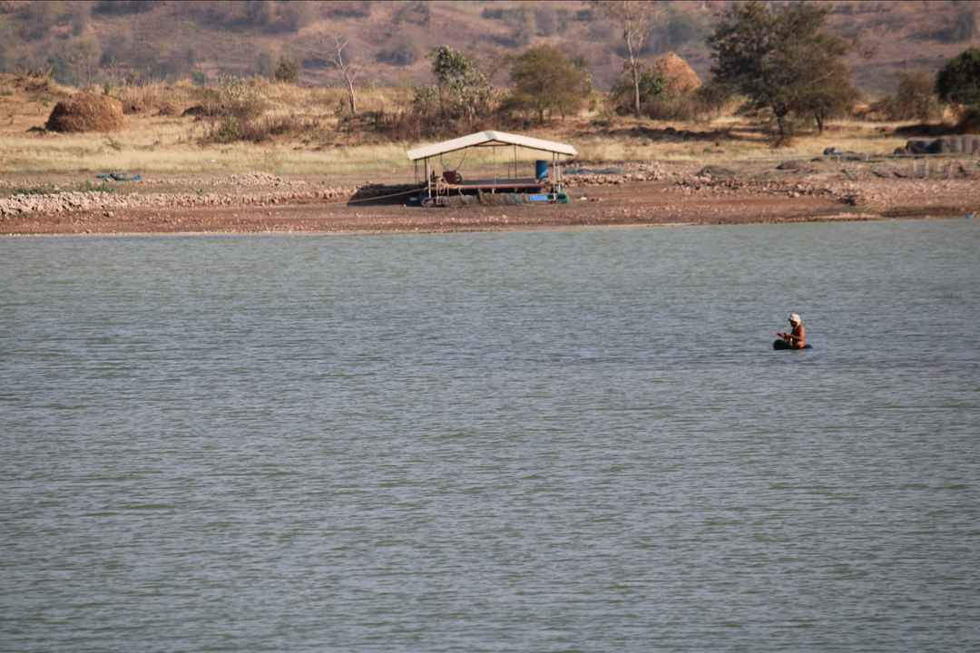

Fig.3 Thuti Fig.4 Navi Ukai

**3. RESULTS AND DISCUSSION**

Different types of crafts used for fishing by the local fishermen.

1. **Plank boat**: This is the most important fishing craft used by the fishermen from studied villages. A Plank boat is a wooden, nonmechanized, manually operated boat. The boats are generally painted with synthetic paints for protection against water. The size of the boat varies from area to area and respective fishing methods The average durability of a plank boat is nearly 10 years. Fishing gear such as cast net and scoop net may operate through the boat. This is locally known as ‘Hodi’ or ‘Nao.
2. **Mechanised boat**: The sizes of the mechanized boats varied according to the area of fishing in the Ukai reservoir. These boats were coated with paints and chemicals to prevent decay from water.
3. **Rubber tube platform**: Fishermen were seen to use discarded vehicle rubber tubes. A wooden platform support is placed over the rubber tube and tied with rope. It is mostly used for setting and hauling of gill nets.
4. **Thermocol raft:** Sheets of thermocol are tied with rope to make a bundle. Two such bundles were tied with rope on which fishermen sit for laying and hauling the fishing gears such as the gill net and cast net. It was also seen to be used for operating dragnet.
5. **Bamboo raft:** This is made easily from bamboo with low investment by the local fishers. Light bamboos are cut horizontally into the same size of pieces and tied together with coir/jute rope or nylon rope for constructing this raft. This type of craft is generally diverse in length and size depending on the water current and the number of bamboos used for making raft.
6. **Tin boat:** This is made from tin sheets and used in marginal areas, especially for operating gillnets.
7. **Catamaran:** It is locally known as ‘Tarapa’ and is made by tying wood logs in such a way that it takes the shape of a canoe, which consists of two main logs and two side logs cut into a boat shape and held together with rope. Tarapa is mainly used for the operation of gillnets, hooks lines and cast nets. It is the most primitive, traditional, and economical craft.
8. **Dugout Canoe:** A simple type of fishing craft for fishing is made by scooping logs of wood in the form of a boat. The dug-out canoes are employed for day-to-day fishing operations.

In India details about crafts used in the freshwater fishery sector were documented by Manna et al. [5], Bhattacharjya [6], Kumar and Kumar [7], Laxmappa et al. [8], Gokulkrishnan and moses[9] . Bhakta et al,[10] study in the Ukai reservoir found similar types of crafts used for fishing.

**4. CONCLUSION**

The survey was undertaken around the Ukai dam where commercial fishing activities take place. The Ukai Dam, constructed across the Tapi River, is the second largest reservoir in Gujarat after the Sardar Sarovar. It is also known as Vallabh Sagar Reservoir. The dam is an earth-cum-masonry dam. Different types of crafts were seen used for fishing by the local fishermen here from nearby villages Selud, Thuti and Navi Ukai. Common crafts were plank boats / Hodi or Nao, Catamaran / Tarapa, Tin-made boats, Thermocol rafts, Rubber tube platforms and simple electric boats.

**5. ACKNOWLEDGEMENT**

The authors are thankful to the farmers fishing around for providing information for the study.

**6. REFERENCES**

1. FAO, (2016). The State of World Fisheries and Aquaculture. Contributing to Food Security and Nutrition for All. Rome,200pp
2. Ayyappan S. (2007). Aquatic resources as a food production system. Proceedings of Taal 2007: The 12th World Lake Conference. pp. 13
3. Ayyappan S, Diwan AD. Fisheries Research and Development in India. Fishing Chimes. 2006; 26(1):19- 23
4. Anon( 2015). Fisheries statistics of Gujarat: Government publication, 2011-12
5. Manna R. K, Das A.K, Rao D.S.K, Karthikeyan M, Singh D.N(2011).. Fishing crafts and gear in river Krishna, Indian J Tradit Knowle. ; 10(3):491-497
6. Bhattacharjya B.K, Manna R.K, Choudhury M.(2005). Fishingcrafts and gear of northeast India, Bull No. 142 (CIFRI,Barrackpore, Kolkata), , 67
7. Kumar. V and Kumar K(2013), A preliminary study on Fishing Craft and Gears in Dhaura reservoir, Uttaarakhand, India, International Research Journal of Biological Sciences, 2(8), 76-78
8. Laxmappa B, Satya Parameshwar K and Sreenivas Reddy B,(2014) Prawn catching methods in Ramanpad reservoir of Mahabubnagar district A.P, India, International Journal of Fisheries and Aquatic Studies, 5, 43-48
9. Gokulkrishnan S, Moses I. R.(2014). Present scenario of fishing methods in Pulicat lagoon Fishing Chimes. 2014; 33(10- 11):43-47.
10. Bhakta Dibakar, Ranjan K Manna, W Anand Meetei, J.K Solanki and R.K Sah(2016)Traditional fishing crafts and gears of Ukai reservoir, Gujarat, India, International Journal of Fisheries and Aquatic Studies ; 4(4): 142-145