##### **Failure Prediction using Machine Learning Techniques**

**1Koya Haritha**

Asst. Professor,

Dept. of CSE,

Chalapathi Institute of Technology,

Guntur, AP, India

harithakoyacse@gmail.com

**2Rajesh Andra**

Asst. Professor,

Dept. of CSE,

Chalapathi Institute of Technology,

Guntur, AP, India

rjshandra@gmail.com

**3Kusuma Polanki**

Asst. Professor,

Dept. of CSE-Data Science,

Chalapathi Institute of Technology,

Guntur, AP, India.

kusuma.polanki@gmail.com

**4Sravanthi Javvadi**

Asst. Professor,

Dept. of CSE-DS,

Chalapathi Institute of Technology,

Guntur, AP, India

sravanthi.javvadi@gmail.com

**5Dr NagamalleswaraRaoPurimetla**

Assoc. Professor,

Dept. of CSE,

Chalapathi Institute of Technology,

Guntur, AP, India

nmrao85@gmail.com

**6Khader BashaSk**

Asst.Professor,

Dept. of CSE-DS,

Chalapathi Institute of Technology,

Guntur, AP, India

khaderbasha576@gmail.com

**ABSTRACT**

It is referred to as a "machine failure" or a "equipment failure" if a piece of industrial machinery fails to work as it should, whether entirely or partly, or when it stops to function as it should have been able to. The breakdown of equipment leads in the loss of asset availability, a departure from protocol, a failure to meet quality and quantity expectations, a harm to time, labor, and resources, and the elimination of an integrated system. Failures in equipment may happen very fast if it is not cleaned, oiled, and maintained in the appropriate manner. Mining for data is a common practice these days, and it's used to handle massive volumes of data. Researchers examine vast volumes of complicated data using a range of data mining and machine learning technologies. This helps equipment professionals estimate when machines may break down. After combining a number of different methods, the most accurate model is used to provide a prediction of the outcome.

**Keywords:** Convolution Neural Network Algorithm, Android Application, denary analysis.

**INTRODUCTION**

There are typically three probable outcomes when working with machinery that need routine maintenance. One, you can regularly maintain a machine. In other words, when it is not essential, the machine accepts maintenance. In this case, you are squandering resources and tossing money out the window by performing unneeded conservation [1][2].

You could, for instance, change the oil on your car every single day. You will spend a lot of money on unneeded upkeep because this is not ideal. Two, you don't regularly repair your equipment. Failure to maintain a machine results in disruptions when it is in use[3][4]. The expenses in this case could be high. You must also factor in the costs of missed production in addition to the repair costs. The assembly line cannot create anything if a machine breaks down. Lack of production equals lost revenue. If injuries resulted from the failure, you will also be responsible for the associated legal and medical expenses. Three, when a machine need maintenance, it receives it[5]. This is without a doubt the superior of the three. Please take note that timely maintenance is still expensive [6].

### 1.1 Objectives of the study

Equipment failure as a result of software difficulties, a lack of usage of AI/ML techniques on current data to anticipate failures, and the presentation degradation of industrial kit are some of the challenges and tests that are encountered in this sector[7].

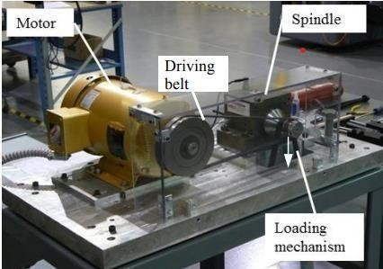

Figure1: Spindle Test-bed at tech Solve

The project's goal is to reduce mistakes and improve prediction outcomes by integrating machine failure with computer-based forecasting. This recommendation has promise since data modeling and analysis techniques, such as data mining, have the ability to create a knowledge-rich environment that can considerably reduce the damage of cost resulting from machine failure [8][9].

For predictive maintenance and equipment tracking, manufacturers have been considering using more contemporary machine learning approaches. Due to the accessibility and affordability of strong computing resources, the enormous amounts of industrial data sets from their own factories, and deep-learning AI/ML algorithms, it is viable to attempt developing these complex systems [10].

## Methodology

In this instance, the purpose of the research is to illustrate, via the use of computer-based prediction and machine failure, how the number of errors may be reduced while simultaneously improving prediction results. This strategy has a good chance of being successful due to the fact that data modeling and analysis technologies, such as data mining, may provide a knowledge-rich environment, which can significantly cut down on the financial loss caused by a machine breaking down. In recent years, manufacturers have started looking at the possibility of adopting more contemporary techniques of machine learning in order to perform predictive maintenance and track equipment. Because powerful computer capabilities are readily available and relatively inexpensive, enormous quantities of industrial data sets collected from the company's own facilities, and deep-learning AI/ML algorithms may make the construction of these complex systems a doable and worthwhile endeavor[11][12].

## 1.3 Basic Concepts

Machine Learning:

## The field of research known as machine learning (ML) refers to the study of computer algorithms that may improve on their own via repeated use. The field of artificial intelligence includes it as one of its subfields. Machine learning algorithms, in order to create predictions or decisions without being explicitly instructed to do so, develop a mathematical model based on sample data, which is often referred to as "training data." This allows the algorithms to learn on their own.

## Classification:

The problem of classification in machine learning and statistics is to determine which of a collection of categories (subpopulations) a new observation belongs to. This may be seen of as an attempt to assign a label to the observation. This conclusion is reached by using a training set of data, which consists of observations (or instances) whose category membership is already established as the foundation for the analysis. In the context of machine learning, classification is considered an example of supervised learning, which may be defined as learning that takes place in the presence of a training set of comments that have already been correctly recognized [22].

## Logistic Regression :

Logistic regression is one of the Machine Learning algorithms that is used in the Supervised Learning category the majority of the time. It makes use of a predetermined group of independent factors in order to provide a prediction for a categorical dependent variable. Logistic regression is a statistical technique that may be used to forecast the value of a categorical dependent variable. Because of this, the result must take on a discrete or categorical value. Rather than providing the exact numbers that are between 0 and 1, it provides the probabilistic values that fall somewhere in that range. It may either be True or False, 0 or 1, Yes or No. These are all possible answers. Logistic regression and linear regression are very comparable, with the primary difference being in the manner in which each is used. In order to solve classification problems, logistic regression is often utilized, however linear regression is preferred for solving regression problems [13].

## Naïve Bayes Algorithm :

## The classification issues that need to be solved are handled using the Nave Bayes method, which makes use of supervised learning and the Bayes theorem. Because it has such a big training set, the majority of its applications are in text classification. The Naive Bayes Classifier is both one of the most straightforward and one of the most powerful classification algorithms that are currently known. It speeds up the process of creating machine learning models that are accurate in their prediction abilities thanks to the assistance provided by this. Because it makes use of a probabilistic classifier, the foundation of its forecasts is the probability that a certain event will take place [14].

## Decision Tree :

The method of supervised learning known as a decision tree may be used to address classification and regression problems; however, the strategy described here is the one that is most usually recommended. It is a classifier that is constructed like a tree, with leaf nodes representing the result of classification and inside nodes representing the attributes of a dataset. The "Decision Node" and the "Leaf Node" are the two nodes that make up a decision tree. Leaf nodes are the results of choices and do not have any more branches, but decision nodes are used to create decisions and contain many branches [15].

Decision nodes also have numerous branches. Using the characteristics of the dataset that was supplied, either the test is carried out or judgments are formed. It is a graphical depiction that may be used to locate every conceivable solution to a problem or choice depending on the criteria that have been set. The term "decision tree" is used to refer to this kind of structure since it begins with a root node and builds outward on successive branches to form something that resembles a tree.

## Support Vector Machine :

Classification strategies are used by a supervised machine learning model referred to as a support vector machine (SVM), which is used to tackle issues involving two-group classification. After acquiring sets of labeled training data for each category, SVM models are able to classify incoming text into those categories. It is certain that hyper plane safe options that aid in the classification of the data points will surface. It is feasible to assign numerous different classifications to different data points that fall on her side of the hyper plane. There will be a direct correlation between the number of features and the size of the hyper plane. If there are just two input characteristics, then the hyper plane can only be represented by a line. If there are three input characteristics, the hyper plane will transform into a plane that only has two dimensions. When there are more than three components, it is difficult to get a mental picture of the whole [16].

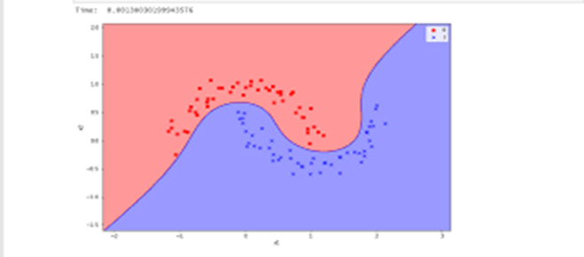

Figure2: Support Vector Machine

Module Diagram:

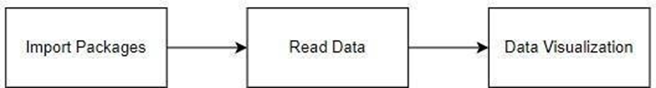

Figure 3: Module Diagram

## LITERATURE SURVEY

It may be difficult to accurately predict when machines in an industrial production process would break down by using data from many time series variables. This article will provide a method for preparing data to be used in the training and testing of a prediction model. Its implementation is extensible and modular, which allows it to adapt alterations to both the data that is collected and the production processes that are underlying it. The effectiveness of convolutional neural networks and recurrent neural networks-based prediction models is evaluated using data from a sophisticated machining process that is used to carve complicated patterns into metal components. This technology is used to carve intricate designs into metal parts [17].

We evaluate several machine learning approaches by applying them to a challenging task based on the real world: forecasting the failure of computer hard drives based on internal variables measured by individual drives. The challenge here is to identify unusual occurrences within a data stream that is both noisy and dispersed across time. We build a novel technique that is particularly built for the low false-alarm condition, and it is demonstrated to have promising performance. This approach is based on the multiple-instance learning framework and the naïve Bayesian classifier (mi-NB). Support vector machines (SVMs), unsupervised clustering, and non-parametric statistical tests (rank-sum and reverse arrangements) are some of the other approaches that are being evaluated and compared. While retaining a low number of false alarms, the failure-prediction performance of the SVM, rank-sum, and mi-NB algorithm is much better than the threshold approach that is presently employed in drives [18]. This is the case even though the SVM, rank-sum, and mi-NB algorithm all have the same name. Our findings lead us to believe that nonparametric statistical tests need to be taken into consideration for solving learning issues that involve locating infrequent occurrences in time series data. In this article, we provide a method for monitoring the performance of optical networks and predicting when they will break that is based on machine learning. This strategy primarily makes use of the support vector machine (SVM) and the double exponential smoothing (DES) approaches. The protection strategy that has been offered focuses primarily on determining how to assess the chance of an equipment failure, with a particular emphasis on risk-aware models in optical networks [19]. To the best of our knowledge, this very important factor has not been taken into consideration in an appropriate manner. When it comes to forecasting the failure state of optical equipment, our method has been shown to have an average prediction accuracy of 95%, based on the results of several experiments. Based on these findings, it seems that our system is able to properly forecast the possibility of a machine malfunction. Our DES-SVM technique is able to effectively augment traditional risk-aware models, which will both protect services from the possibility of failure and increase the stability of the optical network. The K-means technique was used to build the system's observation state, and the linear regression method was used to forecast the system's distinctive characteristics [20]. This approach successfully resolved, to a certain extent, the prediction analysis of the system parameters on the time series by using both of these methods. P. Kumar proposed a data mining clustering approach that is based on HMM as a potential solution to the cloud computing security problem. However, the initial cluster centre decision had a considerable influence on the result of the clustering, and it is possible that the intended goal of the clustering will not be achieved. Because of the increasing size of today's data centres and the increased emphasis placed on maintaining continuous availability, hardware management is becoming an increasingly challenging task. This objective was intended to be accomplished by the development of the Self-Monitoring, Analysis, and Reporting Technology, which provides information on the general health of hard disc drives. Recent years have seen a proliferation of new techniques for the prediction of failures in hard disc drives, all of which are based on the monitoring data described above. However, the majority of approaches simply consider this problem as a static job. This is the reason why they train a static machine learning model using a specified training set and then evaluate its effectiveness using a test set [21]. It is required, however, owing to model ageing and changes in failure patterns to update previously taught prediction models during runtime. This requires a time-dependent assessment to be performed. As a consequence of this, we provide four techniques for maintaining machine learning models, four algorithms for machine learning, and many models for estimating the likelihood of hard disc drive failure. After that, we evaluate the efficacy of the different machine learning algorithms and model update techniques in terms of the accuracy of their predictions. In this article, we present a machine learning model that analyses logs in virtual machines (VMs) that are utilized in network function virtualization (NFV) settings in order to anticipate problems before such failures really take place. The suggested model makes use of something called a convolutional neural network (CNN), and it also incorporates pre-processing and pre-failure labeling methods. In order to verify the validity of the suggested model, we gathered log data from Open Stack virtual machines. We constructed a CNN model to anticipate VM failures and categorized failures based on the early fault reports they generated. The findings of the experiments demonstrated that the suggested model has the ability to anticipate failures 5 minutes in advance, with an F1 score of 0.67. In order to prevent the deterioration of service and disruptions brought on by failures, the suggested architecture would be employed for proactive live migration of virtual machines. The power transformer is the single most important component of the power system; its failure may lead not only to disruptions in the flow of electrical power but also to significant financial losses. Therefore, it is essential to do daily checks on the condition of the transformer. DGA is one of a large number of diagnostic methods that may be used for this goal; among these methods, it has been an essential method. Despite the fact that DGA is an effective method, a significant amount of reliance is placed on the human experts involved. In order to forecast the fault status of a transformer using DGA data, the authors of this research make use of both the Multilayer Artificial Neural Network Model and the Support Vector Machine Classifier Model. The Support Vector Machine Classifier has shown findings that are around 81.4% more accurate than those produced by the Multilayer Artificial Neural Network, which provide approximately 76% accurate prediction results.

## PROBLEM IDENTIFICATION

## 3.1 Existing System

Brushless excitation systems have increased the operating pressures placed on the mechanisms of the excitation system while simultaneously minimizing the need for maintenance and the number of failures in synchronous machines that are caused by brushes. Because the rotating excitation system is inaccessible, it is difficult to spot faults with the excitation system, such as open circuit diodes or open armature windings, in order to prevent deterioration in the machine's presentation and dependability. When it comes to testing or repairing the inaccessible brushless exciter components used in synchronous machines, the process is very challenging and expensive. In order to improve the diagnostic process and get more accurate results while looking for problems with brushless exciters, we suggested adding extra tests. It is hoped that the various testing strategies that have been offered would provide a speedy method of locating faults.

## Proposed System

The creation of a model based on machine learning is the strategy that is recommended for failure prediction. The first thing that has to be done for the project is collecting the dataset that has all of the historical information in it. After the data have been collected, they are subjected to pre-processing in order to remove any data that is superfluous. After then, the data is analyzed, and then the training may begin. Learning by machine is currently a feasible technology that is widely employed across all areas in which it may reduce the amount of time spent on manual labor. During training, a variety of algorithmic approaches are used, and the most effective one is ultimately chosen. The one that is selected is then utilized to create a model file, which is used to the task of estimating the new data.

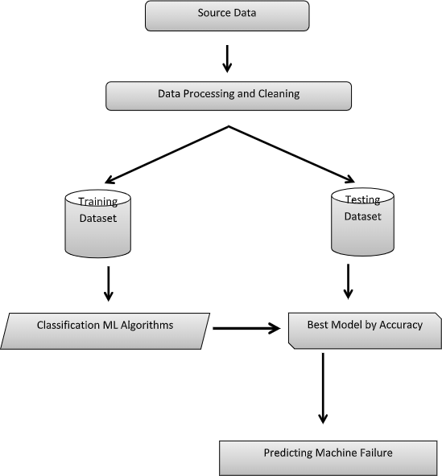



Figure 4: Architecture or Model

## 3.3 System Design and Architecture:

A set of guidelines that outline the creation and assembly of software is known as software architecture. A software system's architecture outlines its organizational and structural layout. In addition, the links between the various software system components, degrees of abstraction, and other factors are spoken about.

Architecture is a tool that may be used to either outline the goals of a project or to lead the development of an entirely new system. The design and building of software are both covered by the software architecture, which is a set of design and construction guidelines. The architecture describes the overall organization and structure of the software system. In addition, there is a discussion of the connections that exist between the different components of the software system, as well as degrees of abstraction and other topics. The objectives of a project can be established using architecture, as can the design process for a brand-new system.

Algorithms Implementation :

The term "software architecture" refers to a set of guidelines that outline the proper procedures for developing and assembling software programs. The architecture lays out the framework for the software system and determines its basic components. In addition to that, it discusses the different degrees of abstraction, several other features, and the linkages between the various software system components.

Architecture may be used to either specify the aims of a project or to guide the development of an entirely new system. Either option is possible. It is essential to conduct accurate evaluations of the performance of a variety of machine learning algorithms, and it will undoubtedly be possible to construct a test framework in Python by making use of scikit-learn in order to evaluate and contrast a wide range of machine learning algorithms.

When you use it to your own machine learning problems, it may utilize this test harness as a model and add more and other algorithms to subordinate. There will be some variation in the demonstrated features from model to model. You may acquire a rough approximation of how accurate each model may be on data that has not yet been seen by using resampling strategies like cross authentication. It has to be able to make use of these approximations in order to choose one or two of the greatest models from the suite of copies that you have sculpted. When you get a fresh dataset, it is a good idea to envision the data using several approaches in order to look at the data from a variety of perspectives. This can help you better understand the data.

The same thinking may be used to the choosing of models. In order to choose the one or two machine learning algorithms to validate, you need first look at the evaluated correctness of all of your algorithms using a variety of methods and then pick the most accurate ones. Using a variety of visualization approaches to display the average accuracy, variance, and other features of the distribution of model accuracies is one strategy for accomplishing this goal. Another strategy is to utilize this information to refine the model. In the next part, you will learn the specific steps that you need to take in order to accomplish this goal using scikit-learn and Python. The protection that each algorithm be tested in the same manner on the same data is essential to ensuring that machine learning algorithms are judged fairly. This may be accomplished by requiring that each algorithm be evaluated on a trustworthy test harness.

## RESULTS

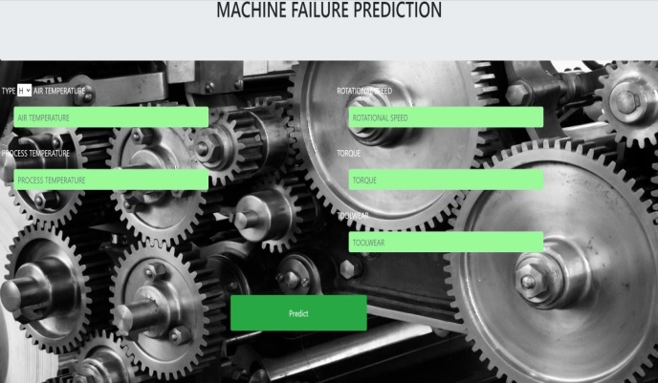

**INPUT**: Assigning the values to the particular attributes to predict the output.

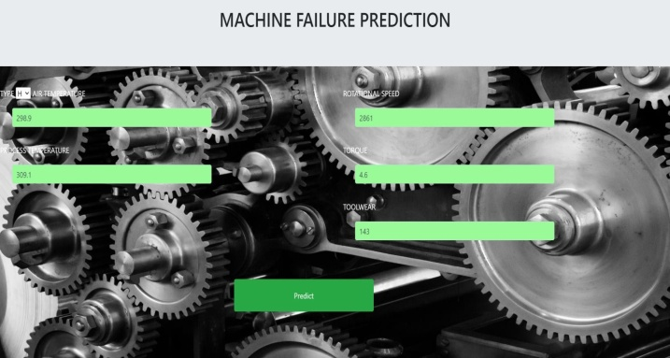

**OUTPUT:** Dependingontheinput values,either Failureor NoFailurewillbethe outcome.

Test Cases and Results:

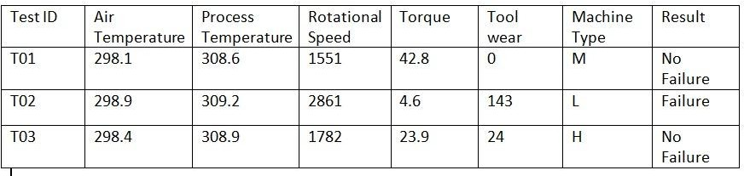

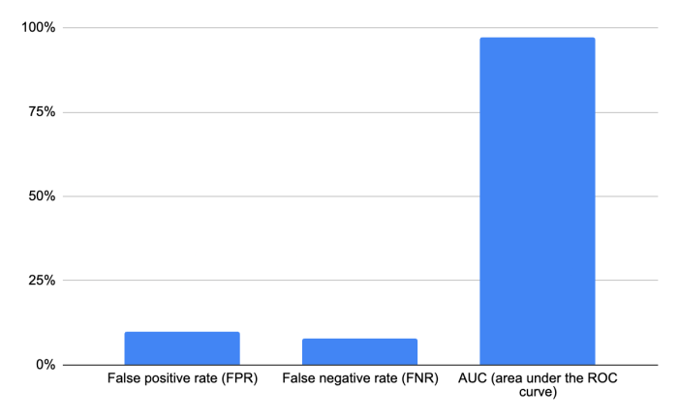

## CONCLUSION

The initial step in the analytical process was the preparation and processing of the data, followed by an examination of missing value, exploratory analysis, model creation, and model assessment. On the basis of the results of the public test set, an evaluation will be carried out to decide which algorithm has the greatest accuracy score. The founded one is used by the program that may provide assistance in determining the machine failure predictions.

**6. REFERENCES**

1. Vellela, S.S., Balamanigandan, R. Optimized clustering routing framework to maintain the optimal energy status in the wsn mobile cloud environment. Multimed Tools Appl (2023). [https://doi.org/10.1007/s11042- 023- 15926-5](https://doi.org/10.1007/s11042-%20023-%2015926-5)
2. Vellela, S. S., BashaSk, K., &Yakubreddy, K. (2023). Cloud-hosted concept-hierarchy flex-based infringement checking system. International Advanced Research Journal in Science, Engineering and Technology, 10(3).
3. Rao, D. M. V., Vellela, S. S., Sk, K. B., &Dalavai, L. (2023). Stematic Review on Software Application Under-distributed Denial of Service Attacks for Group Website. DogoRangsang Research Journal, UGC Care Group I Journal, 13.
4. K. N. Rao, B. R. Gandhi, M. V. Rao, S. Javvadi, S. S. Vellela and S. KhaderBasha, "Prediction and Classification of Alzheimer’s Disease using Machine Learning Techniques in 3D MR Images," 2023 International Conference on Sustainable Computing and Smart Systems (ICSCSS), Coimbatore, India, 2023, pp. 85-90, doi: 10.1109/ICSCSS57650.2023.10169550.
5. Venkateswara Reddy, B., Vellela, S. S., Sk, K. B., Roja, D., Yakubreddy, K., &Rao, M. V. Conceptual Hierarchies for Efficient Query Results Navigation. International Journal of All Research Education and Scientific Methods (IJARESM), ISSN, 2455-6211.
6. S Phani Praveen, RajeswariNakka, AnuradhaChokka, VenkataNagarajuThatha, SaiSrinivasVellela and UddagiriSirisha, “A Novel Classification Approach for Grape Leaf Disease Detection Based on Different Attention Deep Learning Techniques” International Journal of Advanced Computer Science and Applications(IJACSA), 14(6), 2023. http://dx.doi.org/10.14569/IJACSA.2023.01406128
7. Vellela, S. S., &Balamanigandan, R. (2022, December). Design of Hybrid Authentication Protocol for High Secure Applications in Cloud Environments. In 2022 International Conference on Automation, Computing and Renewable Systems (ICACRS) (pp. 408-414). IEEE.
8. Vellela, S. S., Balamanigandan, R., & Praveen, S. P. (2022). Strategic Survey on Security and Privacy Methods of Cloud Computing Environment. Journal of Next Generation Technology, 2(1).
9. Vellela, S. S., & Krishna, A. M. (2020). On Board Artificial Intelligence With Service Aggregation for Edge Computing in Industrial Applications. Journal of Critical Reviews, 7(07).
10. Sk, K. B., &Vellela, S. S. (2019). Diamond Search by Using Block Matching Algorithm. DIAMOND SEARCH BY USING BLOCK MATCHING ALGORITHM. International Journal of Emerging Technologies and Innovative Research (www. jetir. org), ISSN, 2349-5162.
11. VenkateswaraRao, M., Vellela, S., Reddy, V., Vullam, N., Sk, K. B., &Roja, D. (2023, March). Credit Investigation and Comprehensive Risk Management System based Big Data Analytics in Commercial Banking. In 2023 9th International Conference on Advanced Computing and Communication Systems (ICACCS) (Vol. 1, pp. 2387-2391). IEEE.
12. Vellela, S. S., Reddy, B. V., Chaitanya, K. K., &Rao, M. V. (2023, January). An Integrated Approach to Improve E-Healthcare System using Dynamic Cloud Computing Platform. In 2023 5th International Conference on Smart Systems and Inventive Technology (ICSSIT) (pp. 776-782). IEEE.
13. Vullam, N., Vellela, S. S., Reddy, V., Rao, M. V., SK, K. B., &Roja, D. (2023, May). Multi-Agent Personalized Recommendation System in E-Commerce based on User. In 2023 2nd International Conference on Applied Artificial Intelligence and Computing (ICAAIC) (pp. 1194-1199). IEEE.
14. Sk, K. B., Vellela, S. S., Yakubreddy, K., &Rao, M. V. (2023). Novel and Secure Protocol for Trusted Wireless Ad-hoc Network Creation. KhaderBashaSk, Venkateswara Reddy B, SaiSrinivasVellela, KancharakuntYakub Reddy, M VenkateswaraRao, Novel and Secure Protocol for Trusted Wireless Ad-hoc Network Creation, 10(3).
15. Reddy, N.V.R.S., Chitteti, C., Yesupadam, S., Desanamukula, V.S., Vellela, S.S., Bommagani, N.J. (2023). Enhanced speckle noise reduction in breast cancer ultrasound imagery using a hybrid deep learning model. Ingénierie des Systèmesd’Information, Vol. 28, No. 4, pp. 1063-1071. https://doi.org/10.18280/isi.280426
16. Vellela, S.S., Balamanigandan, R. An intelligent sleep-awake energy management system for wireless sensor network. Peer-to-Peer Netw. Appl. 16, 2714–2731 (2023). https://doi.org/10.1007/s12083-023-01558-x
17. Madhuri, A., Praveen, S. P., Kumar, D. L. S., Sindhura, S., &Vellela, S. S. (2021). Challenges and issues of data analytics in emerging scenarios for big data, cloud and image mining. Annals of the Romanian Society for Cell Biology, 412-423.
18. Madhuri, A., Jyothi, V. E., Praveen, S. P., Sindhura, S., Srinivas, V. S., & Kumar, D. L. S. (2022). A New Multi-Level Semi-Supervised Learning Approach for Network Intrusion Detection System Based on the ‘GOA’. Journal of Interconnection Networks, 2143047.
19. Praveen, S. P., Sarala, P., Kumar, T. K. M., Manuri, S. G., Srinivas, V. S., &Swapna, D. (2022, November). An Adaptive Load Balancing Technique for Multi SDN Controllers. In 2022 International Conference on Augmented Intelligence and Sustainable Systems (ICAISS) (pp. 1403-1409). IEEE.
20. Babu, G. B., Gopal, M. V., Srinivas, V. S., & Krishna, V. Efficient Key Generation for Multicast Groups Based on Secret Sharing.
21. Yakubreddy, K., Vellela, S. S., Sk, K. B., Reddy, V., &Roja, D. (2023). Grape CS-ML Database-Informed Methods for Contemporary Vineyard Management. International Research Journal of Modernization in Engineering Technology and Science, 5(03).
22. Sk, K. B., Roja, D., Priya, S. S., Dalavi, L., Vellela, S. S., & Reddy, V. (2023, March). Coronary Heart Disease Prediction and Classification using Hybrid Machine Learning Algorithms. In 2023 International Conference on Innovative Data Communication Technologies and Application (ICIDCA) (pp. 1-7). IEEE.
23. Kiran Kumar Kommineni, RatnaBabu Pilli, K. Tejaswi, P. VenkataSiva,Attention-based Bayesian inferential imagery captioning maker,Materials Today: Proceedings,2023,ISSN 2214-7853,https://doi.org/10.1016/j.matpr.2023.05.231.
24. Vellela, S. S., BashaSk, K., &Javvadi, S. (2023). MOBILE RFID APPLICATIONS IN LOCATION BASED SERVICES ZONE. MOBILE RFID APPLICATIONS IN LOCATION BASED SERVICES ZONE", International Journal of Emerging Technologies and Innovative Research (www. jetir. org| UGC and issn Approved), ISSN, 2349-5162.
25. Venkateswara Reddy, B., &KhaderBashaSk, R. D. Qos-Aware Video Streaming Based Admission Control And Scheduling For Video Transcoding In Cloud Computing. In International Conference on Automation, Computing and Renewable Systems (ICACRS 2022).
26. D, Roja and Dalavai, Lavanya and Javvadi, Sravanthi and Sk, KhaderBasha and Vellela, SaiSrinivas and B, Venkateswara Reddy and Vullam, Nagagopiraju, Computerised Image Processing and Pattern Recognition by Using Machine Algorithms (April 10, 2023). TIJER International Research Journal, Volume 10 Issue 4, April 2023, Available at SSRN: <https://ssrn.com/abstract=4428667>
27. S. S. Priya, S. SrinivasVellela, V. R. B, S. Javvadi, K. B. Sk and R. D, "Design And Implementation of An Integrated IOT Blockchain Framework for Drone Communication," 2023 3rd International Conference on Intelligent Technologies (CONIT), Hubli, India, 2023, pp. 1-5, doi: 10.1109/CONIT59222.2023.10205659.
28. N. Vullam, K. Yakubreddy, S. S. Vellela, K. BashaSk, V. R. B and S. SanthiPriya, "Prediction And Analysis Using A Hybrid Model For Stock Market," 2023 3rd International Conference on Intelligent Technologies (CONIT), Hubli, India, 2023, pp. 1-5, doi: 10.1109/CONIT59222.2023.10205638.
29. Kumar, K. K., Srikanth, V., Prasad, G. N. R., Hazela, B., &Tamrakar, A. K. (2023). Fault detection on the 3-D printed objective surface by using the SVM algorithm. Materials Today: Proceedings.
30. S. S. Vellela, V. L. Reddy, R. D, G. R. Rao, K. B. Sk and K. K. Kumar, "A Cloud-Based Smart IoT Platform for Personalized Healthcare Data Gathering and Monitoring System," 2023 3rd Asian Conference on Innovation in Technology (ASIANCON), Ravet IN, India, 2023, pp. 1-5, doi: 10.1109/ASIANCON58793.2023.10270407.
31. Vellela, S. S., Roja, D., Reddy, V., Sk, K. B., &Rao, M. V. (2023). A New Computer-Based Brain Fingerprinting Technology.
32. Vellela, S. S., Sk, K. B., Dalavai, L., Javvadi, S., &Rao, D. M. V. (2023). Introducing the Nano Cars Into the Robotics for the Realistic Movements. International Journal of Progressive Research in Engineering Management and Science (IJPREMS) Vol, 3, 235-240.
33. Kommineni, K. K., Madhu, G. C., Narayanamurthy, R., & Singh, G. (2022). IoT Crypto Security Communication System. In IoT Based Control Networks and Intelligent Systems: Proceedings of 3rd ICICNIS 2022 (pp. 27-39). Singapore: Springer Nature Singapore.