A Systematic Review on UAVs using Edge Computing and AI

Jami Vivek and Bodem Niharika

GMR Institute of Technology, Rajam, India.

***Abstract*— The convergence of edge computing and artificial intelligence (AI) introduces a realm of new possibilities for Unmanned Aerial Vehicles (UAVs), commonly referred to as drones. This synergy presents a promising prospect for augmenting UAV capabilities through real-time data processing, intelligent decision-making, and self-directed operations at the network's edge. This study delves into the opportunities and challenges that surface from amalgamating edge computing and AI in the UAV domain. The exploration primarily focuses on how AI algorithms facilitated by edge computing can empower UAVs to execute complex functions like self-governing navigation, precise object detection, and environmental perception. Furthermore, the investigation navigates the hurdles associated with limited computational resources, communication latency, and concerns pertaining to security and privacy. Addressing these impediments stands as a pivotal requisite for harnessing the full potential of this convergence. Consequently, by surmounting these challenges, the fusion of edge computing and AI stands poised to bring about a revolutionary transformation in UAV applications, encompassing domains such as surveillance, disaster response, and precision agriculture.**

***Keywords*— Edge computing, Artificial intelligence, UAVs, Real-time data processing, Autonomous operations.**

##### INTRODUCTION

The Internet of Things (IoT), which has benefited from the quick advancement of underlying technologies, is becoming more and more integrated into our daily lives and activities. Through intricate network infrastructures that provide machine-to-machine communication, millions of devices and sensors continuously produce data and exchange crucial information[4]. In recent years, the construction industry has witnessed a significant transformation with the integration of **Unmanned Aerial Vehicles (UAVs),** commonly known as drones, into its operations. This integration has sparked widespread interest due to the immense potential **UAV**s offer in enhancing safety, efficiency, and accuracy within the construction sector[2]. With their ability to capture high-resolution images and data from various angles, drones have opened up new horizons for data collection and analysis in construction[12]. This study's objective is to provide a comprehensive review of the most current advancements in the use of unmanned aerial vehicles (**UAVs**) for monitoring and inspection in the construction sector.

There are many ways of applications of UAVs some are used in **Search And Rescue Operations(SAR)** and inspection of **construction works**. With trillions of dollars invested each year, the construction sector is a key component of the global economy and is predicted to reach $15 trillion by 2030[2]. The complexity of building sites and duties has increased as the sector develops, necessitating the use of automation and cognitive technology to optimise operations[3]. One of the most promising and extensively used technology in this area is unmanned aerial vehicles (UAVs), which provide solutions to enhance construction operations and guarantee the safety of both employees and infrastructure.

1. **UAV**s are aircraft that can be controlled remotely and are equipped with a variety of sensors and cameras that can record high-definition photographs and movies. They are the perfect equipment for monitoring and inspecting building sites due to their accessibility, effectiveness, and affordability[12]. They enable real-time monitoring and data collecting since they can quickly cover huge areas, provide close-up inspections, and access difficult-to-reach regions. This enables construction managers to quickly adjust plans and make educated decisions[3].However, as with any technological advancement, there are challenges and limitations, including regulatory concerns, technical constraints, data processing complexities, training requirements, and safety considerations.

This article briefly describes about **Edge computing, Artificial intelligence, UAVs, Real-time data processing, Autonomous Operations** , looking at the state of UAVs in construction today, the kinds of drones and sensors used, and their applications. It also examines recent technology developments and new trends in the industry. It also looks at potential fixes for these issues, how to integrate it with other building equipment, and how to use machine learning and artificial intelligence to analyse data. By doing so, this study attempts to shed light on the encouraging perspectives and continuous advancements in drone-based building inspection.

##### Paper Motivation

The market potential for AI and edge computing for unmanned aerial vehicles (UAVs) is significantly growing. According to a report by Grand View Research, the global **edge AI** market is expected to grow from **$14.7 billion** in **2022** to **$62.3 billion** by **2030**[19], at a compound annual growth rate(CAGR) of 21.0%. The global **commercial UAV market size** was valued at **USD $9.3 billion** in **2022** and is expected to grow at a compound annual growth rate (CAGR) of 19.5% from 2023 to 2030[20].

The convergence of AI and edge computing for UAVs is creating new opportunities for businesses and governments in a wide range of industries, including:

**Logistics and delivery:** AI-powered UAVs can be used to optimize delivery routes, track packages in real time, and deliver packages to remote or hard-to-reach areas. Edge computing allows these UAVs to process data and make decisions quickly and autonomously, without relying on a cloud connection.

**Inspection and maintenance:** AI-powered UAVs can be used to inspect infrastructure, such as bridges, power lines, and pipelines, for damage or wear and tear. Edge computing allows these UAVs to identify and report problems quickly, so that they can be repaired before they cause major disruptions.

**Search and rescue:** AI-powered UAVs can be used to search for missing people, map disaster zones, and deliver aid to victims. Edge computing allows these UAVs to operate in challenging environments, such as areas with limited or no communication coverage.

**Surveillance and security:** AI-powered UAVs can be used to monitor borders, track suspects, and respond to security threats. Edge computing allows these UAVs to process video and other sensor data in real time, and to identify and track objects of interest.

**AI** and **edge computing** can be utilized to enhance the overall performance and dependability of **UAV**s in addition to these specific applications. AI can be utilized, for instance, to create new flight control algorithms that increase effectiveness and security. Edge computing can be utilized to create new collision avoidance algorithms and increase the precision of UAV navigation. Overall, there is a very substantial market opportunity for AI and edge computing for UAVs. We may anticipate many more inventive and practical uses for AI-powered UAVs in a variety of industries as the technology develops and matures.

##### BACKGROUND

##### The background information that could be needed for the following topics is covered in this section. The six major areas for which background information is given are as follows: 1) Edge computing; 2) Artificial Intelligence; 3) UAVs; 4) Real-time data processing; 5)Autonomous operations and 6) Edge AI.

1. Edge Computing:
   1. In an extension of cloud computing, **edge computing** brings computing services (such processing and storage) closer to users at the network edge.
   2. Edge computing is an architecture rather than a specific technology. It is a [distributed computing](https://en.wikipedia.org/wiki/Distributed_computing) paradigm that brings [computation](https://en.wikipedia.org/wiki/Computation) and [data storage](https://en.wikipedia.org/wiki/Data_storage) closer to the sources of data. This is expected to improve response times and save [bandwidth](https://en.wikipedia.org/wiki/Bandwidth_(computing))[[6]](https://en.wikipedia.org/wiki/Edge_computing#cite_note-ED_CP_01-1).
2. Artificial intelligence:
   1. In contrast to the natural intelligence exhibited by people and other animals, **Artificial Intelligence (AI)** refers to the intelligence expressed by robots.
   2. Deep learning is a specific approach within the broader field of artificial intelligence that leverages deep neural networks to model and solve complex problems, especially those related to data analysis, pattern recognition, and high-level feature extraction[5].

Popular deep learning models include:

* Convolution Neural Network (**CNN**)
* Recurrent Neural Network (**RNN**)
* Generative Adversarial Network (**GAN**)
* Deep Reinforcement Learning (**DLR**)

1. Unmanned aerial vehicles (UAVs):
   1. An **Unmanned Aerial Vehicle (UAV**), commonly known as a drone, is an [aircraft](https://en.wikipedia.org/wiki/Aircraft) without any human [pilot](https://en.wikipedia.org/wiki/Aircraft_pilot), crew, or passengers on board.
   2. 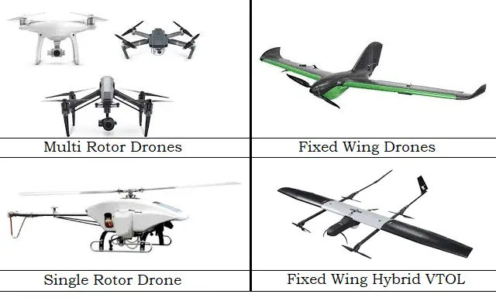Types of UAVs: UAVs can be categorized according to a wide range of factors (such as size, operational range, and degree of autonomy), but a typical broad classification is as follows: fixed-wing, fixed-wing hybrid, single rotor, and multirotor[1].
      1. **Figure1:Types of UAVs**
2. Real-time data processing:
   1. Real-time data processing is a method of data analysis that involves processing data almost instantaneously upon input. It is a continuous operation that requires a constant flow of incoming data to generate a steady output.
   2. Backhaul traffic and data processing time can be reduced by offloading some heavy loaded tasks of MDs to MEC servers, thereby enabling real-time data processing[16].
3. Autonomous operations:
   1. Autonomous operations refer to tasks or activities that are performed by systems, machines, or devices without direct human intervention. These autonomous capabilities continue to evolve with advancements in AI and sensor technologies, revolutionizing their use in fields like agriculture, surveillance, and disaster response.
   2. Using UAVs, SAR activities may be carried out automatically, accurately, and without posing additional hazards. UAVs can help hasten rescue and recovery efforts while the public communications networks are down by sending out timely catastrophe alerts. Medical supplies can be delivered by UAVs to locations that are deemed inaccessible[2].
4. Edge AI:
   1. Companies like Intel, IBM, Google, and Microsoft have proposed pilot projects to show the benefits of edge computing in paving the final mile of AI, drawing attention from the industry to edge AI. Numerous AI applications, including real-time video analytics, smart homes, precision agriculture, and industrial IoT, have advanced thanks to such initiatives. Definitions of edge AI can be vast and diverse, despite both academic and commercial interest[1].
   2. Edge artificial intelligence (AI), or AI at the edge, is the implementation of artificial intelligence in an edge computing environment, which allows computations to be done close to where data is actually collected, rather than at a centralized cloud computing facility or an offsite datacentre. Due to the comparatively restricted computing and storage capabilities, edge AI models are far more constrained than cloud-based forecasts[13].

##### LITERATURE SURVEY

[1] McEnroe, P., Wang, S., & Liyanage, M. (2022). A survey on the convergence of edge computing and AI for UAVs: Opportunities and challenges. IEEE Internet of Things Journal, 9(17), 15435-15459.

This paper provides a comprehensive literature survey on the integration of edge computing and artificial intelligence (AI) for Unmanned Aerial Vehicles (UAVs). It analyzes the impact of edge AI on various UAV technical aspects, covering autonomous navigation, formation control, power management, security, privacy, computer vision, and communication. The document explores implementation challenges, lessons learned, and future research directions in UAV-based edge AI, emphasizing advantages like low latency, reduced energy consumption, improved reliability, and cost reduction for UAV-based Internet of Things (IoT) services. It discusses the use of federated learning in edge AI for UAVs, highlighting privacy benefits and reduced latency. The paper also explores the potential of edge AI in enhancing the reliability and safety of drone light shows compared to cloud-based AI. Although lacking a dedicated literature review section, it references related surveys, aligning its coverage with existing literature and contributing to a comprehensive understanding of the subject. In summary, the paper offers a concise survey and analysis of the convergence of edge computing and AI for UAVs, addressing technical aspects, applications, challenges, and future directions.

[2] Shakhatreh, H., Sawalmeh, A. H., Al-Fuqaha, A., Dou, Z., Almaita, E., Khalil, I., ... & Guizani, M. (2019). Unmanned aerial vehicles (UAVs): A survey on civil applications and key research challenges. *Ieee Access*, *7*, 48572-48634.

This paper conducts a comprehensive literature review on the civil applications of unmanned aerial vehicles (UAVs), shedding light on key research challenges. It explores various applications such as real-time monitoring, wireless coverage, remote sensing, search and rescue, delivery of goods, security and surveillance, precision agriculture, and civil infrastructure inspection. The authors delve into recent literature, identifying open research challenges in charging, collision avoidance, swarming, networking, and security within UAV applications. Providing insights on approaching these challenges, the paper suggests future directions for potential UAV uses. In the context of construction and infrastructure inspection, UAVs are employed for real-time monitoring of construction sites, inspecting power transmission lines, and monitoring gas, oil, and water pipelines. Precision agriculture applications include crop management, disease detection, and reducing herbicide use. Additionally, UAVs find use in surveillance, encompassing moving vehicle detection and tracking, traffic flow parameter estimation, and geographic surveillance data gathering. The paper emphasizes the importance of selecting appropriate UAV systems considering state and federal laws, individual budgets, and privacy and security requirements. While the cited sources don't explicitly label themselves as literature reviews, they provide a comprehensive overview of UAV applications and research challenges in the civil domain.

[3] Huh, J. H., & Seo, Y. S. (2019). Understanding edge computing: Engineering evolution with artificial intelligence. *IEEE Access*, *7*, 164229-164245.

This literature review explores the emerging field of edge computing, a novel paradigm that processes data at the periphery, offering advantages such as reduced response times, lower bandwidth costs, and enhanced data safety and privacy compared to traditional cloud computing. Edge computing involves the decentralization of intelligence to edge systems like mobile devices, smart speakers, sensors, and wearable devices, leveraging their robust hardware and increased processing capacity for faster data processing tasks like inference and pattern matching. Concepts like fog computing, denoting mist-distributed computing technology, and cloudlets, indicating specific platforms, are intricately related to edge computing. Particularly advantageous for real-time processing, edge computing allows immediate responses and analysis of video streams, proving cost-effective for applications such as video analysis by eliminating data transmission latency and privacy concerns associated with cloud computing. The convergence of edge computing with technologies like Multi-Access Edge Computing (MEC), Internet of Things (IoT), and AI-based autonomous vehicles introduces both challenges and opportunities for technological advancement. This review provides a comprehensive overview of the principles, applications, and challenges associated with edge computing while emphasizing its transformative potential in various technological domains.

[4] Kong, X., Wu, Y., Wang, H., & Xia, F. (2022). Edge Computing for Internet of Everything: A Survey. *IEEE Internet of Things Journal*, *9*(23), 23472-23485.

This literature review delves into the pivotal role of edge computing as a crucial enabling technology in the era of the Internet of Everything (IoE), addressing challenges arising from interconnected devices and large-scale data transmission. Identified deficiencies within edge computing in the context of IoE encompass service migration, security and privacy preservation, and deployment issues of edge nodes, for which conventional approaches prove insufficient. The integration of emerging technologies such as artificial intelligence (AI), blockchain, and microservices with edge computing has ushered in innovative and more effective solutions for these challenges. By exploring interdisciplinary intersections and practical implementations, edge computing can be seamlessly integrated with other technologies, including AI, blockchain, 6G, and digital twin, unlocking the potential for mutual benefit. In various application scenarios, such as remote working, new physical retail industries, and digital advertising, edge computing emerges as a transformative force, reshaping the dynamics of how we live, work, and study. This review underscores the evolving landscape of edge computing, its challenges, and the transformative potential unlocked through synergies with emerging technologies across diverse domains.

[5] Zhou, Z., Chen, X., Li, E., Zeng, L., Luo, K., & Zhang, J. (2019). Edge intelligence: Paving the last mile of artificial intelligence with edge computing. *Proceedings of the IEEE*, *107*(8), 1738-1762.

This literature review explores the emerging field of Edge Intelligence (EI), a paradigm that shifts computing tasks and services from the network core to the network edge, facilitating the utilization of edge big data. Acknowledging that research and practice on EI are in the early stages with a lack of dedicated venues for summarizing recent advances, this paper aims to bridge the gap by conducting a comprehensive survey of recent research efforts on EI. The review covers background information on AI, motivation, definition, and rating of EI, as well as computing architectures, enabling technologies for training and inference of EI models, and open research challenges and opportunities. The marriage of edge computing and AI gives rise to EI, leveraging the physical proximity between computing and information-generation sources for benefits like low latency, energy efficiency, privacy protection, reduced bandwidth consumption, on-premises processing, and context awareness. The paper further reviews enabling technologies for improving key performance indicators in the training and inference of EI models, including deep learning frameworks for edge video analytics, scheduling sensor inference algorithms across heterogeneous mobile processors, and efficient processing of deep neural networks. This comprehensive review provides insights into the current state and future directions of the evolving field of Edge Intelligence.

[6] Hua, H., Li, Y., Wang, T., Dong, N., Li, W., & Cao, J. (2023). Edge computing with artificial intelligence: A machine learning perspective. *ACM Computing Surveys*, *55*(9), 1-35.

This literature survey delves into the convergence of Edge Computing (EC) and Artificial Intelligence (AI), emphasizing the role of AI, particularly from a machine learning perspective, in addressing challenges posed by massive data generated by Internet of Things (IoT) devices. Traditional methods' limitations have spurred researchers to deploy AI algorithms on the edge, utilizing deep learning (DL) and reinforcement learning (RL) techniques to optimize EC performance. AI applications within the EC architecture span diverse fields, including intelligent multimedia, transportation, cities, and industries, showcasing the versatility of DL in tasks like food image recognition and product quality classification. The survey highlights the application of deep reinforcement learning (DRL) for resource allocation optimization in EC, addressing dynamic decision problems and changing environmental states. The development of lightweight AI models emerges as a crucial consideration for efficient algorithms in EC, given the constraints of computing and energy resources. In summary, this literature survey underscores the significance of combining AI and EC to enhance computing offloading, privacy, security, resource allocation performance, and enable broader applications of AI across various domains.

[7] Sodhro, A. H., Pirbhulal, S., & De Albuquerque, V. H. C. (2019). Artificial intelligence-driven mechanism for edge computing-based industrial applications. *IEEE Transactions on Industrial Informatics*, *15*(7), 4235-4243.

This research paper discusses the integration of artificial intelligence (AI) with edge computing for industrial applications in the context of the Internet of Things (IoT). It highlights the challenges of resource allocation, energy efficiency, and battery lifetime in IoT-based industrial devices. To address these issues, the paper proposes a Forward Central Dynamic and Available Approach (FCDAA) that optimizes the execution time of sensing and transmission tasks, a system-level battery model to evaluate energy consumption, and a data reliability model for IoT devices in industrial settings. The proposed FCDAA aims to enhance energy efficiency and battery life while maintaining acceptable reliability. The research contributes to the optimization of IoT devices in industrial applications, particularly in scenarios involving dynamic wireless channels and resource-constrained devices. This paper conducts a thorough literature review focusing on duty-cycle-based techniques, power-aware algorithms, architectures, and reliability models for AI-based industrial applications. The review underscores the challenges faced by heterogeneous networks in the industrial sector, particularly in terms of power consumption and limited battery lifetime. Energy harvesting is explored as a viable solution to enhance node lifetime and supplement batteries in IoT-based industrial platforms. The integration of hybrid transmission power control (TPC) and duty-cycle-based approaches is emphasized as a crucial factor in developing energy-aware industrial systems. Additionally, the paper highlights the use of AI-enabled frameworks for industrial applications, involving adaptive edge nodes, network nodes, application nodes, and service nodes. While the provided sources do not offer an extensive literature survey, the paper itself provides valuable insights into existing works and approaches in the realm of AI-driven industrial applications, with a specific focus on energy optimization, battery lifetime extension, and data reliability.

[8] Al-Doghman, F., Moustafa, N., Khalil, I., Tari, Z., & Zomaya, A. (2022). AI-enabled secure microservices in edge computing: Opportunities and challenges. IEEE Transactions on Services Computing.

This research paper discusses the integration of microservices and artificial intelligence (AI) within the context of edge computing for Internet of Things (IoT) networks. Edge computing extends cloud services to the network edge, creating distributed architectures for more efficient decision-making. The paper emphasizes the need for lightweight, interdependent modules in edge applications, aligning with microservices' objectives. However, deploying microservices at the IoT edge introduces security and privacy challenges. The paper explores AI, particularly machine learning, to address these challenges and enable secure decision-making at the edge. It presents a comprehensive survey of securing edge computing-based AI microservices, highlighting requirements and challenges. The proposed microservices-based edge computing framework aims to provide secure AI algorithms through containerization for applications at the network edge. The contributions of the paper include presenting the evolution of AI microservices, examining security and privacy challenges, proposing a framework for secure microservices, and outlining future research directions in this emerging field.

[9] Zhu, S., Ota, K., & Dong, M. (2022). Energy-efficient artificial intelligence of things with intelligent edge. IEEE Internet of Things Journal, 9(10), 7525-7532.

This research article delves into the emerging field of Artificial Intelligence of Things (AIoT), where artificial intelligence is integrated with the Internet of Things (IoT) to enable intelligent IoT applications. The central focus lies in enhancing the energy efficiency of AIoT systems by addressing the energy consumption of both edge devices and cloud services during AIoT task processing. To tackle this challenge, the article introduces a novel multilevel intelligent edge computing framework that coordinates various types of devices, from lightweight edge devices to high-performance ones, and formulates a resource scheduling problem. A key innovation is the proposal of a reinforcement learning-based online method for optimizing task scheduling, ensuring energy-efficient processing. Through extensive simulations and a practical testbed, the study demonstrates the superiority of the proposed approach in terms of lower energy consumption, highlighting its potential to significantly improve the energy efficiency of AIoT systems.

[10] Kouadio, L., El Jarroudi, M., Belabess, Z., Laasli, S. E., Roni, M. Z. K., Amine, I. D. I., ... & Lahlali, R. (2023). A Review on UAV-Based Applications for Plant Disease Detection and Monitoring. Remote Sensing, 15(17), 4273.

This literature survey on UAV-based applications for plant disease detection and monitoring reveals several key findings. Remote sensing technology, coupled with advancements in data processing, has positioned UAVs as valuable tools for acquiring detailed data on plant diseases, offering high spatial, temporal, and spectral resolution. Notably, Asian countries, particularly China, have emerged as the primary contributors to research in this field, while regions like Oceania and Africa are comparatively underrepresented. The survey highlights wheat, sugar beet, potato, maize, and grapevine as the crops receiving the most attention for disease detection using UAVs. Commonly utilized sensors include multispectral, reg-green-blue, and hyperspectral sensors, with a growing trend towards integrating multiple sensor types. Machine learning and deep learning techniques, such as support vector machines, random forests, and convolutional neural networks, are prevalent for disease detection and classification. The survey identifies future research priorities, emphasizing the need for developing cost-effective and user-friendly UAVs, integrating with emerging agricultural technologies, enhancing data acquisition and processing efficiency, and addressing ethical considerations through proper regulations. Overall, the findings underscore the significance of UAVs in advancing plant disease detection and monitoring, while also highlighting key areas for further exploration and improvement.

[11] Liang, H., Lee, S. C., Bae, W., Kim, J., & Seo, S. (2023). Towards UAVs in Construction: Advancements, Challenges, and Future Directions for Monitoring and Inspection. *Drones*, *7*(3), 202.

The utilization of UAVs for monitoring and inspecting construction sites has gained substantial attention in recent years, with the potential to significantly improve safety, efficiency, and accuracy in the construction industry. Although not explicitly labeled as a literature survey, the sources presented offer a comprehensive overview of the latest advancements and technologies in the application of UAVs for construction site monitoring and inspection. They emphasize the diverse use of drones and sensors for data collection and analysis in construction, recognizing the transformative impact of UAV-based inspection on safety and operational efficiency. The sources highlight challenges such as regulatory concerns, technical limitations, data processing complexities, training requirements, and safety considerations. Notable technological progress includes innovative sensor technologies, integration with other construction tools, and the incorporation of machine learning and AI for data analysis. Furthermore, the integration of photogrammetry with LiDAR data is noted for precise measurements in challenging environments, and the application of deep learning techniques for automated feature extraction and semantic segmentation tasks in 3D modeling using UAVs in construction. Though not explicitly termed a literature survey, these sources collectively contribute valuable insights into the current state and potential advancements in UAV applications for construction monitoring and inspection.

[12] Silva, L. A., Leithardt, V. R. Q., Batista, V. F. L., González, G. V., & Santana, J. F. D. P. (2023). Automated Road Damage Detection using UAV Images and Deep Learning Techniques. *IEEE Access*.

This paper conducts a literature survey on the utilization of Unmanned Aerial Vehicles (UAVs) and deep learning techniques for the automated detection of road damage. The authors assert that UAVs, particularly drones, present an efficient and cost-effective means of capturing high-quality images of road surfaces. They emphasize the efficacy of deep learning techniques, specifically Convolutional Neural Networks (CNNs), in various domains, including road damage detection. The paper introduces three algorithms—YOLOv4, YOLOv5, and YOLOv7—for object detection and localization in UAV images. The experimental results demonstrate the effectiveness and accuracy of this proposed approach, achieving mean average precision (mAP) values of 59.9%, 65.70%, and 73.20% for different versions of YOLO. The authors also discuss the dataset employed, comprising images from China and Spain, and detail augmentation techniques applied to enhance dataset size and diversity. A comparative analysis of the detection effectiveness for different damage categories is presented, addressing challenges in distinguishing between similar classes, such as potholes and alligator cracks. In summary, this literature survey underscores the potential of UAVs and deep learning techniques for automated road damage detection, emphasizing advancements in object detection algorithms like YOLO.

[13] Deng, S., Zhao, H., Fang, W., Yin, J., Dustdar, S., & Zomaya, A. Y. (2020). Edge intelligence: The confluence of edge computing and artificial intelligence. *IEEE Internet of Things Journal*, *7*(8), 7457-7469.

This paper employs a diverse set of AI technologies for addressing resource allocation challenges in edge computing. The discussion encompasses statistical learning methods, deep learning methods, and reinforcement learning, illustrating the versatility of AI in optimizing resource allocation. The application of over-the-air computation (Air Comp) and broadband analog aggregation (BAA) techniques is emphasized for functional computation and model updates within the context of Federated learning. Additionally, the paper explores various methods and technologies for model adaptation, including model compression techniques such as quantization, dimensionality reduction, pruning, and components sharing. The authors underscore the significance of learning-driven radio resource management, importance-aware resource allocation, and learning-driven signal encoding as essential components for achieving efficient communication in edge computing scenarios. Overall, the paper integrates a spectrum of AI methods and technologies to tackle resource allocation challenges and enhance the performance of edge computing systems.

[14] Wei, X., Cai, L., Wei, N., Zou, P., Zhang, J., & Subramaniam, S. (2023). Joint UAV Trajectory Planning, DAG Task Scheduling, and Service Function Deployment based on DRL in UAV-empowered Edge Computing. *IEEE Internet of Things Journal*.

This literature survey comprehensively reviews advancements in task scheduling and optimization within edge computing scenarios. The paper outlines the extensive efforts devoted to scheduling independent tasks, delving into the increasing exploration of Directed Acyclic Graph (DAG) tasks. Notably, algorithms addressing dependencies and priorities for executing tasks in vehicular edge computing are discussed. The survey encompasses a diverse array of machine learning-based approaches, including Markov decision process (MDP), temporal-difference (TD) learning, and deep reinforcement learning (DRL), showcasing their utility in deriving optimal task allocation mechanisms. Additionally, the paper details various optimization algorithms such as genetic algorithms, convex programming, mixed integer nonlinear programming (MINLP), and constrained decomposition-based multiobjective evolution algorithms, applied to service deployment, computation offloading, and resource allocation in edge computing systems. UAV-assisted edge computing frameworks and multi-UAV fog computing scenarios are explored, highlighting strategies for trajectory optimization, CPU frequency adjustment, and offloading scheduling to minimize energy consumption. The survey concludes with insights into distributed computation offloading algorithms, reinforcement learning-based strategies, and priority-based assignment and selection (PASS) algorithms in serverless edge computing, providing a comprehensive overview of the state of the art in edge computing optimization.

[15] Tang, J., Wu, G., Jalalzai, M. M., Wang, L., Zhang, B., & Zhou, Y. (2023). Energy-optimal DNN model placement in UAV-enabled edge computing networks. *Digital Communications and Networks*.

This paper focuses on the energy-optimal placement of Deep Neural Network (DNN) models within UAV-enabled edge computing networks, introducing an AOP algorithm and substantiating its efficacy through extensive numerical results. The authors emphasize the widespread benefits of deep learning (DL) methods across diverse domains like Smart City, Smart Grid, and Smart Agriculture, underlining the necessity for training AI models with substantial datasets. The paper acknowledges the reliance on cloud computing for DNN training and addresses the associated challenges, particularly the costliness of transmitting data to remote clouds. To mitigate this, the authors propose an edge intelligence (EI) architecture, leveraging edge computing for low-latency AI services. The paper defines the energy-efficient DNN placement problem, providing key notations within the system model. While the provided sources do not extend into an exhaustive literature survey, they furnish a focused exploration of the energy-efficient placement of DNN models in UAV-enabled edge computing networks and the consequential advancements in the realm of edge intelligence architecture.

[16] Lee, W., & Kim, T. (2023). Multi-Agent Reinforcement Learning in Controlling Offloading Ratio and Trajectory for Multi-UAV Mobile Edge Computing. *IEEE Internet of Things Journal*.

This paper conducts a literature survey within the domain of UAV-Mobile Edge Computing (MEC) networks, focusing on communication task-process environments. The existing research landscape is characterized by various approaches proposing distinctive objective functions, aiming to optimize trajectory control of UAV-MEC and/or task offloading ratios. Conventional optimization-based methods, such as centralized EFO (CEFO) and decentralized EFO (DEFO), have been introduced to minimize energy consumption and task processing time while maximizing the number of processed tasks. In response to the computational complexity of these conventional methods, deep reinforcement learning (DRL)-based alternatives have emerged, encompassing techniques like Q-learning, double DQN (DDQN), decentralized DQN, deep deterministic policy gradient (DDPG), multi-agent DDPG (MADDPG), and end-to-end DQN (E2DQN). The paper introduces an Independent Proximal Policy Optimization (IPPO)-based method as its contribution, leveraging the high maneuverability of UAV-MECs. This approach stands out for its advantageous computational complexity and achieves performance comparable to the convex optimization model (CM) while expediting action decision-making.

[17] Hoang, L. T., Nguyen, C. T., & Pham, A. T. (2023). Deep Reinforcement Learning-Based Online Resource Management for UAV-Assisted Edge Computing With Dual Connectivity. *IEEE/ACM Transactions on Networking*.

In this paper, a multi-user, multi-server Mobile Edge Computing (MEC) system is considered, with a cellular base station and a UAV providing MEC services. Users can offload tasks to both servers via dual connectivity (DC) for parallel computing. The goal is to minimize the system's average power consumption while ensuring queue stability and task execution delay. The complex problem is formulated as a multi-stage mixed-integer non-linear programming (MINLP) problem. To address this, Lyapunov optimization transforms it into manageable deterministic problems for each time slot. An integrated approach using Deep Reinforcement Learning (DRL) and model-based optimization is proposed to solve these problems efficiently. The framework combines data-driven DRL and Lyapunov optimization to achieve energy-efficient resource management, ensuring system stability and low power consumption in a dynamic multi-user MEC system. Extensive simulations validate the approach's effectiveness.

[18] Zhang, Q., Luo, Y., Jiang, H., & Zhang, K. (2023). Aerial Edge Computing: A Survey. *IEEE Internet of Things Journal*.

This paper serves as a comprehensive literature survey on aerial edge computing (AEC) technology, delving into its three-layer architecture, challenges, recent studies on performance metrics, advanced management technologies, applications, and open issues. It references additional studies that target specific challenges in AEC, such as workload balance, task scheduling, energy efficiency, and Quality of Service (QoS) optimization. Noteworthy techniques include deep reinforcement learning (DRL) and distributed optimization methods like the Alternating Direction Method of Multipliers (ADMM). The authors, affiliated with the Network and Communication Research Institute at Southwest University of Science and Technology and the School of Information and Communication Engineering at the University of Electronic Science and Technology of China, acknowledge support from the National Natural Science Foundation of China and the Sichuan Science and Technology Program. Published in the IEEE Internet of Things Journal, this paper provides a comprehensive overview of the current state, challenges, and advancements in AEC technology.

##### METHODOLOGIES

1. **SEARCH AND RESCUE (SAR):**

*HOW SAR OPERATIONS UTILIZE UAV:*

* Path planning process: Rescue team define the targeted search area at the GCS
* GCS computes the optimal trajectory of the SAR mission then each UAV will receive its path
* Searching process: UAVs follow their path and start scanning the targeted region
* Detection process detecting UAV hovers above the object
* Other UAVs act as relay nodes. Create a communication relaying network
* UAVs switch to propagating mode, Setup multi-hop communication link with the GCS
* GCS locates GPS coordinates for the targeted objects.

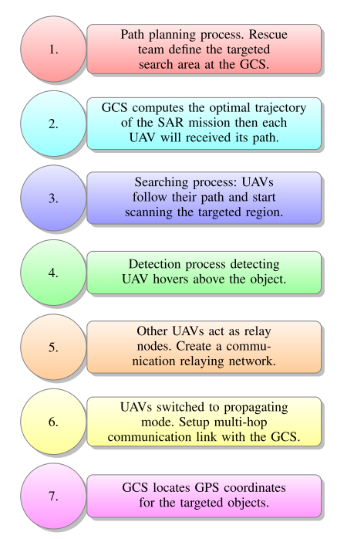

**Figure 2. Use of multi-UAV systems in SAR operations, locate GPS coordinates for the missing persons[2].**

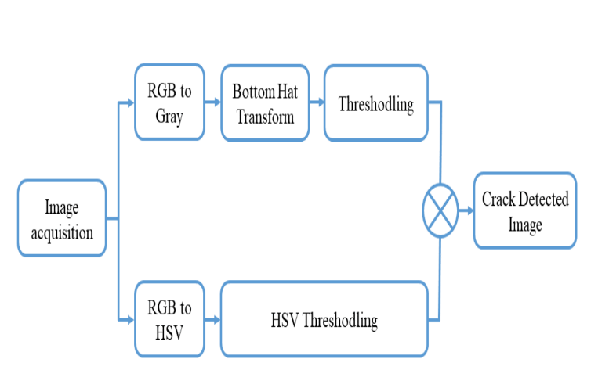

**Figure 3: Proposed approach for crack detection algorithm[2].**

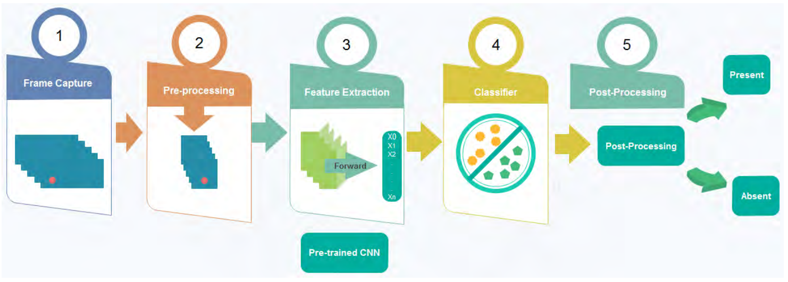

**Figure 4: Block diagram of SAR system using UAVs with machine learning technology[2].**

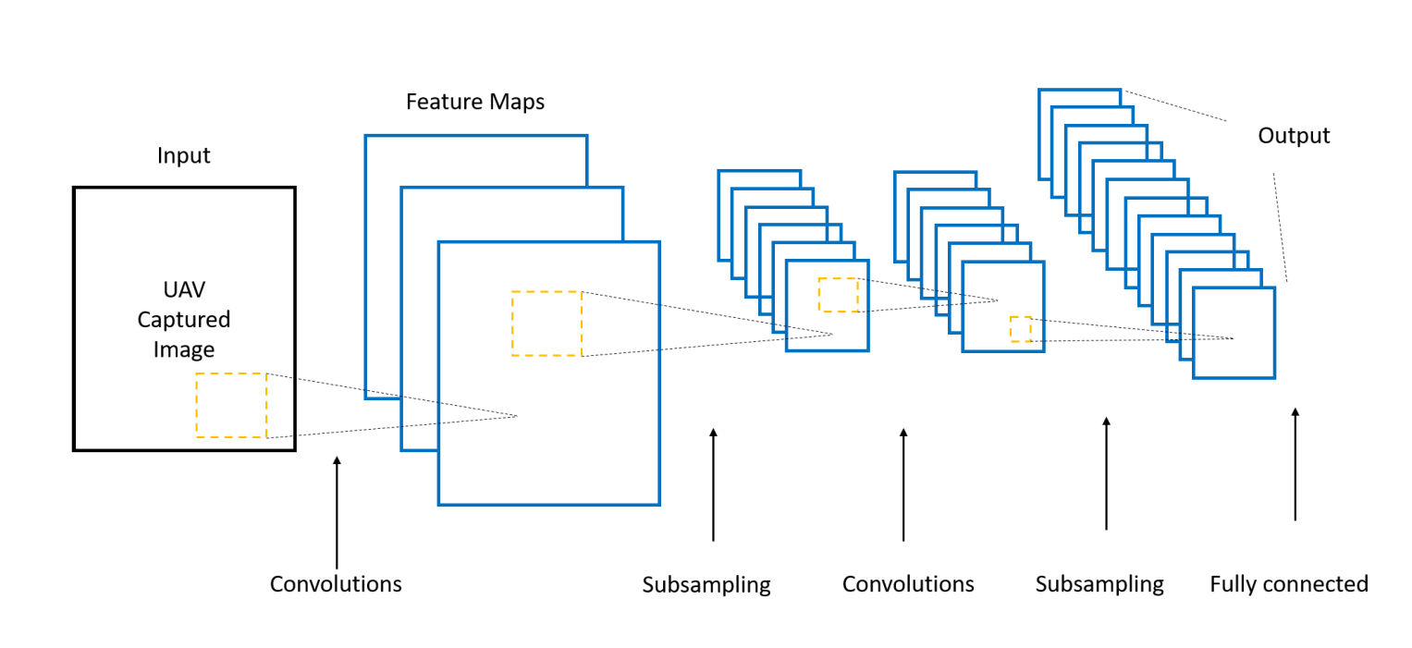

**Figure 5: Illustration of How CNNs work[2].**

***CHALLENGES:***

*WEATHER:*

Weather conditions pose a challenge for UAVs as they can cause deviations from their predetermined paths. During natural or man-made disasters such as tsunamis, hurricanes or terrorist attacks, weather becomes a difficult and crucial challenge. In such scenarios, UAVs may not be able to complete their missions due to unfavorable weather conditions

*ENERGY LIMITATIONS:*

Energy consumption is one of the biggest challenges for UAVs. Typically, UAVs are battery powered. UAV batteries are used for UAV hovering, wireless communications, data processing and image analysis. Some SAR missions require UAVs to operate over disaster-affected regions for extended periods of time. Due to the power limitations of UAVs, it is necessary to decide whether UAVs should perform onboard data and image analysis in real time or whether to store data for later analysis to reduce power consumption.

***RESEARCH TRENDS AND FUTURE INSIGHT:***

We think more research is necessary on the following topics based on the material we've read so far that focuses on SAR scenarios involving UAVs:

* Algorithms for decision and data fusion
* Creating and putting into practise distributed algorithms that save power so that real-time processing of photos, movies, and sensing data from UAV swarms can be done.
* Long-term UAV use may be facilitated by the development of lighter materials, more effective batteries, and energy-efficient systems.

1. **UAV-BASED GOODS DELIVERY SYSTEM:**

***Delivery of Goods :***

A UAV can go from a pick-up site to a delivery position in a UAV-based products delivery system. The GPS module and control processor are installed on the UAV. It obtains a transaction packet for the delivery operation, which includes the package docking device identifier and GPS coordinates linked to the order. When a UAV arrives at the delivery location, the control processor initiates the package transfer operation, verifies that the package docking device's identifier matches the device identifier in the transaction packet, and emails the order originator a confirmation that the operation was completed [2]. If a package docking device's identification at the delivery location differs from the device's identification in the transaction packet, the UAV communication components transmit a request over a short-range network such as bluetooth or WiFi.

**CHALLENGES:**

*THEFT:*

The main issues with using UAVs for data collection and wireless distribution are cyber liability and hacking. Malicious software may attack UAVs used to collect sensitive data in an attempt to steal data. A hacker may even take over the UAV itself in order to carry out unlawful activities like smuggling, privacy invasion, or theft of the drone's stored data or cargo. The kinds of liability insurance policies that the majority of people and businesses now own do not neatly cover responsibility for using a UAV [2].

*WEATHER:*

Like light aircraft, UAVs are not able to hover in every type of weather. The UAV's parameters dictate its ability to withstand various weather conditions [2]. It is obvious that preflight planning will be crucial in ensuring that UAVs can fly their weather-sensitive missions safely and effectively in order to deliver commercial goods. This includes improved meteorological data. Weather information has an impact on a number of in-flight factors, including flight direction, path elevation, and operation duration. Wind speeds in particular are an essential component for a smooth UAV-based operations and

**Figure 6: UAV delivery of goods system Flowchart [2]**

thus should be factored in the operation planning and deployment phases. In post-flight analysis, by analyzing data through advanced weather visualization dashboards, we can improve the UAV flight operations to ensure future mission success [1].

*AIR TRAFFIC CONTROL:*

* Large-scale UAV delivery missions require air traffic control as an essential requirement for coordinating large-sized UAS fleets, and regulations will prohibit such systems.
* This model will only permit the use of "low speed localized traffic" for:• Terminal non-transit tasks like surveying, videography, and inspection are conducted.
* 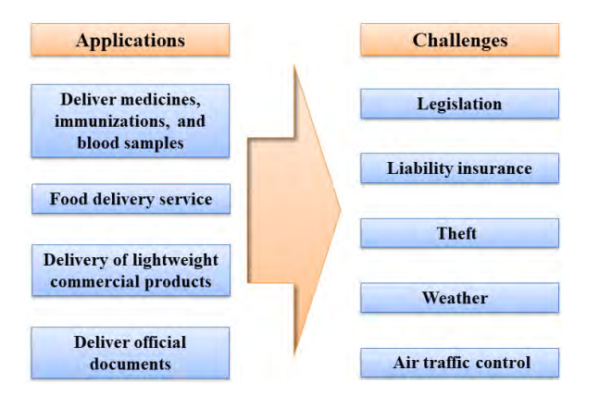UAVs that are not equipped with advanced sensors or technology cannot perform operations. • The performance standards and regulations will dictate the use of well-equipped UAVs for "high speed transit. " • Only in emergencies will UAV operators be permitted to fly within the "no fly zone. ". • Aviation authorities will set low risk locations in areas like the academy of model aeronautics airfields, and altitude and equipage restrictions are already in place.

**Figure 7: challenges for goods delivery using UAVs[2]**

**RESEARCH TRENDS AND FUTURE INSIGHTS:**

* Lithium-ion battery energy density is increasing by 5% to 8% annually, and by 2025, it is anticipated that battery lifetime will have doubled. Commercial UAVs will be able to deliver more items thanks to these advancements, as they will be able to hover for over an hour without needing to be recharged [2].
* Detect-and-avoid systems, which assist UAVs in avoiding obstacles and crashes, are now under development; robust solutions should be available by 2025[2].
* Currently, because of the possibility of collisions, UAVs fly below the height of commercial aircraft. It is anticipated that until 2027, techniques for tracking unmanned aerial vehicles and facilitating communication with standard aircraft air traffic control systems would not be accessible, rendering high-altitude missions unfeasible [2].

1. DISCUSSIONS

**Discussions :**

* Unmanned aerial vehicles (UAVs), have emerged as a versatile and transformative technology with a wide range of civil applications.
* UAVs offer several advantages over traditional methods, including their ability to access remote and hazardous locations, provide real-time data, and perform tasks with minimal human intervention.
* UAVs are increasingly being used for real-time monitoring of infrastructure, traffic, and environmental conditions.
* UAVs equipped with sensors can collect detailed data about the Earth's surface, including vegetation cover, land use, and water resources.
* UAVs play a critical role in search and rescue operations, particularly in areas that are difficult to access by land or air.
* UAVs are transforming the logistics industry by providing a fast, efficient, and cost-effective means of delivering goods to remote or congested areas.
* UAVs are widely used for security and surveillance purposes, providing aerial monitoring of public spaces, border areas, and sensitive infrastructure.
* UAVs are revolutionizing precision agriculture by enabling farmers to collect detailed data about their crops and soil conditions.
* UAVs are increasingly being employed for inspection of civil infrastructure, such as bridges, roads, and buildings.

**Future Scope:**

* Several research challenges remain to fully realize the potential of UAVs and address safety concerns.
* These challenges include charging challenges, collision avoidance and swarming challenges, and networking and security challenges.
* Ongoing research efforts are focused on developing more efficient charging mechanisms, enhancing collision avoidance and swarming capabilities, and improving networking and security protocols.
* As these challenges are addressed, UAVs are poised to play an increasingly transformative role in various aspects of our lives.

##### CONCLUSION

**The integration of AI and edge computing into UAV systems has significantly enhanced their capabilities for SAR operations. AI automates target detection and path planning, while edge computing enables real-time processing and decision-making. These technologies provide rescuers with valuable real-time information, leading to more efficient and effective search efforts, saving lives, and minimizing damage in disaster scenarios. As AI and edge computing technologies continue to advance, their role in SAR operations is expected to expand further, revolutionizing the way search and rescue efforts are conducted.**

##### REFERENCES

[1] McEnroe, P., Wang, S., & Liyanage, M. (2022). A survey on the convergence of edge computing and AI for UAVs: Opportunities and challenges. *IEEE Internet of Things Journal*, *9*(17), 15435-15459.

[2] Shakhatreh, H., Sawalmeh, A. H., Al-Fuqaha, A., Dou, Z., Almaita, E., Khalil, I., ... & Guizani, M. (2019). Unmanned aerial vehicles (UAVs): A survey on civil applications and key research challenges. *Ieee Access*, *7*, 48572-48634.

[3] Huh, J. H., & Seo, Y. S. (2019). Understanding edge computing: Engineering evolution with artificial intelligence. *IEEE Access*, *7*, 164229-164245.

[4] Kong, X., Wu, Y., Wang, H., & Xia, F. (2022). Edge Computing for Internet of Everything: A Survey. *IEEE Internet of Things Journal*, *9*(23), 23472-23485.

[5] Zhou, Z., Chen, X., Li, E., Zeng, L., Luo, K., & Zhang, J. (2019). Edge intelligence: Paving the last mile of artificial intelligence with edge computing. *Proceedings of the IEEE*, *107*(8), 1738-1762.

[6] Hua, H., Li, Y., Wang, T., Dong, N., Li, W., & Cao, J. (2023). Edge computing with artificial intelligence: A machine learning perspective. *ACM Computing Surveys*, *55*(9), 1-35.

[7] Sodhro, A. H., Pirbhulal, S., & De Albuquerque, V. H. C. (2019). Artificial intelligence-driven mechanism for edge computing-based industrial applications. *IEEE Transactions on Industrial Informatics*, *15*(7), 4235-4243.

[8] Al-Doghman, F., Moustafa, N., Khalil, I., Tari, Z., & Zomaya, A. (2022). AI-enabled secure microservices in edge computing: Opportunities and challenges. IEEE Transactions on Services Computing.

[9] Zhu, S., Ota, K., & Dong, M. (2022). Energy-efficient artificial intelligence of things with intelligent edge. IEEE Internet of Things Journal, 9(10), 7525-7532.

[10] Kouadio, L., El Jarroudi, M., Belabess, Z., Laasli, S. E., Roni, M. Z. K., Amine, I. D. I., ... & Lahlali, R. (2023). A Review on UAV-Based Applications for Plant Disease Detection and Monitoring. Remote Sensing, 15(17), 4273.

[11] Liang, H., Lee, S. C., Bae, W., Kim, J., & Seo, S. (2023). Towards UAVs in Construction: Advancements, Challenges, and Future Directions for Monitoring and Inspection. *Drones*, *7*(3), 202

[12] Silva, L. A., Leithardt, V. R. Q., Batista, V. F. L., González, G. V., & Santana, J. F. D. P. (2023). Automated Road Damage Detection using UAV Images and Deep Learning Techniques. *IEEE Access*.

[13] Deng, S., Zhao, H., Fang, W., Yin, J., Dustdar, S., & Zomaya, A. Y. (2020). Edge intelligence: The confluence of edge computing and artificial intelligence. *IEEE Internet of Things Journal*, *7*(8), 7457-7469.

[14] Wei, X., Cai, L., Wei, N., Zou, P., Zhang, J., & Subramaniam, S. (2023). Joint UAV Trajectory Planning, DAG Task Scheduling, and Service Function Deployment based on DRL in UAV-empowered Edge Computing. *IEEE Internet of Things Journal*.

[15] Tang, J., Wu, G., Jalalzai, M. M., Wang, L., Zhang, B., & Zhou, Y. (2023). Energy-optimal DNN model placement in UAV-enabled edge computing networks. *Digital Communications and Networks*.

[16] Lee, W., & Kim, T. (2023). Multi-Agent Reinforcement Learning in Controlling Offloading Ratio and Trajectory for Multi-UAV Mobile Edge Computing. *IEEE Internet of Things Journal*.

[17] Hoang, L. T., Nguyen, C. T., & Pham, A. T. (2023). Deep Reinforcement Learning-Based Online Resource Management for UAV-Assisted Edge Computing With Dual Connectivity. *IEEE/ACM Transactions on Networking*.

[18] Zhang, Q., Luo, Y., Jiang, H., & Zhang, K. (2023). Aerial Edge Computing: A Survey. *IEEE Internet of Things Journal*.

[19] [Commercial UAV Market Size, Share & Growth Report, 2030 (grandviewresearch.com)](https://www.grandviewresearch.com/industry-analysis/commercial-uav-market)

[20] [Edge AI Market Size, Share, Growth & Trends Report, 2030 (grandviewrese`arch.com)](https://www.grandviewresearch.com/industry-analysis/edge-ai-market-report)