**HEALTH INFRASTRUCTURE IN SMALL TOWN: A STUDY OF MANDI MUNICIPAL COUNCIL OF HIMACHAL PRADESH**

**AUTHOR Name-SHASHANK SHEKHAR**

**PIYUSH KUMAR**

# Abstract

Today the health infrastructure in India is really under lackadaisical conditions. It needs radical transmogrification to deal with the new emerging challenges. Also, the role of private players is continuously increasing, henceforth the health care facility getting costlier. Government hospitals are lacking resources and infrastructure. There is an inadequate number of beds, rooms, and medicines. In this paper, we are scoping, eyeing, and discussed the present scenario of healthcare facilities available in one of the small towns of hilly states of Himachal Pradesh “Mandi.” As our connotation is to assess the current conditions of Health care facilities available in Mandi Municipal council have a total population of 26422 people according to the census 2011. We have visited the hospitals that met different incumbent personnel also talked to the private stakeholders. In this regard, we also assessed the availability of the resources of health care in Mandi municipal council. Here we have qualitative as well as quantitative approach for improvement in our health care by focussing on workforce capacity and competency information and data system and organizational capacity ,we have also met local people, chemists and endeavored to find out the execution of the policy framed for the people on the ground level and also enquired about whether it comprises any loopholes or lacuna . Also, our approach was to find out the demands necessities of this town in terms of its infrastructure, types, and patterns of diseases also looked at the NRHM AYUSHMAN BHARAT, JAN AUSHADHI YOJNA of government how its working and what is its procedures? Is it helping on the ground or a mere formality?

# introduction

However, Indian cities have to be more competitive, livable, and bankable in the years to come to match the projected economic growth. Sadly, the quality of infrastructure in Indian cities is weak and requires careful attention. The double-digit growth level that the country envisages in the coming decade faces major infrastructural bottlenecks in cities. Major cities achieved an excessively large population size, which led to the digital deterioration of public services, followed by basic housing, slums, sanitation, infrastructure, quality of life, and other related issues. Water, sanitation, sewerage, public transport, urban energy distribution, transport hubs, storage and, logistics parks fall within the classification of urban infrastructure. Social infrastructure is ancillary to urban development.

Even after ten years, the story remains the same. This is due in large part to the lack of supply in the health sector. Urbanization has contributed to the migration of people from villages to towns. An increase in urban population has put a strain on the health sector. The lack of infrastructure investment in housing, waste management, slum recovery, and drinking water has had a substantial impact on the overall public health index. This strained existing resources underscored the inadequate healthcare infrastructure and polluted the global urban environment.

Across the country, the ratio of bed to a person is 1:422. The current record of government hospitals is worse; one bed per 2,239 people WHO suggests a minimum of 3 beds per 1,000 people. Thirty-five percent of patients in private hospitals are in lower-income groups (those earning less than Rs 10,000 per month. Eighty-five percent of these patients do not have insurance coverage, while 42% attend private facilities in surrounding rural areas. In the study conducted by FICCI, states that about 7-8% of households were forced to live below the poverty line due to health care costs. These facts point to significant weaknesses in infrastructure, in general, concerning telecommunications.

Planning Commission reports stated that India faces a shortage of some 600,000 doctors, 10,00,000 nurses, 200,000 dental surgeons, and a large number of paramedics. Private health care expenditure currently amounts to about 4.2 percent of GDP, making India one of the highest-ranking countries in terms of individual health expenditures. Particular attention should be paid to increasing the number of hospitals in developing cities. Also, there is a requirement of affordable medical equipment, essential drugs, and required tests and surgeries. It can only become a possibility with the help of all stakeholders, including government agencies, private initiatives, people in business, pharmaceutical companies, and insurance companies

Private health spending is currently around 4.2%. GDP, making India one of the countries with the highest individual health expenditure. Particular attention should be paid to increasing the number of hospitals in developing cities. There is also a need for affordable medical equipment, necessary medications, and mandatory testing and surgeries. This can only be possible with the help of everyone involved, including government agencies, private initiatives, entrepreneurs, pharmaceutical companies and insurance companies.

In India, most hospitals are located in major cities rather than rural areas or developing cities.The current capacity of hospital beds is around 7 lakh, with another 7 lakh expected to be added in the next decade. Due to the geographical extent of the country and the varying population density of the region, the ideal situation would be four beds per 1,000 inhabitants. According to a study by Technopark, for a paltry sum of Rs 40 lakhs invested directly in one bed, India will have to spend at least Rs 8,00,000 in the next 20 years to build two million new foundations (Rs

and up to Rs 20) .000,000 US dollars (more than 400 billion dollars) if we want to reach the standard of four beds per 1,000 inhabitants. The sector is expected to provide direct employment to more than 25 million people and indirect employment to 75 to 100 million people. Of these, 2.5 to 3 million will be exclusively trained doctors and 5 to 6 million will be nurses.By 2030, healthcare provider revenues alone would exceed $400 billion, operating approximately three million beds. The 20,000,000 additional beds will require nearly two billion square feet of additional built-up space, providing a huge boost to the construction industry, and business opportunities for medical equipment suppliers will exceed $100-125 billion. "The healthcare infrastructure in Indian states is expected to grow at an average annual rate of 5.8 percent from 2009 to 2013, bringing total expenditure to $14.2 billion in 2013," international consulting firm KPMG said in its Indian Healthcare Sector Report.KPMG says that of the 32 states analyzed, Uttar Pradesh, Maharashtra, Rajasthan, West Bengal, Andhra Pradesh and Tamil Nadu will account for about 50% of the spending. It is estimated that the value of India's healthcare sector will double by 2012 and more than quadruple by 2017. All these facts reveal hidden opportunities in the healthcare sector.

# objectives

This practicum aims towards the looking of health infrastructure in the Mandi Municipal Corporation, that what are the health facilities available in Mandi town, and how they are catering the health services. We are also looking at the different disease which is prevalent in Mandi town and even at some of the various conditions. As the topography of this particular place is very different from the other sites in the plains, so we intended to find out how health issues are tackled by the health infrastructure available here.

**3.1 Objective**

• To find out the health facilities available in Mandi town.

• To find out the type of prevalent disease in mandi municipal council.

• To understand the nexus between the different stakeholders.

• To find out the hiatus of the health services in Mandi town.

• To examine the health services in mandi municipal corporations in Himachal Pradesh through the spatial distribution of healthcare institutions and their human and physical resources available in mandi.

• To know about the different schemes of State regarding healthcare services.

# methodology

The methodology for this practicum includes the primary data collection and to study about the different schemes by the states for various healthcare services.

**4.1 Primary data collection** –

It consists of the survey of the zonal hospital in mandi and the interview with different doctors with specialization and also with various stakeholders like the drug providers companies and different healthcare service providers.

We have visited the Zonal Hospital, Mandi multiple times to know about the services they are providing, and what kind of patients are regularly coming or which disease is prevalent in the city. We have also visited the private hospitals like Mandav Hospital, KS Hospital, Neelkanth Hospital, Banga Hospital, and Aastha Hospital and Harihar Hospital.

The healthcare services we are looking at are –

• Infrastructure available

• Diagnosis Available

• No of beds available in the hospital

• Emergency Services

• Availability of Ambulance

• The blood bank and the availability of blood

**4.2 State policy**

We are also looking at the different schemes launched by the government for the benefit of the public like the National Health Policy, national health mission, and the Ayushman Bharat.

**4.2.1 National Health Mission**

The aim of the National Health Mission is the accomplishment of Universal Access to Equitable, Affordable and Quality medicinal services administrations, responsible and receptive to individuals' needs, with viable between concurrent sectoral activity to address the more extensive social determinants of wellbeing. The main components of this program include the strength of the health system, the Reproductive-Maternal- Neonatal-Child and Adolescent Health, and communicable & non-communicable disease.

**Objective of NHM**

• Defend the soundness of the helpless and burdened, and move towards a privilege based way to deal with wellbeing through qualifications and administration ensures.

• Strengthen general wellbeing frameworks as a reason for complete access and social insurance against the increasing expenses of human services.

• Build a condition of trust among individuals and suppliers of wellbeing administrations.

• Empower people group to become dynamic members during the time spent accomplishment of most high potential degrees of wellbeing.

• Institutionalize straightforwardness and responsibility in all procedures and systems.

• Improve proficiency in upgrading the utilization of accessible assets.

**Goals**

• To reduce Infant Mortality Rate(IMR) to 25/1000 live birth.

• To reduce Maternal Mortality Rate(MMR) to 1/1000 live birth.

• Reduce Total Fertility Rate to 2.1.

• Prevent and reduce the mortality rate from communicable and non-communicable diseases.

• Reduce annual mortality from Tuberculosis by half.

• Prevention and reduction of anemia in women(15-49 years).

**Financing components of NHM**

• National Rural Health Mission -Reproductive Child Health(NRHM-RCH) Flexipool

• National Urban Health Mission Flexipool

• Flexible pool for Communicable disease

• Flexible pool for Non-communicable disease including Injury and Trauma

• Infrastructure Maintenance

• Family Welfare Central Sector component

[Source - https://nhm.gov.in/index4.php?lang=1&level=0&linkid=445&lid=38]

**4.2.2 National Health Policy**

National Health Scheme was formulated by the ministry of health and family welfare on 15th March 2017. The aim of the NHP 2017 was to prioritize the role of government in improving the health system. It was about to inform, clarify, and strengthen the role of government in shaping the health system in all dimensions and improve the health status through concrete policy action in all sectors. The goal is to expand the preventive, promotive, curative, and rehabilitative services provided through the public health sector.

**Principals**

• Professionalism, Integrity, and Ethics – the health policy commits itself to the highest professional, ethical, and integrity to be maintained in the entire system of healthcare delivery across the country supported by a credible and transparent regulatory environment.

1. Patient-Centered and Quality of care

• Gender-sensitive, effective, convenient, and safe healthcare services provided with dignity and confidentiality.

1. Accountability

• Financial and performance responsibility and transparency in decision making and the elimination of corruption in the healthcare system in public and private bodies.

1. Inclusive Partnership

• A multistakeholder approach with partnership and participation of all non-healthcare ministries and communities.

• It would include a collaboration with an academic institution, non-profit agencies, and healthcare industries.

**Objective**

• To improve health status through concerted policy action in all sectors and expand preventive, curative, promotive, rehabilitative, and palliative services provided by the public health sector with a focus on quality.

**Goals**

* To increase life expectancy from 67.5 to 70 by 2025.
* Reduction of Total Fertility Rate to 2.1 by 2025.
* To reduce IMR and MMR by 2020.
* Safe water and sanitation to all by 2020(under Swachh Bharat Abhiyan)
* Increase health Expenditure by Government from 1.15 percent of GDP to 2.5 percent of GDP by 2025.

[Source - https://mohfw.gov.in/sites/default/files/9147562941489753121.pdf]

**4..2.3 Ayushman Bharat**

Ayushman Bharat, a flagship plan of the Government of India, was propelled as prescribed by the National Health Policy 2017, to accomplish the vision of Universal Health Coverage (UHC). This activity had structured on the lines as to meet SDG and its underlining duty, which is "desert nobody."

Ayushman Bharat is an endeavor to move from sectoral and fragmented methodology of wellbeing administration conveyance to an exhaustive need-based social insurance administration. Ayushman Bharat means to embrace way breaking mediations to comprehensively address health (covering counteractive action, advancement, and mobile consideration), at essential, auxiliary, and tertiary level. Ayushman Bharat embraces a continuum of care approach, involving two between related segments, which are -

• Health and Wellness Centers (HWCs) –

In Feb 2018, the Government of India announced the creation of 1,50,000 Health and Wellness Centres (HWCs) by transforming existing Primary Health Centers and sub-centers. These centers deliver Comprehensive Primary Health Care (CPHC), bringing healthcare closer to the homes of people that cover both maternal and child health services and non-communicable diseases, including free services like essential drugs and diagnostics.

• Pradhan Mantri Jan Arogya Yojana (PM-JAY) –

The second component under Ayushman Bharat is PM-JAY, which aims at providing a health cover of 5 lakhs per family per annum for a different kind of hospitalization to over 10.74 crores low-income families (approximately 50 crore beneficiaries). There are no restrictions on the family size under this scheme. Previously this scheme was known as National Health Protection Scheme (NHPS) before it changed to PM-JAY. It was launched on September 23rd, 2018, by the current Prime Minister of India in Ranchi, Jharkhand.

Features of PM-JAY

• It is the world’s largest health insurance scheme fully financed by the government.

• There is no restrictions on the number of family members or gender.

• Public hospitals will reimburse for healthcare services at par with private hospitals.

• Benefits of the scheme can cover across the country, that the beneficiary can go to any public or private hospital for cashless treatment.

• It provides cashless access to most of the health care services in different hospitals.

[Source - https://pmjay.gov.in/about-pmjay]

# demography of mandi(municipal corporation)

Population – 26422

Male population – 13341

Female population – 13081

Female sex ratio – 981/1000 male

Literacy rate – 93.67%

Male literacy – 95.25%

Female literacy – 92.06%

Children Population(0-6yrs) – 2219

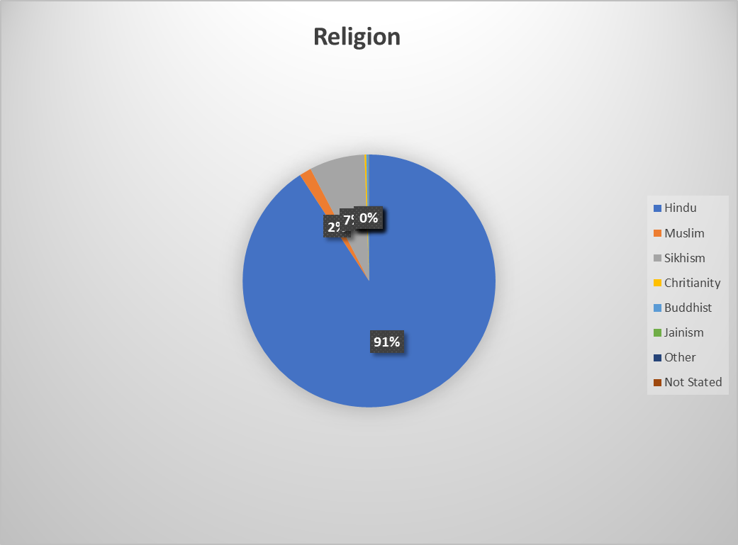

# RESULTS

According to the primary survey, Zonal Hospital Mandi is the mani public hospital, and there are few private hospitals with different specializations like in orthopedic, eye, heart, and general.

**5.1 Zonal Hospital**

**Total no of bed** – 273

According to the staff of the hospital, the number of beds doesn’t matter because they can accommodate as much as patients come to the hospitals.

**Out-Patient Department(OPD)** – OPD timing is from 9:00 AM to 4:00 PM.

**Blood bank** - it is also operational till 1500hrs except for an emergency.

**Blood test center** – It is there but only operational till 12:00 Hrs at noon and to avail facilities after 1200hrs thee is SRL Diagnostics which is 24hr operational under Public Private Partnership Model.

**Emergency Service** – Available 24hrs

**Ambulance** – 3 ambulances are available in the hospital.

**Jan-Ausadhi Kedra** – There is Jan-Ausadhi Kendra in the Hospital Premises but is only operational till 1400hrs.

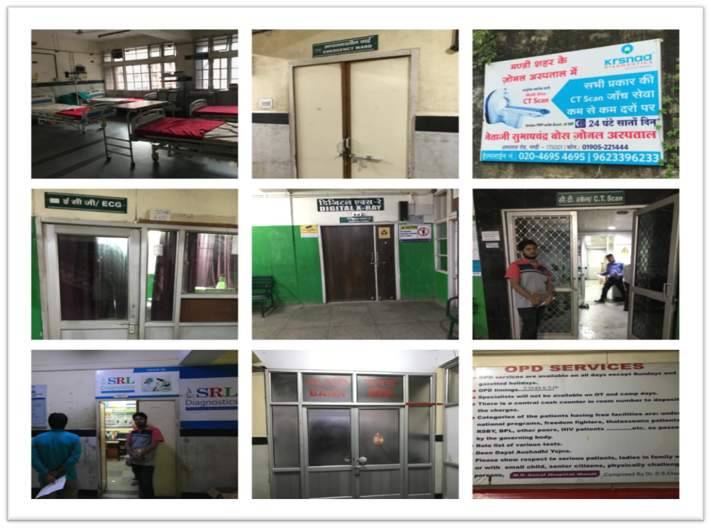

There is an AYUSHMAN center in the hospital where the patients who get benefits under Ayushman Bharat Yojna are enrolled to facilitate the healthcare facilities. There are volunteers from Ayushman Bharat who reimbursed their card so that they can avail cashless facilities at the hospital.

**5.1.1 Patient treated**

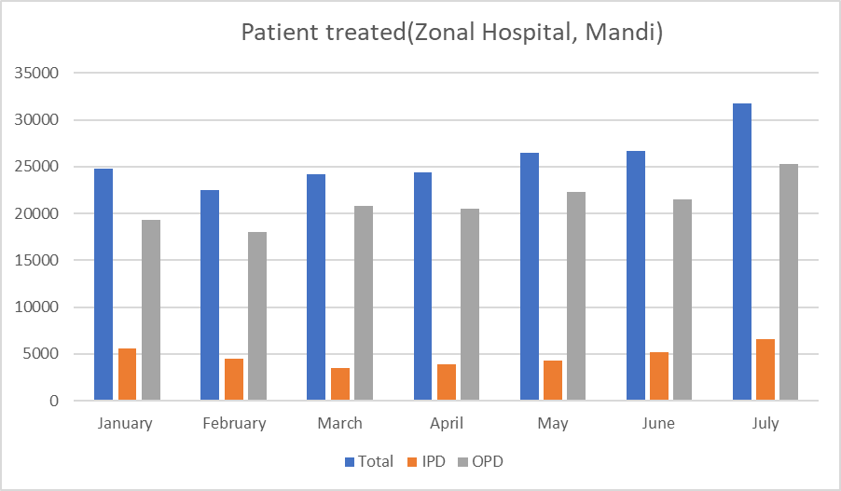

**5.2.2 Types of disease**

Communicable disease

* Acute Respiratory Disease

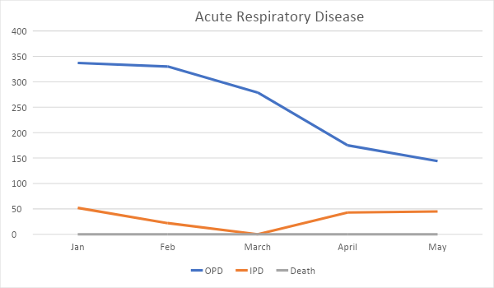

Non-communicable disease

* Asthma

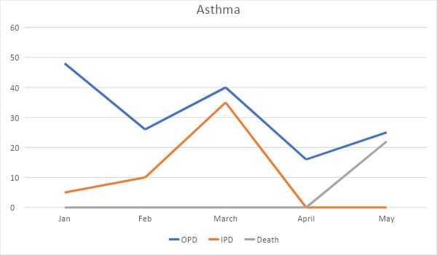

# DISCUSSION

In the current world, things are not as simple as we understand. We sit and think about why the policies are not working out as they implemented for a purpose but are unable to fulfill the mission. Many health programs are launched by the Central govt as well as state govt, whether it is AYUSHMAN Bharat or PMJAY. As our work is mostly based on the primary data collection and when we started talking to the people and the drug distributors, we came to know about the nexus between the doctors and the Pharmaceuticals companies. Here we start talking about the corruption(one vital component) or, more precisely, the cahoot between the medical practitioner in the entire country, especially in the 21st century it has been very grave. Now the maxi of that doctors are the god of the earth is somehow challenging itself by the situation of the stability in them. The gesture given to them by the big giants of pharmaceuticals companies has not limited to pen, pads, and free samples for the physician, but somehow, it has expanded to sponsoring a holiday trip, electronic gadgets, and different types of packages.

Since the Vedic times, there were health issues, various ailments, and diseases, there were ayurvedic remedies, but with time, it has been expanded to retail chemists.

In India, with the inception of the first company based in Calcutta, the Bengal chemical and pharmaceuticals in 1901. It has expanded to the company of 860 billion industry with more than 24000 pharma companies.

They have the burden to cater to so many patients and with the diminishing of the doctor. They are a very hectic schedule; Henceforth, these MR tries their level best to tell the doctor about the new invention of the pharmacies. By having such a massive number of ok pharma companies competition is very much in between them, which results in the form of funding of holiday trips providing freebies without charging anything in return these companies only demand is to medicine should be prescribed, But these freebies need money. Hence all these procedures make the fulcrum for big games happening, and those trends and the corrupt pharmaceutical also succumb to the pressure and tread into the wrong path. By talking to a couple of pharma retail shops. They said that it had become the business nowadays everything is fair in war and competition. Hence the real service of humanity motto has lost somewhere; for achieving the target, these companies from GM to bottom level try to provide the niche and innovation to the doctor. Hence in our finding, we also find the same trend has been following in Mandi town when we talked to 2-3 big retailers of the present in the hospital road. They also due to scarcity of doctors in public hospitals and lacking infrastructure and amenities a couple of private entities like *Mandav, Neel Kanth, KS* have opened. Mandi is very near to Baddi and Solan. Both of these are very famous for the pharmacy plants established here. So this has also an impact on supply and marketing to Mandi's business. The Crux of our finding, while talking with many people of these backgrounds, is that medical education is so expensive that those medical who completed their school start thinking of earning maximum. There has been a hiatus of government medical college, and the price of private medical college is skyrocketing. And these are also the very critical causes we do have regarding the building of Nexus. I don't say that everyone is so or professional like MR been inducted only for wrong reasons it was very fruitful as when doctors became very busy they are those people who explain to them the innovation happening in pharmacies. Like few rotten fish spoils the game. As in a small town in our country. Doctors are conceived and perceived as God, So they need to think above all and take care of the prestige of profession by abstaining the stability for earning maximum renunciation will enhance the image and height and add a feather to the wings in the working of the business.

# conclusion

Despite of the fact that the general accessibility of existing health administrations in Mandi is sufficient as contrasted and the standards of slope conditions of India, yet the appropriation of these healthcare administrations as far as clinics, network health focuses, health sub-focuses and physical and human healthcare assets as beds, specialists, attendants are not similarly diffused in various places of the town. The composite record has been utilised to show the degree of accessibility of dispersion of healthcare administrations as far as healthcare organisations (medical clinics, network health system focuses) and physical and human healthcare assets (beds, specialists, attendants and birthing specialists) in the town. Such an example of accessibility of healthcare administrations might be because of impossible to miss geological conditions, inconsistent appropriation of the populace, political issues, explicit arrangements and financial towns of the town. Along these lines, there is a critical requirement for arranged improvement of healthcare administrations in the investigation region. Keeping in see the current low degree of accessibility of healthcare administrations in numerous areas of the town, it appears to be essential to make reference to here that escalated endeavours have required towards making healthcare administrations open and accessible to the individuals of the country through the justification of healthcare administrations and limiting their bury and intra-local contrasts.

# references

• Ministry of Health & Family Welfare-Government of India. (2017, April 1). National Health Mission. Retrieved from https://nhm.gov.in/index4.php?lang=1&level=0&linkid=445&lid=38.

• About Pradhan Mantri Jan Arogya Yojana (PM-JAY). (2018, February). Retrieved from https://pmjay.gov.in/about-pmjay

• Mandi Population Census 2011 - 2019. (n.d.). Retrieved from https://www.census2011.co.in/data/town/800107-mandi-himachal-pradesh.html.

• Ministry of Health and Family welfare. (2017). National Health Policy 2017, Government of India.