**Predictions of Tesla Stock Price based on Machine Learning Model**

**1Kusuma Polanki**

Asst. Professor,

Dept. of CSE,

Chalapathi Institute of Technology,

Guntur, AP, India

kusuma.polanki@gmail.com

**2Dr NagaMalleswara Rao Purimetla**

**Asst.** Professor,

Dept. of CSE,

Chalapathi Institute of Technology,

Guntur, AP, India

[nmrao85@gmail.com](mailto:nmrao85@gmail.com)

**3Roja D**

Asst. Professor,

Dept. of CSE-Data Science,

Chalapathi Institute of Technology,

Guntur, AP, India.

rojad510@gmail.com

**4Khader Basha Sk**

Asst. Professor,

Dept. of CSE-DS,

Chalapathi Institute of Technology,

Guntur, AP, India

khaderbasha576@gmail.com

**5Raju Thommandru**

Asst. Professor,

Dept. of ECE,

Chalapathi Institute of Technology,

Guntur, AP, India raazu.thommandru@gmail.com

**6Sravanthi Javvadi**

Asst. Professor,

Dept. of CSE,

Chalapathi Institute of Technology,

Guntur, AP, India

sravanthi.javadi@gmail.com

**ABSTRACT**

A company's initial public offering (IPO), when it first sells shares on the market, is what initially determines stock prices. To calculate the appropriate price for the stock, investment firms consider a number of factors, including the total number of shares being offered. After that, the aforementioned factors will cause the share price to fluctuate, mostly based on the earnings that the company is anticipated to produce. Traders continuously assess a company's value using financial metrics, such as its profits history, market fluctuations, and the profit that may be reasonably anticipated. However, any attempt at prediction would be quite impossible due to the stock market's intricacy and turbulence. As a result, stock price forecasting has grown in significance as a field of study. The goal is to forecast machine learning-based stock price prediction methods. SMLT's supervised machine learning technique (SMLT) analyzes the dataset utilizing univariate, bivariate, and multivariate analysis. to suggest a machine learning-based technique for precisely forecasting stock price. The best accuracy with precision, recall, and F1 Score can be compared to the proposed machine learning algorithm technique.

Keywords: Regression Model, SMLT, IPO

**INTRODUCTION**

The inherent unpredictability makes it impossible to predict the stock index and stock price. Investors conduct two different types of analyses before making stock investments. The basic analysis comes first. When deciding whether to invest or not, investors take into account the share price, the state of the market and economy, the political climate, etc. In contrast, technical analysis analyzes stocks by interpreting market activity indicators like prior prices and volumes. Performance analysts use stock charts to spot patterns and trends that could affect how the stock will behave in the future rather than attempting to gauge internal security worth. This makes sense because stock prices will start to reflect how the public perceives the company under various uncertain circumstances, such as the nation's political climate. Therefore, the trend of a stock or stock price index can be forecasted provided the information gleaned from stock prices is pre-processed well and proper algorithms are used.

**PROBLEM STATEMENT**

Every day, the stock market is covered in the news. Every time it achieves a new high or low, you hear about it. If a reliable algorithm could be developed to forecast the short-term price of a specific stock, the rate of investment and business opportunities on the stock market may rise.

The PCC (Pearson Correlation Coefficient) and BLS (Board Learning System) have been used in the past to predict stock prices. The goal of this research is to determine whether it is possible to develop a model that will accurately and efficiently predict stock price by providing future predictions based on data analysis using regression models.

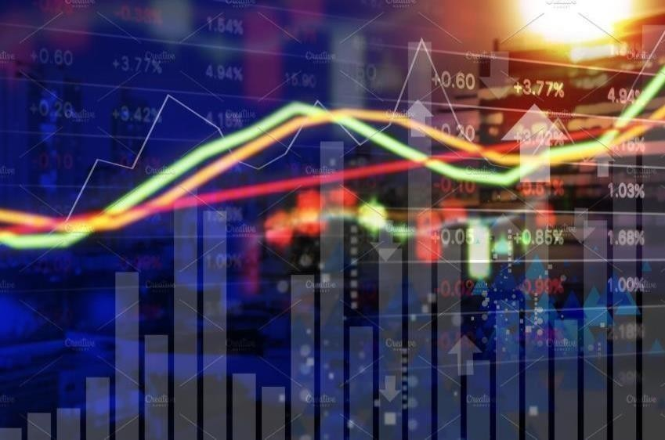

Figure 1. Stock Market Background

***SCOPE***

Stock price forecasting determines the market's future reach. Building a system that will function with the maximum level of accuracy and that considers all significant factors that might have an impact on the result is essential. There have been many research done in the past to predict stock market prices.

Open: The initial price at which a stock trades throughout the day.

A stock's closing price on a trading day.

High: The impartialities symbol's daily highest price.

Lowest share price for the day.

**1.3 OBJECTIVE**

The process of predicting prospective shifts in the value of a stock's position on a financial exchange is known as stock market forecasting. If fluctuations in the price of shares can be accurately forecast, then investors will have a greater opportunity to make a profit. Forecasting the movement of stock prices is done with the objective of realizing big financial gains. The primary goal of the approach that has been suggested is to determine which model is the most accurate in predicting stock market value.

***1.4. BASIC CONCEPTS***

**Machine learning:**

The field of research known as machine learning (ML) focuses on the development of computer programs that can improve themselves over time. It is considered an element of artificial intelligence (AI). In the field of machine learning, algorithms develop a mathematical model using sample data, which is sometimes referred to as "training data," so that they may make predictions or judgments without being specifically instructed to do so. The process by which machine learning operates is fairly complicated and is highly variable, depending not only on the job at hand but also on the algorithm that is employed to complete the task. But at its heart, a machine learning model is nothing more than a computer program that sifts through data in search of patterns and then applies what it has learned to the problem at hand.

**Types of Machine Learning models:**

It is possible that different situations may demand more or less human interaction or reinforcement when it comes to machine learning algorithms. Supervised learning, unsupervised learning, semi-supervised learning, and reinforcement learning are the four basic models that are used in machine learning. A computer is provided with a labeled collection of data in the process of supervised learning. This allows the computer to learn how to do a human skill. This model is the most straightforward one since it is intended to represent human learning. During the process of unsupervised learning, the computer makes discoveries about patterns and insights that it was not previously aware of by making use of data that has not been labeled. This is accomplished through machine learning algorithms in a number of methods, including the following:

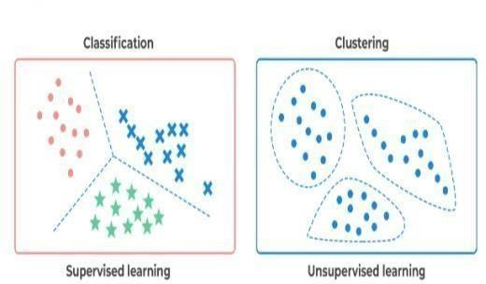

Figure 2.a) Supervised learningb) Unsupervised learning

Clustering is a method in which a computer finds data points within a collection that are similar to one another and then organizes the points into "clusters" as a consequence. Density estimation is a technique in which the computer draws conclusions about a data collection by examining the way in which the data are distributed. The method by which a computer is able to recognize data points that are notably distinct from the rest of the data in a data collection is referred to as anomaly detection. Principal component analysis (PCA) is a statistical technique that involves a data collection being analyzed and summarized by a computer in order to get accurate forecasts from the data.

During the semi-supervised learning process, the computer is provided with a collection of partially labeled data and is tasked with figuring out the parameters for understanding the unlabeled data by using the labeled data and observing its surroundings. Reinforcement learning is used by the computer to select the best course of action that will minimize risk and/or maximize reward. This strategy is iterative and requires some kind of reinforcement signal to assist the computer in selecting the most appropriate action to do.

**Regression Model:**

Regression analysis is a statistical approach that simulates the connection between one or more independent variables and one or more dependent variables using one or more dependent variables. Regression analysis is useful for gaining an understanding of how the value of a dependent variable shifts in response to changes in the value of an independent variable, particularly in situations in which other independent variables are maintained constant. It makes predictions based on actual, ongoing data such as temperature, age, pay, and cost, amongst others.

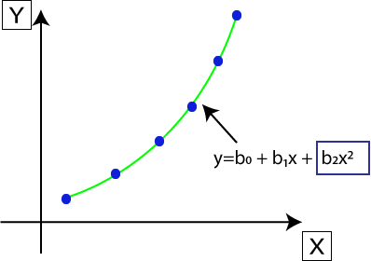

Figure 3. Regression Model

The method of regression, which is part of supervised learning, enables us to make predictions about the continuous output variable based on one or more predictor variables and provides assistance in determining the relationship between the variables. The majority of the time, it is used for making predictions, modeling time series, making forecasts, and figuring out the link between different variables. It is used to figure out patterns in the market. It is used to detect trends in the data. It is useful for forecasting real or continuous data. The method of regression, which is part of supervised learning, enables us to make predictions about the continuous output variable based on one or more predictor variables and provides assistance in determining the relationship between the variables. The majority of the time, it is used for making predictions, modeling time series, making forecasts, and figuring out the link between different variables, identifying trends and patterns in the industry.

**LITERATURE SURVEY**

In this article, we explore how a technology called machine learning is being utilized in order to construct a system that can estimate the price of a used Tesla car. In order to accomplish this objective, many various machine learning approaches, including decision trees, support vector machines (SVM), random forests, and deep learning, were studied, and in the end, boosted decision tree regression was chosen as the approach to use in practice. It is therefore highly crucial, but also very difficult, to make an accurate prediction of the price of a used Tesla car.

Two distinct phases made up the whole of the procedure for developing a system to forecast prices of used goods. A customer's present Tesla vehicle's future value is estimated in one of the sections of the report. It contributes to the process of recommending alternate driving practices that, taken together, would minimize the price decline of the car. Another part of the process consisted of determining how much a Tesla vehicle costs by tracking the pricing of used automobiles on various websites that offered sales of material for used Tesla vehicles and providing a comparison. The operation of this second segment will be the primary focus of our attention.

The most important component of the whole system is called become it. Websites such as truecar.com, autotrader.com, and cars.com are just few examples of those that provide this information. To obtain this information, we made use of a data scrapper, and then we fed it into our machine learning system in order to make a prediction about the price. The standard way of analysis is unable to tackle the problem of resolving the changes in stock price that are caused by the concealed vital information. This results in a significant reduction in the accuracy of the forecast. Within the scope of this investigation, we construct an improved version of a brand-new stock forecasting model. We use methods such as depth learning LASSO and PCA to conduct dimension reduction on the multiple influencing factors of the returned stock price, while also including a number of technical indicators such as investor sentiment indicators and financial data. This allows us to do dimension reduction in a manner that is more manageable.

In addition, a comparison of the capabilities of LSTM and GRU to forecast the stock market under a variety of different circumstances was carried out. Our study demonstrates that (1) neither LSTM nor GRU models are superior to the other in their capacity to accurately predict stock prices, and that (2) for the two different dimension reduction techniques, both of the neural models using LASSO reflect higher prediction ability than the models using PCA. In addition, our findings show that (2) for the two different dimension reduction techniques, both of the neural models using LASSO reflect higher prediction ability than the models using PCA. The traditional methods used to anticipate stock prices are mostly linear models. Some examples of these models include the auto-regressive integrated moving average (ARIMA) model [2, the multiple linear regression model, and the exponential smoothing model. This article presents a clustering approach for mining comparable stocks that combines morphological similarity distance (MSD) and k-means clustering. The goal of this method is to find groups of stocks that are very similar to one another. Hierarchical Temporal Memory (HTM), an online learning model, is then used to learn patterns from comparable stocks and generate predictions in the end.

This model is labeled as C-HTM. The studies on price prediction reveal that 1) C-HTM has greater prediction accuracy than HTM, which has not learnt similar stock pattern, and 2) in terms of short-term prediction, the performance of C-HTM is superior than all baseline models. Both of these findings may be attributed to the fact that C-HTM has learned similar stock patterns. Traditional statistical models have been proven to have less hopeful prospects than machine learning models, which have demonstrated more positive possibilities.

A model for predicting time series that makes use of differences is called autoregressive integrated moving average or ARIMA for short. Based on encoder-decoder architecture, this paper proposes a stock price trend prediction model (TPM) that can anticipate the movement of stock prices and the length of such movements in an adaptive manner. A dual feature extraction technique based on different time periods is offered as the initial step in the process of extracting more information from the data pertaining to the market. In contrast to typical approaches, which only extract features from information at particular exact time periods, the PLR approach and CNN are used by this proposed model in order to extract the long-term temporal characteristics and the short-term spatial features from market data. This is done in order to better predict market behavior.

The second stage of the suggested TPM makes use of an encoder-decoder architecture that is based on a dual attention mechanism in order to choose and combine relevant dual characteristics, as well as to anticipate the trend in stock price. In order to evaluate the efficacy of our proposed TPM, we first gathered high-frequency market data for the stock indexes CSI300, SSE 50, and CSI 500. Then, we put these three data sets through a series of tests. The results of the experiments show that the proposed TPM functions more effectively than the methods that are considered to be state-of-the-art at the moment, such as SVR, LSTM, and CNN. The ability to accurately forecast changes in stock prices is now one of the most pressing challenges facing the stock market. The data on stock prices is an example of a financial time series that is becoming more difficult to forecast due to the attributes it has and the dynamic nature it possesses.

In the practice of forecasting stock prices and the paths those values will take, artificial neural networks and support vector machines are employed extensively. Each algorithm has its own one-of-a-kind strategy when it comes to locating patterns and developing forecasts. Technical analysis is included into a widely used technology that is known as an artificial neural network (ANN). This technique is used for producing projections in the financial markets. In the process of predicting financial time series, the methods of Back Propagation Neural Networks (BPNN), Support Vector Machines (SVM), and Support Vector Regression (SVR) are used the majority of the time. In this article, we evaluate the efficacy of three distinct learning algorithms—Levenberg-Marquardt, Scaled Conjugate Gradient, and Bayesian Regularization—based neural networks for stock market prediction. The data used comes from an Indian firm and is broken down into 15-minute intervals as well as ticks.

In this investigation, we make use of multivariate time series analysis to discover and anticipate trends involving stock indices. Our drive comes from the notion that the pattern recognition and price prediction of stock indexes may be more realistic and helpful for financial planning than more traditional approaches such as the Autoregressive Integrated Moving Average (ARIMA) model. This is the reasoning behind why we decided to pursue this line of inquiry. Toeplitz Inverse Covariation-Based Clustering (TICC) is an example of architecture with three stages. Temporal Pattern Attention and Long-Short-Term Memory (TPA-LSTM) and Multivariate LSTM-FCNs (MLSTM-FCN and MALSTM-FCN) are used for the purposes of pattern identification and predicting stock indexes. Using TICC, our initial step is to search for consistent patterns in stock indexes. After that, in the second step, multivariate stock indices are forecasted by employing a technique called TPA-LSTM, which takes into consideration both weak periodic patterns and lengthy short-term information. During the third stage of the experiment, MALSTM-FCN is used to make predictions on the price trend of stock index indices.

**PROPOSED SYSTEM**

A generalized dataset would be formed by combining datasets coming from a variety of different sources. In this part of the report, the data will be loaded, the cleanliness of the dataset will be checked, and then the dataset will be trimmed and cleaned so that it may be analyzed.

The data set that was gathered for the purpose of making predictions based on supplied data was divided into two parts: the Training set and the Test set. In most situations, ratios of 7:3 are used for dividing the Training set and the Test set. The data model, which was created with the help of machine learning algorithms, is applied to the Training set, and then, based on the accuracy of the test results, a prediction is made about the Test set. The ML prediction model is successful in predicting the Tesla stock issue because it is good in preprocessing outliers and unimportant factors, and it also contains a combination of continuous, categorical, and discrete variables.

**METHODOLOGY:**

**Data:**

Algorithms for machine learning (ML) learn from data. You must be sure to give them the pertinent information for the issue you're trying to resolve. Even if you have decent data, you still need to make sure that it is scaled, formatted, and even contains relevant landscapes. There is data everywhere. Terabytes of new data being created every second. Useful data for machine learning can take many different forms. Effective model training can be achieved with structured data. Extracting samples

In this dataset we have total of 4263 rows of daily composed data of TESLA stock. Here we collected open price, closing price, high price of the day, volume and date.

Tasks

The main point of a task is to decide what to do with all the data we accrued. When different types of data are thrown at you, what do you do with them or how do you go about it? Some categories of tasks include classification and regression (under supervised learning) and clustering and generation (under unsupervised learning).

Models

Finding a mathematical relationship that links the input data to the outputs is what we now need to do. And this function should accomplish this correctly for all situations, not just those in which we already know the outcome. In other words, once you train the function and identify its precise restrictions, it should perform flawlessly even if it had never encountered test data during any of its training cases.

Regression Model:

Using the statistical method known as regression, an effort is made to control the form and strength of the relationship between one dependent variable (commonly denoted by Y) and a number of other factors (referred to collectively as independent variables). When it comes to valuing 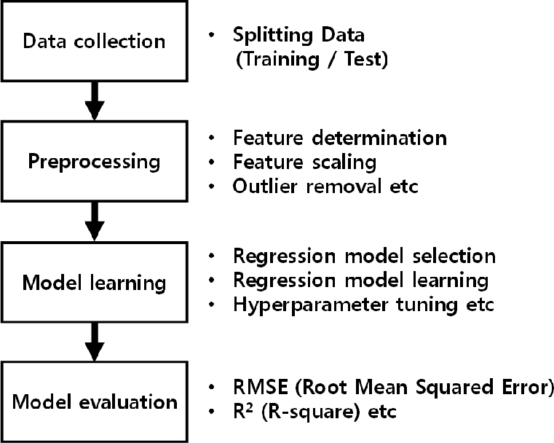assets and understanding the relationships between a variety of elements, such as the price of a commodity and the shares of a firm that deals in that commodity, regression is a useful tool for investment and financial managers. Regression helps these managers understand the connections between numerous aspects.

Simple linear regression: Y = a + bX + u

Multiple linear regression: Y = a + b1X1 + b2X2 + b3X3 + ... + btXt + u

**LEARNING ALGORITHM**

Assume we have some data, we have a exact task that we want to accomplish, we have a proposed model that will hopefully predict the values of the output for every input and undertake the model is given by the function If we have certain values for the parameters a,b and c, then we can also discover a loss function relating how off the forecast function is from the actual values. One way to do it is to assume 1. 2. # change y from {0,1} to {-1,1} y [where (y == 0)] = -1 22 a range for a, b and c, like -20 to +20 and plug in values for all the different groupings and find out by brute force, for which values of a, b and c is the value of the loss function reduced. And to do this resourcefully, we make use of a couple of algorithms.

**EVALUATION**

A model is simply evaluated by looking at the results to see if they match our expectations. It is quite similar to the way we create code: we check for problems, fix them, and then run the code again to make sure it still works.

To determine how well the model has performed in the instance of machine learning, we contrast the expected and received results. The output the labels produce in the various test cases determines whether they pass or fail. The "life-cycle" of deploying a machine learning model ends with evaluation, when we evaluate the results and determine whether they are what we wanted. Evaluation differs from loss function minimization in that it is always conducted on test data rather than training data.

**Methodology Summarization:**

Figure5.1: Flow chart

**RESULTS**

Based on the experimental outcomes presented, it can be concluded that the Ridge regressor exhibits the highest level of accuracy as a prediction model for Tesla stock prices. The Ridge regressor is a variant of linear regression that incorporates L2 regularisation in order to impose a penalty on coefficients with high magnitudes. This strategy aids in mitigating the issue of overfitting in the model's training data, hence enhancing its ability to generalise to unseen data.

The Ridge regressor shown superior performance compared to other prediction models, including Linear Regression, Lasso Regression, and Elastic Net Regression, across many regression model metrics such as Mean Squared Error (MSE), Root Mean Squared Error (RMSE), Mean Absolute Error (MAE), and Median Absolute Error (MedAE). This implies that the Ridge regressor has a higher level of accuracy in forecasting future stock prices for Tesla.

Below are more facts pertaining to the figure that you have presented:

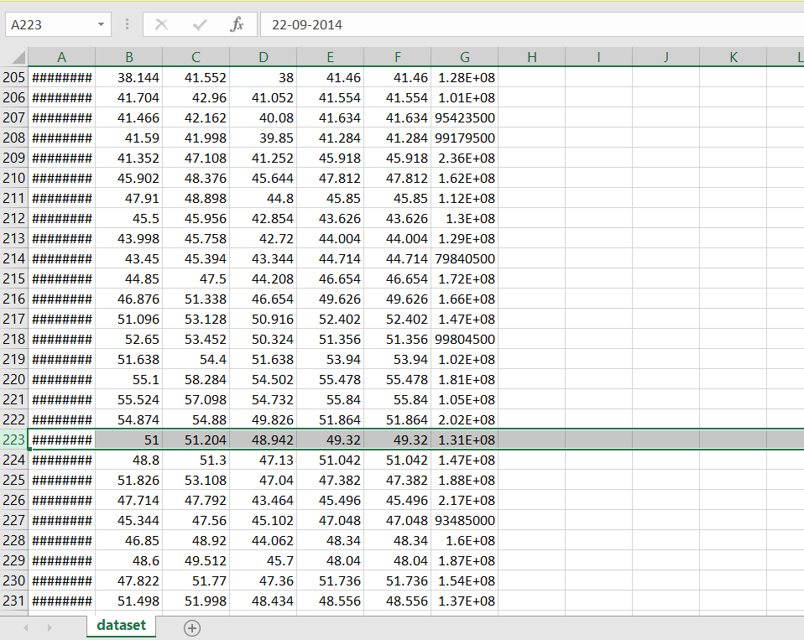

Figure 7.1: Sample input

The provided visual representation depicts a graph illustrating the historical prices of Tesla stocks. The sample inputs are derived from the plot in order to predict the precise model of the programme.

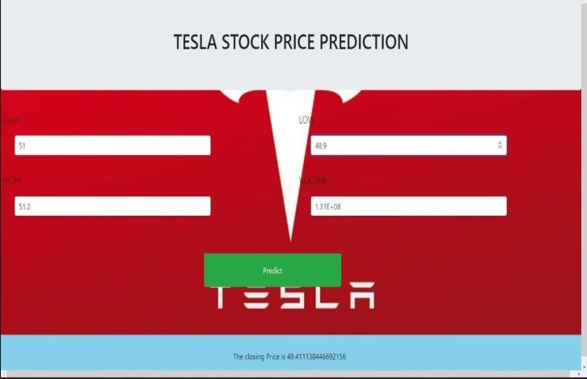

Figure 7.2: Sample Output

The provided graphic illustrates the example outcome obtained from the stock price prediction using the specified inputs. The stock is projected to conform to the exact model.

In general, the empirical results indicate that the Ridge regressor exhibits the highest level of accuracy as a predictive model for Tesla stock prices. The observed phenomenon can be attributed to the Ridge regressor's capacity to mitigate overfitting and enhance generalisation performance.

**CONCLUSION AND FUTURE WORKS**

In this project, by forecasting the stock price using machine learning technique, we are able to anticipate the stock price of any given firm. In the past, a lot of researchers have employed machine learning algorithms that have produced improved results and feature selections for forecasting the performance to evaluate the stock price for the future using previous and historic data. The stock market has previously benefited from the highest accuracy and efficiency thanks to the use of various machine learning algorithms. Now that it is possible to forecast stock prices using regression models and historical data, we are doing so. Regression models were offered as a machine learning technique for forecasting stock prices as they were recorded on the TESLA stock market. The experimental findings demonstrated that, in comparison to the other prediction models stated above, the Ridge regressor delivered more accurate future values.

**6. REFERENCES**

1. Vellela, S.S., Balamanigandan, R. Optimized clustering routing framework to maintain the optimal energy status in the wsn mobile cloud environment. Multimed Tools Appl (2023). [https://doi.org/10.1007/s11042- 023- 15926-5](https://doi.org/10.1007/s11042-%20023-%2015926-5)
2. Vellela, S. S., BashaSk, K., &Yakubreddy, K. (2023). Cloud-hosted concept-hierarchy flex-based infringement checking system. International Advanced Research Journal in Science, Engineering and Technology, 10(3).
3. Rao, D. M. V., Vellela, S. S., Sk, K. B., &Dalavai, L. (2023). Stematic Review on Software Application Under-distributed Denial of Service Attacks for Group Website. DogoRangsang Research Journal, UGC Care Group I Journal, 13.
4. K. N. Rao, B. R. Gandhi, M. V. Rao, S. Javvadi, S. S. Vellela and S. KhaderBasha, "Prediction and Classification of Alzheimer’s Disease using Machine Learning Techniques in 3D MR Images," 2023 International Conference on Sustainable Computing and Smart Systems (ICSCSS), Coimbatore, India, 2023, pp. 85-90, doi: 10.1109/ICSCSS57650.2023.10169550.
5. Venkateswara Reddy, B., Vellela, S. S., Sk, K. B., Roja, D., Yakubreddy, K., &Rao, M. V. Conceptual Hierarchies for Efficient Query Results Navigation. International Journal of All Research Education and Scientific Methods (IJARESM), ISSN, 2455-6211.
6. S Phani Praveen, RajeswariNakka, AnuradhaChokka, VenkataNagarajuThatha, SaiSrinivasVellela and UddagiriSirisha, “A Novel Classification Approach for Grape Leaf Disease Detection Based on Different Attention Deep Learning Techniques” International Journal of Advanced Computer Science and Applications(IJACSA), 14(6), 2023. http://dx.doi.org/10.14569/IJACSA.2023.01406128
7. Vellela, S. S., &Balamanigandan, R. (2022, December). Design of Hybrid Authentication Protocol for High Secure Applications in Cloud Environments. In 2022 International Conference on Automation, Computing and Renewable Systems (ICACRS) (pp. 408-414). IEEE.
8. Vellela, S. S., Balamanigandan, R., & Praveen, S. P. (2022). Strategic Survey on Security and Privacy Methods of Cloud Computing Environment. Journal of Next Generation Technology, 2(1).
9. Vellela, S. S., & Krishna, A. M. (2020). On Board Artificial Intelligence With Service Aggregation for Edge Computing in Industrial Applications. Journal of Critical Reviews, 7(07).
10. Sk, K. B., &Vellela, S. S. (2019). Diamond Search by Using Block Matching Algorithm. DIAMOND SEARCH BY USING BLOCK MATCHING ALGORITHM. International Journal of Emerging Technologies and Innovative Research (www. jetir. org), ISSN, 2349-5162.
11. VenkateswaraRao, M., Vellela, S., Reddy, V., Vullam, N., Sk, K. B., &Roja, D. (2023, March). Credit Investigation and Comprehensive Risk Management System based Big Data Analytics in Commercial Banking. In 2023 9th International Conference on Advanced Computing and Communication Systems (ICACCS) (Vol. 1, pp. 2387-2391). IEEE.
12. Vellela, S. S., Reddy, B. V., Chaitanya, K. K., &Rao, M. V. (2023, January). An Integrated Approach to Improve E-Healthcare System using Dynamic Cloud Computing Platform. In 2023 5th International Conference on Smart Systems and Inventive Technology (ICSSIT) (pp. 776-782). IEEE.
13. Vullam, N., Vellela, S. S., Reddy, V., Rao, M. V., SK, K. B., &Roja, D. (2023, May). Multi-Agent Personalized Recommendation System in E-Commerce based on User. In 2023 2nd International Conference on Applied Artificial Intelligence and Computing (ICAAIC) (pp. 1194-1199). IEEE.
14. Sk, K. B., Vellela, S. S., Yakubreddy, K., &Rao, M. V. (2023). Novel and Secure Protocol for Trusted Wireless Ad-hoc Network Creation. KhaderBashaSk, Venkateswara Reddy B, SaiSrinivasVellela, KancharakuntYakub Reddy, M VenkateswaraRao, Novel and Secure Protocol for Trusted Wireless Ad-hoc Network Creation, 10(3).
15. Reddy, N.V.R.S., Chitteti, C., Yesupadam, S., Desanamukula, V.S., Vellela, S.S., Bommagani, N.J. (2023). Enhanced speckle noise reduction in breast cancer ultrasound imagery using a hybrid deep learning model. Ingénierie des Systèmesd’Information, Vol. 28, No. 4, pp. 1063-1071. https://doi.org/10.18280/isi.280426
16. Vellela, S.S., Balamanigandan, R. An intelligent sleep-awake energy management system for wireless sensor network. Peer-to-Peer Netw. Appl. 16, 2714–2731 (2023). https://doi.org/10.1007/s12083-023-01558-x
17. Madhuri, A., Praveen, S. P., Kumar, D. L. S., Sindhura, S., &Vellela, S. S. (2021). Challenges and issues of data analytics in emerging scenarios for big data, cloud and image mining. Annals of the Romanian Society for Cell Biology, 412-423.
18. Madhuri, A., Jyothi, V. E., Praveen, S. P., Sindhura, S., Srinivas, V. S., & Kumar, D. L. S. (2022). A New Multi-Level Semi-Supervised Learning Approach for Network Intrusion Detection System Based on the ‘GOA’. Journal of Interconnection Networks, 2143047.
19. Praveen, S. P., Sarala, P., Kumar, T. K. M., Manuri, S. G., Srinivas, V. S., &Swapna, D. (2022, November). An Adaptive Load Balancing Technique for Multi SDN Controllers. In 2022 International Conference on Augmented Intelligence and Sustainable Systems (ICAISS) (pp. 1403-1409). IEEE.
20. Babu, G. B., Gopal, M. V., Srinivas, V. S., & Krishna, V. Efficient Key Generation for Multicast Groups Based on Secret Sharing.
21. Yakubreddy, K., Vellela, S. S., Sk, K. B., Reddy, V., & Roja, D. (2023). Grape CS-ML Database-Informed Methods for Contemporary Vineyard Management. International Research Journal of Modernization in Engineering Technology and Science, 5(03).
22. Sk, K. B., Roja, D., Priya, S. S., Dalavi, L., Vellela, S. S., & Reddy, V. (2023, March). Coronary Heart Disease Prediction and Classification using Hybrid Machine Learning Algorithms. In 2023 International Conference on Innovative Data Communication Technologies and Application (ICIDCA) (pp. 1-7). IEEE.
23. Kiran Kumar Kommineni, RatnaBabu Pilli, K. Tejaswi, P. VenkataSiva,Attention-based Bayesian inferential imagery captioning maker,Materials Today: Proceedings,2023,ISSN 2214-7853,https://doi.org/10.1016/j.matpr.2023.05.231.
24. Vellela, S. S., BashaSk, K., &Javvadi, S. (2023). MOBILE RFID APPLICATIONS IN LOCATION BASED SERVICES ZONE. MOBILE RFID APPLICATIONS IN LOCATION BASED SERVICES ZONE", International Journal of Emerging Technologies and Innovative Research (www. jetir. org| UGC and issn Approved), ISSN, 2349-5162.
25. Venkateswara Reddy, B., &KhaderBashaSk, R. D. Qos-Aware Video Streaming Based Admission Control And Scheduling For Video Transcoding In Cloud Computing. In International Conference on Automation, Computing and Renewable Systems (ICACRS 2022).
26. D, Roja and Dalavai, Lavanya and Javvadi, Sravanthi and Sk, KhaderBasha and Vellela, SaiSrinivas and B, Venkateswara Reddy and Vullam, Nagagopiraju, Computerised Image Processing and Pattern Recognition by Using Machine Algorithms (April 10, 2023). TIJER International Research Journal, Volume 10 Issue 4, April 2023, Available at SSRN: <https://ssrn.com/abstract=4428667>
27. S. S. Priya, S. SrinivasVellela, V. R. B, S. Javvadi, K. B. Sk and R. D, "Design And Implementation of An Integrated IOT Blockchain Framework for Drone Communication," 2023 3rd International Conference on Intelligent Technologies (CONIT), Hubli, India, 2023, pp. 1-5, doi: 10.1109/CONIT59222.2023.10205659.
28. N. Vullam, K. Yakubreddy, S. S. Vellela, K. BashaSk, V. R. B and S. SanthiPriya, "Prediction And Analysis Using A Hybrid Model For Stock Market," 2023 3rd International Conference on Intelligent Technologies (CONIT), Hubli, India, 2023, pp. 1-5, doi: 10.1109/CONIT59222.2023.10205638.
29. Kumar, K. K., Srikanth, V., Prasad, G. N. R., Hazela, B., &Tamrakar, A. K. (2023). Fault detection on the 3-D printed objective surface by using the SVM algorithm. Materials Today: Proceedings.
30. S. S. Vellela, V. L. Reddy, R. D, G. R. Rao, K. B. Sk and K. K. Kumar, "A Cloud-Based Smart IoT Platform for Personalized Healthcare Data Gathering and Monitoring System," 2023 3rd Asian Conference on Innovation in Technology (ASIANCON), Ravet IN, India, 2023, pp. 1-5, doi: 10.1109/ASIANCON58793.2023.10270407.
31. Vellela, S. S., Roja, D., Reddy, V., Sk, K. B., &Rao, M. V. (2023). A New Computer-Based Brain Fingerprinting Technology.
32. Vellela, S. S., Sk, K. B., Dalavai, L., Javvadi, S., &Rao, D. M. V. (2023). Introducing the Nano Cars Into the Robotics for the Realistic Movements. International Journal of Progressive Research in Engineering Management and Science (IJPREMS) Vol, 3, 235-240.
33. Kommineni, K. K., Madhu, G. C., Narayanamurthy, R., & Singh, G. (2022). IoT Crypto Security Communication System. In IoT Based Control Networks and Intelligent Systems: Proceedings of 3rd ICICNIS 2022 (pp. 27-39). Singapore: Springer Nature Singapore.