**Review Article**

**THE MEDICINAL BENEFITS OF PEPPERMINT (MENTHA PIPERITA L.)**

**Name:- Mr Yogeshwar Dhanraj Chavan**

**PRN No:- 2054733823033**

**Mentor Name:- Dr Shaikh Habiburrahman , Dr .Swapnil D Deo**

Abstract

The high demand for fragrances in the biotechnology, cosmetics, pharmaceutical and food industries increases their market value. Peppermint (Mentha Piperita L.) is an herb widely recognized by the pharmaceutical and food industries for its significant health benefits. The effectiveness of mint in preventing human diseases should be the focus of further research on this plant. There aren’t many clinical studies on peppermint tea and very few studies on peppermint leaves in humans. Although caution is recommended when using peppermint oil in patients with gastrointestinal disease, hiatal hernia or kidney stones, no side effects of peppermint tea have been observed. Menthone and menthyl esters, especially menthyl acetate, are also present in the oil. The essential oils in dried peppermint mainly contain menthol, menthone, menthyl acetate, menthofuran and 1,8-eucalyptol. Additionally, peppermint oil contains traces of many other chemicals, such as limonene, pulegone, caryophyllene, and pinene. According to the German Commission E monograph, peppermint oil and leaves taken internally can treat gastritis, respiratory catarrh, and oral mucosal inflammation, and act as an antispasmodic agent in the gastrointestinal tract and bile. Detailed up-to-date review of the anti-inflammatory, anti-inflammatory, anti-asthmatic, allopathic, antispasmodic, anticephalic, antibacterial and radioactive properties of peppermint. Therefore, more research on mint is urgently needed.

Keyword:- Peppermint, Peppermint Oil, Medicinal Herbs, Drying Of Mints.

Introduction

Members of the Labiatae (Lamiaceae circle of relatives) are known as mint leaves (Mentha spicata L.). it’s far a full-size family of annual or perennial herbs this is extensively cultivated throughout the world to advantage from its specific natural residences. They produce quadrangular inexperienced or purple stalks and are herbaceous rhizome vegetation. Due to the presence of agencies of secondary metabolites, which includes monoterpenoids determined in important oils and numerous structural forms of phenolic compounds, mint species are extensively utilized in each traditional and contemporary remedy. It’s far nicely identified that important oils have antibacterial, antispasmodic, carminative, and antiviral properties . Medicinal flowers are utilized by people everywhere in the global and have first rate potential benefits for human societies. Even though many of their fitness advantages have not yet been fully explored, their medicinal movements may be considered whilst treating current or potential ailments . Peppermint Leaves, leaf extracts, and water are all utilized in arrangements; but, the plant is grown mostly for its important oil, which is derived through distilling simply-floor leaves. In addition to menthol and menthone, PO also contains pulegone, menthofuran, and limonene. The chemical composition of PO can trade relying at the degree of plant improvement, the place, and the processing instances. The ratio of the diverse components became significantly impacted by the drying technique as nicely. After experimenting with drying mint commonplace (Mentha villosaHuds) at temperatures starting from 50 to 70°C, Radünz (2004) concluded that the air temperature of 50°C is suggested to gain the best vital oil content and higher awareness of the principal active ingredients . Mint (Mentha spicata), amaranth (Amaranthus gangeticus), curry leaves (Murraya koenigii), and gogu (Hibiscus Cannabinum) have been the green leafy greens used. After establishing the essential conditions for blanching, which include blanching time, temperature, and blanching remedy solution, all 4 inexperienced leafy vegetables have been blanched before drying.

BOTANICAL DESCRIPTION

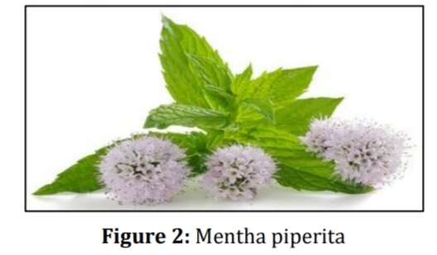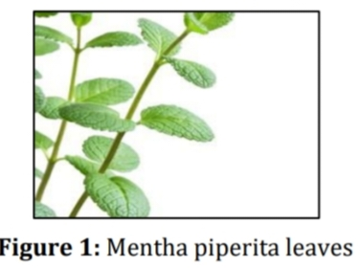

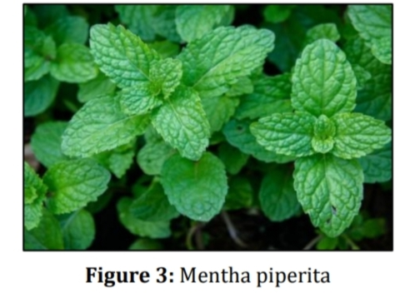

Botanical name: Mentha piperita L.

Family: Lamiaceae

Properties: aromatic, carminative, anti-emetic, stimulating nervine.

Parts used: aerial portion (mainly leaves, flowers).

Stem:Usually square erect or ascending, slightly branched, and upper portion always quadrangular (Figure 1).

Rhizomes:They are wide spreading and fresh with fibrous roots in the herb.

Flower:It is 6-8 mm long, purplish, occurs in thick, terminal, spicoid racemes of verticillasters. Each flower shows tubular calyx with 5 sharp, hairy teeth along with purplish, irregular, 4 cleft corolla, 4 short stamens, 4-celled ovary, and projecting style ending with bifid stigma in the herb (Figure 2).

Leaves:They are opposite, petiolate having 4-9 cm long and 1.5- 4 cm broad, pointed, and dark green on the upper surface of the herb (Figure 3).

Fruit:Fruit contains four ellipsoidal nutlets in the herb, which is pale purplish or pinkish in colour.

CHEMICAL CONSTITUENTS

The primary component in peppermint crucial oil, menthol, is frequently chargeable for the antispasmodic Homes of the drug. Limonene (1.0-5.0%), cineole (three.5-14.0%), menthone (14.0-32.0%), menthofuran (1.0-9.0%), isomenthone (1.5- 10.0%), menthyl acetate (2.8-10.0%), isopulegol (0.2%), menthol (55.0%), pulegone (4.0%), and carvone (maximum 1.0) are a number of the elements of peppermint oil. After chewing, peppermint leaves offer a clean flavor and a chronic, sweetish aroma. The peppermint is a strong and beneficial supply of a wide range of minerals, consisting of Na, Mg, ok, Ca, Cr, Fe, Co, Cu, Zn, and Se

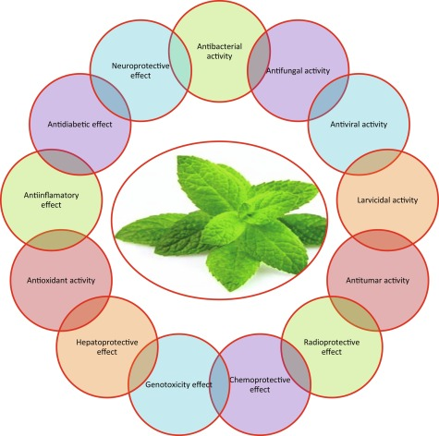PHARMACOLOGICAL ACTION

Anti-viral effects:In 96-properly plastic plates, hep-2 mobile cultures were created and cultured for 2 days at 37 °C with CO2 (5%) incubator. When the mobile culture reached confluence, the media become then taken out of the cells. In 96-properly plates of Hep-2 mobile monolayers, an epidemic suspension (0.1 mL) containing 50% tissue lifestyle-infective dose (TCID50) and upkeep media (0.1 mL) with the suitable awareness of the check pattern had been introduced. The highest attention used turned into the maximal non-cytotoxic awareness . In view that many viruses have remained proof against prevention or remedy longer than other microbes, infectious viral ailments remain a Enormous global hassle.

Anti-bacterial Properties: Because of the giant use of medicinal plant life in modern medication, plant secondary metabolites are becoming increasingly well known as antimicrobial marketers PO and extracts showed an excellent antimicrobial pastime towards: 1) Escherichia coli, 2) Salmonella pullorum, 3) Comamonas terrigena, 4) Streptococcus faecalis, 5) Acinatobacter sp, 6) Streptococcus thermophiles, 7) Lactobacillus bulgaricus, 8) Staphylococcus pyogenes, 9) Staphylococcus aureus, 10) Streptococcus pyogenes, 11) Serratia marcescens, 12) Mycobacterium avium, Salmonella typhi, 13) Salmonella paratyphi A/B, 14) Proteus vulgaris, 15) Enterobacter aerogenes, 16) Yersinia enterocolitica and 17) Shigella dysenteriae

Anti-fungal Activity: In line with in-vitro studies, PO and extracts are effective fungicides in opposition to dermatophytic fungus, Candida albicans, and Aspergillus albus. in accordance to analyze figures, peppermint successfully combats the fungi Candida albicans, Aspergillus albus, and dermatophytes

Allelopathic Effects: Allelopathic is one type of strain that has an impact on the amount, great, and increase of vegetation in agro- ecosystems . Allelopathy is a crucial component of the rural ecological system and influences every plant's maturity, really worth, and ability for development

Antispasmodic effects:- by way of reducing calcium influx in the large gut and jejunum , PO relaxes gastrointestinal easy muscle Atrial and papillary muscle groups from rats and guinea pigs showcase inhibition of calcium channel characteristic in reaction to PO and mentho

Anti-inflammatory properties: peppermint numerous horrible sicknesses, which includes tumours, septic surprise, atherosclerosis, diabetes, and belly weight problems (fatness), are concept to be brought on in big part by irritation ]. consistent with numerous investigations, peppermint chemicals play essential roles in lowering angiogenesis and irritation these plants' extracts have effects on rat and mouse cotton pellet granuloma exams and xylene-caused ear oedema

Allelopathic Effects: Breathing in the vapor of peppermint oil is used to deal with breathing congestion. Coughs, bronchitis, and throat and oral mucosal irritation are all treated with peppermint tea. using essential oilstuberculosis58In complicated individuals with infiltrative pulmonary oil vapour, peppermint is inhaled to relieve respiratory congestion. Coughs, bronchitis, and throat and oral mucosal infection are all handled with peppermint tea. complicated humans with infiltrative pulmonary tuberculosis can also benefit from the usage of vital oil.

Respiratory in the vapor of peppermint oil is applied to deal with breathing blockage. Hacks, bronchitis, and throat and oral mucosal infection are all dealt with with peppermint tea. Complex individuals with infiltrative aspiratory tuberculosis may additionally benefit from using fundamental oil. Breathing in the vapor of peppermint oil is applied to deal with respiratory congestion. Coughs, bronchitis, and throat and verbal mucosal aggravation are all treated with peppermint tea. Complicated human beings with infiltrative pneumonic tuberculosis can also gain from using fundamental oil. Breathing in the vapor of peppermint oil is applied to deal with breathing blockage. Hacks, bronchitis, and throat and oral mucosal aggravation are all treated with peppermint tea. Complex individuals with infiltrative aspiratory tuberculosis may additionally advantage from using essential oil. Allelopathy is one kind of push that has an have an effect on on the quantity, high-quality, and improvement of crops in agroecosystems. Agreeing to a file, tomato seedling development may be hindered through peppermint water extract (10% v/v concentration). The agrarian environmental gadget’s important component, allelopathy, impacts the development, esteem, and Hacks, bronchitis, and throat and verbal mucosal infection are all handled with peppermint tea. Complicated people with infiltrative pneumonic tuberculosis may additionally benefit from utilizing basic oil. Inhaling the vapor of peppermint oil is utilized to deal with respiratory blockage. Hacks, bronchitis, and throat and oral mucosal irritation are all treated with peppermint tea. Complicated individuals with infiltrative aspiratory tuberculosis can also advantage from making use of fundamental oil. Allelopathy is one type of push that has an have an effect on on the quantity, first-class, and improvement of crops in agroecosystems . Concurring to a file, tomato seedling development can be repressed by peppermint water extract (10% v/v concentration) . The agrarian organic device’s critical factor, allelopathy,influences the improvement, esteem, and formative ability of any plants.

Anti-carcinogenic:- results within the handled animal, Mentha Piperita leaf extract extensively inhibited G1 mobile cycle arrest, mitochondrial-mediated apoptosis, and perturbed the oxidative balance in a dose- and time-based manner.

Radio protective activity:-In mice bone marrow, the leaf extract of these flowers confirmed radioprotective traits against radiation induced chromosomal damage.

Anti-diabetic effects:-in keeping with studies, administering peppermint juice to animals has been proven to decrease their blood sugar, Cholesterol, low-density lipoprotein cholesterol (LDL-c), and triglyceride levels. Drying of peppermint and other medicinal leaves:- sparkling and dried peppermint leaves can be used in a ramification of methods. The dried leaves are widely used in each conventional treatments and other cuisines (Hedrick, 1972). Even as drying peppermint leaves prolongs shelf existence and avoids deterioration, it also has the ability to change their flavour and brilliant aroma.The components maximum vulnerable to drying are unstable fragrance molecules. Several variables, which includes drying situations (temperature, air velocity), moisture content, plant range and age, surroundings, soil, and harvesting method, have an effect on modifications in the concentrations of the volatile compounds of mint throughout drying . Evaluated six drying remedies (solar, shade, oven 50 °C, oven 70 °C, microwave, and freeze-drying) for vital oil yield, composition and coloration traits of Thymys daenensis subsp. Daenensis. Celak Leaves.

MEDICINAL BENEFITS

The whole plant is medicinal in and of itself. Tea crafted from dried peppermint leaves is useful for treating oral mucosal and throat irritation, in addition to cough and bronchitis. The herb has historically been used to deal with issues like indigestion, anorexia, flatulence, diarrhoea, nausea, vomiting, and morning illness. additionally, the drugs has spasmolytic homes, which lessens gas and cramping inside the abdomen. Menthol oil is used to make toothpaste, and it also allows girls who experience menstruation cramps. These days, problems like Crohn’s sickness, irritable bowel syndrome, gall bladder disorder, and biliary tract illnesses are handled with species like M. Piperita. Further to its use as a flavouring or fragrance additive in food, toothpaste, mouthwash, and different gadgets, peppermint may also be used medicinally. Because of its clean, nice flavour and aroma, peppermint is a extensively used flavour. Peppermint tea may additionally provide additional advantages for Struggling with terrible breath in addition to assisting to freshen one’s breath. Tea can also be made with dried or sparkling Peppermint (Mentha piperita) leaves. There are several cutting-edge goods that include peppermint, consisting of toothpaste, chocolates, and teas. Further to being popular because of its flavour, peppermint tea might also have an expansion of possible fitness benefits .

CONCLUSION

Because of its massive and varied pharmacological capacity, it may be stated that M. Piperita is a known as herb around the sector. This plant has remarkable capability for treating human illnesses and has a promising future in international exchange. Despite the fact that the peppermint plant performs a tremendous financial and advantageous characteristic in human society, research should bear in mind its mild toxicity and facet effects. The molecular mechanism of PO in human fitness will want to be determined with the aid of destiny in vivo human investigations. PO is currently the most broadly marketed important oil in the entire globe, and it’s miles regarded as a valuable target for both meals and medicinal research in many affluent and growing countries. Because of its medical houses, this herb is now quite popular in the Indian region as nicely. As a result, it has been grown for the exportation of unstable oil. Herbs have drawn the interest of scientists in the biotechnology, cosmetic, pharmaceutical, and meal sectors when you consider that antiquity. They’re now employed for a selection of commercial strategies, along with medicine, flavouring, beverage production, dyeing, and perfume manufacturing.

REFERENCE

[1]. Parv Nayak, Tankesh Kumar, AK Gupta and NU Joshi.

Doi:- <https://doi.org/10.22271/phyto.2020.v9.i3y.11525.>

[2] Aishwarya Balakrishnan, Saveetha Dental College,Chennai-77.

[3] Li Y, Langley N, Zhang J.Biosensors

Doi:- [10.3390/bios13040414.PMID: 37185489.](10.3390/bios13040414.PMID:%2037185489.)

[4] Kadam M, Dattatreya, Goyal RK, Singh KK, Gupta MK. Thin layer convective drying of mint leaves. J

Medi plants [. 2011; 5(2):164-170.](.%202011;%205(2):164-170.)

[5] Hawryl M, Niemiec M, Słomka K, WaksmundzkaHajnos M, Szymczak G. Micro-2d-tlc separation of

Phenolics in some species of mint and their fingerprints on diol bonded polar stationary phase.

Octa chromat [2016; 28:119-127.](2016;%2028:119-127.)

[6] Hocking GM, Edwards LD. Cultivation of peppermint in Florida. Economic Botany. [1955; 9:78-93.](1955;%209:78-93.)

[7] Keifer D, Ulbricht C, Abrams TR, Basch E, Giese N et al. Peppermint (menthax piperita) an

evidence-Based systematic review by the natural standard research collaboration. J Herb Med.

[2008; 7:91-143.](2008;%207:91-143.)

[8] Kripanand SM, Guruguntla S, Korra S. Effect of Various Drying Methods on Quality and Flavor

Characteristics of Mint Leaves (MenthaspicataL.) J Food Pharm. Sci. 2015 <3:38-45.>

[9] Park KJ, Vohnikova Z and Brod F.P.R. Evaluation of drying parameters and desorption isotherms of

Garden mint leaves (Mentha crips L.). J Food Eng. [2002; 51:193- 199.](2002;%2051:193-%20199.)

[10]. Mahboubi M, Kazempour N (2014) Chemical composition and antimicrobial activity of peppermint

(mentha piperita l) essential oil SJST [20: 36.](20:%2036.)

[11]. Almajano MP, Carbó R, Jiménez JAL, Gordon MH (2008) Antioxidant and antimicrobial activities of

Tea Infusions. Food Chem [108: 55-63.](108:%2055-63.)

[12] Shaikh S, Yaacob HB, RahimZHA (2014) Prospective role in treatment of major illnesses and

potential Benefits as a safe insecticide and natural food preservative of mint (mentha spp.): A

review. Asian J Biomed Pharm [4: 1.](4:%201.)

[13] Bohnert T, Patel A, Templeton I, Chen Y, Lu C (2016) Evaluation of a new molecular entity as a

victim of Metabolic drug-drug interactions-an industry perspective.<‎DrD115‎:690-696‎.>

[14]. Rodrigues F, Dupret JM (2002) 3d model of human arylamine n-acetyltransferase 2: Structural

basis of The slow acetylator phenotype of the r64q variant and analysis of the active-site loop.

Biochem. Biophys. Res. Commun [291: 116-123.](291:%20116-123.)

[15] Sun Z, Wang H, Wang J, Zhou L, Yang P (2014) Chemical composition and anti-inflammatory,

cytotoxic And antioxidant activities of essential oil from leaves of mentha piperita grown in china.

[PloS one 9: e114-767.](PloS%20one%209:%20%0d%0ae114-767.)