**AN ECONOMICAL VLC SYSTEM EMPLOYING WAVELENGTH AND CIRCULAR POLARIZATION DIVISION MULTIPLEXING**

**Kamalpreet Kaur1, Er. Sukhminder Kaushal2**

1Student, ECE, BGIET, Sangrur, Punjab, India

2Assistant Professor, ECE, BGIET, Sangrur, Punjab, India

**ABSTRACT**

Visible light communication (VLC) has the potential to revolutionize indoor communication by addressing the limitations of traditional radio frequency (RF) technologies. Its high bandwidth, immunity to interference, low latency, and other features make it well-suited for transmitting critical information in medical environments. In this research, a highly efficient VLC system supporting 6×10 Gbps, incorporating wavelength and circular polarization division multiplexing (CPDM) has been demonstrated. Non-return-to-zero (NRZ) pulse linecoding is a straightforward and effective encoding strategy that is used in the presented VLC system to save costs. Further, the combined effects of CPDM and red/green/blue lasers have been studied. A performance comparison of linear PDM (LPDM) and CPDM is performed in terms of BER and according to the results obtained, CPDM surpasses the LPDM. It is also observed that all channels are successfully transmitted over 235 cm VLC medium and 500 m over optical fiber using CPDM.

**Keywords:** CPDM, LPDM, VLC, NRZ, BER.

1. **INTRODUCTION**

The demand for higher data rates and increased user support in existing networks has indeed driven researchers to explore alternatives beyond traditional radio frequencies (RF). Optical Wireless Communication (OWC) systems have emerged as a promising solution to address the limitations of RF communication [1-4]. OWC systems utilize the infrared (IR) and ultraviolet (UV) regions of the electromagnetic spectrum, offering significantly higher bandwidth compared to RF. Given its adaptability and ease of use, VLC is a promising future option for terrestrial communication. It makes advantage of the widespread commercial uses of light emitting diodes, or LEDs [5]. VLC is a promising technology for many communication scenarios due to its energy economy, fast data speeds, lack of RF interference, and better security features. Researchers are exploring alternative LED structures, such as non-polar and semi-polar LEDs, which may exhibit reduced polarization effects and offer improved performance in terms of modulation bandwidth [6]. These alternative structures aim to address the limitations associated with common c-plane LEDs. The achievement of a 3 Gbps data rate with micro-LEDs represents progress in pushing the boundaries of VLC performance. This higher data rate opens up possibilities for applications with demanding bandwidth requirements [7-8]. Laser diodes are strong contenders for VLC systems that prioritize high-speed and long-reach communication. Their unique characteristics make them well-suited for applications where directional communication, high data rates, and extended coverage are essential [9]. The described VLC link in [10] with a 650-nm laser diode, a 300-meter range, and a 10 Mbps data rate represents a specific configuration suitable for certain applications. The construction of a WDM-VLC system using red and green lasers with a 10-meter range and a 500 Mbps data rate showcases advancements in VLC technology. This approach leverages the benefits of WDM to increase the capacity of the communication link, potentially offering enhanced performance for specific short-range applications [11]. The reported work in [12] using a 450-nm laser diode and QAM-OFDM-based VLC over a range of 5 meters for a data rate of 9 Gbps showcases the potential for VLC to provide ultra-fast and high-capacity wireless communication in specific short-range applications. The demonstration of an RGB laser diode-based VLC system over a bidirectional 1-meter link represents the versatility of VLC technology in supporting short-range, color-multiplexed, and bidirectional communication [13]. The demonstrated 1,250 Mbps VLC system using a yellow phosphorous LD over a range of 1 meter represents a significant achievement [14]. The efficiency of advanced modulation formats like orthogonal frequency division multiplexing (OFDM) in achieving high data rates needs to be weighed against the increased cost and complexity they bring. NRZ remains a viable choice when simplicity and cost effectiveness are paramount, and the application's data rate requirements can be met with this modulation scheme. The optimal solution depends on the specific needs and constraints of the VLC system and its intended use cases. The VLC link demonstration in 2016 highlights the application of OOK modulation in a short-range communication scenario over 2 meter at 266 Kbps [15]. The use of various multiplexing techniques, such as WDM, Multiple Input Multiple Output (MIMO), and PDM, is a common strategy employed by researchers to enhance data rates in communication systems, including VLC. The experimental demonstration of detecting a WDM-VLC signal via a single photodiode with the use of MIMO signal processing is a notable achievement. Additionally, the proposal to further enhance system performance through the implementation of RGB-LD-based WDM-VLC and the introduction of another multiplexing technique, PDM, indicates a comprehensive approach to improving capacity and efficiency [16]. The incorporation of an OFDM-PDM based VLC system with a data rate of 1.4 Gbps represents a prominent development in wireless indoor communication [17]. In 2020, the demonstration of transmitting high-speed data over short distances using dual-polarized green and blue LED-based light streams. Dual-polarization and multi-color LEDs offer advantages in terms of increasing data rates and system capacity at 1.2 Gbps [18]. A 200 cm VLC connection with an overall capacity of 60 Gbps was recently established with the use of WDM-PDM multiplexing and the OOK modulation standard. They produced a total of six WDM channels by using a directly modulated RGB source [19]. CPDM is a highly advanced method that dominates LPDM since it does not need polarization axis alignment and scattering light is distributed uniformly. Depending on how the electrical field vector rotates, CPDM exhibits optical rotations that are interpreted as either right- or left-handed circular polarizations. As a cutting-edge modulation, CPDM will be essential to integrate 5G and 6G communication systems [20].

In this work, a CPDM enabled right and left circular polarization states are modulated with NRZ modulated six channels using RGB LDs are transmitted over VLC channel. A detailed comparison of CPDM and LPDM is performed in terms of BER.

The presented research paper is organized as: Section 1 has the introduction about VLC, different modulation formats, PDM and literature survey. Section 2 represents the proposed system design and results of investigation are discussed in Section 3. Concluding remarks are discussed in Section 4.

1. **SYSTEM SETUP OF WDM-CPDM-VLC SYSTEM**

In this study, a hybrid WDM-CPDM and NRZ modulated VLC system is designed utilizing Optiwave's Optisystem software. The block diagram of the proposed system using externally modulated RGB LDs and operates at 60 Gbps, is shown in Figure 1. With an input power of 0 dB, the wavelengths of the red, green, and blue light detectors are 650 nm, 530 nm, and 450 nm, respectively. Due to their great efficiency, MZMs are used for this duty, and all LDs are externally modulated. Table 1 displays the VLC and suggested system parameters together with their taken into consideration values. Three RGB LDs are combined to provide a total of six channels by varying their right and left circular polarizations.

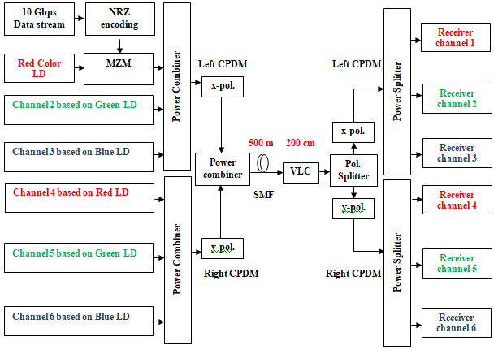

**Figure1:** A WDM-CPDM-VLC system incorporating RGB LDs

Left-polarization is applied to the first three RGB LDs, whereas right-polarization is applied to the last RGB LDs. The MZM and R/G/B LDs are used to externally modulate an NRZ-modulated 10 Gbps data stream at each channel. After being multiplexed, all six channels are transmitted over a VLC connection and a 500 m single-mode fiber. Each channel is connected to a polarization splitter that filters the x- and y-polarizations over a 200 cm VLC connection. Additionally, every polarization output is sent into a 1x3 power splitter, and an avalanche photo-detector (APD) receives the channel signals.

**Table 1.** System Specifications

|  |  |
| --- | --- |
| **Parameter** | **Values** |
| Serial bit stream generation rate | 10 Gbps/channel |
| Number of WDM channels | 6 |
| Product of channel and data rate (capacity) | 60 Gbps |
| LD colors | 650 nm, 530 nm, and450 nm |
| Launched power of LDs | 0 dBm |
| Laser linewidth | 10 MHz |
| PDM type | Circular |
| CPDM states | Left and right circular polarizations |
| Linecoding | NRZ |
| VLC model | Diffuse link |
| Transmitter, Irradiance and incidence half angles | 60 deg, 0 deg, and 0 deg |
| Detection surface area, optical and Index concentration factor | 1 cm2, 1 deg, and 1.5 |
| Simulation window | 1,024 |
| Samples per bit | 64 |
| No. of samples | 65,536 |

1. **RESULTS AND DISCUSSIONS**

The investigation of the proposed hybrid CPDM based WDM enabled externally modulated VLC system involves a detailed analysis and evaluation. The investigation is performed at different link lengths of the VLC channel in terms of the BER and Q factors. First and foremost, the optical carrier spectrums of RGB LDs for left pol. (x-pol.) and right (y-pol.) are illustrated in Figure 2 (a) and (b) respectively. Optical spectrums of RGB LD colors are of almost similar power levels in both left pol. (x-pol.) and right (y-pol.). For checking the availability of the LD light, optical spectrum analyzers are placed after regular intervals.

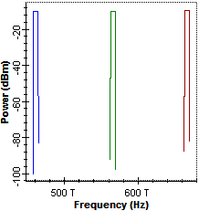\ 

(a) (b)

**Figure2:** Carrier spectrums of (a) left (x-pol.) and (b) right (y-pol.)

To assess the BER in each colour LD, a performance comparison of various LD colours utilising CPDM and LPDM is carried out. The performance comparison between channel 1 (red) and channel 4 (red) using LPDM and CPDM at different VLC durations is shown in Figure 3. Results showed that increasing the VLC connection length caused BER to deteriorate. The VLC link length was changed from 140 to 200 cm. The results show that BER is greater for LPDM than for CPDM because of the non-distributive properties and axis alignment constraints. Moreover, due to the cyclical fluctuation of left/right polarization, the optical carrier spectrum power in CPDM is larger than in LPDM and performs minimal signal blocking. But with LPDM, all other state of polarizations are blocked, allowing only one SOP 0 or 90 degrees to flow from the polarizer, which leads to greater losses. The lowest BER, or 10–13 utilising CPDM, was provided by Channel 1, which was followed by Channel 4 at 200 cm. However, for channels 1 and 4, the BER values for LPDM at 200 cm are 10-3 and 10-3.2, respectively.

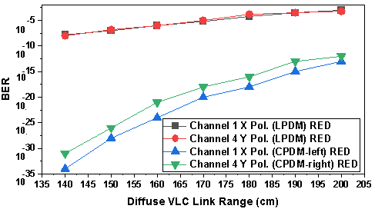

**Figure3:** Performance comparisons of LPDM and CPDM using RED LDs at channel 1 and channel 4 at varied distances

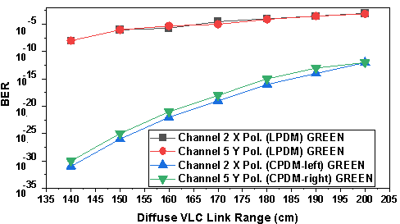

**Figure4:** Performance comparisons of LPDM and CPDM using GREEN LDs at channel 2 and channel 5 at varied distances

Comparing the performance of channels 2 and 5 (GREEN colour) with LPDM and CPDM for different VLC duration in terms of BER, Figure 4 is similar to Figure 3. Channel 2 had the lowest BER (10-12) while utilising CPDM, and channel 4 had the lowest BER (10-12) at 200 cm. On the other hand, channels 1 and 4's BER values for LPDM at 200 cm are 10-3 and 10-3.1, respectively.

Figure 5 illustrates how the blue colour LD performs in the CPDM and LPDM scenarios in terms of BER at various VLC connection lengths. It is observed that for LPDM, the BER is largest in channel 3, while for CPDM, it is lowest in channel 3. For channels 3 and 6, the BER values at 200 cm for CPDM are 10-11 and 10-11, respectively. BER values for channels 3 and 6 in the case of LPDM, however, are 10-3 and 10-3.05, respectively.

According to the analysis, each LD's maximum VLC ink length covered is 235 cm, which is below the permissible BER (without FEC) limit of 10-3. The last part of the optical communication system, the eye diagram, gives details regarding jitter, BER, eye-opening, Q factor, and eye closer. The eye diagrams of several coloured LDs using CPDM at a 235 cm VLC length are displayed at Figure 6. Figure 6(a) depicts the red LD's eye (channel 1), Figure 6(b) the green LD's eye (channel 2), and Figure 6(c) the blue LD's eye (channel 3). It has been noted that the BER values for x-pol at 235 cm are nearly identical, or 10-3. Additionally, the eye diagrams of CPDM enabling red (channel 4), green (channel 5), and blue colour LDs (channel 6) at 235 cm in the case of right pol. (y-pol.) are shown in Figures 7(a), (b), and (c). The right polarization (y-pol) performance is comparable to the right pol. (y-pol.), according to the results, and every colour falls within allowable BER limits (10-3).

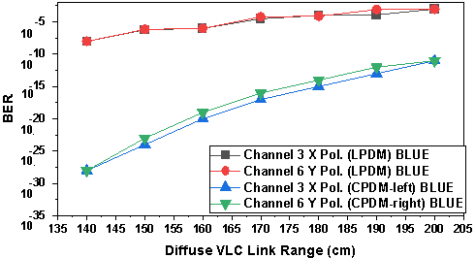

**Figure5:** Performance comparisons of LPDM and CPDM using BLUE LDs at channel 3 and channel 6 at varied distances

The proposed hybrid CPDM-based VLC system with external modulation is thoroughly compared, as Table 2 illustrates, with previously published LPDM-based work [19]. The values showed that, in order to allow for a fair comparison, data rate and capacity were maintained constant in both works. In the proposed study, however, external modulation takes the place of the direct modulation seen in [19]. Furthermore, CPDM is preferred over LPDM because of its superior power tolerance. The results of the comparison showed that using CPDM improves VLC distance by 17.5%. Additionally, at 200 cm VLC length, CPDM significantly outperforms LPDM in terms of BER.

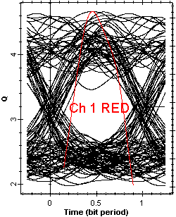 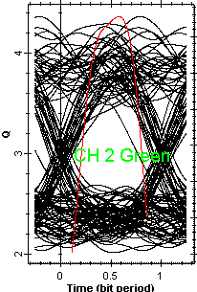 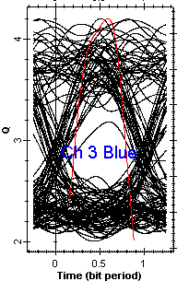

(a) (b) (c)

**Figure6:** Eye diagrams at 235 m for (a) Ch 1 Red LD (b) Ch 2 Green LD (c) Ch 3 Blue LD at 235 m

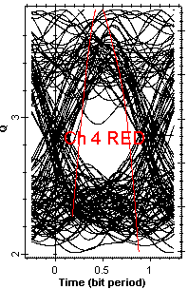 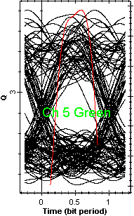 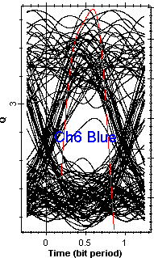

(a) (b) (c)

**Figure7:** Eye diagrams at 235 m for (a) Ch 4 Red LD (b) Ch 5 Green LD (c) Ch 6 Blue LD at 235 m

**Table 2.** Performance and parameter comparison of proposed and existing work

|  |  |  |
| --- | --- | --- |
| Parameter | Existing work [19] | Proposed work |
| Data rate×Channels | 10 Gbps×6 channels | 10 Gbps×6 channels |
| Type of polarization multiplexing | LPDM | CPDM |
| Intensity Modulation | Direct | External using MZM |
| Pulse encoder | NRZ | NRZ |
| BER at 200 cm | | |
| Channel 1 RED color at x-pol. | 10-3 | 10-13 |
| Channel 4 RED color at y-pol. | 10-3.2 | 10-12 |
| Channel 2 GREEN color at x-pol. | 10-3 | 10-12 |
| Channel 5 GREEN color at y-pol. | 10-3.1 | 10-12 |
| Channel 3 BLUE color at x-pol. | 10-3 | 10-11 |
| Channel 6 BLUE color at y-pol. | 10-3.05 | 10-11 |
| Maximum VLC range covered | 200 cm | 235 cm |

1. **CONCLUSION**

This study presents an externally modulated RGB LD based hybrid CPDM based WDM enabled VLC system operating at high speed. In terms of BER, a thorough comparison of CPDM and LPDM polarisation in the VLC system has been carried out. The suggested system operated for a maximum VLC reach of 235 cm and had a total capacity of 60 Gbps, according to the results. In terms of BER, red LED performs best, followed by green and blue LED. Additionally, the left circular pol (x-pol) performs better than the right pol (y-pol). Using CPDM and external modulation is resulted in a 17.5% increase in VLC distance as compared to LPDM. Additionally, at 200 cm VLC length, CPDM significantly outperforms LPDM in terms of BER.

1. **REFERENCES**
2. M. B. Rahaim and T. D. C. Little, "Toward practical integration of dual-use VLC within 5G networks," in IEEE Wireless Communications, vol. 22, no. 4, pp. 97-103, August 2015, doi: 10.1109/MWC.2015.7224733.
3. S. Kaur, M. Kumar, A. Verma, “An Integrated High-Speed Full Duplex Coherent OFDM-PON and Visible-Light Communication System. Journal of Optical Communications, vol. 43, no. 3, pp. 379-383, 2022.
4. S. Chaudhary, X. Tang, Z. Ghassemlooy, B. Lin, X. Wei and S. -K. Liaw, "A 3 × 25 Mbps WDM-Ro-VLC System for Amateur Radio Applications," 2019 2nd West Asian Colloquium on Optical Wireless Communications (WACOWC), Tehran, Iran, 2019, pp. 6-10, doi: 10.1109/WACOWC.2019.8770208.
5. S. Kaur, M. Kumar, A. Verma, "A Novel Hybrid Passive Optical Network, Free Space Optical and Visible Light Communication System", International Journal of Emerging Technologies and Innovative Research, vol.6, no. 4, pp.258-261, April-2019.
6. S. Kaur, G. KAur, G. Singh, A. Verma, N. Julka, “Polarization Crosstalk Suppression in Wavelength Division Multiplexed Free Space Optical System Incorporating Polarization Diversity” IJCRT, vol. , pp. 384-390, 2017.
7. B. Salah, L. Kassa-Baghdouche, A. Verma, “SAC-OCDMA System with EDW codes over FSO under different conditions of Weather”, IJRAR, vol. 6, pp. 749-755, 2019.
8. Y. Chi, D. Hsieh, C. Tsai, H. Chen, H. Kuo, and G. Lin, “450-nm GaN laser diode enables high-speed visible light communication with 9-Gbps QAM-OFDM”, Opt. Express, vol. 23, pp. 13051-13059, 2015.
9. L. Wei, C. Hsu, C. Chow, and C. Yeh, “20.231  Gbit/s tricolor red/green/blue laser diode based bidirectional signal remodulation visible-light communication system”, Photon. Res., vol. 6, pp. 422-426, 2018.
10. C. -H. Yeh, C. -W. Chow and L. -Y. Wei, "1250 Mbit/s OOK Wireless White-Light VLC Transmission Based on Phosphor Laser Diode," in IEEE Photonics Journal, vol. 11, no. 3, pp. 1-5, June 2019, Art no. 7903205, doi: 10.1109/JPHOT.2019.2911411.
11. H. Guo-yong, C. Chang-ying, C. Zhen-qiang, “Free-Space Optical communication using visible light”, Journal of Zhejiang University-SCIENCE A, vol. 8, pp. 186–191, 2007.
12. W. Lin, C. Chen, H. Lu, C. Chang, Y. Lin, H. Lin, and H. Wu, “10m/500Mbps WDM visible light communication systems”, Opt. Express, vol. 20, pp. 9919-9924, 2012.
13. Y. Chi, D. Hsieh, C. Tsai, H. Chen, H. Kuo, and G. Lin, “450-nm GaN laser diode enables high-speed visible light communication with 9-Gbps QAM-OFDM”, Opt. Express, vol. 23, pp. 13051-13059, 2015.
14. L. Wei, C. Hsu, C. Chow, and C. Yeh, “20.231  Gbit/s tricolor red/green/blue laser diode based bidirectional signal remodulation visible-light communication system”, Photon. Res., vol. 6, pp. 422-426, 2018.
15. C. -H. Yeh, C. -W. Chow and L. -Y. Wei, "1250 Mbit/s OOK Wireless White-Light VLC Transmission Based on Phosphor Laser Diode," in IEEE Photonics Journal, vol. 11, no. 3, pp. 1-5, June 2019, Art no. 7903205, doi: 10.1109/JPHOT.2019.2911411.
16. B. Hussain et al., "A fully integrated IEEE 802.15.7 visible light communication transmitter with on-chip 8-W 85% efficiency boost LED driver," 2015 Symposium on VLSI Circuits (VLSI Circuits), Kyoto, Japan, 2015, pp. C216-C217, doi: 10.1109/VLSIC.2015.7231264.
17. A. Messa, et al., “Detecting WDM visible light signals by a single multi-color photodiode with MIMO processing”, Opt. Lett., vol. 45, pp. 1160-1163, 2020.
18. D. Kwon, S. Kim, S. Yang, S. K. Han, “Optimized pre-equalization for gigabit polarization division multiplexed visible light communication”, Optical Engineering, vol. 54, no. 7, pp. 076101-076108, 2015.
19. Y. C. Yang, C. H. Yeh, , S. K. Liaw, C. W. Chow, W. H. Hsu, and B. Y. Wang, “Analysis and Investigation of Dual-Polarized Color LED Based Visible Light Communication System”, in Photonics, vol. 8, pp. 210-2022, 2021.
20. C. Xiang-peng, “A Cost-Efficient RGB Laser-Based Visible Light Communication System by Incorporating Hybrid Wavelength and Polarization Division Multiplexing Schemes”, Frontiers in Physics, vol. 9, no. 731405, pp. 1-6, 2021.
21. S. Ghatwal, H. Saini, “A high power 320 Gbps CPDM-256-QAM based Ro-FSO system enabling 80 GHz under rain and haze effects”, Optical and Quantum Electronics, vol. 55, pp. 80, 2023.