**FINDIND AND COMPARING SOLUTIONS FOR AN UNDETERMINED SYSTEM OF LINEAR EQUATIONS USING SCILAB:**

**MINIMUM-NORM SOLUTION AND CONSISTENCY ANALYSIS**

**M.Dhanalakshmi1 , K.Bhanu Priya2 , Jyothi.G3 Y.Anitha4, V.Divya Rajaratnam5,V.Teerthitejaswini6, S.Chandana7, Sk.Naziya8**

1,2,3(Lecturers, Department of Mathematics, Sri Durga Malleswara Siddhartha Mahila Kalasala, Vijayawada, A.P, India).

4,5,6,7,8(Students, Mathematics, Sri Durga Malleswara Siddhartha Mahila Kalasala, Vijayawada, A.P, India).

**ABSTRACT**

This study investigates an undetermined system of linear equations represented by the matrix equation $AX=b$, where the coefficient matrix A is given by $A=\left[\begin{matrix}1 & 2 & 3 \\ 4 & 5 & 6\end{matrix}\right]$ and the right-hand side vector is $b=\left[\begin{matrix}14 \\ 32\end{matrix}\right]$.The primary objectives include determining the minimum-norm solution through mathematical computations and obtaining a solution using the SCILAB command window. The minimum-norm solution is derived using the formula $X_{min}=A^{T} {[AA^{T}]}^{-1}b$. Additionally, the system is solved in SCILAB through the backslash operator. The study aims to compare the three solutions obtained, shedding light on their consistency and potential uniqueness. The results contribute to understanding the applicability of numerical methods in solving undetermined systems of linear equations and their implications for real-world problem-solving scenarios.

**Keywords:** Undetermined system of linear equations, Minimum-norm solution, SCILAB, Consistency analysis and Solution comparison.

1. **INTRODUCTION : The Undetermined Case(M<N): Minimum-Norm Solution:**

If the number(M) of equations is less than the number(N) of unknowns, the solution is not unique, but numerous. Suppose the M rows of the coefficient matrix A are independent. Then, any N-dimensional vector can be decomposed into two components $X=X^{+}+X^{-}$…………(i)

where the one is in the row space $R(A)$ of A that can be expressed as a linear combination of the M row vectors $X^{+}=A^{T}α$……………(ii)

and the other is in the null space $Ν\left(A\right)$ orthogonal(perpendicular) to the row space so that

$AX^{-}=0$……….(iii)

Substituting the arbitrary N-dimensional vector representation (i) into Equation $AX=b$ yields

$A\left(X^{+}+X^{-}\right)=b$ (from (i))

$AX^{+}+AX^{-}=b$

$AA^{T}α+AX^{-}=b$ (from (ii))

$AA^{T}α=b$ (from (iii))……………..(iv)

Since ${AA}^{T}$ is supposedly a nonsingular MXM matrix resulting from multiplying an MXN matrix by an NXM matrix, we can solve this equation for $α$ to get $α^{0}={[AA^{T}]}^{-1}b$………………(v)

Then, substituting equation (iv) into equation (ii) yields

$X^{0+}=A^{T}α^{0}=A^{T} {[AA^{T}]}^{-1}b$…………(vi)

This satisfies equation $AX=b$ and thus qualifies as its solution. However, it is far from being a unique solution because the addition of any vector $X^{-}$ (in the null space) satisfying equation (iii) to $X^{0+}$ still satisfies equation $AX=b$ (as seen from equation (iv)), yielding infinitely many solutions.

Based on the principle that any one of the two perpendicular legs is shorter than the hypotenuse in a right-angled triangle, equation (vi) is believed to represent the minimum-norm solution. Here, the matrix $A^{T} {[AA^{T}]}^{-1}$ is called the right pseudo-(generalized) inverse of A.

SCILAB has the pinv() command for obtaining the pseudo-inverse. We can use this command or the slash(\) operator to find the minimum-norm solution(vi) to the system of linear equations $AX=b$.

**2. STATEMENT OF THE PROBLEM:** For an undetermined system of linear equations $\left[\begin{matrix}1 & 2 & 3 \\ 4 & 5 & 6\end{matrix}\right]\left[\begin{matrix}x \\ y \\ z\end{matrix}\right]=\left[\begin{matrix}14 \\ 32\end{matrix}\right]$. Finding the minimum-norm solution and the solutions that can be obtained by SCILAB command window. Also comparing the three solutions same.

**2.1 MINIMUM-NORM SOLUTION THROUGH MATHEMATICAL COMPUTATIONS:**

Here the coefficient matrix is $A=\left[\begin{matrix}1 & 2 & 3 \\ 4 & 5 & 6\end{matrix}\right]$

The right-hand side vector is $b=\left[\begin{matrix}14 \\ 32\end{matrix}\right]$.

Transpose of the matrix A is $A^{T}=\left[\begin{matrix}1 & 4 \\ 2 & 5 \\ 3 & 6\end{matrix}\right]$

$AA^{T}=\left[\begin{matrix}1 & 2 & 3 \\ 4 & 5 & 6\end{matrix}\right]\left[\begin{matrix}1 & 4 \\ 2 & 5 \\ 3 & 6\end{matrix}\right]=\left[\begin{matrix}14 & 32 \\ 32 & 77\end{matrix}\right]$

$\left|AA^{T}\right|=\left|\begin{matrix}14 & 32 \\ 32 & 77\end{matrix}\right|=1078-1024=54≠0$

Therefore, inverse of $AA^{T}$ exists.

Adjoint of $AA^{T}=\left[\begin{matrix}77 & -32 \\ -32 & 14\end{matrix}\right]$

${(AA^{T})}^{-1}=\frac{1}{54}\left[\begin{matrix}77 & -32 \\ -32 & 14\end{matrix}\right]$

Right pseudo- inverse of A is

* 1. **SOLUTION OBTAINED USING THE SCILAB COMMAND WINDOW:**

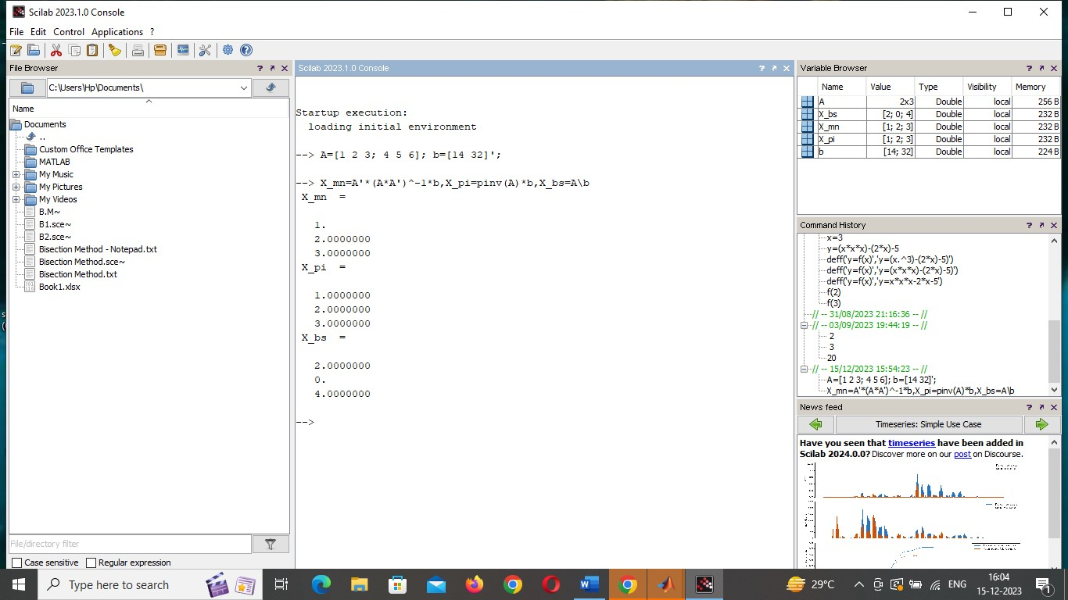

**Figure 1:** SCILAB SOLUTION

**3.COMPARE THE THREE SOLUTIONS OBTAINED**:

Based on the analysis and computations provided.

1. **Minimum-Norm Solution:** The minimum-norm solution of the undetermined system of linear equations is found to be [x,y,z]=[1,2,3].
2. **Solution Obtained Using SCILAB:** The solution obtained through the SCILAB command window is also [x,y,z]=[1,2,3]

It was observed that the minimum-norm solution and the solution obtained by using the SCILAB command window are similar.

**4.CONSISTENCY ANALYSIS:** SCILAB command to analyze the consistency of the system.

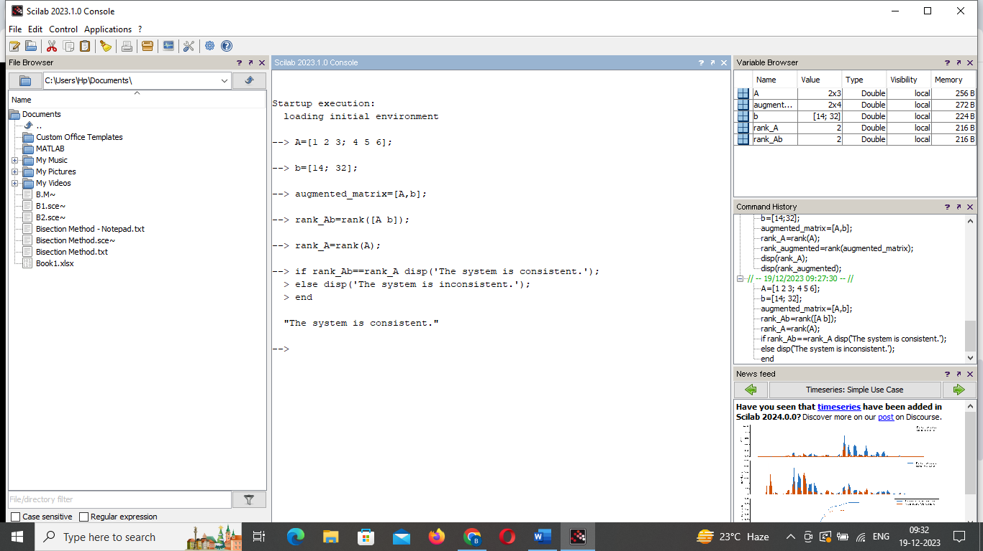

**Figure 2:** Consistency Analysis by SCILAB

**5.CONCLUSION** In this paper, we observed that the undetermined system of linear equations is consistent. The minimum-norm solution, obtained through mathematical computations, and the solution obtained using the SCILAB command window are consistent. This suggests that both approaches yield the same result, confirming the accuracy of the solutions.

**6.REFERENCES**

[1] Fausett, L.V., Applied Numerical Analysis using MATLAB, Prentice-Hall,

Upper Saddle River, NJ, 1999.

[2] Hamming, R. W., Numerical Methods for Scientists and Engineers, 2nd ed.,

McGraw-Hill, New York, 1973.

[3] Won Y.Yang, Wenwu Cao, Tae-Sang Chung, John Morris, Applied

Numerical Methods Using MATLAB.

[4] Maron, Melvin J., Numerical Analysis, Macmillan, Inc., New York, 1982.

[5] Burden, Richard L., and Fairs, J.Douglas, Numerical Anlaysis, 7th ed.,

Brooks/Cole Thomson, Pacific Grove, CA, 2001.