**REVIEW ARTICLE**

**PHARMACOLOGICAL PROPERTIES AND MEDICINAL USES OF ANTIFUNGAL MEDICINAL PLANT**

Tushar Tiwari*1, Dr. Anil Kumar *2, Kashif Azeem*3, Aakash Chauhan*4,

Krishanu Samanta*5,

*1, 3, 4 Research Scholar, Pharmacy College, Itaura, Chandeshwar, Azamgarh, U.P. India

*2 Professor, Pharmacy College, Itaura, Chandeshwar, Azamgarh, U.P. India

*5Associate Professor, Pharmacy College, Itaura, Chandeshwar, Azamgarh, U.P. India

Corresponding author: Tushar Tiwari

**ABSTRACT**

Medicinal plants have been widely used to treat a variety of infectious and non-infectious diseases. According to an estimate, 25% of the commonly used medicines contain compounds isolated from plants. Fungal infections are posing a great threat to the mankind, as a large number of people suffer from fungal infections worldwide due to emerging resistance of fungal strains. Human skin acts as a physical barrier; however, sometimes the skin gets infected by fungi, which becomes more severe if the infection occurs on the skin. the several antifungal creams, lotion, sprays are available to treat fungal infections, these show various side effects on the applications site. Over the past few years, herbal extracts and various essential oils have shown effective antifungal activity. Hence, to overcome these obstacles, polysaccharide-based Nano hydrogels embedded with natural plant extracts and oils have become the primary choice. These gels protect plant-based bioactive compounds and they release multiple bioactive compounds in the targeted area. Nano hydrogels can be applied to infected areas, and due to their contagious nature and penetration power, they get directly absorbed through the skin, quickly reaching the skin’s third layer and effectively reducing the fungal infection. This article describes potential antifungal properties of medicinal plants against fungi, and suggests screening the potential of plants possessing broad-spectrum antifungal effects against emerging fungal infections.

**Keywords**: Medicinal Plants, fungal infection, antifungal. Phytomedicine

**INTRODUCTION**

Phytomedicine can be defined as the herbal medicine with therapeutic and healing properties. It came into existence since the advent of human civilization. Sheng- Nungs. Herbal Book is known as one of the preliminary sources of traditional folk knowledge based on the use of herbs in China and dates back to around 3000 BC

An antifungal plant is a type of plant that produces compounds with properties that inhibit the growth and development of fungi. These plants have evolved a natural defence mechanism to protect themselves from fungal infections, similar to how the human immune system defends against pathogens. The antifungal properties of these plants are often attributed to specific chemical compounds they produce.

Various parts of these plants, such as leaves, stems, roots, seeds, or extracts, may contain these antifungal compounds. Humans have recognized and utilized the medicinal properties of antifungal plants for centuries, employing them in traditional medicine and natural remedies. The application of antifungal plants extends to agriculture, where some plants are used to protect crops from fungal diseases, offering an environmentally friendly alternative to synthetic fungicides.

The active compounds found in antifungal plants can exhibit a range of bioactivities, including antimicrobial, anti-inflammatory, and antioxidant effects. Some of the well-known classes of compounds with antifungal properties include alkaloids, phenols, essential oils, and saponins.

**Fungal Infection**

Fungal infections are any disease or condition you get from a fungus. They usually affect your skin, hair, nails or mucous membranes but they can also infect your lungs or other parts of your body. You’re at higher risk for fungal infections if you have a weakened immune system. Antifungal medications are usually used to treat fungal infections.

**Causes of Fungal infection**

Yeast, molds and other types of fungus cause fungal infections. Most fungi don’t cause disease in people, but a few do. Some infections are opportunistic, meaning they usually don’t cause infections, but can take advantage of certain situations, like a weakened immune system.

**Some common fungi you can get infected**

**Dermatophytes**. Dermatophytes are a group of fungi that live off of keratin, a substance in your hair, your nails and the outer layer of your skin. They don’t infect living tissue.

***Candida***. *Candida albicans* is yeast that naturally lives on your body, usually without causing problems. Under certain conditions, it can grow too much and cause itching and redness. Rarely, it can cause serious infections. Environmental fungithat live in soil or water. Include, *Histoplasma*, *Coccidioides*, *Blastomyces* and *Aspergillus.*

**PHARMACOLOGICAL PROPERTIES OF SOME ANTIFUNGAL PLANTS**

**Zingiber officinalis (Ginger)**

Botanical Classification

Kingdom: Plantae (Plants)

Clade: Angiosperms (Flowering plants)

Clade: Monocots (Monocotyledons)

Order: Zingiberales

Family: Zingiberaceae

Genus: Zingiber

Species: Zingiber officinale

Figure- Ginger

**Chemical constituent**

**Gingerol:** Ginger contains bioactive compounds, with Gingerol being the primary active constituent. Gingerol has demonstrated antimicrobial properties, including antifungal activity against various fungal strains.

**Shogaol:** Shogaol is another important compound in ginger and is closely related to Gingerol. Both Gingerol and Shogaol contribute to the characteristic flavour and medicinal properties of ginger.

**Medicinal Uses**

Ginger is used medicinally for various purposes:

Digestive Aid: Alleviates nausea, motion sickness, and indigestion.

Anti-Inflammatory: Reduces pain and inflammation, beneficial for arthritis.

Respiratory Health: Eases cough, cold symptoms, and sore throat.

Gastrointestinal Health: Relieves upset stomach and stimulates digestion.

Antimicrobial: Exhibits antifungal, antibacterial properties.

Blood Sugar Regulation: May help manage blood sugar levels.

**Antifungal Activity of Ginger**

Healthy and uniform maturity “Changying” Chinese olives were obtained from an olive orchard in Fuzhou, Fujian, China. Antifungal experiment *in vivo* was conducted by injury inoculation with some minor modifications ([Li et al., 2018](https://www.ncbi.nlm.nih.gov/pmc/articles/PMC6218584/#B14)). Firstly, fruits were surface-sterilized using 2% sodium hypochlorite solution (Sinopharm, Beijing, China) for 2 min and rinsed twice with sterilized distilled water, then air-dried. Next, the fruits were artificially injured using a sterilized hole punch to make a 5 mm × 3 mm (diameter × depth) wound on the surface, in which 15 μL freshly prepared spore suspension (1 × 106 spores mL−1) was inoculated, follow by addition of 20 μL of GO with the concentration of 1, 2, 3, and 4 MIC. Finally, the treated fruits were incubated at 28°C and 95% relative humidity (RH) for 6 d. Fruit not treated with GO was used as the control. The lesion diameter (in mm) of fruit was measured using a vernier caliper every another day. Which inhibits the fungal growth.

**Azadirachta indica (Neem)**

Botanical Classification-

Kingdom: Plantae (Plants)

Clade: Angiosperms (Flowering plants)

Clade: Eudicots

Order: Sapindales

Family: Meliaceae

Genus: Azadirachta

Species: Azadirachta indica

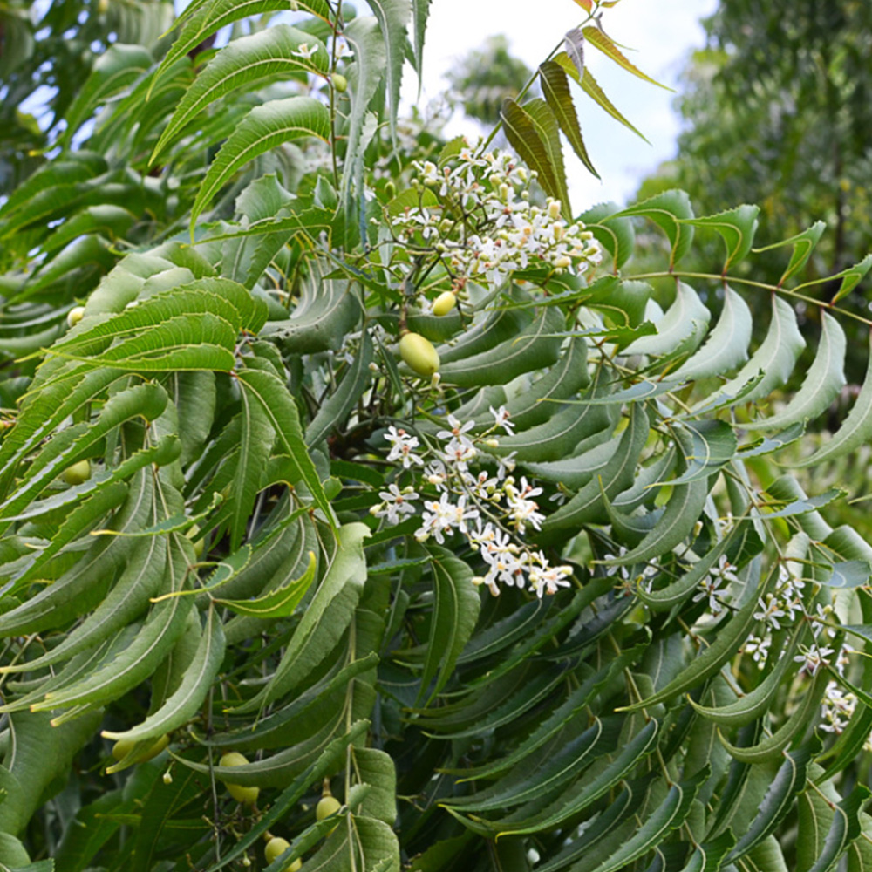

Figure- Neem

**Chemical constituent**

**Azadirachtin:** Neem is particularly rich in Azadirachtin, a compound with insecticidal and antifungal properties. It interferes with the growth and development of fungi, disrupting their life cycle.

**Nimbin:** This compound has been identified in Neem oil and has shown antifungal activity. It contributes to the overall efficacy of Neem as a natural fungicide.

**Nimbidin:** Another compound found in Neem seeds, nimbidin has been studied for its antifungal properties and may play a role in inhibiting fungal growth.

**Medicinal Uses-**

Neem (Azadirachta indica) is utilized as an antifungal plant in various applications:

Skin Care: Neem oil and creams treat fungal skin infections like ringworm and athlete's foot.

Oral Health: Neem-based dental products combat fungi, supporting gum health.

Hair Care: Neem oil in shampoos addresses dandruff and scalp fungal issues.

Pet Care: Neem-based pet shampoos treat fungal infections in animals.

Insect Repellent: Neem oil repels insects, indirectly preventing fungal diseases transmitted by insects.

Personal Hygiene: Neem extracts in soaps offer antifungal and antibacterial benefits for skin health.

**Antifungal Activity different extracts of Neem leaves**

The antifungal effect of aqueous and organic extracts of Neem leaves was assessed by measuring radial growth of the test pathogens following the technique described by

**HPLC analyses and chromatographic purification of nimonol-** Analysis of different components present in the mother organic extract in ethyl acetate obtained from Neem leaves was performed according to the method . The organic extract was fractionated by HPLC apparatus (Perkin-Elmer, Norwalk, CT, USA) consisted of the following: A 410 LC pump equipped with a LC 90 UV spectrophotometric detector and a LCI 100 integrator at 230 nm using acherey-nagel 100 C-18 columns (20 mm x 25 cm, 215 nm). The mobile phase included methanol (Carlo Erba, Milan, Italy) and Ultra-pure water purified in a Milli-Q system (Millipore, Bedford, MA, USA). The chromatographic run which lasted for 2 h was carried out for samples (20 μl for each) containing 3 mg EtoAc extract dissolved in 1 ml methanol at a flow rate of 20 ml/min through a stepwise gradient solvents in the following order: methanol : water (70:30) for 40 minutes; methanol : water (80: 20) for another 40 minutes and finally methanol : water (90: 10%) for 20 min before a final column wash after run completion with methanol in order to remove the non-polar components. Three successive injections were carried out for the neem leaf organic extract and for pure authentic samples of the following: Azadirachtin (Sigma-Aldrich (St. Louis, MO, USA). The main component contained in peak no. 7 was separated at 63 min. by HPLC for spectroscopic analyses (1H- and 13C-NMR).

**Curcuma longa (Turmeric)**

Botanical classification

Kingdom: Plantae (Plants)

Clade: Angiosperms (Flowering plants)

Clade: Monocots (Monocotyledons)

Order: Zingiberales

Family: Zingiberaceae

Genus: Curcuma

Species: Curcuma longa

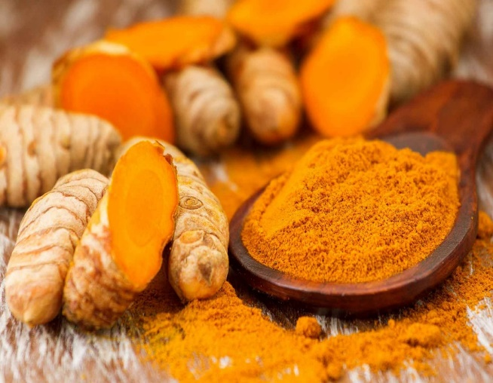

Figure- Turmeric

**Chemical constituent**

**Curcumin:** Turmeric owes its characteristic yellow color and many of its health benefits to curcumin. Curcumin has demonstrated various therapeutic properties, including anti-inflammatory, antioxidant, and antifungal effects.

**Medicinal Uses-**

Turmeric, known for its active compound curcumin, is medicinally used for:

Anti-Inflammatory: Alleviates arthritis and inflammation.

Antioxidant: Protects cells from damage.

Digestive Health: Aids digestion, relieves indigestion.

Liver Support: Enhances detoxification processes.

Cardiovascular Health: Improves heart health.

Anti-Cancer: Potential anti-cancer properties.

Neuroprotection: Supports brain health.

Blood Sugar Regulation: Helps manage blood sugar levels.

Wound Healing: Topical use for wound healing.

**Antifungal Activity-**

Surface of vial-containing fungi was disinfected by alcohol and broken within cotton dipped in alcohol near the heat. Sabouraud's dextrose agar (SDA) slope was used to subculture from a stock culture of *C. albicans* (PTCC5027, Merck, Germany) prepared using the necessary sterile precautions. This growth was used to prepare an inoculum in sterile saline, and four different concentrations of the fungus were prepared using doubling dilution method comprising of 1:10, 1:20, 1:40 and 1:80 concentrations.[[13](https://www.ncbi.nlm.nih.gov/pmc/articles/PMC6714268/#ref13)] An agar dilution assay was modified from the National Committee for Clinical Laboratory Standards (NCCLS, 2002) and used for determination of the MIC.[[14](https://www.ncbi.nlm.nih.gov/pmc/articles/PMC6714268/#ref14)] SDA plates mixed with 7 different concentrations of 50, 100, 200, 400, 800, 1600 and 3200 μl of alcoholic turmeric extract in 7 separate plates were prepared. Each plate with 7 different concentrations of 50, 100, 200, 400, 800, 1600 and 3200 μl of alcoholic turmeric extract in 7 separate plates were prepared. Each plate was divided into four quadrants; different dilutions of fungal suspension were streaked onto the different quadrants of the culture plates 15 min after the preparation of the suspension so that the density does not change. The medium was inoculated by even streaking with the help of a sterile cotton wool swab and incubated for 48 h at 37°C. Following incubation, the number of colonies was visually counted and the relative size of the colonies was visually inspected and data were recorded.

Minimum inhibitory concentration and minimum fungicidal concentration of *Curcuma longa*

The culture plate that did not demonstrate visible growth corresponds with the MIC of the antimicrobial agent. The MIC endpoint is the lowest concentration of the *C. longa* extract at which there was no visible growth in the tubes. The culture plate demonstrating no visible growth was sub cultured to Sabouraud agar plates, and MFC was determined by comparing the growth with the positive control. The MFC endpoint is defined as the lowest concentration of antimicrobial agent that kills >99.9% of the initial fungal population where no visible growth of the fungi was observed on the SDA plates.

Antifungal activity of ethanolic turmeric extract was tested for *C. albicans* using agar dilution method. Alcoholic control was prepared to rule out the antifungal activity of ethanol. Evaluation of plates showed that there was absolutely no antifungal effect in a concentration as low as 50 μl The size and number of the fungal colonies decreased with the increase in concentration of alcoholic extract of turmeric. As the concentration of the alcoholic extract of turmeric increased the size and the number of the fungal colonies decreased The size and number of colonies were inversely proportional to the concentration of turmeric . It was also noted that with increasing dilutions of *C. albicans*, the number of colonies decreased, thereby the number of colonies was inversely proportional to the amount of dilution of *Candida* . The control plate with alcohol only showed maximum growth. Hence, alcohol was not responsible for the inhibition of the growth of *Candida*.

There was complete inhibition of visible growth of all four dilutions of Candida at a concentration of 800 μl and greater. Thus, 800 μl (0.1384 g of C. longa) was considered as the MIC of alcoholic extract of turmeric on C. albicans. On sub culturing these plates, 800 μl showed some amount of growth, while 1600 and 3200 μl did not show any growth in subculture. Hence, the MFC of alcoholic extract of turmeric was 1600 μl (0.2768 g of C. longa).

**Allium sativum (Garlic)**

Botanical Classification-

Kingdom: Plantae (Plants)

Clade: Angiosperms (Flowering plants)

Clade: Monocots (Monocotyledons)

Order: Asparagales

Family: Amaryllidaceae

Subfamily: Allioideae

Genus: Allium

Species: Allium sativum

Figure- Garlic

**Chemical constituent-**

**Allicin:** When garlic is crushed or chopped, allicin is produced. Allicin is a sulphur-containing compound with potent antimicrobial properties, including antifungal activity.

**Sulfur compounds:** Garlic contains sulfur-containing compounds that contribute to its medicinal properties. These compounds are believed to interfere with fungal cell wall synthesis and inhibit their growth.

**Medicinal uses-**  
Garlic (Allium sativum) is medicinally used for:

Antifungal: Effective against various fungi, addressing infections like oral thrush and skin conditions.

Cardiovascular Health: Supports heart health by lowering cholesterol and blood pressure.

Antibacterial: Exhibits antibacterial properties, potentially aiding in infections.

Immune Support: Boosts the immune system, aiding in overall health.

Anti-Inflammatory: Allicin in garlic has anti-inflammatory effects.

Blood Sugar Regulation: May help regulate blood sugar levels.

Antioxidant: Contains antioxidants, protecting against cellular damage.

Cancer Prevention: Some studies suggest a potential role in cancer prevention.

**The antifungal activity of garlic oil against *C. albicans***

In order to determine the antifungal activity of garlic oil, *C. albicans* cells were treated with different concentrations of garlic oil by poisoned food technique. The experimental results are shown in fig. After one day of incubation, the control petri dishes were covered with white colonies, whereas no colonies were observed in the other five experimental groups exposed to garlic oil. However, after seven days of incubation, the petri dishes of the control group, as well as the 0.04, 0.09 and 0.17 μg/mL garlic oil groups were fully covered with white colonies of *C. albicans*. Moreover, the colonies observed in the 0.04, 0.09 and 0.17 μg/mL garlic oil petri dishes were all covered with white colonies despite having more than a three-day delay in their growth compared to the control. No colonies were identified on the 0.35 μg/mL and beyond garlic oil-treated petri dishes during the seven-day incubation. Therefore, the minimum inhibitory concentration (MIC) of garlic oil against *C. albicans* was determined to be 0.35 μg/mL.

The fungicidal kinetic curves of garlic oil against *C. albicans* . The quantities of the surviving cells in all experimental groups were calculated based on the numbers of fungal colonies that grew on the petri dishes. The initial cell concentration in every experimental group was 105 colony-forming units (CFU)/mL. The fungicidal kinetic curves showed that *C. albicans* in the control group grew to exponential phase after a 3-h lag phase and reached the stabilization phase after incubation for 12 h. In contrast, a 24-h growth delay and a slight decline in the number of surviving cells were determined in the 0.04 and 0.09 μg/mL garlic oil groups. The cells reached exponential phase and stabilization phase after incubation for 24 h and 48 h, respectively. More than 90% of cells were killed after treatment for 24 h in the 0.17 and 0.35 μg/mL garlic oil groups and after 9 h in the 0.69, 1.39 and 2.77 μg/mL garlic oil groups. A small number of persistent cells began to grow again gradually after 2 or 3 days of incubation. In addition, a trend was observed that with increasing concentrations of garlic oil, the rate of cell killing and the duration of growth lag phase increased correspondingly. These data indicated that garlic oil had a time- and dose-dependent antifungal effect against *C. albicans*.

**Datura metal (Datura)**

Botanical Classification-

Kingdom: Plantae (Plants)

Clade: Angiosperms (Flowering plants)

Clade: Eudicots

Order: Solanales

Family: Solanaceae

Genus: Datura

Species- metal

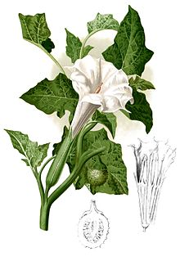

Figure- Datura Plant

**Chemical constituent**

**Scopolamine (Hyoscine):** Scopolamine is a potent antimuscarinic alkaloid that can cause hallucinations, delirium, and central nervous system depression. It is often associated with the psychoactive effects of Datura and is a significant contributor to the plant's toxicity.

**Atropine:** Atropine is another tropane alkaloid present in Datura. Like scopolamine, atropine has antimuscarinic properties and can affect the central nervous system. It is responsible for many of the toxic effects associated with Datura poisoning.

**Hyoscyamine:** Hyoscyamine is another tropane alkaloid found in Datura plants. It has similar pharmacological effects to scopolamine and atropine, contributing to the overall toxicity of the plant.

**Medicinal Uses**

The seeds of Datura are analgesic, anthelmintic and anti-inflammatory and as such, they are used in the treatment of stomach and intestinal pain that results from worm infestation, toothache, and fever from inflammation.

The juice of its fruit is applied to the scalp, to treat dandruff and falling hair.

**Antifungal activity:**

The antifungal activity against the test fungal agents was deter- mined according to the poisoned food technique of Grover and Moore (1962). In fact, PDA medium was prepared and sterilized at 150°C for 30 min in autoclave. Appropriate quantities of aqueous extracts (1.5, 3, 5 and 6.25 ml) and distilled water were added to this medium (40 ml), cooled to 45 to 50°C, to get 1, 2, 3 and 4% (w/v) concentrations of leaf and flower aqueous extracts. The control medium received the same quantity (1.5, 3, 5 and 6.25 ml) of sterile distilled water. Stock solution of organic extracts (5 ml) prepared above at 3000, 6000 and 9000 ppm was added to PDA medium. Control received the same quantity (5 ml) of diluted methanol used as control for all bioassays with organic extracts. The plant extracts were thoroughly mixed with the medium. Ten millilitres of each medium was poured in each 9 cm diameter sterilized Petri plate. After solidification, mycelial plugs of 5 mm diameter were taken with a pre-sterilized cork borer from 5 to 7 days old culture of test fungus and were placed in each Petri plate. Each treatment was replicated thrice. Plates were incubated in an incubator at 25 ± 2°C for 3 to 7 days. Fungal radial growth was measured by averaging the two diameters taken from each colony. Percentage growth inhibition of the fungal colonies was calculated by applying the following formula (Khanh et al., 2005): Growth/inhibition (%) = [(Growth in control – growth in treatment) / growth in control] × 100.

**Salvia officinalis**

Botanical Classification

Kingdom: Plantae (Plants)

Clade: Angiosperms (Flowering plants)

Clade: Eudicots

Order: Lamiales

Family: Lamiaceae (Labiatae)

Genus: Salvia

Species: Salvia officinalis

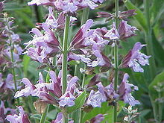

Figure- Salvia officinalis Plant

**Chemical constituent**

**Essential Oils:**

Thujone: Thujone is a major component of sage oil and is known for its neurotoxic properties. It is present in varying concentrations in different sage species.

Camphor: Camphor is another essential oil component found in sage. It contributes to the herb's characteristic aroma and has antimicrobial properties.

Cineole: Also known as eucalyptol, cineole is a common component in sage essential oil. It has been studied for its antimicrobial and anti-inflammatory effects.

**Phenolic Compounds:**

Rosmarinic Acid: This is a polyphenolic compound found in sage with antioxidant properties. It has been studied for its potential anti-inflammatory and antimicrobial effects.

Carnosol: Carnosol is another phenolic compound present in sage that exhibits antioxidant properties.

**Flavonoids:**

Apigenin: Sage contains apigenin, a flavonoid with antioxidant, anti-inflammatory, and potential anticancer properties.

Luteolin: Luteolin is another flavonoid found in sage, known for its antioxidant and anti-inflammatory effects.

**Triterpenoids:**

Ursolic Acid: Sage contains ursolic acid, a triterpenoid that has demonstrated anti-inflammatory, antioxidant, and potential anticancer activities.

**Tannins:**

Ellagic Acid: Sage contains ellagic acid, a type of polyphenol with antioxidant properties. It has been investigated for its potential health benefits.

**Medicinal Uses**

Antimicrobial Properties: Sage has been studied for its antimicrobial properties, particularly against bacteria and fungi. The essential oils in sage, such as thujone and camphor, contribute to these effects.

Anti-Inflammatory Effects: Compounds like rosmarinic acid and ursolic acid in sage have demonstrated anti-inflammatory properties, suggesting potential benefits in conditions involving inflammation.

Antioxidant Activity: Sage contains antioxidants, including rosmarinic acid and flavonoids like apigenin and luteolin, which may help combat oxidative stress and free radical damage.

Cognitive Support: Some research suggests that sage may have cognitive-enhancing effects, potentially benefiting memory and cognitive function.

Gastrointestinal Aid: Sage has been used traditionally to alleviate digestive issues, such as indigestion and bloating.

Menopausal Symptoms: Sage has been explored for its potential to alleviate menopausal symptoms, including hot flashes, although more research is needed to establish its efficacy.

Diabetes Management: Preliminary studies indicate that sage may have a role in managing diabetes, potentially improving blood sugar levels.

**Antifungal Activity-**

The fungal cultures used in this study were provided by the Microbiology Discipline from Horticulture and Forestry Faculty of Timisoara. The Verticillium dahliae strain was isolated from sea bucktorn plants infected with Verticillium dahliae, preserved at -4 °C on PDA medium with Va 09-13 index. (COTUNA O. & al. [13]). The Penicillium aurantiogriseum strain was isolated from the fungal microbiota of the wheat seeds preserved on PDA, at -4 0C, with the index Lv 07-11(ALEXA E. & al [14]).

We used the poisoned medium method to determine the inhibition of the mycelium. First, the young fungi cultures were obtained on CYGA (chloramphenicol- yeast- glucose agar, produced by SIGMA) by spread techniques with a spore suspension in melted agar 0.2% + TWEEN 80, 0.05% . After we stored them for 4 days in dark at a constant temperature, we cut plugs of 8 mm Ø from active mycelia and put them on CYGA medium amended with Salvia officinalis L. EO at the following concentrations (v/v); 0.25 mg·L-1 , 0.5 mg·L-1 , 1 mg·L1 ; 5 mg·L-1 ; 10 mg·L-1 ; 15 mg·L-1 and 0 for control. Thiophanate-methyl, a commercial agricultural fungicide, has been used as negative control for Penicillium and for Verticillium too.

Each Petri dish containing EO, at different concentrations was inoculated with two plugs from young mycelia. After inoculations, dishes were kept in dark at 22±2 °C. The radial mycelia growth was measured after 5 days at two perpendicular diameters. The plug diameter measured 8 mm so we reduced the average of the readings with 8mm. (P. TAYLOR & al. [15]).

MIC is the lowest concentration of oil where no visible fungal growth can be observed. The Petri dishes were sealed with parafilm and incubated in the dark at 22±20C. The readings were made on the 5th and the 14th day. For control and comparison we used a control dish with Thiophanate-methyl (in the recommended dose for practical use).

**Lupinus albus**

Kingdom: Plantae (Plants)

Clade: Angiosperms (Flowering plants)

Clade: Eudicots

Order: Fabales

Family: Fabaceae (Leguminosae)

Subfamily: Faboideae

Tribe: Genisteae

Genus: Lupinus

Species: Lupinus albus

Figure- Lupinus albus plant

**Chemical constituent**

**Alkaloids:** Lupinus albus contains alkaloids, including lupinine, lupanine, and sparteine. Alkaloids are nitrogen-containing compounds that can have diverse physiological effects and may contribute to the plant's bioactivity.

**Protease Inhibitors:** Lupinus albus seeds contain protease inhibitors, which are proteins that can inhibit the activity of protease enzymes. These inhibitors play a role in protecting the plant from predation and may have implications for human health.

**Flavonoids:** Flavonoids are a class of polyphenolic compounds found in various plants, including Lupinus albus. These compounds have antioxidant properties and may contribute to the plant's overall health benefits.

**Proteins:** Lupinus albus seeds are rich in protein, and the composition of lupin proteins includes various essential amino acids. Lupin proteins are considered nutritionally valuable.

**Carbohydrates:** Lupinus albus seeds contain carbohydrates, including dietary fiber, starch, and oligosaccharides. The dietary fiber content contributes to digestive health.

**Fatty Acids:** Lupinus albus seeds contain fatty acids, including linoleic acid and oleic acid. These fatty acids are essential for various physiological functions in the body.

**Medicinal Uses**

Anti-Inflammatory Properties: Certain compounds in Lupinus albus may have anti-inflammatory effects, potentially beneficial for conditions involving inflammation.

Antioxidant Activity: The plant contains flavonoids and other compounds with antioxidant properties, which may help combat oxidative stress in the body.

Nutritional Benefits: Lupinus albus seeds are rich in protein, essential amino acids, and other nutrients, making them a valuable food source.

Potential Hypocholesteremic Effects: Some studies suggest that Lupinus albus may have effects on cholesterol levels, potentially contributing to heart health.

**Antifungal Activity**

The genus *Lupinus* is well-known for high concentrations of isoflavones and quinolizidine alkaloids. The latter specialized metabolites are especially important to *Lupinus* as chemotaxonomic markers. The relevance of this kind of compound for ecological interactions and nitrogen-storing processes has been described previously . In the present study, the composition of the alkaloidal fractions from *L. mirabilis* leaves, obtained by two extraction methods, namely conventional solvent extraction (CSE) and ultrasound-assisted extraction (UAE), during three different extraction periods (1–3) is described. The identified nitrogen-containing compounds along with key chromatographic and spectrometric data by GC-MS are listed in and their structures are depicted in [Appendix A](https://www.ncbi.nlm.nih.gov/pmc/articles/PMC9104632/#app1-molecules-27-02832) These compounds have been previously described in *Lupinus* species and are therefore considered lupine alkaloids. They account for different compound classes as follows: tetracyclic quinolizidine alkaloids (1–3, 8, 9, 11, and 12), tricyclic quinolizidine alkaloids with allylic lateral chain (7 and 10), and dipiperidines 6) . The identity of each compound was confirmed by a thorough comparison of representative MS signals and RI values with those reported in the literature .

To study the effect of both extraction method and extraction duration on the resulting alkaloidal composition, we assessed three different time frames for each method. [Table 1](https://www.ncbi.nlm.nih.gov/pmc/articles/PMC9104632/table/molecules-27-02832-t001/) shows the relative percentage of each nitrogen-containing compound in all the analyzed samples. Two abundant compounds consistently appeared: sparteine (2) and lupanine (11). Although both alkaloids are typically found in *Lupinus*, in most cases, quinolizidine 11 has been reported as the main constituent. Wink et al. found 2 in a higher percentage than 11 only in eleven out of 109 accessions of *Lupinus* around the world, accounting for 56 different species. *L. arboreus* (seeds and leaves), *L. arcticus* ssp. *subalpinus* (leaves), *L. sericeus*  ssp.  *Huffmannii*  (leaves), and  *L.sericeus*  ssp.  *Flexuosus*  (leaves) contained exceptionally high levels of 2 (>70% of the alkaloidal fraction) . More recently, Kordan et al. reported three samples of *L. luteus* (L. cv. Dukat, Perkoz, and Talar) with higher amounts of 2 than 11. Such a study was performed on twelve lupine accessions, including four different species. On the other hand, the existence of chemotypes within *Lupinus* species has also been described. For instance, one out of seven chemotypes observed in *L. sulphureus* displayed exclusively a 2/11 ratio above the unit (in 49 accessions analyzed) . Such diversity encouraged us to further analyze the Colombian *L. mirabilis* specimens. Recently, we studied the alkaloidal profile of a greenhouse-propagated specimen of *L. mirabilis* and a high 2/11 ratio (>1.6) was observed

**CONCLUSION**

This review emphasises the importance of herbal plants as effective antifungal properties due to their high of beneficial phytoconstituents. These plants have therapeutic characteristics that can help treatment of fungal infections. Their active therapeutic properties, safety profile, and efficacy have increased their popularity in developing countries. Herbal medicines are known for having less negative effects than conventional treatments. The complete analysis shows a wide range of plants with antifungal activity, emphasising their potential as natural sources for treating. This leads to the conclusion that plants are the best natural sources because they have fewer side effects while giving superior results,

**REFERENCE**

1. Li W., Yuan S., Sun J., Li Q., Jiang W., Cao J. (2018). Ethyl p-coumarate exerts antifungal activity in vitro and in vivo against fruit Alternaria alternata via membrane-targeted mechanism.  26–35.
2. Dixit S.N., Tripathi S.C., Upadhyay R.R. The antifungal substances of rose flowers (Rosa indica) *Economic Botany.* 344–371.
3. Govindachari T.R., Gobalakrishnan G., Suresh G. Isolation of various Azadirachtins from neem oil by preparative high performance liquid chromatography. *J. Liq. Chromatogr. & Rel. Technol.* 1729–1733.
4. Rodriguez-Tudela JL, Barchiesi F, Bille J, Chryssanthou E, Cuenca-Estrella M, Jenning D, et al. Method for the determination of minimum inhibitory concentration (MIC) by broth dilution of fermentative yeasts. *Clin Microbiol Infect.*1–8.
5. Kumar RS, Ganvir S, Hazarey V. Candida and calcofluor white: Study in precancer and cancer. *J Oral Maxillofac Pathol.*2–8.
6. Choi, H. & Lee, D. G. Antifungal activity and pore-forming mechanism of astacidin 1 against *Candida albicans*. Biochimie 105, 58–63 (2014).
7. Bajwa R, Akhtar N, Javiad A (2001). Antifungal activity of allelopathic plant extracts. I. Effect of aqueous extracts of three allelopathic Asteraceou species on growth of Aspergilli. Pak. J. Biol. Sci. 4: 503-507
8. o. cotuna, r. sumălan, v. sărăţeanu, and c. durău, Diagnosis of Verticillium sp . fungus from sea buckthorn ( Hippophae rhamnoides l .), vol. 46, no. 1, pp. 145– 151, (2014).
9. Khan M.K., Karnpanit W., Nasar-Abbas S.M., Huma Z.E., Jayasena V. Phytochemical Composition and Bioactivities of Lupin: A Review. *Int. J. Food Sci. Technol.*2004–2012.
10. Saito K., Murakoshi I. Chemistry, Biochemistry and Chemotaxonomy of Lupine Alkaloids in the Leguminosae. *Stud. Nat. Prod. Chem.*519–549.
11. Reisfeld R.A., Jolla L., Tuppy H. *Molecular Biology, Biochemistry, and Biophysics—The Biochemistry of Alkaloids.* Volume 32. Springer; Berlin, Germany: 1980. Lupine Alkaloids; pp. 67–75.
12. Frick K.M., Kamphuis L.G., Siddique K.H.M., Singh K.B., Foley R.C. Quinolizidine Alkaloid Biosynthesis in Lupins and Prospects for Grain Quality Improvement. *Front. Plant Sci.*2017;8:1–12..
13. Wink M. Chemische Verteidigung Der Lupinen: Zur Biologischen Bedeutung Der Chinolizidinalkaloide. *Plant Syst. Evol.*1985;150:65–81.
14. Cook D., Mott I.W., Larson S.R., Lee S.T., Johnson R., Stonecipher C.A., Herbarium S.L.W. Genetic Relationships among Different Chemotypes of Lupinus sulphureus. *J. Agric. Food Chem.*2018; 66:1773–1783.
15. Cely-Veloza W., Quiroga D., Coy-Barrera E. Quinolizidine-Based Variations and Antifungal Activity of Eight Lupinus Species Grown under Greenhouse Conditions
16. Wink M. Quinolizidine Alkaloids: Biochemistry, Metabolism, and Function in Plants and Cell Suspension Cultures.509–514.
17. Gandomi Nasrabadi H, Misaghi A, Akhondzadeh basti A, Khosravi A, Bokaei S, Abbasifar A (2008). The effect of Thyme essential oil on Aspergillus flavus. J. Med. Plants., 3(27): 45-51.