# untitled

# COLLEGE OF URBAN DEVELOPMENT AND ENGINNERING

**DEPARTMENT OF ENVIRONMENT AND CLIMATE**

**CHANGE MANAGEMENT**

**MASTERS PROGRAME**

**Challenges of Participatory Land Use Planning in Achieving Sustainability in DembechaWoreda, Amhara Region, Ethiopia**

**By**

**AmanuelYigrem**

**June, 2018**

**Addis Ababa, Ethiopia**

# 

# Acronyms

GIZ Gesellschaftfürfor International Susammenarbeit

GTZ GesellschaftfürTechnischeZusammenarbeit

FAO Food and Agriculture Organization

PLUP Participatory Land Use Planning

LUPD Land Use Planning Department

EPLAUO Environmental Protection, Land Administration and Use Office

SLM Sustainable Land Management

NGOs Non-Governmental Organization

CSA Central Statistics Agency

GPS Geographic poisoning System

UN United Nation

UNCCD United Nation Convention to Combat Desertification

UNEP United Nation Environmental Protection

MoA Ministry of Agriculture

GNP Gross National Product

US United States

NRPP National Resources Policy and Program

BMZ Batterien-Montage-Zentrum GmbH (German Battery Company)

GFA Gross floor area

GLEPA Gambella Environmental Protection Agency

MFED Ministry of Finance and Economic Development

LUPRD Land Use Planning and Reform Department

UNDP United Nation Development Program

MLRA Ministry of Land Reform and Administration

MLUP Master Land Use Plan

ILUP Integrated Land Use Plan

OWWDSE Oromia Water Work Design Supervision Enterprise

ESIF Ethiopia Sustainable Investment Framework

PRA Participatory Rural Appraisal

G.C Gregorian calendar

FGD Focus Group Discussion

E.C Ethiopian Calendar

***Abstract***

*Human being depends on land to produce basic necessities including food, clothing and shelter. Land is the principal resource of human beings in general and agriculture dependent societies in particular. The main objective of this study is to assess the challenges of participatory land use planning in achieving sustainability in Dembecha woreda. The required data for the study were collected by using survey questionnaire including personal interview, focus group discussion and field observation. Three rural kebeles were selected purposively where land and other natural resources degradations is high. However, no studies have been conducted on challenges of participatory land use planning in this area, thus this study focuses on challenges of PLUP, roles of land use planning for sustainable natural resource management, socioeconomic and environmental impacts of using land resources without participatory land use planning and the appropriate solutions. The study was carried out using different sample categories such as house hold respondents, key informants from different sectors, focus groups and researcher observation. Both qualitative and quantitative research methods were employed to achieve all the specific objectives set. The collected data using data collection tools was organized in line with the specific objectives and analyzed using both SPSS software, excel sheet and narrated with text. The analysis results showed that land use planning was hindered by various challenges like lack of awareness, lack of skilled manpower and facilities, land use legislation problems, low community participation, weak kebele councils, limited government attention etc.*

*Household respondents’ information indicates that participatory land use planning can play a great role for reducing social conflicts due to land use, enhancing economic development and sustainable natural resources management /environmental sustainability. But land is used without land use plan which leads socioeconomic and environmental impacts such as land use conflict, reduction of land productivity, soil erosion, deforestation, grazing and wetlands degradation, climate change, water scarcity etc.*

**Key words:** Participatory land use planning, Challenges, Impacts, Roles, Potential solutions

# 1. Introduction

Participatory land use planning aims at achieving the highest level of participation. Community participation ensure that people have a greater voice in planning and decision-making, become empowered, and develop ownership for planning and implementing activities and to sustainable management their land and the natural resources they rely on (Fekadu,2012a). According to FAO, participatory land use planning is a tool for sustainable natural resources management and it is helpful in the context of participatory development and land use planning in many countries contexts including Ethiopia. PLUP together with soil and water conservation function causes a great influence on the productivity of land and economic growth of an area (Biruk, 2014). Besides, the knowledge about impacts of participatory land use planning and climate changes due to un planed land use is essential indicator for resource base analysis and development of effective and appropriate response strategies for sustainable management of natural resources (Kassa, 2009).

Today, persistent population growth, climate change, erosion and desertification as well as urbanization increase the pressure on fertile land and other natural resources in the world; particularly in sub Saharan Africa (Melese, 2014). Participatory Land Use Planning (PLUP) has been gaining international recognition as an important tool for managing locally available resources. Participatory land use planning is the systematic assessment of physical, social and economic factors in such a way as to encourage and assist land users in selecting options that increase their productivity, are sustainable, and meet the needs of society (Fraser, et.al 2006)

Dembecha woreda is one of the largest Woreda in West Gojjam Zone, in the upper parts of the stream was dominantly covered by forests of indigenous species, shrub lands and reverie trees and better land use patterns (Fekadu, 2012b). But now a day, the surface of the land covered by forests and shrub has reduced and the area is exposed to land degradation; on the other hand, there was no farm and grazing land scarcities before 25 years so that there was no/low land use conflicts in the area. But today the land that the people have is small in size (in average below 1 hectare), highly eroded and low in its fertility which leads to low agricultural productivity (Dessie, 2010).

Moreover, the populations who are living in the study area lead their life through sedentary mixed agriculture activity, and the populations who are living in the upper part of the area use the most vulnerable lands for soil erosion due to their steep slopes and removal of forest covers (DembechaWoreda agricultural office 2013).

According to Dembecha woreda Land use planning department (LUPD) of environmental protection, land administration and use office (EPLAUO), since there is no participatory land use planning, land owners and land users use the land as they want without analyzing which land is appropriate for what purpose. Due to the utilization of land without proper land use planning, land that is highly vulnerable to land degradation due to its hill features are using for farming without recommended and sustainable soil and water conservation practice. This situation causes degradation of land due to small and large scale soil erosion. on the other hand, there is serious land use conflicts among land users because of different land use patterns within a clustered areas; for example farmers cover their farm land by permanent plants especially by eucalyptus trees which has great negative influence on the productivity of bordering lands that are used to annual crops (LUPD, 2014). Using land resources without land use planning in the study area has multi dimensional negative impacts such as economical, social, environmental and political (Muluken,2013).

Therefore the area is selected due to 3 main reasons. Firstly, the area is marked by a diverse topographic (relief features) which is vulnerable to land degradation (soil erosion, deforestation grazing land degradation. wetland degradation…); secondly, in the past the lands which are sensitive to soil erosion due to their topographic features are covered by different plant species but today they are changed to cultivated land without land use planning and recommended soil and water conservation practice; that leads to serious natural resource degradation. Thirdly, the awareness of local governments, local communities and civil societies about participatory land use planning and its role for sustainable natural resource management is too low; so that their support for its implementation is negligible. Due to this, many communal lands, shrub lands and grazing lands are changed to cultivated lands without any land use planning that should be prepared by the integration of communities (land users), stakeholders and professionals (Dembecha woreda Agricultural office, Sustainable Land Management project (SLM), 2014). Therefore these situations push the researcher to analyze the challenges of PLUP to achieve sustainability in the study area.

## 2. Description of Study Area

The study area is located in West Gojjam Zone, Amhara Regional State. DembechaWoreda is one of the 13 rural Woredas that are found in West Gojjam administration zone and it is bordered by east MachakelWoreda (East Gojjam Zone), West JavitehinanWoreda, north DegaDamotWoreda and south BurieWoreda. The capital city of Dembechaworeda is Dembecha. It is found at distance of 348 km from Addis Ababa, 205km from Bahir Dar /the capital of Amahara regional state/ and 35 km from FinoteSelam /the zonal capital of West Gojjam/. The town is astronomically located at latitude 100 18′ 30′′ N and 100 43′ 30′′ N and longitude 370 6′ 0′′ E and 370 40′ 30′′ E. The area coverage of Dembechaworeda is 979.26km2 and the current total population is 156629; from this males account 78,355 and females 78274. It has 29 rural 2 urban kebeles. It is divided in to 3 climatic zones. These are Dega (11%), WoinaDega (83%) and kola (6%). It has 25 degree centigrade annual mean temperature, 1900mm average annual rainfall. It has different topography (relief features) such as 30% mountainous, 10% valley and the rest 60% is flat. The elevation ranges from 1500m to nearly 2999 meter above sea level. The study area is characterized by mountainous and highly dissected stretches of land with steep slopes at the upper stream part while an undulating terrain and gentle slopes at the downstream part. Mixed types agriculture on subsistence scale is the major livelihood of the people in the study area. Land and livestock are the most important assets of the people, with which they lead a sedentary life. A Variety of crops are cultivated by a household like Barley, Wheat, Maize, Oats, Beans, Potato and Onion are grown in the upper stream part of the area; and Teff, is additionally cultivated in the downstream part (Dembechaworeda Finance and economic development office 2017).

# Figure1: Map of the Study Area

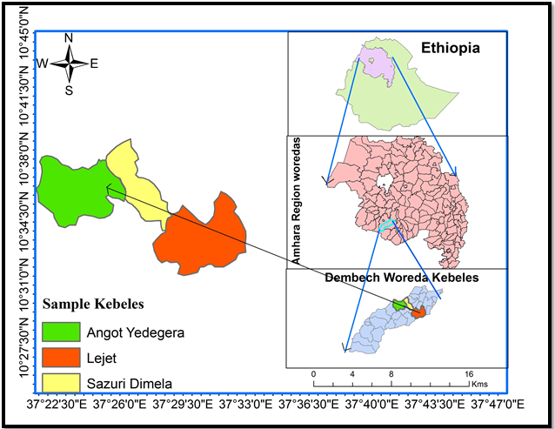**Source: CSA GIS Data, 2007**

# 3. RESEARCH METHODOLOGY

## 3.1. Research Design

Descriptive research method was employed in the data description which involves describing the behavior without influencing it at fundamental way; This study has used both qualitative and quantitative research approach. The researcher has employed both probability and non probability sampling techniques. For probability sampling, the researcher has used simple random lottery method to select respondents from each kebele. In the other hand, non probability sampling; purposive sampling techniques; has employed to participate experts, kebele land use planning committee members or participatory rural appraisal (PRA teams) and elders for interview and group discussion.

Different authors use different formula to determine sample size of the study. For the purpose of this study formula of yemane,1967 finite population correction factors will be employed.

**n = N**

**1+Ne²**

Where: n = the required sample size

N = the target population size

1 = Constant

e = Margin of error or sampling error expressed as a proportion

Based on secondary data obtained from environmental protection land administration and use office the number of household in these kebeles is 1284, so to determine the sample size of the study area

The target population size=1284

Sampling error =0.05(95% confidence level); Based on this information

Sample size (n) = N/ 1+Ne² =1284/1+1284*0.052

= 304 this sample size was too large and unmanageable because it needs long time, high labor, high financial and material resources to collect, organize and analyze data. But the researcher believed that, if the sample size reduced by appropriate formula, it would not have a negative influence on the quality (representativeness) of the samples because the target population in the study area is more homogeneous; so the researcher applied finite population correction factor to reduce the required sample size. The formula for this sample size determination is:

**na = nr**

**1 + (nr -1)**

**N**

Where na= the adjusted sample size, nr = the original required sample size and N= target population size; therefore, the reduced sample size will be;

na = 304

1+ (304-1)

1284 = 245

The samples of respondents and interviewees that were taken from each kebele and different governmental offices of the study area are shown in the following table

# Table 3.1: Summary of Sample Size Selected and Instrument of Data Collection Used

|  |  |  |  |  |  |  |  |
| --- | --- | --- | --- | --- | --- | --- | --- |
| No | Sampling method | Types of respondent | population and Sample size selected | | | | Tools of data collection will be used |
| Type | Total household head | sample size | Proportion |
|  | Simple random sampling | Households | AngotYedegera | 556 | 106 | 43.3 | Closed– and open-ended questionnaires |
| SazuriDimela | 316 | 60 | 24.5 |
| Lejet | 412 | 79 | 32.2 |
|  |  |  | Sub Total (a) | 1284 | 245 | 100 |
|  | Purposive sampling techniques | Key governmental offices experts and other important interviewees | EPLAUO/LUPD | 5 | 1 | - | Semi-structured and unstructured interview |
| Agriculture/natural resource management department | 3 | 1 | - |
| an expert from each kebele | 3 | 3 | - |
| Woreda administration | 1 | 1 | - |
| Environmental protection department | 4 | 1 | - |
| Kebele LAU committee | 15 | 6 | - | Focus group  discussion |
| PRA teams | 45 | 15 | - | Focus group  discussion |

Source: Own Formulation, 2017

To achieve the desired objective of the study, there was a need for appropriate data sources. The data for this study was collected from both primary and secondary sources. After the raw data has gathered from the sample it was organized, categorized and entered in to the computer for analyzing. Therefore, descriptive analysis was used to analyze the demographic backgrounds using the percentage of the respondents from which data is collected. Data presentation techniques have employed based on the nature of the data; the quantitative data has presented by using tables, charts, graphs and percentages whereas the qualitative data has presented through narration and photographs

# Figure 3.1: Methods and Techniques Employed in the Research Data Collection

**Head official**

**Interviews**

**Informal discussion with**

**Plan agents**

**Physical field Observation**

**Land use planning technical report review**

**Assess Challenges of Participatory Land Use planning**

**Planning**

**Questionnaires for households**

**Respondents**

**Focus Group Discussion**

**Experts Interviews**

Agriculture office report review

**Source: Researcher Computation, 2018**

# 4. RESULTS AND DISCUSSION

## 4.1. Response Rate

This study was conducted by collecting data concerning about the challenges of participatory land use planning in achieving sustainability from respondents including Kebele residents, experts head officials etc.

# Table 4.1: Response Rates of the Sample Respondents and Interviewees

|  |  |  |  |
| --- | --- | --- | --- |
| **Respondent** | **Distributed** | **Returned** | |
| **No.** | **%** |
| Questionnaire survey respondents | 245 | 236 | 96.32 |
| Agriculture head office /natural resource management department (interviewee) | 1 | 1 | 100.00 |
| Woreda and kebele EPLAUO expert and head office (Interviewee) | 5 | 5 | 100.00 |
| Woreda administration(Interviewee) | 1 | 1 | 100.00 |
| Focus group discussion conducted(Number) | 3 | 3 | 100.00 |

**Source: Field Survey, 2018**

As it can be seen from table 4.1, 96.32 percent of respondents were participated in giving information; 3.68% of the sample respondents were not participated in giving information; because, they are not living in the study area; thus they unable to provided information; 100% of the Agriculture head office/natural resource management department expert actively participated by giving responses for the interview; 100% of the EPLAUO experts and head office were voluntarily and responsibly responding the interview questions; because they were very interested for the conducting of this research with this topic; 100% of the Woreda administration was participated actively in responding interview questions;100% focus group discussions were conducted with kebele PRA teams and land administration committee.

## 4.3. Demographic Characteristics of Sample Respondents

The demographic characteristics of the sample respondents are categorized by gender, age, marital status, educational level and family size. It has an important function in research study to know the general characteristics of the sample respondents.

### 4.3.1. Sex Composition of the Respondents

The sex of the respondents affect the awareness and level of participation in land use planning; men and women have no similar exposure to awareness creation; females have not got opportunities for participating in the decision making processes of land use planning and other development issues. If the level of awareness and participation of women is increased in land use planning, it will help to enhanced sustainable natural resources management through PLUP.

Figure 4.1; stated that 44(18.6%) of the respondents were females and 192(81.4%) of the respondents were males.

# Figure 4.1: Sex Compositions of Sample Respondents

**Source: Field Survey, 2018**

### 4.3.2. Age Structure of the Respondents

Different age groups of the communities have different perceptions, knowledge and understanding about land and land use planning.

**Figure 4.2: Age Structure of Sample Respondents**

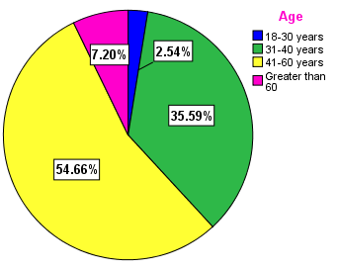

**Source: Field Survey, 2018**

As it is on figure 4.2, 2.54% of the respondents were from 18-30 years old; 35.59% of the respondents were from 31-40 years old; 54.66% of the respondents were from 41-60 years old and 7.20% of the respondents were greater than 60 years old. The figure indicates that most of the respondents are found in the age group of 41 to 60 years.

|  |  |  |  |  |
| --- | --- | --- | --- | --- |
| Table 4.2: Correlations of Age and Sex with Level of Awareness | | | | |
|  | | Age | Level of awareness of the community | Sex |
| Age | Pearson Correlation | 1 | .508** | .096 |
| Sig. (2-tailed) |  | .000 | .140 |
| N | 236 | 236 | 236 |
| Level of awareness of the community | Pearson Correlation | .508** | 1 | -.580** |
| Sig. (2-tailed) | .000 |  | .000 |
| N | 236 | 236 | 236 |
| Sex | Pearson Correlation | .096 | -.580** | 1 |
| Sig. (2-tailed) | .140 | .000 |  |
| N | 236 | 236 | 236 |
| **. Correlation is significant at the 0.01 level (2-tailed). | | | | |

**Source: Author Computation, 2018**

Table 4.2: indicates that age and level of awareness of the community have a positive correlation with a correlation coefficient of 0.508 under0.01 level of significance. Level of awareness of the community and sex of the community has a negative correlation with correlation coefficient -0.580 under 0.01 significant levels. This correlation stated that if the number of women increased in the community, the level of awareness of the community would be low. But if the number of women in one community is low, the awareness level of the community would be high. Based on these data women awareness about land use planning in the study area is lower than males.

4.2. Major Challenges of PLUP to Achieve Sustainability

Challenges are any factors that affect/influences the processes of preparing and implementing participatory land use planning and other development activities. In order to see the major challenges of PLUP in achieving sustainability, assess plan versus implementation of PLUP that was achieved in the study area from 2016 to 2017 is essential; PLUP planned to be implemented =25Kebeles; Implemented =1 kebele; Performance in % =4% only.

Out of the 25 rural kebeles on which PLUP was proposed to be prepared, only one kebele (Sensenkebele) was achieved. This annual plan implementation performance indicated that there were various challenges. As the information obtained from the land use planning department, many challenges were threatening the processes of PLUP in each kebeles. In addition to the challenges which stated by the household respondents in figure 9, there are other challenges which are listed by focus group discussion, key informants, and field observation.

Figure 4.6 depicted that, 2.966% of the respondents said that, lack of awareness; 1.695% of the respondents said that, lack of experts; 1.271% of the respondents said that, lack of community interest; 0.847.% of the respondents said that, land use legislation problem; 5.932% of the respondents said that, lack of the government attention and 87.29% of the respondents said that, all(lack of awareness, experts, community interest, government attention and land use legislation problems) were the main challenges to PLUP in the study area.

# Figure 4.6: Challenges of Participatory Land Use Planning in the Study Area

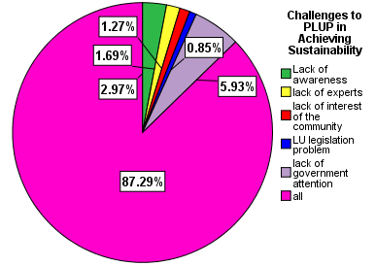

**Source: Field Survey, 2018**

Personal interview and focus group discussion participants clearly stated that farmers use their land without land use planning because the communities have not awareness about PLUP and the government did not give attention to PLUP; most of the positions in land use planning department were not occupied with human resources.

### 4.2.1. Lack of Awareness

About 87.29% of the respondents and focus group discussion participants stated that lack of awareness was the determinant factor to prepare PLUP in the study area. According to them the rural community, stakeholders and civil societies have not awareness about PLUP. No one was involved in the preparation of land use planning processes. Key informants pointed out that, the regional government provided annual plan to prepare land use plan at kebele level without creating sufficient awareness for the community, stakeholders, local government and even for the existing land use planning experts as it is required. Due to lack of awareness about the negative consequences of using the land without PLUP, the communities, and civic societies did not support the woreda and kebele experts while they collect biophysical and socioeconomic data to prepare land use planning. One can understood from this that, the land use planning experts by themselves have not detail enough skills and understanding about PLUP; because they entered into practicing land use planning without creating awareness to the community and stakeholders; without established close interaction with communities and stakeholders to develop common consensus in advance. One key informant said that “*working anything without awareness about it is like walking in the forest without eyes*”. Thus, it can be concluded that, awareness is the backbone of PLUP and any development; because effective and sustainable community participation cannot be real without awareness.

### 4.2.2. Lack of Skilled Man Power (Experts) and Facilities

When we see the experts required for land use planning department and the positions that were occupied, more than two-fold of the positions were vacant. Figure 4.7 depicts that, this department required 15 experts but the positions currently occupied were only 7(46.67%) and 8(53.33%) of the positions were vacant. Information from the department indicated that, the LUP work by its nature is field work and it needs at least three motorcycles to achieve the plan which was set but there is no vehicle provided to the department. Facilities and equipments that required for the department are vehicle/ motorcycles, wide enough office, chair and tables, computers and accessories, field equipments such as, field Borsa, GPS, field shoes, sleeping bags, digital photo camera and etc. But as the key informants, there is no car/motorcycle so the experts used public transport which makes them waste their time and labor by waiting for public transport. There was no accessibility of other equipments/materials such as handheld GPS and stationeries. According to the researcher’s observation which has been indicated on plate1, the department office is too narrow and experts unable to move freely; most of the experts have used one small table for two experts. Due to this, when one expert moved, the other was disturbed; for example, if expert “B” wants to exit, expert “C” should stand up to pass him; this was similar problem for expert “E” and “D”. Researcher observation and land use department experts information indicated that, seven of the department experts are worked on only two computers (one disk top and one laptop). Plate1 depicts the official arrangement and experts’ seat. Informal discussion with some experts and physical observation indicated that, although the number of experts required and occupied were not balanced, the existing experts were not used their full capacity due to inaccessibility of facilities.

# Picture4.1: Land Use Planning Department experts in their office

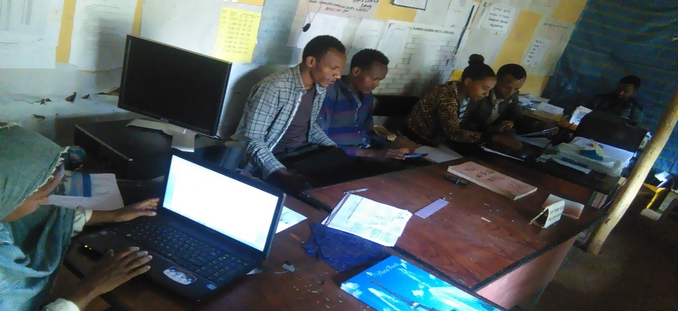**Source: Captured by Researcher, 2018**

A

D

B A

C

F

E

EXIT

Land use experts stated that, they finished a pair of shoes in one month due to walking mostly on the farmlands to collect central coordinates of each parcel; central coordinate is one basic data to prepare LUP. As land use plan expert information, to fulfilled GPS and digital camera gap they borrowed from other departments and sectors; from water sector. But it was not usually accessible. Therefore, one can conclude that inaccessibility of facilities is one determinant challenge for PLUP in achieving sustainability in the study area.

# Figure 4.7: Human Resources in Land Use Planning Department

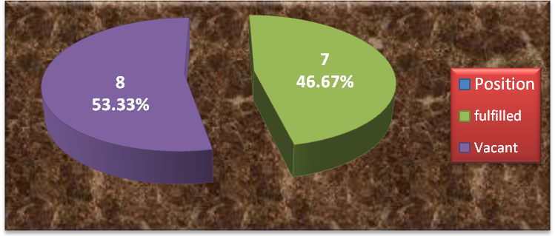

**Source: DembechaWoreda Land Administration and Use Office, 2018**

### 4.2.3. Land Use Legislation Problems

The Amhara regional state land administration and use proclamation No. 133/98 stated that, every rural land will be used by applying participatory land use planning but this proclamation has not regulation and guiding principle about how to and who is responsible for the implementation of land use planning. Article13, sub-article 5 of the above proclamation allowed the land users to use their land for any purpose unless they have given land use plan which is prepared by pertinent bodies. This land use law encourages the land users to use their land according to their want. About 87.29% of the respondents agreed on land use legislation are one of the influencing factors for PLUP in the study area. The land use planning department experts pointed out that, lack of implementation guiding principles make them in confidential; if one landholder uses his land for other purposes after written land use plan is given, there are no clearly indicated legal measurements that should be taken on him. This means there is no guiding rules that indicate for this type of land use crime, this type of measurement will be taken. Kebele experts pointed out that, land use planning legislation is like a *lion which has no teeth*.

### 4.2.4. Low Participation of Communities in LUP Processes

Focus group discussion participants (land administration committee and PRA team members and key informants stated that, the communities were not participated in the land use planning process. According to them and woreda land use planning experts' information, the landholders were not found on their land to show the borders of the land to tell the name of neighboring landholders while the experts prepared land use plan at parcel level although the procedure they have followed was wrong. Kebele experts stated that the communities did not come to when they call to discuss about land use planning; they pointed out that, they do not worried about land use planning as much as land administration and registration(land tenure). According to experts and focus group discussion information, landholders were threatened them to give biophysical and socio-economic data that needed to LUP and defended to sign on the written land use planning form which was prepared by experts; because the community is not aware enough about land use planning and its role in achieving sustainability.

### 4.2.5. The Presence of Weak Kebele Councils

Key informants andfocus group discussioninformation stated that, in principle which was approved by the council, kebele council meeting should be carried out once a month to make decision about kebele level development activities but these meetings were not carried out based on the schedule and with required numbers of participants. For example the researcher was found in two sample kebeles (on 29/06/2010 E.C in Lejetkebele and on 21/07/2010 E.C in AngotYedegerakebele) in which there were kebele council meetings to observe and check the reliability of information which was collected from key informants and focus group discussion. But two of the meetings were missed due to the absence of participants. From 300 participants in each kebele, only 57(19%) and 71(23.7) of participants were come in AngotYedegera and Lejetkebele respectively; but according to the informants, kebele council meeting is undertaken if two-third and above (≥66.67%) of the participants are come.

## 4.3. Land Use Change Trends in the Study Area

As information obtained from DembechaWoreda agriculture office, land use changes have been undertaken without land use planning.

# Table4.3: Land Use Trends/Changes within 20 Years (10 Years Intervals)

|  |  |  |  |  |  |  |  |
| --- | --- | --- | --- | --- | --- | --- | --- |
| No | Land use type | 1996  Area in km2 | 2006  Area in km2 | 2016  Area in km2 | Difference from  1996 to 2016 km2 | | |
| **In km2** | **In %** | **Change/year In km2** |
| 1 | Farm lands | 412.94 | 514.44 | 559.2 | +146.26 | +35.42 | +7.3 |
| 2 | Forest lands | 133 | 72.26 | 53 | -80 | -60.15 | -4 |
| 3 | Grazing lands | 183 | 152.5 | 143.5 | -39.5 | -21.58 | -1.975 |
| 4 | Settlements | 178 | 184 | 188.5 | +10.5 | +5.9 | +0.525 |
| 5 | Wetlands | 60 | 41.75 | 18 | -42 | -70 | -2.1 |
| 6 | Quarry sites | 3.06 | 3.06 | 3.06 | 0 | 0 | 0 |
| 7 | Others(road,river, markets,.. | 9.26 | 11.25 | 14 | +4.74 | +51.19 | +0.237 |
|  | **Total** | **979.26** | **979.26** | **979.26** | **323** |  |  |

**Source; DembechaWoreda Agriculture Office, 2018**

**Note: the (-) and (+) signs indicated the decreased and increased land use types from the initial year, 1996 respectively.**

Table 4.3 indicated that, from 1996 to 2016 farmland grow from 412.94 to 559.2km2; 146.26km2 (35.42%) of land was changed into farmland which is 7.3km2 per year. Forest lands have reduced from 133km2 to 53km2; which indicated that 80km2(60.15%) of forest land is changed to other land use types. The 4km2 forest is destructed per year. Grazing land reduced from 183km2 to 143.5km2 from 1996 to 2016 which is 39.5km2(21.58%) within 20 years or 1.975km2 per year. Lands used for settlements have grown from 178km2 to 188.5km2 which is 10.5km2(5.9%) of land is changed within 20 years or 0.525km2/year.

As it is on the table above, wetlands were highly degraded within 20 years; it decreases from 60km2 to 18km2 that is 42km2(70%) within 20 years or 2.1km2 per year. No changes have occurred on query sites. Other land use types including roads, rivers and eroded lands (changed to bare lands), grow from 9km2 to 14km2; 4.74km2(51.19%) of land was changed to other land use types within 20 years. The land use change trend has illustrated on figure 4.7 for more clarity.

These secondary data which stated land use change trends in the study area have strengthened by household respondents information on figure 4.9; which depicts that, 13.98% of the respondents strongly agreed, 55.93% of the respondents agreed, 5.085% 0f the respondents neither agreed nor disagreed, 14.41% of the respondents disagreed and 10.59% of the respondents strongly disagreed on the undertaken of land use change without PLUP. Thus both the secondary and primary sources of data indicated that land use change is carried out without land use planning in the study area.

# Figure 4.8: Land Use Changes Practiced without Participatory Land Use Planning

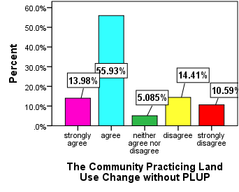

**Source: Field Survey, 2018**

Key informants pointed out that, gullies, eroded lands and roads have taken the higher share of the changes. Researcher observation information indicated that, eroded lands (totally unproductive lands) are mostly created in the upper stream kebeles of the study area due to frequent and serious soil erosion. One kebele expert said that more than hundreds of residents were migrated to other areas including the downstream (kola) kebeles of the study area because of their farmland unable to ensure their food security. As the informants, their land is changed to totally unproductive lands.

## 4.4. Consequences of using land without PLUP

Although land use planning has multi dimensional role, the land user in the study area use it without PLUP and which leads to environmental degradations.the role of PLUP is showed on figure 4.xx

# Figure 4.12: Role of PLUP for Social, Economic and Environmental Aspects of Sustainable Development

**Environmentally**

**Sound**

**Economically**

**Viable**

**Sustainable**

**Development**

**Socially**

**Acceptable**

**P L U P**

**f**

**Foundation**

**Source: Author Computation, 2018**

Figure xx Environmental degradation due to unplaned land use

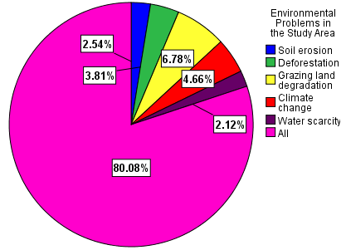

**Source: Field Survey, 2018**

#### 4.4.1. Soil Erosion

Household respondents indicated that, soil erosion was the main problem in the study area. Focus group participants and key informants pointed out that, soil erosion was a common and serious issue especially in the highland parts of the area. According to them very vulnerable lands due to their slop (≥ 30⁰ slop) were used for field crop production without appropriate and recommended soil and water conservation practices such as bunds, trenches and runoff water diverting canals; natural resources department interviewee pointed out that, soil erosion was a serious environmental problem in this woreda. According to the informant’s information, most of farmlands in the highlands of the area are highly eroded and low in their productivity; the informants stated that, they conducted acidic soil diagnosis by cooperating with DebreMarkos soil testing laboratory in Amhara region and the laboratory report is indicated on Table 4.4 below. As it can be shown on this table, from 73 soil samples tested in 2008 E.C, 50( 68.5% of the soil samples were acidic, 23(31.5%) of the samples were non acidic; 212 soil samples were tested in 2009 E.C and from which 135(67.7%) of soil samples were affected by acid and 77(36.3%) were not affected by acid/non acidic; from 273 soil samples that tested in 2010 E.C, 194(71.1%) were acidic and 79(28.9%) were non acidic. Thus, from these data,, it can be concluded that, from soil samples tested in three consecutive years, most of the soil samples are affected by acid. Dembechaworeda soil expert pointed out that, soil erosion is the major cause of soil acidity in the area.

# Table 4.4: Soil Acidity Testing Laboratory Results

|  |  |  |  |  |
| --- | --- | --- | --- | --- |
| **No.** | **Years in Ethiopian**  **Calendar** | **Samples Tested** | **Testing Results** | |
| **Acidic** | **Non acidic** |
| 1 | 2008 | 73 | 50 | 23 |
| 2 | 2009 | 212 | 135 | 77 |
| 3 | 2010 | 273 | 194 | 79 |
|  | **Total** | **558** | **379** | **179** |

**Source: DembechaWoreda Agriculture Office, 2018**

#### 4.4.2. Deforestation

Focus group discussion participants, household respondents and interviewees information indicated that, though deforestation practice becomes decreasing in its rate, it is still one of the environmental problems; as key informants and researchers observation, the regionally and nationally known forest, Sekele Mariam forest is deforesting now for timber and related product industries. According to researcher observation and key informants information, forests are burned for the expansion of private and investment lands; even if the degree of practice differed from area to area (kebele to Keble) almost in all kebelesshrublands were destructed by farmers who have farmland bordering with them. Picture 4.3 and 4.4 indicated that deforestation of forests and shrubs for agriculture expansion and timber production respectively.

# Picture 4.3: Changing Forest Land to Farm Land by Cutting and Burning Forests

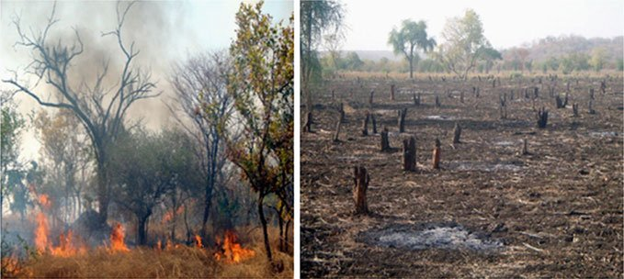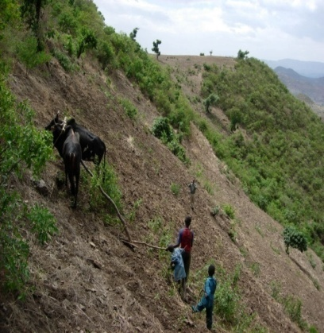

B

**A**

**Source: DembechaWoreda Land Use Planning Department, 2016**

Land use planning experts’ information and researcher field observation, (photo “B”) stated that, agricultural investor and illegal residents who come from other areas (immigrants from neighbor woredas) in Enewondkebele burned forests to expand their farmland; according to land use experts information, (photo “**A**”) farmers changed very steep and forest land to farmland in Angeniekebele without land use planning and recommended soil and water conservation practice.

# Picture4.4: Deforestation of Sekele Mariam Forest

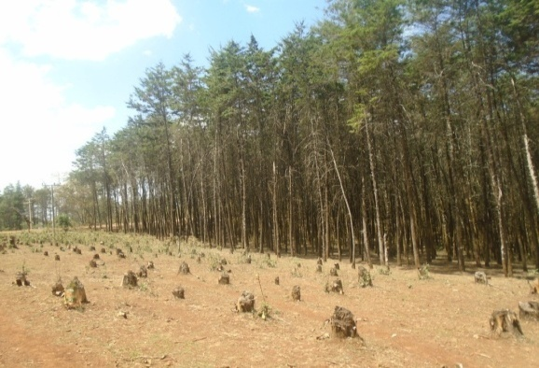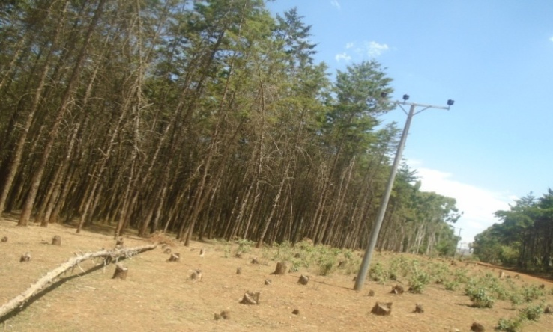

**Source: Captured by Researcher, 2018**

As information obtained from focus group discussion, land use change has been linked to many environmental prob­lems, including air pollution, wa­ter pollution, and loss of wildlife habitat. Runoff often contains nutrients, sediment and toxic con­taminants, and can cause not only water pollution but also large varia­tion in stream flow and temperatures. Habitat destruction, fragmentation, and alteration associated with land use changes have been identified as the leading causes of biodiversity de­cline and species extinctions.

#### 4.4.3. Grazing Lands and Wetlands Degradation

Key informants and researcher observation information indicated that grazing land degradation due to erosion (gully formation) and conversion to farmlands was a very hot issue in the study area. According to them, grazing land degradation (conversion to farmland by illegal farmers and gully formation becomes not only environmental but also it becomes social and political issues. Information on Table 4.3 indicated that 70% of wetlands and 21.58% of grazing land changed to other land use types within 20 years without land use planning. Thus it can be concluded that the above mentioned and other environmental impacts are threatening the sustainable supporting of natural resources for the present and future generations.

In Lejet kebele (photo “A”) locally called Arbuk grazing is highly degraded by gully erosion. The information from informal discussion with grazing land users indicates that, the runoff which formed on farmland was diverted to this grazing land without appropriate waterway and damages this grazing land. Grazing lands stated on Photos "B" and "C" are found in Godberkebele (WorkieMesk) and AngotYedegerakebele (YecherekaMesk) respectively are damaged by similar hazard with Lejetkebele, Arbuk grazing.

# Picture 4.5: Grazing Lands Degradation (Gully Formation)

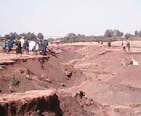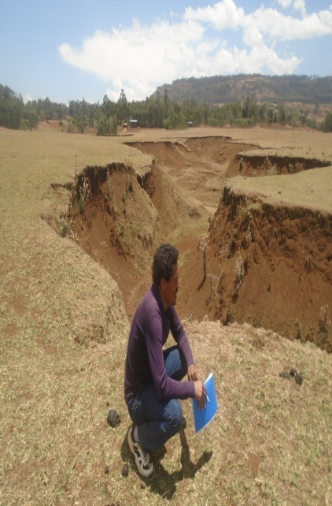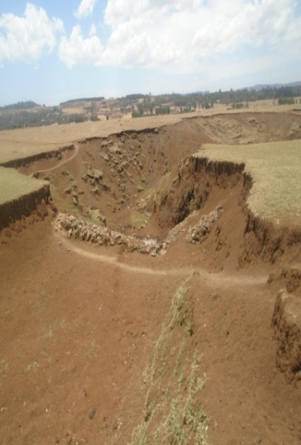

B

**A**

**C**

**Sourc****e: Captured by Researcher, 2018**

# Picture 4.6: Grazing and Wet Lands Changed to Irrigation Agriculture

Irrigation

Wetland

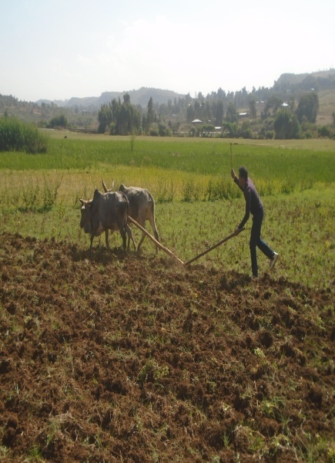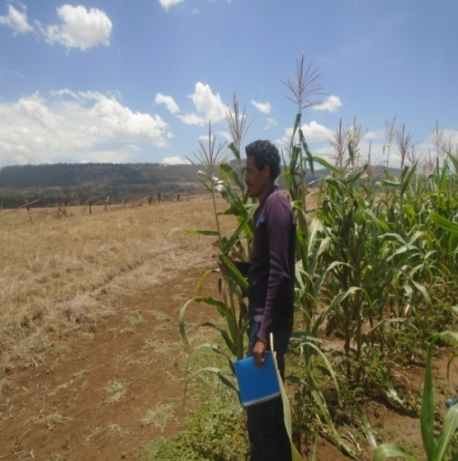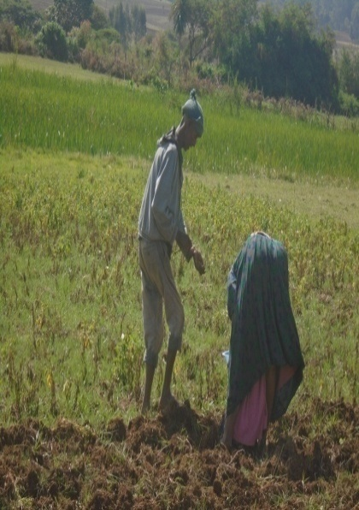

**C**

**B**

**A**

Potato

Cultivation

Grazing land

Irrigation

Wetland

**Source: Captured by researcher, 2018**

As it can be seen on photos above, the irrigation farm on “A” and “C” were converted from wetlands and currently the farmers producing vegetables on it; whereas photo “B” indicated that grazing land is changed to irrigation (currently the land is covered by maize). The landholders said that, they are given these irrigation lands from wetland and grazing land by kebele leaders’ decision without land use planning.

#### 4.4.4. Water Scarcity

Field observation information stated that, the water volume of the most permanent rivers was reduced. The two bigger rivers that have been shown on picture 4.7, have crossed Dembechaworeda from North to South were highly reduced in their water volume and now they are almost dried up. The local people who are found around the river during field observation said that before 20 or 30 years ago the rivers were flowing with the large volume of water but today, the rivers unable to support even the drinking water requirement of both animals and local people who are living around/ along the rivers.

# Picture4.7: Sample photos of Drying Rivers (Gulla and Temcha River) in DembechaWoreda

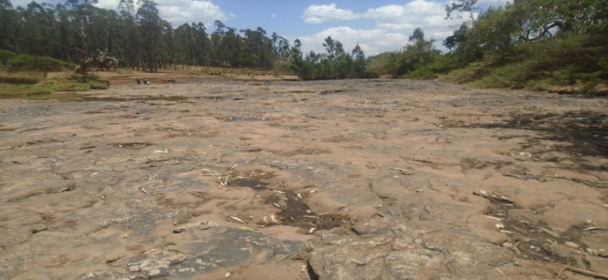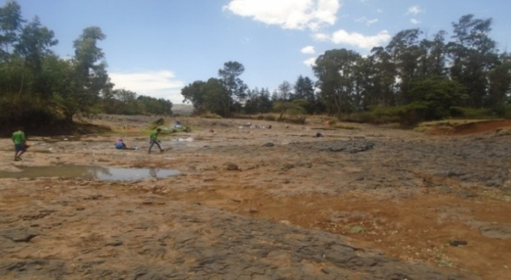

**Temcha River Bank**

**Gulla River Bank**

**Source: Captured by Researcher, 2018**

# Picture4. 8: Focus Group Discussions with PRA Teams and Land Administration Committee in Angot Yedegera Kebele

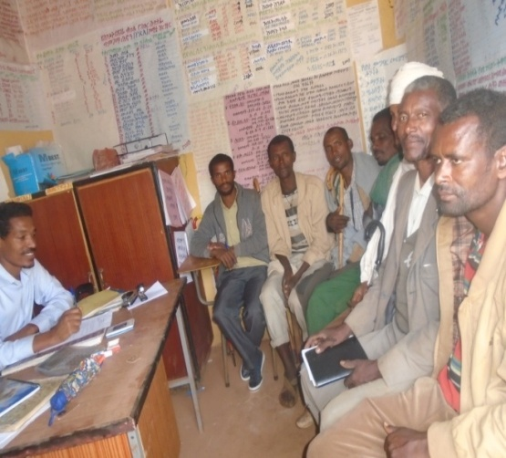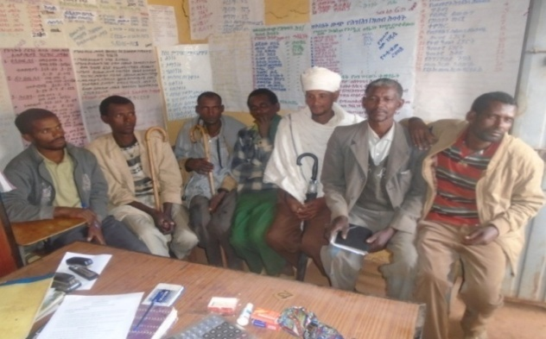

**Source: Captured by Researcher, 2018**

Based on the guiding questions presented to them by the researcher, the participants were raised various issues related to PLUP, environmental problem and the role of PLUP for sustainable natural resources management; the communities have used their land without land use planning because they have not awareness about land use planning. They stated that the governments who have a lion share for this and other development issues to aware and mobilize and work with the community did not give attention to other development sectors such as agriculture. Due to this, various socio-economical and environmental problems happen; these were people to people conflicts on private and communal lands, extinction/ migration of some wildlife having religious and cultural values. according to them the local people believed on tigers can keep churches if they lived around the area but today, they are not found in their kebele. According to the above participants, soil erosion was a serious problem especially on the highland part of the study area because it is highly vulnerable to erosion due to its geographic feature, steep slope. The correlation table 4.5 indicated that the educational level and level of awareness have a strong positive correlation with the correlation coefficient 0.834under 0.01 level of significance. If education level of the respondents increased, the level of awareness of the respondents also increased.

This table indicated that, the educational level of the respondents and their level of awareness have strong positive correlation with the correlation coefficient 0.834 under 0.01 level of significance; as education level of the respondents increases, the level of awareness of the respondents also increase; thus, low education level of the community has played an important role in the low level of community awareness about PLUP in the study area.

The education level of the respondents and use farmland without PLUP has a strong positive correlation with the correlation coefficient of 0.710 under0.01 level of significance. This correlation stated that, if educational level of the communities increases, the use of their land with land use planning could be an increase; in its reverse, if the level of education of the communities is low, use of their land without LUP also increase. Therefore, educating the communities should be given priority to use the land with PLUP. The level of awareness of the respondents and environmental problems has a strong negative correlation with a correlation coefficient of -0.554 under0.01 level of significance.

This correlation indicated that, if the awareness levels of the communities increase, the environmental problems that caused by inappropriate land using could be decreased; if the community aware enough about the environmental problems, they tried to prevent the environmental problems before they have happened; because most of the environmental problems in the study area particularly and in the world generally are human-induced /anthropogenic.

# Table4.5: Correlation of Different Variables

|  |  |  |  |  |  |  |  |
| --- | --- | --- | --- | --- | --- | --- | --- |
|  | | **Level of**  **Education** | **Level of**  **Awareness** | **Challenges**  **of PLUP** | **Use farmland without**  **PLUP** | **Environmental**  **Problems** | **Land use**  **Change without PLUP** |
| **Level of**  **Education** | Pearson Correlation | 1 | .834** | .475** | .710** | .538** | .531** |
| Sig. (2-tailed) |  | .000 | .000 | .000 | .000 | .000 |
| N | 236 | 236 | 236 | 236 | 236 | 236 |
|  |  |  |  |  |  |  |  |
| **Level of**  **Awareness** | Pearson Correlation | .834** | 1 | .380** | .772** | -.554** | .459** |
| Sig. (2-tailed) | .000 |  | .000 | .000 | .000 | .000 |
| N | 236 | 236 | 236 | 236 | 236 | 236 |
| **Challenge of**  **PLUP** | Pearson Correlation | .475** | .380** | 1 | .447** | .860** | .700** |
| Sig. (2-tailed) | .000 | .000 |  | .000 | .000 | .000 |
| N | 236 | 236 | 236 | 236 | 236 | 236 |
| **Use farmland**  **Without**  **LUP** | Pearson Correlation | .710** | .772** | .447** | 1 | .651** | .657** |
| Sig. (2-tailed) | .000 | .000 | .000 |  | .000 | .000 |
| N | 236 | 236 | 236 | 236 | 236 | 236 |
| **Environmental**  **Problems** | Pearson Correlation | .538** | -.554** | .860** | .651** | 1 | .639** |
| Sig. (2-tailed) | .000 | .000 | .000 | .000 |  | .000 |
| N | 236 | 236 | 236 | 236 | 236 | 236 |
| **Land use**  **Change without PLUP** | Pearson Correlation | .531** | .459** | .700** | .657** | .639** | 1 |
| Sig. (2-tailed) | .000 | .000 | .000 | .000 | .000 |  |
| N | 236 | 236 | 236 | 236 | 236 | 236 |
| **Correlation is significance at the 0.01 level (2-tailed)** | | | | | | | |

**Source; Own Formulation, 2018**

Challenges of PLUP and environmental problems have a strong positive correlation with the correlation coefficient of 0.860 under the significant level of 0.01. This strong correlation between two variables indicated that, when the challenges of PLUP become much and complexes, the severity of environmental problems also increase. For example, if lack of attention from the government to LUP becomes increased, the environmental problems could be increased both in their breadth and depth; in the other hand, if the lack of attention from the government resolved (LUP has given attention), the environmental problems could be reduced.

Challenges of PLUP and changing land use without land use planning has a strong positive correlation with the correlation coefficient of 0.700 under 0.01 level of significance; from this correlation, it can be understood that, the challenges which were identified can push the community to use the land without land use planning. For example, land use legislation problems was one challenge for PLUP.

## 5. Conclusion

The general objective of this study wasd to identify challenges for PLUP in achieving sustainability in DembechaWoreda, Ethiopia. Based on the finding of this study, major challenges that hindered participatory land use planning were: lack of awareness, lack of skilled human resource, problems in land use legislation, and low attention from the government, low community participation, weak kebele councils, and uninterested and uncommitted PRA teams. Hence to examine these and other related issues of PLUP to achieve sustainability in the study area, data were collected from household respondents, government officials, focus group discussions, secondary data and personal field observations.

The challenges of PLUP to achieve sustainability in the study area were lack of awareness, lack of skilled human resource, problems in land use legislation, limited attention from the government, low community participation, lack of strong kebele councils, lack of interest and commitment from PRA teams and lack of community trust. Skilled human resource is basic requirement for preparation and implementation of participatory land use planning in any area. Dembechaworeda human resources report stated that, land use planning department requires 15 experts and only 7 positions were occupied;8(53.3%) of positions were vacant. Not only the number but also the awareness, knowledge and skill of the existing experts was low; because some of the experts were come from other sectors have not got enough training and capacity buildings.

Local as well as regional governments play a determinant role for any development of one area. But the head office of DembechaWoreda administration stated that, even if land is the life for both present and the future generation, the government attention to use this limited but important resource with planning is low; this in turn leads to low awareness and participation of the community and stakeholders, low fulfillment of experts and facilities inaccessibility.

Grazing lands were affected by gully formation, encroachment of livestock beyond their carrying capacity, illegal farming and changing into irrigation; wetlands were exposed to soil sedimentation that has washed from farmlands, changing to irrigation, livestock encroachment on it and forests were affected by cutting for timber production (as illustrated on picture 4 and burning for agriculture (as it can be shown on picture 3). These socio-economic and environmental impacts have occurred in the study area due to using land without PLUP.

# References

Amhara region land administration and use bureau 2014, Kebele based participatory land use planning training manual, Bahir Dar, Ethiopia.

BirukAlemayehu 2014, Kebele based participatory land use planning, training manual*,* Dembecha, Ethiopia.

Dembechaworeda Agricultural office 2014, Sustainable Land Management project (SLMp), Work Shope, Dembecha, Ethiopia.

Dembechaworeda Agricultural office 2014, Sustainable Land Management project (SLM), Five years project performance evaluation technique committee report, Dembecha, Ethiopia.

DembechaWoreda Agriculture office 2013, Strategies and methods of soil and water conservation, workshop, Dembecha, Ethiopia.

DembechaWoreda environmental protection, land administration and use office, Land use department 2014, Kebele based participatory land use planning, Training Manual, Dembecha, Ethiopia.

Dembechaworeda finance, economic development and coordination office (2015), woreda*basic information,* (Brochure). 9th edition, Azmeraw.

Dessie A. 2010, sustainable land management project annual project performance monitoring and evaluation annual report, Dembecha, Ethiopia.

Endalew Awoke in 2016, Adequacy of farmland compensation for the sustainable livelihood of evictees, Motta, Ethiopia.

Fekadu T. 2012, Impacts of land use land cover change on the downstream hydrology of the commed watershed, Machakel, Ethiopia.

Gebeyehu B. 2014, the Role of land administration for natural resource management, DebreMarkos, Ethiopia**.**

Girma B. 2011, Pressure of rapid urban development on rural lands in Mackelworeda*,* Ethiopia.

Giz 2012, a Federal ministry for economic cooperation and development, land use planning manual*,* Addis Ababa, Ethiopia.

GTZ 2012, Participatory Approaches in Agriculture and Forestry (PAAF) Project Participatory Land Use Planning (PLUP) Manual*,* Taiyuan, China.

KassaTadele 2009, Watershed Hydrological Response to changes Land Use Land Cover, and Management practices at Hare Watershed, Ethiopia.

Kothari, C.R. 2004, Research Methodology: Methods and Techniques, 2nd ed., New Delhi

Melese D. 2014, Watershed-based land use planning, Training Manual, Dangila, Ethiopia

Ministry of Agriculture (MoA)/Land Administration and Use department 2012,Local Level Participatory Land Use Planning, participatory land use planning Manual, Addis Ababa, Ethiopia.

Ministry of Finance and Economic Development 2008, Annual report on macroeconomic development, Addis Ababa, Ethiopia

Muluken, M. 2013, preparing participatory land use planning at kebele level, workshop, Dembecha, Ethiopia.

Uganda Ministry of Lands, Housing and Urban Development 2017[,“About Us"](http://mlhud.go.ug/about-us/), Kampala,Uganda.