**TRANSLUCENT CONCRETE AS AN ECO-FRIENDLY BUILDING MATERIAL**

**Dr.V. MurugeshPh. D 1 , Dr.Harikumar Pallathadka 2 ,Prof. Rajesh. P. Chinchewadi 3**

1 Assoc.Prof, JCTCET and Post-Doctoral Research Fellow, Manipur International University,Imphal, Manipur

2 Vice-chancellor and Professor, Manipur International University, Imphal, Manipur

3 Dean and Professor, Manipur International University, Imphal, Manipur

**ABSTRACT:**

This study introduces translucent concrete as an intelligent and environmentally friendly building material that possesses enhanced strength, a pleasing look, and the ability to transmit light. Brightness Transparent concrete is another name for transmitting concrete. It is the most innovative advancement in construction materials in the last several years. It is among the newest, most useful, and cutting-edge components of environmentally friendly building materials. This study provides a broad overview of the production, use, and future prospects of transparent concrete. Though it is still mostly in the research and development phase, this novel new material is starting to be applied in a number of architectural applications and holds great potential for the future. This invention's purpose is to update the conventional perception of concrete by incorporating contemporary architectural elements. Although its primary goal is to harness solar radiation to minimize lighting energy usage, LTC has a wide range of other uses as well, such as flooring, pavements, load-bearing walls, furnishings, facades, internal wall cladding, separating walls, and partition walls. Concrete and light-transmitting material are the two main components utilized to create LTC. The ingredients of fine concrete include cement, fine aggregate, tiny chips, and water. Plastic optical fiber is added to the mixture to produce LTC. In LTC, the optical fiber makes up between 1% and 2% of the volume of the concrete. The fiber rows are spaced five millimeters apart.

**INTRODUCTION:**

In an effort to lower the energy used by buildings and the forthcoming development of new buildings. The creation of novel building materials with extremely low energy consumption has drawn the attention of several scientists and experts. Concrete that is transparent is one of these newly discovered materials. The fundamental component or substance needed for all sorts of building is concrete. This kind of translucent concrete is cutting edge because it allows light to flow through it. The optical plastic fibers in this unique concrete are reinforced, giving it transparency. This is due to the fact that sunlight may pass through optical plastic fibers without producing any light, heat, or other photochemical reactions.

**OBJECTIVES:**

* To cast a unique kind of concrete with light-transmitting qualities.
* To investigate their light-emitting traits and create a working material that not only uses less energy but also produces an artistic finish.
* Its excellent architectural qualities contribute to the building's pleasing appearance.
* Translucent concrete may help save energy in a structure.
* For this reason, this project attempts to create concrete that is both aesthetically pleasing and an eco-friendly, energy-efficient building material.

**MATERIALS**

* OPTICAL FIBER: Flexible transparent fibre made up of glass or plastic material and transmitting light between two ends. The thickness of the fibre is 0.75mm.
* CEMENT: In this project we used portland cement of 53 grade
* FINE AGGREGATE: Normal concreting sands are suitable for litracon
* COARSE AGGREAGATE: Coarse aggregate having a size of 10mm were used. Specific gravity is 2.14 with its impact strength of 13.3%
* WATER: Ordinary drinking water can be used for making the concrete.

**MANUFACTURING OF LTC**

There were seven 15 cm by 15 cm by 15 cm cubes created. While certain cubes are used for translucent concrete, another cube is utilized for ordinary concrete. Concrete examples such as cubes are incorporating varying percentages of optical plastic fibers.

The optical fibers in the transparent concrete were evenly spaced along a vertical axis at a distance of 5 cm, making up 1% and 2% of the cubes' total volume. An iron mold with a hardwood base measuring 15 cm by 15 cm by 15 cm was created for the transparent concrete cubes. Each cube has holes to allow optical fibers to pass through it vertically. These cubes were oiled before being filled with concrete to prevent the cubes from sticking to the molds.

**FIG1- MANUFACTURING OF LTC**

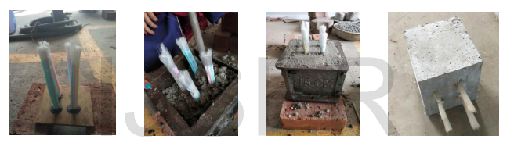

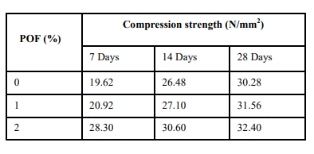

**CONCLUSION:**

This study looks on LTC's compressive behavior. One of the more intriguing modern interpretations of the traditionally rigid and boring building material is translucent concrete. Transparent concrete has countless applications, and as it is utilized more, new ones will be found. It's pricey and has some unresolved flaws, just like any new material. Engineers will undoubtedly use these fascinating new materials in many intriguing ways that will alter the opacity of architecture in the coming years as they continue to investigate them. The amount of power used for interior building lighting each day will be reduced by the average light transmission via the light transmitting concrete (LTC) blocks.

**REFERENCES:**

1 Bashbash, Basma F., et al. "Basics of Light Transmitting Concrete." Global Advanced Research Journal of Engineering 2.3 (2013):076-083.

2 Bhushan, MNV Padma, D. Johnson, and MdAfzalBasheer Pasha. "Optical Fibres in the Modeling of Translucent Concret

3.Cázares, Sergio Omar Galván, and Joel Sosa Gutiérrez. "Formulation for Obtaining a Translucent Concrete Mixture." U.S. Patent Application12/083,724.

4 He, Jianping, et al. "Study on smart transparent concrete product and its performances." Proc., 6th Int. Workshop on Advanced Smart Materials and Smart Structures Technology. Harbin, China: Asian-Pacific Network of Centers for Research in Smart Structure Technology (ANCRISST), Harbin Institute of Technology,2011.

5 Nagdive, H. R., and SHEKAR D. BHOLE. "To Evaluate Properties of Translucent concrete/Mortar &Their Panels." International Journal of Research in Engineering & Technology 1.7 (2013):23-30. 6 Salih, Shakir Ahmed, et al. "Effect of Plastic Optical Fiber on Some Properties of Translucent Concrete.

" 7 Sawant, A. B., R. V. Jugdar, and S. G. Sawant. "Light Transmitting Concrete by using Optical Fiber." e Blocks." International Journal of Engineering Research and Applications 3.3 (2013):13-17.