**A Review on Artificial Intelligence Calculations for Hazard Controlled Algorithmic Exchanging**

**IRFAN BAGAWAN1**,

1Assistant Professor, Department of Computer Science and Engineering

(Data Science),

MLR Institute of Technology, Hyderabad, India

___________________________________________________________________________________

**ABSTRACT**

AI calculations have arisen as useful assets for risk control in algorithmic exchanging, empowering brokers to dissect tremendous measures of market information, distinguish examples, and pursue informed exchanging choices. In the present quick moving and information driven monetary business sectors, viable gamble the board is fundamental to explore market vulnerabilities and enhance exchanging execution. Conventional gamble control strategies frequently battle to catch complex market elements and adjust to quickly evolving conditions, prompting the reception of AI calculations.

These calculations succeed in handling enormous volumes of information, uncovering stowed away examples, and making precise expectations, empowering merchants to create proactive gamble the board systems. AI calculations offer a few benefits in risk control for algorithmic exchanging. They can examine different information sources like verifiable cost information, news opinion also, financial markers, giving important experiences to take a chance with evaluation also, direction.

Also, these calculations can deal with time series information, catching worldly conditions and adjusting to dynamic market conditions. They give continuous gamble checking and early admonition capacities, empowering brokers to answer rapidly to arising gambles and execute risk relief measures. Besides, AI calculations offer the possibility to upgrade portfolio the executives, powerfully changing portfolio loads in view of hazard return profiles and upgrading resource allotment procedures. AI calculations have reformed risk control in algorithmic exchanging by giving high level investigation, prescient abilities, and ongoing checking.

**Keywords:** (AI, Hazard Controlled, Algorithmic Exchanging,

Support Vector Machines(SVMs), Inclination Helping Models (GBMs),

Irregular Timberlands, Repetitive Brain Organizations (RNNs), Long Present moment

Memory (LSTM) Organizations, Generative Ill-disposed Organizations (GANs),).

1. **INTRODUCTION**

AI calculations have changed the scene of chance control in algorithmic exchanging by giving high level scientific apparatuses to handle complex market elements. In the present high speed monetary markets, customary gamble control strategies frequently battle to stay aware of the always evolving conditions.AI calculations offer an answer by breaking down tremendous measures of information, extricating significant examples, and making precise forecasts. These calculations succeed in handling time series information, catching worldly conditions, and adjusting to dynamic market conditions. By utilizing machine

learning calculations, brokers can improve risk the executives procedures, improve exchanging choices, also, relieve possible misfortunes. Besides, AI calculations empower continuous gamble checking and early identification of market oddities. By handling streaming business sector information, these calculations can distinguish uncommon examples, recognize potential gamble occasions, and give convenient cautions to merchants. This enables brokers to rapidly answer to arising chances, change their exchanging positions, and execute risk moderation measures. Moreover, AI calculations offer the possibility to upgrade portfolio the board by powerfully changing portfolio loads in view of hazard appraisals also, improving resource allotment systems. This improves the general gamble control structure and makes a difference brokers accomplish better gamble changed returns in algorithmic exchanging.

**A. BACKGROUND**

Algorithmic exchanging has acquired ubiquity monetary markets because of its speed and proficiency. Be that as it may,

viable gamble control is essential in computerized exchanging frameworks. Conventional techniques frequently battle to deal with complex examples and adjust to changing business sector conditions. AI calculations offer high level information examination procedures that can gain from verifiable information, foresee market drifts, and streamline risk the executives procedures. These calculations succeed in dealing with time series information and give ongoing experiences for informed decision-production in algorithmic exchanging.

**B. MOTIVATION**

AI calculations are persuaded by the want to further develop risk the board techniques and exchanging execution the mind boggling and dynamic monetary market. Customary techniques frequently battle to catch multifaceted market designs and adjust to evolving conditions. By using AI calculations, merchants can break down huge measures of information, make exact forecasts, and answer rapidly to market variances. These calculations reveal stowed away designs, upgrade navigation, and proposition the potential for more vigorous exchanging methodologies.

1. **METHODOLOGY**
2. **Risk-Controlled Algorithmic Trading**

Definition and Concept Risk-controlled algorithmic trading is a methodology that involves the utilization of automated trading systems equipped with risk management mechanisms to mitigate potential losses and preserve capital during the execution of trading strategies. It entails the application of machine learning algorithms and mathematical models to analyze market data, identify patterns, and make well-informed trading decisions while effectively managing associated risks.

The fundamental concept underlying risk control in algorithmic trading lies in acknowledging the inherent unpredictability and uncertainties prevalent in financial markets. By implementing risk management techniques and harnessing the power of machine learning algorithms, traders aim to minimize potential losses and maximize profitability within predefined risk tolerance thresholds.

1. **Importance of Risk-Controlled**

Risk control is of utmost importance in algorithmic trading due to the uncertainties and volatility present in financial markets. Effective risk management mechanisms help preserve capital by setting risk limits and employing techniques such as stop-loss orders and position sizing. They ensure stability and consistency in trading performance over time, reducing the likelihood of catastrophic losses. Risk control also aims to optimize risk-adjusted returns by striking a balance between profitability and risk exposure. It mitigates emotional biases by removing subjective decision-making and adhering to predefined rules. Compliance with regulations is facilitated through the implementation of risk management practices. Risk control contributes to the long-term sustainability of trading strategies by avoiding significant drawdowns and attracting investor confidence. Overall, risk control is essential for protecting capital, achieving stability, complying with regulations, and inspiring investor trust in algorithmic trading.

1. **Challenges in Risk-Controlled**

Implementing effective risk control in algorithmic trading faces several challenges. First, ensuring data quality and availability is crucial, as financial markets produce vast amounts of data that may contain errors or missing values. Second, risk models must be robust and adaptable to changing market conditions and unforeseen events. Third, capturing complex interactions and dependencies between different market factors poses a challenge in risk control modeling.

1. **MODELING AND ANALYSIS**

ML models are rigorously tested in training to ensure they behave as accurately as possible. However, once the models are deployed in production, the model behavior keeps fluctuating. These fluctuations are usually caused by changing data or changing data sources. If these fluctuations are unchecked, the model behavior changes, and the output or prediction of the model will be impacted. This impact is generally observed over a longer duration of time.

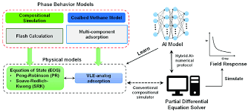

**Figure 1:** Behavior model in AI

To maintain the model behavior and capture the fluctuations at their inception, it is necessary to thoroughly understand the model’s decision-making. This is where **Machine Learning Explain ability** comes into the picture. Machine learning explain ability brings the right approach to explain the reasons behind any specific prediction made by the ML model. It helps understand and interpret the model’s behavior. In simple terms, an AI model is a tool or algorithm that is based on a certain data set through which it can arrive at a decision – all without the need for human interference in the decision-making process. An AI model is a program or algorithm that utilizes a set of data that enables it to recognize certain patterns. This allows it to reach a conclusion or make a prediction when provided with sufficient information, often a huge amount of data. Hence, AI models are particularly suitable for solving complex problems while providing higher efficiency/cost savings and accuracy compared to simple methods.

**4.RESULTS AND DISCUSSION**

Calculation of AI impact scores. The AI’s direct impact by implementing the “AI engram framework.” Specifically, following prior studies67, we identify AI-related papers by the five MAG fields (“machine learning,” “artificial intelligence,” “computer vision,” “natural language processing,” and “pattern recognition”).

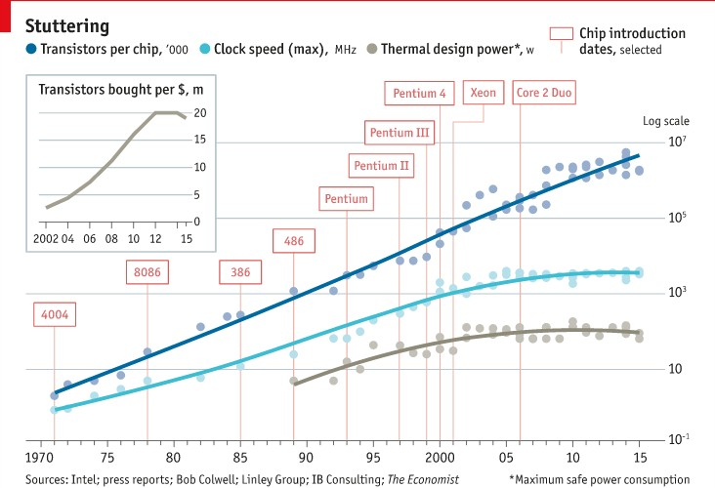

Fig: **Chip manufacturers approaching the theoretical limits of space**

Chip manufacturers are approaching the theoretical limits of space and physics that makes pushing Moore’s Law further both technologically challenging and cost prohibitive. Moore’s Law became a self-fulfilling prophecy because Intel made it so. They pushed investment and catalyzed innovation to produce more power and faster processing (The Economist, 2016). In the face of increasingly high costs and complex design considerations, processing speeds are unlikely to continue to grow in the same fashion.

Identifying AI-related research from publication databases remains a challenging task, and there are other ways to identify AI research. The extract n-grams (bigrams and trigrams) from the titles of AI-related papers and normalize them by lemmatizing words (e.g., “patterns” -> “pattern”) and standardizing them (e.g., “picture” -> “image”).

From these normalized n-grams, we filter AI related n-grams using a list of topics under the five AI field categories in the MAG “field of study” taxonomy. The frequency of AI n-grams per paper to approximate cumulative AI advances.The estimate the potential impact of AI by implementing the “AI capability-field task framework,” which is built on the future of work literature. Finally, we estimate the potential AI impact score overlapping its current tasks with cumulative AI capabilities: where the symbol “ ∑∙ ” represents dot product among matched AI and biology verb-noun frequencies, and the denominator is applied to compare across different years.

**CONCLUSION**

All in all, this review paper has given a extensive outline of AI calculations for risk-controlled algorithmic exchanging. The significance of chance control in algorithmic exchanging has been featured, stressing the requirement for strong methods to oversee and alleviate gambles in the monetary business sectors. The paper investigated different AI calculations pertinent to algorithmic exchanging, counting directed learning calculations, for example, Support Vector Machines and Support Learning calculations like Profound Learning. Each calculation's assets, impediments, and applications in algorithmic exchanging were talked about, giving bits of knowledge into their potential use cases.

By acquiring a more profound comprehension of machine learning calculations and chance administration strategies in algorithmic exchanging, dealers and analysts can settle on informed choices and create vigorous techniques that improve productivity while really overseeing chances. In general, this study paper fills in as a significant asset for people intrigued by the field of algorithmic exchanging and AI. It gives an underpinning of information, features the key ideas, and difficulties, and offers bits of knowledge into the use of AI calculations for riskcontrolled algorithmic exchanging. With the consistent progressions in AI and the ever evolving monetary business sectors, this paper sets the stage for additional exploration and development in the field.

**REFERENCES**

1. Herbert, A. S. The Sciences of the Artificial. (The MIT Press, 1969).
2. Agrawal, A., Gans, J. & Goldfarb, A. The Economics of Artificial Intelligence: An Agenda. (University of Chicago Press, 2018).
3. Brynjolfsson, E. & Mitchell, T. What can machine learning do? Workforce implications. Science 358, 1530-1534 (2017).
4. Autor, D., Mindell, D. A. & Reynolds, E. B. The Work of the Future: Shaping Technology and Institutions. (MIT Task Force, Cambridge, MA, 2019).
5. Tomasev, N. et al. AI for social good: Unlocking the opportunity for positive impact. Nature Communications 11, 2468 (2020). 15
6. Aghion, P., Jones, B. F. & Jones, C. I. Artificial intelligence and economic growth. (University of Chicago Press, Chicago, IL, 2017).
7. Cockburn, I. M., Henderson, R. & Stern, S. in The Economics of Artificial Intelligence: An Agenda 115-146 (University of Chicago Press, 2018).
8. Acemoglu, D. & Restrepo, P. The race between man and machine: Implications of technology for growth, factor shares, and employment. American Economic Review 108, 1488-1542 (2018).
9. Frey, C. B. & Osborne, M. A. The future of employment: How susceptible are jobs to computerization Technological Forecasting and Social Change 114, 254-280 (2017).
10. Iansiti, M. & Lakhani, K. R. Competing in the age of AI: Strategy and leadership when algorithms and networks run the world. (Harvard Business Press, 2020).
11. Dwivedi, Y. K. et al. Artificial Intelligence (AI): Multidisciplinary perspectives on emerging challenges, opportunities, and agenda for research, practice and policy. International Journal of Information Management 57, 101994 (2021).
12. Eshraghian, J. K. Human ownership of artificial creativity. Nature Machine Intelligence 2, 157-160 (2020).
13. Liang, W. X. et al. Advances, challenges and opportunities in creating data for trustworthy AI. Nature Machine Intelligence 4, 669-677 (2022).