**EXPERIMENTAL INVESTIGATION ON INCONEL 718 ALLOY METAL BY USING ADDITIVE MANUFACTURING PROCESS**

***Dr.N.Balasubramanyam1 Dr.P.Hema2***

***Academic Consultant 1, Associate Professor 2***

***Department of Mechanical Engineering 1, 2***

***S.V.University College of Engineering-Tirupati 1, 2***

***S.V.University, Andhra Pradesh1, 2***

**ABSTARCT:**

The Additive Manufacturing (AM) process is a computer-controlled process that uses CAD representations to build physical parts layer by layer. Almost all computer-aided design (CAD) packages allow the creation of stereo lithography (STL) files, which are translated into machine commands to drive the AM process. The process is commonly used for producing complex and intricate metal components with high accuracy. Inconel 718 is a high-strength, corrosion-resistant nickel-based super alloy. It is one of the most widely used materials in demanding applications where high-temperature and extreme environment resistance is required. In present research work the IN718 samples are manufactured by using DMLS and modeled by using CAD as per ASTM Standards. The modeled samples were saved in STL file and fabricated by DMLS method in different orientations. To know the mechanical properties of additively manufactured INCONEL 718 samples by mechanical tests like Tensile, compression, impact wear and corrosion tests will be performed. The results obtained for both the set of samples fabricated in different orientations will be compared with the values of wrought or casted samples of INCONEL 718 alloy and determine the DMLS fabricated parts has good mechanical properties compared to casted samples of INCONEL 718.

***Keywords: Inconel 718, DMLS Process, Horizontal, Vertical, Tensile and Compression Strength, impact strength.***

**1.0 INTRODUCTION:**

To a large extent, the advantages of modern civilization can be attributed to the higher standard of goods that now have access to. The quality of goods can be improved through proper design, which takes into account both functional and manufacturing requirements. Products are made by converting raw materials into finished goods, which include the design and production of goods using a wide range of techniques and methods.

* 1. **HISTORY OF ADDITIVE MANUFACTURING**

In the early 2000s, additive manufacturing (AM) became popular because of the idea of materials being combined. As an alternative, the term "subtractive manufacturing" was coined to refer to a broad range of machining methods in which material removal is the primary method of producing a finished product.

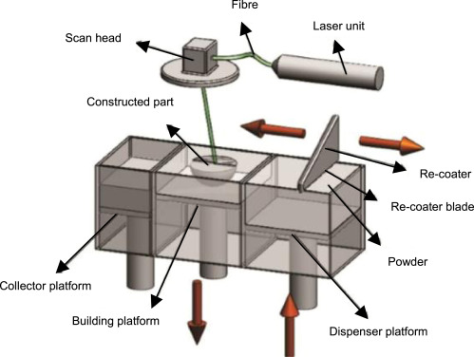

**Figure 1.1: Schematic Diagram of DMLS**

**2. LITERATURE REVIEW**

The experimentally investigated the mechanical properties of the components through DMLS process .mechanical properties of a component fabricated through DMLS process is more inferior to traditional manufacturing process. Process parameters such as layer thickness, scan speed, laser power has showing large impact on hardness [1].

**3. METHODOLOGY AND MATERIAL DESCRIPTION AND FABRICATION**

**Selection of Material:**

Material used for fabrication of samples is Inconel 718. Initially the material is taken in the form of powder. In718 powder was obtained from EOS engineering Inc. The powder is sieved with a mesh size of 90 μm to avoid inhomogeneity in the distribution of the particle size. The machine which is used for fabricating the samples is EOSM290.Produces highest quality metal parts in additive manufacturing. The robust system design and the powerful 400-watt fiber laser enable a reliably high performance day in, day out. Powder bed fusion (PBF) is an additive manufacturing process and works on the same basic principle in that parts are formed through adding material rather than subtracting it through conventional forming operations such as milling**.** Cross sectional area we then begin to apply weight to the material gripped. In this chapter experimental results obtained from the tensile test, compression test, corrosion test, wear test, of horizontal and vertical orientation Inconel 718 samples has been discussed.

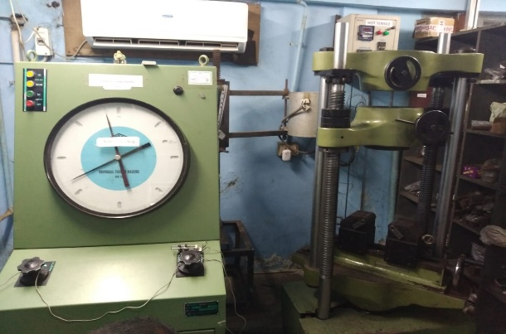 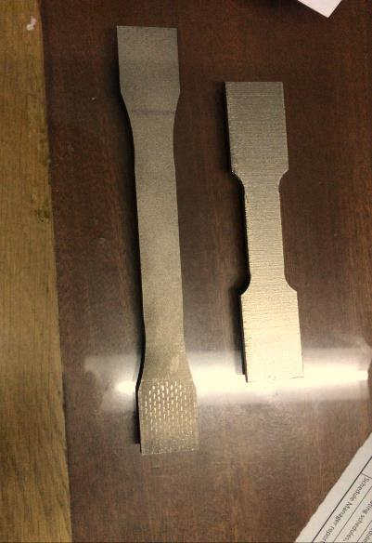**Figure 3.1: Schematic Diagram of UTM Figure 3.6: Tensile Inconel specimens**

Tensile test is performed on this vertical orientation specimen and the results are carried out. After getting results of individual orientations of both the specimens we then compared their results.

**3.3 DIMENSIONS OF COMPRESSION INCONEL 718 SAMPLES**:

Dimensions of compression test horizontal orientation specimen as per ASTM standards are as follows: in our study we are considering only length and height of the specimen for compression test. There are various types of corrosion tests.in our experiment we are using electro chemical corrosion testing. A potentiostat instrument is usually used to perform this sort of this test. A three electrode setup, including working electrode, reference electrode and counter electrode are usually used. Potential, current, and time are three important parameters in electrochemical tests.in these tests an applied potential generally scans in a certain range and the current is measured.

**Table 3.1: Chemical composition of In718 (Metal Composition Data)**

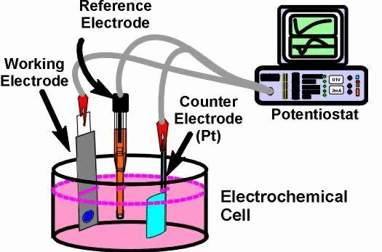 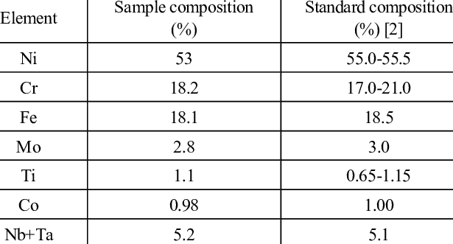

**Figure 3.15: Schematic diagram of corrosion test**

**4. RESULTS AND DISCUSSIONS**

**4.1 Tensile test:**

After performing the tensile test on Inconel 718 specimens of both horizontal and vertical layer orientations which are fabricated through DMLS process, the results obtained are yield strength and tensile strength, The reason behind that is, in horizontal layer orientation the tensile load applied is parallel to the layer fabrication and the bonding between the layers is more when compared to the vertically layer oriented Inconel specimen which results in more tensile strength.

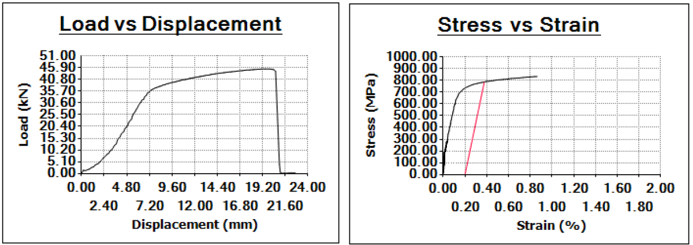 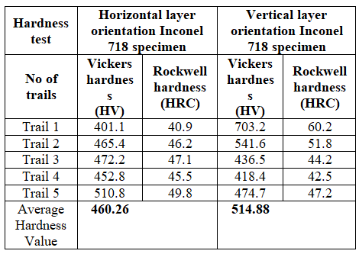

**Figure 4.1: Stress strain graph of horizontal orientation Inconel tensile specimen:**

Figure 4.1 shows the stress strain relationship of vertically oriented tensile specimen. From the graph it is observed that percentage of strain 0.36% is occurred when the stress of 794.18 MPA is applied on the specimen. Table 4.2: Vickers hardness (HV) and Rockwell hardness (HRC) results of horizontal and vertical orientation Inconel 718 specimens: It is observed that average hardness for vertically oriented Inconel 718 specimen is higher than horizontal layer oriented Inconel specimen.

**5. CONCLUSIONS**

The mechanical properties such as hardness, tensile strength, compression strength, impact resistance, wear resistance, corrosion resistance of Inconel 718 specimen of both horizontal and vertical layer orientations, fabricated by powder bed fusion process was studied experimentally. The following conclusions are drawn from the experimental results. Based on the experimental results it is concluded that the ultimate tensile strength, percentage of elongation, wear resistance, wear resistance, corrosion and impact resistance of horizontally fabricated sample is higher than that of vertically fabricated sample.

**6. FUTURE SCOPE**

The work can be extended to analyze other parameters and other mechanical properties. The level of experiments can be increased for better results. For better results and accuracy we can also use optimization techniques like taguchi analysis, in addition to experimental analysis.

**REFERENCES**

1. "An overview of investigation of Fatigue, tensile strength and hardness of the components fabricated through direct metal laser sintering (DMLS) process."**Maurya, Nagendra Kumar, Rohit Sharma, Nikhil Kumar, Anubhav Kumar, Piyush Anand, Prakhar Rai, and Harjeet Singh.** *Materials Today: Proceedings* 47 (2021): 3979-3984.
2. "Toward qualification of additively manufactured metal parts: Tensile and fatigue properties of selective laser melted Inconel 718 evaluated using miniature specimens." **Wan, H. Y., W. K. Yang, L. Y. Wang, Z. J. Zhou, C. P. Li, G. F. Chen, L. M. Lei, and G. P. Zhang***, Journal of Materials Science & Technology* 97 (2022): 239-253.
3. "Investigations on the fracture behavior of Inconel 718 superalloys obtained from cast and additive manufacturing processes." **Vieille, B., Clément Keller, M. Mokhtari, H. Briatta, T. Breteau, J. Nguejio, F. Barbe, M. Ben Azzouna, and E. Baustert.** *Materials Science and Engineering: A* 790 (2020): 139666.
4. "Direct metal laser sintered (DMLS) process to develop Inconel 718 alloy for turbine engine components." Raj, B. Anush, JT Winowlin Jappes, M. Adam Khan, V. Dillibabu, and N. C. Brintha. *Optik* 202 (2020): 163735.