Artificial Intelligence in
Detection of Cardiovascular Diseases in ECG Images

Nadipena Jhansi¹, Saragadam Sridhar², A.Arjuna Rao³
¹ Department of MCA ,Miracle Educational Society Group of Institutions
Email: nadipena.janshi@gmail.com
² Department of MCA ,Miracle Educational Society Group of Institutions
Email: ssaragadam@miracleeducationalsociety.com
³Department of CSE , Miracle Educational Society Group of Institutions
Email: aarao@miracleeducationalsociety.com

ABSTRACT
Cardiovascular diseases (heart diseases) are the leading cause of death worldwide. The earlier they can be predicted and classified; the more lives can be saved. Electrocardiogram (ECG) is a common, inexpensive, and noninvasive tool for measuring the electrical activity of the heart and is used to detect cardiovascular disease. In this article, the power of deep learning techniques was used to predict the four major cardiac abnormalities: abnormal heartbeat, myocardial infarction, history of myocardial infarction, and normal person classes using the public ECG images dataset of cardiac patients. First, the transfer learning

approach was investigated using the low-scale pretrained deep neural networks SqueezeNet and AlexNet. Second, a new convolutional neural network (CNN) architecture was proposed for cardiac abnormality prediction. Third, the aforementioned pretrained models and our proposed CNN model were used as feature extraction tools . According to the experimental results, the performance metrics of the proposed CNN model outperform the exiting works; it achieves better accuracy.

INTRODUCTION
ACCORDING to the World Health Organization, cardiovascular diseases (heart diseases) are the leading cause of death worldwide. They claim an estimated 17.9 million lives each year, accounting for 32% of all deaths worldwide. About 85% of all deaths from heart disease are due to heart attacks, also known as myocardial infarctions (MI) [1]. Many lives can be saved if an efficient diagnosis of cardiovascular disease is detected at an earlier stage [1]. Different techniques are used in the healthcare system to detect heart diseases, such as electrocardiogram (ECG), echocardiography (echo), cardiac magnetic resonance imaging, computed tomography, blood tests, etc. [2], [3]. The ECG is a common, inexpensive, and noninvasive tool for measuring the electrical activity of the heart [4]. It is used to identify heart-related cardiovascular diseases [4], [5]. A highly skilled clinician can detect heart disease from the ECG waves. However, this manual process can lead to inaccurate results and is very time-consuming [5]. There is great potential to benefit from advances in artificial intelligence in healthcare to reduce medical errors. In particular, the use of machine learning and deep learning techniques for automatic prediction of heart diseases [3], [6]–[10]. The machine learning methods require an expert entity for features extraction and selection to identify the appropriate features before applying the classification phase. Feature extraction is a process of reducing the number of features in a data set by transforming or projecting the data into a new lower-dimensional feature space preserving the relevant information of the input data [11], [12]. The concept of feature extraction is concerned with creating a new set of features (different from the input feature) that are a combination of original features into a lower-dimensional space that extract most, if not all, of the information in input data. The most well-known feature extraction method is a principal component analysis [13], [14]. However, feature selection is a process of removing irrelevant and redundant features (dimensions) from the data set in the training process of machine learning algorithms. Various methods can be used for feature selection, classified as unsupervised, which refers to the method that does not need the output label for feature selection, and supervised, which refers to the methods that use output label for feature selection. Under supervised feature selection, there are three methods: the filter method, the wrapper method, and the embedded method [11], [12]. Many machine learning methods have been used for predicting cardiovascular diseases. Soni et al. [15] compared several machine learning algorithms, such as decision tree (DT), Naïve Bayes (NB), K-nearest neighbors (K-NN), and neural network (NN) on UCI Cleveland heart disease dataset. They concluded that DT had the highest accuracy of 89%. Dissanayake and Md Johar [16] studied the effect of the feature selection process on machine learning classifiers for predicting heart diseases from the UCI Cleveland heart disease dataset. They examined different feature selection techniques, such as ANOVA, Chi-square, forward and backward feature selection, and Lasso regression. After that, they applied six machine learning classifiers, which are DT, random forest (RF), support vector machine (SVM), K-NN, logistic regression (LR), and Gaussian NB (GNB). With the feature selection process, the prediction accuracy was improved such that using the backward feature selection method, the highest classification accuracy of 88.52% has been achieved with the DT classifier. The use of machine learning algorithms, such as NB, SVM, and DT algorithms, was studied in [17] using ten-fold cross-validation, on the South African heart disease dataset with 462 instances. The best results were obtained from NB for detecting heart disease with an accuracy rate of 71.6%, sensitivity of 63%, and specificity of 76.16%. Kim et al. [18] compared NN, SVM, classification based on multiple association rule (CMAR), DT, and NB algorithms to predict cardiovascular diseases on two types of datasets consisting of ultrasound images of carotid arteries (CAs) and heart rate variability (HRV) of the ECG signal. The combined extracted features from the CAs+ HRV dataset obtained higher accuracy than the separated features of CAs and HRV. Thus, SVM and CMAR classifiers outperformed the others by the accuracy of 89.51% and 89.46%, respectively. On the other hand, deep learning, which is a subfield of machine learning, automatically extracts important features and patterns from the training datasets for the classification phase without the intervention of separate entities for features extraction and selection. Fig. 1 illustrates the abstract concept of machine learning and deep learning. In deep learning, a model is created by constructing multiple hidden layers of NNs. Convolutional neural network (CNN) is a deep learning method, which has achieved satisfactory results on image classification tasks. The power of deep learning and pretrained networks can be used for feature extraction without having to retrain the whole network, transfer learning, and classification [9]. In this article, the pretrained networks, i.e., SqueezeNet [2] and AlexNet [2], are used as a transfer learning approach to study their performance in heart disease classification and as feature extraction for traditional machine learning methods for heart disease classification. In addition, a new CNN model is proposed for heart disease prediction using ECG images and used for feature extraction of the ECG images after training the new proposed CNN model

LITERATURE SURVEY
In literature a number of laptop mastering based totally analysis methods have been proposed through researchers to analysis HD. This lookup find out about current some current laptop getting to know based totally prognosis strategies in order to give an explanation for the vital of the proposed work. Detrano et al. [1] developed HD classification gadget via the usage of laptop studying classification methods and the overall performance of the machine used to be 77% in phrases of accuracy. Cleveland dataset was once utilized with the technique of international evolutionary and with elements decision method. In every other find out about Gudadhe et al. [2] developed a prognosis machine the usage of multi-layer Perceptron and assist vector computer (SVM) algorithms for HD classification and finished accuracy 80.41%. Humar et al. [3] designed HD classification machine with the aid of utilizing a neural community with the integration of Fuzzy logic. The classification device finished 87.4% accuracy. Resul et al. [9] developed an ANN ensemble primarily based analysis gadget for HD alongside with statistical measuring device business enterprise miner (5.2) and acquired the accuracy of 89.01%, sensitivity 80.09%, and specificity 95.91%. Akil et al. [24] designed a ML based totally HD analysis system. ANN-DBP algorithm alongside with FS algorithm and overall performance was once good. Palaniappan et al. [7] proposed an specialist scientific analysis machine for HD identification. In improvement of the device the predictive mannequin of desktop learning, such as navies bays (NB), Decision Tree (DT), and Artificial Neural Network had been used. The 86.12% accuracy used to be executed with the aid of NB, ANN accuracy 88.12% and DT classifier executed 80.4% accuracy. Olaniyi et al. [18] developed a three-phase method primarily based on the synthetic neural community method for HD prediction in angina and done 88.89% accuracy. Samuel et al. [2] developed an built-in clinical selection guide machine based totally on synthetic neural network and Fuzzy AHP for prognosis of HD. The overall performance of the proposed approach in phrases of accuracy used to be 91.10%. Liu et al. [5] proposed a HD classification gadget the usage of remedy and tough set techniques. The proposed approach done 92.32% classification accuracy. In [6] proposed a HD identification technique the use of function resolution and classification algorithms. Sequential Backward Selection Algorithm (SBS FS) for Features Selection. The classifier K-Nearest Neighbor (K-NN) overall performance has been checked on full and on chosen elements set. The proposed approach received excessive accuracy. In every other find out about MOHAN et al. [7] designed a HD prediction approach via the use of hybrid computer studying techniques. He additionally proposed a new approach for vast characteristic decision from the information for fantastic coaching and checking out of laptop gaining knowledge of classifier. They have been recorded 88.07% classification accuracy. Geweid et al. [8] designed HD identification methods by means of the use of increased SVM based totally duality optimization technique. In the above literature the proposed HD analysis techniques drawback and blessings have been summarized in Table 1 for higher appreciation the necessary of our proposed approach. All these current strategies used severa strategies to pick out the HD at early stages. However, all these methods have lack of prediction accuracy and excessive computation time for prediction of HD. According to Table 1 the prediction accuracy of HD detection approach want in addition enchancment for environment friendly and correct detection at early tiers for higher therapy and recovery. Thus, the primary troubles in these preceding tactics are low accuracy and excessive computation time and these may be due the use of inappropriate facets in dataset. In order to address these issues new techniques are wanted to observe HD correctly. The enchancment in prediction accuracy is a huge assignment and lookup gap.

2.1 A. L. Bui, T. B. Horwich, and G. C. Fonarow, ‘‘Epidemiology and risk profile of heart failure,’’ Nature Rev. Cardiol., vol. 8, no. 1, p. 30, 2011.

Heart failure (HF) is a foremost public fitness trouble with a modern-day occurrence of over 5.8 million in the USA and over 23 million worldwide.1,2 Every 12 months in the USA, extra than 550,000 folks are recognized with HF for the first time, and there is a lifetime chance of one in 5 of growing this syndrome.1,3 A analysis of HF includes big hazard of morbidity and mortality, notwithstanding advances in management. Over 2.4 million sufferers who are hospitalized have HF as a principal or secondary diagnosis, and almost 300,000 deaths yearly are immediately attributable to HF.1
From the Nineteen Seventies to 1990s, a dramatic extend in the occurrence of HF and wide variety of HF hospitalizations used to be observed,4–6 and an epidemic was once declared.7,8 Most of the HF burden is borne via people aged ≥65 years, who account for greater than 80% of the deaths and time-honored instances in the USA and Europe.6,9 The developing incidence of HF may mirror growing incidence, an growing old population, enhancements in the remedy of acute cardiovascular disorder and HF, or a mixture of these factors. Promising proof from country wide databases as properly as community-based cohorts, such as these based totally in Framingham and Olmsted County,3,10–16 suggests that the incidence of HF appears to be stabilizing, if now not decreasing, for women, and that the size of survival in sufferers with HF is increasing. Such tendencies might also have resulted from demographic shifts, adjustments in the occurrence of danger factors, or enhancements in the availability and software of HF treatments.17,18 Furthermore, cognizance of and grasp for HF and preserved left ventricular ejection fraction (LVEF) is increasing. HF and preserved LVEF now represents &gt;50% of HF instances and can have effects as terrible as these related with HF and decreased LVEF, however it does now not but have a validated wonderful administration strategy.19–21 In this Review, we describe the epidemiology of HF, highlighting tendencies in general prevalence, incidence, and mortality of HF as a total and in subgroups. We additionally spotlight how recognized hazard elements affect each incidence and severity of HF and talk about the have an impact on of HF on the utilization of fitness services.
[2] G.-M. Park and Y.-H. Kim, ‘‘Model for predicting cardiovascular disease: Insights from a Korean cardiovascular risk model,’’ Pulse, vol. 3, no. 2, pp. 153–157, 2015, doi: 10.1159/000438683.
Between Western and Asian populations, the profile and prevalence of risk factors for cardiovascular disease (CVD) differ. For the primary prevention of CVD in asymptomatic people, the guidelines advocate individualised interventions based on risk stratification based on CVD risk models. Current risk models for predicting CVD in Asian populations, on the other hand, are restricted. A CVD risk model for predicting global cardiovascular risk was constructed in a recent research of a large cohort of asymptomatic Korean individuals, and it performed well in predicting cardiovascular events. This strategy could be effective in the primary prevention of CVD in both East Asians and Koreans.
Many research works have been conducted for automatically predicting cardiovascular diseases using machine learning and deep learning methods by utilizing ECG as digitals or images data representation. Bharti et al. [2] compared machine learning and deep learning methods on the UCI heart disease dataset to predict two classes. The deep learning method achieved the highest accuracy rate of 94.2%. In their architecture of deep learning model, they used three fully connected layers: the first layer consists of 128 neurons followed by a dropout layer with 0.2 rate, the second layer consists of 64 neurons followed by a dropout layer with 0.1 rate, and the third layer consists of 32 neurons. The machine learning methods with features selection and outliers’ detection achieved accuracy rates as: RF is 80.3%, LR is 83.31%, K-NN is 84.86%, SVM is 83.29%, DT is 82.33%, and XGBoost is 71.4%. The research in [9] concluded that deep learning has proven to be a more accurate and effective technology for a variety of medical problems such as prediction. Deep learning methods will replace the traditional machine learning based on feature engineering. Kiranyaz et al. [30] proposed a CNN that consisted of three layers of an adaptive implementation ofone-dimensional (1-D) convolution layers. This network was trained on the MIT-BIH arrhythmia dataset to classify long ECG data stream. They achieved accuracy rates of 99% and 97.6% in classifying ventricular ectopic beats and supraventricular ectopic beats, respectively. Also, the work in [31] proposed a CNN that consisted of three 1-D convolution layers, three max-pooling layers, one fully connected layer, and one softmax layer. The filter size for the first and second convolutional layers was set to 5 and a stride of 2 was used for the first two max-pooling layers. They achieved an accuracy rate of 92.7% in classifying ECG heartbeats using the MIT-BIH arrhythmia dataset. Khan et al. [22] applied transfer learning approach using the pretrained single shot detector (SSD)-MobileNet-v2 [32] to detect cardiovascular diseases from the ECG images dataset of cardiac patients by predicting the four major heart abnormalities: abnormal heartbeat (AH), MI, history of MI (H. MI), and normal person (NP) classes. As preprocessing steps, the data size was adjusted and the 12 leads of each ECG image were labeled. SSD is used to classify and localize the objects in one step. The dataset was split 80% for training and 20% for testing. They used a batch size of 24, 200K training iterations for the training step, and a learning rate of 0.0002 to train their model. Their training phase lasted almost 4 days.

Methodology
The ECG categorization system developed in this article may be divided into four major stages, as shown in Figure 2. The following are the stages:
(i)Preprocessing ECG
(ii)Detection of QRS and segmentation signal
(iii)Extraction of parameter(iv)Extracted parameter classification and clustering
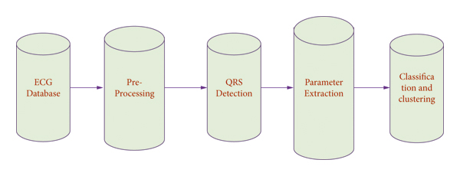
Figure 1

ECG Preprocessing
The preprocessing objective stage is to increase an overall ECG quality signal so that it can be analyzed and examined more accurately. The reduction of baseline deviations and the other patterns in a raw signal produced by the power line intrusions and the artifacts was the first stage in the ECG analysis process [4]. Background drift is an unnecessary minimum-frequency movement in ECG that can affect with analysis of the signal, resulting in incorrect and misleading clinical interpretation. Its spectrum content is typically much below 1 Hz, but higher frequencies may be present during intensive exercise.
Filtering is among the most popular ways for removing excessive noise and baseline drift from ECG readings. In the past, both FIR and IIR filter types were effectively used for this task, with lower and higher rates of cutoff in the 0.8 Hz and 40 Hz ranges, respectively. A cutoff frequency greater than 0.8 Hz has been documented to alter the waveform of ECG significantly, and it should be evaded. Bandpass filtering is utilized in this work to minimize and eliminate the noise disturbance that usually appears in ECG readings. The bandpass ECG filter has a lower cutoff frequency of 5 Hz and a higher cutoff wavelength of 40 Hz.

Detection of QRS
The QRS complex was the single greatest critical element of the ECG signal. For such a QRS complex, the start and delay of the QRS complex, as well as the P and T waveforms, are all defined. Most QRS recognition algorithms are built mainly on a filtering step trailed by the averaging based on a threshold value [5]. This threshold is being used to differentiate between the background and the QRS complex and is based on the ECG signal’s top position. Other techniques based on machine learning include the method of P-spectrum, a powerful way of detecting periodicity derived from data discontinuity.

Extraction of the Parameter
At the next level of the system, AR modeling of the two or more consecutive ECG beats using the discrete variant of an AR signal model of order j, AR(j), is used after an individual heartbeat detection for each ECG signal. Each dataset’s order j is determined by examining the variance of forecast errors as a function of basic functions j. Modeling two consecutive ECG beats identified using the filter bank method briefly mentioned in the preceding section yielded good results in this study [6]. The estimated model’s coefficients are subsequently employed as classification signal characteristics in the design and system period. A signal sequence as
will be described by the AR model in the following equation: The model coefficients, commonly defined as the parameters of autoregressive, utilized in the classiﬁcation model are and is a white noise sequence, technology process with a zero mean, and variance . In equation (2), the calculated autoregressive model is now regarded as a p-point predictions filter, only with actual output predicted from the preceding AR processes target value.
where characterize the assessed limits of the AR design.

Classification
The collected ECG signal characteristics were classified and recognized using various classification techniques. The multidimensional matrices carrying the calculated autoregressive parameters for every beat of the recorded ECG signal are a characteristic of this work. The k-nearest neighbor method is among the most commonly used approaches in bioinformatics and other fields due to its simplicity, although attention must be given while picking the model of order k as appropriate dimension measures. To the next stage of this study, the electrocardiography identifying patient characteristics was addressed and evaluated using linear (LDA) and quadratic (QDA) discriminant analysis classifiers employed in a different bioinformatics application.

Heartbeat Classifier
An echo state network (ESN) is used to create the suggested heartbeat classifier. It divides the analyzed electrocardiogram records’ heart rates into two groups depending on morphological features: VEB+ and SVEB+. Normal (N) and supraventricular ectopic (S or SVEB) heartbeats were both classified as SVEB+. In contrast to VEB + heart rate, which has a ventricular source or aberrant morphology, those heart rates have a regular morphological characteristic and a supraventricular source. Ventricular ectopic beats (V or VEB) and fusion beats were included in the VEB + category (F).
The training (DS1) and testing (DS2) sets’ heartbeat class distributions.
Figure 1 depicts the complete procedure in schematic form. There is a clear distinction between the two phases:
(i) Stage 1: feature extraction, filtering, heartbeat segmentation, and heartbeat detection are all part of the first phase of ECG recorded analysis. In this approach, we integrate morphological and time pauses among heart rates.
(ii)Stage 2: classification between SVEB+ and VEB + classes, to execute this classifying assignment, we utilize an ensemble of ESNs with ring topology. Further in the article, we go over the classification technique in phase two in greater depth.

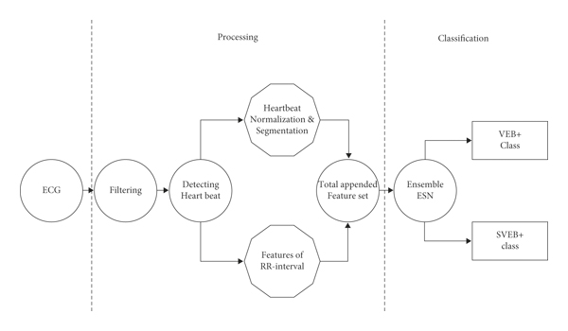

Figure-2

Feature Extraction and ECG Processor
Minor preprocessing of the original ECG recordings is required to achieve arrhythmia categorization. The basic methods are included in the analysis of ECG records in this framework.

ECG Filtering
To adjust the foundation and eliminate undesirable high frequencies noises, every ECG recordings are processed in a band width . With conventional technique, a Butterworth high-pass filter (with a cutoff frequency of ) and a 12th-order limited impulse response filter (35 Hz, at 3 dB point) were utilized.

Resampling of ECG Signals
ECG transmissions were analyzed at a monitoring frequency of 260 Hz. Utilizing the Physio Toolkit application programme, the AHA dataset (260 Hz) is kept at its normal recording frequency, while the MIT-BIH AR dataset (350 Hz) is normalized to 260 Hz.

Computation of the RR Interval
The RR interval is measured as the period among succeeding heart rates. The duration comparison of heartbeat i and the preceding heartbeat (i−1) is represented by the RR interval linked with heartbeat i,

Heartbeat Detection
Annotated coordinates offered by datasets were employed to estimate the placement of heart rates. The annotating position in the MIT-BIHAR database is at the highest of the QRS complex’s localized edges. The identification of beats is outside the focus of this research. There have also been reports of extremely effective automatic beat recognition systems.

Normalization of Segmented Heartbeats
Every segmented heart rate is normalized among [1, 1]. This scalability technique yields a signal that is unaffected by the frequency of the initial ECG recordings.

Heartbeat Segmentation
Every database’s indicated position is used to segment the ECG signals. The segmented heart rates are 250 milliseconds long (65 samples per second at 250 Hz) and are centered on the annotated place.
Every heart rate is characterized by a collection of properties once the ECG recordings have been processed. Because we want to construct a rapid and real-time heartbeat classification, one of the key objectives of selecting parameters in this system is to prevent difficult characteristics with a large computing expense. As a result, we concentrate on straightforward methods for extracting characteristics. In our example, we display it with the actual waveform of every heartbeat between the heart rate points. Every beat’s actual information was provided by an equivalent number of samples from every side of the beat identification position. Every pulse is displayed as a
vector at the conclusion of the preprocessing and extraction of features phase, with three characteristics related to the RR intervals and 65 morphological features that are basically a sampling of the ECG waveform around the point indicated for every heart rate. The categorization technique takes this vector (d = 62) as inputs.

Waveform of ECG
ECG patterns are traces of the heart’s electrical system and play an important role in the diagnosis method for analyzing physical health. A typical ECG trace is comprised of a P wave, QRS complex, and T wave during every ventricular contraction [17]. Arrhythmias are abnormal heartbeats that arise when the usual pattern of electrical impulses in the heart is disrupted. Arrhythmias can happen in both the lower and upper heart chambers, but ventricular arrhythmia will be experienced.
As previously stated, artifacts and noise in signals must be eliminated to identify P, QRS, and T waves. To identify P, QRS complex, and T waveforms, the traditional wavelet transform-based filtering technique is utilized to eliminate noise and artifacts. To improve detection accuracy, TERMA and FFT are combined machine learning methods that were utilized to identify the ECG signals and evaluate if there is any CVD. The next subsections go over the specific duties in further depth.

Signal Filtering
The ECG signals were nonstationary, which means that resonance frequency varies over a period of time. Also, the noise and objects contaminating the ECG signal were nonlinear, with a time-dependent probability density. Time localization is not possible with traditional Fourier transform techniques, but it is possible with DWT. As a result, DWT is more capable of dealing with nonstationary signals [18]. The first step is to use DWT to eliminate the average drift. To do so, first, compute the wavelet’s core frequency,
(also known as the F_{c} factor), which ranges from 0 to 1 based on the signal’s resemblance to the chosen waveform.
Daubechies-4 (db4) has the greatest factor, equal to 0.7, for ECG signals. Then, at each level, the pseudo frequency, is determined using the following equation: where and are the ECG signal’s gauge and selection frequency, respectively. The majority of the baseline drift occurs at 0.5Hz. The scales equivalent to various pseudo frequencies will be easily computed using (3) for the MIT-BIH Fs = 360. Up to scale 9, which corresponds to = 0.5, should be decomposed. As a result, the db4 wavelet divides the ECG signal into approximation and detailed coefficients up to scale 9. To find a baseline signal drift-free, the estimated coefficients related to the drift baseline were eliminated, and the signal was rebuilt using IDWT.

Fusion Algorithm to Detect R Peaks
At the R peak in ECG signal, there was greatest change in the frequency. The time localization can be compromised when using the Fourier transform of the ECG data. FFT should be used to the noise-free information in this stage to transform it in the time-frequency domain. The FFT operation includes chirp multiplying, chirp inversion, and another chirp multiplication, as shown in the arrangements [19]. Rotation of the information with a higher value is comparable to getting closer to the transmitter resonant frequency; however, moving that with a reduced amount is equal to moving away from the signal’s resonant frequency, which is equivalent to getting closer to the signal’s temporal domain. Time localization is crucial when it comes to R peak detection. Using the hit-and-trial techniques, it was discovered that the parameter of
boosts R peaks properly and makes them difficult to recognize. By squaring each sample after applying FFT, then the R peak was increased more. Following the enhancement, the two MAs depending on event and cycle are determined:
MA is represented as moving average, is determined by the length of the QRS complex, and is determined by the length of the heartbeat. The augmented signal’s mean () is determined and increased by factor (); the optimum parameter value was determined using the hit-and-miss approach. The output value was applied to producing threshold values and is represented by . The values were compared to the relevant threshold values. One is assigned if is greater than the nth criterion. A new vector is created if zero is not provided. This produces a stream of nonuniform distribution rectangular pulses.
Finally, illustrated in Figure 4, the pulses with widths equal to are the blocks that include the anticipated event. The R peak value for every block is the high value in the accompanying improved signal. This procedure is described in depth. After applying the suggested technique, the R peaks were accurately recognized.

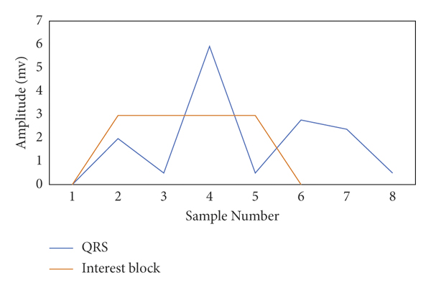
Figure 3
Detection of the R peaks: a block of interests is generated.

Detection of P and T Peak Using Fusion Algorithm
TERMA employs a complex threshold to identify P and T peaks. Using a reduced threshold, we were able to minimize the algorithm’s overall processing complexity. The R peaks are removed in the first phase of the algorithm, allowing the P and T peaks to be more noticeable. In the noise-free signal, 30 samples (0.083 s) were well earlier than the R peak and the 60 samples (0.166 s); then, the R peak value was set to 0 [20]. For any CVD, the probability of the P and T waves in the specified interval was practically nil. The signal was replaced in a time-frequency plane using the FFT to boost the P and T peaks after the QRS interval was removed. Blocks of interest were formed in the same way as in the following step, as illustrated in Figure 5, utilizing two moving axes:
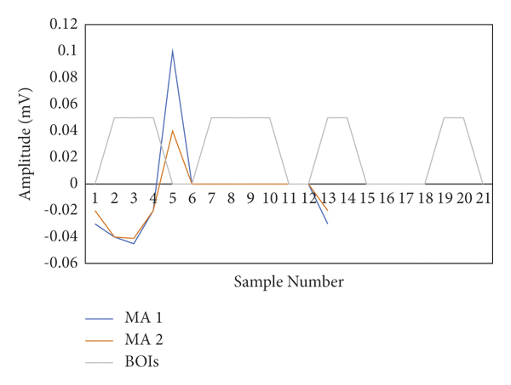
Figure-4

Detection of the P and T peaks and then interest block is generated.
W3 is determined by the frequency of the P wave, W4 is determined by the QT interval, , and W421. The P wave duration in a fit individual will be ms; then, the QT interval will be ms. Instead of using a standard size window to identify P waves, a minimum window is used to account for unique characteristics of the arrhythmias. The measurements were just the values of the next moving average, as opposed to the R peak detection. One is assigned if the initial average was higher than the comparable next moving average. A new vector is created if the zero is not get assigned. This produces a stream of nonuniform rectangular impulses. Finally, to separate the created blocks from blocks containing P and T peaks, a threshold depending on the intervals of PR, RR, and RT was used. The highest power of the block is referenced as the P peak if the gap is between the highest benefits of the block and the nearest R peak on the specified PR interval. If the difference only between the appropriate dosage of the component and the closest R peak is below a prescribed RT period, the highest values of the blocks were referred to as as T peak.

Machine Learning Supervised Algorithms
The categorization of ECG signals is a crucial and difficult endeavor. It will deliver a great deal of information about a patient’s CVDs without the need for cardiology. Only a specialist is needed to connect the inquiries, and also machine learning-based system will detect a patient’s CVDs immediately [21]. This method can quickly identify people that require rapid medical intervention. The MLP and SVM supervised learning techniques are employed for the classification in this study and explained temporarily in the subcategories below.

SVM Classifier
In regression and classification issues, the SVM algorithm can be employed. Information is displayed in the space of l-dimensional in SVM, with l being the variety of attributes. Following the graph of the information, classification is carried out by locating a hyperplane, distinguishing between several classes [22]. The hyperplane is optimized via maximization of the margin. The hyperplane that is nearest to the nearest information points between the other hyperplanes is picked. The ratio that indicates the issue is fixed by the SVM:
subject towhere are the Lagrangian multipliers, W is denoted as constant, and is a kernel function, where are the input features, are class labels. The Gaussian radial basis function is a widely popular kernel.
In higher-dimensional environments, the number of sizes exceeds the number of models and the SVM is particularly successful.

Multilayer Perceptron Classifier
Artificial neural network (ANN) methods identify zones using an approach that mimics human brain functions like comprehending, learning, problem-solving, and decision-making. Three layers make to the ANN model. The input image is the initial layer, and the number of neurons in this sheet are determined by input parameters [23]. The output layer is the final layer, with the hidden neurons representing the number of the output classes. The hidden layers exist among the hidden layer and the output layer. MLP is a feedforward neural ANN subclass used during this study.
This segment is divided into four sections that are focused on recognition of arrhythmias, detection of the peak, cross-database training and testing, and classification, respectively.

Recognition of Arrhythmias
To assess the effectiveness of the proposed scheme, an ECG set of results containing three different types of ECG signals has been used. The dataset contained normal ECG signals (NR) from Politecnico of Milano VCG/ECG Data on Young Normal Subject, arrhythmia (AR) from the MIT-BIH Arrhythmia Database, and ventricular arrhythmia (VAR) again from MIT-BIH Malignant Ventricular Arrhythmia Database. Every kind was represented by 20 half-hour records of two-channel outpatient ECG data, although the testing just took minutes for each person. After the beat recognition and signal separation steps, AR parameters are produced for each extracted group of beats. The frequency of beats in each band and also the number of AR parameters collected for each team could all have an effect on the performance of the classifying program. The effective classification was achieved for 1–5 beats in the band and 2–4 AR variables. This shows the performance of the two beats per set with AR order values of two and three in this study. Figure 6 depicts the error values for different AR-type orders for both preprocessed and raw ECG signals. However, more difficult procedures are normally employed to decide the model order; the modeling error plot’s breakpoint (“knee”) is being used to choose a model or models.
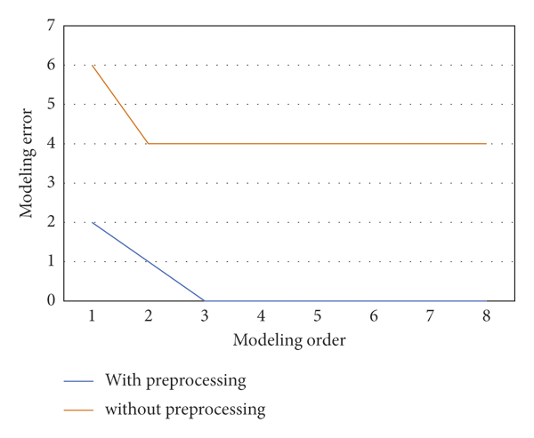
Figure 5
AR model for order selection.
The “knee point” position in Figure 6 is of lesser risk, which is determined to be adequate for such heavily processed ECG signals with an AR basis function of 2 or 3. Making extra orders has no discernible effect on modeling error or classification process accuracy. For processing ECG signals, the discontinuity in this chart is immediately evident (2 or 3); however, the same spot in the raw ECG plot is more difficult to identify. It is also worth noting that the modeling error for the processed signal is substantially smaller than the error modeling acquired when modeling the raw ECG data.
Furthermore, the variation of recovered variables should really be observed, as evidenced by the size of related feature clouds in AI feature space. When comparing the variations of the information clouds to distinguish between the two arrhythmias, the dimensionality of the data cloud associated with daily ECG signals is comparatively small, also with ventricular arrhythmia cloud containing the maximum variation and dispersion of image features.

ECG Detection of Peaks
The P, R, and T peaks are discovered in the initial portion of the simulation using our proposed FFT-based approach, and the suggested algorithm is validated across all 48 records in the MIT-BIH. This research makes use of Lead II (MLII) data. Because our approach is not affected by the magnitude of the waveforms, any following information will be helpful for the detection of the peak. Furthermore, the performance can be evaluated using various metrics described in the literature, including positive predictivity, failure rate, and sensitivity as follows:
where TP means true positive, FN represents false negative considered as marked peaks not discovered by the system, and FP represents false positive as the peaks identified by method but not simply present. If a peak is discovered within a 30 ms of the annotation peak, it is well defined as TP. This evaluated TP, FN, and FPs to measure the algorithm’s efficiency.

CVD Classification
In the next portion of the experiment, the ECG signals are categorized according to their CVDs. For all simulations, 70% of the selected features were used to train a machine learning model, while 30% was kept for test results. As a result, various features were retrieved from the waveforms for classification. The collected features were then sent into the SVM and MLP classifications, which were used to categorize the input ECG signals as regular, PVC, APC, LBBB, RBBB, and PACE heartbeats. The following performance measures were utilized to evaluate the proposed classifier’s effectiveness to that of the current ones:
where TN stands for true negative, which means that the person has a CVD and the classifier indicates that the individual is not normal.

Testing and Training Database
The MLP classifiers are trained using the MIT-BIH arrhythmia collection and subsequently evaluated on the INCART22 and SPH23 databases in St. Petersburg to classify the normal, RBBB, and PVC heartbeats. The sample rates in each of the three datasets varied. As a result, for convenience, all of the data were resized to a frequency of 128 Hz. There was no requirement for preprocessing because the data retrieved from these sources were already free of baseline drift and noise. Age, gender, PR, and RT intervals are among the objective truth. The trained model’s accuracy rate on the IN CART and SPH databases was 99.85 percent and 68 percent, respectively. The suggested approach had been unable to identify inverted, biphasic negative-positive, and biphasic positive-negative T peaks that may be observed in RBBB and PVC; the classification was unable to accurately categorize the RBBB and PVC heartbeats. As a result, its average classification accuracy suffers. There is a disadvantage to cross-database analysis. In both training and testing, illness features were normalized and the normal patient characteristics were not normalized. When applying normalization to all the testing and training data, the classifier’s exactness suffers even further. This illness is unreal and requires more research

RESULTS

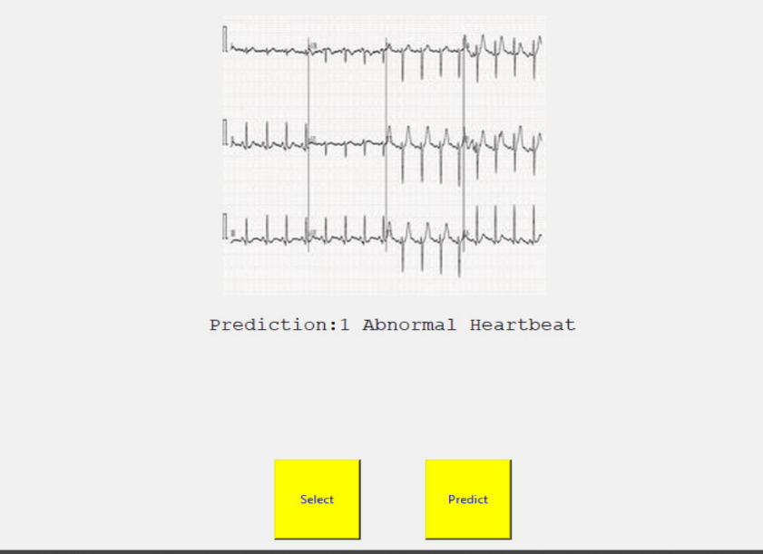

Figure-6

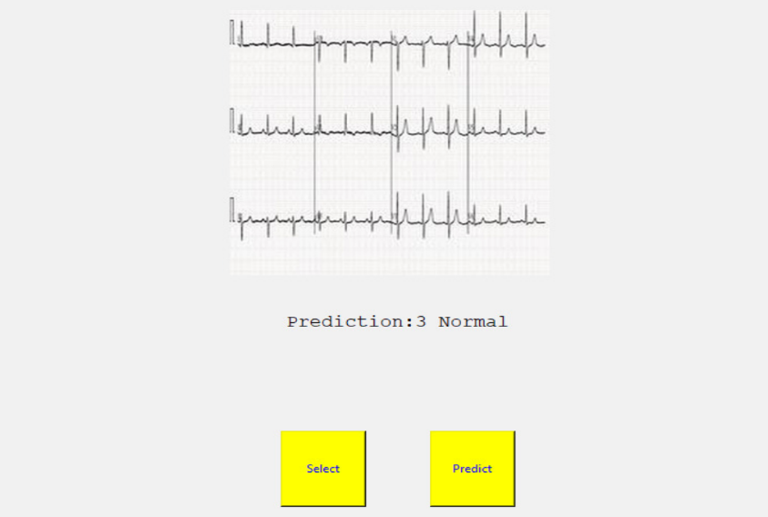

Figure-7
CONCLUSION

In this article, we propose a lightweight CNN-based model to classify the four major cardiac abnormalities using public ECG images dataset of cardiac patients. According to the results of the experiments, the proposed CNN model achieves remarkable results in cardiovascular disease classification and can also be used as a feature extraction tool for the traditional machine learning classifiers. Thus, the proposed CNN model can be used as an assistance tool for clinicians in the medical field to detect cardiac diseases from ECG images and bypass the manual process that leads to inaccurate and time-consuming results.

In the future work, optimization techniques can be used to obtain optimized values for the hyperparameters of the proposed CNN model. The proposed model can also be used for predicting other types of problems. Since, the proposed model belongs to the family of low-scale deep learning methods in terms of the number of layers, parameters, and depth. Therefore, a study on using the proposed model in the Industrial Internet of Things domain for classification purposes can be explored.
A method for automatically classifying ECG data into three groups has been presented in arrhythmia and ventricular arrhythmia. To detect the R, P, and T peaks, a fusion technique based on FFT and TERMA was presented. To denoise data, conventional wavelet transform methods were used; however, the introduction of FFT in the TERMA techniques dramatically enhanced peak detection accuracy. The proposed peak identification performs the role marginally better than the TERMA algorithm in detecting the R peak but much improved in detecting the P and T peaks in the MIT-BIH arrhythmia collection. Following the preprocessing processes, AR modeling is utilized to extract the AR parameters that are used to categorize every portion of the ECG signal into each of three potential categories. Selected features and AR characteristics for sets of the two beats are highly divided in the feature space and effectively categorized, suggesting that excellent classification accuracy may be anticipated in the suggested system’s effective implications. Furthermore, unlike the TERMA method, the effectiveness was not affected by CVDs. Following peak identification, the results are utilized to determine the PR and RT periods as characteristics of two ECG signals for classification constructed a classifier for the cross-database testing and training.

REFERENCES
[1] World Health Organization. (2017). Cardiovascular Diseases (CVDs). [Online].Available:https://www.who.int/health-topics/cardiovasculardiseases/
[2] E. J. Benjamin et al., ‘‘Heart disease and stroke statistics—2019 update: A report from the American heart association,’’ Circulation, vol. 139, no. 10, pp. e56–e528, Mar. 2019, doi: 10.1161/CIR.0000000000000659.
[3] Statistics Korea. (2018). Causes of Death Statistics in 2018. [Online]. Available: http://kostat.go.kr/portal/eng/pressReleases/8/10/index.board?bmode=read&bSeq=&aSeq=378787
[4] World Health Organization. (2017). Cardiovascular Diseases (CVDs). [Online].Available:https://www.who.int/newsroom/factsheets/detail/cardiovascular-diseases-(cvds)
[5] P. Greenland, J. S. Alpert, G. A. Beller, E. J. Benjamin, M. J. Budoff, Z. A. Fayad, E. Foster, M. A. Hlatky, J. M. Hodgson, F. G. Kushner, M. S. Lauer, L. J. Shaw, S. C. Smith, A. J. Taylor, W. S. Weintraub, and N. K. Wenger, ‘‘2010 ACCF/AHA guideline for assessment of cardiovascular risk in asymptomatic adults: A report of the American college of cardiology foundation/American heart association task force on practice guidelines,’’ Circulation, vol. 122, no. 25, pp. e584–e636, Dec. 2010, doi: 10.1161/CIR.0b013e3182051b4c.
[6] J. Perk et al., ‘‘European guidelines on cardiovascular disease prevention in clinical practice (version 2012): The fifth joint task force of the European society of cardiology and other societies on cardiovascular disease prevention in clinical practice (constituted by representatives of nine societies and by invited experts) ∗ developed with the special contribution of the European association for cardiovascular prevention & rehabilitation (EACPR),’’ Eur. Heart J., vol. 33, no. 13, pp. 1635–1701, Jul. 2012, doi: 10.1093/eurheartj/ehs092.
[7] G.-M. Park and Y.-H. Kim, ‘‘Model for predicting cardiovascular disease: Insights from a Korean cardiovascular risk model,’’ Pulse, vol. 3, no. 2, pp. 153–157, 2015, doi: 10.1159/000438683.
[8] G. J. Njie, K. K. Proia, A. B. Thota, R. K. C. Finnie, D. P. Hopkins, S. M. Banks, D. B. Callahan, N. P. Pronk, K. J. Rask, D. T. Lackland, and T. E. Kottke, ‘‘Clinical decision support systems and prevention,’’ Amer. J. Preventive Med., vol. 49, no. 5, pp. 784–795, Nov. 2015, doi: 10.1016/j.amepre.2015.04.006.
[9] V. Sintchenko, E. Coiera, J. R. Iredell, and G. L. Gilbert, ‘‘Comparative impact of guidelines, clinical data, and decision support on prescribing decisions: An interactive Web experiment with simulated cases,’’ J. Amer. Med. Inform. Assoc., vol. 11, no. 1, pp. 71–77, Jan. 2004, doi: 10.1197/jamia.M1166.
[10] K. Kawamoto, C. A. Houlihan, E. A. Balas, and D. F. Lobach, ‘‘Improving clinical practice using clinical decision support systems: A systematic review of trials to identify features critical to success,’’ BMJ, vol. 330, no. 7494, p. 765, Apr. 2005, doi: 10.1136/bmj.38398.500764.8F.
[11]G. Sannino and G. De Pietro, “A deep learning approach for ECG-based heartbeat classification for arrhythmia detection,” Future Generation Computer Systems, vol. 86, pp. 446–455, 2018.
View at: Publisher Site | Google Scholar
[12] S. Sahoo, M. Dash, S. Behera, and S. Sabut, “Machine learning approach to detect cardiac arrhythmias in ECG signals: a survey,” IRBM, vol. 41, no. 4, pp. 185–194, 2020.
View at: Publisher Site | Google Scholar
[13] B. Vuksanovic and M. Alhamdi, “ECG based system for arrhythmia detection and patient identification,” in Proceedings of the ITI 2013 35th International Conference on Information Technology Interfaces, Cavtat, Croatia, June 2013.
View at: Google Scholar
[14] K. Balaskas and K. Siozios, “ECG analysis and heartbeat classification based on shallow neural networks,” in Proceedings of the 2019 8th International Conference on Modern Circuits and Systems Technologies (MOCAST), IEEE, Thessaloniki, Greece, May 2019.
View at: Publisher Site | Google Scholar
[15]K. Luo, J. Li, Z. Wang, and A. Cuschieri, “Patient-specific deep architectural model for ECG classification,” Journal of Healthcare Engineering, vol. 2017, Article ID 4108720, 13 pages, 2017.
View at: Publisher Site | Google Scholar
[16]Z. Han, S. Li, and H. Liu, “Composite learning sliding mode synchronization of chaotic fractional-order neural networks,” Journal of Advanced Research, vol. 25, pp. 87–96, 2020.
View at: Publisher Site | Google Scholar
[17] G. T. Taye, E. B. Shim, H.-J. Hwang, and K. M. Lim, “Machine learning approach to predict ventricular fibrillation based on QRS complex shape,” Frontiers in Physiology, vol. 10, p. 1193, 2019.
View at: Publisher Site | Google Scholar
[18] Y. Zhou, H. Liu, J. Cao, and S. Li, “Composite learning fuzzy synchronization for incommensurate fractional‐order chaotic systems with time‐varying delays,” International Journal of Adaptive Control and Signal Processing, vol. 33, no. 12, pp. 1739–1758, 2019.
View at: Publisher Site | Google Scholar
[19] C. Usha Kumari, A. Sampath Dakshina Murthy, B. Lakshmi Prasanna, M. Pala Prasad Reddy, and A. Kumar Panigrahy, “An automated detection of heart arrhythmias using machine learning technique: SVM,” Materials Today Proceedings, vol. 45, pp. 1393–1398, 2021.
View at: Publisher Site | Google Scholar
[20] V. Ramalingam, V. Ayantan Dandapath, and M. Karthik Raja, “Heart disease prediction using machine learning techniques : a survey,” International Journal of Engineering & Technology, vol. 7, p. 684, 2018.
View at: Publisher Site | Google Scholar
[21] A. H. Chen, S. Y. Huang, P. S. Hong, C. H. Cheng, and E. J. Lin, “HDPS: heart disease prediction system,” in Proceedings of the 2011 Computing in Cardiology, Hangzhou, China, September 2011.
View at: Google Scholar
[22] Po-Ya Hsu and C.-K. Cheng, “Arrhythmia classification using deep learning and machine learning with features extracted from waveform-based signal processing,” in Proceedings of the 2020 42nd Annual International Conference of the IEEE Engineering in Medicine & Biology Society (EMBC), pp. 292–295, IEEE, Montreal, QC, Canada, July 2020.
View at: Publisher Site | Google Scholar
[23] T. Vijayakumar, R. Vinothkanna, and M. Duraipandian, “Fusion based feature extraction analysis of ECG signal interpretation–a systematic approach,” Journal of Artificial Intelligence, vol. 3, no. 01, pp. 1–16, 2021.
View at: Google Scholar
[24] P. Tsinganos and A. Skodras, “On the comparison of wearable sensor data fusion to a single sensor machine learning technique in fall detection,” Sensors, vol. 18, no. 2, p. 592, 2018.
View at: Publisher Site | Google Scholar
[25] F. Y. Osisanwo, J. E. T. Akinsola, O. Awodele, H. Jo, O. Olakanmi, and J. Akinjobi, “Supervised machine learning algorithms: classification and comparison,” International Journal of Computer Trends and Technology, vol. 48, no. 3, pp. 128–138, 2017.
View at: Google Scholar
[26] R. J. P. Princy, S. Parthasarathy, P. Subha Hency Jose, A. Raj Lakshminarayanan, and S. Jeganathan, “Prediction of cardiac disease using supervised machine learning algorithms,” in Proceedings of the 2020 4th International Conference on Intelligent Computing and Control Systems (ICICCS), pp. 570–575, IEEE, Madurai, India, May 2020.
View at: Publisher Site | Google Scholar

