1

*Research Article*

# THE PITCH OF SOUND WITH MOTION GESTURE

|  |  |  |
| --- | --- | --- |
| **Dr. PREETHA J**  **Head of Artificial Intelligence & Data Science**  Muthayammal Engineering College Rasipuram.  [hod.ads@mec.edu.in](mailto:hod.ads@mec.edu.in) | **Ms.SOUNDARYA MS**  **Assistant professor**  Department of Artificial Intelligence & Data Science  Muthayammal Engineering College Rasipuram. [soundaryasathish02@gmail.com](mailto:soundaryasathish02@gmail.com) | **Ms.PRIYADHARSHINI D**  **Assistant professor**  Department of Artificial Intelligence & Data Science  Muthayammal Engineering College Rasipuram. [dpriyadharshini1991@gmail.com](mailto:dpriyadharshini1991@gmail.com) |

|  |  |  |
| --- | --- | --- |
| **BRUNDHA S**  **Student**  Department of Artificial Intelligence & Data Science  Muthayammal Engineering College Rasipuram. [brundhasithan@gmail.com](mailto:brundhasithan@gmail.com) | **RAKGHITHA S M R**  **Student**  Department of Artificial Intelligence & Data Science  Muthayammal Engineering College Rasipuram. [smrrakghitha@gmail.com](mailto:smrrakghitha@gmail.com) | **ARCHANA S**  **Student**  Department of Artificial Intelligence & Data Science  Muthayammal Engineering College Rasipuram. [achumasasi0067@gmail.com](mailto:achumasasi0067@gmail.com) |

**1.Abstraction**

In this paper we are developing a volume controller in which we are using hand gestures as the input to control the system , Opencv module is basically used in this implementation to control the gestures. This system basically uses the web camera to record or capture the images /videos and accordingly on the basis of the input, the volume of the system is controlled by this application. The main function is to increase and decrease the volume of the system. The project is implemented using Python, OpenCV. We can use our hand gestures to control the basic operation of a computer like increasing and decreasing volume. Therefore people will not have to learn machine-like skills which are a burden most of the time. This type of hand gesture systems provides a natural and innovative modern way of nonverbal communication. These systems has a wide area of application in human computer interaction. In this the

system is consist of a high resolution camera to recognise the gesture taken as input by the user. The main goal of hand gesture recognition is to create a system which can identify the human hand gestures and use same input as the information for controlling the device and by using real time gesture recognition

specific user can control a computer by using hand gesture in front of a system video camera linked to a computer. In this project we are developing a hand gesture volume controller system with the help of OpenCV, Python. In this system can be controlled by hand gesture without making use of the keyboard.

# 2.Introduction

Recently, Human computer interaction technology(HCI) has attracted attention as a promising means of human computer communication. Human–machine interaction (HMI)

refers to the communication and interaction between

a human and a machine via a user interface. In recent

decades hand gesture recognition is considered as a

new technique of Human-Computer Interaction

because of its automatic, natural and easiness without

requiring input from output devices like keyboard and

mouse. By using Hand gestures user can interact more

information in less time duration. So for upgrading

the interface between users and computers, human

computers interaction (HCI) technology has great

utilization. The best advantage of hands is the ability

to communicate remotely.The use of HCI hand

gestures requires that the human hand configuration

be measured by a computer. Performance is highly

dependent on the accuracy of the acquisition and

tracking of handicrafts. The main aim of proposed

system is to identify specific human hand gestures

and we can use it to convey information or we can

control any device or robot for working applications.

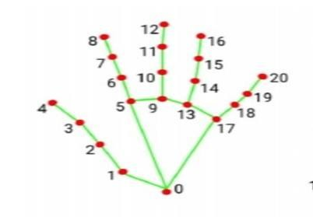

**3.Related work**

There has been significant research and development in the field of hand gesture recognition systems using computer vision and machine learning techniques. Several studies have been conducted on developing systems that use hand gestures to control various devices, including volume controllers. One research study proposed a vision-based system that used color and motion detection to recognize hand gestures for volume control. The system used a camera to capture hand gestures, and the color of the hand was extracted using color segmentation techniques.

1. WRIST 11. MIDDLE_ FINGER_DIP
2. THUMB_CMC 12. MIDDLE_ FINGER_TIP
3. THUMB_MCP 13. RING_FINGER_MCP
4. THUMB_TIP 14. RING_FINGER_PIP
5. INDEX_FINGER_MCP 15. RING_FINGER_DIP
6. INDEX_FINGER_PIP 16. RING_FINGER_TIP
7. INDEX_FINGER_DIP 17. PINKY_MCY
8. INDEX_FINGER_TIP 18.PINKY_PIP
9. MIDDLE_ FINGER_MCP 19.PINKY_DIP
10. MIDDLE_ FINGER_PIP 20.PINKY_TIP

FIGURE 1- Architecture

Community Gestures is a dynamic research area that aims to recognize sign language and enhance human- computer interaction through gesture recognition. To detect people's gestures and use them as input in the system, we utilize algorithms and modules such as opencv-python, media pipe, and numpy. After obtaining user input, the hand tracking system uses the captured image to verify the gesture's size and shape. The Gesture Detection module is responsible for identifying and recognizing gestures in the system. It does this by first classifying and segmenting the gestures.

# 4.Existing System

Currently, most volume controllers are operated using buttons or dials on the device itself or through remote control devices. While these methods are effective, they require physical interaction with the device, which can be inconvenient and limiting in certain situations. Some systems that use hand gestures to control devices exist, such as the Xbox Kinect, which uses a depth-sensing camera to track hand movements and gestures. However, these systems are expensive and require specialized hardware, making them inaccessible to the average user.

The process of gesture recognition using an ANN typically involves the following steps:

1. Data Collection: An accelerometer is used to collect data on the movements and gestures of the user. This data is typically in the form of time- series data, which includes information on the acceleration and orientation of the device over time.
2. Data Preprocessing: The collected data is then preprocessed to remove noise and normalize the data. This step is important to ensure that the ANN can accurately recognize the gestures.
3. Feature Extraction: The preprocessed data is then transformed into a set of features that can be used as inputs for the ANN. The features can include information on the frequency and magnitude of the movements, as well as other relevant parameters.
4. Training the ANN: The ANN is trained on the extracted features using a dataset of labeled gesture data. The training process adjusts the network's weights and biases to reduce the difference between the predicted and actual gesture labels.
5. Testing and Evaluation: The trained ANN is then tested on a separate dataset to evaluate its performance. The performance of the ANN is typically evaluated using metrics such as accuracy, precision, and recall.

# Methodology

In this project, we are using Python to develop the code. The code is written and designed in the Python language, and it uses modules such as OpenCV and NumPy. To begin with, we import the libraries that will be utilized for further input and output processing. The libraries required for this project include OpenCV, media pipe, math, c types, py caw, and NumPy. We obtain the video input from the main camera and use mediapipe to detect gestures in the video input from the camera using the m hand module. Next, we access the speaker using a pycaw and provide the volume range from minimum to maximum. Once the captured input is processed, we convert the input image to an RGB image. Then, we use NumPy to specify the input and the tip of the thumb of the fingers. NumPy is a base package for computing in the Python language. It consists of several parts, including powerful N-dimensional array objects, streaming tools to integrate C, Fourier transform, and random number functions. The main steps include:-

* 1. Identify and define hand gestures: The first step in developing a volume controller using hand gestures is to identify and define the hand gestures that will be used to control the volume.
  2. Collect and preprocess data: The next step is to collect a dataset of hand gestures and corresponding volume levels. The dataset can be collected using a camera or sensor, and it should be preprocessed to remove any noise or outliers.
  3. Train a machine learning model: Once the dataset has been collected and preprocessed, a machine learning model should be trained to recognize the hand gestures and associate them with specific volume levels.
  4. Implement the system: The next step is to implement the system using a microcontroller or single-board computer, such as a Raspberry Pi. The system should include a camera or sensor to capture the hand gestures, a speaker or audio output device to play the audio, and a

3

microcontroller to process the data and communicate with the machine learning model.

* 1. Test and evaluate the system: Once the system has been implemented, it needs to be tested and evaluated to make sure that it is accurate and reliable. The system can be tested using a variety of hand gestures and volume levels, and the results should be compared to the ground truth.

# Process

## Image-Processing

Image processing basically includes the following three steps:

* + Importing the image
  + Analysing and manipulating the image
  + Output in which result can be altered image or report that is based on image analysis

## Mediapipe

Mediapipe is an open source cross-platform framework provided by Google to build a pipeline for processing perceptual data from different modalities such as video and audio. The solutions used in MediaPipe include multiple items such as posture estimation and face recognition. In this paper, we will use MediaPipe Hands for hand tracking.

## Pycaw

Python Core Audio Windows Library. The python package pycaw receives a total of 1,399 weekly downloads. pycaw is a Python library typically used in Programming Style, Reactive Programming applications. pycaw has no bugs, it has no vulnerabilities, it has build file available, it has a Permissive License and it has low support. You can install using 'pip install pycaw' or download it. Basically Pycaw is used to Manipulate the Audio.

## Result

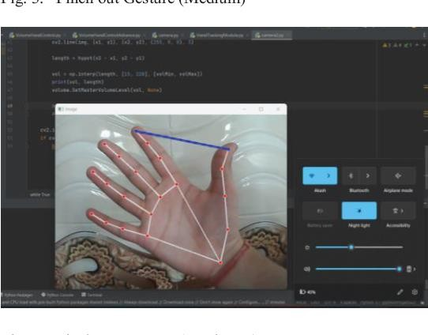

* 1. **– Volume is Increase**

Figure2 : Controlling volume of our system using hand

# System Architecture

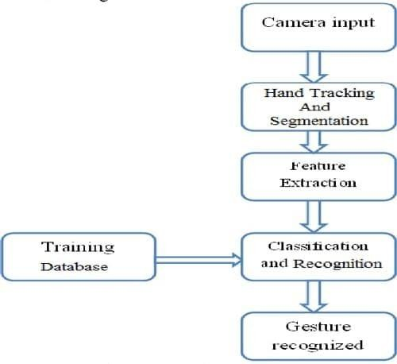

## Figure 3 – System Architecture

Here, we have performd the Hand Gestures recognition system to produce the better output, webcam is enabled while executing the program, also the type of gesture used is static to recognize the shape of the hand and it provides us the required output. In this project the volume is controlled based on the shape of hand. The system takes input and will capture the object ,detects after that hand gesture recognition is performed.

## - Volume is Decrease

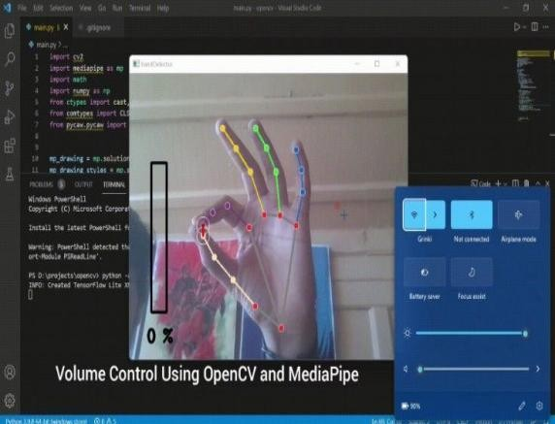As a first step we try the hand detection based on available database of OpenCV. Then for capturing live hand of Camera the initialization has been done. The two gesture detection like palm and fist by green line which is trained by integral images. The second step is the extracted image gestures which are compared with stored positive-negative integral image dataset and perform finger tip tracking by contour detection. The third step Mediapipe locate the palm and detect the 21 hand Landmarks according to Action. Mediapipe tracks the action between thumb and index finger and give command to Pycaw to maximize or Minimize the audio.

# Conclusion

The Aim of this project is to develop a real time Gesture Volume Control System. This paper explains a model that is useful in controlling Audio volume of system with the help of hand gestures. The proposed method here successfully developed a hand gesture volume control, which is able to manipulate (max to min) with gesture is performed by the person and

5

accordingly perform the functionality associated with it accuracy. We have achieved 95% of accuracy using Mediapipe's technology and Machine Learning. The main integral part of the system presently are the webcam**.**

# References

1. https://ieeexplore.ieee.org/abstract/docume nt/7150886/ Real time finger tracking and contour detection for gesture recognition using opencv.
2. <http://citeseerx.ist.psu.edu/viewdoc/downl> oad?doi=10.1.1.667.104&rep=rep1&type= pdf Hand Gesture Recognition Techniques For Human Computer Interaction.
3. https://link.springer.com/chapter/10.1007/ 978-3-030-41862-5_174 Hand gesture recognition using OpenCv and Python
4. https://ijisrt.com/assets/upload/files/IJISR T22MAY250_(1).pdf ] Volume Control using Gestures.
5. Košale U, Žnidaršic P, Stopar K, “Detection of different shapes and materials by glasses for blind and visually impaired,” 2019 6th Student Computer Science Research Conference, Vol. 57, 2019
6. Ayushi Jaiswal Ajay Somkuwar Jayprakash Upadhyay ‘Image denoising and quality measurements by using filtering and wavelet based techniques’ AEU - International Journal of Electronics and Communications 68(8):699-705
7. ]E. Barri, A. Gkamas, E. Michos , C. Bouras, C. Koulouri, S.A.K. Salgado, “Text to Speech through Bluetooth for People with Special Needs Navigation,” International Conference on Ne8tworking and Services, 2010.
8. H. A. Karimi, M.B. Dias, J. Pearlman, G. J Zimmerman, “Wayfinding and Navigation for People with Disabilities Using Social Navigation Networks,” EAI Endorsed Transactions on Collaborative Computing, Vol. 1, Issue 2, e5, October, 2014