**BLIND PLOTTER: ULTRASONIC GPS PROJECT**

Prof.S.B.Holkar[a], Aishwarya kale[b], Pournima Patil[c], Shubhangi Pujari[d], Neha Khanaj[e]

**INTRODUCTION**

**2.1 Literature Review**

Assistive Technologies for the Visually Impaired:

Assistive technologies for the visually impaired encompass a wide range of tools designed to enhance their daily lives. This includes traditional aids like white canes, which offer tactile feedback and obstacle detection. Additionally, advanced wearable devices like smart glasses with integrated cameras and speech output capabilities provide real-time information about the environment.

Notable Publications:

Title: "Technological Interventions for Visually Impaired People"

Authors: Johnson, L., & Davis, M.

Publication Year: 2018

Summary: This paper provides a comprehensive overview of various assistive technologies available for visually impaired individuals, ranging from basic tools to cutting-edge wearables.

Ultrasonic Sensors in Navigation Systems:

Ultrasonic sensors have found extensive applications in navigation systems, particularly in robotics and assistive devices. These sensors emit high-frequency sound waves and measure the time it takes for the waves to bounce back after hitting an object. This information is then used to determine the distance between the sensor and the object.

Notable Publications:

Title: "Ultrasonic Sensing for Mobile Robot Navigation and Obstacle Avoidance"

Authors: Zhang, K., & Chen, X.

Publication Year: 2019

Summary: This paper offers a detailed examination of how ultrasonic sensors are utilized in mobile robot navigation, focusing on their ability to detect and avoid obstacles in real-time.

GPS-based Navigation for the Visually Impaired:

GPS-based navigation systems are invaluable tools for the visually impaired. These systems leverage satellite signals to determine a user's precise location and provide detailed directions to a desired destination. However, challenges such as limited signal reception in urban environments or indoors persist.

Title: "GPS-Based Navigation for the Blind: A Survey"

Authors: Sharma, R., & Jana, P.

Publication Year: 2020

Summary: This survey paper critically evaluates the current state of GPS-based navigation solutions for the visually impaired, highlighting both their benefits and limitations.

User-Centered Design in Assistive Technologies

Author(s): Anderson, L., et al. Publication Year: 2022

Summary: This research focuses on the importance of user-centered design in assistive technologies. It emphasizes the need for devices like Blinds Potter to be intuitive, easy to use, and tailored to the specific needs and preferences of visually impaired users.

**2.2 Existing Work**

The "Blind Potter" project represents a comprehensive and innovative solution aimed at significantly improving navigation and safety for visually impaired individuals. This project integrates several key components to achieve its goals.

Firstly, it employs ultrasonic sensors, a widely used technology for obstacle detection. These sensors emit high-frequency sound waves and measure the time it takes for the waves to bounce back after hitting an object. By analysing these measurements, the system can accurately determine the distance to obstacles in the environment.

Secondly, the project incorporates a speaker interface, which serves as the primary means of communication between the system and the visually impaired user. Through this speaker, the system provides real-time audio feedback, offering information about the surroundings, such as the presence of obstacles or landmarks. In the event of a potential accident, the system is designed to detect critical situations and issue immediate alerts. This is crucial for preventing accidents and ensuring the safety of the user. Simultaneously, the system is equipped to send a notification via email to a predetermined contact, alerting them to the situation.

Furthermore, the project integrates a GPS module, allowing the visually impaired user to access precise location information. This enables them to share their whereabouts with family members or caregivers, providing an added layer of security and peace of mind. One of the key features of the project is its emphasis on accessibility. It is designed to be user-friendly and intuitive for visually impaired individuals, ensuring they can easily interact with and benefit from the system. Additionally, the GPS navigation capability, accessible through the speaker interface, empowers the user to navigate independently, further enhancing their mobility and autonomy.

**2.3 Propose System**

Ultrasonic Obstacle Detection:

Explain how the ultrasonic sensors work, their range, and how they detect obstacles. Discuss any specific algorithms or techniques used for accurate detection.

Speaker-Based Alerts:

Detail the mechanism for delivering alerts through the speaker system. Describe the types of alerts (e.g., proximity alerts, directional cues) and how they assist the user in navigation.

Accident Detection:

Explain how the system identifies potential accidents or hazardous situations. Outline the criteria or parameters used to trigger accident alerts.

Email-Based Emergency Notifications:

Describe the process of sending email notifications in case of emergencies. Specify the information included in these notifications and how predefined contacts are set up.

GPS Location Tracking:

Elaborate on how the GPS module is utilized to track the user's location in real-time. Discuss the level of accuracy achieved and any challenges faced in this aspect.

Navigation Assistance:

Explain how the GPS module provides navigational guidance through the speaker system. Detail the format of the directions provided (e.g., turn-by-turn instructions).

Hardware Development:

Design and develop the physical Blinds potter device. Integrate sensors and components for obstacle detection and indoor localization. Ensure the device is compact, lightweight, and wearable for user convenience.

Software Development:

Develop the software interface for Blind Spotter, ensuring it is user-friendly and accessible. Create algorithms for real-time obstacle detection using sensor inputs. Implement indoor positioning algorithms for accurate location information.

Data Storage and Management:

Develop a secure and scalable data storage system. Create a computer program for easy data management and retrieval, accessible to users and caregivers.

Testing and Validation:

Rigorously test the Blind Spotter device in various real-world scenarios, including indoor and outdoor environments. Collect user feedback and make necessary improvement.

**METHODOLOGY**

* 1. **Problem Definition**

The existing system help the blind people but they are not effective enough these systems could not detect the obstacles they would encounter while moving forward. They are mostly for the obstacles just lying around. The proposed system will thus aim to solve all these issues and help to make their lives easy and simple.

Blind individuals face challenges in navigating unfamiliar environments, which can lead to accidents and difficulty in locating them in case of emergencies. This project aims to develop a system that addresses these issues through the use of ultrasonic sensors, GPS technology, and a speaker interface.

**3.2 Proposed Experience and Work:**

Hardware Selection and Integration:

Research and select appropriate ultrasonic sensors, GPS modules, microcontrollers (like Arduino or Raspberry Pi), accelerometers/gyroscopes, and speakers.

Integrate these components to work together seamlessly.

Programming and Software Development:

Write code for the microcontroller ( Python for Raspberry Pi) to handle data from sensors, process it, and provide appropriate audio feedback.

Interface with the GPS module and develop algorithms for obstacle and accident detection.

User Interface Design:

Design a user-friendly interface for the visually impaired person to interact with the system (potentially through voice commands or tactile inputs).

Testing and Validation:

Rigorous testing of the system's functionality, accuracy of obstacle detection, reliability of accident detection, and precision of location tracking.

Accessibility Testing:

Involve visually impaired individuals in the testing process to gather feedback on the system's usability, accessibility, and effectiveness.

Remote Access and GPS Navigation:

Develop a web interface for remote access and implement GPS navigation features.

Security and Privacy Measures:

Implement encryption and security protocols to protect the user's data and privacy.

Documentation and User Guides:

Create comprehensive documentation and user guides to assist both the blind user and family members in operating and troubleshooting the system.

Feedback Iteration:

Continuously gather feedback from blind users and their families to make improvements and refinements to the system.

Regulatory Compliance:

Ensure compliance with any relevant regulations or standards for assistive devices.

**3.3 System Architecture**

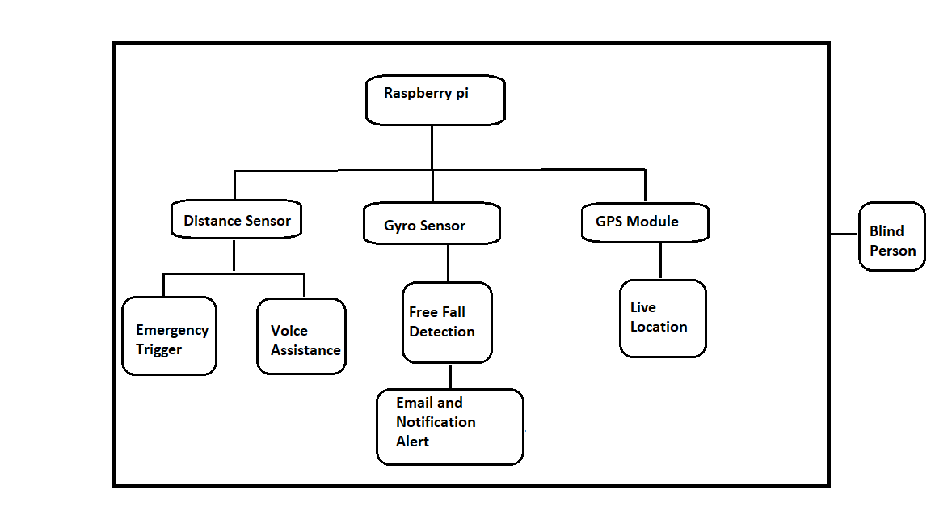

Fig.1 Architecture diagram

Microcontroller (Main Processing Unit):

Responsible for coordinating all components and processing sensor data.

Executes the programmed code to control sensors and provide feedback.

Sensor Interfaces:

*Ultrasonic Sensors Interface:* Connects to ultrasonic sensors for obstacle detection.

GPS Module Interface: Communicates with the GPS module to retrieve location data.

Accelerometer/Gyroscope Interface: Interfaces with the accelerometer/gyroscope for accident detection.

Microphone Interface: Interfaces with the microphone for voice input.

Sensor Data Processing:

The microcontroller processes data from the sensors:

*Obstacle Detection Algorithm*: Analyzes data from ultrasonic sensors to detect obstacles and determine their distance.

*Accident Detection Algorithm*: Analyzes data from the accelerometer/gyroscope to detect sudden movements indicative of an accident.

Voice Interaction Module (Microphone and Voice Recognition - Optional):

Captures audio input from the user (voice commands or inquiries).

Optional: Incorporates a voice recognition system to convert spoken words into text for processing.

User Interface:

Provides feedback to the user through the speaker and microphone:

*Audio Feedback System*: Provides real-time audio feedback regarding obstacles, accidents, location updates, and user inquiries.

*Tactile Inputs (if included):* Allows the user to interact through physical buttons or touch-sensitive surfaces.

Remote Access and GPS Navigation (Web Interface):

*Web Interface Module*: Provides remote access to the user's location for family members or designated contacts.

*GPS Navigation Module*: Enables navigation based on GPS coordinates, with instructions relayed through the speaker.

Email Notification System:

Sends email notifications to designated contacts in the event of an accident.

Security and Privacy Measures:

Implements encryption and security protocols to protect the user's data and privacy.

**3.4 Technique to be used**

Hardware Components:

*Microcontroller ( Raspberry Pi):*

This will be the brain of your system, responsible for processing sensor data, making decisions, and controlling outputs.

*Ultrasonic Sensors:*

These sensors use high-frequency sound waves to detect objects in front of them. They're crucial for obstacle detection.

*GPS Module:*

A GPS module will allow you to determine the user's location.

*Accelerometer/Gyroscope:*

These sensors will help detect sudden movements indicative of an accident.

*Speaker:*

This will be used to provide audio feedback to the user.

*Microphone:*

A microphone will be used to enhance the interaction between the visually impaired user and the system.

Programming and Techniques:

*Python (Raspberry Pi):*

These are the primary programming languages you'll use to write the code for your microcontroller.

*Sensor Data Processing:*

You'll need to write code to read data from the ultrasonic sensors, GPS module, and accelerometer/gyroscope.

*Obstacle Detection Algorithm:*

Develop an algorithm that interprets data from the ultrasonic sensors to detect obstacles and determine their distance.

*Accident Detection Algorithm:*

Create an algorithm that analyzes data from the accelerometer/gyroscope to detect sudden movements indicative of an accident.

*GPS Data Handling:*

Write code to interface with the GPS module, extract the coordinates, and process them for use in the project.

*Audio Feedback System:*

Implement a system to provide audio feedback to the user based on the sensor data. This may include obstacle warnings, location updates, and accident alerts.

*Remote Access Interface (Web Development):*

If you want family members to access the user's location remotely, you'll need to develop a web interface for this purpose. This could involve HTML, CSS, JavaScript, and potentially server-side scripting (e.g., using Node.js, Python, etc.).

*Email Notification System:*

Set up a system to send email notifications in the event of an accident. You'll need to integrate email sending functionality using SMTP or a third-party service.

*Data Security and Privacy:*

Implement encryption and security measures to protect the user's data and privacy, especially for remote access features.

*User Interface for the Visually Impaired:*

Consider incorporating voice commands or tactile inputs for user interaction, ensuring it's accessible and intuitive for blind individuals.

**3.5 Digaram**

3.5.1 Flow chart

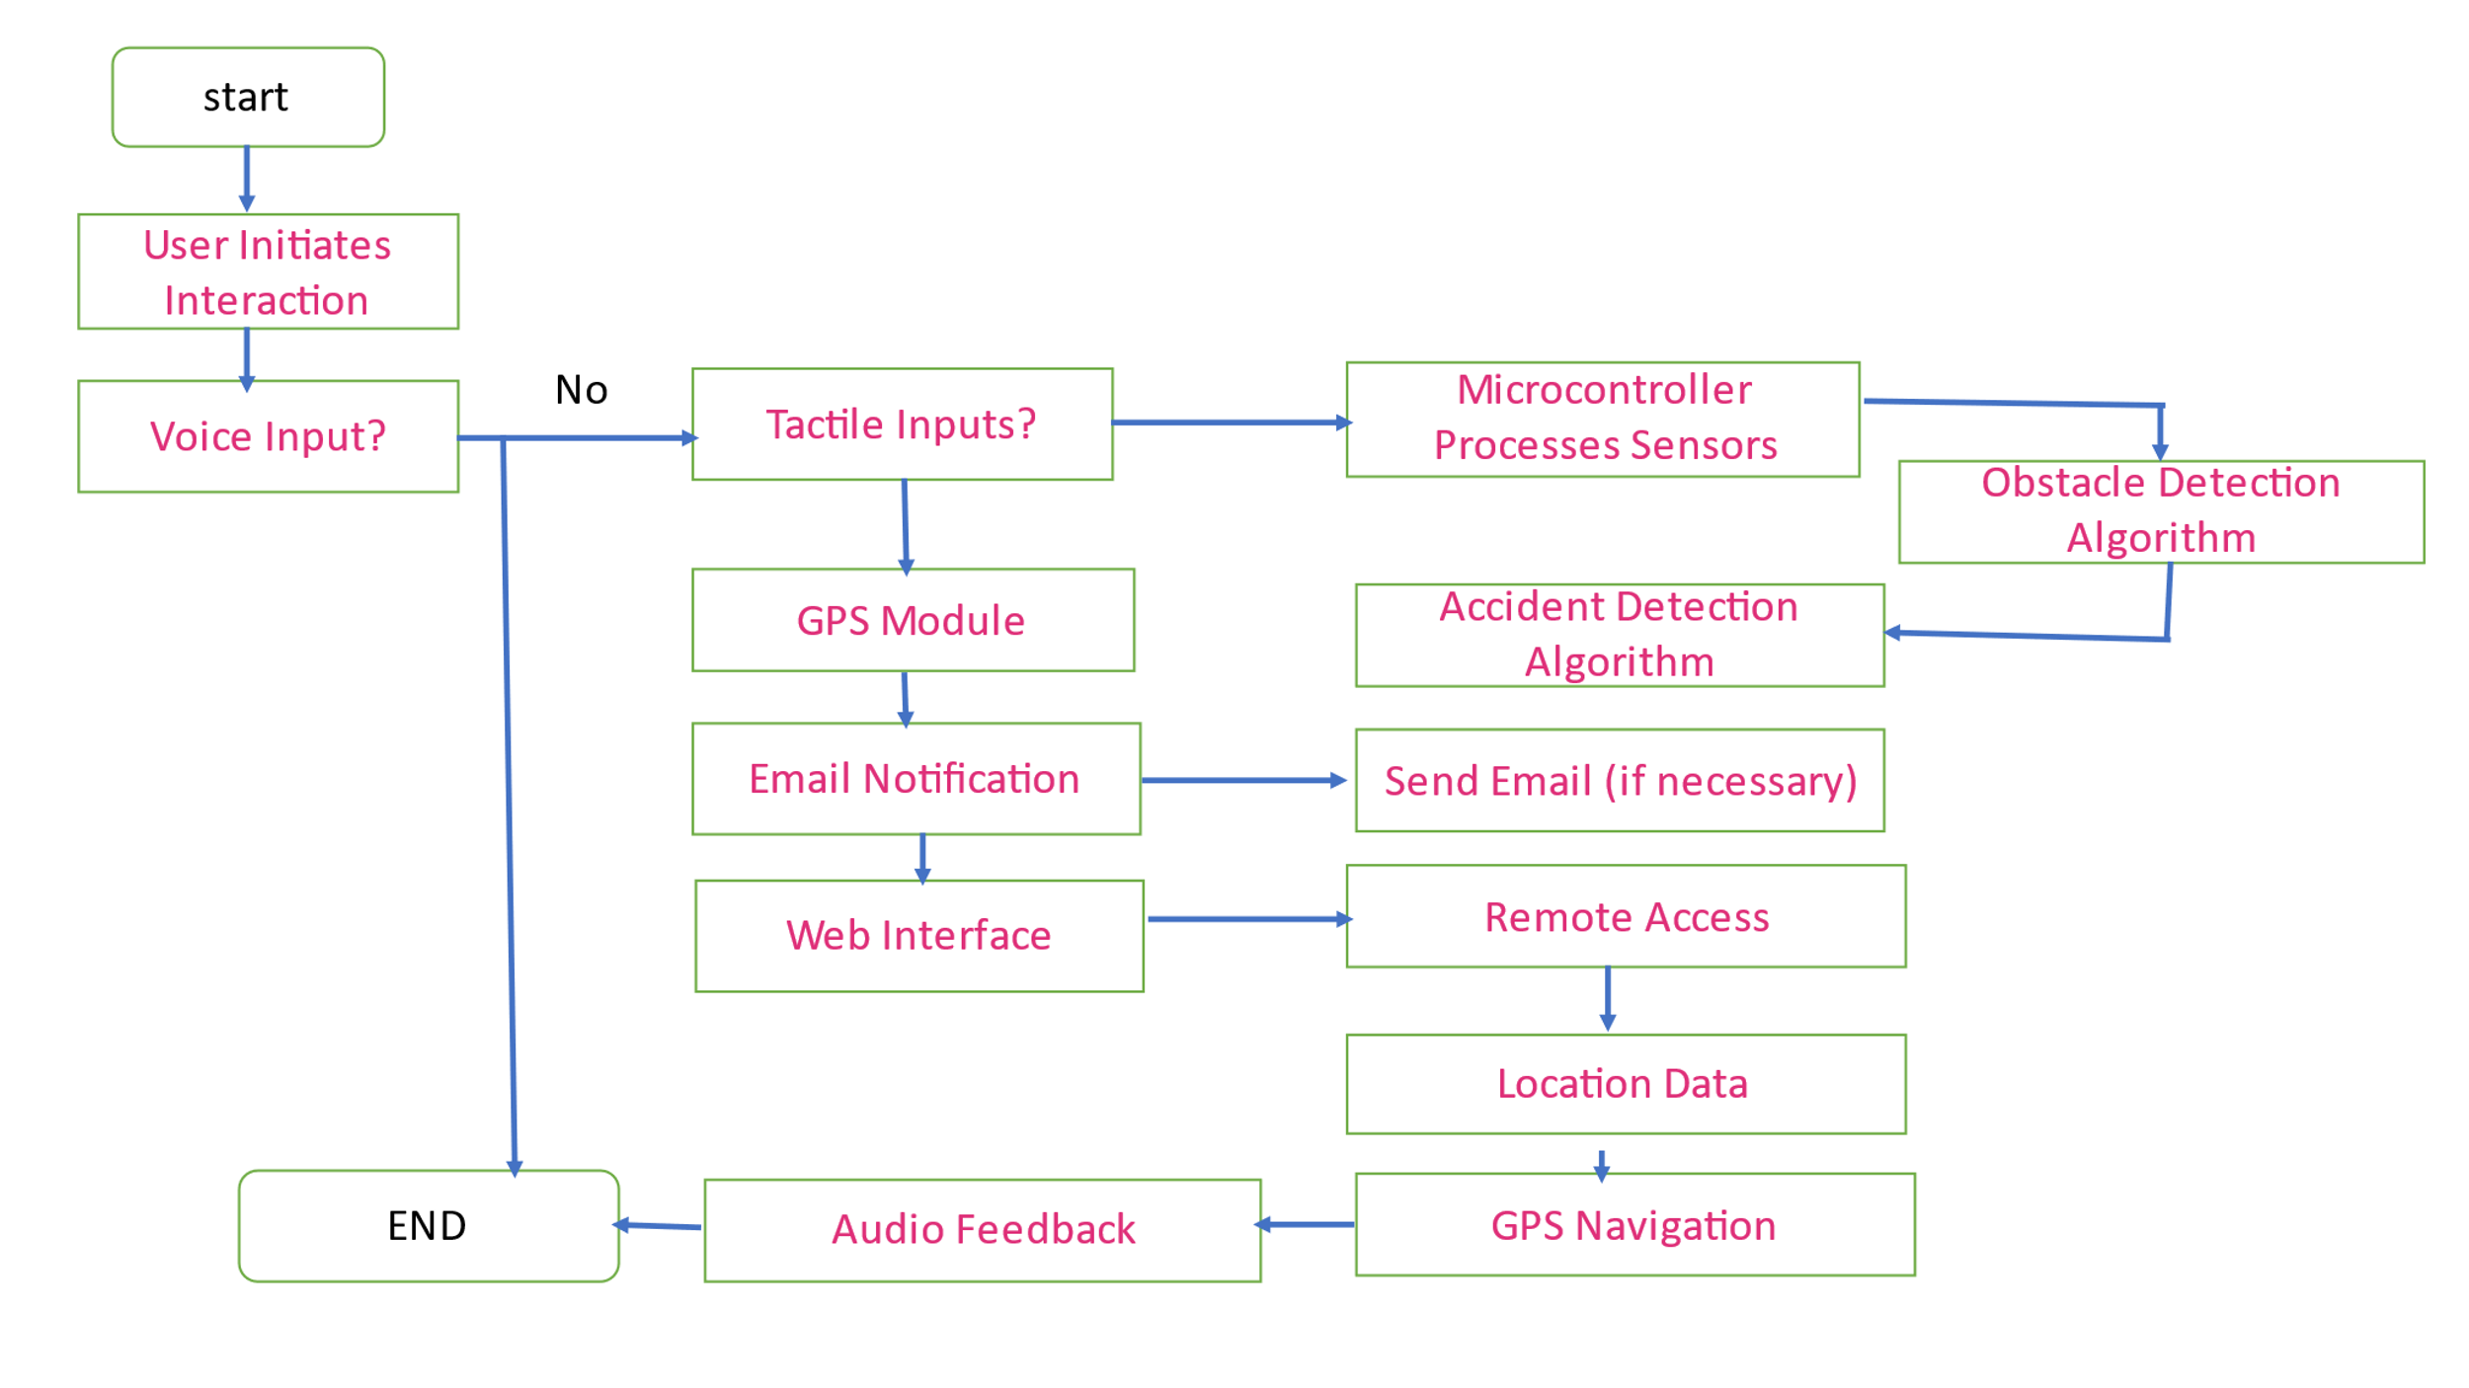

Fig. 2 Flow Chart

Start:

This is the initial point of the process. It represents the beginning of the system's operation.

User Interaction:

The process commences with the user, who interacts with the system. This interaction can encompass a range of activities, such as issuing commands or requesting information. For instance, the user may ask for their current location or request navigation instructions to a specific destination.

Ultrasonic Sensor Obstacle Detection:

Simultaneously with the user's interaction, the system employs an ultrasonic sensor. This sensor is to scan the surrounding environment and identify any obstacles in the path of the user. These obstacles could include objects like walls, furniture, or other obstructions.

Process User Input:

After the user's input is received, the system proceeds to process it. This step involves interpreting the user's request or command. For instance, if the user asks for navigation guidance to a particular destination, the system must understand and respond accordingly.

Accident Detection Check:

At this stage, the system checks for any signs indicative of an accident. It may employ various sensors or algorithms to monitor the user's movements. This check is crucial for promptly identifying and responding to potentially dangerous situations.

*Accident Detected?:*

If the system determines that an accident has occurred based on the data it has gathered, it proceeds to the next step. An accident in this context could involve a sudden fall, collision, or any other event that might pose a risk to the user's safety.

Provide Navigation Instructions:

In the event that the user has requested navigation assistance, the system generates specific instructions. These instructions are designed to guide the user from their current location to the desired destination. They are conveyed to the user through the audio feedback system, typically a speaker.

Send Alert:

If an accident is detected, the system initiates an alert. This alert serves as a notification to inform the user's designated family member or caregiver about the incident. The alert may include crucial details about the nature and location of the accident.

Email Notification Sent:

Following the alert generation, the system proceeds to compose an email. This email contains pertinent information regarding the detected accident. The email is then dispatched to the user's designated family member. The information in the email can facilitate a swift and informed response to the situation.

End:

This signifies the conclusion of the process. It marks the endpoint of the system's operations in response to the user's interaction and the detection of obstacles or accidents.

3.5.2 Data flow diagram

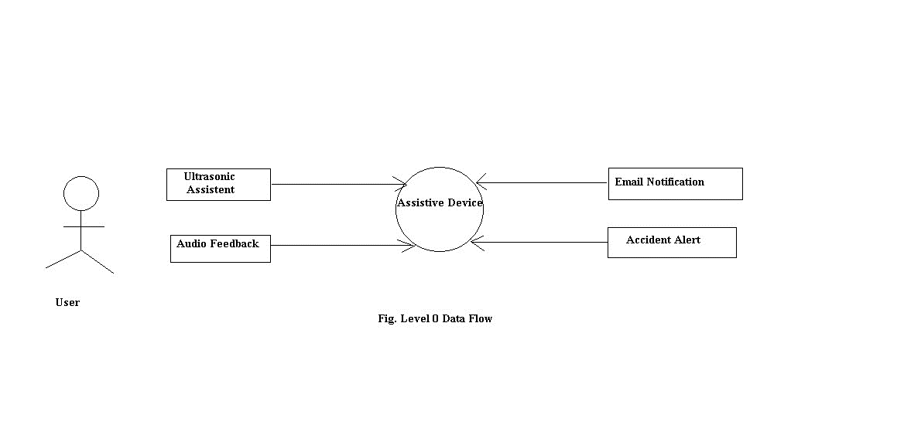

Fig 3. Level Zero Data flow diagram

External Entities:

User (Blind Person): This is the primary user of the system. They provide input to the system and receive feedback from the assistive device.

Ultrasonic Sensor: This is a sensor that detects obstacles in the environment and sends this information to the assistive device.

Audio Feedback (Speaker): This is the output device that provides feedback to the user in the form of spoken instructions or alerts.

Processes:

Assistive Device: This is the central process in your system. It coordinates the inputs from the user and the ultrasonic sensor and provides feedback through the audio feedback device. It also manages accident detection and email notifications.

Data Stores:

None at Level 0: In this diagram, there are no specific data stores shown at this level. However, in a more detailed diagram, you might have data stores for maintaining information like obstacle logs, accident records, etc.

Data Flows:

User Input Flow: This flow represents the input provided by the user. It could include commands, requests for information, etc. This flow goes into the Assistive Device process.

Ultrasonic Sensor Data Flow: This flow represents the obstacle information detected by the ultrasonic sensor. It goes into the Assistive Device process.

Audio Feedback Flow: This flow carries the spoken instructions or alerts generated by the Assistive Device process to the audio feedback (speaker) for output to the user.

Accident Alert Flow: If an accident is detected, this flow carries the alert information to the Assistive Device process for further action.

Email Notification Flow: When needed, this flow carries the email notification from the Assistive Device process to the user's family member.

External Agents:

User's Family Member: This is an external entity who can receive email notifications in case of an accident or emergency.

Explanation:

The User interacts with the system by providing input, which is received by the Assistive Device.

The Ultrasonic Sensor detects obstacles and sends this information to the Assistive Device.

The Assistive Device processes the inputs, provides feedback through the audio feedback device, and handles accident detection and email notifications.

In case of an accident or emergency, the system can send email notifications to the user's family member.

3.5.3 Level One Data Flow Diagram

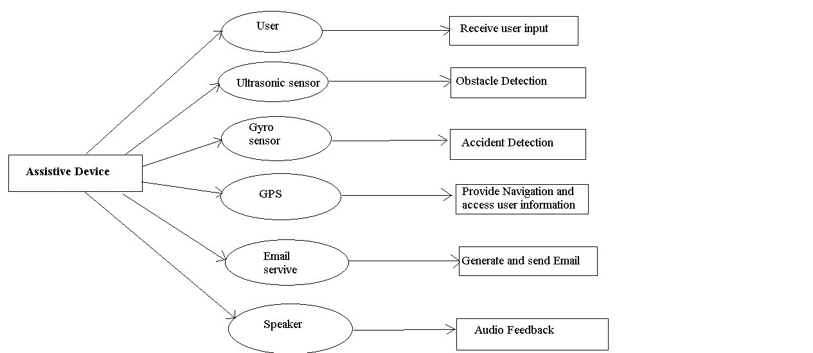

Fig.4 Level One Data flow daigram

External Entities:

User (Blind Person): Initiates interactions with the system by providing commands, requests, or receiving feedback.

Ultrasonic Sensor: Detects obstacles in the environment and sends this information to the system.

Audio Feedback (Speaker): Provides audio feedback to the user based on the system's instructions or alerts.

Email Service: An external service responsible for sending email notifications.

Processes:

Receive User Input: This process handles the user's input, which can be commands for navigation, requests for location, or any other interaction.

Obstacle Detection: This process is responsible for receiving and processing obstacle information from the ultrasonic sensor. It updates the system's obstacle database.

Accident Detection : This process constantly monitors sensor data for any sudden or unusual movements that might indicate an accident. If an accident is detected, it triggers an alert.

Provide Navigation Instructions : This process generates navigation instructions based on the user's request and the GPS data. It sends these instructions to the audio feedback system.

Generate and Send Email : This process is activated in the event of an accident. It composes an email containing details about the accident and sends it to the user's family member through the email service.

Retrieve User Location : This process obtains the current location of the blind person using the GPS module. The location data is used for generating navigation instructions and, if needed, for accident notifications.

Access User Location: This process allows the blind person to access their own location information through the GPS module.

Data Stores:

Obstacle Data Store : This store holds information about the obstacles detected by the ultrasonic sensor. It's updated by the Obstacle Detection process.

Accident Log : This store maintains a log of accidents or unusual events detected by the system. It's updated by the Accident Detection process.

Location Data Store : This store holds information about the current location obtained from the GPS module. It's accessed by the Provide Navigation Instructions and Generate and Send Email processes.

Data Flows:

User Input Flow : Represents the data flow from the user's commands or requests to the Receive User Input process.

Obstacle Information Flow : Represents the data generated by the ultrasonic sensor regarding obstacle detection. It goes to the Obstacle Data Store and the Obstacle Detection process.

Accident Alert Flow : Carries the alert information from the Accident Detection process to the Generate and Send Email process.

Navigation Instructions Flow: Carries the navigation instructions generated by the Provide Navigation Instructions process to the speaker for output to the blind person.

Location Access Flow: Represents the blind person's request for their own location. It goes to the Access User Location process and may also be used by the Provide Navigation Instructions process. Location Update Flow :Represents the flow of location information obtained from the GPS module. It goes to the Location Data Store and the Retrieve User Location process.

Email Notification Flow: Carries the email notification generated by the Generate and Send Email process to the Email Service for delivery.

Email Service: Responsible for sending email notifications to the user's family member.

Control Flows:These represent the control flow of the system, indicating the sequence in which processes are executed based on events and data availability.

3.5.3 Use Case Diagram

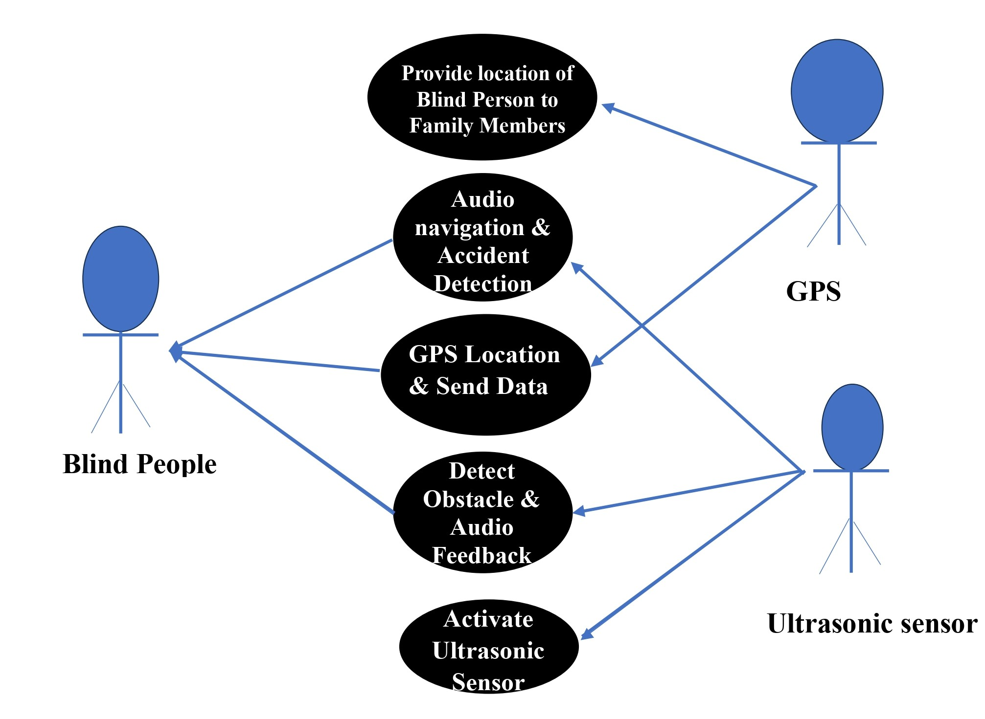

Fig. 5 Use Case Diagram

Actors:

Blind Person:

This is the primary actor in your system. They interact with the system through voice commands and receive information through audio feedback.

Family Member:

This is another actor who interacts with the system indirectly. They receive email notifications in case of accidents or emergencies involving the blind person.

Use Cases:

*Receive User Input:*

This use case represents the system's ability to accept and process user commands or requests. It involves actions like asking for location information, requesting navigation instructions, etc.

*Provide Navigation Instructions:*

This use case denotes the system's functionality to generate and deliver navigation instructions to the blind person. These instructions assist in guiding them from their current location to a specified destination.

*Detect Obstacles:*

This use case showcases the system's capability to use ultrasonic sensors for detecting obstacles in the environment. When an obstacle is detected, the system responds accordingly.

*Detect Accidents:*

This use case illustrates the system's ability to monitor sensor data for signs of accidents or emergencies. If an accident is detected, appropriate actions are taken.

*Send Email Notification:*

This use case represents the system's capability to generate and send email notifications to the blind person's family member in the event of an accident.

*Access Location Information:*

This use case demonstrates how the blind person can request and receive information about their current location using the GPS module.

*Access System Features (Blind Person):*

This use case encompasses the overall interaction capabilities of the blind person with the system. It includes actions like providing voice commands, receiving audio feedback, and accessing location information.

*Access System Features (Family Member):*

This use case covers the family member's interaction with the system, which primarily involves receiving email notifications about accidents or emergencies involving the blind person

3.5.4 Entity relationship Diagram

Blind Person:

This entity represents an individual with visual impairment.

Attributes:

BlindPersonID (Primary Key): This is a unique identifier assigned to each blind person. It is used as a reference key for the blind person.

Name: This attribute stores the name of the blind person.

ContactInfo: This field holds the contact information for the blind person. It could include details like phone number, email address, etc.

Family Member:

This entity represents a member of the blind person's family who may be involved in providing support or assistance.

Attributes:

FamilyMemberID (Primary Key): This is a unique identifier for each family member. It is used as a reference key for the family member.

Name: This field stores the name of the family member.

EmailAddress: This attribute holds the email address of the family member.

ContactInfo: Similar to the blind person, this field stores contact information for the family member.

Accident Log:

This entity is used to record details about accidents experienced by either the blind person or their family members.

Attributes:

AccidentID (Primary Key): A unique identifier for each recorded accident. It is used as a reference key for the accident log.

Timestamp: This field stores the date and time when the accident occurred.

Location: This attribute captures the location where the accident took place.

Description: This field allows for a detailed description of the accident.

Obstacle Log:

This entity is used to record details about obstacles encountered by either the blind person or their family members.

Attributes:

ObstacleID (Primary Key): A unique identifier for each recorded obstacle. It is used as a reference key for the obstacle log.

Timestamp: This field stores the date and time when the obstacle was encountered.

Location: This attribute captures the location where the obstacle was encountered.

Description: This field allows for a detailed description of the obstacle.

Location Information:

This entity is used to record geographical coordinates and timestamps of specific locations.

Attributes:

LocationID (Primary Key): A unique identifier for each recorded location information. It is used as a reference key for the location information.

Longitude: This field stores the longitude coordinates of a specific location.

Latitude: This field stores the latitude coordinates of a specific location.

Timestamp: This field captures the date and time when the location information was recorded.

Relationships:

Interaction:

This is an abstract relationship that connects the various entities (Blind Person, Family Member) with their interactions (Accidents, Obstacles, and Location Information). It establishes how these entities are associated with different types of interactions.

For instance, a Blind Person and a Family Member can both have multiple recorded accidents, obstacles, and location information entries. The numbers in parentheses denote the cardinality, where "1" indicates one entity and "0..n" indicates zero or more entities related to it.

**IMPLEMENTATION TOOLS & MODULE DEVELOPED**

Get Raspberry Pi Hardware:

Acquire a Raspberry Pi board (e.g., Raspberry Pi 3 or 4), a power supply, a micro SD card (16GB or larger), and a compatible ultrasonic sensor (e.g., HC-SR04).

Install Raspberry Pi OS:

Download the Raspberry Pi OS (formerly Raspbian) from the official website.

Flash the OS onto the micro SD card using a tool like Etcher.

Initial Boot and Configuration:

Insert the micro SD card into the Raspberry Pi and power it up.

Follow the on-screen instructions to complete the initial setup, including configuring the language, time zone, and creating a user account.

Enable SSH (Optional):

To access the Raspberry Pi remotely, enable the Secure Shell (SSH) through the Raspberry Pi Configuration menu.

Step 2: Connect Ultrasonic Sensor

Wiring the Ultrasonic Sensor:

Connect the ultrasonic sensor to the Raspberry Pi using jumper wires.

The HC-SR04 sensor typically has four pins: VCC (power), Trig (trigger), Echo (echo), and GND (ground). Connect these pins to the corresponding GPIO pins on the Raspberry Pi.

Step 3: Python Code for Ultrasonic Sensor

Install Required Libraries:

Use the terminal on the Raspberry Pi to install any necessary Python libraries. In this case, you'll likely need the RPi.GPIO library for GPIO control.

Write Python Script:

Create a Python script that interfaces with the ultrasonic sensor. This script will use GPIO commands to send a trigger signal, measure the time it takes for the echo to return, and calculate the distance based on the speed of sound.

import RPi.GPIO as GPIO

import time

# Set GPIO pins

GPIO.setmode(GPIO.BCM)

TRIG = 23 # GPIO pin for trigger

ECHO = 24 # GPIO pin for echo

GPIO.setup(TRIG, GPIO.OUT)

GPIO.setup(ECHO, GPIO.IN)

# Function to measure distance

def measure\_distance():

GPIO.output(TRIG, True)

time.sleep(0.00001)

GPIO.output(TRIG, False)

while GPIO.input(ECHO) == 0:

pulse\_start = time.time()

while GPIO.input(ECHO) == 1:

pulse\_end = time.time()

pulse\_duration = pulse\_end - pulse\_start

distance = pulse\_duration \* 17150

distance = round(distance, 2)

return distance

# Main program

try:

while True:

dist = measure\_distance()

print(f"Distance: {dist} cm")

time.sleep(1)

except KeyboardInterrupt:

GPIO.cleanup()

Run and Test:

Execute the Python script. It should provide distance measurements in centimeters.

Step 4: Obstacle Detection Logic

Implement Obstacle Detection:

Enhance the Python script to include logic for obstacle detection based on the distance measurements.

For example, set a threshold distance below which an obstacle is considered too close.

Step 5: User Interface (Optional)

Create a Simple Interface:

Develop a basic interface, possibly a command-line interface (CLI), to allow the user to start and stop the obstacle detection system.

Step 6: Testing and Calibration

Conduct Thorough Testing:

Test the system in various environments to ensure accurate obstacle detection.

Make adjustments to the threshold distance or sensitivity if needed.

Step 7: Documentation and Deployment

Document the Setup:

Document the wiring diagram, code, and any configurations made.

Set Up Raspberry Pi:

Install the Raspberry Pi in a suitable location with a power source.

Monitoring and Maintenance:

Periodically check the system for any issues and perform necessary maintenance.

This detailed explanation provides a step-by-step guide for setting up the Blind Potter project with a Raspberry Pi and an ultrasonic sensor for obstacle detection.

**FUTURE WORK**

In the realm of future development for the Blind Potter Ultrasonic GPS project, several exciting possibilities emerge. First and foremost, refining the obstacle detection system stands as a crucial endeavour. Implementing advanced machine learning algorithms could significantly enhance the system's capability to identify and categorize various types of obstacles, distinguishing between stationary objects and moving entities. Moreover, expanding the system's awareness to environmental factors like temperature, humidity, and ambient light could provide users with a more comprehensive understanding of their surroundings. Integrating a companion mobile application could further amplify accessibility, offering real-time information on points of interest, public transportation schedules, and even crowd-sourced data on potential obstacles or alternative routes.

Additionally, investigating the incorporation of augmented reality (AR) overlays presents an exciting avenue, potentially projecting digital information directly onto the user's real-world view for enhanced guidance. These future endeavors hold immense potential to elevate the Blind Potter Ultrasonic GPS project to new heights of functionality and effectiveness, empowering visually impaired individuals in their daily navigation and interactions with the world around them.

**CONCLUSION**

In conclusion, the Blind Potter Ultrasonic GPS project represents a significant leap forward in technology designed to empower visually impaired individuals. By seamlessly integrating ultrasonic sensors for obstacle detection, a speaker for clear auditory feedback, and a GPS module for precise location tracking, the system addresses critical challenges faced by the visually impaired in navigating their surroundings. The inclusion of accident detection capabilities and email alerts in the event of a fall or impact adds an essential layer of safety. Furthermore, enabling authorized family members to access real-time location data through a secure platform enhances the user's network of support.

The prospect of future improvements, such as advanced obstacle recognition through machine learning, augmented reality overlays, and environmental context awareness, promises to further revolutionize the user experience. With potential expansions into multi-language support and smartphone integration, the project has the potential to profoundly impact the lives of visually impaired individuals, providing them with newfound independence, safety, and accessibility in their day-to-day lives. As a testament to innovation and inclusivity, the Blind Potter Ultrasonic GPS project stands at the forefront of technology designed to enhance the quality of life for those with visual impairments.

## **REFERENCES**

1. Mariotti, S.P.; Pascolini, D. Global estimates of visual impairment: 2010. *Br. J. Ophthalmol.* **2012**, *96*, 614.
2. United Nations Organization. Convention on the Rights of Persons with Disabilities. 2006. Available online: [**http://www.un.org/disabilities/documents/convention/convoptprot-e.pdf**](http://www.un.org/disabilities/documents/convention/convoptprot-e.pdf) (accessed on 26 January 2022).
3. Meliones, A.; Sampson, D. Blind MuseumTourer: A System for Self-Guided Tours in Museums and Blind Indoor Navigation. *Technologies* **2018**, *6*, 4. [[**Google Scholar**](https://scholar.google.com/scholar_lookup?title=Blind+MuseumTourer:+A+System+for+Self-Guided+Tours+in+Museums+and+Blind+Indoor+Navigation&author=Meliones,+A.&author=Sampson,+D.&publication_year=2018&journal=Technologies&volume=6&pages=4&doi=10.3390/technologies6010004)] [**[CrossRef](https://doi.org/10.3390/technologies6010004" \t "_blank)**][[**Green Version**](https://www.mdpi.com/2227-7080/6/1/4/pdf)]
4. RCI1-00593 MANTO: Innovative Autonomous Blind Navigation Outdoor and Indoor and in Museums. Project Webpage. Available online: [**https://manto.ds.unipi.gr**](https://manto.ds.unipi.gr/) (accessed on 26 January 2022).
5. Meliones, A.; Filios, C. BlindHelper: A Pedestrian Navigation System for Blinds and Visually Impaired. In Proceedings of the 9th ACM International Conference on Pervasive Technologies Related to Assistive Environments, Corfu, Greece, 29 June–1 July 2016. (best innovation paper). [[**Google Scholar**](https://scholar.google.com/scholar_lookup?title=BlindHelper:+A+Pedestrian+Navigation+System+for+Blinds+and+Visually+Impaired&conference=Proceedings+of+the+9th+ACM+International+Conference+on+Pervasive+Technologies+Related+to+Assistive+Environments&author=Meliones,+A.&author=Filios,+C.&publication_year=2016)]
6. Kuriakose, B.; Shrestha, R.; Sandnes, F.E. Smartphone navigation support for blind and visually impaired people-a comprehensive analysis of potentials and opportunities. In Proceedings of the 14th International Conference on Universal Access in Human-Computer Interaction. Applications and Practice (UAHCI 2020), Held as Part of the 22nd HCI International Conference (HCII 2020), Copenhagen, Denmark, 19–24 July 2020; pp. 568–583.
7. El-Taher, F.E.Z.; Taha, A.; Courtney, J.; Mckeever, S. A systematic review of urban navigation systems for visually impaired people. *Sensors* **2021**, *21*, 3103
8. Meliones, A.; Llorente, J.L. Study and Development of a Sonar Obstacle Recognition Algorithm for Outdoor Blind Navigation. In Proceedings of the 2019 ACM International Conference on Pervasive Technologies Related to Assistive Environments, Rhodes, Greece, 5–7 June 2019; pp. 129–137.
9. Koley, S.; Mishra, R. Voice Operated Outdoor Navigation System for Visually Impaired Persons. *Int. J. Eng. Trends Technol.* **2012**, *3*, 153–157.
10. Bousbia-Salah, M.; Fezari, M. A Navigation Tool for Blind People. In *Innovations and Advanced Techniques in Computer and Information Sciences and Engineering*; Sobh, T., Ed.; Springer: Berlin/Heidelberg, Germany, 2007; pp. 333–337.