**Quality Control and Quality Assurance in Pharmaceuticals**

**Mr. Shinde Jayesh santosh ¹, Ms. Sondkar vaishanvi², Mr. Tathwade bhushan³, Mr. Shendage Shantanu⁴, Mr.bhosale Sanket⁵, Mrs. Thorat Pooja Suresh⁶**

Final Year B. Pharmacy, Shri Swami Samarth Institute of Pharmacy, Malwadi (Bota), Maharashtra, India*[1,2,3,4,5]

Assistant Professor (M. Pharm), Research Guide, Department of Quality Assurance Shri Swami Samarth Institute of Pharmacy, , Malwadi (Bota), Maharashtra, India*[6]

[shindejayesh1112@gmail.com](mailto:shindejayesh1112@gmail.com)

1. **ABSTRACT:**

This brief review presents the international approaches to assessment of the content of geotaxis impurities (residual solvents and various inorganic and organic impurities) in pharmaceuticals. Nowadays, it has become necessary to provide not only purity profile but also impurity profile of a particular pharmaceutical product because of national and international regulations. These aspects along with significance of the quality, efficacy and safety of pharmaceuticals, including the source of impurities, kinds of impurities, control of impurities and regulatory aspects are discussed.The supply of essential medicines of good quality has been identified as one of the prerequisites for the delivery of health care system of any country as poor quality medicines can harm or even kill consumers. The presence of unwanted chemicals in a particular medicine, even in extremely small quantities, may influence its efficacy and safety. Unlike in other industries, a medicine is a dynamic product whose color, consistency, weight, and even chemical identity can change between manufacture and ultimate consumption. Hence, quality of pharmaceuticals has been a concern of the people of the whole world, and is now receiving critical attention from regulatory authorities .Impurities in pharmaceutical products are of great concern not only due to the inherent toxicity of certain contaminants, but also due to the adverse effect that contaminants may have on drug stability and shelf-life. In pharmaceutical and drug products, impurities are the unwanted chemicals (organic, inorganic and residual solvents) that remain with the active pharmaceutical ingredients (APIs), or develop/added during formulation, or upon aging. Organic impurities are the most common impurities found in every API which get incorporated normally during the multi-step synthesis process despite proper Care .

## KEYWORDS: Quality control, Quality Assurance, ICH GUIDELINES, Validation, Calibration, QbD

## 2. INTRODUCTION

**2.1 Concept and scopes of Quality Control and Quality Assurance:**

**Definition**

* **Quality assurance** :

Qualityassurance can be defined as "part of quality management focused on providing confidence that quality requirements will be fulfilled.

* **Quality control:-** Quality control can be defined as "part of quality management focused on fulfilling quality requirements."
* **Scope of QA:**
* To prevent defects with a focus on the process.
* To improve development and test processes so that defects do not arise.
* Establish a good quality management system &assessment of its adequacy with continuous monitoring.
* Prevention of quality problems through planned and systematic activities.
* **Scope of QC:**
* To identify defects in the finished product.
* To identify defects after a product is developed and before it's released.
* Finding sources of quality problems to continually meet customer's requirement.
* Analytical techniques used to maintain the product quality and process.

**2.2 Concept of GMP:**

Good Manufacturing Practice is a part of quality assurance which ensure that the products are consistently produced and controlled according to quality standards appropriate to their intended use.

**2.3 Concept of CGMP:**

CGMP refers to the current good manufacturing practices regulations enforced by the FDA. CGMP provides for system that assure proper design monitoring & control of manufacturing process of facilities.

In that the c in GMP is or means current up-to-date technologies[1,2].

* 1. **Overview of ICH Guidelines:**
* **Definition:**

ICH is a joint initiative involving both regulators and research-based industry representatives of the EU, Japan and the US in scientific and technical discussions of the testing procedures required to assess and ensure the safety, quality and efficacy of medicines.

* **Aim:**

The International Conference on Harmonisation of Technical Requirements for the Registration of Pharmaceuticals for Human Use (ICH) was established in 1990 as a joint regulatory/industry project to improve, through harmonisation, the efficiency of the process for developing and registering new medicinal products in Europe, Japan and the United States, in order to make these products available to patients with a minimum of delay.

The six parties to ICH represent the regulatory bodies and research-based industry in the three regions, Europe, Japan and the USA, where the vast majority of new medicines are currently developed.

* **Objective**:
* The objective of such harmonisation is a more economical use of human, animal and material resources, and the elimination of unnecessary delay in the global development and availability of new medicines whilst maintaining safeguards on quality, safety and efficacy, and regulatory obligations to protect public health.
* Harmonising the technical content of the sections of the reporting data where significant differences have been identified between regulatory requirements across the three regions: Europe, Japan and the USA.
* **ICH Guidelines[3]:**

|  |  |  |  |
| --- | --- | --- | --- |
| QUALITY | SAFETY | EFFICASY | MULTIDISCIPLINARY |
| Q1A-Q1F: (Stability) | S1A-S1C (carcinogenicity Studies) | E1: Clinical Safety for Drug used in Long-Term Treatment | M1 (MedDRA |
| Q2 (Analytical Validation) | S2 (Genotoxicity Studies) | E2A E2F: Pharmacovigilance | Terminology)  M2 (Electronic Standards) |
| Q3A-Q3D (Impurities) | S3A-S3B (Toxicokinetics and Pharmacokinetics) | E3: Clinical Study Reports | M3 (Nonclinical Safety Studies) |
| Q4-Q4B (Pharmacopoeias) | S4 (Toxicity Testing) | E4: Dose-Response Studies | M4 (Common Technical Document) |
| Q5A-Q5E (Quality of Biotechnological Products) | S5 (Reproductive Toxicology) | E5: Ethnic Factors | M5 (Data Elements and Standards for Drug Dictionaries) |
| Q6A-Q6B (Specifications) | S6 (Biotechnological Products) | E6: Good Clinical Practice | M6 (Gene Therapy) |
| Q7 (Good Manufacturing Practice) | S7A-S7B (Pharmacology Studies) | E7 Clinical Trials in Geriatric Population | M7 (Mutagenic impurities) |
| Q8 (Pharmaceutical Development) | S8(Immunotoxicology Studies) | E8: General Considerations for Clinical Trials | M8 (Electronic Common Technical Document i.e., eCTD) |
| Q9 (Quality Risk Management) | S9 (Nonclinical Evaluation for Anticancer Pharmaceuticals) | E9 Statistical Principles for Clinical Trials | M9 (Biopharmaceutics Classification System- based Biowaivers) |
| Q10 (Pharmaceutical Quality System) | S10 (Photosafety Evaluation) | E10: Choice of Control Group in Clinical Trials | M10 (Bioanalytical Method Validation) |
| 011 (Development and Manufacture of Drug Substances) | S11 (Nonclinical Paediatric Safety) | E11-E11A: Clinical Trials in Pediatric Population | M11 (Clinical electronic Structured Harmonised Protocol i.e CeSHarP) |
| Q12 (Lifecycle Management) |  | E12 Clinical Evaluation by Therapeutic Category | M12 (Drug Interaction Studies) |
| Q13 (Continuous Manufacturing of Drug Substances and Drug Products) |  | E14 Clinical Evaluation of QT |  |
| Q14 (ANALYTICAL PROCEDURE DEVELOPMENT) |  | E15 Definitions in Pharmacogenetics/Pharmacogenomics |  |
|  |  | E17 Multi-Regional Clinical Trials |  |
|  |  | E18: Genomic Sampling |  |

**Table.No.2.1: ICH Guidelines**

**2.5 Good Warehousing Practices:**

* A suitable space is provided to raw material, handling of raw and packaging materials required for manufacturing. This space is known as Warehouse.
* Different dosage forms must be stored and transported under different environmental conditions and therefore, there cannot be one general rule for their handling.
* Maintaining proper storage condition for pharmaceutical products is vital to ensure their quality, safety and efficacy.
* Thus, it is vital to follow Good Warehousing Practices and Good Distribution Practices to ensure the quality of products is maintained.

**2.6 Regulatory Authority in India:**

* **CDSCO: [4]**

It is the National Drug Regulatory Authority of the Government of India. • Central Drugs Standard Control Organization (CDSCO) exercises regulatory control over the quality of drugs, cosmetics and notiﬁed medical devices in the country. • It is the Central Drug Authority for discharging functions assigned to the Central Government under the Drugs and Cosmetics Act. What is CDSCO….??

* **Vision**: To Protect and Promote public health in India.
* [**Mission**: To safeguard and](https://www.slideshare.net/BiNduXtrEiy/cdsco-functions-responsibilities#3)enhance the public health by assuring the safety, efﬁcacy and quality of drugs, cosmetics and medical devices. Vision: To Protect & Promote Health in India
* [**Functions of Central**](https://www.slideshare.net/BiNduXtrEiy/cdsco-functions-responsibilities#4)**Authority:** 
  1. Laying down standards of drugs, cosmetics, diagnostics and devices.
  2. Laying down regulatory measures, amendments to Acts and Rules.
  3. To regulate market authorisation of new drugs.
  4. To regulate clinical research in India.
  5. To approve licenses to manufacture certain categories of drugs as Central Licence approving Authority i.e., for Blood Banks, Large Volume Parenteral and Vaccines & Sera.
  6. To regulate the standards of imported drugs.
  7. Work relating to the Drugs Technical Advisory Board (DTAB) and Drugs Consultative Committee (DCC).
  8. Testing of drugs by Central Drugs Labs
  9. Publication of Indian Pharmacopoeia.
* [**Functions of State**](https://www.slideshare.net/BiNduXtrEiy/cdsco-functions-responsibilities#5)**Authority:**

1. Licensing of drug manufacturing and sales establishments
2. Licensing of drug testing laboratories.
3. Approval of drug formulations for manufacture.
4. Monitoring of quality of Drugs & Cosmetics, manufactured by respective state units and those marketed in the state.
5. Investigation and prosecution in respect of contravention of legal provisions.
6. Administrative actions.
7. Pre- and post- licensing inspection 8. Recall of sub-standard drugs.

* **Organization of CDSCO:** 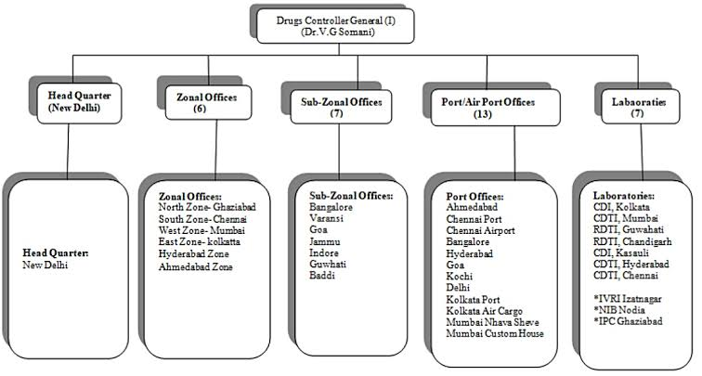

**Fig.No.2.1: Organization of CDSCO**

**2.7 Documentation in Pharmaceutical Industry:**

* Documentation is a systematic procedure of preparation, checking, verifying, issuing, storing and reviewing of any documents.
* The basic rules in any good manufacturing practice (GMP)regulations specify that the pharmaceutical manufacturer must maintain proper documentation and records
* **Purpose of Documentations: -**

1. Defines specifications and procedures for all materials and methods of manufacture and control
2. Ensures all personnel know what to do and when to do it.
3. Ensure that authorized persons have all information necessary for release of product
4. Ensures documented evidence, traceability, provide records and audit trail for investigation
5. Ensures availability of data for validation, review and statistical analysis

* **Types of documents:** 
  1. **Quality manual:** A global company document that describes, in paragraph form, the regulations and/or parts of the regulations that the company is required to follow.
  2. **Policies**: Documents that describe in general terms, and not with step-by-step instructions, how specific GMP aspects (such as security, documentation, health, and responsibilities) will be implemented.
  3. **Standard operating procedures (SOPs):** Step-by-step instructions for performing operational tasks or activities.
  4. **Batch records:** These documents are typically used and completed by the manufacturing department. Batch records provide step-by-step instructions for production-related tasks and activities, besides including areas on the batch record itself for documenting such tasks.
  5. **Test methods:** These documents are typically used and completed by the quality control (QC) department. Test methods provide step-by-step instructions for testing supplies, materials, products, and other production-related tasks and activities, e.g., environmental monitoring of the GMP facility. Test methods typically contain forms that have to be filled in at the end of the procedure; this is for documenting the testing and the results of the testing. Specifications: Documents that list the requirements of the testing.
  6. **Specifications:** Documents that list the requirements that a supply, material, or product must meet before being released for use or sale. The QC department will compare their test results to specifications to determine if they pass the test.
  7. **Logbooks**: Bound collection of forms used to document activities. Typically, logbooks are used for documenting the operation, maintenance, and calibration of a piece of equipment. Logbooks are also used to record critical activities, e.g., monitoring of cleanrooms, solution preparation, recording of deviation, change controls and its corrective action assignment.[5]

**2.8 Drug Discovery and Development:**

Basic Principles of Drug Discovery and Development presents the multifaceted process of identifying a new drug in the modern era, which requires a multidisciplinary team approach with input from medicinal chemists, biologists, pharmacologists, drug metabolism experts, toxicologists, clinicians, and a host of experts from numerous additional fields. Enabling technologies such as high throughput screening, structure-based drug design, molecular modeling, pharmaceutical profiling, and translational medicine are critical to the successful development of marketable therapeutics.

Given the wide range of disciplines and techniques that are required for cutting edge drug discovery and development, a scientist must master their own fields as well as have a fundamental understanding of their collaborator’s fields. This book bridges the knowledge gaps that invariably lead to communication issues in a new scientist’s early career, providing a fundamental understanding of the various techniques and disciplines required for the multifaceted endeavor of drug research and development. It provides students, new industrial scientists, and academics with a basic understanding of the drug discovery and development process. The fully updated text provides an excellent overview of the process and includes chapters on important drug targets by class, in vitro screening methods, medicinal chemistry strategies in drug design, principles of in vivo pharmacokinetics and pharmacodynamics, animal models of disease states, clinical trial basics, and selected business aspects of the drug discovery process.

**Fig.No.2.2: Drug Discovery And Developement**

* **Phages and stages:**
* Step 1: Discovery & Development
* Step 2: Preclinical Research
* Step 3: Clinical Drug Development Process
* Step 4: FDA Review
* Step 5: Post-Market Monitoring[5]
  1. **Instrument Handeling :**

**2.9.1 Demonstration of TLC**

**Principle:** Like other chromatographic techniques, thin-layer chromatography (TLC) depends on the separation principle. The separation relies on the relative affinity of compounds towards both the phases. The compounds in the mobile phase move over the surface of the stationary phase. The movement occurs in such a way that the compounds which have a higher affinity to the stationary phase move slowly while the other compounds travel fast. Therefore, the separation of the mixture is attained. On completion of the separation process, the individual components from the mixture appear as spots at respective levels on the plates. Their character and nature are identified by suitable detection techniques.

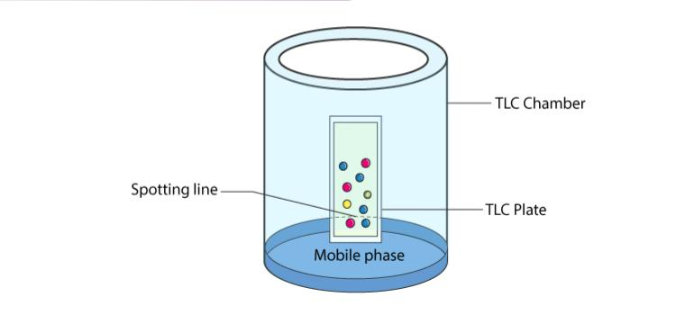**Fig.No.2.3: thin layer chromatography**

### **Thin Layer Chromatography Experiment:**

* To apply sample spots, thin marks are made at the bottom of the plate with the help of a pencil.
* Apply sample solutions to the marked spots.
* Pour the mobile phase into the TLC chamber and to maintain equal humidity, place a moistened filter paper in the mobile phase.
* Place the plate in the TLC chamber and close it with a lid. It is kept in such a way that the sample faces the mobile phase.
* Immerse the plate for development. Remember to keep the sample spots well above the level of the mobile phase. Do not immerse it in the solvent.
* Wait till the development of spots. Once the spots are developed, take out the plates and dry them. The sample spots can be observed under a UV light chamber.
* **Thin Layer Chromatography Applications:**
* The qualitative testing of Various medicines such as sedatives, local anaesthetics, anticonvulsant tranquilisers, analgesics, antihistamines, steroids, hypnotics is done by TLC.
* TLC is extremely useful in Biochemical analysis such as separation or isolation of biochemical metabolites from its blood plasma, urine, body fluids, serum, etc.
* Thin layer chromatography can be used to identify natural products like essential oils or volatile oil, fixed oil, glycosides, waxes, alkaloids, etc.
* It is widely used in separating multicomponent pharmaceutical formulations.
* It is used for the purification of samples and direct comparison is done between the sample and the authentic sample.
* It is used in the food industry, to separate and identify colours[7]
  + 1. **Demonstration of UV Vis spectrophotometer:**
* **Uv-Vis Spectroscopy Theory:**

Generally, the UV and visible spectral bands of substances are large. And may not exhibit a high degree of compound recognition accuracy. Nonetheless, they are sufficient for quantitative assays and are useful as an alternate means of detection for several substances. The radiation from typical hot solids consists of several wavelengths and depends primarily on the temperature of the solid and is predictable from the principle of chance, the energy released at each given wavelength.

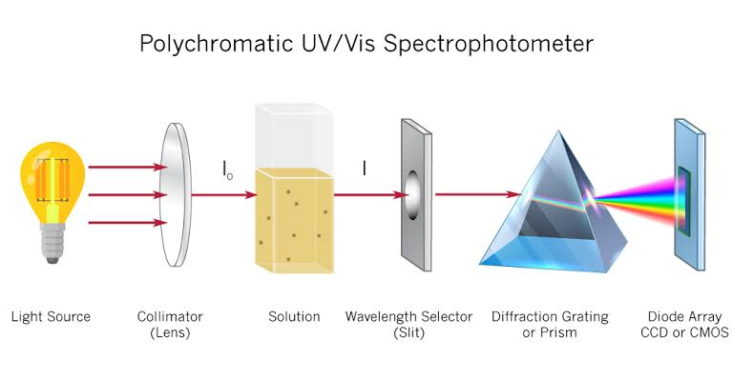More recently, using a version of this-the tungsten-halogen lamp-has become standard practice. Radiation is transmitted deep into the UV zone through the quartz envelope. The most popular source is the deuterium lamp for the UV region itself, and a UV-Visible spectrometer would normally have all types of lamps to fill the whole wavelength spectrum.

**Fig.No.2.4: UV Vis Spectrophotometer**

## Applications of UV-VIS spectroscopy:

* In research, ultraviolet/visible spectroscopy is used more commonly than in detection. Through first reacting the sample to bring the metal into solution as an ion, the trace metal content of an alloy, such as manganese in steel, can be determined.
* A common technique for quantitative analysis of analytes in QA/QC, analytical research, and government regulatory laboratories is UV-Visible spectrophotometry. The fundamentals of the approach are learned in school, such as Beer’s Law. UV-Visible Mid-range to Upper-end Spectrophotometers are typically used in research laboratories, including university and industrial laboratories.[8]
  + 1. **Demonstration of HPLC**
* **HPLC Principle:**
* The purification takes place in a separation column between a stationary and a mobile phase.
* The stationary phase is a granular material with very small porous particles in a separation column.
* The mobile phase, on the other hand, is a solvent or solvent mixture which is forced at high pressure through the separation column.
* Via a valve with a connected sample loop, i.e., a small tube or a capillary made of stainless steel, the sample is injected into the mobile phase flow from the pump to the separation column using a syringe.
* Subsequently, the individual components of the sample migrate through the column at different rates because they are retained to a varying degree by interactions with the stationary phase.
* After leaving the column, the individual substances are detected by a suitable detector and passed on as a signal to the HPLC software on the computer.
* At the end of this operation/run, a chromatogram in the HPLC software on the computer is obtained.
* The chromatogram allows the identification and quantification of the different substances.

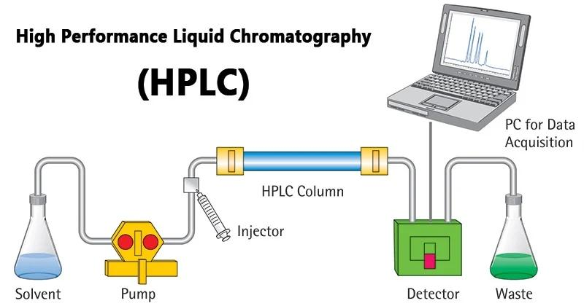

**Fig.No.2.5: HPLC**

* **Types of HPLC:**

1. Normal phase
2. Reverse phase
3. Ion exchange
4. Size exclusion

* **Application of HPLC:**
* Analysis of drugs
* Analysis of synthetic polymers
* Analysis of pollutants in environmental analytics
* Determination of drugs in biological matrices
* Isolation of valuable products
* Product purity and quality control of industrial products and fine chemicals
* Separation and purification of biopolymers such as enzymes or nucleic acids
* Water purification[9]
  + 1. **Demonstration of dissolution test apparatus:-**
* **Dissolution:** Dissolution is the process by which a solid substance enters into a liquid known as dissolution medium or solvent to form a solution.
* Dissolution is a test which is used for a pharmaceutical product to evaluate the rate of release of a drug substance from the dosage form.
* Dissolution test is performed for the Dosage form like Tablets, Capsules, Granules, Ointment and Creams etc. to check the percentage of drug release.
* **Drug dissolution in Body:**

In the body, a pharmaceutical active ingredient must be in solution before it can be absorbed by the blood and ultimately carried to the receptor site to render a therapeutic effect.

Solid oral dosage forms typically begin to disintegrate and dissolve in the stomach and then the resulting solution passes into the small intestine where dissolution continues.

The dissolved active ingredient is absorbed into the blood stream through the walls of the small intestine.

* **Types of Dissolution Apparatus :**

USP Dissolution Apparatus 1 – Basket

USP Dissolution Apparatus 2 – Paddle

USP Dissolution Apparatus 3 – Reciprocating Cylinder

USP Dissolution Apparatus 4 – Flow-Through Cell

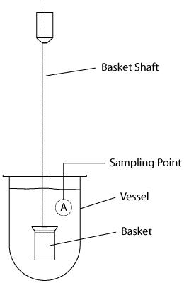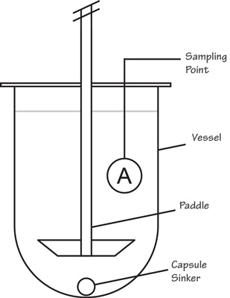

Basket type paddle Type

**Fig.No.2.6: Disso Apparatus**

* **Procedure :-**
* The general procedure for a dissolution involves a liquid known as Dissolution Medium which is placed in the vessels of a dissolution unit. The medium can range from degassed or sonicated deionized water to pH adjusted chemically-prepared solutions and mediums that are prepared with surfactants. The dissolution medium should be water or water-based having a pH in the range of 5-7 at 37 ºC and medium to be used as per the product which is written in the standard test procedure of the respective product.
* Degassing the dissolution medium through sonication or other means is important since the presence of dissolved gases may affect results so the drug is placed within the medium in the vessels after it has reached sufficient temperature and then the dissolution apparatus is operated.
* Sample solutions collected from dissolution testing are commonly analyzed by HPLC and Ultra violet visible spectroscopy.
* There are criteria known as release specifications that samples tested must meet statistically, both as individual values and as average of the whole and one such criteria is the parameter “Q”, which is a percentage value denoting the quantity of dissolved active ingredient within the monograph of a sample solution.
* If the initial sample analysis, known as S1 or stage 1 testing fails to meet the acceptable value for Q, then additional testing known as stage 2 and 3 testing is required. S3 testing is performed only if S2 testing still fails the Q parameter. If there is a deviation from the acceptable Q values at S3, then an OOS (Out of Specification) investigation is generally initiated.[10]

**3. VALIDATION :**

* **Introduction to concept of validation: -**

• ISO definition – Validation is the confirmation by examination and the provision of objective evidence that the particular Requirements for a specific intended use are fulfilled.

**•** “Establish documented evidence which provides a high Degree of assurance that a specific process will consistently Produce a product meeting its predetermined specifications and quality attributes.”

**Method validation: -**

* Formulation development methods
* Analytical methods
* Cleaning methods
* **Scope of validation: -**

Validation done in a structured way according to Documentation including procedures and protocols

* + Validation should be performed for
* new premises, equipment, utilities and systems
* new processes and procedures; at periodic intervals;
* whenever major changes have been made.
* Validation in accordance with written protocol
* Demonstrate suitability for new manufacturing Formula/method
* A written report on the outcome to be produced.
* Validation over a period of time
* **Types of Process Validation:**

1. **Prospective Validation:** Prospective validation is carried out during the development stage of a product. At this point in the product manufacturing process, the steps of production will be split into distinct sections, allowing for the analysis of potential critical points.
2. **Concurrent Validation:** Concurrent validation involves extremely close monitoring of the product during the manufacturing steps and the pre-identified critical points. At this point, there will be lots of in-process testing which involves the testing of weight, viscosity, density, clarity, and the pH value of the product.
3. **Retrospective Validation:** Retrospective validation involves checking a system that has been in operation for some time to ensure that it is still complying with the set standards and regulations.
4. **Revalidation:** Revalidation is the final part of process validation, and this offers the opportunity to check whether a system is operating after a substantial change of circumstances. For instance, this could include: a change in raw material that makes up the product, a change in equipment, a change within the production facility or an increase or decrease in the yield of the product.

* **Advantages of validation:**
  + During the process the knowledge of process increases
  + Assures the repeatability of the process
  + Assures the fluency of production
  + Assures that the product is continuously according to the marketing Authorisation
  + Decreases the risk of the manufacturing problems
  + Decreases the expenses caused by the failures in production
  + Decreases the risks of failing in GMP
  + Decreases the expenses of the everyday production even though
  + The validation itself will create expense documentation of validation
  + The validation activity cannot be completed without proper Documentation of each and every minute activity with Utmost details.

* Documentation of validation is generally different types Such as: –
* Validation Master Plan (VMP)
* Validation protocols (VP)
* Validation reports (VR)
* Standard Operating Procedures (SOPs)
* **Validation Master Plan (VMP):**
* A validation Master Plan (VMP) is a comprehensive document Describing the applicable validation requirements for the Facility, and providing a plan for the meeting those Requirements.
* In short, it is documented evidence that provides a high Degree of assurance that a specific process will consistently Produce a product the meets its predetermined specifications and quality attributes.

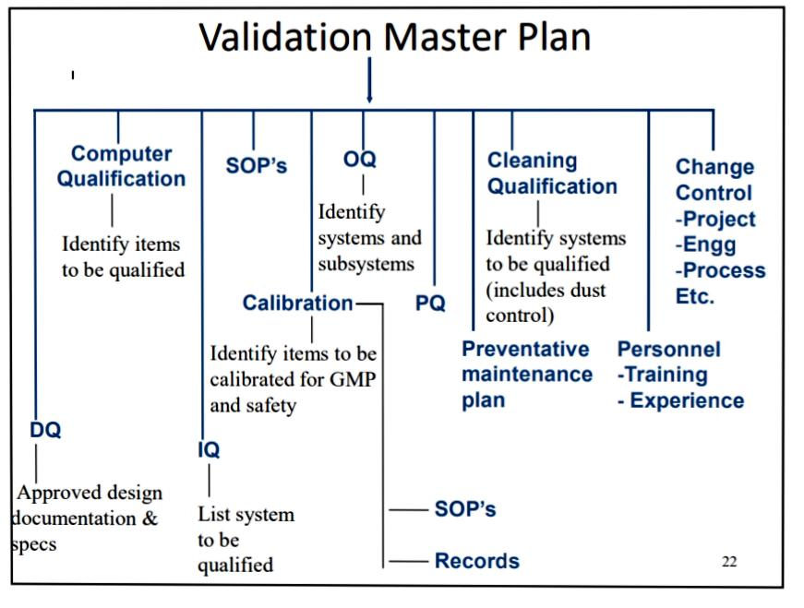

**Fig.No.3.1: Validation Master Plan**

**The Validation Master Plan could consist of:**

* + Introduction and objectives
  + Approval page and table of contents
  + Facility and process description
  + Personnel, planning and scheduling
  + Responsibilities of committee members
  + Process control aspects
  + Equipment, apparatus, processes and systems to be validated
  + Acceptance criteria
  + Documentation e.g. validation protocols and reports
  + SOPs
  + Training requirements[11]
  1. **CALIBRATION:**

Calibration determines if a device or instrument is producing accurate results within the specified limits compared to those produced by a traceable standard over an appropriate range of measurements. Calibration is crucial for justifying qualification and validation. An accredited laboratory can ensure that all the calibration services and activities are performed with qualified instruments.

**Equipment Classification**

* Critical instrument is an instrument within an equipment/system Where the operation, contact, data, control, alarm or failure may Have a direct impact on the quality of a product.

1. The instrument/component controls critical process that may Affect product quality.
2. The instrument/component is used to monitor the parameters Of the manufacturing process.
3. .Failure or alarm of the instrument/component will have a Direct impact

* Non-critical instrument is an instrument within anEquipment/system where the operation, contact, data, Control, alarm or failure will have no impact on the quality of the The product.

**Depending on:**

* Classification of Critical or non-critical
* Usage (light or heavy usage)
* Handling (light or heavy handling)
* Manufacturer’s recommendation
* Reference to NIST or accreditation body guideline for a
* Specific measurement system

**Calibration Identification:**

* Status of equipment calibration shall be available and affixed To the equipment where applicable.
* Equipment identification shall bear the following information:
* name of equipment
* serial no.
* date calibrated
* status
* schedule of next calibration and
* initial/signature of the person who performed the calibration
* **Calibration Process:**

Calibration process must be managed and executed in a Professional manner:

– A particular place for all calibration operations to take place and keeping all Instruments for calibration

– A separate room is preferred because (1) better environmental control and Instruments.

– The performance of all calibration operations is assigned as the clear Responsibility of just one person.

– Calibration procedures, used for quality control functions, are controlled by the international standard ISO 9000.

– It requires that all persons using calibration equipment be adequately Trained[12]

* 1. **Quality By Design:**
* **Quality by design:**

Quality by Design (QbD) is a strategic approach employed in various industries, including pharmaceuticals, manufacturing, and product development, to ensure the consistent delivery of high-quality products. It involves a systematic and proactive process of integrating quality considerations throughout the entire product lifecycle, from conception to production.

In the context of pharmaceuticals, Quality by Design focuses on optimizing the development, manufacturing, and control processes of drugs to enhance their safety, efficacy, and overall quality. It requires a deep understanding of the product's critical quality attributes (CQAs), which are the measurable characteristics that determine its performance, and the critical process parameters (CPPs), which are the variables affecting the manufacturing process.

* **Quality by Design Development Process:**
* The Quality by Design development process begins by carefully defining the requirements of the final product, including use targets, safety profiles and product efficacy goals. The steps in the process include:
* Definition of a product quality profile that represents in-vitro how the product will perform in-vivo. This profile is a quantitative representation of the clinical safety and efficacy targets for product developers.
* Summarizing and centralizing what is known about the Active Pharmaceutical Ingredient (API), excipients and process, and identifying knowledge gaps in order to prioritize study based on risk evaluation
* Design of the composition of the product and careful definition of the quality characteristics that need to be controlled in order to achieve the product quality profile
* Development of a flexible process for the product that has the defined quality characteristics
* Determination of key process specifications and starting material characteristics to be managed in order to achieve the desired end product characteristics. To have a flexible process requires that the acceptable performance envelope of the process is well defined and the boundaries of acceptability are well understood. A methodology, such as [Design of Experiments (DoE)](https://www.mt.com/in/en/home/applications/L1_AutoChem_Applications/L2_ReactionAnalysis/design-of-experiments-doe.html), may be used to aid in process performance.
* Establishment of an overall control strategy for all aspects of the manufacturing process. Risk assessment for the various steps should be considered in the control process. [PAT methodology](https://www.mt.com/in/en/home/applications/L1_AutoChem_Applications/L2_PAT.html) may be employed as part of the overall control strategy.
* Constant auditing of the manufacturing process and revision, as necessary, to maintain final product quality
* **The Current Approach: Quality by Design (QbD):**
* **From Development to Manufacturing:**

Quality by Design encompasses all major aspects of pharmaceutical production. In drug development, a methodical, multivariate approach is used to construct an effective process design based on assessing the risk associated with various steps. In the manufacturing process, a QbD strategy permits process flexibility within the defined design space. Process control effectively uses [process analytical technology](https://www.mt.com/in/en/home/applications/L1_AutoChem_Applications/L2_PAT/quality-by-design.html) to track process trends and quality assurance is a necessity of risk-based control processes, which ensures less likelihood of batch failure.

* Quality built into product and process by design, based on scientific understanding
* Knowledge-rich submission – showing product knowledge and process understanding
* Specifications based on product performance requirements
* Flexible process within design space – allowing continuous improvement
* Focus on robustness – understanding and controlling variations
* **Advantages of Quality by Design:**
* “Right first time” – reduced costs and less process downtime
* Science-based understanding of the process results in minimized batch failure or rework
* Better consistency in drug quality and efficacy
* Ensures therapeutic efficacy of generics
* Reduced time to market for new drugs
* Less intensive regulatory oversight
* Process changes within approved design space are permitted without regulatory resubmission
* In-depth process understanding results in process improvement over time – improved yields, lower costs
* Real-time process monitoring and trending using Process Analytical Technology (PAT) reduces the analysis burden and improves the product quality
* **Potential Challenges Associated with Quality by Design:**
* All stakeholders must be in agreement
* Corporate inertia
* Initial cost of new equipment and training
* Developing a Quality by Design-oriented information system to capture necessary documentation
* Supply chain issues
* Regulatory standards by which to judge Critical Quality Attributes (CQAs), analytical methods, etc.
* Global acceptance (or lack of)
* Lack of understanding of actual cost savings and positive business model [13]

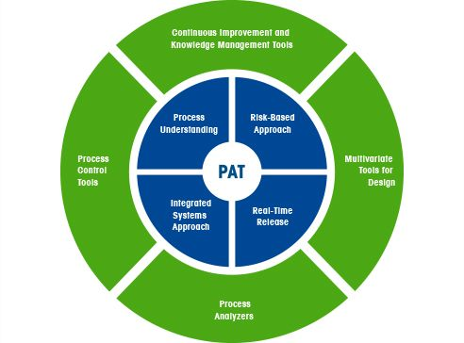

**Fig.No.5.1: PAT**

* 1. **CONCLUSION:**

As a conclusion on the entire discussion it clearly shows that quality assurance is somehow Related to all the departments in a pharmaceutical industry, and it plays an important role in Each department to enhance the process of that particular department. As how the title mentions That the quality assurance plays vital role and it is said as the backbone of a pharmaceutical Industry. Quality Assurance they emphasize on customers satisfaction and also based on the Guidelines which have been set up by the authorities. As the thalidomide incident which took Place long ago it shows a clearly failure in the quality assurance and the clinical trial phase Which lead to such a big disasters which caused teratogenicity (Phocomelia). The drug was first Invented for morning sickness problem in the pregnant women’s. Due to lack of proper analysis And quality check it has cause a black history, thus this also clearly proves that the quality Assurance has a very important role in production of medication. Quality assurance is not only Implemented or emphasize in pharmaceutical industry whereas it is emphasize on every Production industry which is related to every feel. As it was said that QA works based on Customers satisfaction, customer is the main source which gives profit and revenue to any Industry. If the product does not have qualities then it will a big failure to the industry.QA has its role in every part of a industry which is inter-related, QA can form many branches of department “under their Umbrella” to increase the efficacy and the standard of the quality by Ever means and methods.

* 1. **REFERENCE :**

1. Yadav Ravi, Piyush yadav ,Priyanshu Maurya, Tushar Yadav, Rohit kumarQUALITY CONTROL AND QUALITY ASSURANCE IN PHARMACEUTICAL INDUSTRY, IJCRT2101391, Volume 9, Issue 1 January 2021.

# Kulsoom Farhat, Pharmaceutical Quality Assurance, Researchgate

# Khagga Bhavyasri, ICH Guideline- Q Series- A Review, GSC, Biological and Pharmaceutical Science, 2019;06(03),89-106

1. Nithya J Gogtay, Renju Ravi, and Urmila M Thatte, Regulatory requirements for clinical trials in India, PMC,2017 Mar; 61(3): 192-199
2. Pranshu Tangri, Praveen Mamgain, Shaffi, Abhay ML Verma, Lakshmayya, IN PROCESS QUALITY CONTROL: A REVIEW,ijipbs,2014
3. Amol B. Deore, Jayprabha R. Dhumane, The Stages of Drug Discovery and Development Process, Researchgate,7(6):62-67
4. Shashank Tiwari and Shreya Talreja. “Thin Layer Chromatography (TLC) VS. Paper Chromatography: A Review". Acta Scientific Pharmaceutical Sciences 6.9 (2022): 05-09.
5. Govinda Verma and Dr. Manish Mishra, DEVELOPMENT AND OPTIMIZATION OF UV-VIS SPECTROSCOPY – A REVIEW,World Journal of Pharmaceutical Research, Volume 7, Issue 11, 1170-1180.
6. Priya Sadapha, Kavita Dhamak,Review Article on High-Performance Liquid Chromatography (HPLC) Method Development and Validation, International Journal of Pharmaceutical Sciences Review and Research,74(2), May – June 2022; Article No. 03, Pages: 23-29
7. Shobhit Sharma, M.P. Khinchi, A REVIEW ON DISSOLUTION APPARATUS, Asian Journal of Pharmaceutical Research and Development,Vol.1 (3) May– June 2013: 34-40
8. indal D, Kaur H, Patil RK, Patil HC. Validation – In pharmaceutical industry: Equipment validation: A brief review. Adesh Univ J Med Sci Res 2020;2(2):94-8.
9. CH. Aparna and D. Gowrisankar, A REVIEW ON CALIBRATION OF ANALYTICAL INSTRUMENTS,IJPCBS 2015, 5(3), 572-582
10. Bansal V., Journal of Global Pharma Technology. 2010; 2(5): 22-26