A STUDY ON ACCEPTANCE OF INDIAN HANDICRAFT AMONG COMSUMER

**Dr Sushree Sangita Ray*, Dr Rachita Ota* & Ms Rohinee Sahoo**

*\*Asst. Professor, Amity Global Business School, Bhubaneswar*

*\*\* MBA Student of Amity Global Business School, Bhubaneswar*

### Abstract

This study explores consumer acceptability of Indian handicrafts by looking at the variables affecting customers' views and purchase decisions. The study intends to reveal customer preferences, cultural concerns, and market trends connected to Indian handicrafts through empirical research and analysis. The purpose of the research is to provide stakeholders, legislators, and marketers with information about how to improve consumer acceptability, promote cultural appreciation, and aid in the expansion of this important industry in the global economy. In the end, the study sheds light on potential and problems for the sustainable growth of the Indian handicrafts sector and provides insightful information on consumer behaviour in this context.

**Keywords:** Handicraft, Handloom, Indian Industry, Consumer preferences, Market trends, Consumer buying Behaviour

### Introduction

Handmade with love, skill, and tradition, that’s what Indian handicrafts are all about. Handicrafts is the term used to describe the art of creating goods and crafts by hand. Everyday necessities were made by hand in antiquity. All of the hunting and agricultural tools, cooking and preserving utensils, housing construction, etc., were made by hand. However, the high level of technical skill necessary to create these products sparked the development of "crafts" or "Handicrafts”. Handicraft creation needs a great level of imagination and ability.

Handicrafts are the expressions of human creativity and skill that transform ordinary materials into extraordinary objects. Handicrafts are made by hand, not by machines, using simple tools or techniques that have been passed down from generation to generation. Handicrafts are more than just products or activities; they are also stories, cultures, and art forms that reflect the identity and diversity of the makers. Handicrafts can serve various purposes, such as beautifying, enhancing, or enriching our lives. Handicrafts can be made from anything, such as wood, metal, clay, fabric, or paper, and they can take many forms, such as pottery, weaving, knitting, embroidery, carving, basketry, and origami. Handicrafts are valuable for the makers and the consumers, as they can provide aesthetic, social, economic, or environmental benefits.

More than 7 million artists who practice more than 3,000 different craft styles in India create a vast variety of handcrafted goods. After agriculture, the handicraft sector in India is one of the greatest employers and a substantial contributor to export revenue. India exported 3.5 billion dollars’ worth of handicrafts in 2019–20. The main nations that import handicrafts from India include the US, the UK, the UAE, Germany, France, countries in Latin America, Italy, the Netherlands, Canada, and Australia.

Handicrafts are the expressions of the culture, tradition, and creativity of the artisans. They reflect the skills, knowledge, and passion of the people who make them. But not everything is rosy in the world of Indian handicrafts, However, the Indian handicraft industry faces many challenges in the era of globalization and changing consumer preferences. The industrialization, mechanization, and mass production of similar products have reduced the demand and value of handmade products. Consumers are becoming more aware and conscious of the quality, design, innovation, and sustainability of the products they buy. The artisans are struggling to cope with the competition, market dynamics, technological changes, and lack of resources and support. Therefore, it is important to understand the factors that influence the consumer acceptance of innovation in handicraft products and how to enhance the competitiveness and attractiveness of the Indian handicraft industry.

### Indian Handicraft and Handloom Industry

The handicraft and handloom sectors in India provide a kaleidoscope of cultural diversity, exhibiting region-specific workmanship. Every region offers a different kind of craftsmanship, from Rajasthan's vivid block prints to North India's elaborate Banarasi silk. This industry promotes economic progress by maintaining traditional crafts while also adjusting to modern needs. Initiatives such as 'Make in India' support craftspeople in spite of obstacles. The industry's endurance may be attributed to its ability to combine history with modernity in a way that ensures that India's artisanal brilliance is recognized throughout the world. This helps to preserve cultural heritage and stimulate the economy by offering a variety of unique regional crafts.

|  |  |
| --- | --- |
| STATE | FAMOUS HANDICRAFT |
| Andhra Pradesh | Kondapalli Toys, Kalamkari Art |
| Arunachal Pradesh | Thangka Painting, Weaving Craft |
| Assam | Bamboo and Cane Handicraft, Water Hyacinth Handicraft |
| Bihar | Madhubani Painting, Sikki Grass Craft |
| Chhattisgarh | Dhokra Craft, Terracotta craft |
| Goa | Seashell craft, Azulejos or Hand painted tiles |
| Gujarat | Bead Craft, Khavda Pottery |
| Haryana | Sarkanda Craft, Bagh Art |
| Himachal Pradesh | Wood Carving, Chamba Rumal |
| Jharkhand | Jadupatua Painting, Sohrai Painting |
| Karnataka | Sandalwood craft, Mysore Painting |
| Kerala | Kathakali Masks, Coir Products |
| Madhya Pradesh | Leather Crafts, Chanderi Craft |
| Maharashtra | Warli Painting, Kolhapuri Chappals |
| Manipur | Kaun Grass Craft, Stone Carving |
| Meghalaya | Bamboo and Cane Craft, Weaving |
| Mizoram | Weaving, Bamboo and Cane Craft |
| Nagaland | Bamboo and Cane Craft, Weaving |
| Odisha | Silver Filigree of Cuttack, Pattachitra |
| Punjab | Phulkari Art, Paranda |
| Rajasthan | Blue Pottery, Usta Art |
| Sikkim | Choktse Table, Carpet Weaving |
| Tamilnadu | Toda Embroidery, Tanjore Painting |
| Telangana | Bidri Craft, Banjara Needlecraft |
| Tripura | Cane and Bamboo Handicrafts, Handlooms |
| Uttar Pradesh | Chikankari, Banarasi Saree |
| Uttarakhand | Wood carving, Woolen handicrafts |
| West Bengal | Madur, Shola craft |
| Jammu and Kashmir | Kashmiri carpets, Kashmiri shawls |

### Evolution of Handicraft Industry in India

India's handcraft sector has changed dramatically throughout the years, fusing traditional artistry with contemporary styles. The industry has expanded its services, moving from local specialties to a worldwide market. This progression showcases a well-balanced blend of tradition and modernity, augmenting India's abundant cultural history and thriving economy.

**Pre-British era:**

India is a land of diversity and richness in art and handicraft. The history of Indian art and handicraft goes back to the ancient times of the Indus Valley Civilization, which flourished around 2500 BCE. Since then, Indian art and handicraft have been influenced by various religious and cultural factors, such as Hinduism, Buddhism, Jainism, Sikhism, Islam, and foreign trade and invasions. Indian art and handicraft have also developed through different periods and styles, such as Mauryan, Indo-Greek, Indo-Scythian, Greco-Buddhist, Kushan, Gupta, Pandyan, Pallava, Chola, Indo-Islamic and Mughal. Each period and style had its own distinctive features and achievements in various forms of art, such as sculpture, painting, architecture, pottery and textile.

Some of the famous examples of Indian art from this era are the Sarnath Lion Capital of Ashoka, which is a symbol of India’s national emblem; the Ajanta Caves, which are a UNESCO World Heritage Site for their exquisite paintings of Buddhist themes; the Khajuraho Temples, which are known for their erotic sculptures depicting human emotions; and the Taj Mahal, which is one of the seven wonders of the world for its architectural beauty and love story. Indian handicraft was also a major source of employment and trade for the people. The artisans used various materials and techniques to produce a wide range of products, such as wood carving, metal casting, ivory carving, jewelry making, weaving, printing, painting, dyeing and embroidery.

**British Era:**

The British era was a time of turmoil and transformation for Indian art and handicraft. The British colonial rule (1757 to 1947 CE) had a negative impact on the local crafts and industries, as they were suppressed and replaced by the British industrialization and trade. Many Indian artisans lost their jobs and markets, and their skills and products declined in quality and quantity. The British also brought new styles and influences in Indian art, such as academic realism, orientalism, romanticism and modernism. These styles were based on the Western standards of art and often depicted the British views and interests in India. Some of the Indian artists who adopted these styles were Raja Ravi Varma, who painted realistic portraits of Indian royalty and mythology; Abanindranath Tagore, who founded the Bengal School of Art that blended Indian and European elements; Nandalal Bose, who was influenced by the Japanese style of painting; and Amrita Sher-Gil, who was known as the pioneer of modern Indian art for her expressive paintings of Indian women and rural life.

However, not all Indian artists followed the British styles and influences. Some of them resisted and tried to revive the traditional forms of Indian art that were rooted in the Indian culture and heritage. Some of these artists were Rabindranath Tagore, who experimented with various media and techniques to create abstract and symbolic art; Jamini Roy, who used folk art motifs and bright colors to depict the simple life of the villagers; and Ramkinkar Baij, who sculpted realistic figures of peasants, workers, and animals. Some of the movements that emerged during this era were the Bombay Progressive Artists’ Group and the Calcutta Group, which challenged the conservative and academic norms of art and explored various themes and expressions, such as nationalism, social realism, abstraction, expressionism, surrealism and pop art.

The British era was a period of conflict and change for Indian art and handicraft. It witnessed the decline and revival of the local crafts and industries, as well as the introduction and resistance of the foreign styles and influences. It also saw the emergence of new movements and artists who shaped the course of modern Indian art.

**Post British Era:**

The post-British era was a time of freedom and innovation for Indian art and handicraft. After India gained independence in 1947 CE, Indian art and handicraft entered a new phase of development and diversity. The artists explored various themes and expressions, such as nationalism, social realism, abstraction, expressionism, surrealism and pop art. They experimented with different media, techniques, and styles to create original and expressive works of art. Some of the prominent artists of this era are M.F. Husain, who painted bold and colourful scenes of Indian culture and history; S.H. Raza, who used geometric shapes and symbols to represent the cosmic harmony; F.N. Souza, who depicted the harsh realities of urban life and human condition; Tyeb Mehta, who created powerful and minimalist paintings of violence and suffering; and K.G. Subramanyan, who combined folk art and modern art to create playful and whimsical works.

The government also took various measures to promote and preserve the Indian handicrafts, such as setting up institutions like the All India Handicrafts Board, the National Handicrafts Development Corporation and the National Institute of Design. These institutions provided training, funding, marketing, and design support to the artisans. The handicrafts also gained recognition and appreciation in the international market for their quality and beauty. They showcased the diversity and richness of the Indian crafts and culture. Some of the popular handicrafts from this era are the Dhokra metalwork, which uses a lost-wax casting technique to create intricate sculptures of animals and humans; the Channapatna toys, which are wooden toys painted with natural colors; the Phulkari embroidery, which uses vibrant threads to create floral patterns on fabric; the Rogan painting, which uses a thick paste of oil and color to create designs on cloth; and the Kalamkari painting, which uses a pen made of bamboo to draw motifs on cotton or silk.

The post-British era was a period of growth and diversity for Indian art and handicraft. It witnessed the emergence of new artists and movements who shaped the course of contemporary Indian art. It also saw the revival and recognition of the traditional crafts and industries that represented the identity and heritage of India.

### A Global Perspective of Indian Handicrafts Industry

One of the most significant industries in India's economy, handicrafts employ more than 7 million people. The nation makes wood and art metal products, hand-printed fabrics, zari and embroidered items, imitation jewelry, sculptures, ceramics, glass, attars, agarbattis, and more. Over 56% of all craftsmen in India's handcraft sector are women, making up the majority of the workforce. There are almost 35,000 goods available in the nation's 744 handicraft clusters, which employ roughly 212,000 craftspeople. Among the principal clusters are Surat, Bareilly, Varanasi, Agra, Hyderabad, Lucknow, Chennai, and Mumbai. There is a sizable market potential in all Indian cities as well as abroad, but the majority of industrial facilities are in rural and small towns.

The expansion of the Indian market is being supported by significant improvements in the accessibility of handicraft items on numerous internet portals. The demand for handicrafts is rising as the nation's travel and tourist sector expands. Tourists spend a lot of money on souvenirs and other handmade goods, which increases the chance for regional craftsmen and crafters to create and market useful products. Additionally, growing demand from the gifting sector and expanding desire for handmade décor elements in homes, businesses, and restaurants are boosting market growth. Due to its high value addition ratio, minimal capital investment, and great export potential, the industry is commercially feasible.

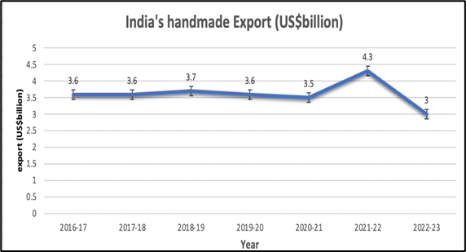

**Export Trend**

India is one of the top exporters of handicrafts and the market leader in both volume and value for handmade carpets. The entire value of handcraft exports between April 2022 and February 2023 was US$ 3 billion. The value of all Indian handcraft exports in 2021–22 was $4.35 billion, up 25.7% from the previous year. The export of handcrafted handicrafts, particularly carpets, has increased substantially during the last three years. About 40% of the world's handmade carpet exports come from India. In FY20, India exported carpets worth $1.37 billion USD. Total carpet exports from April 2020 to February 2021 were worth US$1.33 billion. Handmade woollen, woodwares, embroidered and crocheted items, art metal ware, hand-printed textiles and scarves, agarbatties & attars, zari & zari products, and imitation jewelry are among India's top exports. From April 2022 to February 2023, exports of different types of handicrafts totaled US$800.4 million for woodwares, US$369,6 million for embroidered and crocheted items, US$394.22 million for art metal items, US$296.96 million for handprinted textiles and scarves, US$149.89 million for imitation jewelry, and US$865.24 million for other handicrafts.

**Export Destinations**

Due to its uniqueness and outstanding beauty, demand for Indian handcraft items has been steadily rising in international markets. USA, UK, LAC, Australia, Canada, France, Germany, Italy, Japan, Netherlands, UAE, and Switzerland are India's top export markets for handicrafts. With a 38% share of all exports from India in 2020–21, the USA is the country that imports the most handicrafts from India. India exports carpet to more than 70 nations, mostly to the United States, Australia, and Europe. With a share of around 57%, 6%, 5%, and 5%, respectively, the USA, Germany, the UK, and Australia are India's top four carpet export markets.

The USA is a large consumer of shawls, zari woods, embroidered products, and counterfeit jewellery. In 2021–2022 carpet export to the USA reached over US$ 1.2 billion, compared to US$ 896 million from April 2022–January 2023. Indian handicrafts are sold to the UK, which also buys art supplies, crocheted goods, handcrafted goods, wooden goods, and counterfeit jewellery. Additionally, the nation has been a significant importer of carpets manufactured in India. One of the biggest markets for handprinted fabrics, embroidered products, and art metalware is the UAE. Germany frequently buys hand-printed textiles, imitation jewellery, needlework goods, and art metals. In addition, the nation bought carpets for US$116.64 million in 2021–2022 and US$80.59 million from April 2022–January 2023.

### Trends of Indian handicraft sector

The future of Indian handicrafts appears optimistic in the coming days, due to successful government programmes, the introduction of specific platforms, technology coming to the rescue, and a slew of other factors. Indian handicrafts represent our country's distinct culture and traditions. Indian painters craft their work into forms that may be passed down to future generations, bringing out a legacy of their country and culture via exquisitely articulated patterns. Not unexpectedly, the handicrafts sector is now highly vital to the Indian economy, revolutionizing the lives of millions of people across the country as one of the most important job generators and contributors to the country's export. State and regional clusters have a significant impact on handicraft exports. The Indian handicrafts sector is fragmented, according to the India Brand Equity Foundation (IBEF), with over seven million regional artisans and 67,000 exporters/export houses promoting regional art and craftsmanship in domestic and international markets.

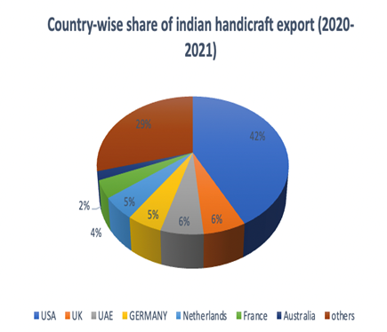

### The growing prominence of the industry

For decades, the sector has been the backbone of rural India's economy. It employs a huge number of skilled artisans in rural and semi-urban locations. Handicrafts also provide substantial foreign cash while preserving the country's cultural heritage. Because of the government's consistent promotional and growth efforts, the handicraft industry has grown considerably over the years. According to the Ministry of Textiles, the sector has been increasing at a steady pace of 20% per year and now employs over 68.86 lakh artisans.

### Tech jumps to the rescue

Without a question, technical developments have become the only option for survival for any business, especially in such unusual times, and the handicraft sector is no exception. The development of technology that allows individuals to interact across boundaries has undoubtedly benefitted the handicraft business. If you have a product to sell, finding a global buyer is no longer a pipe dream. By allowing producers from all over the world to promote their wares on these online platforms, e-commerce has opened the path for simple access to consumer goods, promoting inclusive growth. Even social media platforms are helping to promote Indian handicrafts over the world.

### Changed behaviour of craftsmen

To solve the obstacles and issues that Indian handicraft manufacturers encounter, multifaceted solutions are necessary. The good news is that there is already a market in place, and more are on their way. In order to enhance their earnings, artisans adapt to new talents and create things that meet changing market needs. The emergence of technology and the ease it brings to their table has resulted in a significant shift in the behaviors of handicraft producers and customers.

### Government initiatives

The federal government is working hard to help the business expand to its full potential. Several programs and initiatives have been put in place to help our artisans overcome the challenges they face. The 'Dastkar Shashktikaran Yojana' has partnered with the 'Ambedkar Hastshilp Vikas Yojana' to provide infrastructure, technology, and human resource development to artisans. It was founded in order to organize artists into self-help groups and societies in order to stimulate bulk production and cost savings in raw material purchase. The 'Mega Cluster Scheme' aims to assist employment creation and enhance the standard of life of our craftsmen by using a cluster-based strategy in expanding infrastructure at handicraft centers, particularly in rural areas.

The 'Research and Development Scheme' was designed to collect information on the economic, artistic, social, and promotional elements of crafts and craftsmen in the sector to help in the implementation of other welfare programs. Furthermore, the Ministry of Textiles has approved a 2.8 crore cash for the integrated project for the development and marketing of Varanasi handicrafts in September 2020, in order to assist craftspeople in overcoming COVID-19 difficulties.

### Imports vs. exports

Despite India's limited part of the world market, the total potential for increasing exports is enormous as the global market increases. The handicrafts market is estimated to increase at a CAGR of 10.9 percent between 2022 and 2027. It is expected to reach USD 1,204.7 billion by 2026. According to IBEF, the Indian government boosted incentive rates for handcrafted products under the merchandise export from India scheme (MEIS) from 5% to 7%.

### Aligning Technology with The World Of Handicrafts

The handicrafts industry is a treasure trove of art, culture and heritage that showcases the skills and creativity of countless artisans. However, to survive and thrive in the competitive and dynamic market, the industry needs to embrace innovation and collaboration. By adopting modern technology. Artisans are the makers of beauty and value, who offer their handcrafted products to the world. However, in the globalized world, they face many barriers, such as distance, language, culture and competition. Technology and AI can be their bridges, rather than their walls, in overcoming these barriers and expanding their market.

The world around us is accelerating at breakneck pace. In a few years, technology has brought the world to our doorstep, and things we never imagined conceivable have revolutionized the way we function. COVID-19 has accelerated the digitalization process even more. When the pandemic hit, there was a shift in how businesses functioned – a lot of firms went online, the hotel industry shrank dramatically, and some organizations began to consider work-from-home as a new business model for the future. Digitisation components have therefore become major discussion points for the "future" that the epidemic has imposed upon us all.

# Technology and AI could turn out to be the partners of handicraft rather than their adversaries.

- By enhancing the design and quality of the products.

- By expanding the market and customer base.

- By providing training and education to the artisans.

- By preserving the cultural heritage and authenticity of the products.

**Enhancing the design and quality of the products**: Technology and artificial intelligence (AI) may assist artists in creating unique and appealing designs by giving them inspiration, feedback, and tools to conceptualize and test their ideas. Technology and artificial intelligence (AI) can help craftsmen in improving the quality of materials and workmanship by providing them with knowledge, training, and automation to maximize resource usage and assure consistency and longevity. Technology and artificial intelligence (AI) may assist artists in reducing production costs and time by providing them with solutions, platforms, and networks to simplify their operations and reach their clients more quickly and easily. Technology and artificial intelligence (AI) may assist artists in realizing their full potential, preserving their identity, and achieving their objectives.

**Expanding the market and customer base**: Technology and AI can help artisans to reach out to more customers, both domestic and international, through online platforms, e-commerce, social media, etc. Technology and AI can help artisans to showcase their products, tell their stories, connect with their buyers and deliver their orders. Technology and AI can also help artisans to understand the customer preferences, feedback and trends, by providing them with data, analytics and insights. Technology and AI can help artisans to adapt their products, improve their quality and increase their value. Technology and AI can help artisans to grow their business, build their reputation and achieve their dreams.

**Providing training and education to the artisans**: Technology and AI can be their mentors, rather than their rivals, in filling these gaps and enhancing their learning. Technology and AI can help artisans to learn new skills, techniques and tools, as well as access information and resources related to handicrafts. Technology and AI can help artisans to find online courses, tutorials, videos, books, etc., that can teach them new ways of making and improving their products. Technology and AI can also help artisans to collaborate with other artisans, experts and organizations, by providing them with platforms, communities, networks and opportunities. Technology and AI can help artisans to share their experiences, challenges, solutions and ideas with others who can support them, guide them and inspire them. Technology and AI can help artisans to enrich their learning, broaden their horizons and achieve their potential.

**Preserving the cultural heritage and authenticity of the products**: Artisans are the storytellers of culture and heritage, who convey their meaning and emotion through their handcrafted products However, in the crowded world, they face many risks, such as losing their identity, authenticity and originality. Technology and AI can be their guardians, rather than their threats, in mitigating these risks and enhancing their storytelling. Technology and AI can help artisans to document and showcase the history, stories and values behind their products, by providing them with tools, media, formats and channels.

**Some AI tools for handicraft**

Technology and AI can help artisans to create digital portfolios, blogs, podcasts, videos, etc., that can capture and communicate the essence and significance of their products. Technology and AI can also help artisans to protect their intellectual property rights and prevent imitation or plagiarism, by providing them with solutions, systems, services and policies. Technology and AI can help artisans to register, track, verify and enforce their rights over their products. Technology and AI can help artisans to preserve their storytelling, enhance their credibility and increase their respect.

**ChatGPT**: It is an AI application that can assist you in generating text for a variety of tasks, including producing content, documentation, emails, surveys, and more. It can also be used to produce material for your handcrafted items or projects, as well as to communicate with potential customers or consumers. Adobe Firefly Adobe Firefly is an artificial intelligence (AI) application that can aid you make graphics from text or add effects and textures to text. It can be used to make pictures, logos, graphics, or templates for your handmade items or projects

**Gencraft:** Gencraft is an artificial intelligence (AI) application that can assist you in creating bespoke 3D models, prototypes, and visualizations using thousands of high-quality materials and components. It gets used to develop and test your own items or projects, as well as to cooperate with other people.

**Craft AI Assistant**: Craft AI Assistant is an AI tool that can assist you in writing quicker, generating ideas, proofreading your work, translating text into any language, summarizing papers, and finding information inside your Craft space documents.

### Research Methodology

Research methodology provides detailed information about the procedures and tools that were applied during this entire research study. Some of the technical aspects about this study are:

**Research Objectives:**

• To explore the factors that influence consumer perceptions and attitudes towards Indian artwork, which is a rich and diverse form of cultural expression.

• To understand how consumers appreciate and value Indian artwork, and what motivates them to extent of consumer acceptance and willingness to engage with Indian artwork as part of their art collection or decor.

• To analyze the role of digital platforms, in promoting and popularizing Indian artwork among consumers, and how they affect their awareness, interest, and preference for this art form.

**Research Design:** A descriptive research design was adopted during the entire research study.

**Sampling Technique:** Convenient sampling techniques were used in this research investigation with regard to sample techniques. Considering that the sample's source was just PAN India. To gather primary data, a structured questionnaire was utilized. For this study, attributes including requests, awareness, product preferences, etc., were gathered, and the percentage approach was used.

**Sample Size:** The sample size considered for the study was 172 all over India.

**Research Instrument:** A structured and well-drafted questionnaire was used as a research instrument.

**Data Types:** Both primary as well as secondary data was used in this research study.

**Methods of Data Collection:** Primary data was collected with the help of a well drafted and structured questionnaire by convenience sampling method. While secondary data was collected through online journals, news articles, and transcripts of podcasts from experts in this field.

**Limitations of the study:** The results of the study are specified to PAN India only; the results of this study may vary in some other countries where the economy is stronger than ours. Another limitation is the sample size.

### Results and Findings

In order to do the further research, we found 170 authentic consumers and evaluated their Preferences and Perceptions of Indian Artwork.

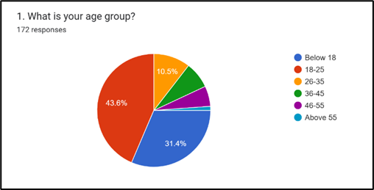

From the survey we got that majority of people of range 18-25 or the youth having a percentage of 43.6% are more interested to give their response on Indian handicraft.

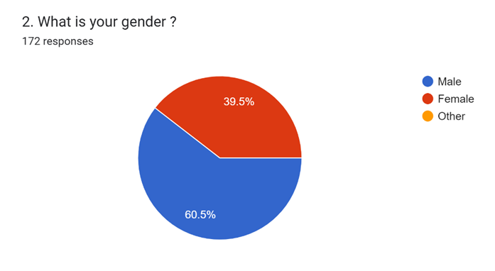From the pie chart we can infer that males (60.5) are more interested than women (39.5) to give their responses.

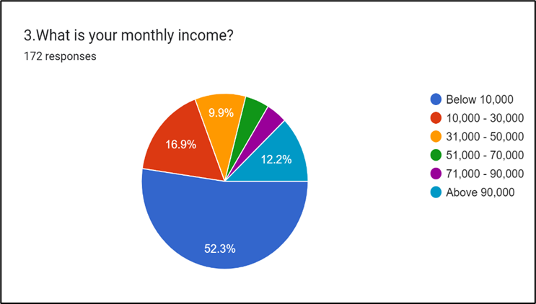

From the analysis, most of the people, whose income is less than 10,000 (52.3%) had shown their interest towards Indian handicraft. They are mostly students or part time employees (youth).

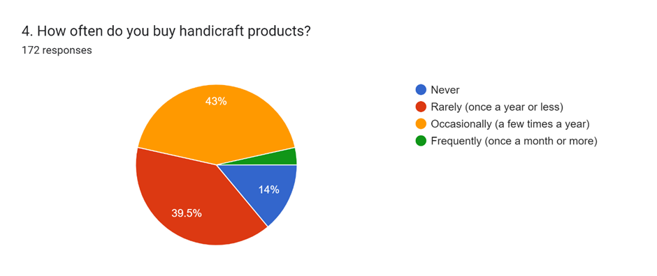

From the graph, we can infer that most of the people buy handicraft item occasionally, which is 43% of the total sample. They generally buy the handicrafts items in festive season or any special occasion.

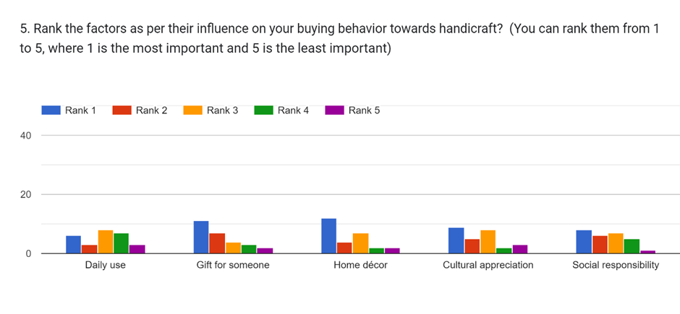

Here, we have asked the customer to rank the given factors as per their influence on their buying behaviour towards handicraft. We can see that most of the people buy handicraft for their home décor, for adding some aesthetic or uniqueness to their house.

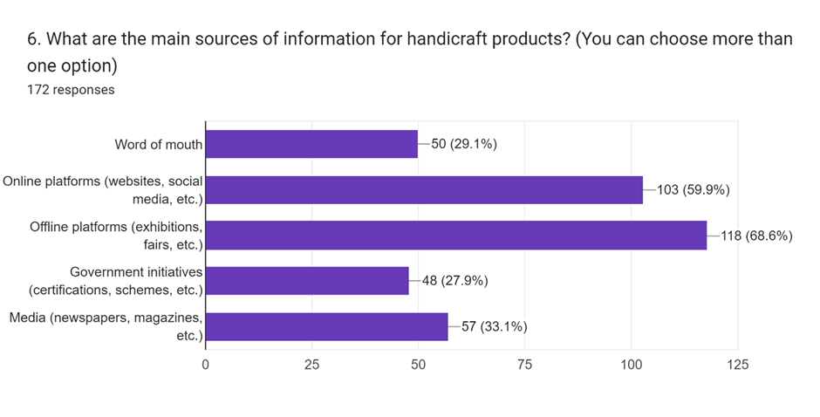

Here, the customer was asked regarding the source of information about the handicraft product and from the analysis, it was inferred that for information related to the handicraft, customers mostly depend on offline platforms like – exhibitions, fairs, etc.

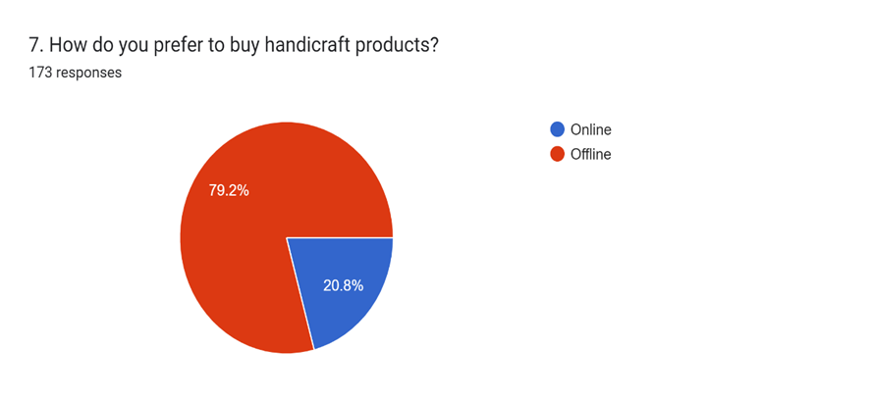

Further, when customers were asked their preferences among online and offline stores 79 percent of the respondents agreed that we would like to prefer to buy the handicraft offline.

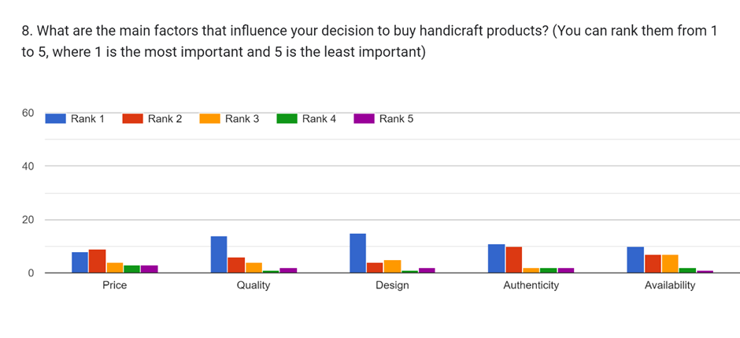

Among the multiple factor which influences the purchase decisions towards the handicraft product, the graph clearly denotes that most of the people focus on quality of items over other factors.

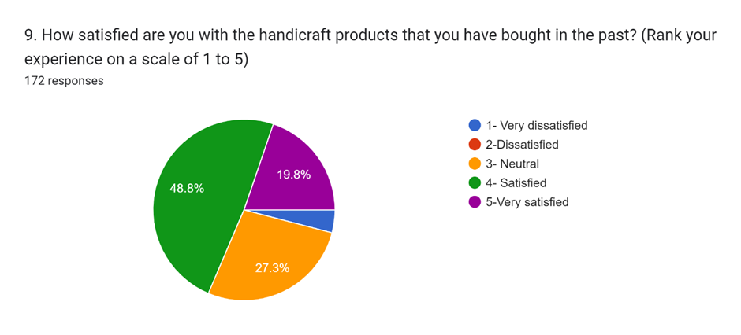

Regarding the satisfaction of the customers towards their bought handicraft products, among the respondents 49% of the respondents are satisfied towards their purchase.

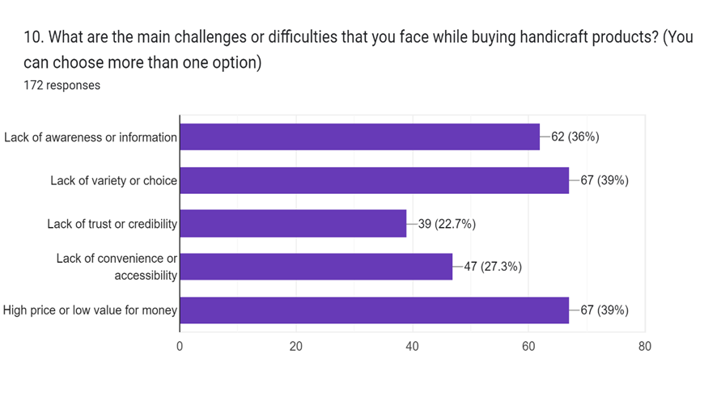

Further in the analysis, the study has highlighted various challenges and difficulties that the customers face while buying handicraft products. Among the various mentioned difficulties, certain difficulties and challenges have been given higher acceptance among the highlighted challenges and these are ‘Lack of variety or choice and high price and low value of money.

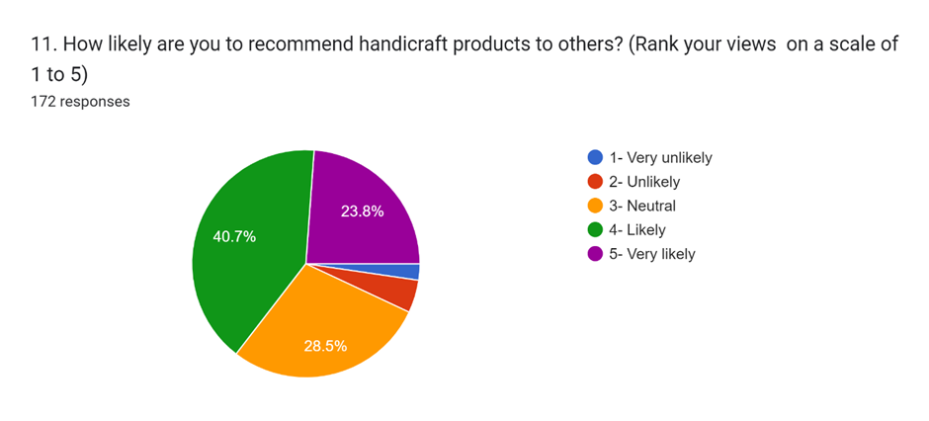

Among the respondents, around 41 percent are likely to recommend the handicraft products to others while 23.8 percent are very likely to recommend the handicraft products.

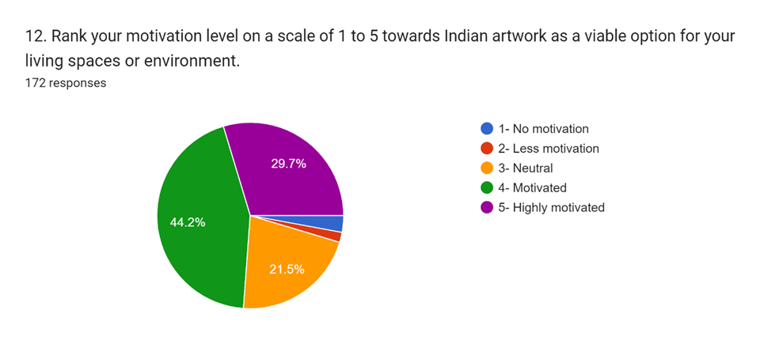

Finally, around 73 percent of respondents have considered Indian artwork as a viable option fo once living spaces or environment.

### Conclusion:

The handicrafts industry is large and crucial to the economy of the nation. It supports a sizable sector of craft workers in rural and semi-urban regions and earns significant foreign exchange for the nation. The handicraft industry, however, has suffered from its lack of organization, as well as from other obstacles including illiteracy, a lack of access to finance, a lack of exposure to new technologies, a lack of market intelligence, and a weak institutional framework. It so pales in comparison to a structured, knowledgeable, and organized sector that exists in a developed nation like Germany, where it plays a little role in the total economy.

However, given the changing environment, Indian Handicraft has a great deal of development potential. Its main advantage is the easy and affordable availability of labor, and as it is a traditional occupation for millions of people, it still requires relatively little investment compared to other nations, with the exception of China. However, it faces a serious challenge from the Chinese economy's expanding influence, their cheap but disciplined labor force, and the high-quality goods produced by industrialized nations.

### References:

1. Annual Report (2017-18). Ministry of textiles. Government of India; 2018.

2. Agnihotri MP. Dead end at the silk road: the possible revival of the Banaras handloom industry. Prabandhan: Indian Journal of Management. 2015;8(8):30–38.

3. Anumala, K. & Acharyulu, G., (2015). “A Demographic Study on Customer Satisfaction about

Handloom Products in India - A Study on Andhra Pradesh State Handloom Weavers'

Cooperative Society Limited(APCO showrooms)”, Journal of Textile and Apparel, Technology

and Management, Vol. 9, Issue 3, pp. 1-13.

4. Bagade, S., Mehta, D., (2014). „Geographical Indications in India: Hitherto and Challenges‟,

Research Journal of Pharmaceutical, Biological and Chemical Sciences (RJPBCS), Vol. 5 Issue

2, pp. 1225–1239.

5. Das,K.,(2010). “Prospects and Challenges of Geographical Indications in India”,The Journal of

World Intellectual Property, Vol. 13, pp.148 - 201.

6. Desai, N., (2008). “International Trade Law: The Indian Perspective”, International Journal of

Legal Information, Vol. 36, Issue 2, Article 18.

7. Deshmukh, P. M., (2013). “Buying Behavior of Consumer Towards Handloom And Handcraft

With Special Reference To Cidco Urban Haat Project Navi Mumbai.” Aarhat Multidisciplinary

International Education Research Journal, Vol. 2, Issue: 5, pp. 205–215. Available at:

<http://amierj.weebly.com/uploads/1/0/8/0/10800505/pd18.pdf>

8. Kumudha, A., & Rizwana, M.,(2013). “A Study on Consumer Awareness about Handloom

Products with Special Reference to Erode District”, Journal of Marketing and Consumer

Research- - An Open Access International Journal, Vol. 1, pp. 17–21. Available at:

http://www.iiste.org/Journals/index.php/JMCR/article/view/9221/9430

9. Londhe, C., (2020)“A Study of Profile of Textile Industry for Geographical Indications in India”.

Available at:

https://www.academia.edu/29259875/Title_A_Study_of_Profile_of_Textile_Industry_for_Geogra

phical_Indications_in_India_Full_Paper_Title_A_Study_of_Profile_of_Textile_Industry_for_Geo

graphical_Indications_in_India

10. Mahapatra, A., (2019). “Revival of dying Indian art and crafts”, Across the globe. Available at:

<https://www.atg.world/view-article/28753/revival-of-dying-indian-art-and-crafts>

11. Pandey R, Pandit P, Pandey S, et al. Solutions for sustainable fashion and textile industry. Recycling from Waste in Fashion and Textiles: A Sustainable and Circular Economic Approach. 2020;15:33.