Review on Blue Eye Technology

Jayasheelan Palanisamy¹  Assistant Professor  Dept of Computer Science  Sri Krishna Adithya College  of Arts and Science  sheelan.jsp@gmail.com | Yamuna Gowri B²  UG Student  Dept of Computer Science  Sri Krishna Adithya College  of Arts and Science  yamunagowribs@gmail.com | Pushpavalli A³  UG Student  Dept of Computer Science  Sri Krishna Adithya College  of Arts and Science  pushpaa3107@gmail.com

ABSTRACT:
The term "BLUE EYE TECHNOLOGY" refers to the state of technology today when we sit in front of a computer that can perceive and regulate human emotion. Technology such as facial and speech recognition is utilized to use devices that are able to detect the physical emotions of physical bodies. Blue Eye Technology uses technology that validates our identification, feels our gifts, and can detect our emotions at a distance. It can also start a conversation with us. This study discusses the most recent methods known as the "Emotion Sensory World of Blue Eye Technology," which use image processing techniques to discern human emotions such as sadness, happiness, and surprise.
Key words: magical pointing, emotive mouse, blue eye, and sensing.

- INTRODLCTION
Envision a world in which people communicate with computers. In blue eyes technology, the words "blue" and "eye" stand for Bluetooth and information gleaned from our emotions, respectively. It is the ability to gather data about you and engage with it using specialized methods like speech and face recognition. even when you have mouse-click understanding of your feelings. It begins communicating with you after confirming your identity and feeling your gifts. Perception, interpretation, and integration

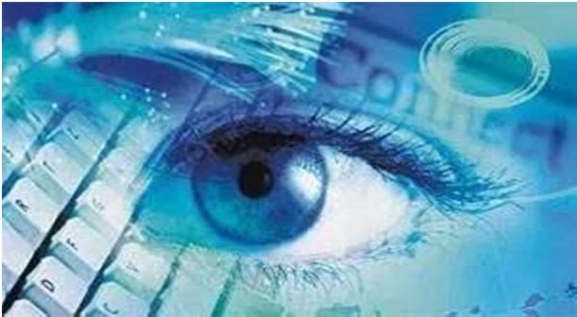
Fig 1.1 blue eye technology^{[1]}

of sensor data and audio-visuals are the only factors that determine human recognition[3].
- METHODOLOGY
A. Techniques Of Blue Eyes Technology
1) Emotional Mouse: It obtains physiological data and spirits like pulse, pressure, skin temperature etc through the touch of the user on mouse where different sensors (such as pressure sensor, pulse sensor, GSR sensor, temperature sensor) are deployed inside it. Then it determines the personality of the user.
2) Manual And Gage Input Cascading (Magic Pointing): A webcam is employed to quickly determine the glints and pupils of the user under variable and real lightning conditions and wrap the cursor to and looking for the next. Then users get control of the target by hand near the target or ignoring it and looking for the next one.
3) Artificial Intelligence Speech Identification: The user asks the pc through the microphone which talk gets filtered and saved in Random Access Memory. The input words are scanned and matched against the internally stored words. If it’s matching due to variations in loudness, pitch, frequency difference and time gap etc. The identification causes some action to be taken.
4) Simple User Interest Trackers (Suitor): Blue eye enabled suitors become active when the user builds an eye fixed contact and frequently detects the user's area of interest and starts searching it. E.g.: If you're reading a title, the story pops up within the browser window [2].
3. SOFTWARE
Looking after working operators' physiology. The condition is that the most task of Blue Eye System Software. Real- time buffering of the incoming data, physiological data analysis and alarm triggering is being performed by the software to show the instance reaction on Operator condition. Several functional modules System core consists of The Blue Eyes software which facilitates the flow of transfer between other system modules (eg. transfers data from the Connection Manager to data analyser’s, processed data from the data analyser’s to GUI controls, other data analyser’s, and data.^{[4]} The Visualization module provides an interface for the supervisors. A preview of selected video source and related sound stream the working operator’s physiological condition’s watching is enabled by this software. whenever the supervisor instantly signalled the incoming of alarm messages. The Visualization module is often set in an off-line mode, where all the data is fetched from the database. The supervisor reconstructs the course of the chosen information. Adding extraordinary perceptual abilities to computers would enable computers to work together with citizenry as intimate partners.
Researchers try to introduce more capabilities to computers which can allow them to interact like humans, recognize human presents, talk, listen, or even guess their feelings. It aims at creating computational machines that have perceptual and sensory ability like those of citizenry. It uses a non-obtrusive sensing method, employing latest video cameras and microphones to identify the user’s actions through the use of imparted sensory abilities. The machine can understand what a user wants, where he's watching, and even realize his physical or emotional states. The BLUE EYES technology aims at creating computational machines that have perceptual and sensory ability like those of its . It uses a non obtrusive sensing method, employing latest video cameras and microphones to identify the user's actions through the use of imparted sensory abilities. The machine can understand what a user wants, where he is watching, and even realize his physical or emotional states. Within the name of BLUE EYES, Blue in this term stands for Bluetooth (which enables wireless communication) and eyes because eye movement enables us to urge plenty of interesting Information. Operator's duty by watching all the recorded physiological parameters, alarms, video and audio data. A set of custom-built GUI controls is used to present physiological data.
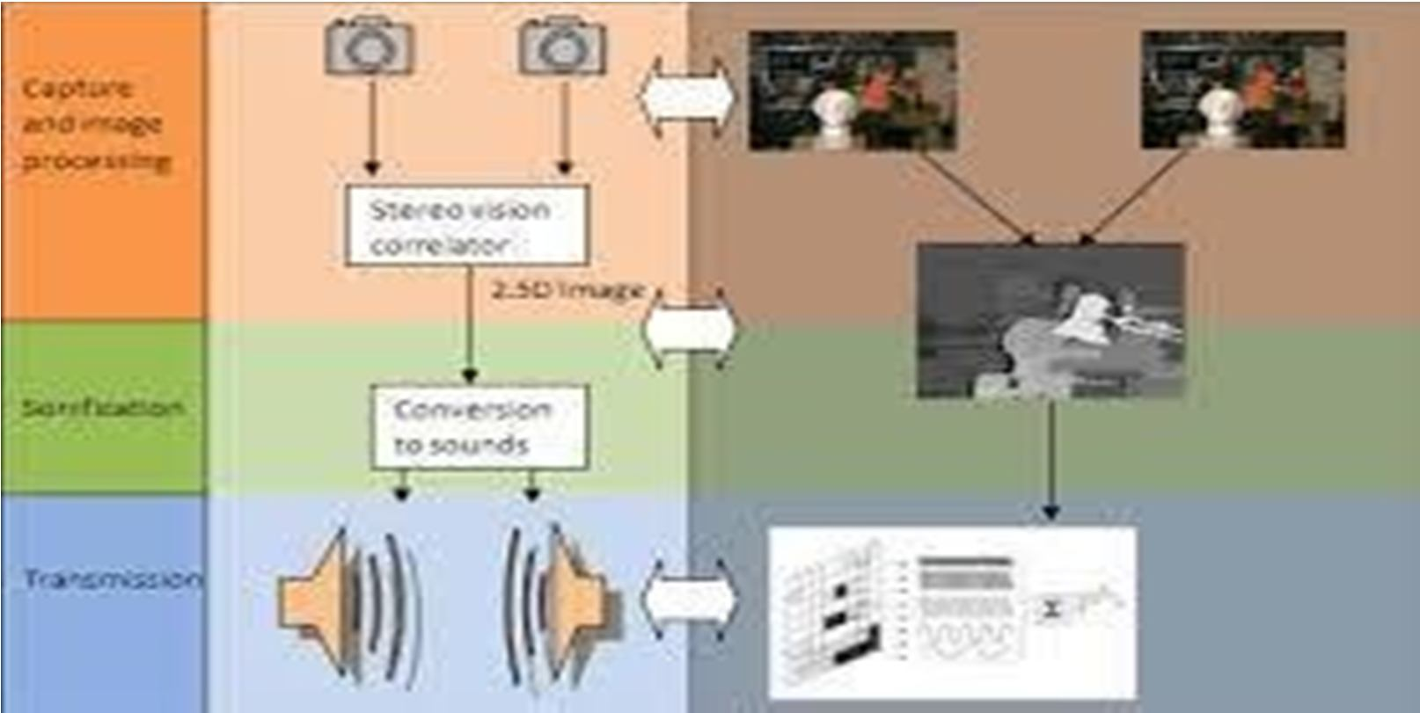
Fig 3.1 Software ^{[6]}
4.EMOTIONAL COMPUTING
A. Two types of Blue Eye Technology
- For Hand: Emotion Mouse: The major aim of Brain Computer Interface (BCI) is to develop a wise and accommodative automatic processing system. These sorts of projects should embrace speech recognition, eye tracking, face recognition, gesture recognition etc. software and hardware. Similarly, in Blue Eyes technologies, to create a system that has the facility to identify those perceptual abilities of peoples. In Blue Eyes, the machines have the facility to identify the minor variations within the moods of citizenry. Say someone might strike the keyboard hurriedly or softly depending on his emotion like happy or angry. The Blue Eyes technology allows the machines to identify their emotional variations of human even by one bit on the mouse or keyboard and also the machines began to react with the users keeping with these emotional levels. This is often finished by the steerage of intelligent devices like Emotion Mouse. Actually, this sense Mouse is an associated device to trace the emotions of a user by an easy bit there on. The sensation Mouse is meant to gauge and determine the user's emotions. when he/she is interacting with a computer. The most objective of the sensation Mouse is to assemble the users physical and physiological information by an easy bit.
- For Eye: Expression Glass Expression Glass is another for the sometimes-offered machine vision face or eye recognition ways. By analyzing the pattern recognition and skeletal muscle variations, the glass senses and identifies the expressions like interest or confusion of the user. The image used for this glass uses electricity sensors ^{[8].}

5. HARDWARE
- Data Acquisition Unit
The Data Acquisition Unit may be a mobile part of the Blue eyes system. Its main task is to fetch the physiological information from the sensing element and to send it to the central system to be processed. To accomplish the task the device should manage wireless Bluetooth connections (connection establishment, authentication and termination). Personal ID cards and PIN codes give operator’s authorization. Communication with the operator is carried on employing a simple 5-key keyboard, a little LCD display and a beeper. When an exceptional situation is detected the device uses them to notify the operator. Voice data is transferred employing a small headset, interfaced to the DAU with standard mini- jack plugs The Data Acquisition Unit comprises several hardware modules: Atmel 89C52 microcontroller – system core Bluetooth module HD44780, small LCD display 24C16, I2C EEPROM, MC145483 13bit PCM codec Jazz Multi Sensor interface Beeper and LED indicators ,6 AA batteries and voltage level monitor.
- Central System Unit Hardware
It is the second peer of the wireless connection. The box contains a Bluetooth module (based on ROK101008) and a PCM codec for voice data transmission. The module is interfaced to a PC employing a parallel, serial and USB cable. The audio data is accessible through standard mini-jack sockets. To program operator’s personal ID cards we developed a simple programming device. The computer programmer is interfaced to a computer victimization serial and PS/2 (power source) ports. Inside the system Atmel 89C2051 microcontroller, which handles UART transmission and I2C EEPROM programming [5].

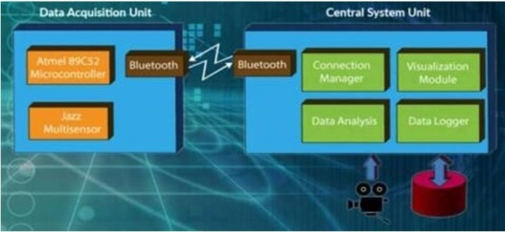
Fig 5.1 Hardware ^{[5]}

6. CONCLUSION
The modern world is developing new technology. In several areas of technology, the blue eye technology is quite helpful. By offering more delicate and user-friendly features on computing devices, it guarantees a practical approach to simplify life. In any case, this is just a technology projection. By using Blue Eye technology, it will be feasible to construct hardware in the future and create computers that can communicate with one another.

REFERENCES
- https://krazytech.com/technical-papers/blue-eyes-technology
- https://www.geeksforgeeks.org/what-is-blue-eyes-technology
- https://www.slideshare.net/ChaitanyaGubbala/blue-eyestechnology.
- Chandani Suryawanshi T. Raju, Blue Eyes Technology S.Madhumitha, IJSRD - International Journal for Scientific Research & Development| Vol. 2, Issue 01, 2014.
- https://www.electroniclinic.com/blue-eye-technology-and-application-of-the-blue-eye-technology.
- Manisha Kumavat,Garima Mathur,Nikita Susan Saju Research Paper on Blue Eyes Technology.
- Priyadharshini.R, harini.R.V Blue Eye Technology Consuming Non Nature Intellect.
- Anagha.p A Survey on Blue Eye Technology.

