Expert brain tumor detection and classification system using two level diagnosis

**1Prof. Pramod G Patil, 2Yadnesh Patil, 3Nagesh Sanap, 4Gunjan Patil, 5Janhavi Mahajan Sandip Institute Of Technology And Research Centre Nashik, Maharashtra, India**

***Abstract*— Brain tumors are a significant health concern globally, with early and accurate detection being critical for effective treatment and improved patient outcomes. This paper presents an innovative approach for brain tumor detection and classification using a two-level diagnosis system. The proposed system combines advanced medical imaging techniques with artificial intelligence algorithms to enhance the accuracy and efficiency of brain tumor diagnosis. Furthermore, the proposed system incorporates an expert system that integrates medical knowledge and decision-making rules. The expert system refines the diagnosis results by considering additional clinical parameters, patient history, and expert opinions, ensuring a comprehensive and accurate diagnosis. This research contributes significantly to the field of medical imaging and artificial intelligence, offering a robust and reliable solution for brain tumor detection and classification. The proposed system has the potential to revolutionize clinical practices, leading to early diagnosis, personalized treatment plans, and ultimately, improved outcomes for patients with brain tumors.**

***Index Terms*—Brain Tumor Detection, Tumor Classification, Medical Imaging, Deep Learning.**

1. INTRODUCTION

Brain tumors continue to pose a significant threat to public health, necessitating advanced diagnostic techniques for early detection and accurate classification. Timely diagnosis is crucial as it directly influences treatment decisions and patient outcomes. Conventional diagnostic methods, while valuable, often face limitations in terms of accuracy and efficiency. The integration of advanced medical imaging technologies with cutting-edge artificial intelligence (AI) algorithms has paved the way for more precise and swift diagnosis of brain tumors. This research introduces an expert brain tumor detection and classification system employing a sophisticated two-level diagnosis approach. The system integrates state-of-the-art medical imaging, deep learning, and machine learning techniques to enhance the accuracy and reliability of brain tumor diagnosis. By combining the strengths of image processing, convolutional neural networks (CNNs),and expert systems, this approach aims to revolutionize the field of neuroimaging diagnostics.

The subsequent sections of this paper will detail the methodology, including the image preprocessing techniques, the architecture of the CNN model, the machine learning algorithms utilized for tumor classification, and the incorporation of expert knowledge into the diagnostic process. The results of extensive evaluations on diverse datasets will be presented, showcasing the system's effectiveness and reliability. Finally, we will discuss the implications of our findings, potential applications in the medical field, and avenues for future research, emphasizing the transformative potential of this expert brain tumor detection and classification system.

II . RELATED WORK

1.In Znet: Deep Learning Approach for 2D MRI Brain Tumor Segmentation et.al Mohammad ashraf ottom, Hanif abdul rahman has explained Detection and segmentation of brain tumors using MR images are challenging and valuable tasks in the medical field. Early diagnosing and localizing of brain tumors can save lives and provide timely options for physicians to select efficient treatment plans. Deep learning approaches have attracted researchers in

medical imaging due to their capacity, performance, and potential to assist in

accurate diagnosis, prognosis, and medical treatment technologies. Methods and procedures: This paper presents a novel framework for segmenting 2D brain tumors in MR images using deep neural networks (DNN) and utilizing data augmentation strategies. The proposed approach (Znet) is based on the idea of skip-connection, encoder-decoder architectures, and data amplification to propagate the intrinsic affinities of a relatively smaller number of expert delineated tumors, e.g., hundreds of patients of the low-grade glioma (LGG), to many thousands of synthetic cases. This research demonstrates a practical example of AI applications in medical imaging.

2.In A Deep Learning Model Based on Concatenation Approach for the Diagnosis of Brain Tumor et.al Neelum noreen , Sellappan palaniappan , Abdul qayyum researched that Brain tumor is a deadly disease and its classification is a challenging task for radiologists because of the heterogeneous nature of the tumor cells. Recently, computer-aided diagnosis-based systems have promised, as an assistive technology, to diagnose the brain tumor, through magnetic resonance imaging (MRI). In recent applications of pre-trained models, normally features are extracted from bottom layers which are different from natural images to medical images. To overcome this problem, this study proposes a method of multi-level features extraction and concatenation for early diagnosis of brain tumor. Two pretrained deep learning models i.e. Inception-v3 and DensNet201 make this model valid. With the help of these two models, two different scenarios of brain tumor detection and its classification were evaluated. First, the features from different Inception modules were extracted from pre-trained Inception-v3 model and concatenated these features for brain tumor classification.

3.In SBTC-Net: Secured Brain Tumor Segmentation and Classification Using Black Widow With Genetic Optimization in IoMT et.al M. V. S. Ramprasad, Md. Zia ur rahman has notice that People around the globe are suffering from different types of brain tumors. So, early prediction of brain tumors can save human lives. This work focused on implementing a secured brain tumor classification network (SBTC-Net) using transfer learning methods. Initially, security is achieved by performing the medical image watermarking (MIW) operation using translation invariant wavelet transform (TIWT). Here, the watermarking process covers a patient’s source MRI brain tumor image with an unknown medical image (cover image). Then, this watermarked image is transmitted over the Internet of Medical Things (IoMT) environment. Here, the attackers are unable to visualize the source image. So, the source brain tumor image is transmitted over a secured environment.

4. In CKD-TransBTS: Clinical Knowledge-Driven Hybrid Transformer With Modality-Correlated Cross-Attention for Brain Tumor Segmentation et.al Jianwei Lin, Jiatai Lin, Cheng Lu, Hao Chen has explained that Brain tumor segmentation (BTS) in magnetic resonance image (MRI) is crucial for brain tumor diagnosis, cancer management and research purposes. With the great success of the ten-year BraTS challenges as well as the advances of CNN and Transformer algorithms, a lot of outstanding BTS models have been proposed to tackle the difficulties of BTS in different technical aspects. However, existing studies hardly consider how to fuse the multi-modality images in a reasonable manner. Instead of directly concatenating all the modalities, we re-organize the input modalities by separating them into two groups according to the imaging principle of MRI. A dual-branch hybrid encoder with the proposed modality-correlated cross-attention block (MCCA) is designed to extract the multi-modality image features. The proposed model inherits the strengths from both Transformer and CNN with the local feature representation ability for precise lesion boundaries and longrange feature extraction for 3D volumetric images. To bridge the gap between Transformer and CNN features, we propose a Trans&CNN Feature Calibration block (TCFC) in the decoder. We compare the proposed model with six CNN-based models and six transformer-based models on the BraTS 2021 challenge dataset. Extensive experiments demonstrate that the proposed model achieves state-of-theart brain tumor segmentation performance compared with all the competitors.

1. OBJECTIVES

This paper is aimed to Develop and implement a robust deep learning-based algorithm to accurately detect brain tumors in magnetic resonance imaging (MRI) scans, improving sensitivity and specificity compared to conventional methods. to significantly improve the accuracy, efficiency, and clinical relevance of brain tumor diagnoses, ultimately leading to better patient outcomes and enhanced healthcare practices.

1. 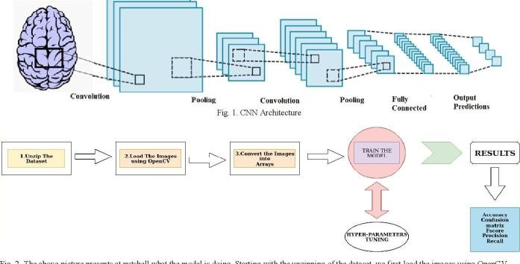METHODOLOGY

Gather a diverse and comprehensive dataset of brain MRI scans, including images of various tumor types and healthy brain tissues, ensuring data representativeness.

Apply noise reduction, image normalization, and contrast enhancement techniques to standardize the input data. Employ image registration methods to ensure consistency across different imaging modalities.

Design and train a convolutional neural network (CNN) using the preprocessed MRI images for tumor detection. Utilize architectures like CNN tailored for medical image analysis.

Segment the detected tumors and extract relevant features, such as shape, texture, and intensity, from the segmented regions. Apply techniques like gray-level co-occurrence matrices (GLCM) and Haralick features.

Develop a rule-based expert system incorporating medical knowledge and decision-making rules. Integrate the expert system with the output from the machine learning classifier to refine the classification results.

Integrate the initial tumor detection model, tumor classification algorithm, and expert system into a cohesive two-level diagnosis system. Ensure seamless communication and data flow between the components.

Generate visual explanations, such as heatmaps and saliency maps, to highlight regions of interest in the MRI images. Provide these visualizations to medical professionals for better understanding and validation of the diagnostic results.

Optimize the algorithms and models for computational efficiency, exploring techniques like model quantization and hardware acceleration to reduce inference time.

Collaborate with healthcare institutions to conduct clinical trials and validate the system's performance in real clinical settings.

CNN Algorithm Working:

Data Collection: To train a CNN for brain tumor detection, a dataset of brain MRI (Magnetic Resonance Imaging) scans is required. These scans typically consist of two types of images.

Data Preprocessing: The first step is to preprocess the images. This involves resizing them to a consistent size, normalizing pixel values, and possibly augmenting the data by applying transformations like rotation, flipping, or blurring to increase the diversity of the training set.

Architecture Selection: You need to choose or design a CNN architecture suitable for the task. Common architectures include AlexNet, VGG, Inception, and ResNet. These architectures have proven effective for image classification tasks.

Training: The CNN is trained on the preprocessed brain MRI images. During training, the network learns to recognize patterns and features that distinguish between healthy brain scans and those with tumors. It adjusts its internal parameters (weights and biases) to minimize the classification error.

Loss Function: Typically, a loss function like cross-entropy is used to measure the difference between the predicted class labels and the true labels of the training data. The CNN's goal isto minimize this loss during training.

Back propagation: Back propagation is used to update the model's weights. This process calculates gradients that indicatehow much each weight should be adjusted to reduce the loss.

Validation: The model's performance is regularly evaluated on a separate validation dataset not used during training. This helps in monitoring overfitting and determining when the model is ready for testing.

Testing: After training, the CNN is tested on a new set of brain MRI images to evaluate its performance. It provides predictions(e.g., healthy or tumor) for each image.

1. System Architecture

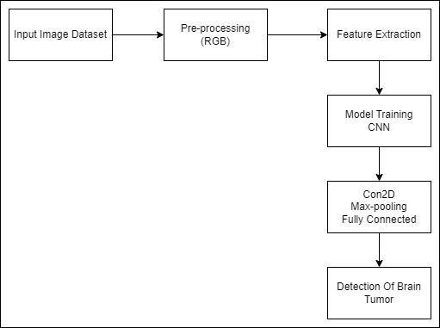

Fig. 5.1. System Architecture of Brain Tumor

1. WORKING

Benign Tumors: These are non-cancerous growths that tend to grow slowly and typically do not invade nearby tissues or spread to other parts of the body.

Malignant Tumors (Cancerous): These are cancerous growths that can grow more rapidly and invade nearby healthy brain tissue.

Tumor Growth:

Expansive Growth: Tumors can exert pressure on the surrounding brain tissue, causing symptoms such as headaches, nausea, and neurological deficits.

Infiltrative Growth: Malignant tumors can infiltrate healthy brain tissue, making complete surgical removal difficult

Symptoms: The symptoms of a brain tumor can vary widely and may include:

Headaches, often worsening in the morning Nausea and vomiting Seizures Changes in vision or hearing Cognitive and behavioral changes.

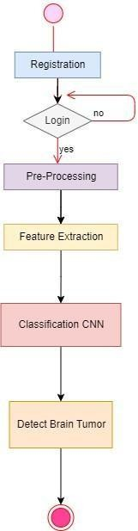

Surgery: The primary treatment for many brain tumors involves surgical removal when possible. Benign tumors are often curable with surgery.

Radiation Therapy: This is commonly used to treat both benign and malignant brain tumors, either as the primary treatment or following surgery to destroy any remaining cancer cells.

Prognosis: The prognosis for a brain tumor depends on its type, grade, location, and how early it's detected and treated. Some benign tumors can be completely cured, while malignant tumors may be more challenging to treat.

Monitoring: Even after successful treatment, patients with brain tumors often require long-term monitoring to detect any recurrence or new tumor growth.

1. RESULTS

The deep learning-based initial diagnosis phase is expected to achieve a notably high accuracy rate in detecting brain tumors from MRI scans, outperforming traditional methods.

The second level of diagnosis, involving machine learning classifiers and expert system integration, is anticipated to provide precise classification results for different tumor types. The system will accurately categorize tumors into specific classes such as gliomas, meningiomas, and pituitary tumors based on extracted features and expert knowledge.

The two-level diagnosis approach is expected to enhance both sensitivity and specificity in brain tumor diagnosis. Sensitivity will be improved due to the detailed analysis at both detection and classification levels, ensuring fewer false negatives. Specificity will increase as the system differentiates between tumor types with higher accuracy, reducing false positives.

i.Expected Outcomes:

Successful Treatment and Cure: Some brain tumors are benign (non-cancerous) and can often be successfully treated and cured with surgery alone. Many low-grade malignant tumors can also be cured with a combination of surgery, radiation therapy, and/or chemotherapy.

Long-Term Remission: In some cases, even if a brain tumor cannot be completely cured, it can be managed effectively, leading to long-term remission. This means that the tumor is controlled, and the patient can live a relatively normal life with regular medical follow-ups and treatments.

Stabilization: For certain slow-growing or low-grade brain tumors, the goal of treatment may be to stabilize the tumor's growth and control symptoms without necessarily aiming for a cure.

It's crucial to note that each case is unique, and outcomes can vary widely. The treatment approach and prognosis are determined by factors such as the tumor type, stage, patient's age and overall health, and the availability of advanced treatments. Patients should work closely with a medical team, including neurosurgeons, oncologists, and supportive care professionals, to discuss treatment options and expected outcomes specific to their situation.

ii.Discussion:

Types of Brain Tumors: There are various types of brain tumors, including gliomas, meningiomas, pituitary tumors, and metastatic tumors, among others.

Causes: The exact cause of most brain tumors is not well understood. However, there are risk factors, such as exposure to radiation, genetic predisposition, and certain environmental factors that may increase the risk of developing a brain tumor.

Symptoms: The symptoms of a brain tumor can vary depending on its location and size. Common symptoms include headaches, seizures, changes in mental function, weakness, speech problems, and personality changes.

Diagnosis: Brain tumors are typically diagnosed through imaging studies like MRI or CT scans. If a tumor is found, a biopsy or surgical resection may be needed to determine its type and grade.

Treatment: The treatment of a brain tumor depends on its type, size, location, and grade. Treatment options may include surgery, radiation therapy, chemotherapy, targeted therapy, and immunotherapy.

Prognosis: The prognosis for a brain tumor can vary widely. Some benign tumors can be cured with surgery, while malignant tumors may require ongoing treatment.

Support and Resources: Coping with a brain tumor diagnosis can be challenging. Patients and their families often benefit from support groups, counseling, and educational resources provided by medical professionals and advocacy organizations.

iii.Future Work:

Develop and refine non-invasive diagnostic tools, such as advanced imaging techniques, liquid biopsies, and biomarkers, to detect brain tumors at an early stage when treatment is more effective.

Investigate novel treatment options, including targeted therapies, immunotherapies, and precision medicine approaches tailored to the genetic and molecular characteristics of individual tumors.

Develop algorithms and models to predict treatment responses and outcomes for individual patients based on their tumor characteristics.

Develop BCIs that can assist with cognitive rehabilitation and communication for brain tumor patients.

Focus on pediatric brain tumors, with research directed towards developing treatments that minimize long-term side effects on growing brains.

Promote and participate in clinical trials to evaluate the safety and efficacy of new treatments and interventions for brain tumors.

Utilize AI and machine learning to analyze large datasets of brain tumor information, including imaging data and patient records, to identify patterns, predict outcomes, and guide treatment decisions.

Advocate for policies that improve access to care and support for brain tumor patients and their families.

a.Advantages:

Advances in brain tumor research and treatment have led to improved survival rates for many types of brain tumors.

Research has led to the development of more sensitive diagnostic tools and imaging techniques, enabling the early detection of brain tumors, which is crucial for timely intervention.

Improvements in supportive care and rehabilitation programs help patients maintain a better quality of life during and after treatment.

Brain tumor research has garnered more public awareness and advocacy, leading to increased funding, support, and resources for patients and their families.

b.Disadvantages:

Despite advancements, some types of brain tumors are still challenging to treat, and curative options remain limited.

Many treatments for brain tumors, such as surgery, radiation therapy, and chemotherapy, can lead to significant side effects, including cognitive impairment, fatigue, and nausea.

The brain is a highly complex and delicate organ, making surgical interventions and treatments more challenging and risky.

Brain tumor research receives less funding compared to other cancer types, which can slow down the pace of discovery and innovation.

Not all patients have access to clinical trials, which may offer cutting-edge treatments. This limited accessibility can be a disadvantage for those seeking experimental therapies.

OUTPUT:

This is first page of GUI .This page create from Spyder using anaconda navigater and using tikenter framework. Using python libraries.

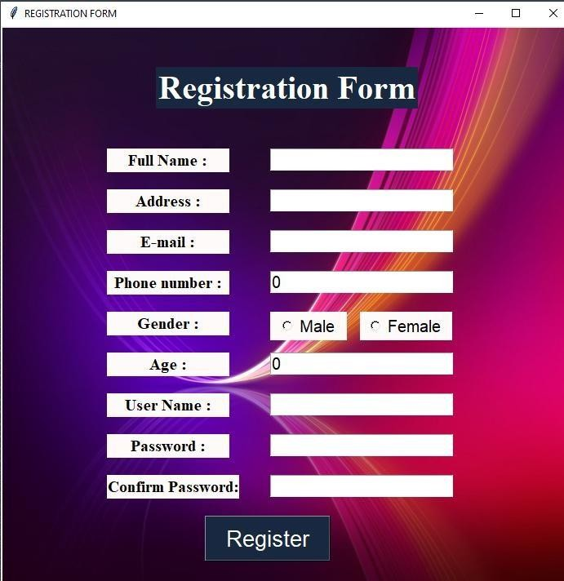

This is registration page.

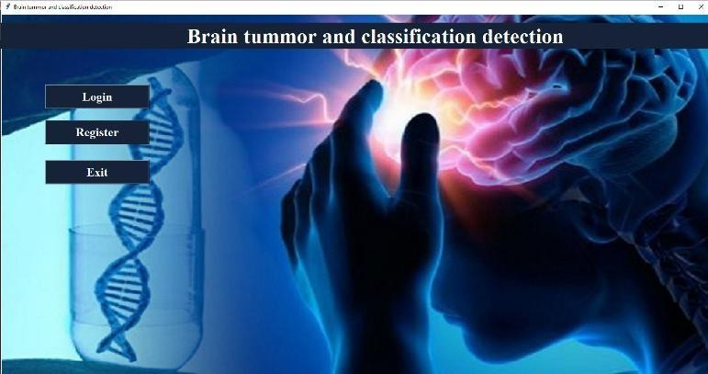

REFERENCES

1. Louis D.N., Perry A., Reifenberger G., Von Deimling A., Figarella-Branger D., Cavenee W.K., Ohgaki H., Wiestler O.D., Kleihues P., Ellison D.W. The 2016 world health organization classification of tumors of the central nervous system: a summary. Acta Neuropathol. 2021;131(6):803–820. [PubMed] [Google Scholar]
2. Dasgupta A., Gupta T., Jalali R. Indian data on central nervous tumors: A summary of published work. South Asian J Cancer. 2021;5(3):147. [PMC free article] [PubMed] [Google Scholar].
3. C.R. UK, Published on may, 2019; 2021. URL: https://[www.cancerresearchuk.org.](http://www.cancerresearchuk.org/)
4. Hollon T.C., Pandian B., Adapa A.R., Urias E., Save A.V., Khalsa S.S.S., Eichberg D.G., D’Amico R.S., Farooq Z.U., Lewis S., et al. Near real-time intraoperative brain tumor diagnosis using stimulated raman histology and deep neural networks. Nat Med. 2020;26(1):52–58.
5. Kasraeian S., Allison D.C., Ahlmann E.R., Fedenko A.N., Menendez L.R. A comparison of fineneedle aspiration, core biopsy, and surgical biopsy in the diagnosis of extremity soft tissue masses. Clin Orthopaedics Rel Res. 2021;468(11):2992–3002.
6. El-kenawy E.S.M., Albalawi F., Ward S.A., Ghoneim S.S.M., Eid M.M., Abdelhamid A.A., Bailek N., Ibrahim A. Feature Selection and Classification of Transformer Faults Based on Novel Meta-Heuristic Algorithm. Mathematics. 2022;10:3144. doi: 10.3390/math10173144.
7. El-Kenawy E.S.M., Mirjalili S., Alassery F., Zhang Y.D., Eid M.M., El-Mashad S.Y., Aloyaydi B.A., Ibrahim A., Abdelhamid A.A. Novel Meta-Heuristic Algorithm for Feature Selection, Unconstrained Functions and Engineering Problems. IEEE Access. 2022;10:40536–40555.doi:

10.1109/ACCESS.2022.3166901.

1. Ibrahim A., Mirjalili S., El-Said M., Ghoneim S.S.M., Al-Harthi M.M., Ibrahim T.F., El-Kenawy

E.S.M. Wind Speed Ensemble Forecasting Based on Deep Learning Using Adaptive Dynamic Optimization Algorithm. IEEE Access. 2021;9:125787–125804.doi:

10.1109/ACCESS.2021.3111408.

1. El-kenawy E.S.M., Abutarboush H.F., Mohamed A.W., Ibrahim A. Advance Artificial Intelligence Technique for Designing Double T-shaped Monopole Antenna. Comput. Mater. Contin. 2021;69:2983– 2995. doi: 10.32604/cmc.2021.019114.

Samee N.A., El-Kenawy E.S.M., Atteia G., Jamjoom M.M., Ibrahim A., Abdelhamid A.A., El-Attar N.E., Gaber T., Slowik A., Shams M.Y. Metaheuristic Optimization Through Deep Learning Classification of COVID-19 in Chest X-Ray Images. Comput. Mater. Contin.2022;73:4193–4210.doi: 10.32604/cmc.2022.031147.

1. Lee G., Nho K., Kang B., Sohn K.A., Kim D. Predicting Alzheimer’s disease progression using multi-modal deep learning approach. Sci. Rep. 2019;9:1952. doi: 10.1038/s41598-018-37769-z.
2. Sharma K., Kaur A., Gujral S. Brain Tumor Detection based on Machine Learning Algorithms. Int. J. Comput. Appl. 2014;103:7–11. doi: 10.5120/18036- 6883.
3. Agrawal M., Jain V. Prediction of Breast Cancer based on Various Medical Symptoms Using Machine Learning Algorithms; Proceedings of the 2022 6th International Conference on Trends in Electronics and Informatics (ICOEI); Tirunelveli, India. 28–30 April 2022; pp. 1242–1245.